Western Australia
Crimes at Sea Act 2000

Western Australia
Crimes at Sea Act 2000
CONTENTS
---1. Short title 1
2. Commencement 2
3. Interpretation 2
4. Ratification of cooperative scheme 2
5. Classification of offences 2
6. Publication of intergovernmental agreement 3
7. Regulations 3
8. Crimes (Offences at Sea) Act 1979 repealed 3
9. Off-shore (Application of Laws) Act 1982 amended 3
10. Application of repeal and amendments 3
Schedule 1 — The Cooperative Scheme
Part 1 — Preliminary
1. Definitions 4
Part 2 — Application of State criminal law in adjacent area
2. Application of State criminal law in adjacent area 6
3. Application of laws of criminal investigation, procedure and evidence 7
4. Evidentiary presumption about the locus of an offence 9
Part 3 — The intergovernmental agreement
5. Intergovernmental agreement 10
6. Effect of the agreement 10
Part 4 — Limitations and exclusions
7. Commonwealth Attorney-General’s consent required for certain prosecutions 10
8. Non-exclusion of consistent extraterritorial legislative schemes 11
9. Exclusion of certain laws from ambit of scheme 11
10. Non application of scheme to the Joint Petroleum Development Area 12
Part 5 — Miscellaneous
11. Interpretation 12
12. Regulations 12
Part 6 — Adjacent areas
13. Definitions 12
14. Adjacent areas 13
15. Baselines 14
16. Indicative map 14
Appendix 1 — Indicative map
Schedule 2 — Off-shore (Application of Laws) Act 1982 amended
1. Section 2 amended 16
2. Section 3 amended 16
3. Section 3A amended 16
Notes
Compilation table 17

Western Australia
Crimes at Sea Act 2000
An Act to give effect to a cooperative scheme for dealing with crimes at sea, to repeal the Crimes (Offences at Sea) Act 1979, to amend the Off-shore (Application of Laws) Act 1982, and for other purposes.
Why this Act needs to be enacted
The Commonwealth and the States have agreed to a cooperative scheme to apply the criminal law of the States extraterritorially in the areas adjacent to the coast of Australia.
Under the scheme, the criminal law of each State is to apply in the area adjacent to the State —
(a) for a distance of 12 nautical miles from the baseline for the State —by force of the law of the State; and
(b) beyond 12 nautical miles up to a distance of 200 nautical miles from the baseline for the State or the outer limit of the continental shelf (whichever is the greater distance) — by force of the law of the Commonwealth.
Responsibility for administering criminal justice in the area covered by the scheme will be divided between the Commonwealth and the States under the scheme and an intergovernmental agreement.
The purpose of this Act is to give legal force to the scheme (so far as it depends on the legislative power of the State) and to provide for consequential vesting of judicial and other powers.

1. Short title
This Act may be cited as the Crimes at Sea Act 2000.

2. Commencement
(1) The provisions of this Act come into operation on a day fixed by proclamation.
(2) Different days may be fixed under subsection (1) for different provisions.

3. Interpretation
In this Act, unless the contrary intention appears —
cooperative scheme means the legislative and administrative scheme for applying and enforcing criminal law in the areas adjacent to the coast of Australia set out in Schedule 1;
intergovernmental agreement means the agreement entered into under clause 5 of Schedule 1.

4. Ratification of cooperative scheme
To the extent that it lies within the legislative competence of the State to give the cooperative scheme the force of law, it has the force of law.

5. Classification of offences
Offences (other than offences arising under the law of the State) are classified for the purposes of the cooperative scheme as follows —
(a) if the maximum penalty for the offence is a fine or imprisonment for not more than 2 years, the offence is classified as a summary offence;
(b) if the maximum penalty for the offence is (or includes) imprisonment for more than 2 years but not more than 5 years, the offence is classified as a misdemeanour;
(c) if the maximum penalty for the offence is (or includes) imprisonment for more than 5 years or for an indefinite term, the offence is classified as a crime.

6. Publication of intergovernmental agreement
The Minister must have the intergovernmental agreement, and any amendment to the intergovernmental agreement, published in the Gazette.

7. Regulations
(1) The Governor may make regulations prescribing any matter that is necessary or convenient to be prescribed for giving effect to the purposes of this Act.
(2) Subsection (1) does not authorize the making of regulations for the purposes of the cooperative scheme.

8. Crimes (Offences at Sea) Act 1979 repealed
The Crimes (Offences at Sea) Act 1979 is repealed.

9. Off-shore (Application of Laws) Act 1982 amended
Amendments are made to the Off-Shore (Application of Laws) Act 1982 as set out in Schedule 2.

10. Application of repeal and amendments
(1) In this section—
commencement day means the day on which sections 8 and 9 come into operation.
(2) Although section 8 repeals the Crimes (Offences at Sea) Act 1979, that Act continues to apply, in relation to acts and omissions that took place before the commencement day, as if the repeal had not happened.
(3) The amendments referred to in section 9 apply to acts and omissions that take place on or after the commencement day.
(4) For the purposes of this section, if an act or omission is alleged to have taken place between two dates, one before and one on or after the commencement day, the act or omission is alleged to have taken place before the commencement day.

Schedule 1 — The Cooperative Scheme
[s. 3]

Part 1 — Preliminary
1. Definitions
(1) In this scheme —
adjacent area for a State has the meaning given by clause 14 of this Schedule;
Australian ship means —
(a) a ship registered in Australia; or
(b) a ship that operates, or is controlled, from a base in Australia and is not registered under the law of another country; or
(c) a ship that belongs to an arm of the Defence Force;
baseline for a State has the meaning given by clause 15 of this Schedule;
foreign ship means a ship other than an Australian ship;
indictable offence means an offence for which a charge may be laid by indictment or an equivalent process (whether that is the only, or an optional, way to lay a charge of the offence);
inner adjacent area for a State means the parts of the adjacent area for the State that are —
(a) on the landward side of the baseline for the State; and
(b) on the seaward side, but within 12 nautical miles from, the baseline for the State;
intergovernmental agreement means the agreement entered into under clause 5 of this Schedule;
Joint Petroleum Development Area has the same meaning as in the Petroleum (Timor Sea Treaty) Act 2003 (Commonwealth);
law of criminal investigation, procedure and evidence means law (including unwritten law) about —
(a) the investigation of offences (including coronial inquiry); or
(b) immunity from prosecution and undertakings about the use of evidence; or
(c) the arrest and custody of offenders or suspected offenders; or
(d) bail; or
(e) the laying of charges; or
(f) the capacity to plead to a charge, or to stand trial on a charge; or
(g) the classification of offences as indictable or summary offences (and sub-classification within those classes); or
(h) procedures for dealing with a charge of a summary offence; or
(i) procedures for dealing with a charge of an indictable offence (including preliminary examination of the charge); or
(j) procedures for sentencing offenders and the punishment of offenders; or
(k) the hearing and determination of appeals in criminal proceedings; or
(l) the rules of evidence; or
(m) other subjects declared by regulation to be within the ambit of the law of criminal investigation, procedure and evidence; or
(n) the interpretation of laws of the kinds mentioned above;
maritime offence means an offence against a law that applies in the adjacent area for a State under this scheme;
offence means an indictable or summary offence;
outer adjacent area for a State means the part of the adjacent area for the State that is outside the inner adjacent area for the State;
participating State Minister means a Minister responsible for administering a State Act that gives effect to this scheme;
ship means a vessel or boat of any description and includes —
(a) a floating structure; and
(b) a hovercraft or similar craft;
State includes the Northern Territory;
substantive criminal law means law (including unwritten law) —
(a) creating offences or imposing criminal liability for offences; or
(b) dealing with capacity to incur criminal liability; or
(c) providing a defence or for reduction of the degree of criminal liability; or
(d) providing for the confiscation of property used in, or derived from, the commission of an offence; or
(e) providing for the payment of compensation for injury, loss or damage resulting from the commission of an offence, or the restitution of property obtained through the commission of an offence; or
(f) dealing with other subjects declared by regulation to be within the ambit of the substantive criminal law of a State; or
(g) providing for the interpretation of laws of the kinds mentioned above;
summary offence means any offence other than an indictable offence.
(2) The law of criminal investigation, procedure and evidence of the Commonwealth includes provisions of State law on the relevant subjects applied under the Judiciary Act 1903 (Commonwealth).
[Clause 1 amended by No. 42 of 2010 s. 183(2) and (3).]

Part 2 — Application of State criminal law in adjacent area
2. Application of State criminal law in adjacent area
(1) The substantive criminal law of a State, as in force from time to time, applies, by force of the law of the State, throughout the inner adjacent area for the State.
(2) The provisions of the substantive criminal law of a State, as in force from time to time, apply, by force of the law of the Commonwealth, throughout the outer adjacent area for the State.
(3) However, this clause does not —
(a) apply to a substantive criminal law that is incapable of applying in an adjacent area or is limited by its express terms to a place within the area of a State; or
Example. A law making it an offence to drive a motor vehicle at a speed exceeding a prescribed limit on a road could not apply in an adjacent area because of the inherent localizing elements of the offence. The scheme does not therefore purport to extend the application of such a law to the adjacent area.
(b) give a legal effect to a provision of a substantive criminal law that the provision does not have within the area of the State.
Example. If the effect of a provision of the substantive criminal law of a State is limited under section 109 of the Constitution within the area of the State, the effect is similarly limited in the outer adjacent area for the State even though the provision applies in the outer adjacent area under the legislative authority of the Commonwealth.
3. Application of laws of criminal investigation, procedure and evidence
(1) In this clause —
act includes an omission;
area of administrative responsibility for a particular State is —
(a) the area of the State; and
(b) the inner adjacent area for the State; and
(c) other parts of the adjacent area in which the State has, under the intergovernmental agreement, responsibility (which may be either exclusive or concurrent) for administering criminal justice;
authority includes an agent or official;
Commonwealth judicial proceeding means —
(a) a judicial proceeding related to a maritime offence —
(i) initiated by an authority of the Commonwealth; or
(ii) for the conduct of which an authority of the Commonwealth has assumed responsibility;
or
(b) a judicial proceeding about an investigation, procedure or act by an authority of the Commonwealth in relation to a maritime offence;
judicial proceeding means —
(a) a proceeding in a court (whether between parties or not) or a proceeding incidental to or connected with a proceeding in court; or
(b) the laying of a charge; or
(c) the preliminary examination of a charge of an indictable offence or a proceeding incidental to or connected with the preliminary examination of a charge of an indictable offence;
preliminary examination of a charge of an indictable offence means a proceeding to decide whether the defendant should be committed for trial or, if the defendant pleads guilty to the charge, to commit the defendant for sentence or trial;
State judicial proceeding means —
(a) a judicial proceeding related to a maritime offence —
(i) initiated by an authority of a State; or
(ii) for the conduct of which an authority of a State has assumed responsibility;
or
(b) a judicial proceeding about an investigation, procedure or act by an authority of a State in relation to a maritime offence.
(2) The laws of criminal investigation, procedure and evidence of the Commonwealth and the States apply to maritime offences as follows —
(a) the law of the Commonwealth applies to investigations, procedures and acts (other than judicial proceedings) by authorities of the Commonwealth; and
(b) the law of a State applies to investigations, procedures and acts (other than judicial proceedings) by authorities of the State operating within the area of administrative responsibility for the relevant State; and
(c) in a Commonwealth judicial proceeding the law of the Commonwealth applies and in a State judicial proceeding the law of the State in which the proceeding was commenced applies (subject to the Constitution) irrespective of whether —
(i) the maritime offence arises under the law of the State in which the proceeding was commenced or another State; or
(ii) the substantive criminal law against which the offence was committed applies in the relevant part of the adjacent area under the law of the State in which the proceeding was commenced, another State or the Commonwealth.
Example 1. Suppose that a person is charged by a State authority with a maritime offence on the assumption that the offence was committed in the inner adjacent area for the State but the court is satisfied in the course of proceedings that the acts alleged against the defendant took place in the outer adjacent area for the State. In this case, the court could continue with the proceedings under the procedural laws of the State. However, the court could not (for example) convict the defendant on the basis of a majority verdict of a jury (because to do so would be contrary to the Commonwealth Constitution — see Cheatle v The Queen (1993) 177 CLR 541).
Example 2. Suppose that a person is charged by a State authority in a South Australian court with a maritime offence alleged to have been committed in the adjacent area for Western Australia. For the purposes of the proceedings, the offence would be classified as a major indictable, minor indictable or summary offence according to the South Australian rules and not by reference to its classification under the law of Western Australia or the Commonwealth.
(3) This clause operates to the exclusion of any Commonwealth or State law that is inconsistent with it.
(4) A Commonwealth or State law enacted or made after the commencement of this clause is to be construed as having effect subject to this clause, unless the law expressly overrides this clause.
(5) The Administrative Decisions (Judicial Review) Act 1977 (Commonwealth) does not apply to a decision taken under a State law that applies to investigations, procedures and acts by authorities of the State under paragraph (b) of subclause (2).
4. Evidentiary presumption about the locus of an offence ²
If, in proceedings for a maritime offence, an alleged act, omission or state of affairs, that is an element of the offence, is proved, an allegation in the information or complaint that the act, omission or state of affairs happened in the adjacent area, inner adjacent area or outer adjacent area for a particular State is taken to be proved in the absence of proof to the contrary.

Part 3 — The intergovernmental agreement
5. Intergovernmental agreement
(1) The Commonwealth Attorney-General, on behalf of the Commonwealth, and the participating State Ministers may enter into an agreement providing for the division of responsibility for administering and enforcing the law relating to maritime offences.
(2) The intergovernmental agreement may provide for concurrent responsibility in specified parts of the adjacent area.
6. Effect of the agreement
(1) A charge of a maritime offence must not be brought in a court contrary to the intergovernmental agreement.
(2) If a charge of a maritime offence is brought in a court in contravention of subclause (1), the court must, on application by the Commonwealth Attorney-General or a participating State Minister, permanently stay the proceedings in that court.
(3) However —
(a) a contravention of subclause (1) does not affect a court’s jurisdiction; and
(b) if a charge of a maritime offence is brought in a court, the court will not (except on an application under subclause (2)) be concerned to enquire into whether the intergovernmental agreement has been complied with.

Part 4 — Limitations and exclusions
7. Commonwealth Attorney-General’s consent required for certain prosecutions
(1) The Commonwealth Attorney-General’s written consent is required before a charge of a maritime offence can proceed to hearing or determination or, if the offence is an indictable offence, to a preliminary examination in committal proceedings, if —
(a) the offence is alleged to have been committed on or from a foreign ship; and
(b) the ship is registered under the law of a country other than Australia; and
(c) the country of registration has, under international law, jurisdiction over the alleged offence.
(2) Before granting such a consent, the Commonwealth Attorney-General must take into account any views expressed by the government of the country of registration.
(3) Even though the Commonwealth Attorney-General has not granted such a consent, the absence of consent is not to prevent or delay —
(a) the arrest of the suspected offender or proceedings related to arrest (such as proceedings for the issue and execution of a warrant); or
(b) the laying of a charge against the suspected offender; or
(c) proceedings for the extradition to Australia of the suspected offender; or
(d) proceedings for remanding the suspected offender in custody or on bail.
(4) If the Commonwealth Attorney-General declines to grant consent, the court in which the suspected offender has been charged with the offence must permanently stay the proceedings.
(5) In any proceedings, an apparently genuine document purporting to be a copy of a written consent granted by the Commonwealth Attorney-General in accordance with this clause will be accepted, in the absence of proof to the contrary, as proof of such consent.
8. Non-exclusion of consistent extraterritorial legislative schemes
This scheme does not exclude the extraterritorial operation of State law to the extent that the State law is capable of operating extraterritorially consistently with the scheme.
9. Exclusion of certain laws from ambit of scheme
This scheme does not apply to State and Commonwealth laws excluded by regulation from the ambit of the scheme.
10. Non application of scheme to the Joint Petroleum Development Area
This scheme does not apply to The Joint Petroleum Development Area.
[Clause 10 amended by No. 42 of 2010 s. 183(4).]

Part 5 — Miscellaneous
11. Interpretation
The Acts Interpretation Act 1901 (Commonwealth) applies to this scheme in the same way as to a Commonwealth Act.
12. Regulations
(1) The Governor-General may make regulations prescribing matters—
(a) required or permitted by this scheme to be prescribed; or
(b) necessary or convenient to be prescribed for carrying out, or giving effect to, this scheme.
(2) However, a regulation affecting the operation of this scheme in relation to the inner adjacent area for a State may only be made with the agreement of the participating State Minister for the relevant State.

Part 6 — Adjacent areas
13. Definitions
In this Part —
baseline of Australia’s territorial sea means the baseline from which the breadth of the territorial sea is to be measured under section 7 of the Seas and Submerged Lands Act 1973 (Commonwealth);
continental shelf has the same meaning as in the Seas and Submerged Lands Act 1973 (Commonwealth);
territorial sea has the same meaning as in the Seas and Submerged Lands Act 1973 (Commonwealth).
14. Adjacent areas
(1) The “adjacent area” for New South Wales, Victoria, South Australia or Tasmania is so much of the area described in Schedule 1 to the Offshore Petroleum and Greenhouse Gas Storage Act 2006 (Commonwealth) in relation to that State as is within the outer limits of the continental shelf and includes the space above and below that area.
(2) The “adjacent area” for Queensland is —
(a) so much of the area described in Schedule 1 to the Offshore Petroleum and Greenhouse Gas Storage Act 2006 (Commonwealth) in relation to Queensland as is within the outer limits of the continental shelf; and
(b) the Coral Sea area (within the meaning of section 7(2) of the Offshore Petroleum and Greenhouse Gas Storage Act 2006 (Commonwealth) other than the territorial sea within the Coral Sea area; and
(c) the areas within the outer limits of the territorial sea adjacent to certain islands of Queensland as determined by proclamation on 4 February 1983 under section 7 of the Seas and Submerged Lands Act 1973 (Commonwealth); and
(d) the space above and below the areas described in paragraphs (a), (b) and (c).
(3) The “adjacent area” for Western Australia is so much of the area described in Schedule 1 to the Offshore Petroleum and Greenhouse Gas Storage Act 2006 (Commonwealth) in relation to Western Australia as —
(a) is within the outer limits of the continental shelf; and
(b) is not within the Joint Petroleum Development Area,
and includes the space above and below that area.
(4) The “adjacent area” for the Northern Territory is —
(a) so much of the area described in Schedule 1 to the Offshore Petroleum and Greenhouse Gas Storage Act 2006 (Commonwealth) in relation to the Northern Territory as —
(i) is within the outer limits of the continental shelf; and
(ii) is not within the Joint Petroleum Development Area;
and
(b) the offshore area for the Territory of Ashmore and Cartier Islands (within the meaning of section 7(1) of the Offshore Petroleum and Greenhouse Gas Storage Act 2006 (Commonwealth)) other than the territorial sea within that area; and
(c) the space above and below the areas described in paragraphs (a) and (b).
(5) However, the adjacent area for a State does not include any area inside the limits of any State or Territory.
(6) A reference in this clause to the area described in Schedule 1 to the Offshore Petroleum and Greenhouse Gas Storage Act 2006 (Commonwealth) in relation to a State or Territory is a reference to the scheduled area for that State or Territory within the meaning given in that Schedule.
[Clause 14 amended by No. 42 of 2010 s. 183(5)-(9).]
15. Baselines
The “baseline” for a State is the part of the baseline of Australia’s territorial sea from which the part of the territorial sea that is within the adjacent area for that State is measured.
16. Indicative map
(1) A map showing the various areas that are relevant to this scheme appears in Appendix 1 to this scheme.
(2) The map is intended to be indicative only. The provisions of this scheme and of the body of this Act prevail over the map if there is any inconsistency.

Appendix 1 — Indicative map

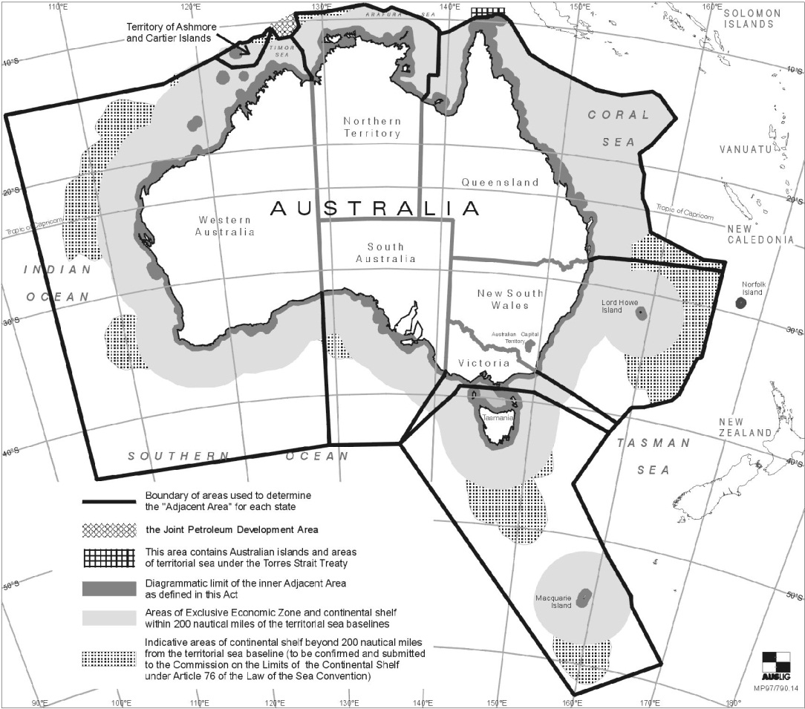
[Appendix 1 amended by No. 42 of 2010 s. 183(10).]

Schedule 2 — Off-shore (Application of Laws) Act 1982 amended
[s. 9]
1. Section 2 amended
In section 2, before the definition of “law of the State”, the following definitions are inserted —
“
cooperative scheme has the same meaning as that expression has in the Crimes at Sea Act 2000;
criminal laws means the substantive criminal law, and the law of criminal investigation, procedure and evidence, within the meaning of the cooperative scheme;
”.
2. Section 3 amended
Section 3(2)(b) is deleted and the following paragraph is inserted instead —
“
(b) to apply the provisions of the criminal laws of the State to or in relation to the coastal waters of the State or the sea-bed or subsoil beneath or the airspace above those waters.
”.
3. Section 3A amended
Section 3A(2)(b) is deleted and the following paragraph is inserted instead —
“
(b) to apply the provisions of the criminal laws of the State to or in relation to the adjacent area in respect of the State or the sea-bed or subsoil beneath or the airspace above that adjacent area.
”.

Notes
¹ This is a compilation of the Crimes at Sea Act 2000. The following table contains information about that Act ^{1a}.

Compilation table
Short title | Number and Year | Assent | Commencement
Crimes at Sea Act 2000 | 11 of 2000 | 9 May 2000 | 31 Mar 2001 (see s. 2 and Gazette 30 Mar 2001 p. 1755)
Petroleum and Energy Legislation Amendment Act 2010 s. 183 | 42 of 2010 | 28 Oct 2010 | 25 May 2011 (see s. 2(b) and Gazette 24 May 2010 p. 1892
² The Criminal Procedure and Appeals (Consequential and Other Provisions) Act 2004 s. 81 reads as follows —
“
81. References to “complaint” to be read as references to “prosecution notice”
(1) A reference in a written law or book, document or writing to a complaint in the context of commencing proceedings in a court for an offence is, unless the contrary intention appears, to be taken to be a reference to a prosecution notice.
(2) A reference in a written law to a complaint in the context of applying for a warrant to enter or search a place or to seize any thing is, unless the contrary intention appears, to be taken to be a reference to an application.
”.

