Western Australia

Liquor Control (Spinifex Restricted Area) Regulations 2014
Compare between:
[03 Jun 2017, 00-b0-01] and [23 May 2020, 00-c0-00]

Liquor Control Act 1988
Liquor Control (Spinifex Restricted Area) Regulations 2014

1. Citation
These regulations are the Liquor Control (Spinifex Restricted Area) Regulations 2014.

2. Commencement
These regulations come into operation as follows —
(a) regulations 1 and 2 — on the day on which these regulations are published in the Gazette;
(b) the rest of the regulations — on the day after that day.

3. Terms used
Restricted Area means the area declared to be a restricted area under regulation 5(1);
Spinifex Native Title Determination Area means the area described in the Schedule 1;
tourist means a person who is —
(a) staying at a place that is at least 50 kilometres from his or her usual place of residence for a period of at least one night; and
(b) intending to stay away from his or her usual place of residence for a period of less than 12 months; and
(c) not in the course of travelling on a regular journey between his or her usual place of residence or his or her place of work or education; and
(d) travelling in the course of a holiday or for leisure, business, to visit friends or relatives or for any other reason; and
(e) not usually resident in the Restricted Area.

[4. Deleted: SL 2020/62 r. 19.]

5. Declaration of Restricted Area
(1) The Spinifex Native Title Determination Area, excluding the portion that is within Reserve 17614, is declared to be a restricted area for the purposes of section 175(1a) of the Act.
(2) The map in Schedule 2 shows the Restricted Area crosshatched.

6. Notice of Restricted Area
(1) The Director of Liquor Licensing must take all reasonable steps to cause to be posted, and while the Restricted Area continues to be a restricted area by operation of regulation 5(1) to be kept posted, at each place where a customary access route enters the Restricted Area a notice —
(a) describing the offences set out in regulation 7; and
(b) specifying the penalties for those offences.
(2) A failure to comply with subregulation (1) does not invalidate the declaration in regulation 5(1).

7. Prohibitions as to liquor in Restricted Area
(1) Subject to regulation 8, a person who —
(a) brings liquor into, or causes liquor to be brought into, the Restricted Area; or
(b) has liquor in his or her possession in the Restricted Area,
commits an offence.
Penalty:
(a) if subregulation (2) applies, a fine of $5 000;
(b) in any other case, a fine of $2 000.
(2) This subregulation applies to an offence under subregulation (1) committed by a licensee, a manager of licensed premises or a director of a body corporate that holds a licence.

8. Defences for tourists
(1) A tourist to whom this regulation applies does not commit an offence under regulation 7.
(2) This regulation applies to a tourist if —
(a) the tourist is in the portions of the Restricted Area that are within 50 metres either side of the Anne Beadell Highway (also known as the Serpentine Lakes Road), and continuously maintains possession of, or consumes, the liquor in his or her possession; or
(b) the tourist is in any other part of the Restricted Area and continuously maintains possession of, but does not consume, the liquor in his or her possession.
(3) The map in Schedule 2 shows the Anne Beadell Highway.

9. Seizure and disposal of containers of liquor
Despite section 155(4) and (5) of the Act, a member of the Police Force may seize and, as soon as is practicable, dispose of any opened or unopened container of liquor suspected on reasonable grounds to be the subject of an offence under regulation 7.

10. Period during which these regulations have effect
Unless sooner repealed, these regulations have effect for the period that ends at the close of 2 July 2023.

[Regulation 10 inserted: SL 2020/62 r. 20.]

Schedule 1 — Spinifex Native Title Determination Area
[r. 3]
All those lands and waters —
(a) commencing at the westernmost north-western corner of Yowalga Location 7 as shown on Deposited Plan 220992 and extending east along the northernmost northern boundary of that location and east and south-easterly along boundaries of Milyuga Location 20 to the Western Australian-South Australian Border;
(b) then southerly along that border to latitude 29.498578 South;
(c) then west to the south-eastern corner of Delisser Location 9;
(d) then west and north along boundaries of that location and north along the western boundary of Delisser Location 8 to the south-western corner of Yowalga Location 7;
(e) then generally northerly along boundaries of Delisser Location 8 to the commencement point.
Note:
Deposited Plan 220992 is held by the Western Australian Land Information Authority established by the Land Information Authority Act 2006.

Schedule 2 — Map of Restricted Area
[r. 5(2) and (4)]
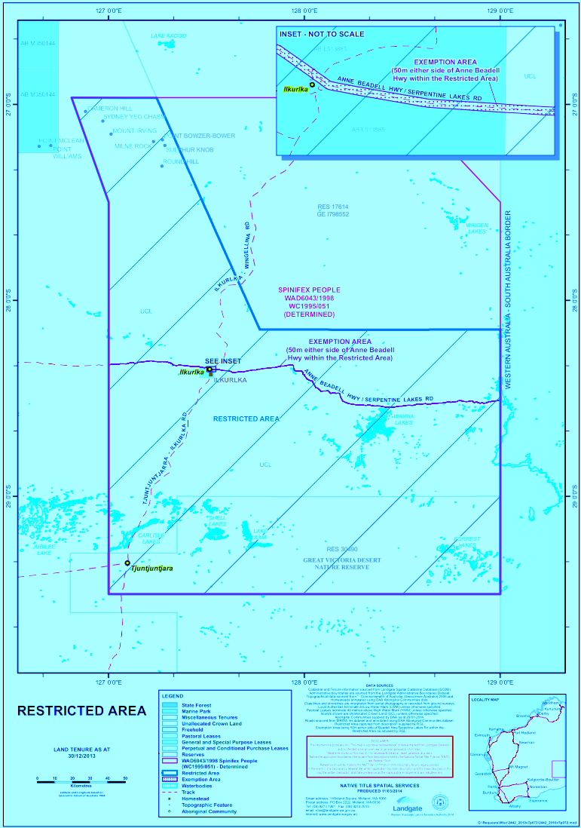

Notes
This is a compilation of the Liquor Control (Spinifex Restricted Area) Regulations 2014 and includes amendments made by other written laws ¹. For provisions that have come into operation see the compilation table.

Compilation table
Citation | Published | Commencement
Liquor Control (Spinifex Restricted Area) Regulations 2014 | 1 Jul 2014 p. 2341-4 | r. 1 and 2: 1 Jul 2014 (see r. 2(a));  Regulations other than r. 1 and 2: 2 Jul 2014 (see r. 2(b))
Liquor Control (Spinifex Restricted Area) Amendment Regulations 2017 | 2 Jun 2017 p 2751-2 | r. 1 and 2: 2 Jun 2017 (see r. 2(a));  Regulations other than r. 1 and 2: 3 Jun 2017 (see r. 2(b))

Racing and Gaming Regulations Amendment (Liquor Control) Regulations 2020 Pt. 7 | SL 2020/62 22 May 2020 | 23 May 2020 (see r. 2(b))

Other notes
¹ These regulations expire at the close of 2 July 2023 (see r. 10).

