Western Australia
East Perth Redevelopment Act 1991
East Perth Redevelopment (Subtracted Area - Stage 3) Regulations 2011

Western Australia
East Perth Redevelopment (Subtracted Area - Stage 3) Regulations 2011
CONTENTS
-1. Citation 1
2. Commencement 1
3. Terms used 1
4. Schedule 1 replaced 2
Schedule 1 — Redevelopment area
5. Minister may amend planning schemes 3
6. Transitional matters to do with Perth Schemes 3
7. Transitional matters to do with Vincent Scheme 5
8. Other transitional matters 5
9. Expiry of regulations 5
Notes
Compilation table 7

Western Australia
East Perth Redevelopment Act 1991
East Perth Redevelopment (Subtracted Area - Stage 3) Regulations 2011

1. Citation
These regulations are the East Perth Redevelopment (Subtracted Area - Stage 3) Regulations 2011.

2. Commencement
These regulations come into operation as follows —
(a) regulations 1 and 2 — on the day on which these regulations are published in the Gazette;
(b) the rest of the regulations — on the day after that day.

3. Terms used
In these regulations —
order means an order made under regulation 5(2);
Perth Schemes means —
(a) the City of Perth City Planning Scheme 2; and
(b) the City of Perth Local Planning Scheme 26;
Redevelopment Scheme means the redevelopment scheme in force under Part 4 of the Act immediately before an order under regulation 5(2) takes effect;
Schedule 1 means the East Perth Redevelopment Act 1991 Schedule 1;
scheme means any of the following —
(a) the Metropolitan Region Scheme;
(b) the Perth Schemes;
(c) the Vincent Scheme;
Vincent Scheme means the City of Vincent Town Planning Scheme 1.

4. Schedule 1 replaced
When an order takes effect, delete Schedule 1 and insert:

Schedule 1 — Redevelopment area
[s. 4]
All of the land and waters in the area described as the redevelopment area on Plan No. 4 held at the office of the Authority, that plan being certified by the Minister as being the plan prepared for the purpose of defining the redevelopment area.
For guidance, the redevelopment area is indicated in the following representation of Plan No. 4.
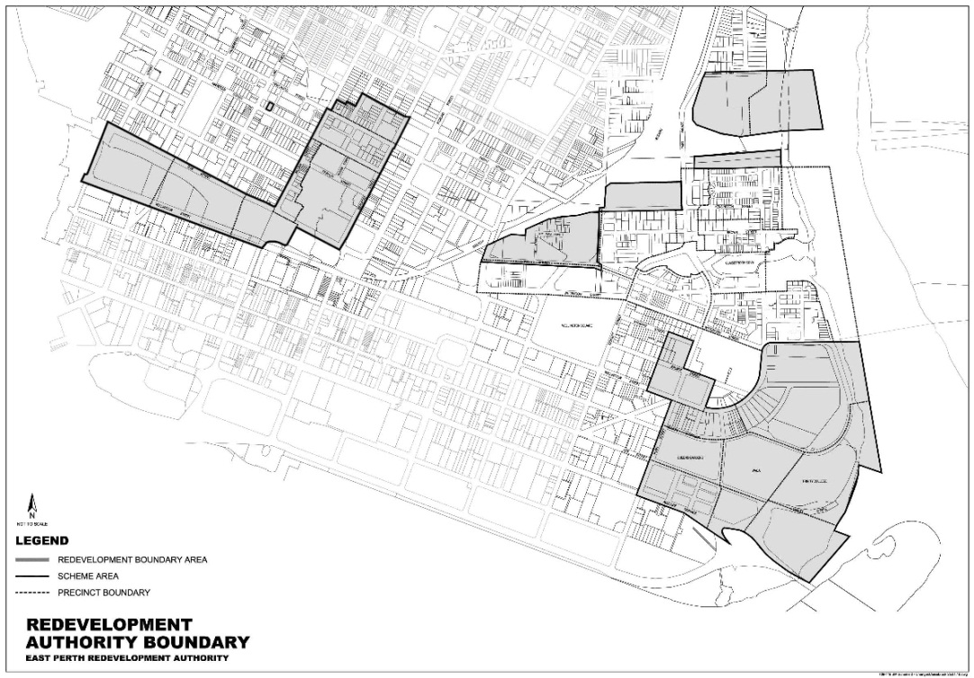

5. Minister may amend planning schemes
(1) In this regulation —
subtracted area means the area that ceases to be in the redevelopment area when Schedule 1 is replaced under regulation 4.
(2) The Minister may, by order published in the Gazette, amend a scheme to provide for any of the following —
(a) land in the subtracted area to be included in the area to which the scheme applies;
(b) land in the subtracted area to have a reservation or zoning under the scheme the same as, or similar to, that which applied to the land immediately before it ceased to be in the redevelopment area.
(3) An order takes effect at the beginning of the day after the day on which it is published in the Gazette.

6. Transitional matters to do with Perth Schemes
(1) This regulation applies in relation to land included under regulation 5(2)(a) in the area to which the Perth Schemes apply, but only to the extent that the Perth Schemes have not been amended to expressly exclude the application of this regulation.
(2) The provisions of the Redevelopment Scheme that applied in relation to the land before it was included in the area to which the Perth Schemes apply continue to apply in relation to that land as if they were a part of the Perth Schemes, with —
(a) references to the Authority being read as references to the City of Perth; and
(b) any other necessary modifications.
(3) Provisions of the Redevelopment Scheme that are listed in the Table do not continue to apply under subregulation (2).
Table
cl. 5.6 | cl. 5.10
cl. 5.13 | cl. 5.14
cl. 5.16 | cl. 5.32
cl. 5.33 | cl. 5.38
cl. 5.39 | cl. 7.1 to 7.16
cl. 8.2 | cl. 8.3
cl. 8.5 | cl. 8.11 to 8.14
cl. 8.16 | cl. 8.17
(4) To the extent of any inconsistency with any other provision of the Perth Schemes, the provisions applying under subregulation (2) prevail.
(5) The New Northbridge Design Guidelines, Foundry Site Design Guidelines, Belvidere Design Guidelines and Village Northbridge Heritage Inventory adopted under the Act are to be treated —
(a) as if they were Policies prepared under the provisions applying under subregulation (2); and
(b) to the extent of any inconsistency with any other provision of the Perth Schemes, as if they prevailed over that provision.
(6) The New Northbridge Design Guidelines clauses 1.2.2 and 1.2.9 and Sections 4, 5 and 6 do not continue to apply under subregulation (5).

7. Transitional matters to do with Vincent Scheme
(1) This regulation applies in relation to land included under regulation 5(2)(a) in the area to which the Vincent Scheme applies, but only to the extent that the Vincent Scheme has not been amended to expressly exclude the application of this regulation.
(2) The provisions of the New Northbridge Design Guidelines and Village Northbridge Heritage Inventory that applied in relation to the land before it was included in the area to which the Vincent Scheme applies continue to apply in relation to that land as if they were a part of the Vincent Scheme, with any necessary modifications.
(3) For the purposes of subregulation (2), references in the New Northbridge Design Guidelines to the City of Perth are to be read as references to the City of Vincent.
(4) To the extent of any inconsistency with any other provision of the Vincent Scheme, the provisions applying under subregulation (2) prevail.
(5) The New Northbridge Design Guidelines clauses 1.1.2, 1.1.3 and 1.2.7 and Sections 2 to 6 do not continue to apply under subregulation (2).

8. Other transitional matters
When an order takes effect, the effect of a decision, if any, previously made by the Authority or the Minister about a development application or an approval continues.

9. Expiry of regulations
(1) These regulations expire when whichever of the following events happens first —
(a) an order takes effect and there is no longer any land in relation to which regulation 6 or 7 applies;
(b) the period of 2 years, commencing on the day mentioned in regulation 2(b), ends.
(2) The expiry of these regulations does not affect —
(a) the amendment of the redevelopment area under regulation 4; or
(b) an amendment of a scheme under an order.

Notes
¹ This is a compilation of the East Perth Redevelopment (Subtracted Area - Stage 3) Regulations 2011. The following table contains information about those regulations.

Compilation table
Citation | Gazettal | Commencement
East Perth Redevelopment (Subtracted Area - Stage 3) Regulations 2011 | 16 Dec 2011 p. 5334-7 | r. 1 and 2: 16 Dec 2011 (see r. 2(a));  Regulations other than r. 1 and 2: 17 Dec 2011 (see r. 2(b))

