Western Australia

Life Assurance Companies Act 1889
Compare between:
[09 Feb 2008, 02-h0-04] and [22 May 2009, 02-i0-04]

Western Australia
Life Assurance Companies Act 1889
An Act to regulate Life Assurance.
Whereas it is expedient to encourage the practice of Life Assurance, and to protect persons assured: Be it therefore enacted by His Excellency the Governor of Western Australia and its Dependencies, by and with the advice and consent of the Legislative Council thereof, as follows: —

[1. Repealed by No. 10 of 1998 s.76.]

Part I — Preliminary

2. Short title
This Act may be cited as the Life Assurance Companies Act 1889.

3. Interpretation
In this Act the following terms have the following meanings, unless the context requires a different construction —
Bankruptcy includes any proceeding under the Bankruptcy Act 1892, or any Act amending the same, whereby the property of the debtor becomes vested in any other person for division among creditors.
Company means any persons corporate or unincorporate, who grant assurances, endowments, or annuities upon human life within Western Australia.
Any reference in this Act to a company which issued the policy shall include a reference to any company which has become the successor (whether by amalgamation, transfer, purchase, arrangement or otherwise) of that company.
Chairman means the person for the time being presiding over the board of directors, committee of management, or other managing body in Western Australia of the company.
Industrial life assurance policy means a policy upon human life the premiums in respect of rich are by the terms of the policy made payable at intervals of less than two months and are contracted to be received or are usually received by means of collectors of the company rich issued the policy.
Policy means any contract for assurance, endowment, or annuity on human life, and includes all moneys, howsoever payable, assured thereby, or which may be paid or become payable thereunder, and all the property and interest therein of the person assured.
Life assurance business means the granting of policies.
Financial year means each period of twelve months at the end of which the balance of the accounts of the company is struck, or if no such balance is struck, then each period of twelve months ending with the thirty-first day of December.
Court means the Supreme Court of Western Australia.
Registrar means the Registrar of Joint Stock Companies under the Joint Stock Companies Ordinance 1858.
Local company means a company having its head office in Western Australia.
Foreign company means a company not having its head office in Western Australia.
Will includes codicil.
[Section 3 amended by No. 23 of 1905 s.5; No. 47 of 1939 s.2.]

Part II — Provisions for security of assured

4. Companies to deposit securities with Treasurer
Every company which shall commence or carry on the business of life assurance within the colony shall deposit with the Treasurer securities to the value of ten thousand pounds, being mortgages of freehold real estate in Western Australia, on which the money advanced does not exceed two-thirds of the value of the estate mortgaged, or title deeds or certificates of real estate, or bonds, debentures, treasury bills, or other securities issued by the Government, or by any local government in the Colony, duly authorized in that behalf, or the receipt of some incorporated or chartered joint stock bank carrying on business in Western Australia, as approved by the Treasurer, for moneys placed on fixed deposit at the said bank in the name of the Treasurer, the income arising from such deposit being received by the company: Provided always, that any local company shall not be required to deposit more than fifty per centum on the amounts of the premiums actually received until the deposit shall amount to Ten thousand pounds.
[Section 4 amended by No. 8 of 1925 s.2; No. 14 of 1996 s.4.]

5. Time for making deposits
As regards any company which now carries on the business of life assurance in Western Australia, the deposit may be made at any time not later than one year after this Act shall come into operation; and as regards any company formed after this Act, the deposit may be made at any time within six months of its incorporation or registration; and no company shall be deemed to carry on the business of life assurance by reason only of receiving premiums in respect of policies issued before this Act shall come into operation.

6. Further deposits to be made out of receipts
Every company which shall carry on the business of life assurance in Western Australia shall send in annually to the Treasurer, on or before the first day of June in each year, returns, verified by the certificate of the agent or principal officer of the company in Western Australia, of the amounts received and paid by the company during the year ending the thirty-first day of December then last, or on such other date as the financial year of each company shall determine, on account of policies issued in Western Australia by the company, whether before or after the commencement of this Act, and shall, until the total amount deposited by the company under section four and this section shall amount to the sum of twenty thousand pounds, deposit with the Treasurer securities similar to those mentioned in section four to the value of twenty-five per centum of the excess of the receipts over the disbursements appearing from such returns.
[Section 6 amended by No. 8 of 1925 s.2.]

7. Provision in case of loss of securities
If any securities deposited under this Act, are whilst so deposited, lost, stolen, destroyed, or damaged, the injury occasioned to all persons interested shall be made good out of moneys to be appropriated for the purpose by an Act of the Legislative Council.

8. Further deposits may be made
Any company may from time to time deposit with the Treasurer any securities of any kind, and to any amount, besides and beyond the securities hereby required to be deposited.
[Section 8 amended by No. 8 of 1925 s.2.]

9. Income and withdrawal of deposits
Any company depositing any securities under this Act shall be entitled to receive the income therefrom, and securities deposited may be withdrawn on timely notice, and where the deposit is compulsory, on the substitution of similar securities of equal value, and the decision, of the Treasurer shall be conclusive in all matters relating to the value of securities under this Act.
[Section 9 amended by No. 8 of 1925 s.2.]

10. Securities deposited to be charged with liabilities in Western Australia
All securities deposited with the Treasurer under this Act shall be primarily charged with the payment and satisfaction of all the liabilities in Western Australia of the depositing company, whether arising in respect of policies issued before or after the commencement of this Act or otherwise howsoever and no part of such securities shall be applied in payment of any liabilities other than those so charged as aforesaid until the whole of such last-mentioned liabilities shall be paid in full.
[Section 10 amended by No. 8 of 1925 s.2.]

11. Discharge of Western Australian liabilities of foreign companies
Every foreign company shall keep separate account of all the life assurance business transacted in Western Australia, and of the entire assets of the company in Western Australia; and in the event of the company becoming bankrupt, or being ordered to be wound up, the entire assets of the company in Western Australia shall be applied, so far as the same will extend, in or towards satisfaction of the liabilities of the company in Western Australia, and no part of such assets shall be applied in payment of any liabilities of the company incurred elsewhere than in Western Australia until the whole of the liabilities incurred in Western Australia shall have been paid in full.

12. Mode of distribution of assets of insolvent foreign company
If any foreign company is adjudged bankrupt, or ordered to be wound up, elsewhere than in Western Australia, such company, so far only as regards its assets and liabilities in Western Australia, may, upon the application of any policy-holder or shareholder, be ordered to be wound up in Western Australia in like manner as if such company were registered under the Joint Stock Companies Ordinance 1858, and proof of such company having become adjudged bankrupt, or ordered to be wound up, shall be conclusive evidence that it is unable to pay its debts.

13. Penalty for infringement of Act
Any director, agent, officer, or servant of any company wilfully committing or assisting in the commission of any breach of the provisions of section eleven shall be deemed guilty of a breach of trust, and be held liable to replace the amount applied contrary to the said section, and shall also be deemed guilty of a crime punishable on conviction, at the discretion of the Court, by imprisonment for any term not exceeding three years, or by a fine not exceeding Five hundred pounds.
[Section 13 amended by No. 70 of 2004 s. 82.]

14. Separation of life assurance and other business
Every company transacting other business besides life assurance business shall keep a separate account of all receipts after the passing of this Act in respect of the life assurance business of the company, and the said receipts shall be carried to and form a separate fund to be called the “Life Assurance Fund” of the company, and such fund, however invested, shall be as absolutely the security of the life assurance policy-holders as though it belonged to a company carrying on no other than life assurance business, and shall not be liable for any contracts of the company for which it would not have been liable had the business of the company been only life assurance business.

15. Application of preceding section to existing companies
In respect to all existing companies the exemption of the life assurance fund from liability for other obligations than to its life assurance policy-holders shall have reference only to the contracts entered into after the passing of this Act, unless by the constitution of the company such exemption already exists; but this and the preceding section shall not apply to any contracts made by any existing company by the terms of whose deed of settlement or articles of association the whole of the profits of all the business are paid exclusively to the life and endowment policy or annuity holders and on the face of which contracts the liability of the insurers distinctly appears: Provided, always, that this Act shall not diminish the liability of the life assurance fund for any contracts of the company entered into before the passing of this Act.

16. Accounts to be rendered by life assurance companies
Every company transacting life assurance business only shall, at the expiration of each financial year or half-year of such company, prepare a statement of its revenue account for such year or half-year, and of its balance-sheet at the close of such year or half-year, in the forms respectively contained in the First and Second Schedules to this Act.

17. Accounts to be rendered by companies carrying on life assurance and other business
Every company which concurrently with the transaction of life assurance business, transacts any other kind of assurance or other business, shall, at the expiration of each financial year of such company, prepare a statement of its revenue account for such year, and of its balance sheet at the close of such year, in the forms respectively contained in the Third and Fourth Schedules to this Act.

18. Accounts to be rendered by foreign companies
Every foreign company shall, at the expiration of each financial year of such company, prepare, in addition to all other statements required by this Act, a statement of all its policies in force at the close of such year, in the form contained in the Fifth Schedule to this Act.

19. Actuarial report and abstract
Every company shall, once in five years, or at such shorter intervals as may be prescribed by the instrument constituting the company, or by its articles of association, regulations, or by-laws cause an investigation to be made into its financial condition by an actuary and shall cause an abstract of the report of such actuary to be made in the form prescribed in the Sixth Schedule to this Act.

20. Statement of life annuity business
Every company shall, on or before the thirty-first day of December, One thousand eight hundred and ninety, and thereafter within nine months after the date of each such investigation as aforesaid into its financial condition, prepare a statement of its life assurance and annuity business, in the form contained in the Seventh Schedule to this Act, each of such statements to be made up as at the date of the last investigation, whether such investigation be made previously or subsequently to the passing of this Act: Provided as follows —
(1) If the next financial investigation, after the passing of this Act, of any company fall during the year One thousand eight hundred and ninety-one, the said statement of such company shall be prepared within nine months after the date of such investigation instead of on or before the thirty-first day of December, One thousand eight hundred and ninety.
(2) If such investigation be made annually by any company, such company may prepare such statement at any time, so that it be made at least once in every three years.
The expression “date of each such investigation,” in this section, shall mean the date to which the accounts of each company are made up for the purposes of each such investigation.

21. Forms authorized by Imperial Statute, Life Assurance Companies Act 1870 may be used in certain cases
Any company whose head office or principal place of business is not in Western Australia may, in lieu of the statement and abstract mentioned in the preceding two sections, deposit at the office of the registrar a copy, certified in accordance with the seventeenth section of the Act of the Imperial Parliament known as the Life Assurance Companies Act 1870, of the last preceding statement or abstract deposited with the Board of Trade in conformity with the provisions of the tenth section of the said Act.

22. Forms may be altered
The Governor may alter the forms contained in the schedules to this Act, for the purpose of adapting them to the circumstances of any company, or of better carrying into effect the objects of this Act.

22A. Governor may authorize use of abridged forms during certain periods
(1) When in the opinion of the Governor there exists in this State any emergency (whether in consequence of the Commonwealth of Australia being engaged in a war or from any other cause) which the Governor considers justifies the substitution of abridged forms for the forms contained in the Schedules to this Act, the Governor may, notwithstanding anything to the contrary contained elsewhere in this Act but subject as in this section hereafter provided, by Order in Council authorize and direct that for a period to be specified in the order it shall not be necessary for companies which by any provisions of this Act are required to furnish statements or returns in the forms contained in the Schedules to this Act to furnish such statements or returns in such last-mentioned forms and that it will be sufficient if the said companies furnish such statements or returns in such abridged forms as may be prescribed by the said Order.
Provided that no abridged form shall be prescribed by any Order in Council under this section unless and until it has first been approved by the State Government Statistician and the Registrar of Companies as being sufficient to meet their official requirements respectively.
(2) Subject to subsection (3) of this section when the use of abridged forms in lieu of the forms contained in the Schedules to this Act is authorized and directed by all Order in Council under this section and whilst such order continues in force, every company which furnishes in the appropriate abridged forms any statements or returns which it is required by any provision of this Act to furnish in the forms contained in the Schedules to this Act shall be deemed to have complied duly with the requirements of any such provision.
(3) Notwithstanding that an Order in Council authorizing and directing the use of abridged forms is still in force, it shall be lawful for the State Government Statistician by notice in writing under his hand served upon any company to require such company to furnish any statement or return, which by any provision of this Act such company is required to furnish, in the appropriate forms contained in the Schedules to this Act instead of in the abridged form prescribed by such Order in Council, when the State Government Statistician considers that special circumstances (of which he shall be the sole judge) make it necessary or expedient for his official requirements that further particulars than those provided for in the abridged form shall be furnished by such company. Where any company is served with a notice as provided for in this subsection, such company shall comply in every respect with the requisitions thereof, and in such case the provisions of subsection (2) of this section shall not apply or have effect.
(4) The Governor may by any Order in Council made under this section direct that in addition to the three printed copies of every statement or abstract required by section twenty-three of this Act to be deposited at the office of the Registrar all additional printed copy of such statement or abstract as prepared in the abridged forms authorized by the Order in Council shall be so deposited for transmission by the Registrar to the Commonwealth Statistician and such direction shall be complied with.
[Section 22A inserted by No. 2 of 1944 s.2.]

23. Statement, etc., to be signed and printed and deposited with Registrar
Every statement or abstract hereinbefore required to be made shall be signed by the chairman and two of the directors or committee of management, or by the agent of the company in Western Australia, and by the principal officer or agent managing the life assurance business of the company in Western Australia, and if the company has a managing director in Western Australia, by such managing director, and shall be printed; and the original so signed as aforesaid, together with three printed copies thereof, shall be deposited at the office of the registrar within three months of the dates respectively hereinbefore prescribed as the dates at which the same are to be prepared; and every annual statement so deposited after the first investigation after the passing of this Act, shall be accompanied by a printed copy of the abstract required to be made as aforesaid.

24. Copies to be furnished
A printed copy of the last deposited statement, abstract, or other document, by this Act required to be printed, shall be forwarded by the company, by post or otherwise, to every shareholder, member, and policyholder of the company in Western Australia.

25. Agent to be appointed for foreign companies
Every foreign company shall, within six calendar months after the coming into operation of this section, or before doing business in Western Australia, in writing, appoint a person resident therein as general agent, upon whom all lawful processes against the company may be served with like effect as if the company existed in this province; and the said writing or power of attorney shall stipulate and agree, on the part of the company making the same, that any lawful process against the said company which is served on the said general agent shall be of the same legal force and validity as if served on the said company.

26. Copy of writing to be filed in officer of Registrar
A copy of the writing, duly certified and authenticated, shall be filed in the office of the registrar, and copies certified by him shall be sufficient evidence in all Courts of law and in all judicial proceedings.

27. Agency to continue as long as any liability outstanding in the Colony
The said agency shall continue while any liability remains outstanding against the company in Western Australia, and the power shall not be revoked until the same power is given to another such agent and a like copy filed as aforesaid.

28. Service of process, etc., on agent sufficient
Service of any process, notice, or otherwise upon the said agent shall be deemed sufficient service upon the principal.

29. Penalty for non-compliance
No person shall Act either as general or other agent of a foreign company until he has complied with all the requirements of this Act; and every person so acting without such compliance, or who knowingly procures payment, or any obligation for the payment, of any premium for insurance or endowment, or for sale of an annuity by fraudulent representations, shall be liable to a penalty not exceeding Two hundred and fifty pounds for each offence.

30. When contracts valid
Every contract for life assurance made by any foreign company without complying with the provisions of this Act contained in the sections numbered twenty-five to twenty-nine, both inclusive, shall be valid and binding on the company; but the agent making the contract shall be liable to the penalty provided in section thirty-one of this Act; and any such company which neglects to appoint and keep appointed a general agent agreeably to the provisions of this Act shall not recover any premium or other payment on any contract of life assurance with a person resident in Western Australia.

31. Companies may be prohibited from transacting business in certain cases
Every company which makes default in complying with the provisions of this Act shall not only be liable to the penalties set forth in the fifty-third section, but may also, if it be made to appear to the Governor that such default has continued for a period of three months, be prohibited by the Governor from transacting business within the province, either absolutely or for a time, as the Governor may think fit.

32. Prohibition to be published in Government Gazette
Such absolute or temporary prohibition shall be published in the Government Gazette of Western Australia; and if any such company, or any person as agent for such company, or otherwise for or on behalf of any such company, shall, after such absolute prohibition, or during any such temporary prohibition, receive any applications for any life assurance, or accept any premium for any life assurance, or otherwise carry on the business of life assurance within Western Australia, such company and person shall respectively be liable to a penalty of two hundred and fifty pounds.

33. Interest of assured protected in certain cases
The property and interest of the assured in a policy effected upon his own life shall not be liable to be applied or made available in payment of his debts by any judgment, order, or process of any court, and shall not, in the event of his bankruptcy, pass to the official receiver or the trustee or assignee of his estate.
In the case of an assured person dying after the passing of this Act, the moneys payable upon the death of the assured under or in respect of a policy effected upon his life shall not be liable to be applied or made available in payment of his debts by any judgment, order, or process of any court, or in any other manner whatsoever, except by virtue of a contract or charge made by the assured in his lifetime, or by virtue of an express direction contained in his will or other instrument having testamentary effect in respect of his estate, that the moneys arising from the policy shall be so applied.
A direction to pay debts, or a charge of debts upon the whole or any part of the testator’s estate, or a trust for the payment of debts, shall not be deemed to be such an express direction:
Provided that, in case of the death of the assured within three years from the date of the policy, a sum equal to all sums which have been paid by way of premium on such policy, with simple interest thereon at the rate of five pounds per centum per annum, shall be set apart from the moneys payable under the policy, and shall be available for the payment of the debts of the assured:
Provided also that the provisions of this section —
(a) shall not apply, except in case of the death, of the assured, until the policy shall have endured for at least two years; and
(b) shall only apply to policies the payments for which to the company issuing the same are, by the policy, provided to be made during the lifetime of the assured, or during ten years at least, and to be payable by equal instalments at intervals of not more than a year.
[No. 12 of 1905 s. 2 inserted in place of s. 33 of 53 Vic. No. XII, repealed by No. 12 of 1905 s. 6; amended by No. 27 of 2007 s. 25.]

34. Former payments to discharge liability
All payments heretofore bona fide made by any company under any policy protected under the principal Act to any executor or administrator of the assured shall discharge the company having paid the same from all liability to pay or account therefor to any other person claiming the same; and all payments heretofore bona fide made by any executor or administrator of any money received by him under any policy so protected as aforesaid shall discharge the executor or administrator having paid the same from all liability to pay or account therefor to any other person claiming the same.

35. Industrial life assurance policies not to be avoided immediately on account of non-payment of premiums
An industrial life assurance policy shall not be avoided on account of the non-payment of any premium unless —
(a) where the policy has been in force for less than of one year — the premium has been unpaid for not less than four weeks after it became due and payable;
(b) where the policy has been in force for one year and less than two years — the premium has been unpaid for not less than eight weeks after it became due and payable;
(c) where the policy has been in force for two years and upwards — the premium has been unpaid for not less than twelve weeks after it became due and payable.

36. When policy holder becomes entitled to a paid-up policy
Where in respect of an industrial life assurance policy which has been in force for three years there has been paid in premiums an amount equal to not less than the premiums payable in respect of that policy for such period of three years aforesaid, the policy holder shall be entitled to receive a paid-up policy.

37. Circumstances in which paid-up policies to be granted
(1) When a holder of an industrial life assurance policy becomes entitled to receive a paid-up policy then —
(a) upon application in writing in that behalf to the company which issued the policy; or
(b) if the policy holder fails to pay to the company which issued the policy a premium payable in respect of the policy within twelve weeks after it becomes due and payable
the company shall, within one month after receiving such application or the expiration of such period (as the case may be), grant him a paid-up policy and furnish him with some documentary evidence setting forth the amount and date of such paid-up policy and the contingency or contingencies upon which it is payable.
It shall be a sufficient discharge of the obligation on the company under this subsection to furnish the policy holder with such documentary evidence, if such evidence is either delivered at the last known place of abode or business of the policy holder in a wrapper or envelope addressed to him thereat or sent so addressed prepaid through the post.
(2) (a) The amount (exclusive of bonuses) of a paid-up policy shall in the case of endowment and endowment assurance policies be ascertained as provided in Part I. of the Tenth Schedule to this Act.
(b) The amount (exclusive of bonuses) of a paid-up policy shall in the case of whole life policies be ascertained as provided in Part II. of the Tenth, Schedule to this Act.
(3) Where a policy holder is entitled to receive a paid-up policy pursuant to the provisions of the last preceding section there shall be added to the amount thereof, as ascertained as aforesaid, all bonuses declared upon the original policy in respect of the period between a date five years after the issue of the original policy and the date of the grant of such paid-up policy.
(4) then pursuant to the foregoing provisions of this section a company is required to grant a paid-up policy to a policy holder and there are any moneys owing to the company on the security of the original policy the company may elect: —
(a) to treat the moneys so owing as moneys secured on the paid-up policy, and thereupon the paid-up up policy shall be a security for the moneys so owing; or
(b) in the ascertainment of the amount of the paid-up policy to reduce the same by taking into account upon a basis approved by the Government Actuary the moneys so owing to the company, and thereupon such moneys shall cease to be owing to the company.

38. When policy holders entitled to surrender policies and receive surrender value therefor.
(1) Where in respect of any industrial life assurance policy which has been in force for a period of six years there has been paid in premiums an amount equal to not less than the premiums payable during such period of six years aforesaid, the policy-holder shall be entitled to surrender his policy, and upon making application in writing in that behalf to the company which issued the policy be entitled to receive in cash a surrender value therefor.
(2) Where a policyholder has received a paid-up policy, he shall at any time after the expiration of the period of six years after the date of the original policy be entitled to surrender such paid-up policy, and upon making an application in writing in that behalf to the company which issued the policy be entitled to receive in cash a surrender value therefor.
(3) (a) The surrender value referred to in subsection (1) or subsection (2) of this section shall be the present value, calculated as at the date when the application aforesaid is received by the company, of the paid-up policy which the policy-holder is entitled to receive from the company at the said date or of the paid-up police received by the policy-holder (as the case may be).
(b) Such present value shall be ascertained by the use of a table of mortality and rate of interest prescribed by regulations made under this Act.
(4) Notwithstanding anything in the foregoing provisions of this section, the surrender value which a policyholder is entitled to receive as aforesaid shall not in any case exceed the amount which would be payable under the policy upon the death of the person whose life is assured if such death had occurred on the date when the application aforesaid was received by the company.

39. Saving of certain rights of certain policy holders
Where the rights of a holder of an industrial life assurance policy apart from sections thirty-five, thirty-six, thirty-seven and thirty-eight of this Act to and in relation to a paid-up policy are more favorable to the policy holder than the rights conferred by this Act nothing in this Act shall prevent the policy holder from claiming under the first mentioned rights instead of under the rights so conferred by this Act.

40. Application of Act
Sections thirty-five, thirty-six, thirty-seven, thirty-eight, and thirty-nine of this Act shall —
(a) apply to industrial life assurance policies (including paid-up policies) in force at the commencement of this Act as well as to all such policies issued hereafter; and
(b) take effect notwithstanding anything in any policy (including any paid-up policy) or agreement to the contrary.

41. Notification to be printed on industrial life assurance policy and industrial premium receipt book
Every industrial life assurance policy issued after the passing of this Act and every current and subsequent industrial premium receipt book shall have printed thereon in clear and legible type, a notification to the effect that the policy shall not become void for non-payment of premium unless a premium has been overdue for at least four weeks such longer period as may be provided by statute by the company’s regulations for the time being.

Part III — Application of Companies Act, procedure and miscellaneous

42. Application of Companies Act to life assurance companies
The provisions of the Joint Stock Companies Ordinance 1858, and of any Act amending the same, shall, apply to life assurance company, except in so far as such provisions are modified by this Act, and except also that no life assurance company shall be required to hold more than one general meeting in the year.

43. List of shareholders
Every proprietary company shall provide a book, to be called “the Shareholders’ Address Book,” in which the company shall cause to be entered from time to time, in alphabetically order, the corporate names and places of business of the several shareholders of the company being corporations, and the surnames of the several other shareholders, with their respective christian names, places of abode, and descriptions, so far as the same shall be known to the company; and every policy-holder or shareholder or if such shareholder or policy-holder be a corporation, the clerk or agent of such corporations, may at all convenient times peruse such book gratis, and the company shall furnish on application, to every shareholder and policy-holder of the company, a copy of such book, or of any part thereof, on payment of a sum not exceeding sixpence for every hundred words to be copied for such purpose.

44. Deed of settlement to be printed
Every company which is not registered under the Joint Stock Companies Ordinance 1858, shall cause a sufficient number of copies of its deed of settlement, Act, or charter of incorporation or other instrument regulating the constitution of the company, to be printed, and shall furnish on application to every shareholder and policy-holder of the company a copy thereof, on payment of a sum not exceeding two shillings and sixpence.

45. Amalgamation or transfer
Where it is intended to amalgamate two or more companies, or to transfer the life assurance business of one company to another, the directors of any one or more of such companies may apply to the court by petition to sanction the proposed arrangement, fourteen days’ previous notice of such application being published in the Government Gazette of Western Australia, and the Court, after hearing the directors and other persons whom it considers entitled to be heard upon the petition, may confirm the same if it is satisfied that no sufficient objection to the arrangement has been established.

46. Procedure
Before any such application is made to the court, notice of such application, together with a statement of the nature of the amalgamation or transfer, as the case may be, and an abstract containing the material facts embodied in the agreement or deed under which such amalgamation or transfer is proposed to be effected, and copies of the actuarial or other reports upon which such agreement or deed is founded, shall be forwarded to each policy-holder of both companies in cases of amalgamation, or to each policy-holder of the transferred company in case of transfer by the same being transmitted through the post, directed according to the registered or other known address of such policy-holder, within such period as to admit of its being delivered in the due course of delivery fourteen days at least before the day named for the hearing of such application; and in proving such service it shall be sufficient to prove that such notice was properly addressed and put into the post office; and the agreement or deed under which such amalgamation or transfer is effected shall be open for inspection of the policy-holders and shareholders at the office or offices of the company or companies for a period of fifteen days after the issuing of the abstract herein provided.

47. Conditions
The court shall not sanction any amalgamation or transfer in any case in which it appears to the court that policy-holders representing one-fifth or more of the total amount assured in any company which it is proposed to amalgamate, or in any company the business of which it is proposed to transfer, dissent from such amalgamation or transfer.

48. Confirmation
No company shall amalgamate with another, or transfer its business to another, unless such amalgamation, or transfer is confirmed by the court in accordance with this section: Provided always, that this section shall not apply in any case in which the business of any company which is sought to be amalgamate or transferred does not comprise life assurance business.

49. Statements in case of amalgamation or transfer
When an amalgamation, takes place between any companies, or when the business of one company is transferred to another company, the combined company or the purchasing company, as the case may be, shall, within ten days from the date of the completion of the amalgamation or transfer, deposit at the office of the registrar certified copies of statements of the assets and liabilities of the companies concerned in such amalgamation or transfer, together with a statement of the nature and terms of the amalgamation or transfer, and a certified copy of the agreement or deed under which such amalgamation or transfer is effected, and certified copies of the actuarial or other reports upon which such agreement or deed is founded, and the statement and agreement or deed of amalgamation or transfer shall be accompanied by a declaration under the hand of the chairman of each company, and the principal managing officers of each company, that to the best of their belief, every payment made, or to be made, to any person whatsoever on account of the said amalgamation or transfer, is therein fully set forth, and that no other payments beyond those set forth have been made or are to be made either in money, policies, bonds, valuable securities, or other property, by or with the knowledge of all parties to the said amalgamation or transfer.

50. Regulation as to notations by policy-holders
Where a company, either before or after the passing of this Act, has transferred its business to, or been amalgamated with, another company, no policy-holder in the first-mentioned company who shall pay to the other company the premiums accruing due in respect of his policy shall, by reason of any such payment made after the passing of this Act, or by reason of any other Act done after the passing of this Act, be deemed to have abandoned any claim which he would have had against the first-mentioned company on due payment of premiums to such company, to have accepted, in lieu thereof, the liability of the other company, unless such abandonment and acceptance have been signified by some writing signed by him, or by his agent lawfully authorized.

51. Inspection of deposited documents
Any person may, on payment of such fees as the Governor may direct, inspect at the office of the registrar any printed or other document required by this Act to be deposited at such office, and procure copies thereof.

52. Documents to be received in evidence
Every statement, abstract, or other document deposited with, the registrar under this Act shall be receivable in evidence, and every document purporting to be certified by the registrar to be such deposited document, and every document purporting to be similarly certified to be a copy of such deposited document, shall, if produced out of the custody of the registrar, be deemed to be such deposited document as aforesaid, or a copy thereof, and shall be received in evidence as if it were the original document, unless some variation between it and the original document shall be proved.

53. Penalty for non-compliance with Act
Every company which makes default in complying with the requirements of this Act, and shall continue in such default for seven days after notice by the registrar, or any person interested in the matter of such default, shall be liable to a penalty not exceeding fifty pounds for every day during which the default continues; and in the case of a foreign company the general agent shall be liable to such penalty as well as the company; and in the case of companies registered under the Joint Stock Companies Ordinance, 1858, if default continues for a period of three months after notice of default by the Treasurer, which notice shall be published in one or more newspapers as the Treasurer may direct, the court may order the winding up of the company, in accordance with the said Act, upon the application of one or more policy-holders or shareholders.
[Section 53 amended by No. 8 of 1925 s.2.]

54. Penalty for falsifying statements
If any statement, abstract, or other document required by this Act is false in any particular to the knowledge of any person who signs the same, such person shall be guilty of a crime and being convicted thereof shall be liable, at the discretion of the Court, to be imprisoned for any term not exceeding three years, or to a penalty not exceeding five hundred pounds.
[Section 54 amended by No. 70 of 2004 s. 82.]

55. Surrender value to be declared
Every life assurance society shall declare the surrender value at which the said society becomes bound to accept their policies.

56. Recovery and application of penalties
Every penalty imposed by this Act shall be recovered and applied in the same manner as penalties imposed by the Joint Stock Companies Ordinance 1858, are recoverable and applicable.

57. Winding-up of company
The Court may order the winding up of any company in accordance with the Joint Stock Companies Ordinance 1858, on the petition of five or more policy-holders or shareholders, upon its being proved to the satisfaction of the Court that the company is insolvent; and in determining whether or not the company is insolvent the Court shall take into account its contingent or prospective liability, under policies and annuity and other existing contracts.

58. Security for costs
The Court shall not give a hearing to the petition until security for costs, for such amount as a Judge shall think, reasonable, shall be given, and until a prima facie case shall also be established to the satisfaction of the Judge.

59. Proprietary company
In the case of a proprietary company having an uncalled capital of an amount sufficient, with the future premiums receivable by the company, to make up the actual invested assets equal to the amount of the estimated liability, the Court shall suspend further proceedings on the petition for a reasonable time (in the discretion of the Court) to enable the uncalled capital, or a sufficient part thereof, to be called up, and if, at the end of the original or any extended time, for which the proceedings have been suspended, such an amount shall not have been realized by means of calls as with the already invested assets shall be equal to the liabilities, an order shall be made on the petition as if the company had been proved insolvent.

60. Winding-up of subsidiary company
Where the business or any part of the business of a company has, either before or after the passing of this Act, been transferred to another company, under an arrangement in pursuance of which such first-mentioned company (in this Act called the subsidiary company), or the creditors thereof, has or have claims against the company to which such transfer was made (in this Act called the principal company), then, if such principal company is being wound up by or under the supervision of the Court, either at or after the passing of this Act, the Court shall (subject as hereinafter mentioned) order the subsidiary company to be wound up in conjunction with the principal company, and may, by the same or any subsequent order, appoint the same person to be liquidate for the two companies, and make provisions for such other matters as may seem to the Court necessary, with a view to such companies being wound up as if they were one company, and the commencement of the winding up of the principal company shall, save as otherwise ordered by the Court, be the commencement of the winding up of the subsidiary company. The Court, nevertheless, shall have regard, in adjusting the rights and liabilities of the members of the several companies between themselves, to the constitution of such companies, and to the arrangements entered into between the said companies, in the same manner as the Court has regard to the rights and liabilities of different classes of contributors in the case of the winding up of a single company or as near thereto as circumstances admit.

61. Contracts of insolvent company may be reduced
The Court, in the case of a company which has been proved to be insolvent, may, if it thinks fit reduce the amount of the contracts of the company or society, upon such terms and subject to such conditions as the Court thinks fit, in place of making a winding-up order.

62. Provision in case of subsidiary company not being in process of winding-up
Where any subsidiary company, or company alleged to be subsidiary, is not in process of being wound up at the same time as the principal company to which it is subsidiary, the Court shall not direct such subsidiary company to be wound up unless after hearing all objections (if any) that may be urged by or on behalf of such company against its being wound up, the Court is of opinion that such company is subsidiary to the principal company, and that the winding up of such company in conjunction with the principal company is just and equitable.

63. Application for winding-up subsidiary company
An application may be made in relation to the winding up of any subsidiary company in conjunction with the principal company by any creditor or policy-holder of, or person interested in, such principal or subsidiary company.

64. Grouping of companies
Where a company stands in the relation of a principal company to one company, and in the relation of a subsidiary company to some other company, or where there are several companies standing in the relation of subsidiary companies to one principal company, the Court may deal with any number of such companies, together or in separate grounds, as it thinks most expedient upon the principles laid down in this section.

65. Valuation of policies
Where a company is being wound up by the Court, or subject to the supervision of the Court, or voluntarily, the value of every life annuity and life policy requiring to be valued shall be estimated in manner provided by the Eighth Schedule.

66. Notice of valuation to be given
When an assurance company is being wound up by the Court, or subject to the supervision of the Court, the official liquidate, in case of all persons appearing by the books of the company to be entitled to or interested in policies granted by such company for life assurance endowment, annuity, or other payment, is to ascertain the values of such policies, and give notice of such value to such persons; and any person to whom notice is so given shall be bound by the value so ascertained, unless he give notice of his intention to dispute such value in manner and within a time to be prescribed by a rule or order of the Court.

67. Notices to policy-holders
Any notice which is by this Act required to be sent to any policy-holder may be addressed and sent to the person to whom notices respecting such policy are usually sent, and any notice so addressed and sent shall be deemed and taken to be notice to the holders of such policy.

68. Statements to be laid before Legislative Council
There shall be laid annually before the Legislative Council the statements and abstracts of reports deposited with the registrar under this Act during the preceding year.

69. Bonds, guarantees, or other securities not to be required from employees of company
No company and no person with the instructions, or, on behalf of such company, shall request, require, or receive from any person making application for employment with or actually employed by such company (whether as a clerk, agent, canvasser, collector or otherwise) a bond, guarantee, or other security executed by such person and some other person or persons as guarantor or guarantors to secure payment to the company of any moneys coming to the hands of such person as clerk, agent, canvasser, collector, or otherwise, unless such bond, guarantee, or other security be limited to cover the amount of cash shortages in such person’s accounts, and losses sustained by the company through his fraud or misconduct.
The breach or attempted breach of any of the provisions of this section shall be an offence against this Act and shall be punishable by a fine not exceeding fifty pounds to be imposed upon the company and any person acting with the instructions of or on behalf of the company.
The provisions of this section shall not apply to a fidelity guarantee issued by any incorporated company carrying on the business of fidelity guarantee insurance.

70. Probate or administration may be dispensed with in certain cases
Upon the death of any holder of a policy upon his own life for a sum not exceeding two hundred pounds, if no probate of his will or letters of administration to his estate be taken out within three months after his death, the company may pay the amount of such policy to any —
(a) person who was the spouse or de facto partner of the holder of the policy immediately before the death of the holder; or
(b) child who has attained the age of 18 years of the holder of the policy,
and the receipt of any of those persons shall be a valid discharge, both at law and in equity, for the same.
[Section 70 amended by No. 28 of 2003 s. 103.]

71. Receipts of executors or administrators valid discharges
The receipt of the executor or administrator of any deceased policy-holder shall be a valid discharge, both at law and in equity, for any moneys payable under the policy held by him at the time of his death.

72. Assignment of policies
Every assignment made after the first day of January, one thousand eight hundred and ninety, of a policy, may be made by memorandum of transfer, indorsed upon such policy, in the form in the Ninth Schedule, and no such assignment shall be of any validity until registered as hereinafter provided.

73. Notice and registration
Notice of every such assignment shall be given to the company for the time being liable upon the policy assigned, and such assignment shall be registered in a book to be provided by the company for that purpose, and the date of such registration shall be inserted in the memorandum of transfer, which shall be also signed by the principal officer managing the life assurance business of the company in Western Australia, or his deputy, and thereafter the assignee may sue, as well at law as in equity, in his own name, on the policy assigned, and the receipt of such assignee shall be a valid discharge, both at law and in equity, for all moneys payable thereunder. Every such memorandum of transfer signed as last aforesaid shall be conclusive evidence of the registration thereof, and of the date of such registration.

74. No notice of mortgage or trusts
If any policy is assigned by way of mortgage, or upon any trust, such mortgage or trust shall be effected by way of defeasance or declaration of trust by some separate instrument, and no notice of any such mortgage or trust shall be entered on the memorandum of transfer or indorsed on the policy, and the company shall not be affected either by express, implied, or constructive notice of any such mortgage or trust, nor be bound or concerned to see to the application of any moneys payable under such policy.

75. Duties of Treasurer
It shall be the duty of the Treasurer to secure the due observance by every company of the provisions of this Act; and the Governor may, by regulation to be published in the Government Gazette of Western Australia, declare what fees shall be payable by companies in respect of the duties to be performed hereunder by the Treasurer.
[Section 75 amended by No. 8 of 1925 s.2.]

76. Registration in case policy lost
In case any policy or instruments required to be registered, or the production of which is in any way essential to any registration required to be made under this Act, shall be lost or destroyed, the manager upon such evidence, and subject to such conditions as he shall think fit, shall issue a certified copy of such policy, and he may upon such conditions as lie shall see fit, effect any registration notwithstanding the loss or destruction of such instrument as aforesaid.

77. Lost policy
(1) If a policy is lost or destroyed, the company liable upon the policy may, upon such evidence of loss destruction as the company deem sufficient, issue to the policy-holder a special policy.
(2) Every special policy shall contain, so far as the same can be known or ascertained, the same or similar terms and conditions as were contained in the policy so lost or destroyed, and every memorandum or endorsement thereon, or the substance or the particulars thereof so far as the same may be known to the company, and shall state why such special policy is issued.
(3) Before issuing a special policy, the company shall, if the amount assured exceeds one hundred pounds, give at least one month’s notice of its intention so to do in at least one newspaper circulating in Perth, and in at least one newspaper circulating in the neighborhood where the policy-holder resides.
The expense of such advertisement, and all other costs of the issue of a special policy, shall be paid by the policy holder prior to its issue to him.
(4) The fact of the issue of a special policy, with the reason for such issue, shall be registered in a book provided by the company for that purpose.
(5) Every special policy shall be valid and available or all purposes for which the lost or destroyed policy would have been valid and available, and after issue thereof the lost or destroyed policy shall be absolutely null and void.
(6) If the company fails to issue a special policy within six months after being requested, in writing, so to do by the policy-holder, the Court may, upon application by summons made after due notice to the company, and upon such evidence as to the loss or destruction of the policy as the Court deems sufficient, order the company upon such terms and within such time as the Court thinks fit to issue such special policy.
(7) In the event of the loss or destruction of a special policy, the provisions of this section shall apply as if the same were an original policy issued by the company.

78. Policies on Western Australian register subject to laws of colony
All policies for the time being on the Western Australian register shall be treated as Western Australian assets and liabilities of the company on whose register they are, and be subject in every respect to the laws of such colony.

79. Transfers
Any policy issued in Western Australia by a company, or transferred to the register of that company in Western Australia, may, at the request in writing of the policy-holder and with the consent of the company, be transferred to the register of that company in any other colony or country, and shall thereupon cease to be subject to the laws of this colony.

80. Transfers
Any policy issued outside Western Australia by a company, or transferred from the Western Australia register of that company to its register in any other colony or country, may, at the request in writing of the policy-holder and with the consent of the company, be transferred to the register of that company in Western Australia.

81. Operation of two preceding sections
The provisions of the two preceding sections shall be retrospective as well as prospective, and shall apply to transfers of policies already made as well as to those which shall be made after the passing of this Act.

82. Regulations
The Governor in Council may make regulations for or with respect to prescribing —
(a) tables of mortality for the purposes of the rules contained in Part II. of the Tenth Schedule to this Act and to be used in the calculation of surrender values;
(b) the rate of interest to be used in the calculation of surrender values; and
(c) any matters which are necessary or expedient to be provided for giving effect to the provisions of this Act.

First Schedule
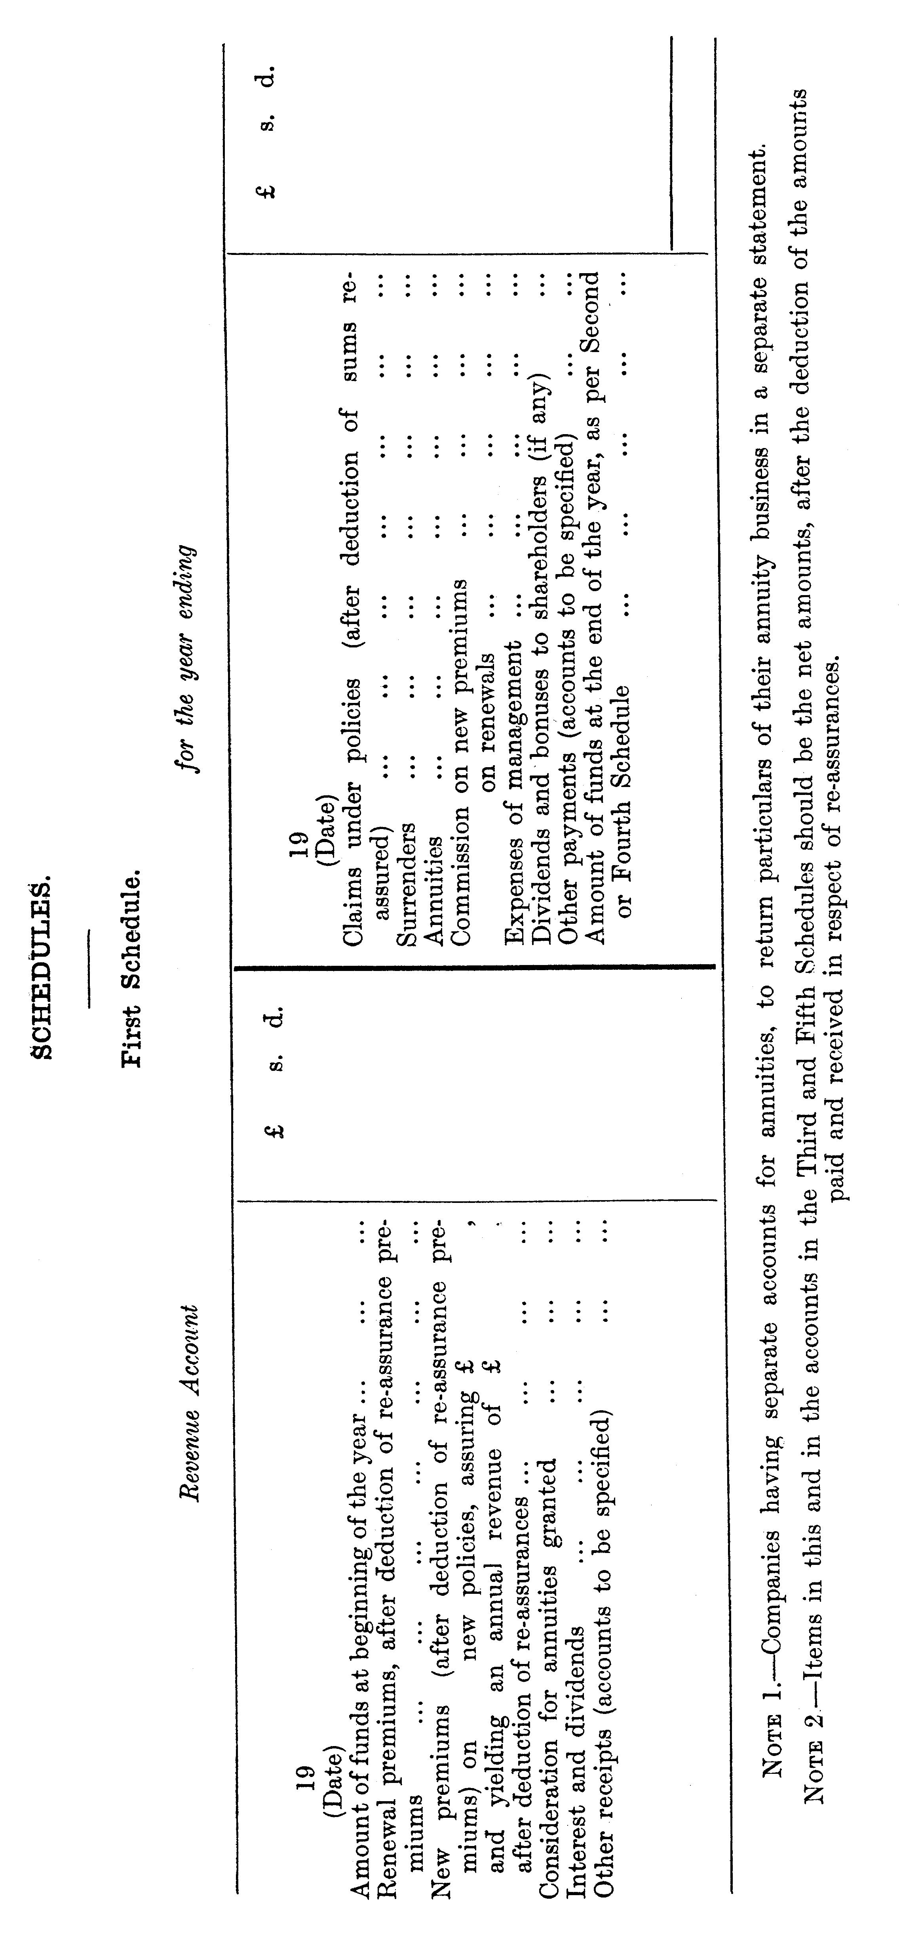

Second Schedule
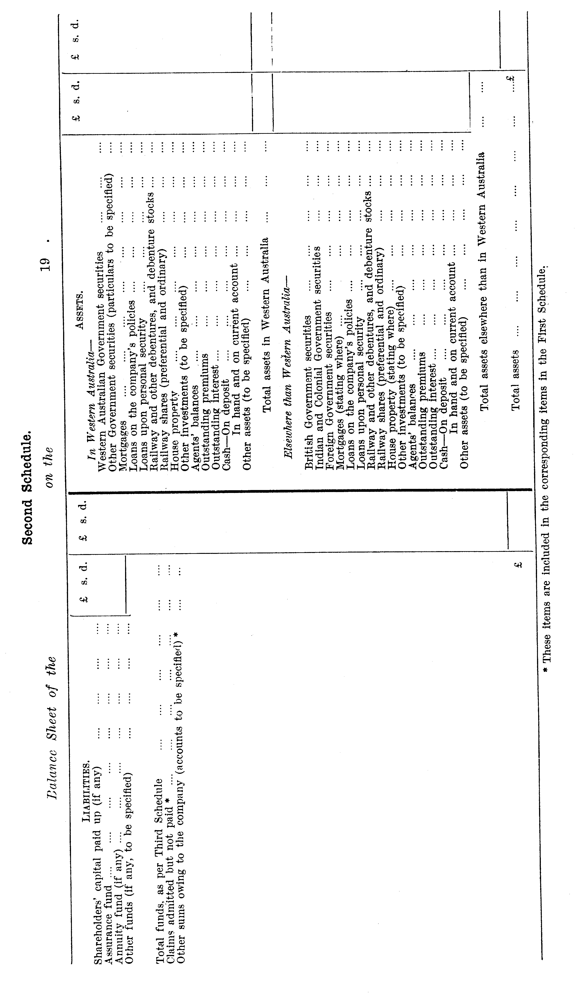

Third Schedule
Revenue Account of the for the year ending
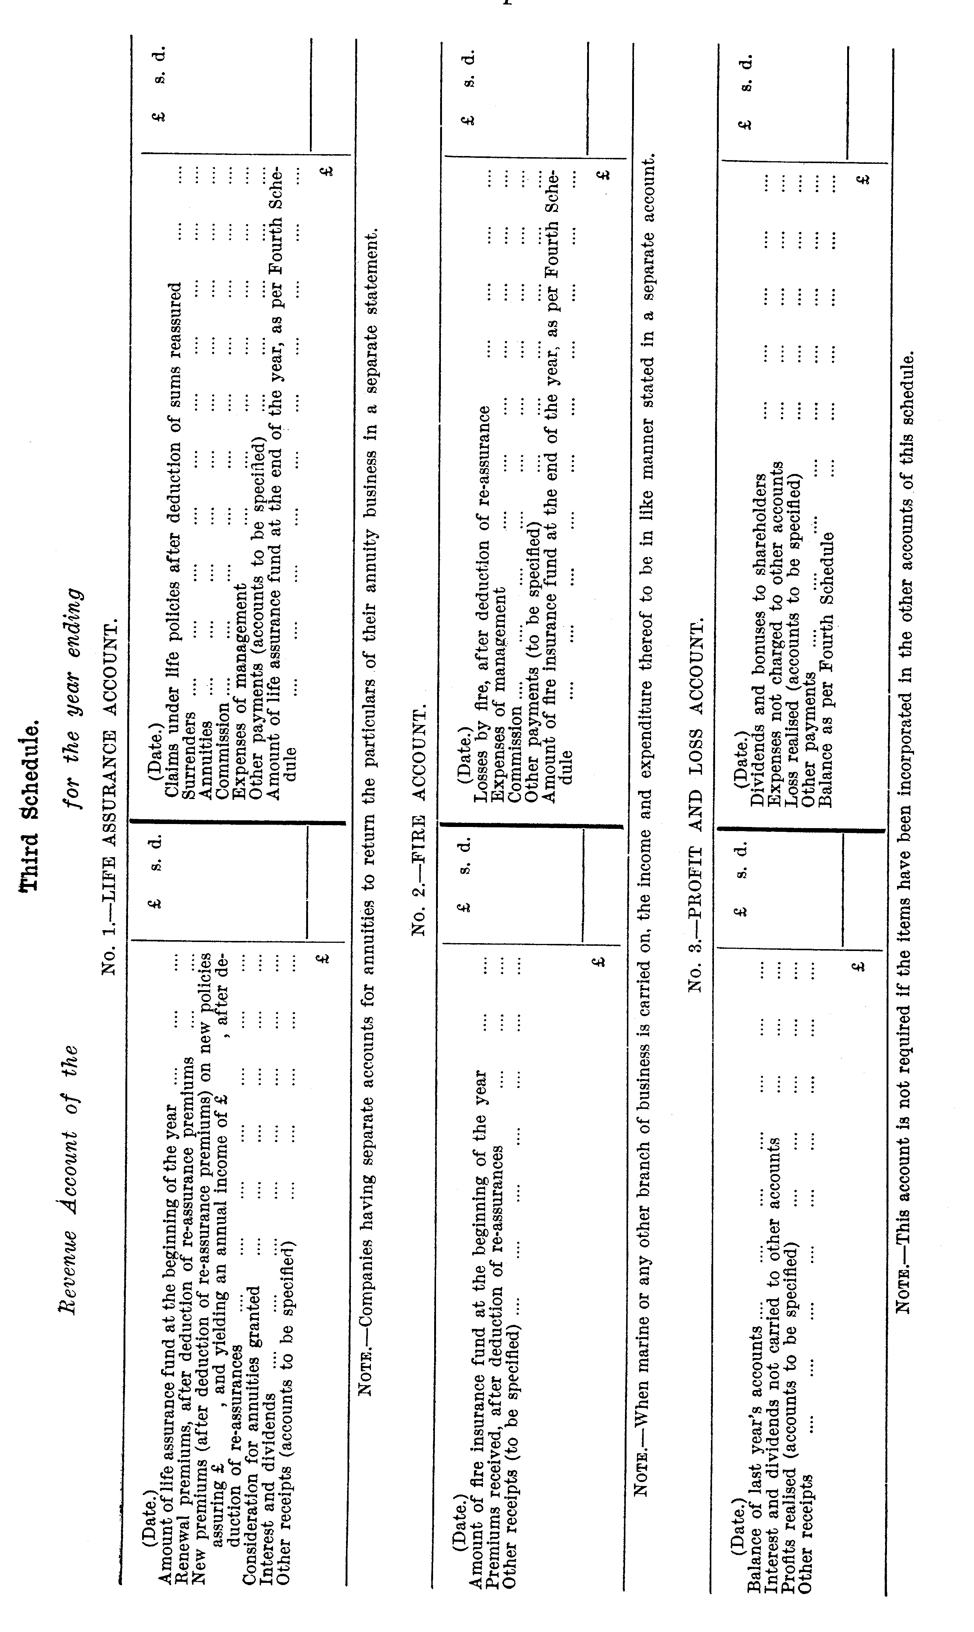

Fourth Schedule
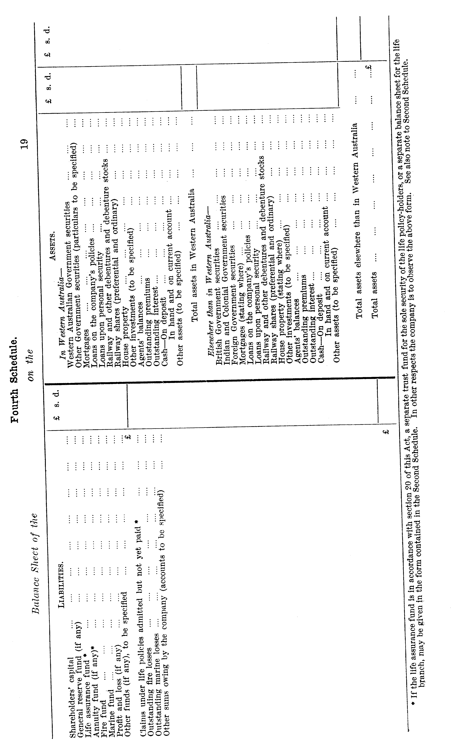

Fifth Schedule
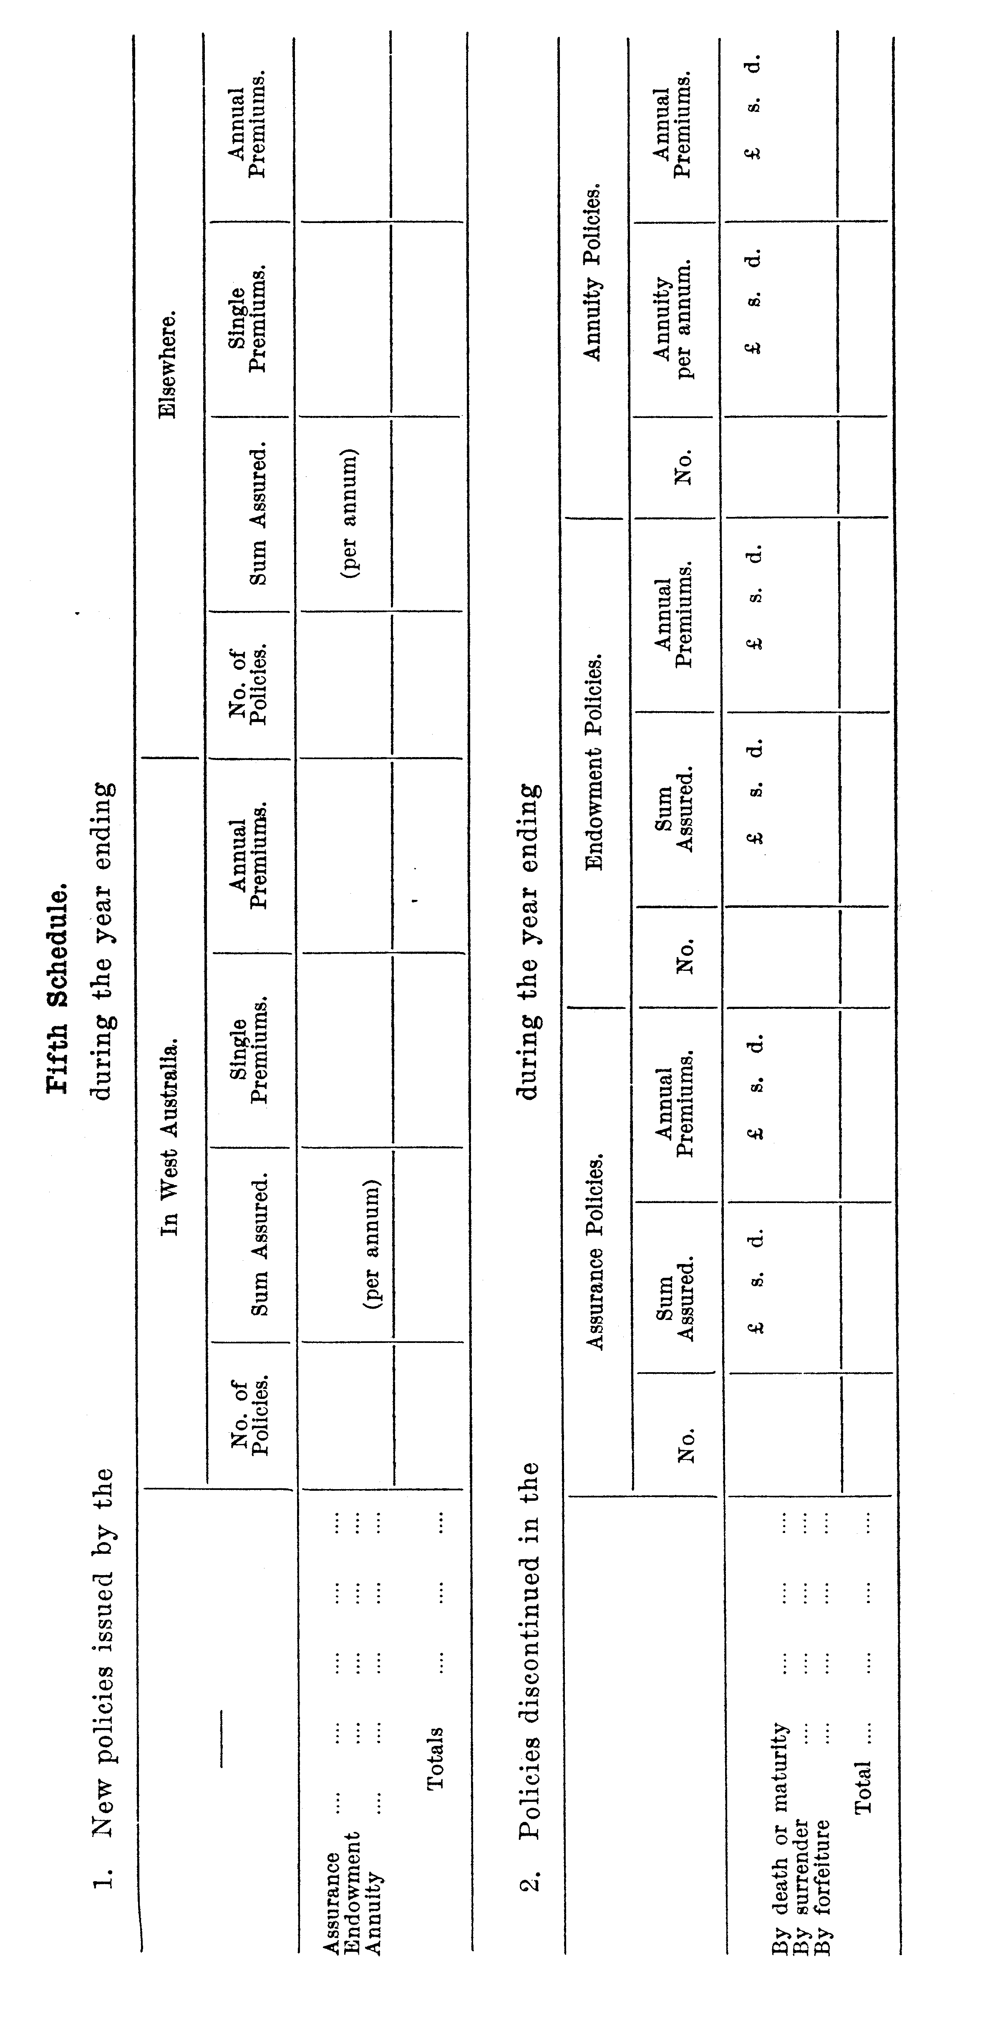
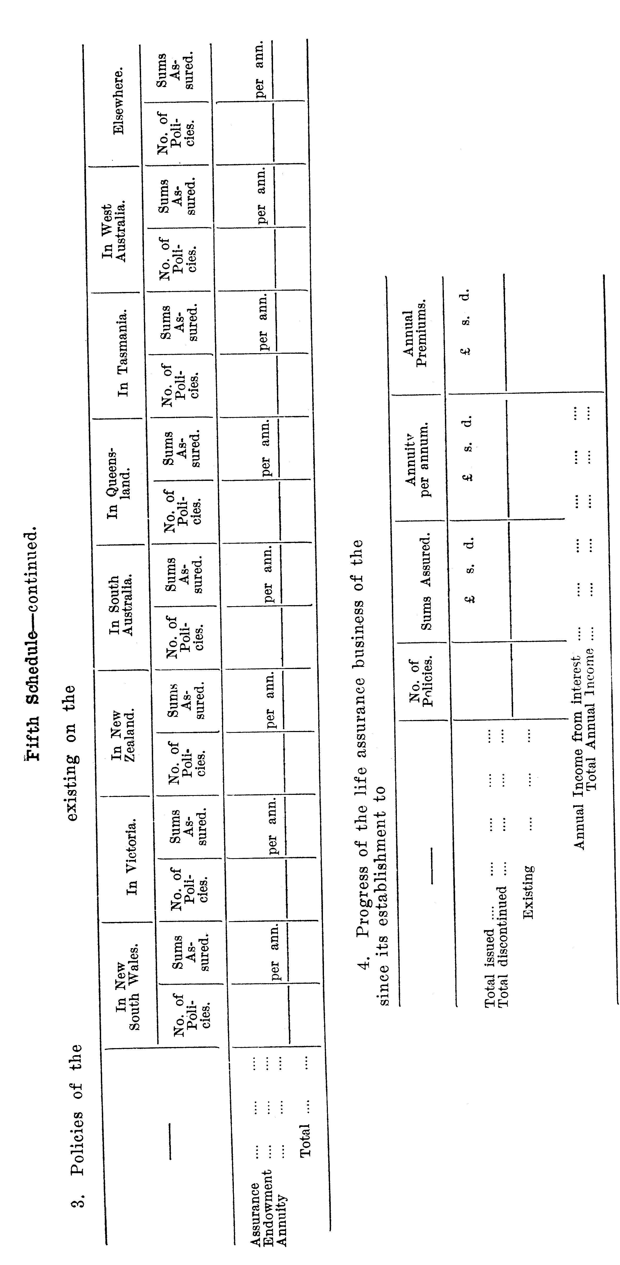

Sixth Schedule
Statement respecting the Valuation of the Liabilities under Life Policies and Annuities of the . . . . . . . . . . to be made by the Actuary.
[The answers should be numbered to accord with the numbers of the corresponding questions.]
1. The date up to which, the valuation was made?
2. The principles upon which the valuation was made, and whether these principles were determined by the instrument constituting the company or by its regulations, or by-laws or otherwise?
(a) Were the policies valued individually or in classes?
(b) If in classes, how was the valuation age determined?
(c) What portion (if any) of a year’s premium was assumed to be due?
(d) Were lives assured at increased rates assured to be of the age at entry corresponding to the premium charged? If not, how were they dealt with?
3. The table or tables of mortality used in the valuation?
4. The rate or rates of interest assumed in the calculations?
5. By what table of mortality, and according to what rate of interest, have the net premiums valued been computed? Give specimens of such premiums for a whole life and an endowment Assurance policy of £100, for ages at entry, 20, 25, 30, 35, 40,45, 50, 55, 60.
6. The proportion of the annual premium income (if any) reserved as a provision for future expenses and profits? [If none, state how this provision is made.] In cases where assurances have been effected by single or limited premiums, state what provision has been made for expenses when the premiums cease to be payable.
7. The consolidated revenue account since the last valuation, or, in case of a company which has made no valuation, since the commencement of the business? [This return must be made in the form annexed.]
8. The liabilities of the company under life policies and annuities at the date of the valuation, showing the number of policies, the amount assured, and the amount of premiums payable annually under each class of policies, both with and without participation in profits, and also the net liabilities and assets of the company, with the amount of surplus or deficiency? [These returns must be made in the forms annexed.]
9. The principles upon which the distributions of profit are made?
10. The time during which a policy must be in, force to entitle it to share in the profits?
11. The results of the valuation, showing —
(a) The total amount of profit made by the company.
(b) The amount of profit divided among the policy-holders, and the number and amount of policies which participated.
(c) Specimens of bonuses allotted to policies for £100, effected at the respective ages of 20, 30, 40, 50, and having been respectively in force for five years, ten years, and upwards, at intervals of five years, together with the amount appropriated under the various modes in which the bonus might be received.
[Form referred to under heading No. 7 in Sixth Schedule.]
Consolidated Revenue Account of the for years,
commencing and ending
Amount of funds on 19 , the beginning of  Premiums, after deduction of reassurance premiums  Consideration for annuities granted  Interest and dividends  Other receipts (accounts to be specified)  £ | £ s d | Claims under policies, after deduction of sums re-assured  Surrenders  Annuaities  Commission  Expenses of management  Dividents and bonuses to shareholders (if any)  Other payments (accounts to be specified)  Amount of funds on 19 ,  the end of the period, as per First (or Third) Schedule  £ | £ s d
[Form referred to under heading No. 8 in Sixth Schedule.]
Summary and Valuation of the Policies of the as at
Description of Transaction | Particulars of the Policies |  |  |  |  |  | Valuation
 | No. of Policies | Sum Assured | Bonus Addition | Office Yearly Premiums | Net Yearly Premiums | Loading | Value by the table  Interest per cent
 |  |  |  |  |  |  | Summ Assured | Bonus Addition | Office Yearly Premium | Net Yearly Premium | Loading | Net liability
Assurances
1. With participation in profits—
For whole term of life
Other classes (to be specified)
Extra premiums payable
Total assurances with profits
2. Without participation in profits—
For the whole term of life
Other classes (to be specified)
Extra premiums payable
Total assurances without profits
Total assurances
Deduct re-assurances
Net amount of assurances
Adjustments (if any)
Annuities
Immediate
Other classes (to be specified)
Total of the results
The item “extra premium,” in this Act shall be taken to mean the charge for any risk not provided for in the minimum contract premium. If policies are issued in or for any country, at rates of premium deduced from tables other than the European mortality tables adopted by the company, separate schedules, similar in form to the above, must be furnished.
[Form referred to under heading No. 8 in Sixth Schedule.]
Valuation Balance-sheet of as at 19
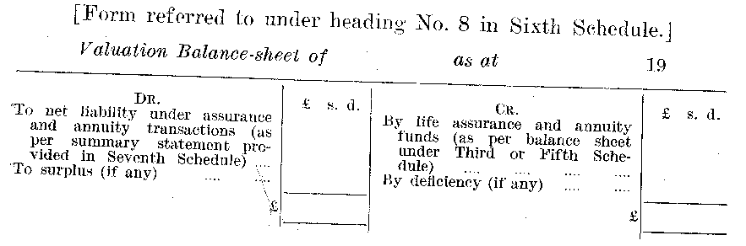

Seventh Schedule
Statement of the Life Assurance and Annuity business
of the on the
[The answers should be numbered to accord with the numbers of the corresponding questions. Statements of re-assurances, corresponding to the statements in respect of assurances under headings, 2, 3, 4, 5, 6, and 7, are to be given.]
1. The published table or tables of premiums for assurances for the whole term of life which were in use at the date above mentioned?
2. The total number of policies and amounts assured on lives for the whole term of life which were in existence at the date above mentioned, distinguishing the portions assured with and without profits, stating separately the total reversionary bonuses, and specifying the sums assured for each year of life, from the youngest to the oldest ages?
3. The amount of premiums receivable annually for each year of life after deducting the abatements made by the application of bonuses in respect of the respective assurances mentioned under heading No. 2, distinguishing ordinary from extra premiums?
4. The total amount of premiums which have been received form the commencement upon all policies mentioned under heading No. 2, which were in force at the above-mentioned date.
5. The total number of policies and amounts assured under classes of assurance business other than for the whole term of life, distinguishing the number of policies and the sums assured under each class, and stating separately the amount assured, with and without profits, and the total amount of reversionary bonuses?
6. The amount of premiums receivable annually in respect of each such special class of assurances mentioned under heading No. 5, distinguishing ordinary from extra premiums?
7. The total amount of premiums which have been received from the commencement upon all policies under each special class mentioned under heading No. 5, which were in force at the date above-mentioned?
8. The total amount of immediate annuities on lives, distinguishing the amount for each year of life?
9. The amount of all annuities other than those specified under heading No. 8, distinguishing the amount payable under each class, the amount of premiums annually receivable, and the amount of consideration money received in respect of each such class, and the total amount of premiums received from the commencement upon all deferred annuities?
10. The average rate of interest at which the life assurance fund of the company was invested at the close of each year during the period since the last investigation, together with a statement of the manner in which such average has been computed?
11. A table of minimum value (if any) allowed for the surrender of policies for the whole term of life, and for endowments, and endowment assurances, or a statement of the method pursued in calculating such surrender values, with instances of its application to policies of difference standing, and taken out at various intervals ages, from the youngest to the oldest?
12. Separate statements to be furnished for business at other than European rates, together with a statement of the manner in which policies on unhealthy lives are dealt with?

Eighth Schedule
Rule for Valuing an Annuity
An annuity shall be valued according to the tables used by the company which granted such annuity at the time of granting the same; and where such tables cannot be ascertained or adopted to the satisfaction of the court, then according to the table known in England as the Government Annuities Experience Table, interest being reckoned at the rate of Four Pounds per centum per annum.
Rule for Valuing a Policy
The value of the policy is to be the difference between the present value of the reversion in the sum assured on the decease of the life, including any bonus or addition thereto made before the commencement of the winding up, and the present value of the future annual premiums.
In calculating such present values the rate of interest is to be assumed as being Four pounds per centum per annum, and the rate of mortality as that of the tables known in England as the Institute of Actuaries H.M. Life Tables.
The premium to be calculated is to be such a premium as, according to the said rate of interest and rate of mortality, is sufficient to provide for the risk incurred by the office in issuing the policy, exclusive of any addition thereto for office expenses and other charges.

Ninth Schedule
Memorandum of Transfer
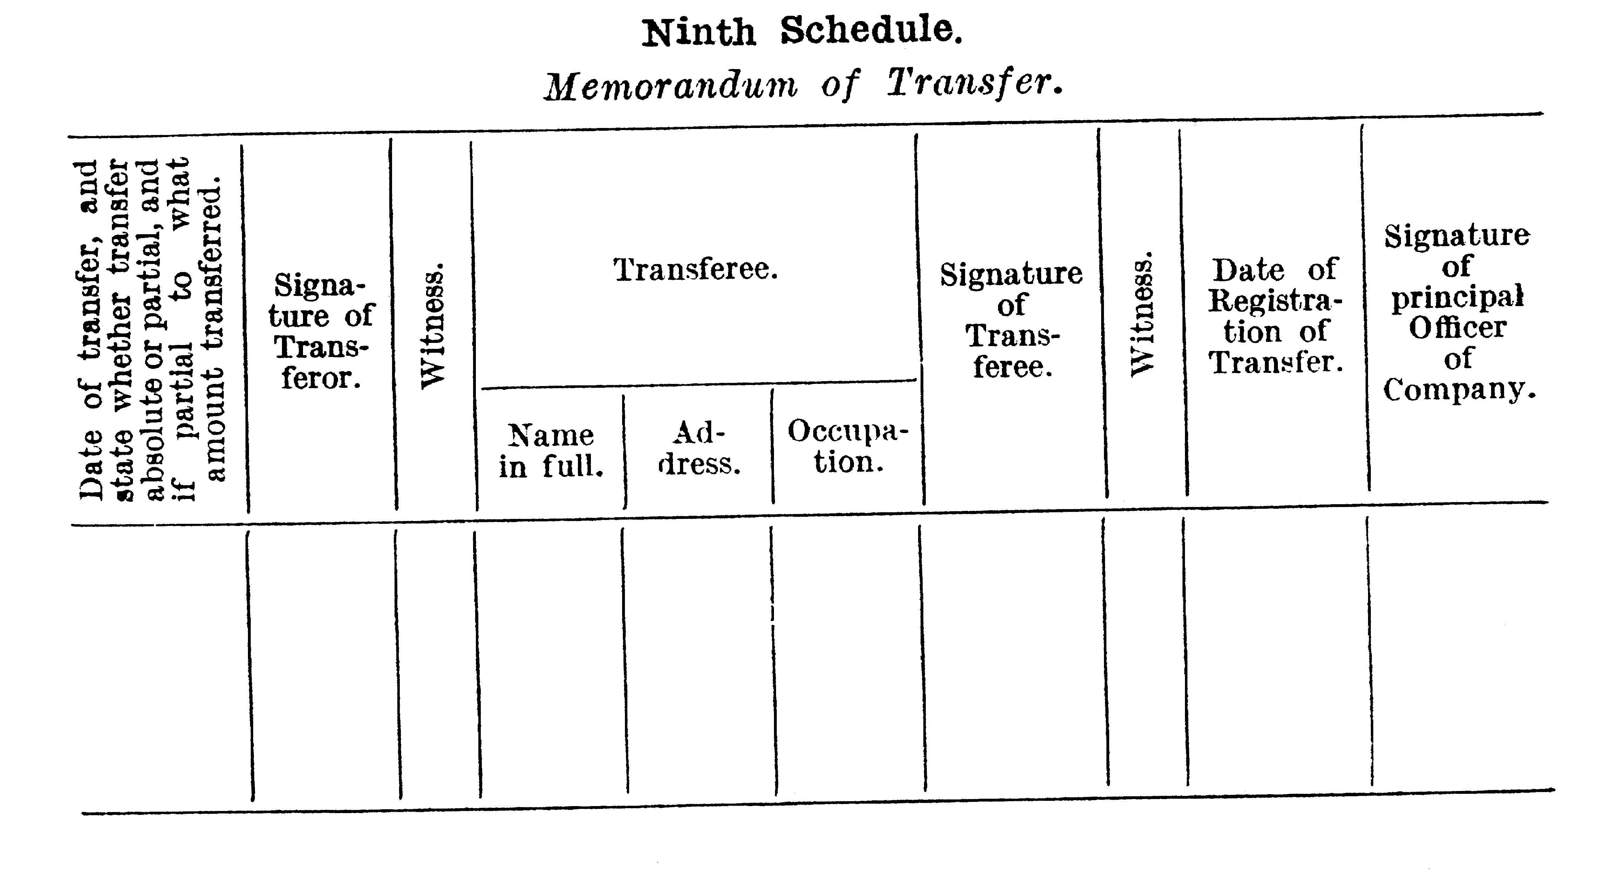

Tenth Schedule
Part I
The amount of a paid-up policy, exclusive of bonuses, in the case of endowment and endowment assurance policies, shall be ascertained in the following manner: —
By ascertaining the sum which bears to the original sum assured, the same proportions as the number of complete months in the period for which premiums have been paid on the policy bears to the number of complete months in the period for which premiums were originally payable and taking in respect of the undermentioned policies the following percentages of the sum so ascertained: —
(1) For policies in respect of which there has been paid in premiums an amount equal to the premiums payable in respect of that policy for any period of not less than three but less than four years — seventy per centum.
(2) For policies in respect of which there has been paid in premiums an amount equal to the premiums payable in respect of that policy for any period of not less than four but less than five years — eighty per centum: and
(3) For policies in respect of which there has been paid in premiums an amount equal to the premiums payable in respect of that policy for any period of five years and upwards — ninety per centum.
Part II
The amount of the paid-up policy, exclusive of bonuses, in the case of whole of life policies, shall be ascertained in accordance with the following rules: —
(1) Rule for ascertaining the amount of a paid-up policy: —
The amount of a paid-up policy shall be a sum bearing the same proportion to ninety per centum of the value of the policy as the sum of one pound bears to the value of the reversion in the sum of one pound, according to the contingency upon which the sum assured under the original policy was payable.
(2) Rules for valuing policies: —
The value of the policy, for the purpose of the preceding rule, shall be determined in the following manner: —
(a) The value of the policy shall be the difference between the present value of the reversion in the sum assured according to the contingency upon which it is payable and the present value of the future net premiums.
(b) The net premium shall be such premium as according to the assumed rate of interest and rates of mortality and the age of the person whose life is assured at his birthday next following the date of the policy is sufficient to provide for the risk incurred by the company in issuing the policy exclusive of any addition thereto for office expenses and other charges.
Provided that the date of the policy may be assumed to be one year after the actual date.
(3) General rules applicable both for valuing the policy and for ascertaining the amount of the paid-up policy: —
(a) Interest shall be assumed at the rate of four per centum per annum.
(b) The rates of mortality shall be assumed according to such tables as are from time to time prescribed.
(c) The age of the person whose life is assured shall be obtained by adding to the age attained by him at his birthday next after the date of the issue of the policy, the duration of the policy in completed years and months at the date as at which the value of the policy is required to be ascertained.
[Tenth Schedule inserted by No. 47 of 1939 s.7.]

Notes
¹ This is a compilation of the Life Assurance Companies Act 1889 and includes the amendments made by the other written laws referred to in the following table.

Compilation table
Short title | Number and Year | Assent | Commencement
Life Assurance Companies Act 1889 | 12 of 1889 | 4 Dec 1889 | 4 Dec 1889
 | 12 of 1905 | 23 Dec 1905 | 23 Dec 1905
Ministers’ Titles Act 1925 | 8 of 1925 | 24 Sep 1925 | 24 Sep 1925
 | 47 of 1939 | 23 Dec 1939 | 23 Dec 1939
 | 5 of 1944 | 12 Oct 1944 | 12 Oct 1944
Local Government (Consequential Amendments) Act 1996 s. 4 | 14 of 1996 | 28 Jun 1996 | 1 Jul 1996 (see s. 2)
Statutes (Repeals and Minor Amendments) Act (No. 2) 1998 s. 76 | 10 of 1998 | 30 Apr 1998 | 30 Apr 1998 (see s. 2(1))
Acts Amendment (Equality of Status) Act 2003 Pt. 35 | 28 of 2003 | 22 May 2003 | 1 Jul 2003 (see s. 2 and Gazette 30 Jun 2003 p. 2579)
Criminal Law Amendment (Simple Offences) Act 2004 s. 82 | 70 of 2004 | 8 Dec 2004 | 31 May 2005 (see s. 2 and Gazette 14 Jan 2005 p. 163)
Wills Amendment Act 2007 s. 25 | 27 of 2007 | 26 Oct 2007 | 9 Feb 2008 (see s. 2 and Gazette 8 Feb 2008 p. 313)
This Act was repealed by the Statutes (Repeals and Miscellaneous Amendments) Act 2009 s. 3(b) (No. 8 of 2009) as at 22 May 2009 (see s. 2(b))
N.B. This Act is affected by No. 10 of 1924, notice published in Gazette 24 Oct 1941 p. 1538 and order published in Gazette 23 Feb 1945 p. 222-5.

