Western Australia
Motor Vehicle Dealers Act 1973

Motor Vehicle Dealers (Sales) Amendment Regulations 2024

Western Australia
Motor Vehicle Dealers (Sales) Amendment Regulations 2024
Contents
1. Citation 1
2. Commencement 1
3. Regulations amended 1
4. Regulation 2 amended 1
5. Regulation 5 amended 1
6. Regulation 7 replaced 1
7. Information statement to be given before sale 1
8. Details to be included in copies of notice after sale 1
7. Schedule 1 Form 4 amended 1
Form 4 — Vehicle particulars
8. Schedule 1 Form 5 amended 1
9. Schedule 1 Form 5A inserted 1
Form 5A — Information statement — statutory warranty
10. Schedule 1 Form 6 amended 1
11. Schedule 5 clause 8 amended 1

Motor Vehicle Dealers Act 1973
Motor Vehicle Dealers (Sales) Amendment Regulations 2024
Made by the Governor in Executive Council.

1. Citation
These regulations are the Motor Vehicle Dealers (Sales) Amendment Regulations 2024.

2. Commencement
These regulations come into operation as follows —
(a) regulations 1 and 2 — on the day on which these regulations are published on the WA legislation website (publication day);
(b) the rest of the regulations — on the day after the period of 3 months beginning on publication day.

3. Regulations amended
These regulations amend the Motor Vehicle Dealers (Sales) Regulations 1974.

4. Regulation 2 amended
(1) In regulation 2 delete “regulations unless the contrary intention appears —” and insert:

regulations —

(2) In regulation 2 insert in alphabetical order:

corresponding, in relation to the law of another jurisdiction and a law of this State, has the meaning given in the Road Traffic (Administration) Act 2008 section 4;
interstate written-off vehicle register means a register (however described) established and maintained under a law of another jurisdiction corresponding to the Road Traffic (Vehicles) Regulations 2014 Part 7;
jurisdiction has the meaning given in the Road Traffic (Administration) Act 2008 section 4;
registered repairable write-off means a vehicle that is —
(a) registered in the Written-Off Vehicle Register (WA) as a repairable write-off; or
(b) registered in an interstate written-off vehicle register in a category that substantially corresponds to repairable write-off;
repairable write-off has the meaning given in the Road Traffic (Vehicles) Regulations 2014 regulation 151;
VIN, in relation to a vehicle, means the vehicle identification number that is required under the Road Traffic (Vehicles) Regulations 2014 regulation 274(4) for the vehicle;
Written-Off Vehicle Register (WA) means the Written-Off Vehicle Register established and maintained under the Road Traffic (Vehicles) Regulations 2014 regulation 156(1).

(3) In regulation 2 in the definition of section delete “Act.” and insert:

Act;

Note: The heading to amended regulation 2 is to read:
Terms used

5. Regulation 5 amended
(1) Before regulation 5(1) insert:

(1A) For the purposes of section 33(1), the notice must be —
(a) in the form of Form 4; and
(b) printed, typed or written in a clear and legible manner.

(2) In regulation 5(1):
(a) delete “section 33(1) of the Act the form of the notice containing the required particulars shall also set out —” and insert:

section 33(3)(g), the other particulars are —

(b) in paragraph (b) delete “of a type or class” and insert:

one

(c) in paragraph (b) delete “section 34A of the Act apply.” and insert:

section 34 will apply; and

(d) after paragraph (b) insert:

(c) whether the vehicle is a registered repairable write-off; and
(d) the VIN of the vehicle; and
(e) the engine number (if any) of the vehicle; and
(f) if a vehicle licence has been granted in respect of the vehicle under the Road Traffic (Vehicles) Act 2012 and is current, the date on which that vehicle licence expires; and
(g) the register reference number or stock number assigned to the vehicle by the dealer.

(3) Delete regulation 5(2).
(4) In regulation 5 delete the Table.

6. Regulation 7 replaced
Delete regulation 7 and insert:

7. Information statement to be given before sale
(1) Before a dealer sells a vehicle to which the obligations imposed by section 34 will apply, the dealer must ensure that the purchaser is given an information statement that —
(a) is in the form of Form 5A; and
(b) includes whichever of the following is applicable —
(i) if the vehicle is not a motor cycle — the illustration in Form 5A entitled “The Used Car Warranty”;
(ii) if the vehicle is a motor cycle — the illustration in Form 5A entitled “The Used Bike Warranty”.
(2) Before a dealer sells a vehicle to which the obligations imposed by section 34 will not apply, the dealer must ensure that the purchaser is given an information statement in the form of Form 6.
8. Details to be included in copies of notice after sale
If a dealer sells a vehicle, the dealer must ensure that each copy of the notice required under section 33(7) includes —
(a) the date of the sale; and
(b) if the vehicle is equipped with an odometer — the reading on the odometer at the time of the sale.

7. Schedule 1 Form 4 amended
(1) Delete the heading to Schedule 1 Form 4 and the reference after it and insert:

Form 4 — Vehicle particulars
[r. 5]

(2) In Schedule 1 Form 4:
(a) delete “regulation 7” and insert:

regulation 5

(b) delete “AND WARRANTY”;
(c) delete “Kilometres/Miles” and insert:

kms/miles

(d) delete “V.I.N./Chassis No.” and insert:

VIN

(e) delete “Registration” and insert:

Vehicle licence

(f) before “Date of sale” insert:

Vehicle will be covered by the statutory warranty under section 34 of the Motor Vehicle Dealers Act 1973..........................................................................................YES NO
Vehicle is a registered repairable write-off..................................................YES NO

(g) delete the passage that begins with “STATUTORY WARRANTY” and continues to the end of the Form.

8. Schedule 1 Form 5 amended
In Schedule 1 Form 5:
(a) delete “V.I.N./Chassis No.” and insert:

VIN

(b) delete “kilometres/miles” and insert:

kms/miles

(c) delete “Internet: www.dmirs.wa.gov.au” and insert:

Internet: www.demirs.wa.gov.au

9. Schedule 1 Form 5A inserted
After Schedule 1 Form 5 insert:

Form 5A — Information statement — statutory warranty
[r. 7]
WESTERN AUSTRALIA
Motor Vehicle Dealers Act 1973 section 56
Motor Vehicle Dealers (Sales) Regulations 1974 regulation 7
STATUTORY WARRANTY
A motor vehicle is covered by the terms of a statutory warranty under the Motor Vehicle Dealers Act 1973 if the cash price (inc. GST) paid is $4 000 or more and the vehicle is not more than 12 years old and has travelled not more than 180 000 km. The length of time the vehicle is covered under warranty is determined by the age of the vehicle and kilometres it has travelled at the time of sale. Where a vehicle is —
• not more than 10 years old and has travelled not more than 150 000 km at the time of sale — the warranty is for 3 months or 5 000 km, whichever happens first; or
• more than 10 years but not more than 12 years old or has travelled more than 150 000 km but not more than 180 000 km at the time of sale — the warranty is for 1 month or 1 500 km, whichever happens first.
A motor cycle is covered by the terms of a statutory warranty if the cash price (inc. GST) paid is $3 500 or more and the motor cycle is not more than 8 years old and has travelled not more than 80 000 km. The warranty is for 3 months or 5 000 km, whichever happens first.
The warranty means that the selling dealer must repair or make good all defects which make or are likely to make the vehicle unroadworthy or unserviceable. The repair should make the vehicle roadworthy and in a reasonable condition having regard to its age.
WARRANTY AGAINST DEFECTS UNDER AUSTRALIAN CONSUMER LAW
A motor vehicle is also covered by the Australian Consumer Law, which requires a warranty against defects that includes the following text: “Our goods come with guarantees that cannot be excluded under the Australian Consumer Law. You are entitled to a replacement or refund for a major failure and compensation for any other reasonably foreseeable loss or damage. You are also entitled to have the goods repaired or replaced if the goods fail to be of acceptable quality and the failure does not amount to a major failure.”.
MORE INFORMATION
If you have any questions or require further information about warranties, contact the Consumer Protection Call Centre on 1300 304 054 (Mon to Fri). TTY 13 36 77 (hearing impaired). 13 14 50 (interpreter service).
Internet: www.demirs.wa.gov.au
ALWAYS CONTACT THE DEALER FIRST TO DISCUSS WARRANTY REPAIRS
Please see reverse for a “Quick Guide to Warranty Items”
(reverse — for cars)
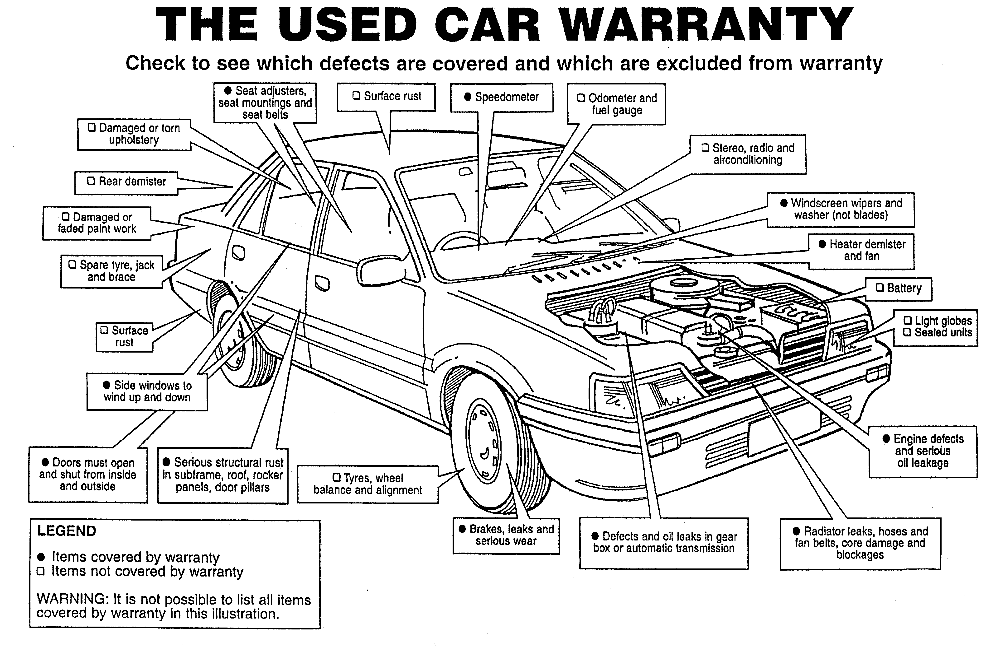
(reverse — for bikes)
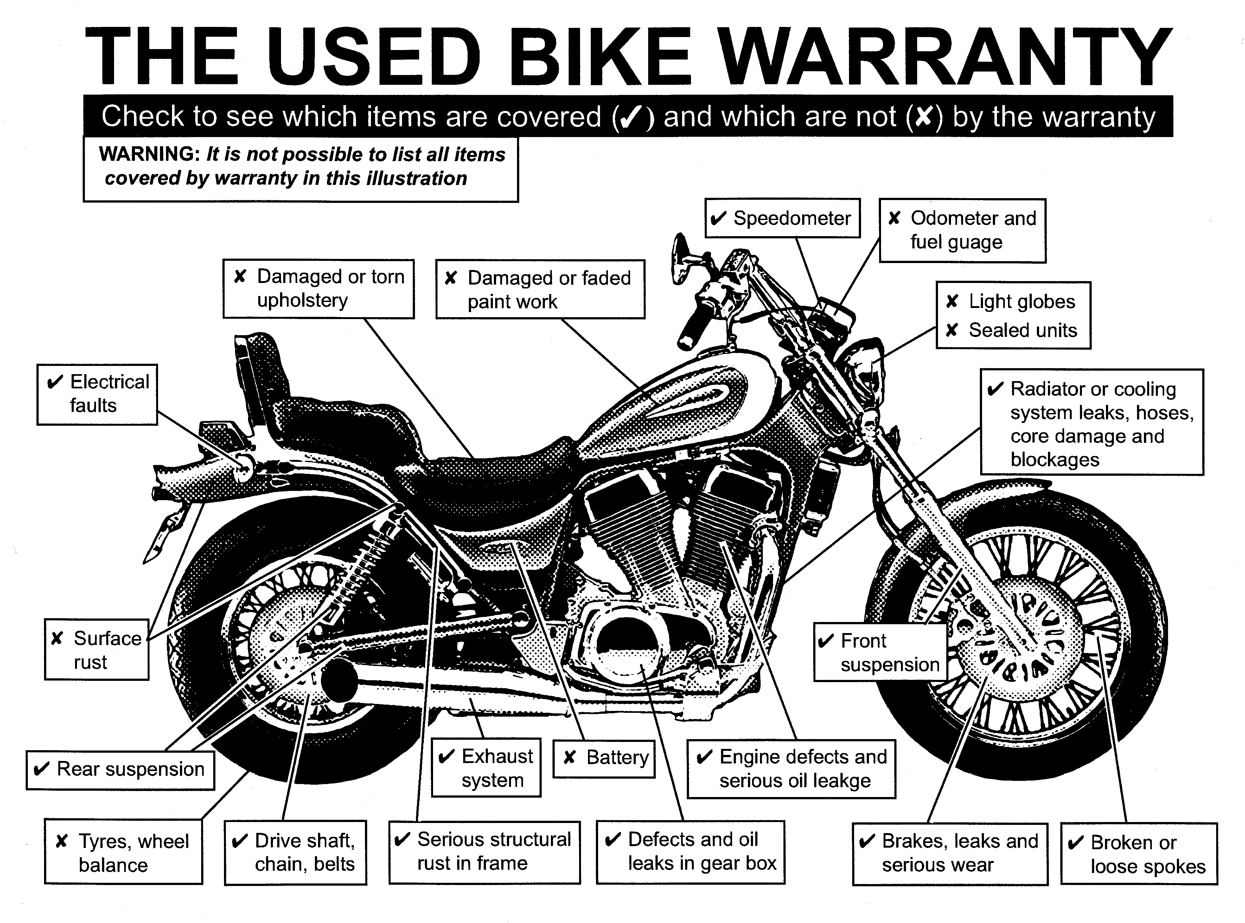

10. Schedule 1 Form 6 amended
(1) In the heading to Schedule 1 Form 6 delete “Vehicle particulars — no” and insert:

Information statement — no statutory

(2) In Schedule 1 Form 6:
(a) delete “section 33” and insert:

section 56

(b) delete the passage that begins with “VEHICLE PARTICULARS — NO WARRANTY” and ends with “(reverse)”;
(c) delete “Part III Division 4” and insert:

section 34

(d) delete “Internet: www.dmirs.wa.gov.au” and insert:

Internet: www.demirs.wa.gov.au

11. Schedule 5 clause 8 amended
(1) In Schedule 5 clause 8.2 delete “liquidated”.
(2) Delete Schedule 5 clause 8.3 and insert:

8.3 Any amount sought by the Dealer under Clause 8.2 must be a genuine estimate of the Dealer’s loss arising from the Purchaser’s breach of the obligations imposed on the Purchaser by this Contract.
8.4 Any deposit paid by the Purchaser may be used by the Dealer to meet the pre-estimated damages payable by the Purchaser. Any surplus will be refunded to the Purchaser.

V. MOLAN, Clerk of the Executive Council
© State of Western Australia 2024.
This work is licensed under a Creative Commons Attribution 4.0 International Licence (CC BY 4.0). To view relevant information and for a link to a copy of the licence, visit www.legislation.wa.gov.au.
Attribute work as: © State of Western Australia 2024.
By Authority: GEOFF O. LAWN, Government Printer

