Western Australia

Reserves (Tjuntjuntjara Community) Act 2018
Compare between:
[12 Dec 2018, 00-a0-02] and [24 Dec 2022, 00-b0-00]

Western Australia
Reserves (Tjuntjuntjara Community) Act 2018
An Act —
- to excise an area from Reserve 30490 so that a lease over the excised area can be granted by the Minister for the use and benefit of the Tjuntjuntjara Community; and
- for related purposes.
The Parliament of Western Australia enacts as follows:

1. Short title
This is the Reserves (Tjuntjuntjara Community) Act 2018.

2. Commencement
This Act comes into operation as follows —
(a) sections 1 to 4 and 6 — on the day on which this Act receives the Royal Assent;
(b) the rest of the Act — on a day fixed by proclamation, and different days may be fixed for different provisions.

3. Terms used
In this Act —
Deposited Plan, followed by a number, means the deposited plan of that number —
(a) lodged with the Western Australian Land Information Authority established by the Land Information Authority Act 2006 section 5 (the Authority); and
(b) available in electronic form on the Authority’s official website;
Great Victoria Desert Nature Reserve means Reserve 30490, being an area of about 2 495 777 hectares that is a class A nature reserve (as defined in the Land Administration Act 1997 section 45(1));
Registrar of Titles means the Registrar of Titles referred to in the Transfer of Land Act 1893 section 7;
Tjuntjuntjara Community land means Lot 9 on Deposited Plan 220992 comprising an area of 78 578 hectares;
Tjuntjuntjara Community lease means a lease granted by the Minister under the Land Administration Act 1997 section 83(1) over the Tjuntjuntjara Community land;
unallocated Crown land has the meaning given in the Land Administration Act 1997 section 3(1).

4. Great Victoria Desert Nature Reserve boundary amended
(1) The Great Victoria Desert Nature Reserve is amended by correcting the description of its eastern boundary (as published in the Gazette on 21 August 1970 at p. 2620-1) by deleting the words “situate 2 chains 46 links west and” and “in the State of South Australia”.
(2) The amendment does not affect the area of the reserve.

5. Great Victoria Desert Nature Reserve — Tjuntjuntjara Community land excised
(1) The Great Victoria Desert Nature Reserve is amended by excising the Tjuntjuntjara Community land.
(2) The Great Victoria Desert Nature Reserve, as amended by subsection (1), comprises an area of 2 417 201 hectares being the land in Lot 300 on Deposited Plan 403087 version 2.
(3) The boundaries of the Great Victoria Desert Nature Reserve as amended by subsection (1) are shown, for information purposes, on the plan in Schedule 1 but subsection (2) prevails if there is any inconsistency.

6. Registrar of Titles to take certain measures
(1) The Registrar of Titles must take any necessary measures to register the amendments effected by sections 4 and 5.
(2) For the purposes of subsection (1), sections 4 and 5 may be treated as if they were orders under the Land Administration Act 1997.

7. Residential Tenancies Act 1987 not applicable to Tjuntjuntjara Community lease
A Tjuntjuntjara Community lease is not a residential tenancy agreement for the purposes of the Residential Tenancies Act 1987 section 3.

8. Proposed easement over Great Victoria Desert Nature Reserve
(1) In this section —
access easement means the easement shown on Deposited Plan 414191 version 2 providing access over that part of the Great Victoria Desert Nature Reserve shown on that plan and benefitting the holder of a leasehold interest granted by a Tjuntjuntjara Community lease.
(2) The Land Administration Act 1997 section 44 does not apply to a proposal by the Minister to grant the access easement.
(3) For the purposes of the Transfer of Land Act 1893 section 81S(2)(b), the Registrar of Titles may register the access easement as if the Land Administration Act 1997 section 44 had been complied with.

9. Mining on Tjuntjuntjara Community land
(1) In this section —
mining has the meaning given in the Mining Act 1978 section 8(1);
mining tenement has the meaning given in the Mining Act 1978 section 8(1);
Minister for Mines means the Minister to whom the administration of the Mining Act 1978 is committed by the Governor.
(2) This section is in addition to the provisions of the Mining Act 1978.
(3) It is a condition of each mining tenement granted in respect of the Tjuntjuntjara Community land that the holder of the tenement must not carry out mining on or under that land unless it is carried out in accordance with the consent of the Minister for Mines given under subsection (4)(b).
(4) The Minister for Mines may, if asked to consent to mining for the purposes of subsection (3) —
(a) refuse to give consent; or
(b) give written consent subject to the terms and conditions (if any) that the Minister for Mines specifies in the consent.
(5) Before giving consent under subsection (4)(b), whether conditionally or unconditionally, the Minister for Mines must consult with, and obtain the recommendations of, the following —
(a) the Minister to whom the administration of the Conservation and Land Management Act 1984 is committed by the Governor;
(b) any person holding a Tjuntjuntjara Community lease or in whom the control and management of the land is vested or placed;
(c) if the Tjuntjuntjara Community land is unallocated Crown land, the Minister to whom the administration of the Land Administration Act 1997 is committed by the Governor.
(6) A mining tenement referred to in subsection (3) is liable to be forfeited under the Mining Act 1978 section 96, 96A or 97 (as the case requires) if the holder of the tenement contravenes the condition imposed by subsection (3).
(7) For the purposes of subsection (6), in the Mining Act 1978 section 96(2) “the requirements of this Act” includes a reference to the condition imposed by subsection (3).

10. Petroleum and geothermal energy operations on Tjuntjuntjara Community land
(1) In this section —
geothermal energy operation has the meaning given in the Petroleum and Geothermal Energy Resources Act 1967 section 5(1);
geothermal title has the meaning given in the Petroleum and Geothermal Energy Resources Act 1967 section 69A(1);
Minister for Petroleum means the Minister to whom the administration of the Petroleum and Geothermal Energy Resources Act 1967 is committed by the Governor;
petroleum operation has the meaning given in the Petroleum and Geothermal Energy Resources Act 1967 section 5(1);
petroleum title has the meaning given in the Petroleum and Geothermal Energy Resources Act 1967 section 69A(1);
registered holder has the meaning given in the Petroleum and Geothermal Energy Resources Act 1967 section 5(1).
(2) This section —
(a) is in addition to the provisions of the Petroleum and Geothermal Energy Resources Act 1967; and
(b) applies despite the Petroleum and Geothermal Energy Resources Act 1967 section 15(1).
(3) It is a condition of each petroleum title or geothermal title granted in respect of the Tjuntjuntjara Community land that the registered holder of the title must not carry out a petroleum operation or geothermal energy operation on or under that land unless it is carried out in accordance with the consent of the Minister for Petroleum given under subsection (4)(b).
(4) The Minister for Petroleum may, if asked to consent to a petroleum operation or geothermal energy operation for the purposes of subsection (3) —
(a) refuse to give consent; or
(b) give written consent subject to the terms and conditions (if any) that the Minister for Petroleum specifies in the consent.
(5) Before giving consent under subsection (4)(b), whether conditionally or unconditionally, the Minister for Petroleum must consult with, and obtain the recommendations of, the following —
(a) the Minister to whom the administration of the Conservation and Land Management Act 1984 is committed by the Governor;
(b) any person holding a Tjuntjuntjara Community lease or in whom the control and management of the land is vested or placed;
(c) if the Tjuntjuntjara Community land is unallocated Crown land, the Minister to whom the administration of the Land Administration Act 1997 is committed by the Governor.
(6) A petroleum title or geothermal title referred to in subsection (3) is liable to be cancelled under the Petroleum and Geothermal Energy Resources Act 1967 section 99, 105 or 106 (as the case requires) if the registered holder of the title contravenes the condition imposed by subsection (3).

Schedule 1 — Great Victoria Desert Nature Reserve (for information purposes only)
[s. 5(3)]
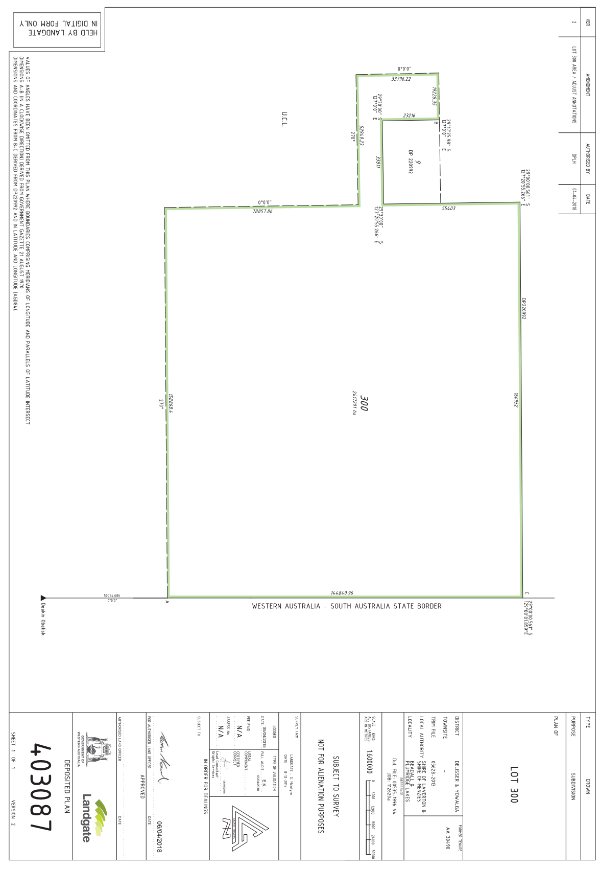

Notes
This is a compilation of the Reserves (Tjuntjuntjara Community) Act 2018. For provisions that have come into operation see the compilation table.

Compilation table
Short title | Number and year | Assent | Commencement
Reserves (Tjuntjuntjara Community) Act 2018 | 40 of 2018 | 12 Dec 2018 | s. 1-4 and 6: 12 Dec 2018 (see s. 2(a));  Act other than s. 1-4 and 6: 24 Dec 2022 (see s. 2(b) and SL 2022/213 cl. 2)

