Western Australia
Shipping and Pilotage Act 1967
Western Australian Marine Act 1982

Mooring Regulations 1998

Western Australia
Mooring Regulations 1998
Contents
Part 1 — Preliminary
1. Citation 1
2. Terms used 1
3. Application 3
Part 2 — Moorings and mooring sites in mooring control areas
Division 1 — Installation, removal and use of moorings
4. Installation of moorings 5
5. Removal of unauthorised mooring 5
6. Use of moorings 6
7. Securing and anchoring vessels in mooring control areas 7
Division 2 — Classes of mooring sites
7A. Term used: permissible vessel length 8
7B. Designation of mooring sites 9
7C. Recreational mooring sites: use by licensees 9
7D. Recreational mooring sites: use of shared-use moorings 10
7E. Cancellation of shared-use authorisation 12
7F. Rental moorings sites 13
7G. Refund of rental mooring site fee 14
7H. Emergency mooring sites 15
7I. Courtesy mooring sites 16
7J. Damage to moorings on certain mooring sites 16
7K. Commercial general mooring sites 18
7L. Commercial resources mooring sites 18
Part 3 — Mooring licences
8. Applications for mooring licence 19
9. Register of mooring licences 20
10. Waiting lists for mooring licences may be established 22
11. Offer of mooring licence 23
12. Mooring licence and registration of mooring site 25
13. Annual fee 26
13A. Surrender of mooring licence 27
14. Cancellation of mooring licence 28
14A. Variation of mooring licence 30
15. Exchange of mooring sites 31
17. Mooring licences not otherwise transferable 31
Part 4 — Registered mooring sites
Division 1 — Use of registered mooring sites
18. Installation of mooring 33
19. Maintenance of mooring 33
20. Mooring inspection reports 34
20A. CEO may reject mooring inspection report 35
21. Dealing with mooring 36
22. Relocation or removal of mooring 37
23. Vessel to be maintained in seaworthy condition 37
Division 2 — Licensed vessels
24. Licensed vessels 38
25. Substitution of licensed vessel 38
Division 3 — Additional vessels
26. Additional vessels authorised to use registered mooring site 40
27. Application for registration of additional vessel 40
28. Registration of additional vessel 42
29. Duration of registration 43
Part 5 — Prescribed offences and modified penalties
30. Prescribed offences and modified penalties 45
31. Approved officers and authorised officers 45
32. Forms 46
Part 6 — Transitional provisions for Transport Regulations Amendment (Mooring Management) Regulations 2021
Division 1 — Terms used
33. Terms used 47
Division 2 — Mooring licences
34. Transitional provisions for mooring licences 48
Division 3 — Transitional provisions for MCA Regulations
35. Application of new regulations to registered owners 49
36. Application of new regulations to moorings registered under MCA Regulations 51
Part 7 — Waiver and refund of fees
37. Terms used 52
38. Authorised fee officers 52
39. Waiver of fees 53
40. Details of waivers to be accessible on website 53
41. Emergency waivers 54
42. Effect of waiver 54
43. Refund of fees 54
Schedule 1 — Mooring control areas
Division 1 — Mooring control areas to which these regulations apply
Division 2 — Mooring control area in which only temporary anchoring is permitted
Schedule 2 — Excluded areas
Division 1 — Excluded area in Rockingham Mangles Bay Mooring Control Area
Division 2 — Excluded areas in Swan and Canning Rivers Mooring Control Area
Schedule 3 — Fees
Schedule 4 — Prescribed offences and modified penalties
Schedule 5 — Forms
Notes
Compilation table 74
Other notes 76
Defined terms

Shipping and Pilotage Act 1967
Western Australian Marine Act 1982
Mooring Regulations 1998

Part 1 — Preliminary

1. Citation
These regulations may be cited as the Mooring Regulations 1998.

2. Terms used
In these regulations, unless the contrary intention appears —
Act means the Western Australian Marine Act 1982;
additional vessel means a vessel authorised to use a mooring site under regulation 26(1);
approved means approved by the CEO;
CEO means the chief executive officer;
certificate of registration means a certificate of registration issued under the Navigable Waters Regulations 1958 ¹;
commercial general mooring site means a mooring site designated under regulation 7B(1)(e);
commercial resources mooring site means a mooring site designated under regulation 7B(1)(f);
courtesy mooring site means a mooring site designated under regulation 7B(1)(d);
emergency mooring site means a mooring site designated under regulation 7B(1)(c);
length, in relation to a vessel, means —
(aa) in the case of a vessel that has a certificate of survey in which the length of the vessel is specified — the length so specified; and
(a) in the case of a vessel that is registered under the Navigable Waters Regulations 1958 ¹ —
(i) the length of the vessel specified in the certificate of registration of that vessel; or
(ii) if the Minister is not satisfied as to the accuracy of that registered length, the length determined under paragraph (b);
and
(b) in any other case, the distance from the fore part of the hull to the after part of the hull taken at the upperside of the uppermost weathertight deck or, in the case of an open vessel, at the height of the gunwale;
licensed vessel means a vessel authorised to use a mooring site under regulation 24;
maximum vessel length, for a mooring site, means the approved maximum length that a vessel may have to use the mooring site;
mooring means any gear (including an anchor or stake) set out in a permanent manner to which a vessel or other floating structure may be secured by a chain, cable, wire or rope;
mooring control area means a mooring control area declared under the Shipping and Pilotage Act 1967 section 10(2) to which these regulations apply under regulation 3;
mooring licence means a licence granted —
(a) under section 65 of the Act in respect of waters in a mooring control area; and
(b) after the coming into operation of these regulations;
mooring licensee means the holder of a mooring licence;
mooring site means the waters in a mooring control area —
(a) in respect of which a mooring licence is granted; or
(b) in respect of which the CEO has designated an emergency mooring site, a courtesy mooring site or a rental mooring site;
pleasure vessel has the meaning given in section 98(1) of the Act;
recreational mooring site means a mooring site designated under regulation 7B(1)(a);
register means the register referred to in regulation 9;
registered mooring site means a mooring site —
(a) in respect of which a mooring licence is in force; and
(b) that is recorded in the register;
rental mooring site means a mooring site designated under regulation 7B(1)(b);
shared-use recreational mooring site means a recreational mooring site to which regulation 7C(3) applies;
tender has the meaning given in the Navigable Waters Regulations 1958 regulation 45A(2);
waiting list means the waiting list established under regulation 10.
[Regulation 2 amended: Gazette 28 Feb 2003 p. 677; SL 2021/147 r. 4.]

3. Application
(1) Subject to subregulation (2), these regulations apply to each mooring control area specified in Schedule 1 Division 1.
(2) These regulations do not apply to an area within a mooring control area specified in Schedule 1 Division 1 if the area is identified as an excluded area on a plan in Schedule 2.
(3) The CEO must publish on the Department’s website plans of each mooring control area specified in Schedule 1 Division 1, and those plans must show each area identified as an excluded area.
[Regulation 3 inserted: SL 2021/147 r. 5.]

Part 2 — Moorings and mooring sites in mooring control areas
[Heading inserted: SL 2021/147 r. 6.]

Division 1 — Installation, removal and use of moorings
[Heading inserted: SL 2021/147 r. 6.]

4. Installation of moorings
(1) A person must not install a mooring in a mooring control area without the written permission of the CEO.
Penalty for this subregulation: a fine of $2 000.
(2) Subregulation (1) does not apply to the CEO.
[Regulation 4 inserted: SL 2021/147 r. 7.]

5. Removal of unauthorised mooring
(1) If a mooring is installed contrary to regulation 4, the CEO may by written notice —
(a) given to the owner of the mooring; or
(b) if the identity or whereabouts, or both, of the owner cannot be ascertained after reasonable inquiry — published once in a newspaper circulating throughout the State,
require the mooring to be removed from the mooring control area within such period (being not less than 7 days after the date the notice is given or published) as is specified in the notice.
(2) If the owner of the mooring fails to comply with a notice under subregulation (1), the CEO may dispose of the mooring by —
(a) removing the mooring; and
(b) storing or destroying the mooring.
(3) The CEO is not liable for any loss suffered by the owner of the mooring because of action taken by the CEO under subregulation (2), and any costs incurred in taking that action may be recovered by the CEO —
(a) as a debt due to the State in a court of competent jurisdiction; or
(b) by the sale of the mooring.
(4) The proceeds of a sale referred to in subregulation (3)(b) are to be applied —
(a) first to the expenses of the sale; and
(b) second to the costs of removing the mooring,
and the balance, if any, of those proceeds is to be paid to the owner of the mooring but, if the identity or whereabouts, or both, of the owner cannot be ascertained after reasonable inquiries, credited to the Consolidated Account ².
[Regulation 5 amended: SL 2021/147 r. 8.]

6. Use of moorings
(1) A person must not cause or permit a vessel to be secured to a mooring on a mooring site unless the vessel is authorised for the purposes of subregulation (2).
Penalty for this subregulation: a fine of $1 000.
(2) A vessel is authorised for the purposes of this subregulation —
(a) if the vessel is authorised to use the mooring site under Division 2 or under regulation 24 or 26 or, subject to paragraph (b), is a tender of a vessel so authorised; and
(b) for a tender of a vessel referred to in paragraph (a) that uses the mooring site under the authority of a mooring licence or another form of authorisation — if the tender’s use of the mooring site complies with the conditions of the licence or authorisation.
(3) Subject to subregulation (5), a person must not cause or permit a vessel for which an identification sticker has been issued under these regulations to be secured to a mooring on a mooring site unless the vessel exhibits the identification sticker so that it is clearly visible from the exterior of the vessel.
Penalty for this subregulation: a fine of $1 000.
(4) In subregulation (3) —
identification sticker means the adhesive sticker referred to in regulation 7D(4)(a), 24(3) or 28(1)(c).
(5) Subregulation (3) does not apply to a vessel that is —
(a) authorised under regulation 7F to use the mooring on a rental mooring site; or
(b) authorised under regulation 7H to use the mooring on an emergency mooring site; or
(c) authorised under regulation 7I to use the mooring on a courtesy mooring site.
(6) A vessel secured to a mooring on a mooring site is secured at the risk of the owner of the vessel.
[Section 6 inserted: SL 2021/147 r. 9.]

[6A. Deleted: SL 2021/147 r. 9.]

7. Securing and anchoring vessels in mooring control areas
(1) In this regulation —
Division 2 mooring control area means a mooring control area specified in Schedule 1 Division 2;
mooring site includes a mooring site in respect of which a mooring licence —
(a) has previously been in force but is not currently in force; or
(b) has been offered under regulation 11 but not yet accepted.
(2) A person must not cause or permit a vessel to be secured or anchored in a mooring control area at a location, or in a manner, that causes a risk of damage to —
(a) a mooring on a mooring site; or
(b) a vessel secured to a mooring on a mooring site.
Penalty for this subregulation: a fine of $1 000.
(3) A person must not cause or permit a vessel to be secured or anchored for a period of more than 6 hours in a Division 2 mooring control area.
Penalty for this subregulation: a fine of $1 000.
(4) Subregulation (3) does not apply to —
(a) a vessel that is secured to a mooring that is not an anchor; or
(b) a tender that is secured to another vessel; or
(c) a vessel that is secured or anchored in an emergency; or
(d) a vessel on which there remains, for the whole of the period that it is secured or anchored, a person who is qualified to move the vessel.
[Section 7 inserted: SL 2021/147 r. 9.]

Division 2 — Classes of mooring sites
[Heading inserted: SL 2021/147 r. 10.]

7A. Term used: permissible vessel length
In this Division —
permissible vessel length means the maximum vessel length for a shared-use recreational mooring site, as indicated by an approved coloured disc attached to the mooring on the site, when used by a vessel authorised under regulation 7C(5) or 7D(2).
[Regulation 7A inserted: SL 2021/147 r. 10.]

7B. Designation of mooring sites
(1) The CEO may designate a mooring site as —
(a) a recreational mooring site; or
(b) a rental mooring site; or
(c) an emergency mooring site; or
(d) a courtesy mooring site; or
(e) a commercial general mooring site; or
(f) a commercial resources mooring site.
(2) The CEO may exercise the power conferred under subregulation (1) to change the designation of a mooring site previously designated under that subregulation.
[Regulation 7B inserted: SL 2021/147 r. 10.]

7C. Recreational mooring sites: use by licensees
(1) A recreational mooring site is a mooring site for a pleasure vessel.
(2) Subject to this regulation and regulation 7D, a mooring licensee whose mooring licence specifies a recreational mooring site has the exclusive use of the mooring on that mooring site by —
(a) the licensed vessel for that mooring site; and
(b) any additional vessel for that mooring site.
(3) A mooring licensee whose mooring licence specifies a recreational mooring site may agree, in the application for the licence or by written notice given to the CEO at any anniversary of the grant of the licence, to allow the mooring site to be used as a shared-use recreational mooring site.
(4) A mooring licensee who agrees to allow a recreational mooring site to be used as a shared-use recreational mooring site may withdraw that agreement by written notice given to the CEO at any anniversary of the grant of the mooring licence.
(5) Subject to regulation 7D, if subregulation (3) applies to a mooring licensee, the CEO must authorise the licensee’s licensed vessel under regulation 7D(2), without payment of the fee referred to in regulation 7D(3)(b), to use the mooring on any other shared-use recreational mooring site.
(6) The authorisation of a licensed vessel under regulation 7D(2) by the operation of subregulation (5) —
(a) has no effect during any period when the mooring licensee’s annual mooring licence fee remains unpaid after the day on which payment is required under regulation 13(2); and
(b) is cancelled if the mooring licensee gives notice under subregulation (4).
(7) If a mooring licensee sells a licensed vessel (the sold vessel) that is authorised under regulation 7D(2) by the operation of subregulation (5), the sold vessel continues to be authorised under those provisions until the next anniversary of the grant of the mooring licence.
(8) If another vessel (the substituted vessel) is substituted for the sold vessel as the licensed vessel following a request by the mooring licensee under regulation 25(1), the substituted vessel cannot be authorised under regulation 7D(2) by the operation of subregulation (5) until the payment of the annual mooring licence fee at the next anniversary of the grant of the mooring licence.
[Regulation 7C inserted: SL 2021/147 r. 10.]

7D. Recreational mooring sites: use of shared-use moorings
(1) In this regulation —
shared-use mooring means the mooring on a shared-use recreational mooring site.
(2) Subject to subregulation (5), if the owner of a pleasure vessel applies to the CEO in the approved form, the CEO may, by written notice given to the applicant, authorise the vessel to use any shared-use mooring.
(3) An application under subregulation (2) —
(a) must be made by an individual who has reached 17 years of age whose principal place of residence is in the State; and
(b) must be accompanied by the fee specified in Schedule 3 item 1; and
(c) must provide the particulars of the vessel proposed to use any shared-use mooring, including satisfactory evidence of the vessel’s length and ownership.
(4) The authorisation by the CEO under subregulation (2) (including by the operation of regulation 7C(5)), may be given subject to conditions, including conditions relating to —
(a) the use of an adhesive sticker designed to identify a vessel using a shared-use mooring; and
(b) the times when a person who is qualified to move the vessel may be required to remain on a vessel using a shared-use mooring.
(5) The authorisation for a vessel to use a shared-use mooring —
(a) subject to paragraph (d) and regulation 7C(6) — is valid for the period of 12 months; and
(b) has effect only if the length of the vessel does not exceed the permissible vessel length for the mooring site; and
(c) is suspended for any period during which the use of the mooring is required for —
(i) the licensed vessel for the mooring site; or
(ii) any additional vessel for the mooring site;
and
(d) may be cancelled by the CEO if any condition to which the authorisation is subject under subregulation (4) is breached.
[Regulation 7D inserted: SL 2021/147 r. 10.]

7E. Cancellation of shared-use authorisation
(1) In this regulation —
authorisation means an authorisation given by the CEO under regulation 7D(2).
(2) If the CEO proposes to cancel an authorisation, the CEO must give the owner of the vessel that is the subject of the authorisation written notice of the proposal and the reasons for the proposal.
(3) A notice given under subregulation (2) must state that, within 14 days after the notice is given, the owner of the vessel may make written representations to the CEO concerning the proposed cancellation.
(4) If, after considering any representations received within the period of 14 days referred to in subregulation (3), the CEO determines to cancel the authorisation, the CEO must give the owner of the vessel that was the subject of the authorisation written notice of the cancellation.
(5) The cancellation of an authorisation has effect —
(a) on the date specified in the notice, which must be later than the date the notice is given; or
(b) if no date is specified in the notice — 7 days after the notice is given.
(6) The validity of a mooring licensee’s mooring licence is not affected if —
(a) the licensee’s licensed vessel is authorised under regulation 7D(2) by the operation of regulation 7C(5); and
(b) the authorisation is cancelled by the CEO or otherwise ceases to have effect.
[Regulation 7E inserted: SL 2021/147 r. 10.]

7F. Rental moorings sites
(1) In this regulation and regulation 7G —
rental period means the period determined by the CEO under subregulation (2);
specified mooring site means the rental mooring site specified in an application under subregulation (2).
(2) If a person applies to the CEO in the approved form, the CEO may, by written notice given to the applicant, authorise the vessel specified in the application to use the specified mooring site for the period determined by the CEO.
(3) When determining the rental period, the CEO must have regard to the information provided by the applicant under subregulation (4)(d).
(4) An application under subregulation (2) —
(a) must be made by an individual who has reached 17 years of age; and
(b) must be accompanied by the fee specified in Schedule 3 item 2; and
(c) must provide the particulars of the vessel proposed to use the specified mooring site, including satisfactory evidence of the vessel’s length; and
(d) must state the dates on which the period requested by the applicant as the rental period begins and ends.
(5) The authorisation by the CEO under subregulation (2) —
(a) may be given subject to conditions, including conditions relating to the maximum vessel length for the specified mooring site; and
(b) may be cancelled by the CEO if any condition to which the authorisation is subject under paragraph (a) is breached.
(6) The CEO must give written notice of the cancellation of an authorisation, including the reasons for the cancellation, to the person who applied for the authorisation.
(7) Without limiting the Interpretation Act 1984 sections 75 and 76, the notice may be given by being attached to the vessel that is the subject of the authorisation.
(8) The cancellation of an authorisation has effect —
(a) on the date specified in the notice, which must be later than the date the notice is given; or
(b) if no date is specified in the notice — 7 days after the notice is given.
[Regulation 7F inserted: SL 2021/147 r. 10.]

7G. Refund of rental mooring site fee
(1) If the person who applied for an authorisation under regulation 7F(2) notifies the CEO in the approved manner before the beginning of the rental period that the person no longer requires the use of the specified mooring site, the CEO —
(a) may determine and retain a reasonable amount of the fee paid under regulation 7F(4)(b) as a cancellation fee; and
(b) must refund to the person the balance of that fee.
(2) The reasonable amount referred to in subregulation (1)(a) —
(a) may vary according to the circumstances in which the applicant notifies the CEO under subregulation (1), including how long before the beginning of the rental period the notification is given; and
(b) must not exceed 50% of the relevant fee paid by the applicant.
(3) The CEO may refund all of the relevant fee paid by the applicant if the CEO determines that it is appropriate to do so in the circumstances.
[Regulation 7G inserted: SL 2021/147 r. 10.]

7H. Emergency mooring sites
(1) The mooring on an emergency mooring site may be used by a vessel without charge —
(a) for the period during which the vessel is experiencing an emergency; or
(b) for any longer approved period.
(2) Within 24 hours after a vessel is secured to the mooring on an emergency mooring site, the person in charge of the vessel must notify the CEO in the approved manner of the vessel having been so secured.
Penalty for this subregulation: a fine of $1 000.
(3) The person in charge of a vessel must not, without the approval of the CEO, cause or permit the vessel to be secured to the mooring on an emergency mooring site if —
(a) the vessel is not experiencing an emergency; or
(b) the emergency that the vessel was experiencing has ended; or
(c) the length of the vessel exceeds the maximum vessel length for the mooring site, as marked on the buoy that forms part of that mooring.
Penalty for this subregulation: a fine of $1 000.
[Regulation 7H inserted: SL 2021/147 r. 10.]

7I. Courtesy mooring sites
(1) The mooring on a courtesy mooring site may be used by a vessel without charge —
(a) for the period marked on the buoy that forms part of that mooring; or
(b) for any longer approved period.
(2) The person in charge of a vessel must not cause or permit the vessel to be secured to the mooring on a courtesy mooring site for a period that is greater than the period referred to in subregulation (1)(a) or (b), as the case requires.
Penalty for this subregulation: a fine of $1 000.
(3) The person in charge of a vessel must not, without the approval of the CEO, cause or permit the vessel to be secured to the mooring on a courtesy mooring site if the length of the vessel exceeds the maximum vessel length for the mooring site, as marked on the buoy that forms part of that mooring.
Penalty for this subregulation: a fine of $1 000.
[Regulation 7I inserted: SL 2021/147 r. 10.]

7J. Damage to moorings on certain mooring sites
(1) In this regulation —
applicant means the person who applied to the CEO under regulation 7F(2);
rental period has the meaning given in regulation 7F(1).
(2) Subregulation (4) applies if —
(a) the mooring on a rental mooring site is damaged or destroyed during the rental period; or
(b) the mooring on an emergency mooring site is damaged or destroyed by a vessel using the mooring under regulation 7H; or
(c) the mooring on a courtesy mooring site is damaged or destroyed by a vessel using the mooring under regulation 7I.
(3) For the purposes of subregulation (2)(a), the mooring on a rental mooring site is taken to have been damaged or destroyed during the rental period if —
(a) at the end of the rental period, the mooring is damaged or destroyed; and
(b) the applicant did not report the damage or destruction to the CEO at the beginning of the rental period.
(4) The CEO may recover the cost of the repair or replacement of the mooring (the damage) as a debt due to the State in a court of competent jurisdiction from —
(a) if subregulation (2)(a) applies, the applicant or the person referred to in subregulation (5)(a), as the case requires; or
(b) if subregulation (2)(b) or (c) applies —
(i) the person in charge of the vessel at the time the damage occurred; or
(ii) the owner of the vessel that caused the damage if, after reasonable inquiry, the identity or whereabouts of the person referred to in subparagraph (i) cannot be ascertained.
(5) Subregulation (4)(a) does not apply to the applicant if the applicant satisfies the CEO that —
(a) the damage was caused by the act or omission of another person identified by the applicant; and
(b) the applicant could not have prevented the damage by the exercise of reasonable care.
[Regulation 7J inserted: SL 2021/147 r. 10.]

7K. Commercial general mooring sites
(1) A commercial general mooring site is a mooring site for a commercial vessel other than a commercial vessel of the kind referred to in regulation 7L(1)(a).
(2) A mooring licensee whose mooring licence specifies a commercial general mooring site has the exclusive use of the mooring on that mooring site by —
(a) the licensed vessel for that mooring site; and
(b) any additional vessel for that mooring site.
[Regulation 7K inserted: SL 2021/147 r. 10.]

7L. Commercial resources mooring sites
(1) A commercial resources mooring site is a mooring site for —
(a) in the case of the licensed vessel for the mooring site — a commercial vessel that is used primarily in connection with a mining industry, including an industry engaged in mining for minerals, petroleum or geothermal energy; and
(b) in the case of an additional vessel for the mooring site — a commercial vessel.
(2) A mooring licensee whose mooring licence specifies a commercial resources mooring site has the exclusive use of the mooring on that mooring site by —
(a) the licensed vessel for that mooring site; and
(b) any additional vessel for that mooring site.
[Regulation 7L inserted: SL 2021/147 r. 10.]

Part 3 — Mooring licences

8. Applications for mooring licence
(1) A person may apply to the Minister for a mooring licence in relation to a vessel only if the vessel is 5 metres or more in length.
(2) An application for a mooring licence —
(a) must be made in an approved form; and
(b) must be made —
(i) if the relevant mooring site is, or is proposed to be, a recreational mooring site — by an individual who has reached 17 years of age whose principal place of residence is in the State; or
(ii) if the relevant mooring site is, or is proposed to be, a commercial general mooring site or a commercial resources mooring site — by a body corporate or by an individual who complies with subparagraph (i);
and
(c) must state —
(i) the length of the vessel proposed to be authorised to use the mooring site; or
(ii) the estimated length of that vessel if it is not owned by the applicant at the time the application is made;
and
(d) if the application is made in respect of an existing mooring site — must nominate the relevant mooring control area; and
(e) if the application is made in respect of a proposed mooring site — must nominate a general location or area for the proposed mooring site; and
(f) must state whether that mooring site is, or is proposed to be, a recreational mooring site, a commercial general mooring site or a commercial resources mooring site; and
(g) must be accompanied by —
(i) the fee listed in Schedule 3 item 3; and
(ii) any other information that the Minister reasonably requires for a proper consideration of the application.
(3) If the application is made by a body corporate —
(a) the information referred to in subregulation (2)(g)(ii) may include satisfactory evidence that the individual who completed the application form was authorised by the body corporate to do so; and
(b) the application form must include details of at least 1 individual —
(i) who has reached 17 years of age whose principal place of residence is in the State; and
(ii) who is authorised by the body corporate to act on its behalf in relation to the mooring licence and the Department.
[Regulation 8 inserted: SL 2021/147 r. 11.]

9. Register of mooring licences
(1) The CEO must keep a register of the mooring licences issued in relation to each mooring control area.
(2) The register must specify for each mooring licence —
(a) the location and number of the mooring site for which the licence is granted (the relevant mooring site); and
(b) if the mooring licensee is an individual — the licensee’s full name, address, telephone number and date of birth; and
(c) if the mooring licensee is a body corporate —
(i) if applicable, the body corporate’s Australian Company Number or Australian Registered Body Number; and
(ii) the body corporate’s principal business address and telephone number; and
(iii) the full name, address, telephone number and date of birth of an individual whose details were included in the application for the mooring licence under regulation 8(3)(b); and
(iv) details of an individual nominated by the licensee to be contacted in an emergency, including the individual’s full name, address and telephone number;
and
(d) the maximum vessel length for the relevant mooring site; and
(e) the particulars of the licensed vessel for the relevant mooring site; and
(f) the particulars of —
(i) any additional vessel authorised to use the relevant mooring site; and
(ii) unless the relevant mooring site is a commercial resources mooring site — the owner of that vessel.
(3) The CEO must, on the written request of a mooring licensee, provide the licensee with a copy of the particulars specified in the register in respect of the licensee’s mooring licence.
(4) The CEO must —
(a) keep a record of the number of every registered mooring site, and the name of the mooring licensee authorised to use the mooring site, at an office of the Department specified on the Department’s website; and
(b) make the record available for inspection by the public, free of charge, during office hours.
(5) A person who inspects the record kept under subregulation (4) must not copy, photograph or otherwise make a record or image of any information in that record.
Penalty for this subregulation: a fine of $500.
(6) A mooring licensee must give the CEO written notice of any alteration to the particulars referred to in subregulation (2)(b), (c), (e) and (f) within 15 days after the alteration occurs.
Penalty for this subregulation: a fine of $500.
(7) If a mooring licence is surrendered or cancelled, the CEO must delete from the register the particulars relating to the licence and the mooring site for which the licence was granted.
[Regulation 9 inserted: SL 2021/147 r. 11.]

10. Waiting lists for mooring licences may be established
(1) The Minister may divide a mooring control area into different areas for the purpose of establishing waiting lists.
(2) If insufficient mooring sites are available in an area the Minister may —
(a) maintain a waiting list specifying the particulars of applicants for mooring licences in that area; and
(b) on notification of an application for a mooring licence in that area, place the applicant at the end of the waiting list for that area.
(3) The Minister may place an applicant on a waiting list if the application relates to a vessel that is 5 metres or more in length.
(4) The Minister may —
(a) at any time by written notice require an applicant to confirm or update the particulars provided by the applicant in an application or to provide further particulars; and
(b) if an applicant fails to respond to a notice given to the applicant under paragraph (a) within the time specified in the notice, remove the applicant’s name from the waiting list.
[Regulation 10 amended: SL 2021/147 r. 12.]

11. Offer of mooring licence
(1) If the Minister is satisfied that a mooring site is available the Minister, by written notice to the applicant or, if there is a waiting list in respect of the area in which the mooring site is available, to the first applicant on the waiting list who has specified a vessel of appropriate length for the site, may —
(a) offer a mooring licence to that applicant; and
(b) if there is already a mooring on the site, give the applicant contact details of the person in whose name the mooring site was previously registered to allow the applicant, if the applicant so wishes, to negotiate with that person for the purchase of the mooring.
(1A) Despite the operation of subregulation (1) in relation to a waiting list, the Minister may offer a mooring licence to an applicant who is not the first applicant on the waiting list if the Minister is satisfied that there are special circumstances that justify the applicant being offered the licence.
(1B) The special circumstances mentioned in subregulation (1A) are circumstances determined by the Minister and include such circumstances that relate to —
(a) the specified vessel forming part of a deceased person’s estate; and
(b) the size of the specified vessel; and
(c) the joint ownership of the specified vessel.
(2) The Minister is to send the notice offering a mooring licence to the applicant at the address specified in the application.
(3) When accepting an offer in respect of a mooring site on which there was already a mooring, the applicant is to give the Minister written notice as to whether the applicant has, or has not, reached an agreement with the person in whose name the mooring site was previously registered to acquire the mooring.
(4) If, for any reason —
(a) the applicant does not accept the offer in accordance with its terms within 14 days of being given notice of the offer, or such further time as the Minister may by written notice allow; or
(b) the applicant accepts the offer under paragraph (a) but does not meet the requirements of regulation 12(1)(b), (c), (d) and (e) within 28 days of receiving notice of the offer, or such further time as the Minister may by written notice allow,
then —
(c) the offer lapses; and
(d) the name of the applicant may be removed from the waiting list; and
(e) the Minister may make the offer to another applicant.
(5) Nothing in subregulation (4) prevents an applicant from making a further application for a mooring licence.
(6) The Minister is not obliged to offer a mooring licence in respect of any mooring site.
[Regulation 11 amended: SL 2021/147 r. 13.]

12. Mooring licence and registration of mooring site
(1) The Minister may grant a mooring licence —
(a) if the Minister is notified of acceptance of an offer; and
(b) if the applicant nominates a suitable vessel as the licensed vessel; and
(c) if the appropriate annual mooring licence fee specified in Schedule 3 item 4, 5, 6 or 7 is paid; and
(d) where there is a mooring on the mooring site — if the Minister has received satisfactory evidence that the applicant has acquired the mooring or that the applicant does not intend to acquire the mooring; and
(e) where the applicant has acquired the mooring — if the applicant has obtained and given to the Minister a mooring inspection report, as defined in regulation 20(1), that certifies that the mooring complies with —
(i) the requirements specified in regulation 20(3)(a) to (d); and
(ii) any other matter that the Minister requires to be certified for the purposes of this paragraph.
(2) If the Minister grants a mooring licence, the CEO must register the mooring site for which the licence is granted.
(3) A vessel is a suitable vessel for the purposes of subregulation (1)(b) if —
(a) the applicant is named on the certificate of registration of the vessel as the owner of that vessel, or produces satisfactory evidence of ownership of the vessel to the Minister; and
(b) the length of the vessel is 5 metres or more and does not exceed, and is not significantly less than, the maximum vessel length for the mooring site; and
(c) the vessel is not the licensed vessel for any other registered mooring site in the same mooring control area.
(3A) Subregulation (3)(a) does not apply if the mooring site is a commercial resources mooring site.
(3B) The Minister may exempt a vessel from complying with subregulation (3)(c) if the Minister considers there are special circumstances that justify the exemption.
(4) A mooring licence may be granted on conditions as to —
(a) the location of any mooring to be installed on the mooring site; and
(b) the form and maintenance of any mooring to be installed on the mooring site; and
(c) the size, shape and colour of any mooring float or buoy used on the mooring site; and
(d) the display of a mooring number, an approved coloured disc or other information or identification data on any mooring to be installed on the mooring site; and
(e) the inspection of any mooring to be installed on the mooring site; and
(f) such other matters as the Minister thinks fit.
(5) In accordance with paragraph (d) of the definition of licence in the Personal Property Securities Act 2009 (Commonwealth) section 10, a mooring licence is declared not to be personal property for the purposes of that Act.
[Regulation 12 amended: Gazette 14 Feb 2012 p. 669; SL 2021/147 r. 14.]

13. Annual fee
(1) A mooring licensee must pay, in respect of each year, the appropriate annual mooring licence fee specified in Schedule 3 item 4, 5, 6 or 7.
(2) The fee must be paid on or before the day that is the anniversary of the day on which the licence was granted.
(3) If a mooring licensee fails to pay the fee as required by subregulation (2), the Minister must give written notice to the licensee that, unless the annual mooring licence fee and the late fee specified in Schedule 3 item 8 are paid by the licensee before a day specified in the notice, being a day that is not earlier than 14 days after the giving of the notice, the licence may be cancelled under regulation 14(1)(c).
[Regulation 13 amended: SL 2021/147 r. 15.]

13A. Surrender of mooring licence
(1) A mooring licensee may surrender the mooring licence by giving written notice to the Minister.
(2) A mooring licence cannot be surrendered if the licence has been cancelled under regulation 14(1).
(3) A mooring licensee who surrenders a mooring licence is entitled to a proportionate refund of the fee paid for the licence if the Minister is satisfied that —
(a) any mooring on the mooring site has been removed or disposed of in accordance with regulation 21; and
(b) if it had not been surrendered, the licence would not have been cancelled under regulation 14(1).
(4) If a mooring licensee’s licensed vessel is authorised under regulation 7D(2) by the operation of regulation 7C(5), the surrender of the licensee’s mooring licence does not affect the validity of the authorisation.
(5) The Minister must give the mooring licensee written notice of the date on which the surrender of the mooring licence has or had effect.
(6) Without limiting the Interpretation Act 1984 sections 75 and 76, subregulation (5) is complied with if the notice is sent by post to the mooring licensee’s address that is recorded in the register.
[Regulation 13A inserted: SL 2021/147 r. 16.]

14. Cancellation of mooring licence
(1) Subject to this regulation, the Minister may, by written notice given to a mooring licensee, cancel the mooring licence if —
(a) the Minister is of the opinion that the mooring licensee has committed an offence under these regulations or has caused or permitted another person to do so; or
(b) the Minister is of the opinion that the mooring licensee has failed to comply with a condition of the licence or has caused or permitted another person to do so; or
(ba) the Minister is of the opinion that the mooring licence was obtained by deception or fraud; or
(bb) for a mooring licensee who is an individual — the Minister is of the opinion that the licensee’s principal place of residence is not in the State; or
(bc) for a mooring licensee that is a body corporate — the Minister is of the opinion that the principal place of residence of the individual referred to in regulation 8(3)(b)(ii) as authorised to act on behalf of the body corporate is not in the State; or
(c) the annual mooring licence fee or the late fee has not been paid in accordance with a notice given under regulation 13(3); or
(d) the licensed vessel of the mooring licensee has been sold or disposed of and the mooring licensee has not nominated a substitute vessel under regulation 25(3); or
(da) the mooring licensee has entered into an arrangement for another person to lease or otherwise use the mooring site or has published a statement to the effect that the mooring site is available to be leased or otherwise used; or
(db) the mooring licensee has attempted to sell, or has invited an offer to purchase, the mooring licence; or
(dc) in the case of a mooring licence that specifies a recreational mooring site — the licensed vessel is no longer a pleasure vessel; or
(dd) in the case of a mooring licence that specifies a commercial general mooring site —
(i) the mooring licensee has ceased to use the licensed vessel in connection with a commercial activity; or
(ii) the licensed vessel is no longer a commercial vessel;
or
(de) in the case of a mooring licence that specifies a commercial resources mooring site —
(i) the mooring licensee has ceased to use the licensed vessel primarily in connection with a mining industry, including an industry engaged in mining for minerals, petroleum or geothermal energy; or
(ii) the licensed vessel is no longer a commercial vessel;
or
(df) regulation 20(5) has effect; or
(e) the Minister is of the opinion that it is in the public interest or the best interest of good management of the mooring control area to do so.
(2) If the Minister proposes to cancel a mooring licence under subregulation (1), except under subregulation (1)(c), the Minister is to give to the mooring licensee written notice of the proposal and the reasons for the proposal.
(3) A notice given under subregulation (2) is to state that within 14 days after the notice is given, the person to whom it is given may make written representations to the Minister concerning the matter, and the Minister is not to determine the matter without considering any representations received within that period of 14 days.
(4) If the Minister cancels a mooring licence under subregulation (1)(e), the Minister may, despite regulation 11(1), offer the mooring licensee a mooring licence for any other mooring site.
(5) The Minister must give the mooring licensee written notice of the cancellation of a mooring licence.
(6) Without limiting the Interpretation Act 1984 sections 75 and 76, subregulation (5) is complied with if the notice is sent by post to the mooring licensee’s address that is recorded in the register.
(7) The cancellation of a mooring licence has effect —
(a) on the date specified in the notice, which must be later than the date the notice is given; or
(b) if no date is specified in the notice — 7 days after the notice is given.
(8) If a mooring licensee’s licensed vessel is authorised under regulation 7D(2) by the operation of regulation 7C(5), the cancellation of the licensee’s mooring licence does not affect the validity of the authorisation.
[Regulation 14 amended: SL 2021/147 r. 17.]

14A. Variation of mooring licence
(1) The Minister may, by written notice given to the mooring licensee, vary the terms or conditions of a mooring licence if the Minister considers it is necessary or desirable to do so in the interests of safety or the better management of the relevant mooring control area.
(2) The notice given by the Minister —
(a) must specify the day on which the variation to the terms or conditions is to take effect, which must not be earlier than 14 days after the notice is given; and
(b) must include the reasons for the variation of the terms or conditions.
[Regulation 14A inserted: SL 2021/147 r. 18.]

15. Exchange of mooring sites
(1) A mooring licensee may, with the permission of the Minister and subject to such conditions as the Minister may impose, exchange the registered mooring site of that licensee for another registered mooring site in the same mooring control area.
(2) If —
(a) the Minister permits the exchange of mooring sites under subregulation (1); and
(b) the fee specified in Schedule 3 item 9 is paid by each of the mooring licensees; and
(c) the conditions imposed by the Minister are met,
the register and relevant mooring licences are to be amended accordingly.
[(3) deleted]
[Regulation 15 amended: SL 2021/147 r. 19.]

[16. Deleted: SL 2021/147 r. 20.]

17. Mooring licences not otherwise transferable
(1) Except as provided in regulation 15 —
(a) a mooring licence is not transferable; and
(b) rights conferred on a person in respect of a mooring licence under these regulations are not assignable and may not pass by will or intestacy or vest by operation of law in any other person.
[(2) deleted]
(3) Nothing in this regulation prohibits the sale or disposal of a mooring installed on a registered mooring site.
[Regulation 17 amended: SL 2021/147 r. 21.]

Part 4 — Registered mooring sites

Division 1 — Use of registered mooring sites

18. Installation of mooring
(1) A mooring licensee may install a mooring on the mooring site specified in the mooring licence in accordance with the written directions of the CEO.
(2) A mooring licensee who does not comply with the written directions of the CEO under subregulation (1) commits an offence.
Penalty for this subregulation: a fine of $2 000.
(3) A mooring on a mooring site specified in a mooring licence is the property and responsibility of the mooring licensee.
[(4) deleted]
[Regulation 18 amended: SL 2021/147 r. 22.]

19. Maintenance of mooring
(1) The mooring licensee must maintain any mooring on a registered mooring site so that it is safe and fit for the purpose of securing a vessel that does not exceed the maximum vessel length for the mooring site.
Penalty for this subregulation: a fine of $2 000.
(2) The mooring licensee must maintain any mooring on a registered mooring site in the location required by any condition imposed on the licence under regulation 12(4)(a).
Penalty for this subregulation: a fine of $2 000.
(3) The mooring licensee must maintain any mooring on a registered mooring site so that the display on the mooring of any mooring number, approved coloured disc or other information or identification data required by a condition imposed on the licence under regulation 12(4)(d) is clear and visible.
Penalty for this subregulation: a fine of $2 000.
[Regulation 19 inserted: SL 2021/147 r. 23.]

20. Mooring inspection reports
(1) In this regulation —
mooring inspection report means a report prepared by a mooring inspector that —
(a) is in an approved form; and
(b) certifies that a mooring on a mooring site has been inspected by the mooring inspector and complies with the requirements specified in subregulation (3);
mooring inspector means a person who has, in the opinion of the CEO, the appropriate qualifications and experience to carry out inspections and prepare reports for the purposes of this regulation.
(2) The CEO may at any time, by written notice given to a mooring licensee, require the licensee to obtain, at the licensee’s expense, a mooring inspection report in relation to a mooring on a registered mooring site.
(3) The mooring inspection report must state that the mooring inspector has inspected the mooring and certifies that —
(a) it is safe and fit for the purpose of securing a vessel that does not exceed the maximum vessel length for the registered mooring site; and
(b) it is in the correct location; and
(c) it is appropriately numbered; and
(d) if required by a condition of the mooring licence under regulation 12(4)(d) — it is marked with an approved coloured disc; and
(e) it complies with any other matter that the notice under subregulation (2) requires to be certified by the mooring inspector in the report.
(4) The mooring licensee must give the mooring inspection report to the CEO within —
(a) 28 days after being given notice under subregulation (2) or, if applicable, regulation 20A(1); or
(b) any longer period allowed by the CEO.
(5) The mooring licence may be cancelled under regulation 14(1)(df) if the mooring inspection report is not given to the CEO within the period specified or allowed under subregulation (4).
(6) A mooring licensee must not use a mooring on a registered mooring site, or cause or permit the mooring to be used, if a mooring inspection report required under subregulation (2) or regulation 20A(1) to be obtained by the licensee in relation to that mooring has not been given to the CEO in accordance with subregulation (4).
Penalty for this subregulation: a fine of $1 000.
[Regulation 20 inserted: SL 2021/147 r. 23.]

20A. CEO may reject mooring inspection report
(1) The CEO may, by written notice given to the mooring licensee, reject a mooring inspection report given to the CEO under regulation 20 and require the licensee to obtain another mooring inspection report in accordance with that regulation.
(2) The notice given by the CEO must include the reasons for the rejection of the mooring inspection report.
(3) A mooring inspection report rejected by the CEO is taken not to have been given to the CEO for the purposes of regulation 20(6).
[Regulation 20A inserted: SL 2021/147 r. 23.]

21. Dealing with mooring
(1) If a mooring licence ceases to be in force, the mooring licensee immediately before the licence ceased to be in force or, if that person has died, the person’s personal representative, (the previous licensee) must —
(a) remove any mooring on the mooring site; or
(b) dispose of the mooring to the person to whom the Minister has offered the mooring licence.
Penalty for this subregulation: a fine of $2 000.
(2) The CEO may, by written notice given to the previous licensee, direct the previous licensee to comply with subregulation (1) within a time specified in the notice.
(2A) If a mooring licensee that is a body corporate (a body corporate licensee) is to be wound up or is otherwise to cease operating, the licensee must give written notice accordingly to the CEO.
Penalty for this subregulation: a fine of $10 000.
(2B) A body corporate licensee that is to be wound up or is otherwise to cease operating must, in accordance with any directions given by the CEO under subregulation (2C) —
(a) remove any mooring on the mooring site; or
(b) dispose of the mooring.
Penalty for this subregulation: a fine of $10 000.
(2C) The CEO may, by written notice given to a body corporate licensee, give the body corporate licensee directions for the purposes of subregulation (2B).
(3) If a previous licensee does not comply with a direction given under subregulation (2), or a body corporate licensee does not comply with a direction given under subregulation (2C), the mooring may be dealt with under regulation 5.
[Regulation 21 amended: SL 2021/147 r. 24.]

22. Relocation or removal of mooring
(1) The Minister may direct a mooring licensee —
(a) to move the mooring to another position on the mooring site specified in the mooring licence or to another mooring site; or
(b) if the mooring is a safety hazard, to remove the mooring.
(2) A mooring licensee must comply with a direction under subregulation (1) within 7 days after being given the direction.
Penalty for this subregulation: a fine of $2 000.
(3) If the mooring licensee does not comply with a direction under subregulation (1) within 7 days after being given the direction, regulation 5(2) and (3) apply as if the failure to comply with the direction were a failure to comply with a notice under regulation 5(1).
(4) If the mooring licensee moves a mooring to another mooring site in accordance with a direction, or the mooring is moved to another mooring site under subregulation (3), the register and mooring licence are to be amended accordingly.
[Regulation 22 amended: SL 2021/147 r. 25.]

23. Vessel to be maintained in seaworthy condition
The owner of a vessel moored on a registered mooring site must maintain the vessel in a seaworthy condition so that the vessel is capable of undertaking a voyage.
Penalty: a fine of $2 000.
[Regulation 23 amended: SL 2021/147 r. 26.]

Division 2 — Licensed vessels

24. Licensed vessels
(1) A vessel is authorised to use a registered mooring site if it is recorded in the register and on the mooring licence in respect of the mooring site as the licensed vessel for that mooring site.
(1A) Subregulation (1) does not limit —
(a) the use of a registered mooring site by a licensed vessel’s tender, if that use complies with the conditions of the mooring licence; or
(b) the use of a recreational mooring site, if that use is authorised under regulation 7D(2).
(2) Only one vessel may be recorded as the licensed vessel for any registered mooring site.
(3) The Minister is to issue to the owner of each licensed vessel that is not required to be registered under the Navigable Waters Regulations 1958 ¹ and is not a commercial vessel an adhesive sticker designed to identify it as the licensed vessel for a registered mooring site.
[Regulation 24 amended: SL 2021/147 r. 27.]

25. Substitution of licensed vessel
(1) A mooring licensee may, by written notice to the Minister, request that —
(a) the particulars of the licensed vessel be deleted from the register and mooring licence of the licensee; and
(b) another suitable vessel nominated by the mooring licensee be substituted as the licensed vessel.
(2) A mooring licensee who sells or otherwise disposes of the licensee’s interest in a licensed vessel must give written notice of the sale or disposal, and the date of the sale or disposal, to the Minister within 15 days after the sale or disposal.
Penalty for this subregulation: a fine of $2 000.
(2A) Subregulation (2) does not apply to a mooring licensee whose mooring licence specifies a commercial resources mooring site.
(3) A mooring licensee who gives notice under subregulation (2) may, within 6 months after the date of the sale or disposal, by written notice request the Minister to substitute as a licensed vessel in the register and on the mooring licence another suitable vessel nominated and owned by the mooring licensee.
(4) A request referred to in subregulation (1) or (3) is to be accompanied by full particulars of the nominated vessel.
(5) If —
(a) a notice is given in accordance with subregulation (1) or (3); and
(b) the fee specified in Schedule 3 item 10 is paid; and
(c) the Minister is satisfied that the nominated vessel is a suitable vessel,
the register and mooring licence are to be amended accordingly.
(6) For the purposes of this regulation a vessel is a suitable vessel if —
(a) the mooring licensee is named on the certificate of registration of the vessel as the owner of that vessel or produces satisfactory evidence of ownership of the vessel to the Minister; and
(b) the vessel is not a licensed vessel for any other mooring site in the same mooring control area; and
(c) the length of the vessel is 5 metres or more and does not exceed the maximum vessel length for the mooring site.
(7) Subregulation (6)(a) does not apply if the relevant mooring site is a commercial resources mooring site.
(8) The Minister may exempt a vessel from complying with subregulation (6)(b) if the Minister considers there are special circumstances that justify the exemption.
[Regulation 25 amended: SL 2021/147 r. 28.]

Division 3 — Additional vessels

26. Additional vessels authorised to use registered mooring site
(1) A vessel other than a licensed vessel is authorised to use a registered mooring site if particulars of the additional vessel are recorded in the register and on the mooring licence in respect of that mooring site.
(2) Subregulation (1) does not limit the use of a registered mooring site by an additional vessel’s tender, if that use complies with the conditions of the mooring licence.
[Regulation 26 amended: SL 2021/147 r. 29.]

27. Application for registration of additional vessel
(1) An application to register an additional vessel is to —
(a) be made to the Minister in an approved form; and
(b) if the relevant mooring site is a recreational mooring site — be made by an individual —
(i) who has reached 17 years of age; and
(ii) whose principal place of residence is in the State; and
(iii) who is named on the certificate of registration as the owner of the vessel or who produces to the Minister satisfactory evidence of ownership of the vessel; and
(iv) who produces to the Minister satisfactory evidence that the vessel is a pleasure vessel;
and
(ba) if the relevant mooring site is a commercial general mooring site — be made by —
(i) a body corporate that produces to the Minister satisfactory evidence of ownership of the vessel and that the vessel is a commercial vessel; or
(ii) an individual who complies with paragraph (b)(i) and (ii) and produces to the Minister satisfactory evidence of ownership of the vessel and that the vessel is a commercial vessel;
and
(bb) if the relevant mooring site is a commercial resources mooring site — be made by a body corporate that, or an individual who complies with paragraph (b)(i) and (ii) who, produces to the Minister satisfactory evidence that the vessel is a commercial vessel; and
(c) specify the particulars of the vessel in respect of which the application is made; and
(d) unless subregulation (3) applies, be accompanied by a notice in the approved form from the mooring licensee nominating the vessel as an additional vessel; and
(e) be accompanied by the application fee specified in Schedule 3 item 11.
(2) An application to register an additional vessel cannot be made under subregulation (1) if —
(a) the relevant mooring licence is a recreational mooring licence; and
(b) an additional vessel has been registered in respect of that licence; and
(c) the particulars of that vessel have not been deleted from the register under regulation 29.
(3) An application to register an additional vessel in respect of a commercial general mooring site can only be made by the mooring licensee.
[Regulation 27 amended: SL 2021/147 r. 30.]

28. Registration of additional vessel
(1A) In this regulation —
owner, of an additional vessel registered in respect of a commercial resources mooring site, means the person who applied to register the additional vessel.
(1) If the Minister grants an application for registration of an additional vessel —
(a) the particulars of the additional vessel, and its owner, are to be recorded in the register; and
(b) the relevant mooring licence is to be endorsed; and
(c) if the vessel is not required to be registered under the Navigable Waters Regulations 1958 and is not a commercial vessel, the owner of the additional vessel is to be issued with an adhesive sticker designed to identify the vessel as an additional vessel for the registered mooring site.
(2) The Minister may refuse to register an additional vessel on the ground that the length of the vessel —
(a) is less than 5 metres; or
(b) exceeds the maximum vessel length for the relevant mooring site.
(3) The Minister may impose any conditions that the Minister thinks fit on the use of the mooring site for which an additional vessel is registered, and the relevant mooring licence must be endorsed accordingly.
[Regulation 28 amended: SL 2021/147 r. 31.]

29. Duration of registration
(1) In this regulation —
nominated means nominated under regulation 27(1)(d);
owner has the meaning given in regulation 28(1A).
(2) Subject to this regulation, the registration of an additional vessel has effect from the date of registration —
(a) for the period during which the mooring licence of the mooring licensee who nominated the additional vessel is in force before the next annual licence fee is due; or
(b) if the additional vessel is registered for a recreational mooring site — for the lesser of the following periods —
(i) the period referred to in paragraph (a);
(ii) the period of 9 months.
(3) The Minister must delete the particulars of the additional vessel and its owner from the register at the end of the period of registration of the vessel.
(4) The Minister may delete the particulars of the additional vessel and its owner from the register if —
(a) the owner of the additional vessel makes a written request to the Minister that the registration of the vessel be cancelled; or
(b) the additional vessel is sold or disposed of; or
(c) the mooring licensee who nominated the additional vessel gives to the Minister written notice that the nomination is withdrawn; or
(d) a condition imposed by the Minister under regulation 28(3) has been breached; or
(e) the mooring licence of the mooring licensee who nominated the additional vessel ceases to be in force; or
(f) in the case of an additional vessel for a recreational mooring site — the additional vessel has ceased to be a pleasure vessel; or
(g) in the case of an additional vessel for a commercial general mooring site or a commercial resources mooring site —
(i) the additional vessel has ceased to be used in connection with a commercial activity; or
(ii) the additional vessel is no longer a commercial vessel.
(5) The Minister must not delete the particulars under subregulation (4)(c) or (e) until written notice has been given to the owner of the additional vessel, at the address recorded in the register, that the particulars are to be deleted.
(6) The Minister must not delete the particulars under subregulation (4)(d), (f) or (g) until —
(a) written notice has been given to the owner of the additional vessel, at the address recorded in the register, that the particulars are to be deleted; and
(b) the owner has been given 14 days after the notice is given in which to make a written response to the notice.
(7) If the particulars of the additional vessel and its owner are deleted under subregulation (3) or (4), the registration of the vessel is cancelled.
[Regulation 29 inserted: SL 2021/147 r. 32.]

Part 5 — Prescribed offences and modified penalties
[Heading inserted: SL 2021/147 r. 33.]

30. Prescribed offences and modified penalties
(1) The offences specified in Schedule 4 are offences for which an infringement notice may be issued under the Criminal Procedure Act 2004 Part 2.
(2) The modified penalty specified opposite an offence in Schedule 4 is the modified penalty for that offence for the purposes of the Criminal Procedure Act 2004 section 5(3).
[Regulation 30 inserted: SL 2021/147 r. 33.]

31. Approved officers and authorised officers
(1) In this regulation —
inspector means an officer of the Department designated as an inspector under section 117(1) of the Act.
(2) Each inspector is appointed as an authorised officer for the purposes of the Criminal Procedure Act 2004 Part 2 in relation to infringement notices issued under that Part for an offence prescribed under regulation 30(1).
(3) An authorised officer can show that the authorised officer is authorised to issue infringement notices by showing the officer’s certificate of appointment as an inspector issued under section 118(1) of the Act.
(4) The CEO may, in writing, appoint a person employed in the Department who is not an inspector to be an approved officer for the purposes of the Criminal Procedure Act 2004 Part 2 in relation to infringement notices issued under that Part for an offence prescribed under regulation 30(1).
[Regulation 31 inserted: SL 2021/147 r. 33.]

32. Forms
For the purposes of the Criminal Procedure Act 2004 Part 2, the forms set out in Schedule 5 are prescribed.
[Regulation 32 inserted: SL 2021/147 r. 33.]

Part 6 — Transitional provisions for Transport Regulations Amendment (Mooring Management) Regulations 2021
[Heading inserted: SL 2021/147 r. 33.]

Division 1 — Terms used
[Heading inserted: SL 2021/147 r. 33.]

33. Terms used
In this Part —
amending regulations means the Transport Regulations Amendment (Mooring Management) Regulations 2021;
commencement day means 28 September 2021;
current mooring licence means a mooring licence that is in force immediately before the commencement day;
current registration period means the registration period that is current on the commencement day in respect of a registered owner;
excluded area means an area identified as an excluded area on a plan of a mooring control area in Schedule 2;
MCA Regulations means the Shipping and Pilotage (Mooring Control Areas) Regulations 1983;
new regulations means these regulations as amended by the amending regulations;
next anniversary, in relation to a current mooring licence, means the day that is the next anniversary of the day on which the licence was granted;
old regulations means these regulations as in force immediately before the commencement day;
registered mooring site, in relation to a registered owner, has the same meaning as it has in the MCA Regulations;
registered owner has the meaning given in the MCA Regulations regulation 3;
registration period has the same meaning as it has in the MCA Regulations.
[Regulation 33 inserted: SL 2021/147 r. 33.]

Division 2 — Mooring licences
[Heading inserted: SL 2021/147 r. 33.]

34. Transitional provisions for mooring licences
(1) Despite the amendments made to these regulations by the amending regulations and subject to subregulation (2) —
(a) a current mooring licence continues in force until the next anniversary or until it is sooner cancelled; and
(b) the old regulations continue to apply to the current mooring licence until the next anniversary or until it is sooner cancelled.
(2) If a current mooring licence that continues in force under subregulation (1)(a) is transferred before the next anniversary under regulation 16 of the old regulations, for the purposes of that transfer subregulation (3) of that regulation is to be taken to refer to regulations 11 and 12 of the new regulations.
(3) The new regulations apply, on and from the next anniversary, to a current mooring licence that continues in force under subregulation (1)(a) until that day as if —
(a) the licence had been granted under regulation 12 of the new regulations; and
(b) regulation 13(2) of the new regulations stated that the fee referred to in that subregulation was required to be paid no later than 14 days after the anniversary of the day on which the licence was granted; and
(c) the reference in regulation 13(3) of the new regulations to the late fee specified in Schedule 3 were deleted.
(4) The registration of an additional vessel in respect of a current mooring licence that continues in force under subregulation (1)(a) until the next anniversary is cancelled immediately before that day.
(5) Subregulation (3) applies to a current mooring licence that continues in force under subregulation (1)(a) until the next anniversary whether or not the licensed vessel in respect of the licence is 5 metres or more in length.
[Regulation 34 inserted: SL 2021/147 r. 33.]

Division 3 — Transitional provisions for MCA Regulations
[Heading inserted: SL 2021/147 r. 33.]

35. Application of new regulations to registered owners
(1) Despite regulation 3 of the new regulations, the new regulations do not apply in respect of a registered owner whose registered mooring site is located in a mooring control area specified in Schedule 1 Division 1 otherwise than in an excluded area.
(2) Subregulation (1) has effect in respect of a registered owner until the expiry of the current registration period unless —
(a) the registration of the registered mooring site is sooner terminated under the MCA Regulations regulation 15; or
(b) the registered mooring site is sooner surrendered under the MCA Regulations regulation 18.
(3) At least 28 days before the expiry of the current registration period, the Minister must offer a mooring licence to the registered owner under regulation 11(1A) of the new regulations.
(4) Subregulation (3) does not apply to a registered owner if subregulation (2)(a) or (b) has effect in respect of the registered owner’s registered mooring site.
(5) For the purposes of subregulation (3) —
(a) a registered owner’s current registration period that, if not for this paragraph, would expire between 28 September and 30 October 2021 (both dates inclusive) is taken to expire at the end of 31 October 2021; and
(b) the registered owner must provide to the Minister any information specified by the Minister by written notice given to the registered owner before the expiry of the current registration period —
(i) that an applicant under regulation 8 of the new regulations would be required to provide when making the application; or
(ii) that is required for the purposes of the register;
and
(c) the registered owner can be, but is not required to be, the owner of the vessel that would become the licensed vessel on the grant of a mooring licence to the registered owner by the operation of this regulation; and
(d) the Minister does not need to be satisfied that there are any special circumstances referred to in regulation 11(1A) of the new regulations; and
(e) regulation 11(3) and (6) of the new regulations do not apply; and
(f) regulation 11(4) of the new regulations has effect as if the reference in paragraph (b) of that subregulation to regulation 12(1)(b), (c), (d) and (e) were a reference to regulation 12(1)(c); and
(g) regulation 12(1)(b), (d) and (e), (3), (3A) and (3B) of the new regulations do not apply.
(6) A mooring licence cannot be granted to a registered owner by the operation of this regulation if the registered owner does not provide any information specified in a written notice under subregulation (5)(b) within 14 days after being given the notice or any further time that the Minister may by written notice allow.
(7) If a mooring licence is granted to a registered owner by the operation of this regulation, the licence has effect on and from the expiry of the current registration period.
(8) For the purposes of subregulation (7) —
(a) the expiry of the current registration period is determined by the operation of subregulation (5)(a), if applicable; and
(b) if subregulation (5)(a) is applicable, the next anniversary of the grant of the mooring licence is determined as if the current registration period had not been extended by the operation of that provision.
[Regulation 35 inserted: SL 2021/147 r. 33.]

36. Application of new regulations to moorings registered under MCA Regulations
(1) Subregulation (2) applies if a mooring licence is granted to a registered owner by the operation of regulation 35 of the new regulations.
(2) The mooring registered in the name of the registered owner under the MCA Regulations regulation 8 immediately before the expiry of the current registration period is taken, on and from that expiry and for the purposes of regulation 4(1) of the new regulations, to have been installed with the written permission of the CEO.
[Regulation 36 inserted: SL 2021/147 r. 33.]

Part 7 — Waiver and refund of fees
[Heading inserted: SL 2022/47 r. 7.]

37. Terms used
In this Part —
authorised fee officer means an official designated under regulation 38 acting in accordance with the terms of the designation;
fee means a fee, due or charge in respect of which these regulations make provision;
written instrument means an instrument in writing signed by the CEO or by an authorised fee officer.
[Regulation 37 inserted: SL 2022/47 r. 7.]

38. Authorised fee officers
(1) The CEO may, in writing, designate an official to be an authorised fee officer for the purposes of this Part.
(2) A designation under this regulation may authorise the official to act —
(a) generally for the purposes of this Part; or
(b) as specified in the terms of the designation, only —
(i) in relation to particular functions under this Part; or
(ii) in relation to particular fees or kinds of fees; or
(iii) in particular circumstances.
(3) An official performing a function in reliance on a designation under this regulation is taken to do so in accordance with the terms of the designation unless the contrary is shown.
[Regulation 38 inserted: SL 2022/47 r. 7.]

39. Waiver of fees
(1) The CEO or an authorised fee officer may by written instrument waive in whole or in part, during a period specified in the instrument, a fee or a class of fees either —
(a) generally; or
(b) as specified in the instrument, in relation to —
(i) a particular vessel or a class of vessels; or
(ii) a particular place or places; or
(iii) a particular person or a class of persons.
(2) The CEO or an authorised fee officer may by written instrument (the amending instrument) —
(a) if a waiver made under subregulation (1) has not yet come into effect — revoke the waiver; or
(b) if a waiver made under subregulation (1) is in effect — alter the date on which the waiver is to cease to have effect, but not to a date earlier than the day after the date on which the amending instrument is signed.
(3) A written instrument made under this regulation is not subsidiary legislation for the purposes of the Interpretation Act 1984.
[Regulation 39 inserted: SL 2022/47 r. 7.]

40. Details of waivers to be accessible on website
(1) While a waiver made under regulation 39(1) is in effect and for at least 12 months after it ceases to have effect, the CEO must provide public access on a website maintained by, or on behalf of, the Department to —
(a) the written instrument by which the waiver is made; and
(b) any amending instrument, as defined in regulation 39(2), relating to the waiver.
(2) A failure to comply with subregulation (1) does not affect the validity of the written instrument or instruments concerned.
[Regulation 40 inserted: SL 2022/47 r. 7.]

41. Emergency waivers
The CEO or an authorised fee officer may, without the need for a written instrument, waive in whole or in part a fee for the use of a mooring site by a vessel —
(a) in need of emergency repair; or
(b) in another situation of urgency.
[Regulation 41 inserted: SL 2022/47 r. 7.]

42. Effect of waiver
Despite any other provision of these regulations, if a fee that would otherwise be payable is waived under regulation 39 or 41 —
(a) there is no requirement to pay the fee; and
(b) the rights and obligations under the Act of every person are as they would be if the fee had not been waived, and had been paid.
[Regulation 42 inserted: SL 2022/47 r. 7.]

43. Refund of fees
(1) Subject to subregulation (2), the CEO or an authorised fee officer may refund in whole or in part any fee that has been paid.
(2) Subregulation (1) does not apply to —
(a) a fee paid under regulation 7F(4)(b) in connection with a rental mooring site authorisation that is surrendered under regulation 7G; or
(b) an annual mooring licence fee paid under regulation 13(1) in connection with a mooring licence that is surrendered under regulation 13A.
(3) If a fee is refunded under subregulation (1) the rights and obligations under the Act of every person —
(a) are as specified by the CEO or authorised fee officer on making the refund; and
(b) to the extent that they are not specified under paragraph (a), are as they would be if the fee, or so much of it as has been refunded, had not been paid.
[Regulation 43 inserted: SL 2022/47 r. 7.]

Schedule 1 — Mooring control areas
[r. 3 and 7]
[Heading inserted: SL 2021/147 r. 34.]

Division 1 — Mooring control areas to which these regulations apply
[Heading inserted: SL 2021/147 r. 34.]
Carnarvon Fascine Mooring Control Area
Oyster Harbour Mooring Control Area
Peel Mooring Control Area
Rockingham Mangles Bay Mooring Control Area
Swan and Canning Rivers Mooring Control Area
[Division 1 inserted: SL 2021/147 r. 34.]

Division 2 — Mooring control area in which only temporary anchoring is permitted
[Heading inserted: SL 2021/147 r. 34.]
Swan and Canning Rivers Mooring Control Area
[Division 2 inserted: SL 2021/147 r. 34.]

Schedule 2 — Excluded areas
[r. 3(2)]
[Heading inserted: SL 2021/147 r. 34.]

Division 1 — Excluded area in Rockingham Mangles Bay Mooring Control Area
[Heading inserted: SL 2021/147 r. 34.]
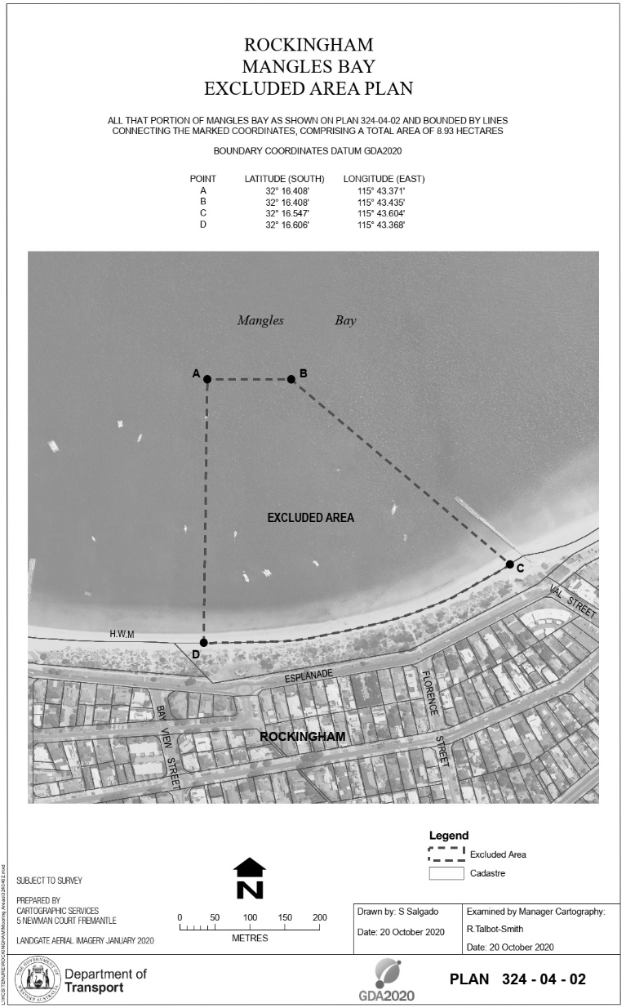
[Division 1 inserted: SL 2021/147 r. 34.]

Division 2 — Excluded areas in Swan and Canning Rivers Mooring Control Area
[Heading inserted: SL 2021/147 r. 34.]
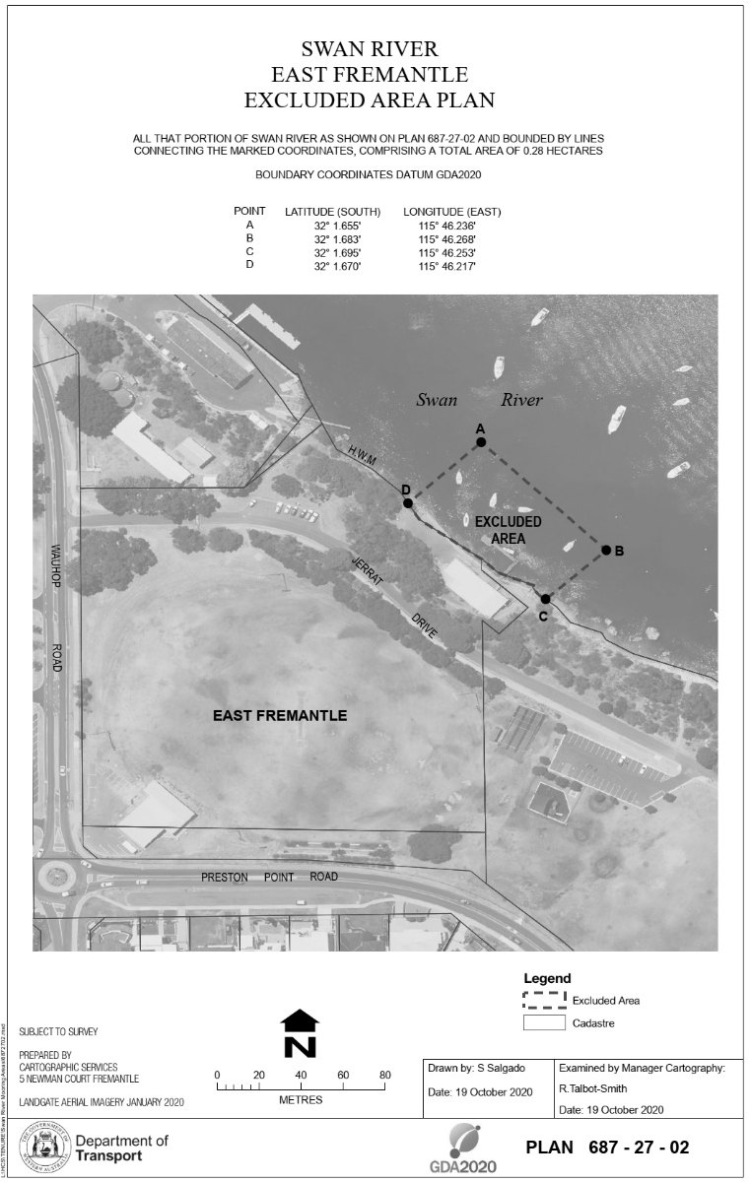
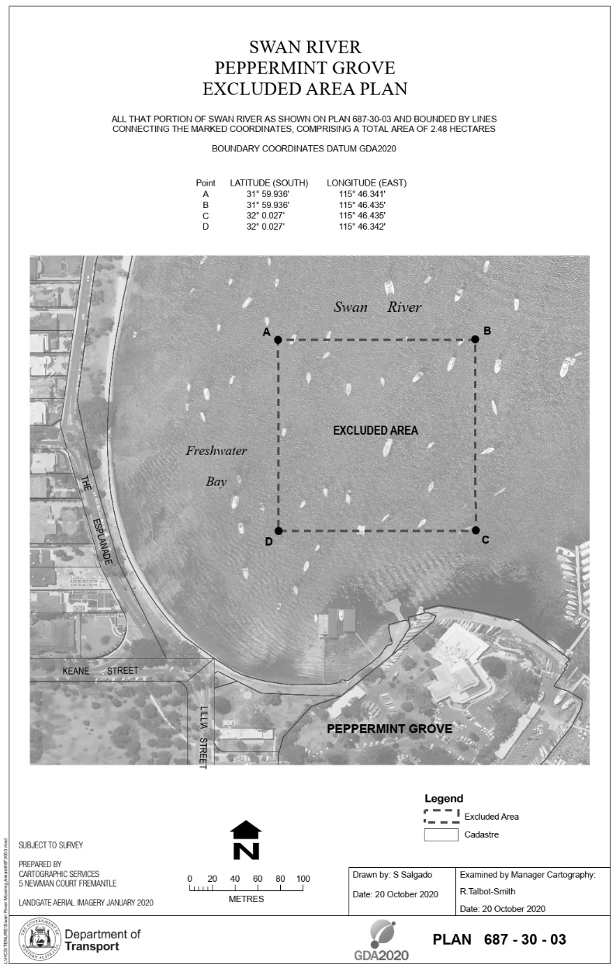
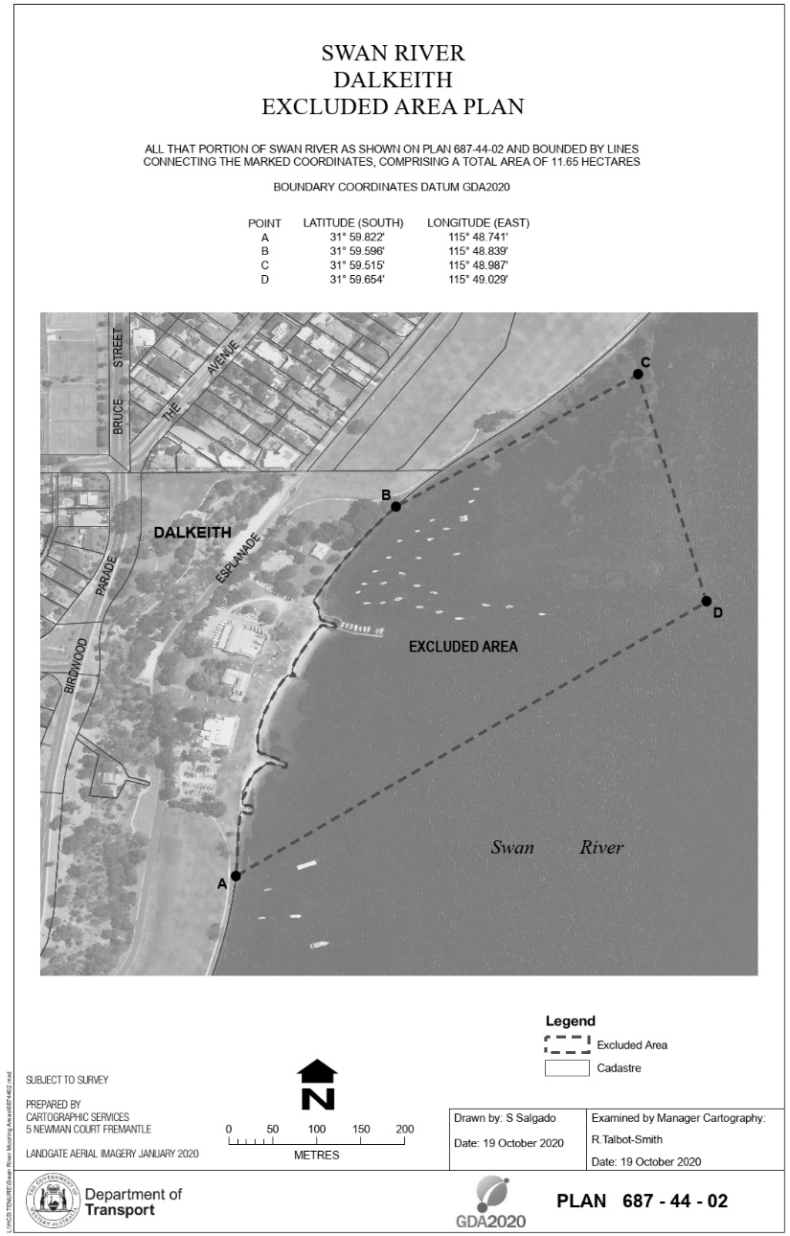
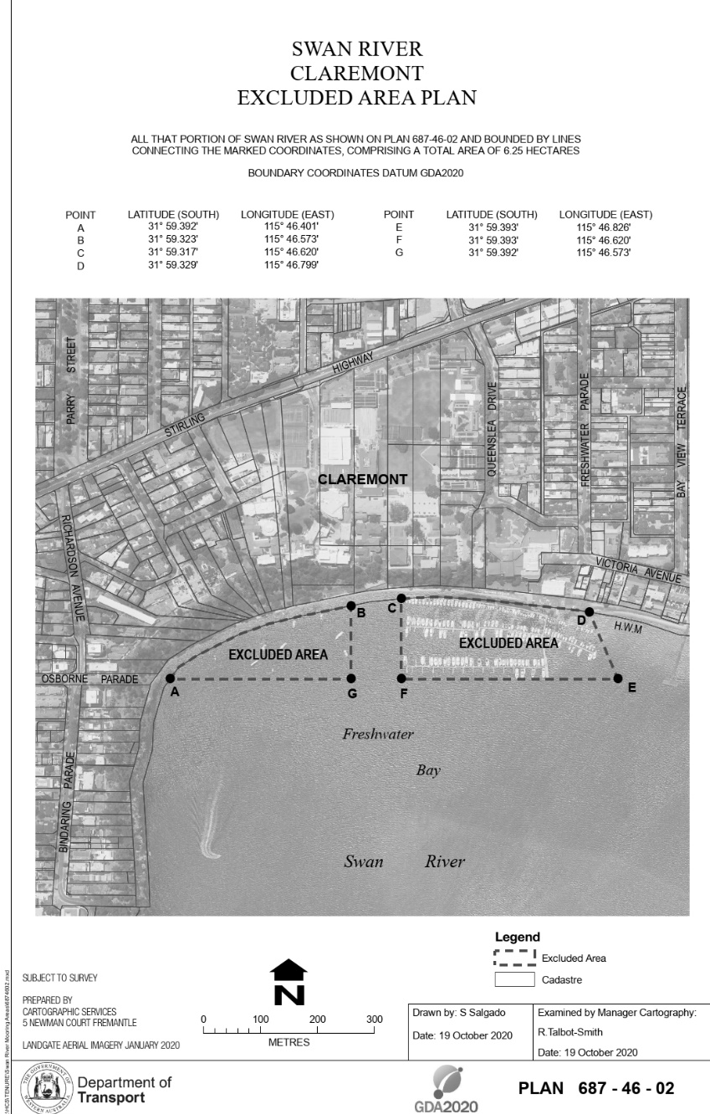
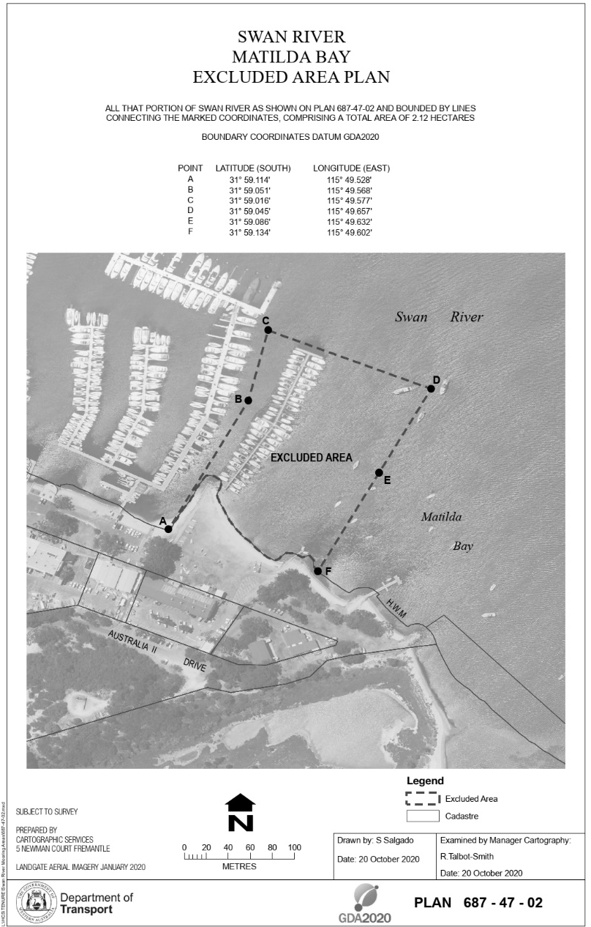
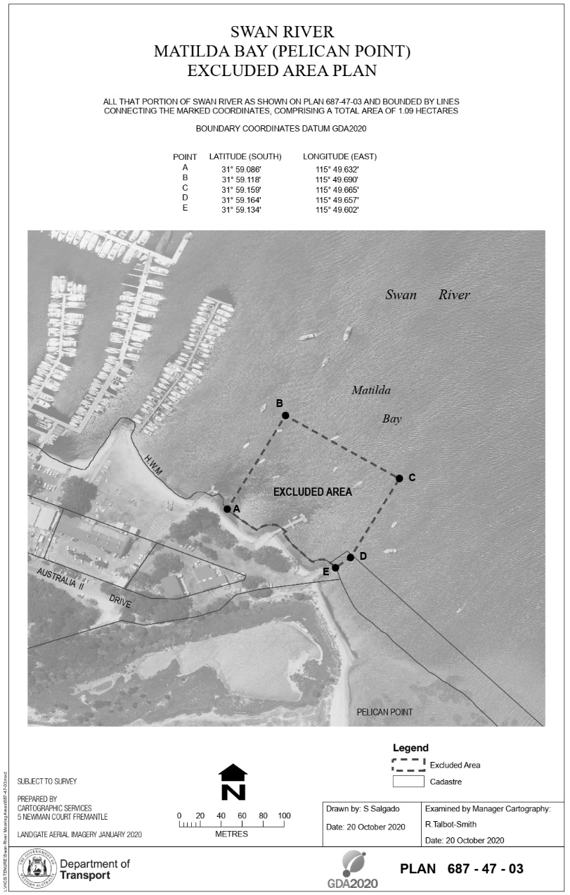
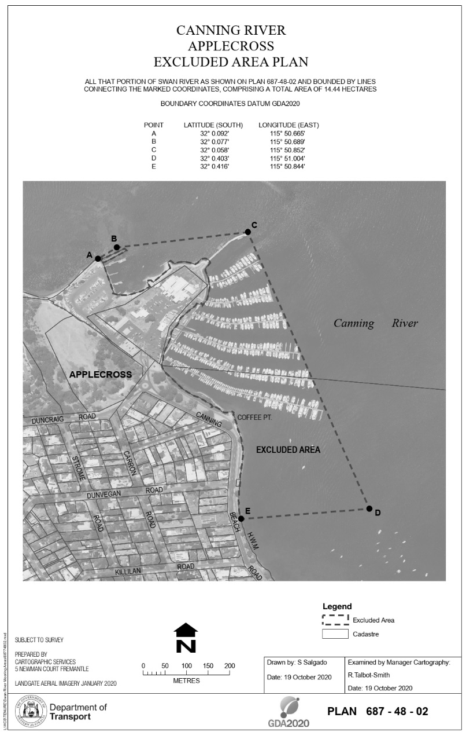
[Division 2 inserted: SL 2021/147 r. 34.]

Schedule 3 — Fees
[r. 7D, 7F, 8, 12, 13, 15, 25 and 27]
[Heading inserted: SL 2023/45 r. 6.]
Table
Item | Description | Fee
1. | Shared-use mooring authorisation for 12 months (r. 7D(3)(b)) | $108.45
2. | Rental mooring site authorisation for each day of rental period (r. 7F(4)(b)) | $34.10
3. | Application for mooring licence (r. 8(2)(g)(i)) | $120.85
4. | Annual mooring licence for recreational mooring site (exclusive use) (r. 12(1)(c) and 13(1)) | $677.35
5. | Annual mooring licence for recreational mooring site (shared use) (r. 12(1)(c) and 13(1)) | $349.00
6. | Annual mooring licence for commercial general mooring site (r. 12(1)(c) and 13(1)) | $872.50
7. | Annual mooring licence for commercial resources mooring site (r. 12(1)(c) and 13(1)) | $2 836.30
8. | Annual mooring licence late payment (r. 13(3)) | $120.85
9. | Exchange of registered mooring sites (r. 15(2)(b)) | $120.85
10. | Substitution of licensed vessel (r. 25(5)(b)) | $120.85
11. | Application to register additional vessel (r. 27(1)(e)) | $120.85
[Schedule 3 inserted: SL 2023/45 r. 6.]

Schedule 4 — Prescribed offences and modified penalties
[r. 30]
[Heading inserted: SL 2021/147 r. 34.]
Item | Provision | Description of offence | Modified penalty  $
1. | r. 4(1) | Installing a mooring in mooring control area without written permission | 400
2. | r. 6(1) | Causing or permitting vessel to be secured to mooring on mooring site without authorisation | 200
3. | r. 6(3) | Causing or permitting vessel to be secured to mooring on mooring site without vessel displaying issued identification sticker | 200
4. | r. 7(2) | Causing or permitting vessel to be secured or anchored in mooring control area and causing risk of damage | 200
5. | r. 7(3) | Causing or permitting vessel to be secured or anchored for more than 6 hours in Division 2 mooring control area | 200
6. | r. 7H(2) | Failing to notify CEO within 24 hours after vessel is secured to emergency mooring site | 200
7. | r. 7H(3) | Causing or permitting vessel to be secured to emergency mooring site if there is no emergency, if emergency has ended, or if vessel’s length exceeds maximum permitted | 200
8. | r. 7I(2) | Causing or permitting vessel to be secured to courtesy mooring site for period greater than authorised | 200
9. | r. 7I(3) | Causing or permitting vessel to be secured to courtesy mooring site if vessel’s length exceeds maximum permitted | 200
10. | r. 9(5) | Copying, photographing or otherwise making record or image of registered mooring site record | 100
11. | r. 9(6) | Failing to give CEO written notice within 15 days after alteration to particulars | 100
12. | r. 18(2) | Failing to comply with written directions of CEO regarding installing mooring on mooring site | 400
13. | r. 19(2) | Failing to maintain mooring on mooring site in location as required by licence condition | 400
14. | r. 19(3) | Failing to maintain mooring on mooring site so that information or identification data is or are displayed as required by licence condition | 200
15. | r. 20(6) | Using mooring on registered mooring site without having given CEO required mooring inspection report | 200
16. | r. 21(1) | Failing to remove or dispose of mooring on mooring site after mooring licence ceases to be in force | 400
17. | r. 21(2A) | Failing to give CEO notice that body corporate licensee is to be wound up or cease operating | 400
18. | r. 21(2B) | Body corporate licensee that is to be wound up or cease operating failing to remove or dispose of mooring on mooring site | 400
19. | r. 22(2) | Failing to comply within 7 days after given direction by Minister as to moving or removing mooring | 400
20. | r. 23 | Failing to maintain vessel moored on registered mooring site in seaworthy condition | 400
21. | r. 25(2) | Failing to give Minister written notice within 15 days after sale or disposal of interest in licensed vessel | 200
[Schedule 4 inserted: SL 2021/147 r. 34.]

Schedule 5 — Forms
[r. 32]
[Heading inserted: SL 2021/147 r. 34.]
Form 1 — Infringement notice
Shipping and Pilotage Act 1967  Mooring Regulations 1998  Infringement notice |  | Infringement notice no.
Alleged offender | Name: Family name
 | Given names
 | or Body corporate name ______________________________
Address ______________________________________________
Postcode
Alleged offence | Description of offence (include details of vessel if applicable)  __________________________________________________
 | Mooring Regulations 1998 r.
 | Date / /20 Time am/pm
 | Modified penalty $
Officer issuing notice | Name
 | Signature
 | Office
Date | Date of notice / /20
Notice to alleged offender | It is alleged that you have committed the above offence.  If you do not want to be prosecuted in court for the offence, pay the modified penalty within 28 days after the date of this notice.  How to pay  By post: [Insert details for paying by post]  In person: [Insert details for paying in person]  Online: [Insert details for paying online]  By telephone: [Insert details for paying by telephone]
If you do not pay the modified penalty within 28 days, you may be prosecuted or enforcement action may be taken under the Fines, Penalties and Infringement Notices Enforcement Act 1994. Under that Act, some or all of the following action may be taken — your driver’s licence may be suspended, your vehicle licence may be suspended or cancelled, you may be disqualified from holding or obtaining a driver’s licence or vehicle licence, your vehicle may be immobilised or have its number plates removed, your details may be published on a website, your earnings or bank accounts may be garnished, and your property may be seized and sold.
If you need more time to pay the modified penalty, you can apply for an extension of time by writing to the Approved Officer at the Department of Transport at this address: [Insert postal address for Approved Officer]
If you want this matter to be dealt with by prosecution in court, sign here
____________________________________________
and post this notice to the Approved Officer at the Department of Transport at the above postal address within 28 days after the date of this notice.
Form 2 — Withdrawal of infringement notice
Shipping and Pilotage Act 1967  Mooring Regulations 1998  Withdrawal of infringement notice |  | Withdrawal no.
Alleged offender | Name: Family name
 | Given names
 | or Body corporate name ____________________________
Address ____________________________________________
Postcode
Infringement notice | Infringement notice no.
 | Date of infringement notice / /20
Alleged offence | Description of offence _________________________________
 | Mooring Regulations 1998 r.
 | Date / /20 Time am/pm
Approved officer withdrawing notice | Name
 | Signature
 | Office
Date | Date of withdrawal / /20
Withdrawal of infringement notice  [*delete  whichever  is not applicable] | The above infringement notice issued against you has been withdrawn.  If you have already paid the modified penalty for the alleged offence you are entitled to a refund.  * Your refund is enclosed.  or  * If you have paid the modified penalty but a refund is not enclosed, to claim your refund sign this notice and post it to the Approved Officer at the Department of Transport at this address: [Insert postal address for Approved Officer]  Signature / /20
[Schedule 5 inserted: SL 2021/147 r. 34.]

Notes
This is a compilation of the Mooring Regulations 1998 and includes amendments made by other written laws. For provisions that have come into operation, and for information about any reprints, see the compilation table.

Compilation table
Citation | Published | Commencement
Mooring Regulations 1998 | 11 Dec 1998 p. 6659-78 | 11 Dec 1998
Mooring Amendment Regulations 2001 | 27 Jul 2001  p. 3801 | 1 Aug 2001 (see r. 2)
Mooring Amendment Regulations 2002 | 14 Jun 2002 p. 2319-20 | 1 Jul 2002 (see r. 2)
Mooring Amendment Regulations 2003 | 28 Feb 2003 p. 677 | 28 Feb 2003
Mooring Amendment Regulations (No. 2) 2003 | 27 Jun 2003 p. 2535 | 1 Jul 2003 (see r. 2)
Reprint 1: The Mooring Regulations 1998 as at 8 Aug 2003 (includes amendments listed above)
Mooring Amendment Regulations 2004 | 25 Jun 2004 p. 2289 | 1 Jul 2004 (see r. 2)
Mooring Amendment Regulations 2005 | 24 Jun 2005 p. 2779-80 | 1 Jul 2005 (see r. 2)
Mooring Amendment Regulations 2006 | 26 May 2006 p. 1879-80 | 26 May 2006
Mooring Amendment Regulations (No. 2) 2006 | 23 Jun 2006 p. 2206 | 1 Jul 2006 (see r. 2)
Mooring Amendment Regulations 2007 | 12 Jun 2007 p. 2725-6 | 1 Jul 2007 (see r. 2)
Mooring Amendment Regulations 2008 | 24 Jun 2008 p. 2893 | r. 1 and 2: 24 Jun 2008 (see r. 2(a));  Regulations other than r. 1 and 2: 1 Jul 2008 (see r. 2(b))
Reprint 2: The Mooring Regulations 1998 as at 12 Sep 2008 (includes amendments listed above)
Mooring Amendment Regulations 2009 | 12 Jun 2009 p. 2119 | r. 1 and 2: 12 Jun 2009 (see r. 2(a));  Regulations other than r. 1 and 2: 1 Jul 2009 (see r. 2(b))
Mooring Amendment Regulations 2010 | 4 Jun 2010 p. 2473 | r. 1 and 2: 4 Jun 2010 (see r. 2(a));  Regulations other than r. 1 and 2: 1 Jul 2010 (see r. 2(b))
Mooring Amendment Regulations 2011 | 21 Jun 2011 p. 2229-30 | r. 1 and 2: 21 Jun 2011 (see r. 2(a));  Regulations other than r. 1 and 2: 1 Jul 2011 (see r. 2(b))
Mooring Amendment Regulations 2012 | 14 Feb 2012 p. 668-9 | r. 1 and 2: 14 Feb 2012 (see r. 2(a));  Regulations other than r. 1 and 2: 15 Feb 2012 (see r. 2(b))
Mooring Amendment Regulations (No. 2) 2012 | 15 Jun 2012 p. 2524 | r. 1 and 2: 15 Jun 2012 (see r. 2(a));  Regulations other than r. 1 and 2: 1 Jul 2012 (see r. 2(b))
Reprint 3: The Mooring Regulations 1998 as at 12 Apr 2013 (includes amendments listed above)
Mooring Amendment Regulations 2013 | 28 Jun 2013 p. 2767-8 | r. 1 and 2: 28 Jun 2013 (see r. 2(a));  Regulations other than r. 1 and 2: 1 Jul 2013 (see r. 2(b))
Mooring Amendment Regulations 2014 | 30 May 2014 p. 1686-7 | r. 1 and 2: 30 May 2014 (see r. 2(a));  Regulations other than r. 1 and 2: 1 Jul 2014 (see r. 2(b))
Mooring Amendment Regulations 2015 | 12 Jun 2015 p. 2028 | r. 1 and 2: 12 Jun 2015 (see r. 2(a));  Regulations other than r. 1 and 2: 1 Jul 2015 (see r. 2(b))
Transport Regulations Amendment (Fees and Charges) Regulations (No. 2) 2016 Pt. 2 | 14 Jun 2016 p. 1987-2003 | 1 Jul 2016 (see r. 2(b))
Transport Regulations Amendment (Fees and Charges) Regulations 2017 Pt. 2 | 26 May 2017 p. 2639-45 | 1 Jul 2017 (see r. 2(b))
Transport Regulations Amendment (Fees and Charges) Regulations (No. 2) 2018 Pt. 3 | 22 Jun 2018 p. 2184-93 | 1 Jul 2018 (see r. 2(b))
Transport Regulations Amendment (Fees and Charges) Regulations (No. 2) 2019 Pt. 3 | 31 May 2019 p. 1721-8 | 1 Jul 2019 (see r. 2(b))
Transport Regulations Amendment (Fees and Charges) Regulations 2020 Pt. 3 | SL 2020/60 22 May 2020 | 1 Jul 2020 (see r. 2(b))
Transport Regulations Amendment (Fees and Charges) Regulations 2021 Pt. 4 | SL 2021/68 4 Jun 2021 | 1 Jul 2021 (see r. 2(b), SL 2021/51 r. 2(b) and SL 2021/50 cl. 2)
Transport Regulations Amendment (Mooring Management) Regulations 2021 Pt. 2 | SL 2021/147 13 Aug 2021 | 28 Sep 2021 (see r. 2(b))
Transport Regulations Amendment (Waiver and Refund) Regulations 2022 Pt. 3 | SL 2022/47 8 Apr 2022 | 9 Apr 2022 (see r. 2(b))
Transport Regulations Amendment (Fees and Charges) Regulations 2023 Pt. 3 | SL 2023/45 19 May 2023 | 1 Jul 2023 (see r. 2(c))

Other notes
¹ Formerly referred to the Navigable Waters Regulations the citation of which was changed to the Navigable Waters Regulations 1958 by the Navigable Waters Amendment Regulations (No. 2) 2005 r. 3. The reference was changed under the Reprints Act 1984 s. 7(3)(gb).
² Under the Financial Legislation Amendment and Repeal Act 2006 Sch. 2 cl. 13 a reference to the Consolidated Fund may, where the context so requires, be read as if it had been amended to be a reference to the Consolidated Account. This reference was changed under the Reprints Act 1984 s. 7(5)(a).

Defined terms

[This is a list of terms defined and the provisions where they are defined. The list is not part of the law.]
Defined term Provision(s)
Act 2
additional vessel 2
amending instrument 39(2)
amending regulations 33
applicant 7J(1)
approved 2
authorisation 7E(1)
authorised fee officer 37
body corporate licensee 21(2A)
CEO 2
certificate of registration 2
commencement day 33
commercial general mooring site 2
commercial resources mooring site 2
courtesy mooring site 2
current mooring licence 33
current registration period 33
damage 7J(4)
Division 2 mooring control area 7(1)
emergency mooring site 2
excluded area 33
fee 37
identification sticker 6(4)
inspector 31(1)
length 2
licensed vessel 2
maximum vessel length 2
MCA Regulations 33
mooring 2
mooring control area 2
mooring inspection report 20(1)
mooring inspector 20(1)
mooring licence 2
mooring licensee 2
mooring site 2, 7(1)
new regulations 33
next anniversary 33
nominated 29(1)
old regulations 33
owner 28(1A), 29(1)
permissible vessel length 7A
pleasure vessel 2
previous licensee 21(1)
recreational mooring site 2
register 2
registered mooring site 2, 32
registered owner 33
registration period 33
relevant mooring site 9(2)
rental mooring site 2
rental period 7F(1), 7J(1)
shared-use mooring 7D(1)
shared-use recreational mooring site 2
sold vessel 7C(7)
specified mooring site 7F(1)
substituted vessel 7C(8)
tender 2
waiting list 2
written instrument 37

© State of Western Australia 2023.
This work is licensed under a Creative Commons Attribution 4.0 International Licence (CC BY 4.0). To view relevant information and for a link to a copy of the licence, visit www.legislation.wa.gov.au.
Attribute work as: © State of Western Australia 2023.
By Authority: GEOFF O. LAWN, Government Printer

