Western Australia
Perth Theatre Trust Act 1979

Perth Theatre Trust (Common Seal) Regulations 1980
These regulations were repealed by the Arts and Culture Trust Act 2021 s. 73(2) (No. 15 of 2021) on 1 Jul 2022 (see s. 2(b) and SL 2022/77 cl. 2).

Western Australia
Perth Theatre Trust (Common Seal) Regulations 1980
Contents
1. Citation 1
2. Form of common seal 1
3. Safe custody of common seal 1
Schedule
Form of common seal of Trust
Notes
Compilation table 3

Western Australia
Perth Theatre Trust Act 1979
Perth Theatre Trust (Common Seal) Regulations 1980

1. Citation
These regulations may be cited as the Perth Theatre Trust (Common Seal) Regulations 1980.

2. Form of common seal
The form of the common seal of the Trust is the form set out in the Schedule.

3. Safe custody of common seal
The manager or, in his absence, the person appointed to act in his stead shall keep the common seal of the Trust in safe custody.

Schedule
(Regulation 2)

Form of common seal of Trust
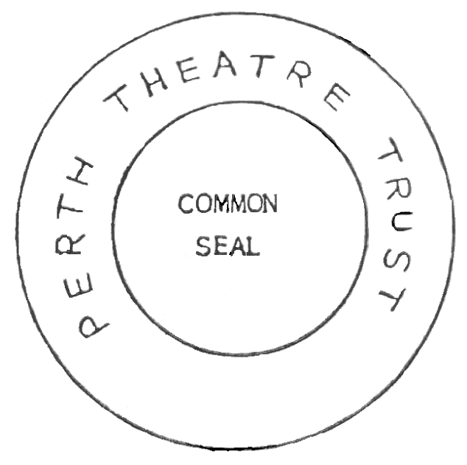

Notes
This is a compilation of the Perth Theatre Trust (Common Seal) Regulations 1980. For provisions that have come into operation, and for information about any reprints, see the compilation table.

Compilation table
Citation | Published | Commencement
Perth Theatre Trust (Common Seal) Regulations 1980 | 1 Feb 1980 p. 340 | 1 Feb 1980 (see Gazette 1 Feb 1980 p. 285)
Reprint 1: The Perth Theatre Trust (Common Seal) Regulations 1980 as at 7 May 2004
These regulations were repealed by the Arts and Culture Trust Act 2021 s. 73(2) (No. 15 of 2021) on 1 Jul 2022 (see s. 2(b) and SL 2022/77 cl. 2)

