Western Australia

Northern Developments Pty Limited Agreement Act 1957

Western Australia

Northern Developments Pty Limited Agreement Act 1957

CONTENTS

1. Short title and citation 1

2. Approval, ratification and confirmation of Agreement 1

Schedule

NOTES

Western Australia

Northern Developments Pty Limited Agreement Act 1957

An Act to Approve, Ratify and Confirm an Agreement relating to the Disposal of Certain Crown Lands.

[Assented to 6 December 1957.]

BE it enacted by the Queen’s Most Excellent Majesty, by and with the advice and consent of the Legislative Council and the Legislative Assembly of Western Australia in this present Parliament assembled, and by the authority of the same, as follows: —

##### 1. Short title and citation

This Act may be cited as the *Northern Developments Pty Limited Agreement Act 1957*.

##### 2. Approval, ratification and confirmation of Agreement

The agreement entered into by the Treasurer for and on behalf of the State with Northern Developments Pty Limited and executed on the twelfth day of November one thousand nine hundred and fifty‑seven, a copy of which is set forth in the Schedule to this Act, is approved, ratified and confirmed.

Schedule

THIS AGREEMENT under seal made the twelfth day of November One thousand nine hundred and fifty seven BETWEEN THE HONOURABLE ALBERT REDVERS GEORGE HAWKE, MLA Premier and Treasurer of the State of Western Australia contracting for and on behalf of the said State and the Government and Instrumentalities thereof from time to time (hereinafter referred to as “the State”) of the one part AND NORTHERN DEVELOPMENTS PTY. LIMITED a company duly incorporated in the State of New South Wales and having its registered Office in the State of Western Australia at the Third Floor Pastoral House Saint George’s Terrace Perth (hereinafter referred to as “the Company” which expression where the context permits shall extend and include its successors and permitted assigns) of the other part.

WHEREAS:

(i) The Company — being desirous of acquiring land in the State of Western Australia for the purpose of cultivating and processing thereon rice and other agricultural crops necessitated by the rotational cultivation of rice — has requested the State pursuant to the provisions of section 89D of the *Land Act 1933‑1956* to dispose of the subject land to it for that purpose,

(ii) The State has agreed so to dispose of the subject land to the Company upon and subject to the terms and conditions hereinafter contained.

WITNESSETH:

1. IN this Agreement unless the context otherwise requires —

“Minister” means the Minister for Lands of the State of Western Australia and the person acting in that capacity from time to time.

“parcel” means such area of land of approximately five thousand acres comprised within the subject land as the Minister determines.

“subject land” means the Crown lands described in the First Schedule hereto and delineated and bordered in blue in the plan drawn thereon.

2. THIS Agreement is made subject to ratification by the Parliament of Western Australia within six months of the date of the execution hereof. If this Agreement is not so ratified within the time aforesaid it shall be void and of no effect and neither of the parties hereto will have any claim against the other with respect to anything arising out of this Agreement.

3. SUBJECT to the provisions of this Agreement the Company may from time to time apply to the State for a licence in respect of a parcel of land comprised in the subject land in the form set out in the Second Schedule hereto.

4. THE Company shall be entitled to make an application for a license in respect of: —

(a) the first parcel — within thirty days from the date this Agreement is ratified by the Parliament of Western Australia

(b) the second parcel: —

(i) when the Minister in his absolute opinion signifies in writing to the Company that he is satisfied that rice can be successfully and economically grown upon the first parcel;

(ii) when the whole cultivable area of the first parcel has been planted with rice whether in one or more seasons; and,

(iii) within seven years after the date this Agreement is ratified by the Parliament of Western Australia or such further time or times as the Minister in his absolute discretion may allow for such cause or reason as he deems fit.

(c) the third parcel: —

(i) when the whole cultivable area of the second parcel has been planted with rice, whether in one or more seasons; and,

(ii) within fourteen years after the date of this Agreement is ratified by the Parliament of Western Australia or such further time or times as the Minister in his absolute discretion may allow for such cause or reason as he deems fit.

(d) the fourth parcel: —

(i) when the whole cultivable area of the third parcel has been planted with rice whether in one or more seasons; and,

(ii) within twenty‑one years after the date this Agreement is ratified by the Parliament of Western Australia or such further time or times as the Minister in his absolute discretion may allow for such cause or reasons as he deems fit.

5. THE State shall within seven days after the ratification by the Parliament of Western Australia of this Agreement by notice advise the Company of the details of the boundaries of the first parcel which it is entitled to make application for and shall within four calendar months of a request from the Company advise the Company of the details of the boundaries of each remaining parcel for which the Company becomes entitled to make application under clause 4 of this Agreement PROVIDED that the State shall not be required to give the Company the details of the boundaries of any parcel until the Company is so entitled to make application for that parcel.

6. WITHIN thirty days of the receipt by the State of a written application by the Company for a license in respect of a parcel and provided there is no existing breach or non observance of any of the terms and conditions on the part of the Company herein contained the State shall issue or cause to be issued to the Company a license in the form set out in the Second Schedule hereto.

7. THE Company shall not without the previous consent in writing of the State first had and obtained assign or transfer the benefit of this Agreement or any part thereof or interest therein or license hereunder to any person or persons or corporation or otherwise by any act or deed procure allow or suffer either voluntarily or involuntarily this Agreement or any part thereof or interest therein or license hereunder to be assigned or transferred PROVIDED HOWEVER that the State may condition its consent upon the execution of an agreement to be prepared by the State’s solicitor and executed by the proposed assignee or transferee binding him or it (as the case may be) to observe and comply with the terms and conditions contained in this Agreement and such further terms and conditions as the Minister may deem fit.

8. (1) When a license in respect of a parcel is granted to the Company it shall forthwith proceed with the progressive and continuous development of the parcel for the cultivation of rice and other agricultural crops necessitated by the rotational cultivation of rice.

(2) Without affecting the generality of the provisions of the preceding subclause the Company at its own cost and expense shall in respect of each parcel for which it is granted a license: —

(i) within sixty calendar months following the day on which the license is granted therefor, in a substantial and workmanlike manner with the best materials of their several kinds and to the satisfaction of the Minister erect along the external boundaries of the parcel a cattle‑proof fence,

(ii) within twelve months following the day on which the license is granted therefor, provide such equipment for the use of available water supplies as the Minister in his absolute discretion deems necessary for the cultivation of rice thereon,

(iii) during the first four seasons following the day on which the license is granted therefor, the Company shall in a proper and husbandlike manner seed the whole of the cultivable area of the parcel with rice and to so ensure the Company shall at the appropriate time in each of those seasons in the manner aforesaid seed with rice an area of not less than one‑fifth of the virgin soil of the area of the parcel.

(3) The Company shall pay to the State upon demand the cost of such topographical and boundary definition surveys in respect of each parcel as the Minister in his absolute discretion considers necessary. The cost of those surveys shall be in accordance with the scale set out in Regulation 168 of the Regulations for the Guidance of Surveyors or any amendment of that Regulation for the time being in force.

(4) The land comprised in a parcel shall not be used for any purpose other than the cultivation and processing of rice and other agricultural crops necessitated by the rotational cultivation of rice.

9. (1) In respect of a parcel for which the State grants the Company a licence the Company shall pay to the State the yearly rental of ONE HUNDRED POUNDS (£100).

(2) The rental payable under the provisions of this clause in respect of the land comprised in a parcel for which a license is granted shall be payable half‑yearly in advance on the First day of March and the First day of September in each year during the currency thereof the first of such payments however to be made on the issue of the license therefor and to be apportioned for the period commencing on the day of the issue of the license and expiring on the day immediately preceding the next succeeding half‑yearly day.

10. THE State —

(1) at its own cost and expense in all things shall construct a weir across Uralla (Snake) Creek at approximately the position marked with the letter “D” on the plan delineated in the Third Schedule hereto (and being more particularly at the point 17 miles 1,750 feet along the traverse of Uralla (Snake) Creek shown on plan P.W.D. W.A. 34105 and which traverse is defined on the ground by concrete bench marks at mile intervals). The height of the weir top shall be R.L. 130.5 feet and in constructing the weir provision shall be made for the erection on the weir top of stop boards whereby the height of the weir may be increased to 132.0 feet. The general objective of the weir is —

(a) to provide some water storage in Uralla (Snake) Creek upstream from the weir;

(b) to act as a control point for the diversion of irrigation water; and,

(c) to provide some water from the weir for the lower reaches of Uralla (Snake) Creek.

(2) Subject to all investigations tests and surveys which the Director of Works of Western Australia considers necessary in respect of the erection of the barrage herein mentioned being completed and in his opinion proving satisfactory shall construct in due course and in a manner to be mutually agreed between the parties hereto a suitable barrage in the bed of the Fitzroy River close downstream to the existing off‑take works on Uralla (Snake) Creek at approximately the position marked with the letter “E” on the plan delineated in the Third Schedule hereto. The State accepts no obligation to complete the construction of the barrage by a particular date, but will use reasonable endeavours to complete the construction by the end of the year One thousand nine hundred and sixty.

(3) Shall construct in due course from the weir and when reasonably required by the Company two irrigation channels one on each side of Uralla (Snake) Creek and each leading to the nearest practicable point on the boundary of the first parcel, for which a license is granted, on each side of the Creek.

(4) At its own cost and expense in all things may from time to time during the currency of this Agreement maintain and keep in repair —

(a) the weir, barrage and off‑take works herein‑before referred to in this clause; and,

(b) such part or parts of the irrigation channels as are from time to time during the currency of this Agreement outside the area of a parcel for which a license has been granted.

(5) Shall construct or cause to be constructed and may authorize the Commissioner of Main Roads to maintain or (with funds accruing to the local authority of the district in which the subject land is situate or with vehicle license fees) to cause to be maintained in a satisfactory condition —

(a) a trafficable road which in the opinion of the Commissioner of Main Roads is suitable for the reasonable requirements of the Company for the purposes of this Agreement from Derby to the point marked with letter “X” on the plan delineated in the Third Schedule hereto via Camballin Homestead; and

(b) a road or roads, the total length of which will not exceed one‑half a mile, within the town‑site to be constituted near the subject land.

(6) Shall construct or cause to be constructed a road of approximately two and one‑half miles in length from the position marked with the letter “X” to the position marked with the letter “P” on the plan in the Third Schedule hereto.

(7) Shall improve or cause to be improved both the approaches to the Uralla (Snake) Creek Bridge; strengthen or cause to be strengthened that Bridge and increase or cause to be increased the width of that Bridge to twelve feet.

(8) Arrange for the building for the accommodation of the Company’s employees at such place or places within the townsite to be constituted near the subject land and of such standard designs of the State Housing Commission as may from time to time be agreed upon in writing with the Company five houses; the first two of which shall be completed before the thirtieth day of June One thousand nine hundred and fifty‑eight and each of the remaining three within six months after notice by the Company to the Commission of its requirement but subject to the Company’s first satisfying the State that the Company is then making progressive and continuous development of the subject land in accordance with the provisions of this Agreement and for those purposes requires the house.

(9) Let all such houses to the Company at rentals calculated in accordance with the formula laid down in the *Commonwealth and State Housing Agreement Act 1945* (as amended from time to time) and subject to any subsidy granted by the State in respect of the rental of houses erected by the State Housing Commission north of the twenty‑sixth parallel of south latitude, and otherwise for such period or periods and on such terms and conditions as the said Commission may reasonably require.

11. THE Company —

(1) At its own cost and expense in all things during the currency of this Agreement —

(a) shall make construct maintain and keep in repair all improvements works and facilities that are necessary within each parcel, for which a license has been granted, to reticulate water therein; and,

(b) shall maintain and keep in repair such part or parts of any of the irrigation channels referred to in subclause (3) of clause 10 hereof as may from time to time be or become included within the boundaries of any parcel for which a license has been granted.

(2) In consideration of the State making and constructing the several works referred to in clause 10 hereof shall pay to the State —

(a) for the period commencing on the day of completion by the State of the barrage in the bed of the Fitzroy River and expiring on the termination of this Agreement the annual sum of THREE THOUSAND POUNDS (£3,000) subject however to the provisions of clause 12 hereof. Payment of that sum will be made by half‑yearly payments in advance on the first days of the months of January and July in each and every year during that period the first of such payments however to be made on the day of completion and to be apportioned if necessary in respect of that portion of the half‑year commencing on the day of completion and expiring on the day preceding the next succeeding half‑yearly day. The punctual payment of that annual sum shall entitle the Company to the delivery during the year in respect of which it is paid of such amount of water from the weir as is available up to but not exceeding thirty thousand acre feet of water. All water delivered by the State to the Company in excess of that quantity the Company shall subject however to the provisions of clause 12 hereof pay for at the rate of five shillings (5/‑) per acre foot payment for which shall be made by the Company to the State within sixty days following the service of the assessment on the Company in respect of same. For the purpose of measuring the quantity of water delivered by the State to the Company all water obtained by the Company by means of any pump operating on near or about Uralla (Snake) Creek and within the boundaries of any parcel for which a license has been granted shall be deemed to be delivered by the State to the Company.

(b) In respect of such part or parts of an irrigation channel referred to in subclause (3) of clause 10 hereof as may from time to time become enclosed within the boundaries of a parcel for which a license has been granted an annual charge equal to five and one‑half per centum of all the cost incurred by the State in constructing same. Such annual charge shall become payable from the day or respective days when such part or parts are so enclosed until the termination of this Agreement and shall be payable half‑yearly on the last day of the months of June and December in each and every year the first of which shall be payable on the first of those half‑yearly dates next following the first enclosure of any such part of the irrigation channels.

(3) Shall accept the details, as kept by the Public Works Department of Western Australia in respect of all the costs of construction of the irrigation channels referred to in subclause (3) of clause 10 hereof as *prima facie* evidence of such costs.

(4) Grants unto the State full and free right and liberty for the State at all times during the currency of this Agreement by its servants workmen contractors and agents to enter and to go pass and repass with or without animals carts or other carriages or vehicles or motor or other mechanical vehicles laden or unladen into and out of and from any parcel for which the Company has been granted a license for the purposes of —

(a) installing and maintaining such gauging equipment as the said Director approves on the irrigation channels within that parcel and at any place where water is obtained by pump or pumps therein; and,

(b) reading such gauging equipment.

(5) Shall accept the register of each gauging equipment referred to in subclause (3) of this clause as *prima facie* evidence of the quantity of water provided by the State through the point whereon it is erected and installed.

(6) Shall indemnify and keep indemnified the State against all actions claims damages costs and demands arising out of or in connection with the construction or maintenance by the State of the weir barrage off‑take works irrigation channels and gauging equipment referred to in clause 10 hereof or any of them.

(7) Shall ensure that the houses referred to in subclause (8) of clause 10 shall be let only to employees of the Company engaged in working the subject land pursuant to this Agreement.

(8) When and as often as required by the State Housing Commission shall enter into tenancy agreements with respect to the houses referred to in subclause (8) of clause 10 to carry out the provisions of subclause (9) thereof.

12. DURING the six calendar months immediately preceding the expiration of each term of ten successive years in the period mentioned in subclause (2) (a) of clause 11 hereof the State may review the annual sum and the rate per acre foot referred to in that subclause and determine the annual sum and rate per acre foot to be payable in respect of the next succeeding term of ten successive years and in the event of the State making such review it shall forthwith give written notice to the Company of the amount of the reviewed annual sum and of the reviewed rate and the amount of the reviewed annual sum and the reviewed rate shall become payable by the Company to the State in respect of the term for which they are so made payable.

13. THE Company shall not at any time or times during the currency of this Agreement enter into any contract with any person or corporation for the disposal of or supply either directly or indirectly any person or corporation with any water obtained or delivered —

(a) from the weir referred to in subclause (1) of clause 10 hereof; or,

(b) from any pump or other device operating on the subject land

without the previous consent in writing of the Minister first had and obtained PROVIDED HOWEVER the Minister may condition his consent to such disposal or supply of water at such rate or rates and on such terms and conditions as the Minister may deem fit.

14. SUBJECT to the provisions of subclause (2) of clause 19 hereof any dispute or difference between the parties arising out of or in connection with this Agreement or any agreed variation thereof or as to the construction of this Agreement or any such variation or as to the rights duties or liabilities of either party thereunder or as to any matter to be agreed between the parties in terms of this Agreement shall in default of agreement between the parties be referred to and settled by arbitration under the provisions of the *Arbitration Act 1895* and its amendments for the time being in force.

15. THE Company shall forthwith and at all times duly and punctually comply with observe carry out and conform to all statutes now or hereafter in force and all ordinances regulations and by‑laws thereunder and all requirements and orders of any authority statutory or otherwise in all cases affecting a parcel the licensee or occupier thereof or any business carried on upon the parcel or the use of the parcel.

16. ANY obligation or right under the provisions of or any plan referred to in this Agreement may from time to time be cancelled added to varied or substituted by agreement under seal between the parties hereto so long as such cancellation addition variation or substitution shall not constitute a material or substantial alteration of the obligation or rights of either party under this Agreement.

17. THIS Agreement shall be interpreted according to the laws for the time being in force in the State of Western Australia.

18. (1) If the Company has observed performed and complied with all the terms and conditions on its part herein contained then on written application by the Company for a Crown Grant being made within thirty days after the expiry of the license in respect of a parcel and the payment of the purchase price therefor calculated —

(i) at the price of ONE POUND ([Pound]1) per acre for the land comprised in the first and second parcel; and,

(ii) at such price per acre as the Minister determines for the remaining parcels (but not exceeding FIVE POUNDS (£5) per acre for the land comprised in the third parcel and TEN POUNDS (£10) per acre for the land comprised in the fourth parcel) and subject to the provisions of the next succeeding subclause,

the State shall cause a Crown Grant to issue to the Company in respect of that parcel freed from all encumbrances in the form set out in the Third Schedule to the *Land Act 1933* as reprinted as amended in Volume 3 of the Reprinted Acts of the Parliament of Western Australia but subject to the insertion of the words “for the purpose of an area of not less than one‑fifth of the said land being planted annually with rice provided there is sufficient water available therefor and in the event of there being insufficient water such lesser area for which sufficient water is available and conditional upon such area or such lesser area of the said land being so used and for no other purpose whatsoever save and except with the consent in writing of the Governor” after the words, “fee simple” in line twenty‑one of that form.

(2) In the event of the Company being dissatisfied with the price per acre determined by the Minister under the provisions of the preceding subclause in respect of the land comprised in either or both of the third and fourth parcels the Company shall within fourteen days following the notification to it of the price per acre so determined give notice to the State that it is so dissatisfied and the reasons for that dissatisfaction whereupon the State shall direct the Board of Appraisers (as appointed under the provisions of the *Land Act 1933* as amended from time to time) or other body person or persons in substitution thereof to review the price per acre so determined. Notice of the time and place of hearing shall be given by the Board of Appraisers to the Company and after having heard the Company by its solicitor or agent and considered any evidence adduced or if the Company by its solicitor or agent does not attend the hearing of the Board of Appraisers may either maintain or vary the price per acre as so determined and the price per acre so maintained or fixed (as the case may be) by the Board of Appraisers shall be the price per acre payable for the land comprised in that parcel.

19. THE Board of Appraisers shall when acting under the provisions of this Agreement have all powers (*mutatis mutandis*) of a Board of Appraisers appointed under the provisions of section 98A of the *Land Act 1933* (as amended from time to time) as if the review of the price per acre referred to in clause 18 of this Agreement were a review or reassessment referred to in that section.

20. THE parties hereto agree that this Agreement is made subject to any delays in the performance of obligations under this Agreement which may be occasioned by or arise from circumstances beyond the power and control of the party responsible for the performance of such obligations including delays caused by or arising from Act of God, act of war, *force majeure*, act of public enemies, strikes, lockouts, stoppages, restraint of labour, or other similar acts, whether partial or general, shortages of essential materials, reasonable failure to secure or delay of contractors, riots and civil commotion.

21. ANY application notice request demand notification consent or other writing authorized or required by this Agreement to be given or sent shall be deemed to have been duly given or sent by the State if signed by the Premier or the Minister and forwarded by prepaid post to the Company at its registered office in the State; and by the Company if signed by the attorney, general manager, manager or secretary of the Company in the State and forwarded by prepaid post to the Premier or Minister, other than a notice under the provisions of subclause (7) of clause 10 hereof which shall be forwarded to the Manager of the State Housing Commission; and any such application notice request demand notification consent or writing shall be deemed to have been duly given or sent on the day on which it would be delivered in the ordinary course of post.

22. IF at any time the Company has been in default under any of the provisions of this Agreement for a period of not less than two calendar months the State may give to the Company a notice in writing specifying the matter or matters in respect of which the Company is so in default and specifying a period not being less than three calendar months within which the Company shall remedy the default and unless within the period specified in the notice the Company to the satisfaction of the Minister remedies the default the State shall not after the expiration of the period so specified be bound by the provisions of this Agreement and any license in force at the expiration of that period may thereupon be revoked and cancelled or if the Company goes into liquidation whether voluntary (save for the purpose of amalgamation or reconstruction) or compulsory the State shall not be bound by the provisions of this Agreement and any license in force at the time of that liquidation may thereupon be revoked and cancelled and in case of any revocation and cancellation the Company shall not be entitled to any compensation damages or other money payment whatsoever in respect of or arising out of any revocation and cancellation.

23. THIS Agreement will, subject to the provisions hereof, expire on the thirty‑first day of December Two thousand and seven.

AS WITNESS the execution hereof the day and year first herebefore written.

**1st Schedule**

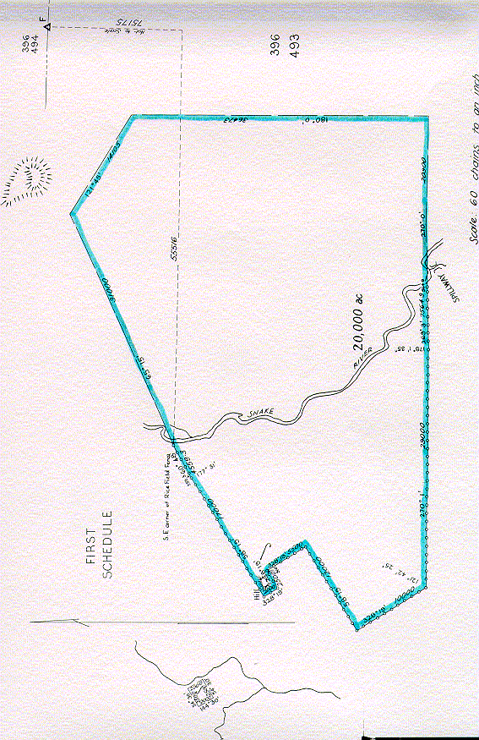

**2nd Schedule**

LICENSE

KNOW all men and these presents witness that   
             in pursuance of the powers  
vested in him pursuant to the provisions of section 89D of the Land Act 1933‑1956 does hereby authorize empower and license NORTHERN DEVELOPMENTS PTY. LIMITED a company duly incorporated in the State of New South Wales and having its registered office in Western Australia at the Third Floor Pastoral House Saint George’s Terrace Perth (hereinafter referred to as “the Company”) by its servants workmen and agents to enter upon the parcel of land described in the Schedule hereto and delineated and bordered in blue in the plan drawn hereon and to hold the same from the natural surface thereof to a depth of forty feet below the natural surface for the purpose of cultivating and processing thereon rice and other agricultural crops necessitated by the rotational cultivation of rice for the term of five years from the     day of  
One thousand nine hundred and fifty‑    SUBJECT to the terms and conditions set out in the Agreement dated the twelfth day of November One thousand nine hundred and fifty‑seven and made between THE HONOURABLE ALBERT REDVERS GEORGE HAWKE M.L.A. Premier and Treasurer of the State of Western Australia contracting for and on behalf of the said State and the Government and Instrumentalities thereof from time to time of the one part and NORTHERN DEVELOPMENTS PTY. LIMITED of the other part AND to the provisoes contained in the prescribed form of Crown Grant for Rural lands under the said Act such provisoes being construed as if the parcel referred to in this License were the tract or parcel referred to in the said form of Crown Grant AND the Company hereby accepts this License on the terms and conditions herein set out.

THE SCHEDULE

(Description of parcel of land)

GIVEN under my hand at Perth on the     day of

One thousand nine hundred and fifty —

By Order of the Minister for Lands,

|  |  |  |
| --- | --- | --- |
| The Common Seal of NORTHERN DEVELOPMENTS PTY. LIMITED was hereunto affixed in the presence of —   . . . . . . . . . . . . . . . . . . . . . . |  |  |

|  |  |  |
| --- | --- | --- |
| SIGNED SEALED AND DELIVERED by THE HONOURABLE ALBERT REDVERS GEORGE HAWKE M.L.A. in the presence of —   R. H. Doig, J.P. |  | A. R. G. HAWKE  [L.S] |

|  |  |  |
| --- | --- | --- |
| The Common Seal of NORTHERN DEVELOPMENTS PTY. LIMITED was hereunto affixed in the presence of —   H. Meyer, Secretary. |  | M. E. RARLEY,  A. RICHMOND,  Directors.  [C.S.] |

**3rd Schedule**

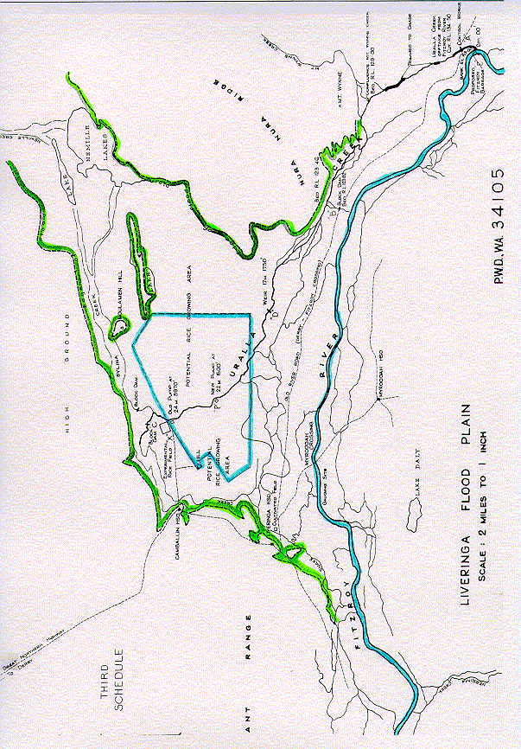

Notes

1. This is a compilation of the *Northern Developments Pty Limited Agreement Act 1957* and includes all amendments effected by the other Acts referred to in the following Table.

Compilation table

| **Short title** | **Number and year** | **Assent** | **Commencement** |
| --- | --- | --- | --- |
| *Northern Developments Pty Limited Agreement Act 1957* | 65 of 1957 | 6 Dec 1957 | 6 Dec 1957 |