Western Australia
East Perth Redevelopment Act 1991

East Perth Redevelopment (Subtracted Area - Stage 2) Regulations 2011
These regulations expired as at 7 Sep 2011 (see r. 7(1)(a) and Gazette 6 Sep 2011 p. 3655-6).

Western Australia
East Perth Redevelopment (Subtracted Area - Stage 2) Regulations 2011
Contents
1. Citation 1
2. Commencement 1
3. Terms used 1
4. Schedule 1 replaced 1
Schedule 1 — Redevelopment area
5. Minister may amend planning schemes 2
6. Other transitional matters 3
7. Expiry of regulations 3
Notes
Compilation table 4
Defined terms

Western Australia
East Perth Redevelopment Act 1991
East Perth Redevelopment (Subtracted Area - Stage 2) Regulations 2011

1. Citation
These regulations are the East Perth Redevelopment (Subtracted Area - Stage 2) Regulations 2011.

2. Commencement
These regulations come into operation as follows —
(a) regulations 1 and 2 — on the day on which these regulations are published in the Gazette;
(b) the rest of the regulations — on the day after that day.

3. Terms used
In these regulations —
order means an order made under regulation 5(2);
Schedule 1 means the East Perth Redevelopment Act 1991 Schedule 1;
scheme means either of the following —
(a) the Metropolitan Region Scheme;
(b) the City of Perth City Planning Scheme 2.

4. Schedule 1 replaced
When an order takes effect, delete Schedule 1 and insert:

Schedule 1 — Redevelopment area
[s. 4]
All of the land and waters in the area described as the redevelopment area on Plan No. 3 held at the office of the Authority, that plan being certified by the Minister as being the plan prepared for the purpose of defining the redevelopment area.
For guidance, the redevelopment area is indicated in the following representation of Plan No. 3.
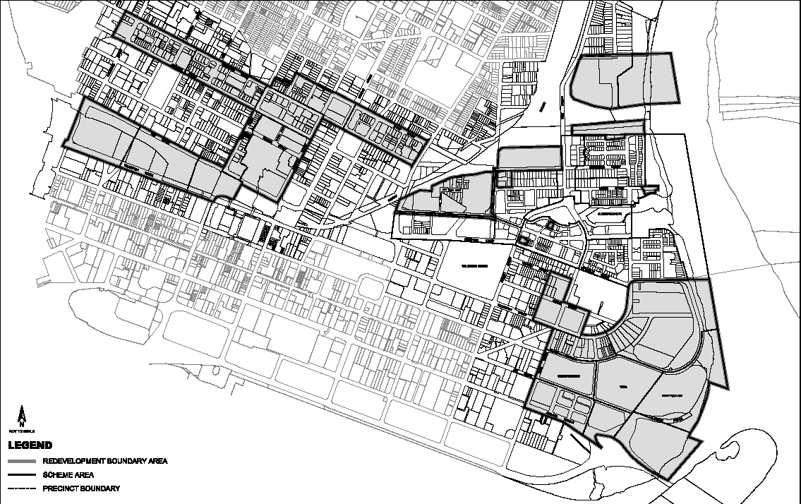

5. Minister may amend planning schemes
(1) In this regulation —
subtracted area means the area that ceases to be in the redevelopment area when Schedule 1 is replaced under regulation 4.
(2) The Minister may, by order published in the Gazette, amend a scheme to provide for any of the following —
(a) land in the subtracted area to be included in the area to which the scheme applies;
(b) land in the subtracted area to have a reservation or zoning under the scheme the same as, or similar to, that which applied to the land immediately before it ceased to be in the redevelopment area.
(3) An order takes effect at the beginning of the day after the day on which it is published in the Gazette.

6. Other transitional matters
When an order takes effect, the effect of a decision, if any, previously made by the Authority or the Minister about a development application or an approval continues.

7. Expiry of regulations
(1) These regulations expire when whichever of the following events happens first —
(a) an order takes effect;
(b) the period of 2 years, commencing on the day mentioned in regulation 2(b), ends.
(2) The expiry of these regulations does not affect —
(a) the amendment of the redevelopment area under regulation 4; or
(b) an amendment of a scheme under an order.

Notes
¹ This is a compilation of the East Perth Redevelopment (Subtracted Area - Stage 2) Regulations 2011. The following table contains information about those regulations.

Compilation table
Citation | Gazettal | Commencement
East Perth Redevelopment (Subtracted Area - Stage 2) Regulations 2011 | 6 Sep 2011 p. 3653-5 | r. 1 and 2: 6 Sep 2011 (see r. 2(a));  Regulations other than r. 1 and 2: 7 Sep 2011 (see r. 2(b))
These regulations expired as at 7 Sep 2011 (see r. 7(1)(a) and Gazette 6 Sep 2011 p. 3655-6)

Defined terms

[This is a list of terms defined and the provisions where they are defined. The list is not part of the law.]
Defined term Provision(s)
order 3
Schedule 1 3
scheme 3
subtracted area 5(1)

