Western Australia
Armadale Redevelopment Act 2001
Armadale Redevelopment (Addition of Land to Redevelopment Area) Regulations 2011

Western Australia
Armadale Redevelopment (Addition of Land to Redevelopment Area) Regulations 2011
CONTENTS
-1. Citation 1
2. Commencement 1
3. Term used: Schedule 1 1
4. Schedule 1 amended (land added to redevelopment area) 1
Notes
Compilation table 3

Western Australia

Armadale Redevelopment Act 2001
Armadale Redevelopment (Addition of Land to Redevelopment Area) Regulations 2011

1. Citation
These regulations are the Armadale Redevelopment (Addition of Land to Redevelopment Area) Regulations 2011 ¹.

2. Commencement
These regulations come into operation as follows —
(a) regulations 1 and 2 — on the day on which these regulations are published in the Gazette;
(b) the rest of the regulations — on the day after that day.

3. Term used: Schedule 1
In these regulations —
Schedule 1 means the Armadale Redevelopment Act 2001 Schedule 1.

4. Schedule 1 amended (land added to redevelopment area)
In Schedule 1 delete Plan No. 2 and insert:
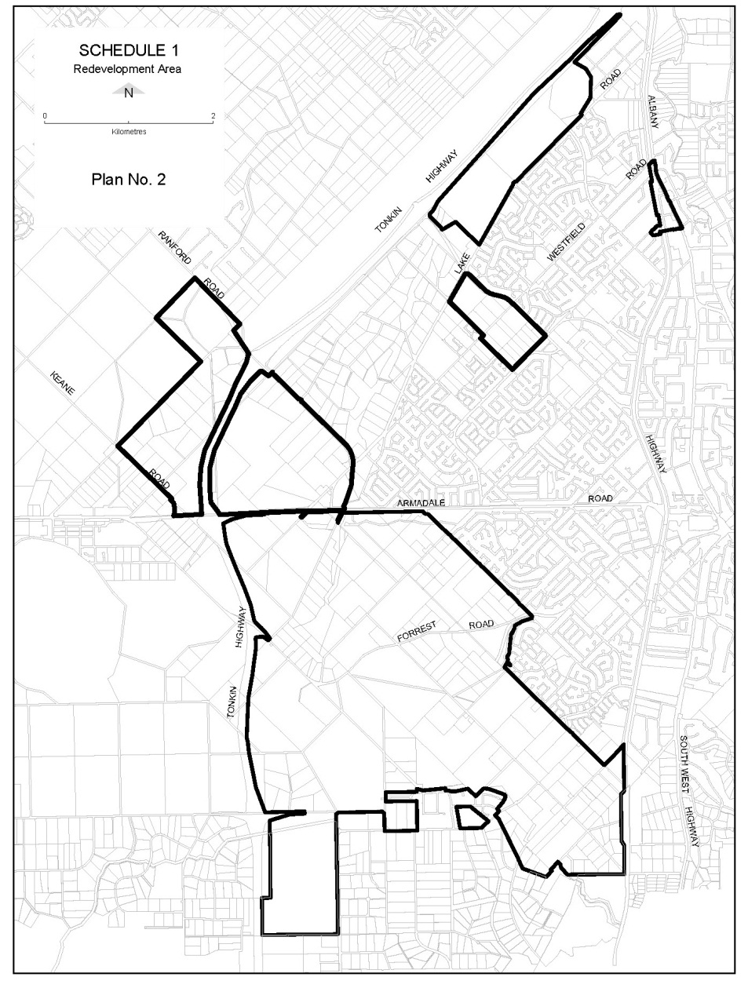

Notes
¹ This is a compilation of the Armadale Redevelopment (Addition of Land to Redevelopment Area) Regulations 2011. The following table contains information about those regulations.

Compilation table
Citation | Gazettal | Commencement
Armadale Redevelopment (Addition of Land to Redevelopment Area) Regulations 2011 | 16 Dec 2011 p. 5348-9 | r. 1 and 2: 16 Dec 2011 (see r. 2(a));  Regulations other than r. 1 and 2: 17 Dec 2011 (see r. 2(b))

