Western Australia
Statistics Act 1907

Statistics Regulations

Western Australia
Statistics Regulations
Contents
1. Matters for which statistics may be collected 1
2. Banks to provide information 3
3. Prescribed person under section 9 3
4. Obligations to fill up and furnish forms and returns 4
5. Statistical Agents 4
6. Prescribed forms 8
7. Compilation and publication of lists of names 9
8. Prescribed or allowed injuries 9
Schedule
Notes
Compilation table 15
Defined terms

Western Australia
Statistics Act 1907
Statistics Regulations
Government Statistician’s Office,
Perth, 31st August, 1939.
C.L.D. 1161/37; Ex. Co. No. 1820.
His Excellency the Lieutenant-Governor in Executive Council, acting pursuant to the power conferred by section 24 of the Statistics Act 1907, has been pleased to repeal and revoke all regulations heretofore made and in force under and for the purposes of the said Act, and in lieu thereof to make new regulations, as set out in the Schedule hereunder, under and for the purposes of the said Act, to come into operation as from the publication of this notice in the Government Gazette.
S. BENNETT,
Government Statistician.

1. Matters for which statistics may be collected
(1) In addition to the matters specifically mentioned in section 8 of the Act, the Statistician shall, subject to these regulations, collect annually statistics in relation to the following matters, that is to say: —
(a) motor omnibus services;
(b) goods transport services, other than railways;
(c) wholesale and retail prices and house rents;
(d) commercial air services;
(e) co-operative companies or societies.
(f) Electricity generating stations, plants, or works of any kind or nature, including those used on or in connection with quarries, or gold, coal, or other mines in which minerals are mined, whether the electricity generated is sold to the public or used solely for the purpose of the generating station, plant, works, quarries, or mines, or for any other purpose.
(g) building operations.
(2) The owner of every omnibus (as defined in and for the purposes of the Traffic Act 1919-1935); the owner of every goods transport vehicle licensed or required to be licensed under the State Transport Coordination Act 1933; the owner of any wholesale or retail establishment; the controller, or his responsible representative of any auction market; the owner of any rented dwelling, the owner of any commercial air service, and the managing body or the manager of every cooperative company or society, and the owner, manager, or agent of any electricity generating station, plant, or works of any kind or nature including those used on or in connection with quarries or gold, coal, or other mines in which minerals are mined and any person or his responsible representative who engages or who appears on reasonable grounds to engage in building operations other than as an employee shall, when so required by the Statistician and to the best of his knowledge and ability, fill up, or cause to be filled up, and at such times and in respect of such periods as the Statistician may from time to time prescribe by notice in the Government Gazette, supply to the Statistician the particulars specified and required in the form or forms which are from time to time prepared and issued by the Statistician in accordance with his duty in respect thereto under section 7 of the Act, and also to fill up or cause to be filled up such particulars in such form or forms in accordance with the instructions stated therein or which accompany such form or forms.
(3) Every such owner aforesaid, and every servant or agent of every such owner whom the owner instructs or authorises to make the returns required by this regulation, shall be a prescribed person within the meaning and for the purposes of section 9 of the Act.
[Regulation 1 amended: Gazettes 2 February 1940 p.151; 22 March 1946 p.304.]

2. Banks to provide information
(1) The manager or other person in charge of any bank or banking business in Western Australia shall, to the best of his knowledge and ability, within fourteen days after the close of each and every quarter ending respectively on the thirtieth day of September, the thirty-first day of December, the thirty-first day of March, and the thirtieth day of June in each financial year of the State, or as soon thereafter as practicable, furnish, or cause to be furnished to the Statistician, the particulars specified and required in the form which is from time to time prepared and issued by the Statistician in accordance with his duty in respect thereto under section 7 of the Act, and also shall furnish or cause to be furnished such particulars aforesaid in such form and in accordance with the instructions stated therein or which accompany such form.
(2) Every such manager or other person aforesaid, and every servant or agent whom such manager or other person aforesaid instructs or authorises to make the returns required by this regulation, shall be a prescribed person within the meaning and for the purposes of section 9 of this Act.

3. Prescribed person under section 9
(1) For the purpose of carrying out his duties and functions under section 8 of the Act, the Statistician may at any time and from time to time determine the person who shall be the prescribed person within the meaning of section 9 of the Act whom the Statistician may require to fill up and supply to the Statistician the particulars required by him.
(2) As and when the Statistician determines the person who shall be the prescribed person as aforesaid in relation to any particulars aforesaid, he shall publish notification thereof in the Government Gazette and also cause a similar notification to be made in or upon the form or forms in relation to the supply of such particulars which the Statistician, in accordance with his duty under section 7 of the Act, shall prepare and issue.
(3) Upon notification in the Government Gazette as provided for in paragraph (2) hereof, the person mentioned in such notification shall be a prescribed person within the meaning and for the purposes of section 9 of the Act in relation to the supply of the particulars mentioned in such notification until such notification is cancelled or revoked by a subsequent notification in the Government Gazette.

4. Obligations to fill up and furnish forms and returns
A person who is required to fill up and furnish to the Statistician any form or return under the provisions of the Statistics Act 1907, or these regulations, shall comply with the instructions contained in or accompanying the form or return and shall deliver it or cause it to be delivered to the Statistician or such officer as is specified in the instructions.
[Regulation 4 inserted: Gazette 15 June 1956 p.1479.]

5. Statistical Agents
(1) (a) For the purpose of carrying out the provisions of the Statistics Act 1907, the persons designated hereunder are Statistical Agents for the purpose of the collection of import and export returns required to be furnished under these regulations: —
The Secretary to the Fremantle Harbour Trust.
The Secretaries to the Albany and Bunbury Harbour Boards.
The Goods Agents and Stationmasters of the Commonwealth Railways in Western Australia, the Western Australian Government Railways throughout the State and of the Midland Railway Co. of W.A. Ltd.
The Boundary Stock Inspector of the State Department of Agriculture.
The Wharfingers of Ports under the control of the State Harbour and Light Department.
Such persons as shall be subsequently appointed by the Governor in Council.
(b) For the purposes of this regulation —
goods includes livestock;
person includes body corporate;
port includes airport, railway station, post office, warehouse, depot or place at or from which goods are received or despatched.
(2) Exports — (a) A person who despatches goods from any port in Western Australia to any port in any of the other States or mainland territories of the Commonwealth of Australia, shall at the time of despatching the goods, or before the goods are forwarded, from the port in this State, fill up and furnish to the Statistical Agent holding office at the port in this State, or if there is no Statistical Agent at that port, shall fill up and furnish to the Statistician, a return in the form or to the effect of Form J.1 in the Schedule to these regulations: But the provisions of this paragraph do not apply to a person who accepts goods from another person in this State for the purpose of despatching, forwarding or delivering those goods from a port in Western Australia to a port in any of the States or mainland territories of Australia on behalf of that other person.
(b) A person who accepts goods from another person for the purpose of despatching, forwarding or delivering the goods from a port in Western Australia to a port in any of the other States or mainland territories of the Commonwealth of Australia on behalf of that other person, shall at the time of despatching the goods or before the goods are forwarded from the port in Western Australia fill up and furnish to the Statistical Agent holding office at the port in this State, or if there is no Statistical Agent at that port, shall fill up and furnish to the Statistician a return in the form or to the effect of Form J.2 in the Schedule to these regulations.
(c) A person whose name appears as the consignor of goods on any return in the form or to the effect of Form J.2 furnished by any person in accordance with the provisions of paragraph (b) of this subregulation, but who accepts the goods for the purpose of forwarding or delivering the goods from a port in this State to a port in any of the other States or mainland territories of the Commonwealth of Australia on behalf of any person, shall at the request of the Statistician fill up and furnish to the Statistician a return in the form or to the effect of Form J.2 in the Schedule to these regulations.
(d) A person whose name appears as the consignor of goods on any return in the form or to the effect of Form J.2 furnished in accordance with the provisions of paragraph (b) or (c) of this subregulation shall at the request of the Statistician fill up and furnish to the Statistician a return in the form or to the effect of Form J.1 in the Schedule to these regulations: But the provisions of this paragraph do not apply to a person who accepts goods from another person for the purpose of despatching, forwarding or delivering the goods from a port in Western Australia to a port in any of the other States or mainland territories of the Commonwealth of Australia on behalf of that other person.
(3) Imports — (a) Where goods have arrived at a port in Western Australia from a port in any of the other States or mainland territories of the Commonwealth of Australia, any person accepting delivery of those goods, other than a person accepting delivery for the purpose of despatching, conveying or delivering those goods to another person or other persons in this State, shall, when obtaining possession of the goods fill up and furnish to the Statistical Agent holding office at that port, or if there is no Statistical Agent at that port, shall fill up and furnish to the Statistician a return in the form or to the effect of Form J.3 in the Schedule to these regulations.
(b) Where a person accepts delivery of goods which have arrived at a port in Western Australia from a port in any of the other States or mainland territories of the Commonwealth of Australia for the purpose of despatching, conveying or delivering those goods to other persons in this State, he shall at the time of obtaining possession of those goods fill up and furnish to the Statistical Agent holding office at that port, or if there is no Statistical Agent at that port, shall fill up and furnish to the Statistician a return in the form or to the effect of Form J.4 in the Schedule to these regulations.
(c) A person whose name appears as the consignee of goods on any return in the form or to the effect of Form J.4 furnished by any person in accordance with the provisions of paragraph (b) of this subregulation but who accepts the goods for the purpose of despatching, forwarding or delivering them on behalf of any person to any other person in this State, shall at the request of the Statistician fill up and furnish to the Statistician a return in the form or to the effect of Form J.4 in the Schedule to these regulations.
(d) A person whose name appears as the consignee of goods on any return in the form or to the effect of Form J.4 furnished in accordance with paragraph (b) or (c) of this subregulation, shall at the request of the Statistician, fill up and furnish to the Statistician, a return in the form or to the effect of Form J.3 in the Schedule to these regulations: But the provisions of this paragraph do not apply to a person who accepts delivery of the goods for the purpose of despatching, conveying or delivering the goods to any other person in this State.
(e) Where a person conveys or delivers goods from a port in any of the other States or mainland territories of the Commonwealth to a port in Western Australia, he shall at the time of arrival at the port in Western Australia, fill up and furnish to the Statistician, a return in the form or to the effect of Form J. 4 in the Schedule to these regulations.
(4) (a) On the application of a person required to furnish a return under the provisions of subregulation (2) or (3) of this regulation, the Statistician may authorise him to furnish the return periodically or at regular intervals in respect of goods handled by him during specified periods and shall appoint the day on which the return shall be furnished in respect of each period.
(b) A person so authorised shall —
(i) furnish the return on the day so appointed for each specified period, and
(ii) if no goods are handled by him during any specified period, furnish the return with the word “Nil” written across it on the day appointed for furnishing the return in respect of that period.
(c) The provisions of regulation 4 and of subregulations (2) and (3) of this regulation apply mutatis mutandis to a return furnished under the provisions of paragraph (a) of this subregulation, but where the Statistician authorises a person to furnish a return periodically under the provisions of that paragraph the person shall furnish the return on the day or days appointed by the Statistician.
(d) An authority given by the Statistician under the provisions of paragraph (a) of this subregulation may be revoked by him at any time.
[Regulation 5 inserted: Gazette 15 June 1956 pp.1479-81; amended: Gazette 7 January 1958 p.17.]

6. Prescribed forms
Where in accordance with his duty in respect thereto, under section 7 of the Act the Statistician from time to time prepares and issues forms and instructions for the collection of statistics, such forms, until altered or amended or otherwise dealt with by the Statistician, shall be prescribed forms within the meaning and for the purposes of the Act and these regulations, and such instructions, when they are contained in or accompany any such form, shall be deemed to be a part of such prescribed form.

7. Compilation and publication of lists of names
(1) Subject to section 18 of the Act, the Statistician, and any officer under the Statistician duly authorised in that behalf by the Statistician, may, with the approval of the Minister, from the contents of forms filled up in pursuance of this Act, or from other information obtained under the authority of this Act, compile and publish or otherwise make available to any person or persons from time to time lists containing the names and addresses of the following persons, namely: —
(1) Owners of —
(a) motor vehicles, according to make and type;
(b) any particular class of livestock or poultry.
(2) Growers of any particular kinds of crop or plant.
(3) Makers of wine.
(2) Insofar as the Statistician or any officer under the Statistician has prior to the coming into operation of this regulation, compiled and published any lists of a kind which by paragraph (1) hereof is now authorised to be compiled and published, the compilation and publication of such lists shall be deemed to have been duly authorised to the same extent as if this regulation was in force and operation at the time of such compilation and publication, and the same had been compiled and published under the authority of this regulation.

8. Prescribed or allowed injuries
Where in accordance with section 11 of the Act the Statistician or any officer duly authorised by him desires to make any inquiry necessary for the proper carrying out of the Act, and satisfies the Minister as to the nature and necessity of the inquiry which he proposes to make, and the Minister approves by writing under his hand of such inquiry being made, such inquiry shall be an inquiry prescribed or allowed by the regulations within the meaning and for the purposes of section 11 of the Act.

Schedule
Form J1
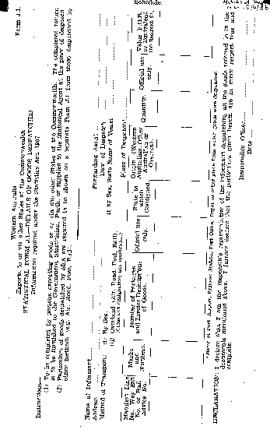
Form J.2.
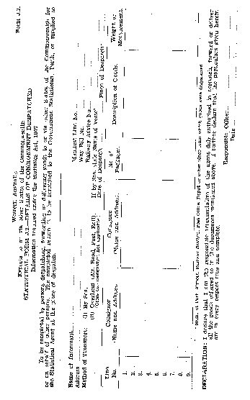
Form J.3.
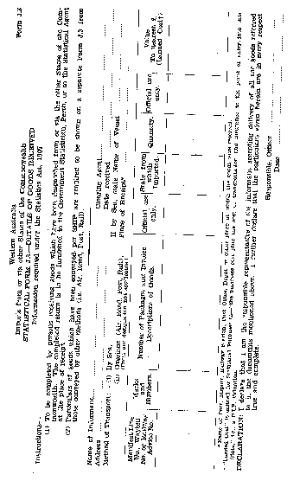

Form J.4.
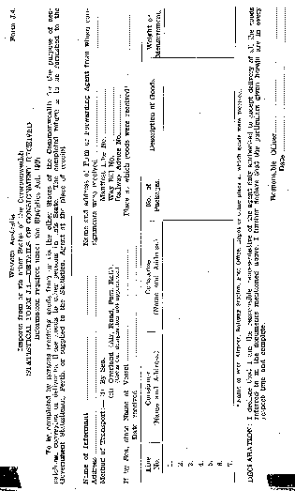
[Schedule inserted: Gazette 15 June 1956 p.1482-5.]

Notes
¹ This is a compilation of the Statistics Regulations and includes the amendments referred to in the following Table.

Compilation table
Citation | Gazettal | Commencement
Untitled | 8 Sep 1939 p. 1558-60
 | 2 Feb 1940 p. 151
 | 22 Mar 1946 p. 304
 | 4 Aug 1950 p. 1718
 | 15 Jun 1956 p. 1479-85
 | 7 Jan 1958 p. 17

Defined terms

[This is a list of terms defined and the provisions where they are defined. The list is not part of the law.]
Defined term Provision(s)
goods 5(b)
person 5(b)
port 5(b)

