Western Australia

Hairdressers Registration Regulations 1965
Compare between:
[12 May 2006, 02-d0-03] and [01 Jul 2006, 02-e0-03]

Western Australia
Hairdressers Registration Act 1946
Hairdressers Registration Regulations 1965

1. Citation
These regulations may be cited as the Hairdressers Registration Regulations 1965 ¹.

2. Application
These regulations apply only within the area referred to in section 3 of the Act, and do not apply to the persons mentioned in section 4(1) of the Act.
[3. Omitted under section 7(4)(f) of the Reprints Act 1984.]
[4. Omitted under section 7(4)(d) of the Reprints Act 1984.]

Part I — Introductory

5. Interpretation
In these regulations, unless the context requires otherwise —
“approved” means approved in writing by the Board;
“approval” has a corresponding interpretation;
“Board” means the Hairdressers Registration Board of Western Australia constituted under the Act;
“hairdresser’s shop” means any place wherein or whereon hairdressing is practised;
“inspector” means an authorised officer of the Board appointed for the purpose of inspecting the premises of a hairdresser’s shop and of enforcing the provisions of the Act and these regulations;
“Registrar” means the Registrar appointed by the Board pursuant to section 7 of the Act;
“the Act” means the Hairdressers Registration Act 1946, and includes any amendments thereto.

6. Classes of hairdressing
Hairdressing for the purposes of the Act and these regulations is divided into 5 classes as follows: —
(1) Men’s Hairdressing (Inclusive) which comprises dressing, curling, waving, cleansing, cutting, shaving, beard trimming, style blow drying, bleaching, tinting, colouring of the hair of the head or beard of any male person whether with or without the aid of any apparatus, appliance, preparation or substance. It includes the usual maintenance and use of equipment and tools of trade as practised in men’s hairdressers’ shops.
The expression “men’s hairdresser (inclusive)” in these regulations means a person qualified to perform all of the operations of this class of hairdressing.
(2) Men’s Hairdressing (Limited) which comprises dressing, cutting, style blow drying the hair of the head of any male person whether with or without the aid of any apparatus, appliance, preparation or substance.
The expression “men’s hairdresser (limited)” in these regulations means a person qualified to perform all of the operations of this class of hairdressing.
(3) Ladies’ Hairdressing (Inclusive) which comprises dressing, curling, waving, cleansing, cutting, style blow drying, blow wave, bleaching, tinting, colouring of the hair of the head of any female person, whether with or without the aid of any apparatus, appliance, preparation or substance. The expression “ladies’ hairdresser (inclusive)” in these regulations means a person qualified to perform all of the operations of this class of hairdressing.
(4) Ladies’ Hairdressing (Limited) which comprises dressing, cutting, style blow drying of the hair of the head of any female person, whether with or without the aid of any apparatus, appliance, preparation or substance. The expression “ladies’ hairdresser (limited)” in these regulations means a person qualified to perform all of these operations of this class of hairdressing.
(5) Combined Hairdressing which comprises dressing, curling, waving, cleansing, cutting, shaving, beard trimming, style blow drying, blow wave, bleaching, tinting, colouring of the hair of the head or beard of any male person or the hair of the head of any female person whether with or without the aid of any apparatus, appliance, preparation or substance. It includes the usual maintenance and use of equipment and tools of trade as practised in hairdressers’ shops. The expression “combined hairdresser” in these regulations means a person qualified to perform all of the operations of this class of hairdressing.
[Regulation 6 inserted in Gazette 17 December 1976 p.5003; amended in Gazette 26 July 1985 p.2670.]

6A. Transitional
Subject to the Act and these regulations —
(a) where, immediately before the date on which this regulation comes into force, a hairdresser was registered in respect of the prescribed class “Men’s Hairdressing” that hairdresser shall, on and from that date, be deemed to be registered in respect of the prescribed class “Men’s Hairdressing (Inclusive)”;
(b) where, immediately before the date on which this regulation comes into force a hairdresser was registered in respect of the prescribed classes “Men’s Hairdressing” and “Ladies’ Hairdressing (Inclusive)” that hairdresser shall, on and from that date, be deemed to be registered in respect of the prescribed class “Combined Hairdressing”.
[Regulation 6A inserted in Gazette 17 December 1976 pp.5003-4.]

7. The Board
The proceedings of the Board shall be conducted as follows: —
(1) Meetings — The Board shall meet at such times and places as the Board decides, and the Registrar shall convene a meeting at any time when so directed by the Chairman.
(2) Notice — Not less than 3 days’ notice of any meeting shall be given to every member of the Board by letter directed to such address as he shall from time to time furnish to the Registrar.
(3) Cheques — Cheques shall be signed as directed by the Board from time to time.
(4) Documents — Documents requiring to be signed by the Board shall be signed, for and on behalf of the Board, by the Registrar, or as may be directed by the Board.

8. Remuneration of board members
(1) A fee at the rate specified in subregulation (2) is to be paid to a member of the Board, or a deputy of a member of the Board, for —
(a) attending a meeting of the Board; or
(b) performing another service as a member or deputy, if the Minister has approved that kind of service for the purposes of this paragraph.
(2) The fee to be paid is —
(a) for the Chairman or the Chairman’s deputy, $350 for a period of more than 4 hours on a single day, or $230 for a shorter period on a single day; and
(b) for each other member of the Board or other deputy, $240 for a period of more than 4 hours on a single day, or $160 for a shorter period on a single day.
[Regulation 8 inserted in Gazette 12 May 2006 p. 1783.]

Part II — Officers of the Board

9. The Registrar
(1) The duties of the Registrar are —
(a) to act as Secretary to the Board, and to carry out the directions of the Board and all such duties as pertain to that office;
(b) to receive all moneys, due to the Board and pay them into an account in the Board’s name kept with such Bank as the Board may from time to time determine, and to submit to the Board monthly statements showing the receipts and payments for the past month. He shall prepare the financial statement required by section 14(6) of the Act;
(c) to keep registers in the Form Nos. 1 and 2 in the Schedule of such persons as may be approved, by the Board, for registration and to record the class or classes of hairdressing in which registration has been approved; and
(d) to issue certificates and badges of registration for the appropriate class or classes in the Forms Nos. 3, 4 and 5 in the Schedule.
(2) If the Registrar, by reason of absence on leave or ill-health is unable to perform the duties required to be performed by him by the Act or these regulations, the Board may appoint an acting Registrar who shall during such incapacity or absence of the Registrar perform the duties of the Registrar.

10. Appointment of inspectors
(1) For the purpose of enforcing the Act and these regulations, the Board may appoint one or more inspectors.
(2) The Board may terminate the appointment of any inspector by giving one month’s notice, in writing, under the hand of the Registrar of the Board, save in the case of misconduct or breach of his duties, when no period of notice shall be required.

11. Entry for inspection
(1) In any area in which any of the provisions of the Act or these regulations is in force, any inspector may at any time when hairdressing is in progress or is usually or thought to be carried on, enter into and upon the premises of a hairdresser’s shop for the purpose of ascertaining whether any of the provisions of the Act or these regulations is being contravened.
(2) For the purpose of subregulation (1) of this regulation, the inspector may require any person on such premises who is performing any of the functions of a hairdresser to produce either or both his certificate or badge of registration for inspection, or to establish to the satisfaction of the inspector that he is an apprentice.
(3) Any person who refuses or fails to comply with the request under this regulation of an inspector commits an offence against these regulations.

Part III — Examinations

12. Board may conduct examinations
For the purpose of satisfying itself as to the qualifications of any applicant for registration, whether as principal or employee, the Board may —
(a) conduct all or any theoretical, practical, or oral examinations in any class or classes of hairdressing; and
(b) require any applicant for registration to present himself for any such examination.

13. Board may refuse to examine or register candidate
(1) The Board may refuse to examine or to register any candidate who has commenced but failed to complete an apprenticeship or who has not been actively engaged as a hairdresser for a period of at least 5 years or who has not completed an approved course of training.
(2) For the purposes of this regulation, an approved course of training is a course of training in any class or classes of hairdressing that, having regard to the time required for the course, the subjects dealt with, and the nature of the theoretical and practical instruction involved, is or are approved by the Board as being reasonably comparable to the corresponding course of training from time to time prescribed or required for apprentices in hairdressing pursuant to the provisions of the Industrial Arbitration Act 1912 ² (as amended), and the regulations made thereunder.

14. Application for examination
Any person who wishes to present himself for examination shall make application therefor to the Board in the Form No. 6 in the Schedule.

15. Content of examinations
(1) The subjects of the examinations shall be determined by the Board and shall be all or any of the activities set out in paragraph (1) of regulation 6 in the case of applicants for registration as men’s hairdressers (inclusive) in paragraph (2) of that regulation in the case of applicants for registration as men’s hairdressers (limited) in paragraph (3) of that regulation in the case of applicants for registration as ladies’ hairdressers (inclusive) in paragraph (4) of that regulation in the case of applicants for registration as ladies’ hairdressers (limited) and in paragraph (5) of that regulation in the case of applicants for registration as combined hairdressers.
(2) The Board may specify the type or types of apparatus, appliance, preparation or substance to be used and may specify methods and also types of results or styles to be produced, and may require more than one type of work or style in any individual category such as a short cut or crew cut or a continental style cut in men’s hairdressing.
[Regulation 15 amended in Gazette 17 December 1976 p.5004.]

16. Pass mark for examination
To obtain a pass a candidate must obtain at least 65% of the marks allotted in each subject on which he is examined.

17. Examinations for classes of hairdressing
(1) A hairdresser registered in respect of the prescribed class “Men’s Hairdressing (Limited)” who is eligible to qualify by examination for registration in the prescribed class “Men’s Hairdressing (Inclusive)” shall be required to submit himself for examination in and to pass all or any of the additional subjects required by the Board that are additional to the activities set out in paragraph (2) of regulation 6 but are included in paragraph (1) of that regulation.
(1a) A hairdresser registered in respect of the prescribed class “Ladies’ Hairdressing (Limited)” who is eligible to qualify by examination for registration in the prescribed class “Ladies’ Hairdressing (Inclusive)” shall be required to submit himself for examination in and to pass all or any of the additional subjects required by the Board that are additional to the activities set out in paragraph (4) of regulation 6 but are included in paragraph (3) of that regulation.
(1b) A hairdresser registered in respect of any one or more of the prescribed classes “Men’s Hairdressing (Inclusive)”, “Men’s Hairdressing (Limited)”, “Ladies’ Hairdressing (Inclusive)” or “Ladies Hairdressing (Limited)” who is eligible to qualify by examination for registration in the prescribed class “Combined Hairdressing” shall be required to submit himself for examination in and to pass all or any of the additional subjects required by the Board that are additional to the activities set out in regulation 6 of these regulations in relation to the prescribed class or classes in respect of which he is registered but are included in paragraph (5) of that regulation.
(2) Notwithstanding anything contained in these regulations, where a hairdresser, who has been registered by the Board in respect of any prescribed class (or classes) of hairdressing, is eligible to take and passes the examination (or examinations) prescribed by the Board entitling him to be registered in respect of a further class (or classes) he shall be entitled, on payment of the prescribed fee for the issue of a fresh certificate, to be registered in respect of such additional class (or classes).
[Regulation 17 amended in Gazette 17 December 1976 p.5004.]

18. Results of examinations
(1) After every examination each examiner shall submit in writing to the Board a report signed by him showing details of the results obtained by the candidate and the marks allotted for each subject and also, if required by the Board, written comment concerning the quality of the work in each subject.
(2) Where in the opinion of the examiners there is an unusually high percentage of failures at an examination, the examiners shall make a report on the matter to the Board.
(3) A candidate who has not passed in all subjects at a previous examination or examinations may retain credit for any subject passed and complete the remaining required subjects at a subsequent examination, except that a candidate shall not, without the approval of the Board, be given credit at any examination for subjects passed 6 months or more previously.
[Regulation 18 amended in Gazette 17 December 1976 p.5004.]

19. Times for holding examinations
(1) Examinations of candidates for registration as hairdressers of any prescribed class of hairdressing shall be held at such times and at such places as the Board shall determine from time to time.
[(2) deleted]
[Regulation 19 amended in Gazette 19 December 1975 p.4604; 26 May 1978 p.1640.]

Part IV — Registration

Division 1 — Registration of hairdressers

20. Application for registration
(1) Every person claiming to be entitled to be registered under the Act, shall make written application in the appropriate Form 7 in the Schedule.
(2) Every such application shall set out the prescribed class or classes of hairdressing in respect of which registration is sought, and whether the applicant applies for registration as a principal or employee, and shall be verified by a statutory declaration.
(3) In every such application there shall be stated the full name and address of the applicant together with full details of the hairdressing training and experience of the applicant, any examinations passed by him or her, any certificates or diplomas held by him or her, and any additional information that may be required by the Board.
(4) Every such application shall be supported by 2 written character references.
(5) The applicant shall in addition to the statements contained in such application forward such further evidence of his bona fides and qualifications as may be required by the Board.

Division 2 — Registration generally

21. Registration and certificate fees
There shall be paid to the Board in respect of each registration and certificate the fees set out in Part V.

22. Issue of certificate and badge
(1) When the Board has granted registration of a hairdresser, the Registrar shall, on payment of the prescribed fees, issue to the applicant a certificate and badge of registration in the appropriate forms in the Schedule.
(2) The certificate and badge shall remain the property of the Board, and shall be given up on demand by the Registrar on loss of registration by the holder.
(3) The badge shall, at all times when the person to whom it is issued is actually engaged in performing the duties of a hairdresser, be worn on the lapel of the outer garment of such person in such a manner as to be clearly visible.

23. Notification of change of status
Every hairdresser who —
(a) being registered as a principal, becomes an employee; or
(b) being registered as an employee, becomes a principal;
shall immediately —
(i) notify the Board of the fact;
(ii) apply for a certificate of registration in accordance with his altered status; and
(iii) forward to the Registrar his current certificate and fees applicable for the issue of a new certificate corresponding to his altered status.

24. Notification of change of name and address
Every hairdresser, whether a principal, or employee, who has obtained registration shall, upon changing his or her name or address forthwith notify the Board of the fact and furnish the new name and address for entry in the Register of Hairdressers.

Division 3 — Nomination of principals

25. Principal to be nominated in relation to premises
(1) Subject to subregulation (1a), upon all premises in which the business of hairdressing of any prescribed class or classes is carried on, there shall be present and in control of each prescribed class of hairdressing at all times whilst it is carried on in such premises at least one person who is registered in respect of the prescribed class or each of the prescribed classes of hairdressing carried on in such premises (as the case may be), and who for the purpose of the Act shall be the principal of the business. Where several classes of hairdressing are carried out on any one premises, if necessary more than one principal must be nominated by the owner as aforesaid so that every class of hairdressing carried out on the premises is superintended at all times as aforesaid by a principal. Where there is more than one principal on any premises each principal shall be fully responsible for the performance of his own duties.
(1a) Where the class of hairdressing carried out on the premises is the class “combined hairdressing” the principal of that class may be one person registered —
(a) in respect of the class “combined hairdressing”; or
(b) in respect of the classes of “Ladies’ Hairdressing (Inclusive)” and “Men’s Hairdressing (Limited)”.
(2) The principal of the business (or, as the case may be, the principal for each class of hairdressing carried out on the premises) shall be responsible to ensure the compliance with the provisions of the Act by all persons engaged in hairdressing (or, as the case may be, in each class of hairdressing) in the premises.
(3) The principal shall give full co-operation and assistance to the Board’s Inspector and make available to him all information and documents that are properly required by the inspector in the performance of his duties and shall, if required, direct all hairdressers operating on the premises to inform the inspector of their full names and addresses and show to him their certificates and badges of registration.
(4) The owner or proprietor of every hairdressing business shall nominate a principal or principals as the case may require in respect of each premises in which such owner or proprietor carries on business and shall notify the Board in writing of the person nominated as principal at each address.
(5) A person may not be a principal of more than one premises.
(6) It shall be the responsibility of the owner or proprietor of a business to ensure that a nominated principal or nominated principals, qualified in all or each classes of hairdressing being carried on, is or are present at all times at all hairdressing shops and if he fails to do so he commits an offence against these regulations.
(7) If a principal so nominated ceases to act as principal such owner or proprietor shall within 7 days thereof notify the Board of the fact and furnish it with particulars required by these regulations in respect of the principal appointed in his place.
(8) It shall not be necessary for the owner or proprietor to nominate a principal in respect of premises in which the owner or proprietor thereof, or one of the owners or proprietors thereof, is during all business hours in direct personal control as a principal and as a principal is registered in respect of the prescribed class or each of the prescribed classes of hairdressing practised in connection with the said business.

Part V — Fees and Forms

26. Fees
The fees set out in the Table to this regulation are payable in respect of the matters set out in the Table.
Table
1 | Theoretical examination on a class of hairdressing, taken for the first time ...................... | $70.50
2 | Practical examination on a class of hairdressing, taken for the first time .....................................…... | $204.00
3 | Practical examination on a class of hairdressing, taken for a second or subsequent time, when the examination is on —  (a) 1 subject ......................................................  (b) 2 subjects ....................................................  (c) 3 or more subjects ....................................... | $70.50  $105.00  $141.00
4 | Application for registration as a hairdresser (principal or employee) .......................................... | $128.00
5 | Registration as a principal hairdresser —  (a) if applicant is an employee hairdresser .......  (b) otherwise ..................................................... | $13.80  $80.00
6 | Registration as an employee hairdresser —  (a) if applicant is a principal hairdresser ..........  (b) otherwise ..................................................... | $13.80  $51.00
7 | Issue of certificate of registration ........................... | $13.80
8 | Voluntary suspension, or re-instatement, of registration ………………………………………… | $13.80
[Regulation 26 inserted in Gazette 27 Jun 2006 p. 2266-7.]

26A. Pro rata reduction for 3 monthly expired periods
Where initial registration occurs after the first quarter of the year the registration fee for that initial registration shall be reduced by one quarter for each 3 months that have expired since 1 January of that year.
[Regulation 26A inserted in Gazette 24 June 1988 p.2061.]

27. Use of similar forms
Where any of these regulations requires the use of one of the Forms in the Schedule, it shall be a sufficient compliance with the regulation if a form to the like effect is used.

The Schedule
Form No. 1  Western Australia  Hairdressers Registration Act 1946  THE HAIRDRESSERS REGISTRATION BOARD OF WESTERN AUSTRALIA  (Regulation No. 9)  REGISTER OF HAIRDRESSERS — PRINCIPALS  Surname ……………………… Christian Names ………………………. Registered Number ……………….  Address ……………………………… Date of Registration as —  (a) Men’s Hairdresser (Inclusive) ………..…..………..  (b) Men’s Hairdresser (Limited) ………………………  (c) Ladies’ Hairdresser (Inclusive) ..………..……..…..  (d) Ladies’ Hairdresser (Limited) ………….……….…  (e) Combined Hairdresser …………...……..…………  Qualification(s) …………………………………………… Minute Book Folio …………………….….……..  Remarks …………………………………………………………………………………………………..………. | Bal.
 | Dr. or Cr.
 | Cr.
 | Dr.
 | Ref.
 | Item
 | Date
 | Bal.
 | Dr. or Cr.
 | Cr.
 | Dr.
 | Ref.
 | Item
 | Date
[Form 1 amended in Gazette 17 December 1976 p.5004.]
Form No. 2  Western Australia  Hairdressers Registration Act 1946  THE HAIRDRESSERS REGISTRATION BOARD OF WESTERN AUSTRALIA  (Regulation No. 9)  REGISTER OF HAIRDRESSERS — EMPLOYEES  Surname ……………………………….. Christian Names …………………………. Registered Number ……....  Home address ……………………… Date of Registration as —  Name and address ………………………………. (a) Men’s Hairdresser (Inclusive) …………………  of employer (b) Men’s Hairdresser (Limited) ………………..…  …………………………………………. (c) Ladies’ Hairdresser (Inclusive) ….…………….  (d) Ladies’ Hairdresser (Limited)..………..……….  (e) Combined Hairdresser …………………………  Qualification(s) …………………………………………… Minute Book Folio …………………….….……..  Remarks …………………………………………………………………………………………………..………. | Bal.
 | Dr. or Cr.
 | Cr.
 | Dr.
 | Ref.
 | Item
 | Date
 | Bal.
 | Dr. or Cr.
 | Cr.
 | Dr.
 | Ref.
 | Item
 | Date
[Form 2 amended in Gazette 17 December 1976 p.5004.]
Form No. 3
Hairdressers Registration Act 1946
CERTIFICATE OF REGISTRATION
No…………………………
This is to Certify that………………………………………………..has this day been registered by the Hairdressers Registration Board of Western Australia as a Hairdresser
PRINCIPAL
qualified in the following prescribed classes of hairdressing, viz.:
……………………………………………………………………………………
Dated at Perth this………………………..day of……………………..19……….
……………………………
Registrar
This Certificate is the property of the Hairdressers Registration Board of Western Australia.

Form No. 4
Hairdressers Registration Act 1946
CERTIFICATE OF REGISTRATION
No…………………………
This is to Certify that…………………………………...……………has this day been registered by the Hairdressers Registration Board of Western Australia as a Hairdresser
EMPLOYEE
qualified in the following prescribed classes of hairdressing, viz.:
……………………………………………………………………………………
Dated at Perth this………………….day of…………………………. 19…….….
……………………………
Registrar
This Certificate is the property of the Hairdressers Registration Board of Western Australia.
Form No. 5
Western Australia
Hairdressers Registration Act 1946
REGISTRATION BADGES
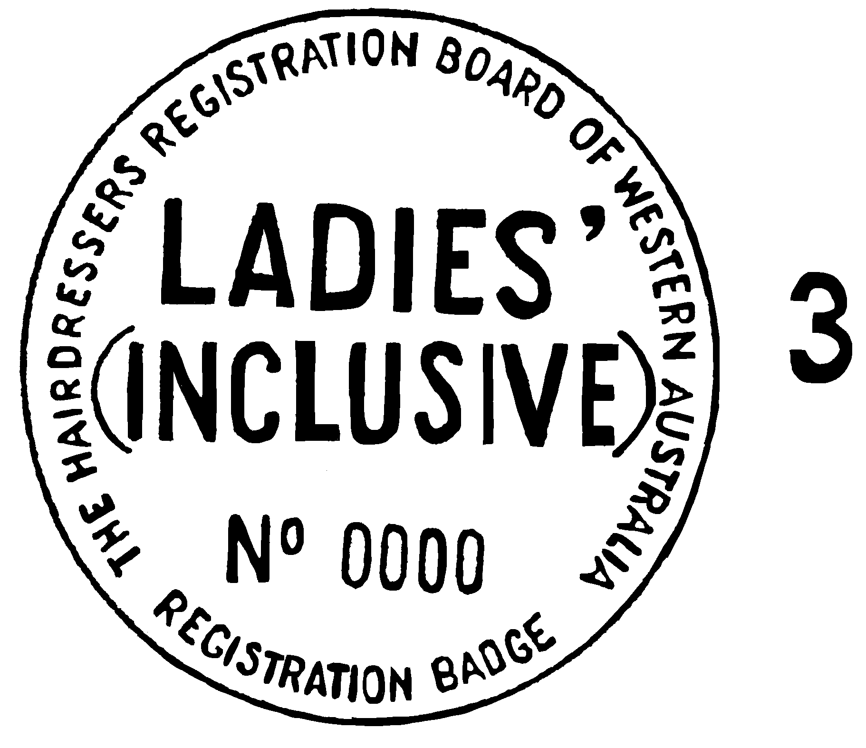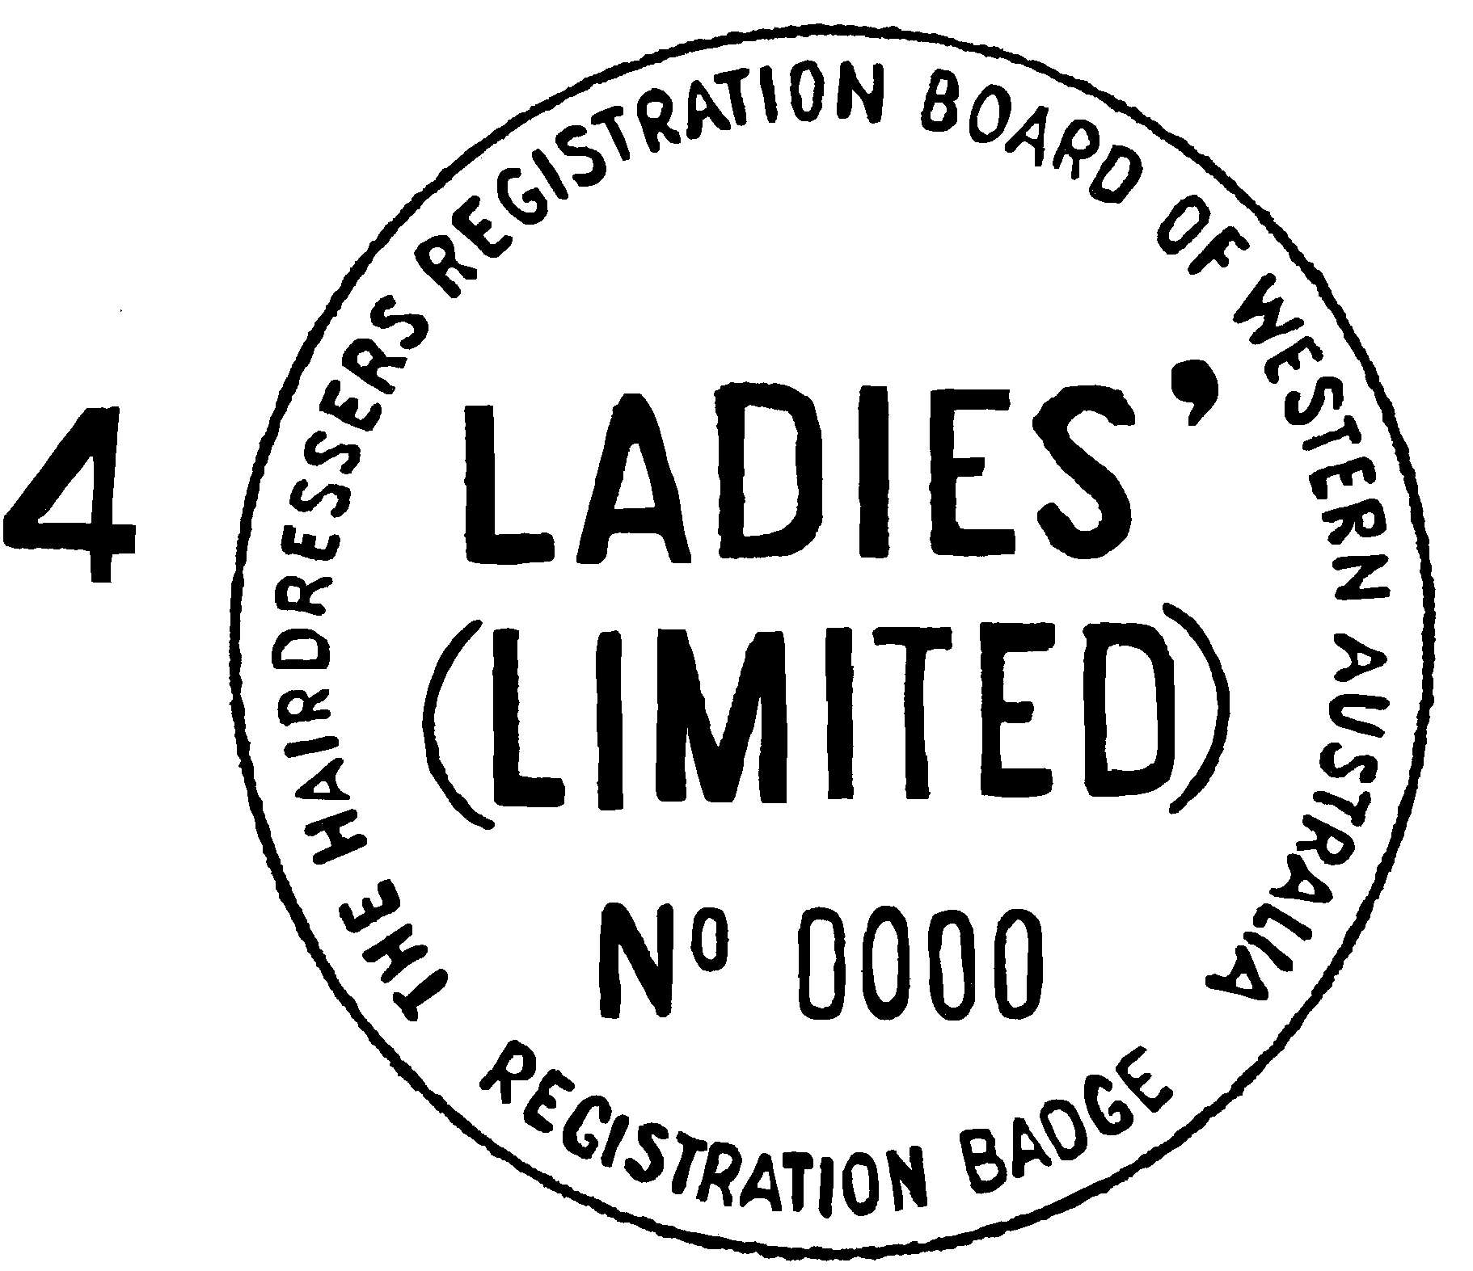
(Note: — Badges are to be numbered consecutively — size to be determined. Colour of badges is as follows: — Class 1 — all red; class 2 — all grey; class 3 — all blue; class 4 — all green; class 5 — all gold).
[Form 5 inserted in Gazette 17 December 1976 p.5005.]
Form No. 6
Western Australia
Hairdressers Registration Act 1946
APPLICATION FOR EXAMINATION
Date……………………………
To the Hairdressers Registration Board of Western Australia.
I…………………………………………………………………………………...
(Name in block letters)
of………………………………………………………………………………….
(Address)
hereby apply for examination in hairdressing:
Men’s inclusive
Men’s limited
Ladies’ inclusive
Ladies’ limited
Combined
(cross out what is not applicable)
…………………………………..
(Signature)
[Form 6 inserted in Gazette 17 December 1976 p.5005.]
Form No. 7
Western Australia
Hairdressers Registration Act 1946
(Regulation No. 20)
APPLICATION FOR REGISTRATION AS A HAIRDRESSER
(* Cross out whichever is not applicable)
* Employee
* Principal
To the Hairdressers Registration Board of Western Australia,
168 St. George’s Terrace, Perth.
Mr.
1. Mrs………………………………………………………………
Miss (Surname) (Christian names in full)
of (address)……………………………………………in the State of Western Australia hereby apply for registration in the following prescribed class(es) of hairdressing: —
† Strike out what does not apply.
† Men’s Hairdressing (Inclusive).
† Men’s Hairdressing (Limited).
† Ladies’ Hairdressing (Inclusive).
† Ladies’ Hairdressing (Limited).
† Combined Hairdressing.
2. My qualifications for such registration are as follows: —
(a) I am a person of good character as evidenced by the 2 testimonials attached to this application.
(b) (i) I have completed the following approved course of training in Western Australia (give details).
Apprenticeship to………………………………from………./………./19….
to………../………/19……..
(Name and address of salon proprietor)
and have passed the following examinations (give details of subjects passed and dates): —
………………………………………………………………
………………………………………………………………
(ii) I make this application pursuant to section 12(2) of the above Act by reason that —
(A) during a continuous period of not less than 5 years immediately preceding the date of this application I have been bona fide engaged in Western Australia in the practice of hairdressing in the class (or classes) as stated in detail in subparagraph (iii). I have been so engaged at the following addresses and between the following dates: —
………………………………………………………………………………………………………………………………………………………………………
OR
(B) (I) during a continuous period of
…………………………………………………
preceding the date of this application I have been bona fide engaged in Western Australia in the practice of hairdressing in the class (or classes) as stated in detail in subparagraph (iii). I have been so engaged at the following addresses and between the following dates: —
………………………………………………………………………………………………………………………………………………………
AND
(II) I have passed the following examinations (give details of subjects passed and dates): —
……………………………………………………………………………………………………
(iii) In connection with sub-subparagraph (ii) above I have, during the said period been practising the subjects of the sub-joined lists opposite which I have written the word “Yes.”
Men’s Hairdressing | Yes or No | Ladies’ Hairdressing | Yes or No
Dressing . . . . . . . . . . . | . . . . . . . . . . | Dressing . . . . . . . . . . . . . . | . . . . . . . . . . .
Curling and Waving (Ordinary) . . . . . . . . . | . . . . . . . . . . | Curling and Waving (Ordinary) . . . . . . . . . . . . | . . . . . . . . . . .
Cleansing . . . . . . . . . . | . . . . . . . . . . | Cleansing . . . . . . . . . . . . . | . . . . . . . . . . .
Haircutting . . . . . . . . . | . . . . . . . . . . | Haircutting . . . . . . . . . . . . | . . . . . . . . . . .
Shaving . . . . . . . . . . . | . . . . . . . . . . | Style blow drying . . . . . . | . . . . . . . . . . .
Style blow drying . . . . | . . . . . . . . . . | Blow wave . . . . . . . . . . . . | . . . . . . . . . . .
Beard trimming . . . . . | . . . . . . . . . . | Bleaching* . . . . . . . . . . . . | . . . . . . . . . . .
Bleaching* . . . . . . . . . | . . . . . . . . . . | Tinting* . . . . . . . . . . . . . . | . . . . . . . . . . .
Tinting* . . . . . . . . . . . | . . . . . . . . . . | Colouring* . . . . . . . . . . . . | . . . . . . . . . . .
Colouring* . . . . . . . . . | . . . . . . . . . . | Curling* . . . . . . . . . . . . . . | . . . . . . . . . . .
Curling* . . . . . . . . . . . | . . . . . . . . . . | Waving* . . . . . . . . . . . . . | . . . . . . . . . . .
Waving* . . . . . . . . . . . | . . . . . . . . . .
* With the use of chemical preparations or substances or electrical apparatus or appliances.
Office Use Only.
……………………………………………………………………………………………………………………………………………………………………………………………………………………………………………………………………………………………………………………………………………………
(See over page)
(iv) I have outside of Western Australia completed the following appropriate course(s) of training and have passed the following examination(s). (Please give full details with dates — approximate if necessary — of all training and experience, also names and addresses where you have worked) ……………………………………………………………………………………………………………………………………………………………………………………………………………………………………………………………………………………………………………………………………………
3. Registration fee ($30.00 principal or $15.00 employee) accompanies this application.
Dated at………………….this…………………….day of………………………. 19……….
………………………………….
Signature of Applicant
Declaration
I, the abovenamed applicant, do solemnly and sincerely declare that the particulars contained in my above application are true and correct and I make this declaration under the provisions of section 106 of the Evidence Act 1906.
Declared at………………………………….in the State of Western Australia this………………………………day of……………………………...19……….
………………………………..
Applicant
Before me……………………………………………….
J.P., or Commissioner for Declarations
PRESCRIBED CLASSES OF HAIRDRESSING
(1) Men’s Hairdressing (Inclusive) which comprises dressing, curling, waving, cleansing, cutting, shaving, beard trimming, style blow drying, bleaching, tinting colouring of the hair of the head or beard of any male person whether with or without the aid of any apparatus, appliance, preparation or substance. It includes the usual maintenance and use of equipment and tools of trade as practised in Men’s Hairdressers’ Shops.
(2) Men’s Hairdressing (Limited) which comprises dressing, cutting, style blow drying of the hair of the head of any male person whether with or without the aid of any apparatus, appliance, preparation or substance.
(3) Ladies’ Hairdressing (Inclusive) which comprises dressing, curling, waving, cleansing, cutting, style blow drying, blow wave, bleaching tinting colouring of the hair of the head of any female person whether with or without the aid of any apparatus, appliance, preparation or substance.
(4) Ladies’ Hairdressing (Limited) which comprises cutting, style blow drying of the hair of the head of any female person, whether with or without the aid of any apparatus, appliance, preparation or substance.
(5) Combined Hairdressing which comprises dressing, curling, waving, cleansing, cutting, shaving, beard trimming, style blow drying, blow wave, bleaching, tinting colouring of the hair of the head or beard of any male person or the hair of the head of any female person whether with or without the aid of any apparatus, appliance, preparation or substance. It includes the usual maintenance and use of equipment and tools of trade as practised in hairdressers’ shops.
[Form 7 amended in Gazette 10 December 1970 p.3792; 19 December 1975 p.4604; 17 December 1976 pp.5006-7; 28 December 1979 p.4056; 11 October 1985 pp.3971-2; 26 July 1985 p.2670.]

Notes
¹ This is a compilation of the Hairdressers Registration Regulations 1965 and includes the amendments made by the other written laws referred to in the following table.

Compilation table
Citation | Gazettal | Commencement
Hairdressers Registration Regulations 1965 | 21 Jul 1965 p. 2121-32 | 21 Jul 1965
 | 8 Nov 1974 p. 5039 | 8 Nov 1974
 | 19 Dec 1975 p. 4604 | 19 Dec 1975
 | 17 Dec 1976 p. 5003-7 | 17 Dec 1976
 | 26 May 1978 p. 1640 | 26 May 1978
 | 28 Dec 1979 p. 4056 | 1 Jan 1980 (see Gazette 28 Dec 1979 p. 4056)
 | 13 Jun 1980 p. 1752 | 13 Jun 1980
Hairdressers Amendment Regulations 1982 | 5 Feb 1982 p. 441 | Regulation 4 operative 15 Feb 1982; balance:  5 Feb 1982 (see r. 2)
Hairdressers Registration Amendment Regulations 1983 | 6 Jan 1984 p. 18  (This amendment had no effect being superceded by the amendment of 16 March 1984) | 6 Jan 1984
Hairdressers Registration Amendment Regulations 1984 | 16 Mar 1984 p. 716 | 16 Mar 1984
Hairdressers Registration Amendment Regulations (No.2) 1984 | 30 Mar 984 p. 910 | 30 Mar 1984
Hairdressers Registration Amendment Regulations (No.3) 1984 | 2 Nov 1984 p. 3545 | 2 Nov 1984
Hairdressers Registration Amendment Regulations (No.4) 1984 | 7 Dec 1984 p. 4082 | 1 Jan 1985 (see r. 2)
Hairdressers Registration Amendment Regulations 1985 | 26 Jul 1985 p. 2670 | 26 Jul 1985
Hairdressers Registration Amendment Regulations (No.2) 1985 | 26 Jul 1985 p. 2670-1 | 1 Jan 1986 (see r. 2)
Hairdressers Registration Amendment Regulations (No.3) 1985 | 11 Oct 1985 p. 3971-2 | 11 Oct 1985
Hairdressers Registration Amendment Regulations 1986 | 31 Oct 1986 p. 4101 | 1 Jan 1987 (see r. 2)
Hairdressers Registration Amendment Regulations 1987 | 8 May 1987 p. 2101-2 | 8 May 1987
Hairdressers Registration Amendment Regulations (No.2) 1987 | 27 Nov 1987 p. 4312 | 1 Jan 1988 (see r. 2)
Hairdressers Registration Amendment Regulations 1988 | 24 Jun 1988 p. 2061 | 24 Jun 1988
Hairdressers Registration Amendment Regulations (No.2)1988 | 24 Jun 1988 p. 2061 | 24 Jun 1988
Hairdressers Registration Amendment Regulations (No.3)1988 | 30 Dec 1988 p. 5115 | 1 Jan 1989 (see r. 2)
Hairdressers Registration Amendment Regulations 1989 | 15 Dec 1989 p. 4525 | 1 Jan 1990 (see r. 2)
Hairdressers Registration Amendment Regulations 1998 | 16 Jun 1998 p. 3255 | 16 Jun 1998
Hairdressers Registration Amendment Regulations 2003 | 4 Apr 2003 p. 1024-5 | 4 Apr 2003
Hairdressers Registration Amendment Regulations 2004 | 29 Jun 2004 p. 2510-11 | 1 Jul 2004 (see r. 2)
Hairdressers Registration Amendment Regulations 2005 | 28 Jun 2005 p. 2915-16 | 1 Jul 2005 (see r. 2)
Hairdressers Registration Amendment Regulations 2006 | 12 May 2006 p. 1782-3 | 12 May 2006
Hairdressers Registration Amendment Regulations (No. 2) 2006 | 27 Jun 2006 p. 2266-7 | 1 Jul 2006 (see r. 2)
² Repealed by the Industrial Relations Act 1979 (No. 114 of 1979).

