Western Australia

South Fremantle Oil Installations Pipe Line Act 1948

Western Australia
South Fremantle Oil Installations Pipe Line Act 1948
Contents
1. Short title 1
2. Interpretation 1
3. Power to use and maintain pipe line 2
4. Notice to be served and plan deposited before breaking up streets, etc. 2
5. Streets broken up to be reinstated without delay 3
6. Penalty for breaking up without notice or delay in reinstating 4
7. In cases of delay other parties may reinstate and recover expenses 4
8. When streets broken up room to be allowed for vehicles to pass 5
9. Operator to make compensation for any damage 5
10. Offences 5
11. Court in which proceedings to be taken 6
12. Payment in lieu of rates 6
The Schedule
Notes
Compilation table 9

Western Australia
South Fremantle Oil Installations Pipe Line Act 1948
An Act to authorize the maintenance and use by the Commonwealth of Australia or its assigns of a certain oil pipe line and for other purposes incidental thereto.
Be it enacted by the King's Most Excellent Majesty, by and with the advice and consent of the Legislative Council and Legislative Assembly of Western Australia, in this present Parliament assembled, and by the authority of the same, as follows: —

1. Short title
This Act may be cited as the South Fremantle Oil Installations Pipe Line Act 1948.

2. Interpretation
In this Act, unless the context otherwise requires —
Commonwealth means the Commonwealth of Australia;
local authority means, within their respective jurisdictions the City of Fremantle, the Fremantle Road Board, the Commissioner of Railways and the Fremantle Port Authority;
Minister means the Minister for Works and also any other Minister of the Crown charged for the time being with the administration of the Public Works Act 1902-1945;
operator means the Commonwealth and also any person who may at any time with the consent of the Commonwealth, use the pipe line;
pipe line means the pipe line constructed by the Commonwealth along the route delineated on the plan in the Schedule to this Act or any part of such pipe line, together with all mains, service pipes, fixtures, fittings and appliances connected with or affixed to such pipe line.
[Section 2 amended: No. 5 of 1999 s.21.]

3. Power to use and maintain pipe line
Subject to the provisions of this Act, the operator may —
(a) use and maintain the pipe line;
(b) open, break up, and interfere with the soil or surface of any road, street, bridge, railway, wharf or reserve along the route traversed by the pipe line for the purpose of repairing, altering, renewing or removing the pipe line or any part thereof and for such purpose may remove any earth and material in or under such road, street, bridge, railway, wharf or reserve:
Provided that the power to open, break up, or interfere with any reserve, railway or wharf shall be exercised only with the consent of the Minister administering the Land Act 1933-1946, or the Government Railways Act 1904-1947, or the Port Authorities Act 1999, and its amendments, respectively, and subject to such conditions as such Minister may deem expedient.
[Section 3 amended: No. 5 of 1999 s.21.]

4. Notice to be served and plan deposited before breaking up streets, etc.
(1) Before the operator proceeds to open, break up or interfere with any road, street, bridge, railway, wharf, or reserve it shall give to the Minister and to the local authority concerned, notice in writing of its intention so to do not less than three clear days before commencing such work and shall at the same time deposit with the Minister and local authority a plan setting forth the extent to and the manner in which it proposes to carry out such work, and the time at which it is intended to commence the same, and, except as hereinafter provided, no road, street, bridge, railway, wharf or reserve shall be opened, broken up or interfered with unless under the superintendence of the Minister and the local authority and in accordance with the plan deposited as aforesaid:
Provided always that if no officer appointed by the Minister or no officer appointed by the local authority attends at the time fixed in such notice and remains during the opening, breaking up, or interference with any road, street, bridge, jetty, railway, wharf or reserve, the operator may, subject to the proviso to paragraph (b) of section three of this Act, perform the work specified in such notice and set out in such plan without the superintendence of the Minister and the local authority, or either of them, as the case may be:
Provided further that in cases of emergency arising from accidents to or defects in the pipe line necessitating the opening, breaking up of, or interference with, any road, street, bridge, railway, wharf or reserve, such accidents or defects may be repaired or remedied without previous notice and without the deposit of any plan, but such notice shall be given and such plan shall be deposited as soon as possible after the necessity for the work has arisen.
(2) The operator shall pay to the Minister and to the local authority, the costs respectively incurred by or occasioned to them in respect of any examination or preparation of plans or of the superintendence or inspection of any work performed by the operator under this Act.

5. Streets broken up to be reinstated without delay
Whenever the operator opens, breaks up or interferes with any road, street, bridge, railway, wharf or reserve, it shall with all convenient speed, complete the work and make good the same to the satisfaction of the Minister and the local authority concerned, and shall immediately upon completion of the work, carry away all rubbish occasioned thereby, and whilst any road, street, bridge, railway, wharf or reserve shall be opened, broken up or interfered with, the operator shall cause the same to be properly guarded and sufficiently lighted and shall affix adequate signs or notices on or near the works for the warning of the public, and shall, on completion of the work, re-surface such part of any road, street, bridge, railway or wharf as shall have been opened, broken up or interfered with and when and as required by the Minister of the local authority, keep the same in good repair for six months after replacing, making good and re-surfacing the same.

6. Penalty for breaking up without notice or delay in reinstating
If the operator (being a person other than the Commonwealth of Australia) commits, permits or suffers any act, delay, neglect of omission, contrary to the provisions of sections four and five of this Act and be liable to a penalty not exceeding fifty pounds for every such offence and an additional penalty of forty shillings for each day during which any such neglect, omission, or delay shall continue after notice thereof by the Minister or local authority:
Provided that nothing in this section contained shall relieve the operator (being either the Commonwealth of Australia or any other person) from liability in respect of the right of action or remedy of any person for any act, delay, neglect or omission on the part of the operator contrary to the provisions of sections four and five of this Act.

7. In cases of delay other parties may reinstate and recover expenses
If any such delay, neglect or omission contrary to the provisions of sections four and five of this Act, take place, the Minister or local authority may cause any work so delayed, neglected or omitted to be completed, executed or performed, and all expenses so incurred shall be repaid to the Minister or the local authority, as the case may be, by the operator:
Provided that nothing in this section contained shall render it compulsory for the Minister or local authority to complete, execute or perform any such work or render either of them liable for any delay, neglect or omission so to do.

8. When streets broken up room to be allowed for vehicles to pass
Whenever the operator opens, breaks up or interferes with any road or street, it shall so carry out such work as to allow room in such road or street for at least one vehicle, of the maximum width permitted to travel along such road or street, to pass the said works and in any case where room is allowed for only one such vehicle to pass while the road or street is being opened, broken up or interfered with, the operator shall not open, break up, or interfere with more than fifty yards of such road or street at any one time and in any other case, the operator shall not open, break up or interfere with more than one hundred yards of such road or street at any one time.

9. Operator to make compensation for any damage
The operator shall do as little damage and cause as little inconvenience as may be in the execution of the powers conferred by this Act, and shall make compensation for any physical damage which may be done in the execution of such powers.

10. Offences
Any person who —
(a) lays or causes to be laid any pipe to connect with the pipe line without the consent of the operator first had and obtained for that purpose; or
(b) erects or keeps erected any apparatus or fitting where by oil, liquid fuel, petroleum, spirits, kerosene or petroleum products may be obtained from any part of the pipe line without the consent in writing of the operator first had and obtained for that purpose; or
(c) wilfully or by negligence removes, destroys or damages any part of the pipe line,
shall be guilty of an offence against this Act and shall without prejudice to any right or remedy of the operator to recover damages, be liable to a penalty not exceeding five pounds for every such offence.

11. Court in which proceedings to be taken
All penalties in respect of offences under this Act may be recovered in a court of summary jurisdiction.

12. Payment in lieu of rates
The pipe line shall, whenever any operator other than the Commonwealth has the right to use the same, be deemed to be rateable land, but in lieu of the provisions of the Municipal Corporations Act 1906-1947, and the Road Districts Act 1919-1947, relating to the valuation of land and the making of rates in respect thereof, such operator shall, in each and every year during which the right to use the pipe line shall subsist, pay to the City of Fremantle and the Fremantle Road Board, a sum equal to one-eighth per centum of the amount actually received by the operator for the sale of the oil and liquid fuel conveyed through the pipe line during the twelve months ending on the thirty-first day of December immediately preceding, or the sum of one hundred pounds, whichever amount shall be the greater.
The amount to be payable by the operator under this section shall be paid on or before the thirty-first day of March in each year and shall be apportioned between the City of Fremantle and the Fremantle Road Board proportionately to the length of the pipeline with the Fremantle Municipal District and the Fremantle Road District, respectively, and shall be in full satisfaction and discharge of all rates and rents, if any, payable to the City of Fremantle and to the Fremantle Road Board in respect of the pipe line:
Provided that it shall be lawful for the operator and the City of Fremantle and the Fremantle Road Board by mutual agreement to vary any one or more of the provisions of this section relation to the method of computing the amount payable by the operator under this section, the minimum amount so payable, the time of payment of such amount and the apportionment between the City of Fremantle and the Fremantle Road Board of any such amount.

The Schedule
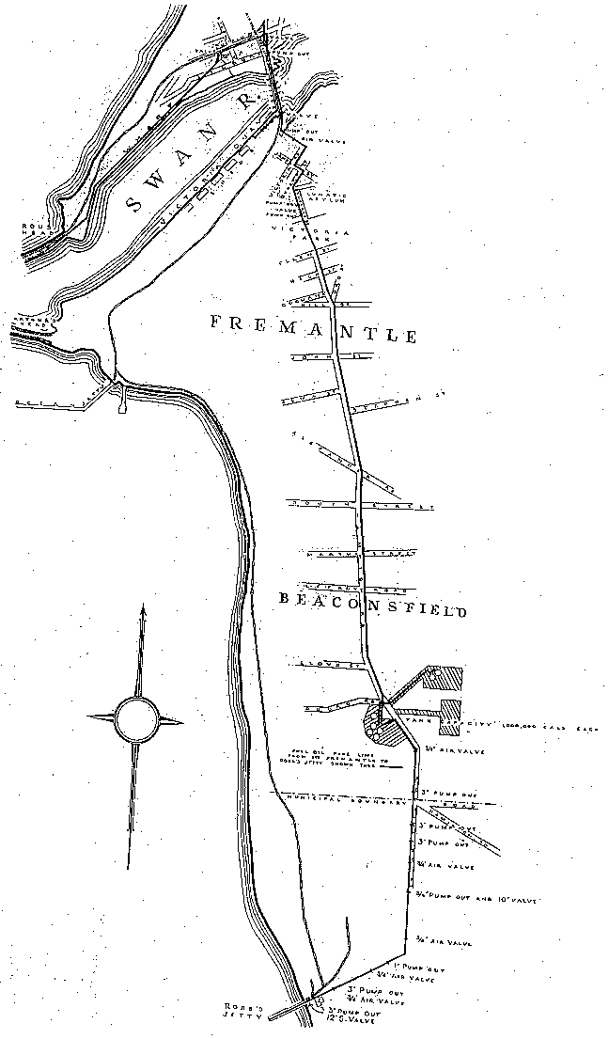

Notes
^{1.} This is a compilation of the South Fremantle Oil Installations Pipe Line Act 1948 and includes all amendments effected by the other Acts referred to in the following Table.

Compilation table
Short title | Number and year | Assent | Commencement
South Fremantle Oil Installations Pipe Line Act 1948 | 48 of 1948 | 7 Jan 1949 | 7 Jan 1949
Port Authorities (Consequential Provisions) Act 1999,  section 21 | 5 of 1999 | 13 Apr 1999 | 14 Aug 1999 (see s. 2 and Gazette 13 Aug 1999 p.3823)

Defined terms

[This is a list of terms defined and the provisions where they are defined. The list is not part of the law.]
Defined term Provision(s)
Commonwealth 2
local authority 2
Minister 2
operator 2
pipe line 2

