Western Australia
Health Act 1911

Health (Meat Inspection, Branding and Processing) Regulations 1950
These regulations were repealed by the Health (Meat Hygiene) Regulations 2001 r. 28(c) as at 1 Jun 2001 (see Gazette 1 Jun 2001 p. 2760)

Reprinted under the Reprints Act 1984 as
at 1 June 2001
Western Australia
Health (Meat Inspection, Branding and Processing) Regulations 1950
Contents
1. Citation 1
1AA. Interpretation 1
1A. Inspection powers 2
1B. Adoption of Australian Standard for Hygienic Production of Meat for Human Consumption 2
1C. Compliance with Australian Standard for Hygienic Production of Meat for Human Consumption 3
2. Carcass to be branded 3
3. Restrictions on sale of meat 5
3A. Importation of meat from another State or Territory 6
4A. Meat on premises 7
4B. Restriction on removing meat where meat is being sold or is being offered for sale 8
5. Appointed places where meat to be exhibited for inspection 8
6. Fees 11
6A. Offences and penalties 13
7. Repeal 14
Schedule A
Schedule B
Schedule C
Schedule D
Notes
Compilation table 46

Reprinted under the Reprints Act 1984 as
at 1 June 2001
Western Australia
Health Act 1911
Health (Meat Inspection, Branding and Processing) Regulations 1950

1. Citation
These regulations may be cited as the Health (Meat Inspection, Branding and Processing) Regulations 1950 ¹.
[Regulation 1 inserted in Gazette 10 October 1980 p.3460; amended in Gazette 11 April 1997 p.1828.]

1AA. Interpretation
In these regulations unless the context otherwise requires —
“inspector” means —
(a) an officer appointed under section 6 of the Health Legislation Administration Act 1984;
(b) an officer appointed under section 27 of the Health Act 1911; or
(c) a meat inspector employed by the Commonwealth under the Public Service Act 1922 and performing meat inspection functions in accordance with an arrangement between the Commonwealth and the State;
“rabbit” means a rabbit farmed under the permit issued under regulation 16 of the Agriculture and Related Resources Protection (Declared Animals) Regulations 1985, employing the caged system of rabbit housing.
[Regulation 1AA inserted in Gazette 20 February 1987 p.451; amended in Gazette 28 June 1991 p.3147; 8 November 1991 p.5724 (disallowed in Gazette 13 December 1991 p.6237).]

1A. Inspection powers
Every animal slaughtered for food, and every carcass or portion thereof imported for food, shall be subject to inspection by an inspector.
[Regulation 1A inserted in Gazette 10 October 1980 p.3460; amended in Gazette 29 June 1984 p.1783; 8 November 1991 pp.5724-5 (disallowed in Gazette 13 December 1991 p.6237).]

1B. Adoption of Australian Standard for Hygienic Production of Meat for Human Consumption
(1) Subject to this regulation, the Australian Standard for Hygienic Production of Meat for Human Consumption (Standing Committee on Agriculture and Resources Management: Report No. 54) is adopted —
(a) as a whole; and
(b) as amended from time to time.
(2) A reference in the adopted standard to the controlling authority, shall be read as a reference to the Executive Director, Public Health.
(3) The Executive Director, Public Health is not to approve a quality assurance arrangement referred to in clause 4 of the adopted standard for any premises unless he or she is satisfied that at least one government inspector will be present at the premises when carcasses are being processed for human consumption.
(4) In clause 4(c) of the adopted standard a reference to company employees includes a reference to government inspectors.
(5) In this regulation —
“government inspector” means a person referred to in paragraph (a) or (b) of the definition of “inspector”;
“the adopted standard” means the Australian Standard referred to in subregulation (1).
[Regulation 1B inserted in Gazette 11 April 1997 p.1828; amended in Gazette 30 September 1997 pp.5424-5.]

1C. Compliance with Australian Standard for Hygienic Production of Meat for Human Consumption
The inspection and processing of carcasses shall be undertaken in accordance with the Australian Standard referred to in regulation 1B.
[Regulation 1C inserted in Gazette 11 April 1997 p.1828.]

2. Carcass to be branded
Every carcass, other than a game carcass as defined in section 207A of the Act, passed by an inspector as wholesome shall be branded by or under the direction of such inspector with one of the brands described or set out in Schedule A.
Except in the case of rabbits, the brand shall be affixed to each side of the carcass and, in every case, the brand shall be affixed as illustrated or specified as follows —
(a) In the case of beef —
(1) On the upper surface of the tongue.
(2) On the outside of the buttock.
(3) On the outside of the ribs.
(4) On the inside of the pelvic cavity.
(5) On the shoulder.
(b) In the case of sheep, lambs, goats or deer —
(1) On the outside of the leg.
(2) On the outside of the shoulder.
(c) In the case of pigs —
(1) On the outside of the leg.
(2) On the outside of the loin.
(3) On the outside of the shoulder.
(4) On the outside of the cheek.
(d) In the case of calves —
Non-flayed carcasses:
(1) On the parietal peritoneum of the abdominal wall.
(2) On the parietal pleura of the thorax wall.
(3) On the brisket.
Flayed carcasses shall be branded as specified in this regulation for the branding of beef carcasses.
“Calf” shall mean a bovine animal of under 70 kilograms.
(da) In the case of rabbit —
On one side of the neck.
(e) The inspector rejecting any carcass or part of a carcass as unfit for consumption shall brand such carcass or part carcass with a brand as shown hereunder, the outline of the brand to be broken at 12 places as shown: —
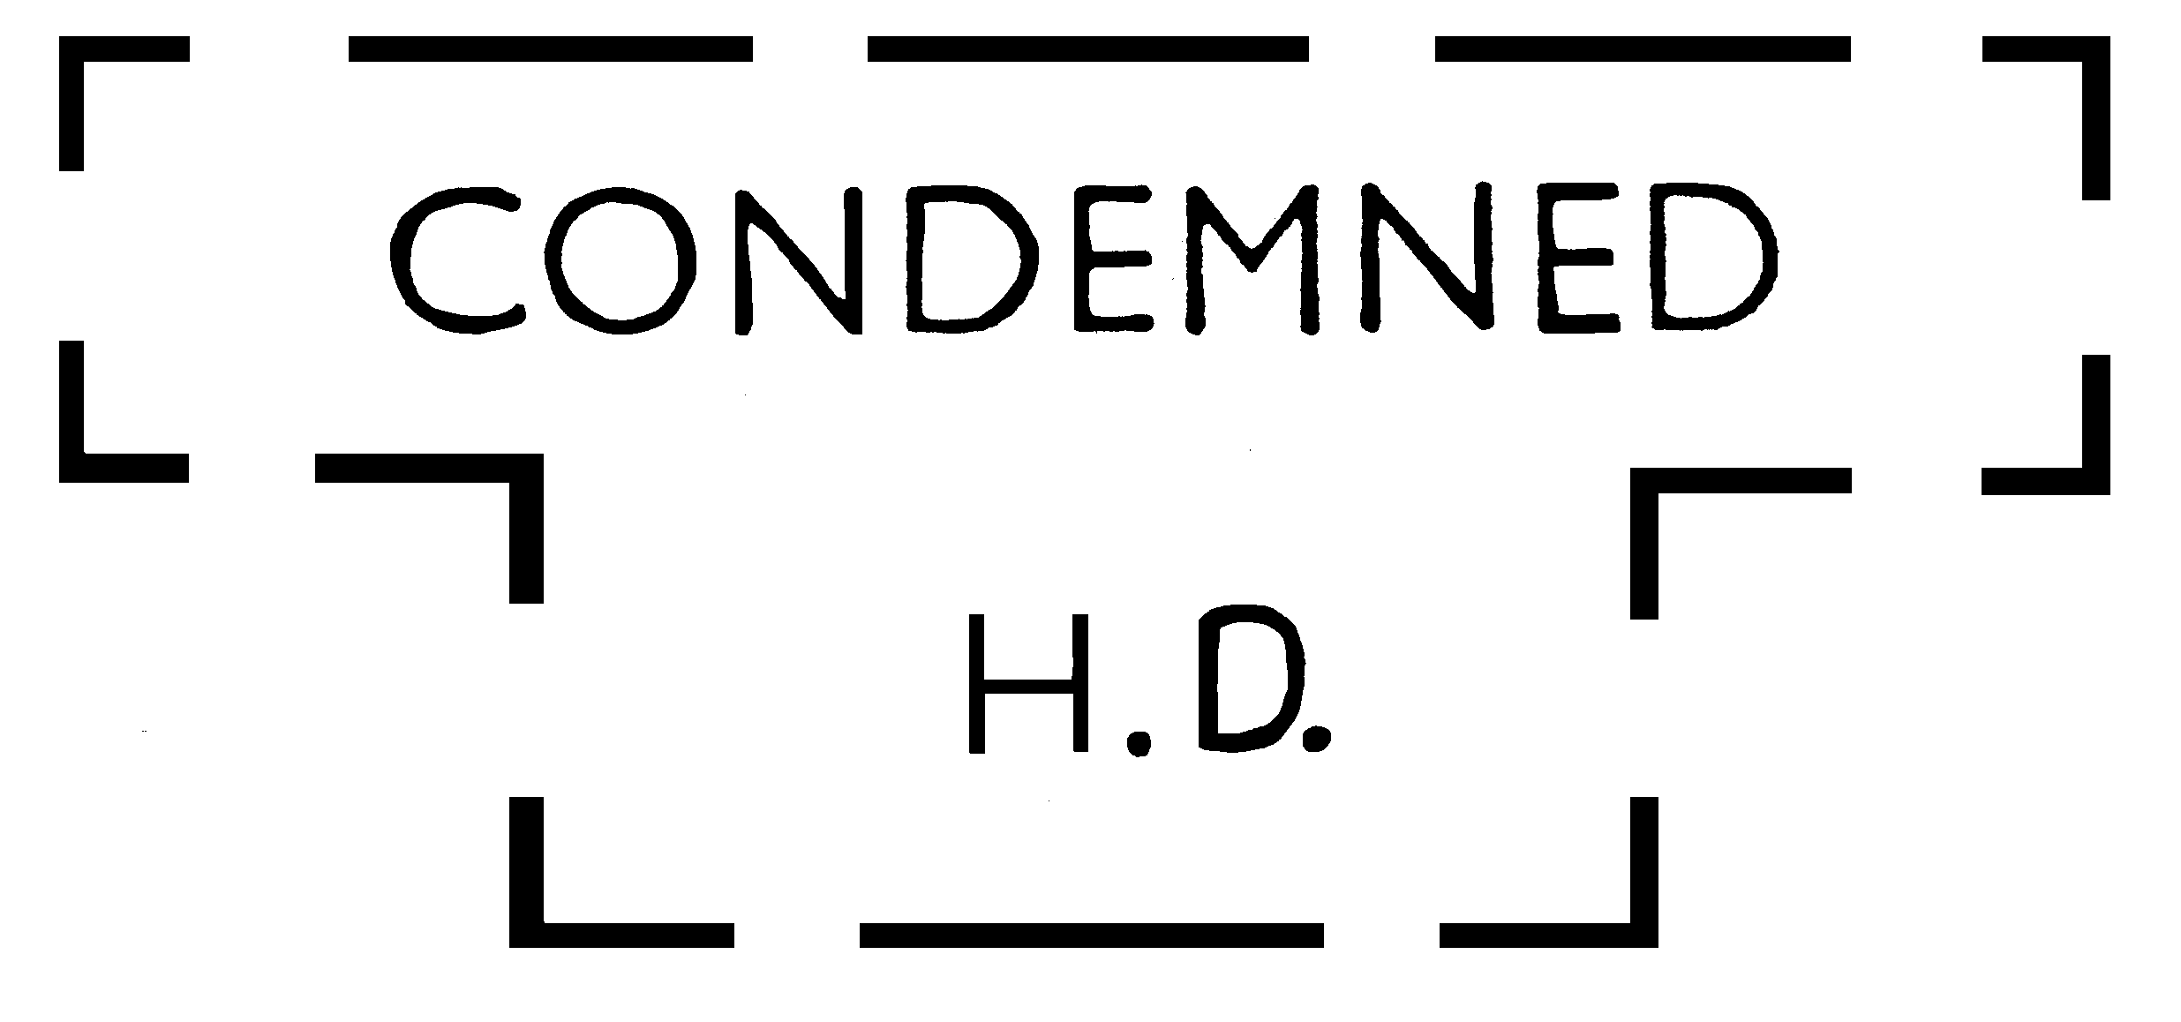
Such brand shall be applied to the shoulders, loins, and legs of every rejected carcass, or to such portion of a carcass as may be rejected.
Such rejected carcasses or portion of a carcass shall be dealt with by the inspector in accordance with Part VIII of the Health Act 1911.
(f) The colour of a brand applied under this regulation shall be red shade, made from —
(1) one of the synthetic colouring substances specified in Standard A5(2)(d)(i) of the Food Standards Code (as defined in the National Food Authority Act 1991 of the Commonwealth, and as adopted by the Health (Adoption of Food Standards Code) Regulations 1992); or
(2) such other substance as is approved by the Executive Director, Public Health from time to time.
[Regulation 2 amended in Gazette 5 October 1973 p.3659; 11 January 1974 p.61; 14 August 1981 p.3309; 27 January 1984 p.236; 29 June 1984 p.1783; 20 February 1987 p.451; 17 February 1989 p.465; 28 June 1991 p.3147; 23 December 1992 p.6250; 12 May 1995 p.1779.]

3. Restrictions on sale of meat
(1) No person shall, within any of the health districts specified in Schedule B —
(a) sell, offer to sell or expose for sale; or
(b) purchase for resale, or otherwise acquire for resale,
any carcass or portion of a carcass that —
(c) does not bear a brand indicating that it has been passed as wholesome in accordance with regulation 2; or
(d) has not been, or is not deemed to have been, inspected and branded as fit for human consumption in accordance with Part 4 of the Health (Game Meat) Regulations 1992.
(2) No person shall, within any of the health districts specified in Schedule B —
(a) sell, offer to sell or expose for sale; or
(b) purchase for resale, or otherwise acquire for resale,
any piece meat or comminuted meat unless that meat is accompanied by a certificate signed by an inspector or veterinary officer indicating that the meat has been inspected and passed as wholesome.
[Regulation 3 inserted in Gazette 6 February 1968 p.221; amended in Gazette 8 November 1991 p.5725 (disallowed in Gazette 13 December 1991 p.6237); 23 December 1992 p.6250; 29 February 2000 p.991.]

3A. Importation of meat from another State or Territory
No person shall bring or cause or permit to be brought into the State from another State or Territory of the Commonwealth, meat of an animal for the purposes of sale for human consumption unless —
(a) the animal from which the meat is derived was slaughtered at premises that are certified by an inspector of the State or Territory of origin as conforming to the Australian Code of Practice for Construction and Equipment of Abattoirs;
(b) the meat has been inspected in accordance with the laws of the State or Territory of origin;
(c) the meat is accompanied by a meat inspection health certificate issued by an inspector of the State or Territory of origin; and
(d) the meat bears a brand of certification given by an inspector of the State or Territory of origin.
[Regulation 3A inserted in Gazette 15 December 1989 p.4547.]

[4. Repealed in Gazette 6 February 1968 p.221.]

4A. Meat on premises
(1) Subject to subregulation (2) the occupier of any premises wherein food is stored or prepared for sale or sold, and which are within any district mentioned in Schedule B, commits an offence if there is at any time on the premises a carcass or any portion of a carcass or any other meat which —
(a) has not been inspected and passed as fit for human consumption in accordance with these regulations; or
(b) has not been, or is not deemed to have been, inspected and branded as fit for human consumption in accordance with Part 4 of the Health (Game Meat) Regulations 1992.
(2) (a) The provisions of subregulation (1) do not apply if the carcass or portion of the carcass is kept on those premises pursuant to a written permit issued by the local government of the district or by an officer duly authorized by the local government authorizing the occupier of those premises to keep it on the premises pending submission for inspection.
(b) The permit referred to in paragraph (a) —
(i) must contain particulars of the carcass or portion of carcass or of the number of carcasses or portions of carcasses (if more than one) and a description of each carcass or portion of carcass the subject of the permit; and
(ii) shall have no force or effect after the expiry of the period of validity specified in the permit.
[Regulation 4A inserted in Gazette 20 January 1959 p.241; amended in Gazette 6 February 1968 p.221; 8 November 1991 p.5725 (disallowed in Gazette 13 December 1991 p.6237); amended in Gazette 23 December 1992 p.6250; 29 October 1996 p.5721; 29 February 2000 p.991.]

4B. Restriction on removing meat where meat is being sold or is being offered for sale
No person shall remove from any place at which unmarked or unbranded meat prior to being sold or offered or exposed for sale is exhibited for inspection, or from any slaughter-house or other premises connected therewith, situated within any of the health districts specified in Schedule B, any carcass or portion of a carcass which —
(a) has not been inspected and passed as fit for human consumption in accordance with these regulations; or
(b) has not been, or is not deemed to have been, inspected and branded as fit for human consumption in accordance with Part 4 of the Health (Game Meat) Regulations 1992.
[Regulation 4B inserted in Gazette 19 August 1965 p.2345; amended in Gazette 16 December 1965 p.4159; 8 November 1991 p.5725 (disallowed in Gazette 13 December 1991 p.6237); 23 December 1992 p.6251; 29 February 2000 p.991.]
[Regulation 4C inserted in Gazette 8 November 1991 pp.5725-6 (disallowed in Gazette 13 December 1991 p.6237).]
[Regulation 4D inserted in Gazette 8 November 1991 p.5726 (disallowed in Gazette 13 December 1991 p.6237).]

5. Appointed places where meat to be exhibited for inspection
The following places are appointed to be places at which all unmarked or unbranded meat prior to being sold or offered or exposed for sale shall be exhibited for inspection —
Albany — Thomas Borthwick and Sons (A/asia) Ltd., Deepwater Jetty
Augusta-Margaret River — Sussex Location 3947(Karridale)
Boddington — Williams Location 15608 Greys Road
Boyanup — AA Location 222
Boyup Brook — Abattoir on Nelson Location 1005
Bridgetown — Local Government Hall
Bruce Rock Abattoirs on Avon Location 16216D, Reserve 13033
Bunbury — Local Government Offices
Busselton — Local Government Offices
Canning — 37-45 Ewing Street, Bentley
Carnamah — Lot 82, Lakes Road
Carnarvon — Abattoir at Lot 310, North River Road; also Local Government Office, Lot 233, Francis Street, Carnarvon
Collie — Local Government Offices
Coolgardie — Coolgardie Slaughterhouse
Cuballing — Narrogin AA Lot 16
Dandaragan — Local Government Offices, Lot 124, Bashford Street, Jurien
Dardanup — J. L. Gardiner & Son — Pt. 2 of Location 854, Dardanup
Denmark — Thompsons Butchers, Denmark; also Iwankiws Slaughter Yards, Scotsdale, via Denmark
Esperance — Local Government Offices
Fitzroy Crossing — Urabi Location 19
Fremantle — City Meat Inspection Depot, Lot 92 of C.S.L., 551 Pritchard Street, O’Connor
Geraldton — Local Government Offices
Goomalling — Avon Location 11578
Government Abattoirs, South Fremantle
Government Abattoirs, Midland Junction
Greenough — Geraldton Meat Export Works, Narngulu, at the Narngulu Abattoirs site
Halls Creek — Halls Creek Meat Supply, Lot 42, Bulara, Halls Creek
Kalgoorlie — Abattoirs, Kalgoorlie
Kalgoorlie — Local Government Offices
Katanning — Local Government Abattoirs on Pinwernying Sub-lot 36 at Katanning
Kojonup — Location 5164, Kojonup Abattoirs, Lot 218, Katanning Road
Kununurra — Abattoir on King Location 438
Manjimup — Local Government Office
Moora — Slaughter Yard at Melbourne Location 18 of Original Location 908
Murray Area — Local Government Office, Pinjarra Road, Pinjarra
Nabawa — Rossvale Meats, Nabawa
Nannup — Nannup Location No. 853
Narrogin — Lot 109, Forrest Street, Narrogin
Northam — Local Government Ice Works, Glebe Street, Northam
Northampton — Victoria Location 10791
Perth — Metropolitan Market Trust Building, Wellington Street
Perth — Thomas Borthwick and Sons Ltd., 106 Burswood Road, Victoria Park
Picton Junction — Lot 1 of Leschenault Location 12
Plantagenet Area — Local Government Office, Lowood Road, Mt. Barker
(a) J. B. Mitchell’s slaughter house on part Wellington Location 190, or Egan & Co’s slaughter house on part Wellington Location 323 in respect of meat brought in from within the meat inspection area
(b) In respect of meat brought in from outside the meat inspection area, the Preston Local Government Office
Port Hedland — Location 33 situated at Redbank, Port Hedland
Rockingham — Baldivis Poultry, Mandurah Road, Baldivis
Sussex-Busselton — Sussex Location 5, Lot 162, and part of Sussex Location 1, Lot 12
Tammin — Abattoir on Tammin Agricultural Area Lot 1
Three Springs — Rossiters & Co. Abattoirs, Victoria Location, Lot Pt. M765
Toodyay — Local Government Office, Fiennes Street, Toodyay
Wagin — Williams Location 3495
West Arthur — Darkan Abattoirs
Williams — Williams Location 6558
West Pilbara — Tom Price Shire Office
Wongan-Ballidu Area — Wongan Hills Suburban Lot 167
York — Lot 7, Joaquina Street, York
[Regulation 5 inserted by Gazette 9 November 1971 pp.4327-8; amended by Gazette 23 December 1971 p.5319; 13 April 1972 p.795; 20 July 1973 p.2707; 13 December 1974 p.5328; 10 December 1976 p.4895; 15 September 1978 p.3409; 10 October 1980 p.3460; 27 February 1981 p.805; 19 November 1982 p.4513; 27 May 1983 p.1604; 27 January 1984 p.236; 7 June 1985 p.1938; 5 December 1986 p.4463; 17 February 1989 p.465; 10 July 1991 p.3399; 8 November 1991 pp.5726-7 (disallowed in Gazette 13 December 1991 p.6237); 13 November 1992 p.5536; 2 September 1994 p.4528; 29 October 1996 p.5721.]

6. Fees
(1) Where meat is inspected in accordance with these regulations by an officer appointed under the Health Legislation Administration Act 1984 who is acting on behalf of the Executive Director, Public Health, the occupier of the premises where the meat is inspected shall pay to the Executive Director, Public Health the fees specified in Table 1 of Schedule C.
(2) Where meat is inspected in accordance with these regulations by —
(a) an officer appointed by a local government under section 27 of the Health Act 1911; or
(b) an officer appointed under the Health Legislation Administration Act 1984 who is acting on behalf of a local government,
the occupier of the premises where the meat is inspected shall pay to that local government the fees specified in the scale in Table 2 of Schedule C that is applicable to those premises.
(2a) Subregulations (1) and (2) do not apply to meat brought into the State from any other State or Territory of the Commonwealth where it was inspected and the inspection fees were paid —
(a) if it is accompanied by meat inspection health certification; and
(b) if it bears a brand of certification,
in accordance with regulations made by the State or Territory of origin.
(3) Subject to subregulation (3a) fees shall be payable weekly, fortnightly or monthly as determined by the Executive Director, Public Health or a local government and shall be paid within 7 days of the termination of the week, fortnight or month in respect of which they fell due.
(3a) Where a determination is not made under subregulation (3) fees shall be paid monthly, and within 7 days of the termination of the month in respect of which they fell due.
(4) The occupier of every premises where meat is inspected in accordance with these regulations shall lodge with the fees payable by him a statement in writing signed by him in the form in Schedule D.
(5) All fees paid to the Executive Director, Public Health under this regulation shall be used to defray, or assist in defraying, the expenses incurred in the inspection and branding of meat in accordance with these regulations by officers acting on behalf of the Executive Director, Public Health.
(6) All fees paid to a local government under this regulation shall be used to defray, or assist in defraying, the expenses incurred in the inspection and branding of meat in accordance with these regulations by officers appointed by, or acting on behalf of, that local government.
[Regulation 6 inserted in Gazette 10 December 1976 p.4895; amended in Gazettes 2 October 1981 p.4181; 23 July 1982 p.2851; 11 May 1984 p.1248; 29 June 1984 p.1783; 21 September 1984 p.3091; 22 September 1989 p.3462; 29 October 1996 p.5721; 11 April 1997 p.1827.]

6A. Offences and penalties
(1) A person who contravenes a provision of the regulations specified in the Table to this subregulation commits an offence.
Table
Regulations 1C, 3, 3A and 4B
(2) A person who commits an offence under subregulation (1) or under regulation 4A is liable to —
(a) a penalty which is not more than $2 500 and not less than —
(i) in the case of a first offence, $250;
(ii) in the case of a second offence, $500; and
(iii) in the case of a third or subsequent offence, $1 250;
and
(b) if that offence is a continuing offence, a daily penalty which is not more than $250 and not less than $125.
[Regulation 6A inserted in Gazette 23 December 1988 p.4971; amended in Gazette 14 September 1990 p.4773; 8 November 1991 p.5727 (disallowed in Gazette 13 December 1991 p.6237); 11 April 1997 p.1828.]

7. Repeal
[Omitted under section 7(4)(f) of the Reprints Act 1984.]
Diagrams showing positioning of brands referred to in regulation 2
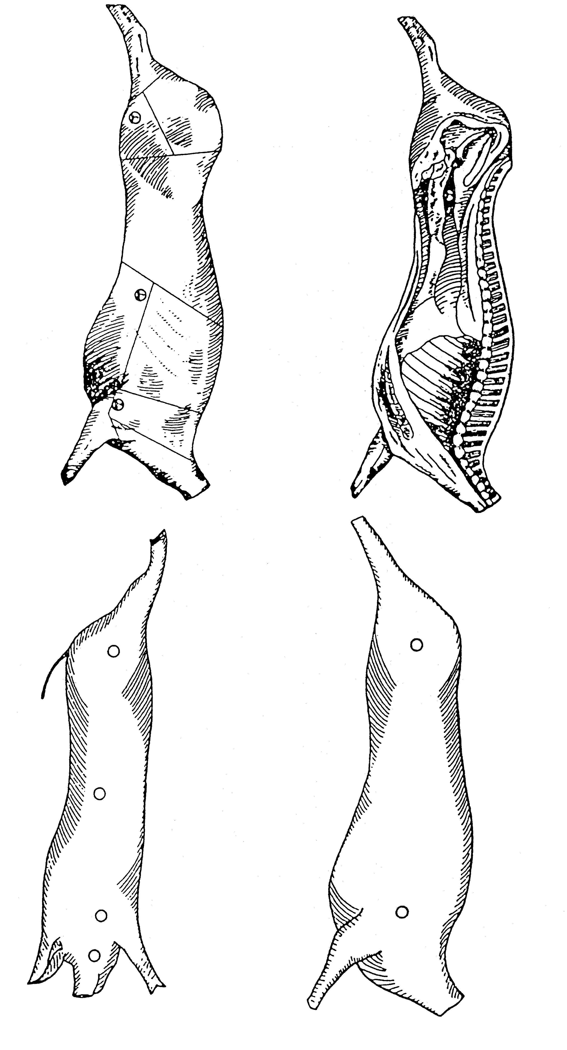

Schedule A
[Reg. 2]
1. The following brand —
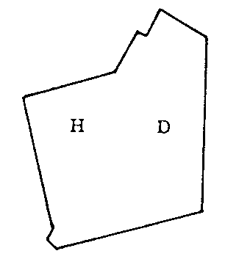
(with identifying numerals); or
2. For large stock, the following brand —
(The number allotted to the registered establishment by the Western Australian Meat Industry Authority shall be inserted in the space marked “A”); or
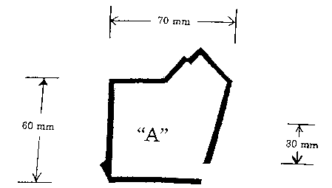
2A. For stock other than large stock referred to in item 2, the following brand —
(The number allotted to the registered establishment by the Western Australian Meat Industry Authority shall be inserted in the space marked “A”.)
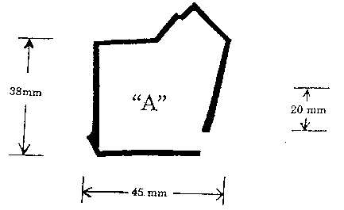
3. One of the brands illustrated hereunder —
Manjimup York Municipality
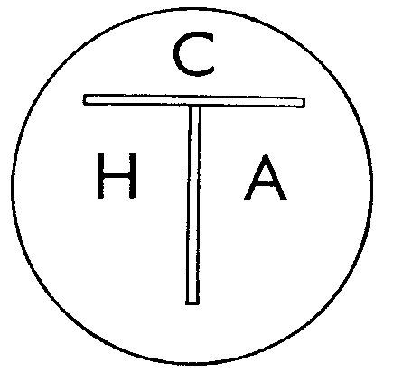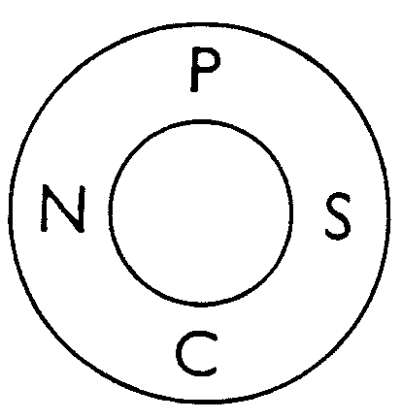
Canning Nannup
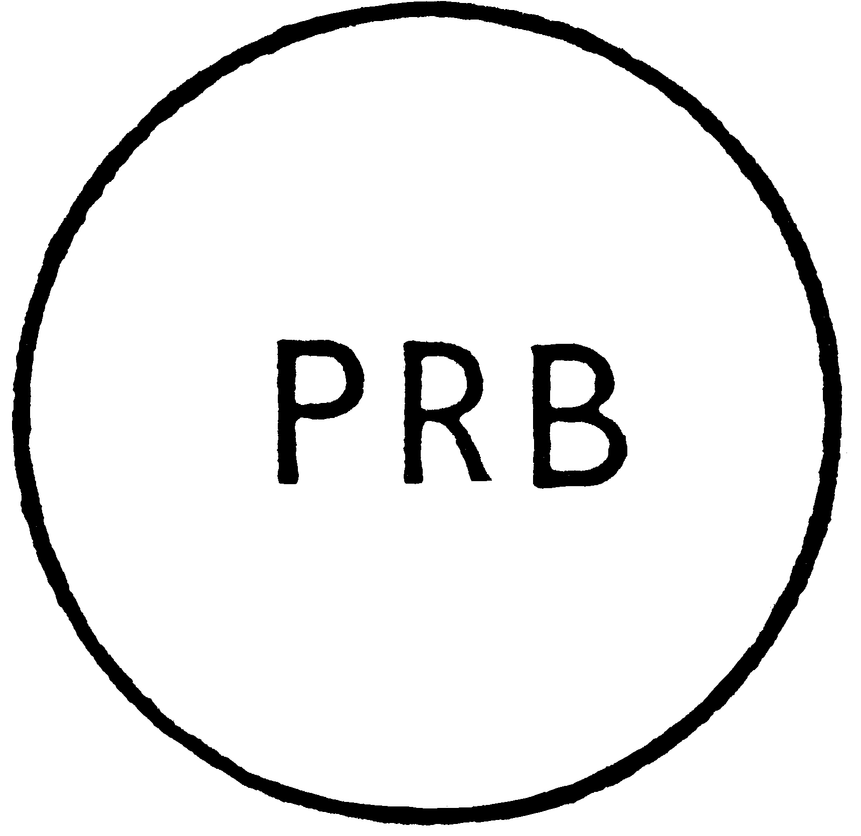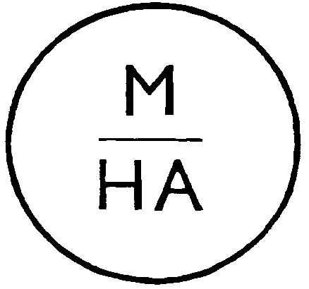
Preston Merredin
Sussex Wagin
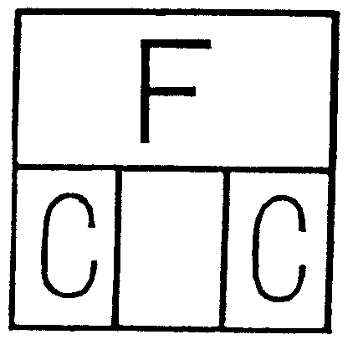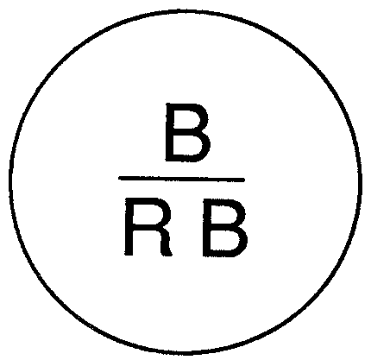
Fremantle Bridgetown Road Board
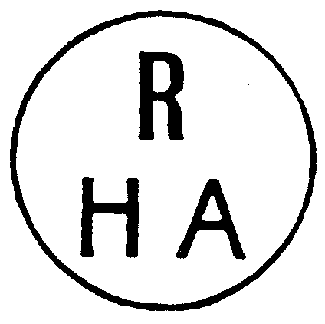
Albany Rockingham
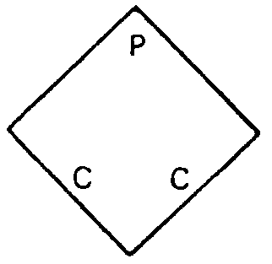
Perth Narrogin
(with identifying numerals)
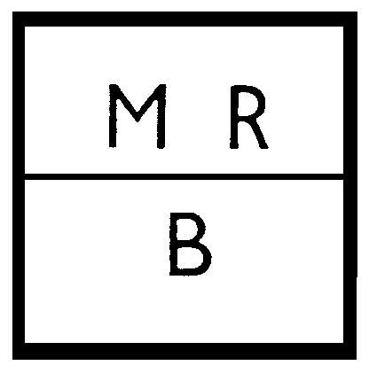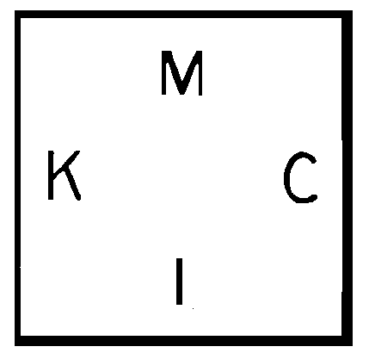
Mandurah Kalgoorlie
Busselton Katanning
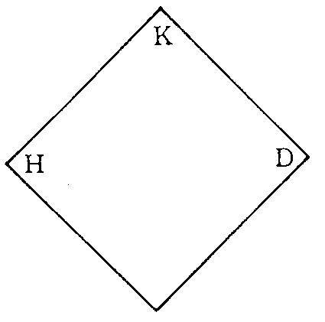
Kojonup Geraldton
(with identifying numerals)
Collie
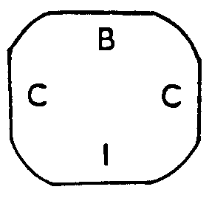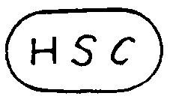
Bunbury Harvey
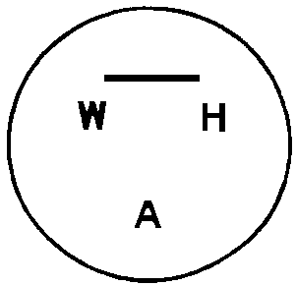
Northam M.C. Woodanilling
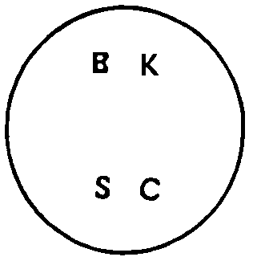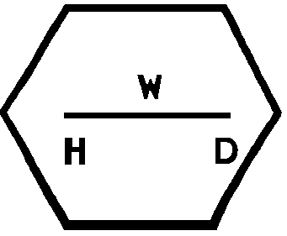
Bruce Rock Waroona
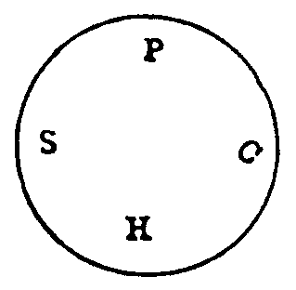
Dandaragan Port Hedland
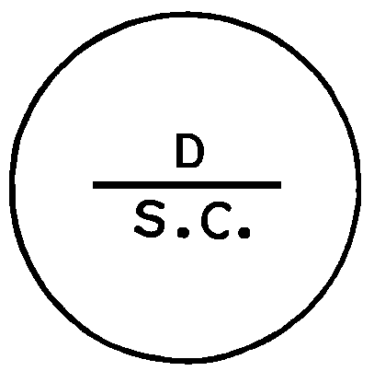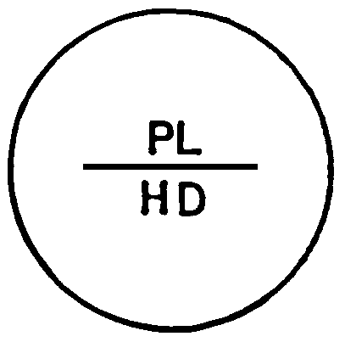
Denmark Plantagenet
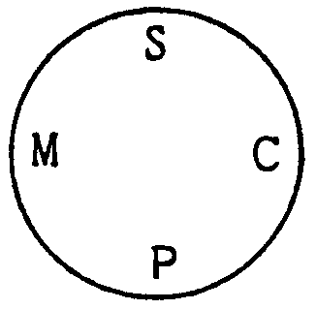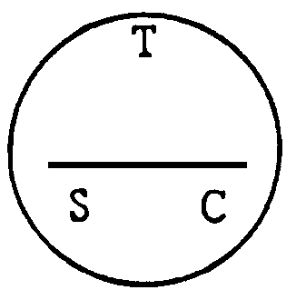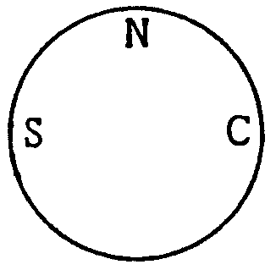
Murray Toodyay Northam S.C
(with identifying
numerals)
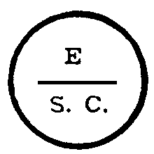
Esperance Upper Blackwood
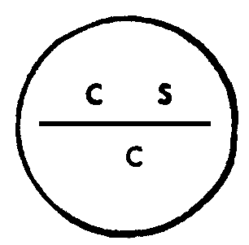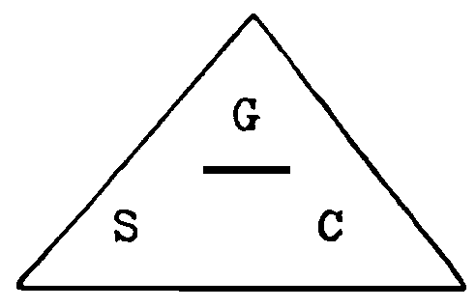
Carnarvon Greenough
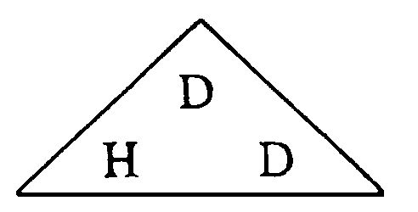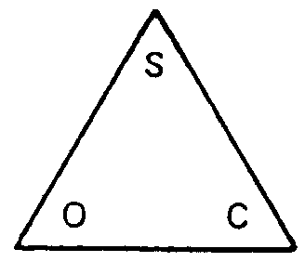
Dardanup Cuballing
(with identifying numerals)
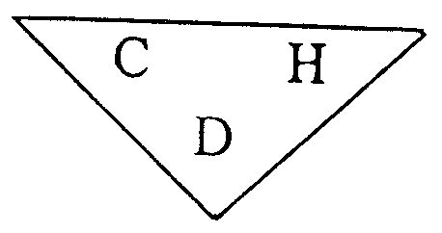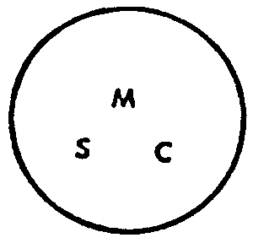
Capel Moora
(with identifying numerals)
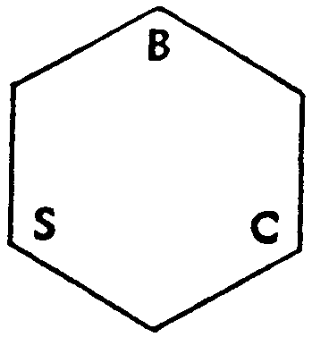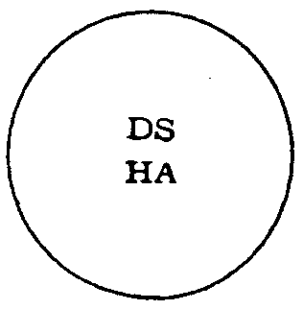
Boulder S.C. Dundas
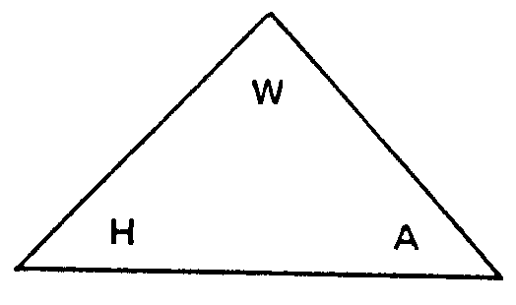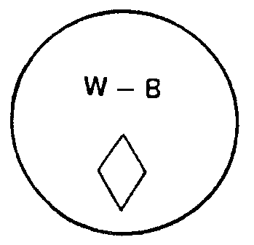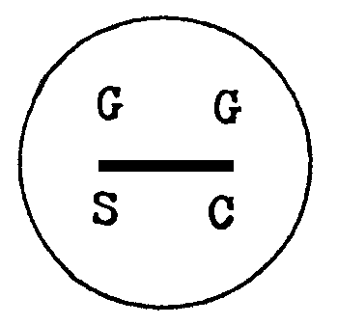
Wickepin Wongan-Ballidu Gingin
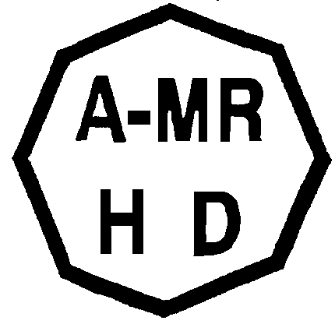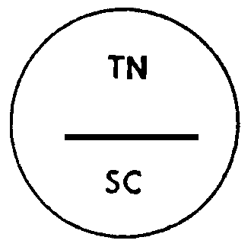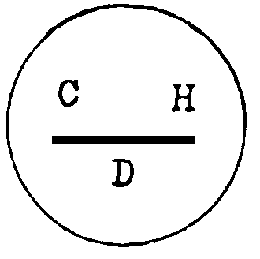
Augusta-Margaret River Tammin Cunderdin
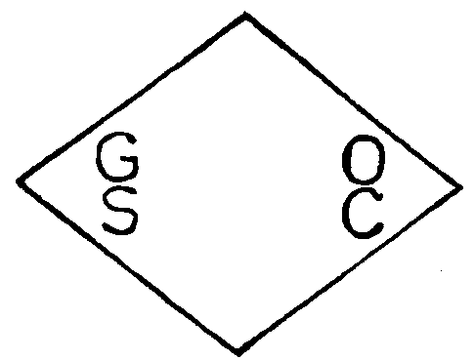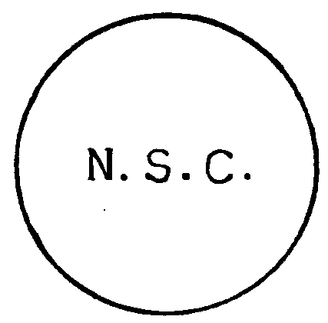
Goomalling Northampton
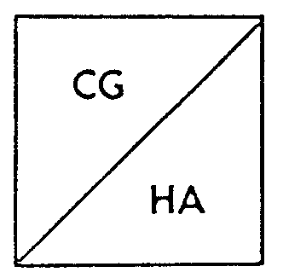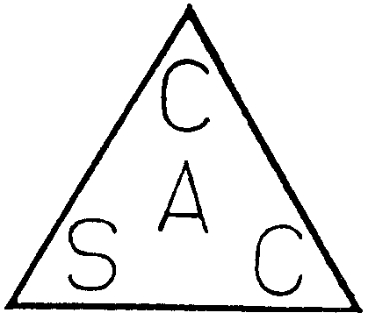
Coolgardie Carnamah
West Pilbara
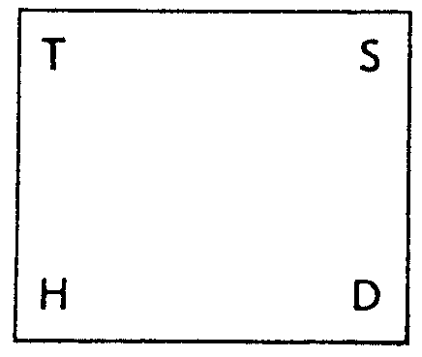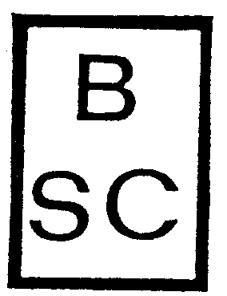
Three Springs Boddington
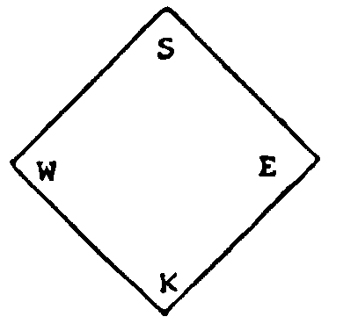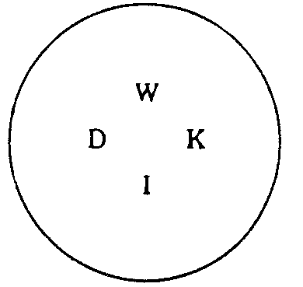
Wyndham-East Kimberley Derby/West Kimberley
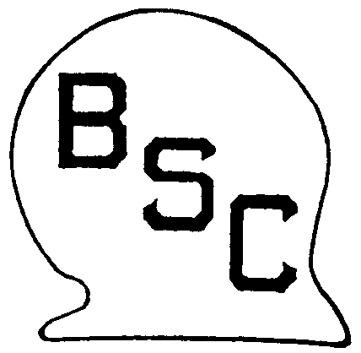
Broome West Arthur Shire Council
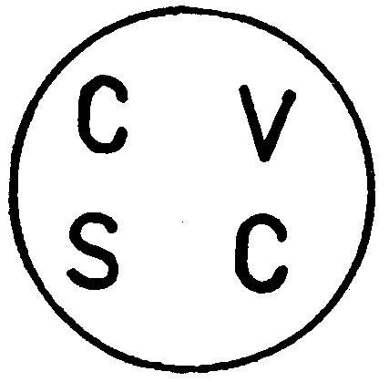
Morawa Chapman Valley
Halls Creek Shire Council
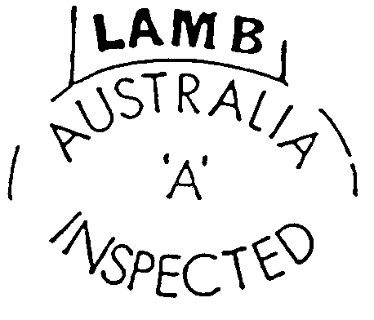
Commonwealth Department of Primary Industry (The number allotted to the registered establishment shall be inserted in the space marked ‘A’).
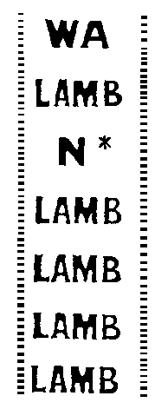
Western Australian Meat Industry Authority (The number allotted to the registered establishment shall be inserted in the space marked “N*”.)
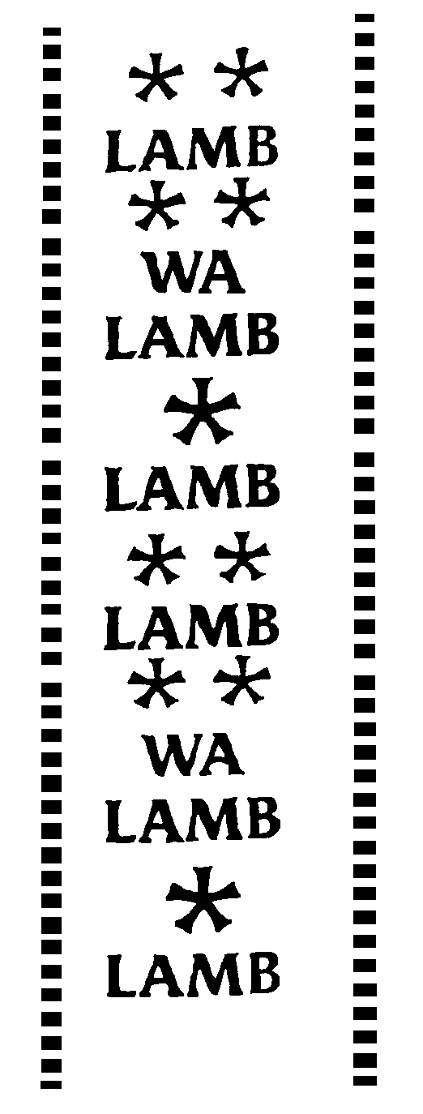
Western Australian Meat Industry Authority
(The Western Australian Meat Authority Abattoir number is to be inserted in the space marked ).
(A trade or company name or symbol is to be inserted in the space
marked ).
[Schedule A amended in Gazette 1 May 1962 p.1013; 18 July 1963 pp.2043-44; 8 July 1964 p.2639; 11 August 1964 p.2875; 12 October 1965 p.3516; 15 December 1966 p.3303; 14 June 1967 p.1581; 25 June 1968 p.1846; 6 February 1969 p.451; 9 March 1970 p.755; 4 May 1971 p.1319; 22 July 1971 p.2685; 23 December 1971 p.5319; 13 April 1972 p.795; 20 July 1973 pp.2707-08; 30 May 1975 p.1601; 12 March 1976 p.735; 10 December 1976 p.4895; 23 December 1977 p.4689; 15 September 1978 p.3410; 21 December 1979 p.3920; 10 October 1980 p.3460; 27 February 1981 p.805; 14 August 1981 p.3309; 19 November 1982 p.4513; 27 May 1983 p.1604; 25 November 1983 p.4660; 27 January 1984 p.236; 9 March 1984 p.633; 29 June 1984 p.1783; 7 June 1985 p.1938; 31 January 1986 p.331; 23 May 1986 p.1715; 5 December 1986 p.4464; 20 February 1987 p.452; 29 May 1987 pp.2220-21; 17 August 1990 p.4082; 14 September 1990 p.4773; 10 July 1991 p.3399; 8 November 1991 pp.5727-28 (disallowed in Gazette 13 December 1991 p.6237); 16 April 1992 p.1629; 7 August 1992 pp.3861-2; 13 November 1992 p.5536; 12 January 1996 p.105.]

Schedule B
Albany Health District  Armadale-Kelmscott Health District  Augusta-Margaret River Health District  Bassendean Health District  Bayswater Health District  Belmont Health District  Boddington Health District  Boulder Health District  Bridgetown-Greenbushes Health District  Broome Health District  Bruce Rock Health District  Bunbury Health District  Busselton Health District  Canning Health District  Capel Health District  Carnamah Health District  Carnarvon Health District  Chapman Valley Health District  Claremont Health District  Cockburn Health District  Collie Coalfields Health District  Coolgardie Health District  Corrigin Health District  Cottesloe Health District  Cuballing Health District  Cunderdin Health District  Dalwallinu Health District  Dandaragan Health District  Dardanup Health District  Denmark Health District  Derby/West Kimberley Health District  Donnybrook/Balingup Health District | Dundas Health District  East Fremantle Health District  Esperance Health District  Fremantle Health District  Geraldton Health District  Gingin Health District  Gosnells Health District  Greenough Health District  Halls Creek Health District  Harvey Health District  Jerramungup Health District  Kalamunda Health District  Kalgoorlie-Boulder Health District  Katanning Health District  Kojonup Health District  Kwinana Health District  Mandurah Health District  Manjimup Health District  Melville Health District  Merredin Health District  Midland Junction Health District  Moora Health District  Morawa Health District  Mosman Health District  Mundaring Health District  Murray Health District  Nannup Health District  Narrogin Health District  Nedlands Health District  North Fremantle Health District  Northam (Shire) Health District  Northam (Town) Health District | Peppermint Grove Health District  Perth Health District  Perth Road Health District  Plantagenet Health District  Port Hedland Health District  Ravensthorpe Health District  Rockingham Health District  Serpentine-Jarrahdale Health District  Shark Bay Health District  South Perth Health District  Subiaco Health District  Swan-Guildford Health District  Tammin Health District  Three Springs Health District  Toodyay Health District  Upper Blackwood Health District  Wagin Health District  Wanneroo Health District  Waroona Health District  West Arthur Health District  West Pilbara Health District  Wickepin Health District  Williams Health District  Wongan-Ballidu Health District  Woodanilling Health District  Wyndham-East Kimberley Health District  York Health District

¹ All that land within a circle having a radius of 6 kilometres from the southernmost corner of Cemetery Reserve No. 2218.
[Schedule B inserted in Gazette 9 November 1971 pp.4329-31; amended in Gazette 23 December 1971 p.5319; 13 April 1972 p.796; 20 July 1973 p.2708; 13 December 1974 p.5328; 30 May 1975 p.1601; 12 March 1976 p.735; 10 December 1976 p.4896; 11 January 1977 p.61; 23 December 1977 p.4689; 19 December 1980 p.4296; 27 February 1981 p.805; 19 November 1982 p.4513; 27 May 1983 p.1604; 27 January 1984 p.236; 7 June 1985 p.1938; 23 May 1986 p.1715; 5 December 1986 p.4464; 4 September 1987 p.3492; 14 September 1990 p.4773; 10 July 1991 p.3399; repealed and new Schedule B inserted in Gazette 8 November 1991 p.5728 (disallowed in Gazette 13 December 1991 p.6237); 21 August 1992 p.4128; 13 November 1992 p.5536; 10 June 1994 p.2377; 12 May 1995 p.1779; 23 February 1996 p.657; 29 October 1996 p.5722; 13 May 1997 p.2331; 16 January 1998 p.343; 29 February 2000 p.991.]

Schedule C
[Reg. 6(1)]
Table 1
Fees Payable to Executive Director, Public Health
 | Carcass | Side | Piece or Quarter
For each swine | $0.16 | $0.082 | $0.040
Table 2
Part 1 — Fees payable to local governments
Scale A
Unit of Livestock | Carcass | Side | Piece
For each sheep, lamb, goat, calf or deer (under 70 kg)............................. | 3.3c | 1.65c | .82c
For each swine....................................... | 16.5c | 8.25c | 4.12c
For each cow, bull, heifer or steer......... | 26.4c | 13.2c | 6.6c
For each carton of meat on which no previous charge has been made under this Schedule.................... | Carton (27 kg approx.)  6.6c | — | —
Scale B
Unit of Livestock | Carcass | Side | Piece
For each sheep, lamb, goat, calf or deer (under 70 kg)............................. | 5.5c | 2.75c | 1.37c
For each swine....................................... | 27.5c | 13.75c | 6.87c
For each cow, bull, heifer or steer......... | 44c | 22c | 11c
For each carton of meat on which no previous charge has been made under this Schedule.................... | Carton (27 kg approx.)  11c | — | —
Scale C
Unit of Livestock | Carcass | Side | Piece
For each sheep, lamb, goat, calf or deer (under 70 kg)............................. | 22c | 11c | 5.5c
For each swine....................................... | $1.10 | 55c | 27.5c
For each cow, bull, heifer or steer......... | $1.76 | 88c | 44c
For each carton of meat on which no previous charge has been made under this Schedule.................... | Carton (27 kg approx.)  44c | — | —
Scale D
Unit of Livestock | Carcass | Side | Piece
For each rabbit............................ | 36c
Scale E
Unit of Livestock | Carcass | Side | Piece
For each sheep, lamb, goat, calf, deer or rabbit (under 70 kg).................. | 33c | 16.5c | 8.25c
For each swine....................................... | $1.65 | 82.5c | 41.25c
For each cow, bull, heifer or steer......... | $2.64 | $1.32 | 66c
For each carton of meat on which no previous charge has been made under this Schedule.................... | Carton (27 kg approx.)  66c | — | —
Scale F
Unit of Livestock | Carcass | Side | Piece
For each sheep, lamb, goat, rabbit, calf or deer (under 70 kg)................ | 38.5c | 19.25c | 9.62c
For each swine....................................... | $1.92 | 96.25c | 48.125
For each cow, bull, heifer or steer......... | $3.08 | $1.54 | 77c
For each carton of meat on which no previous charge has been made under this Schedule.................... | Carton (27 kg approx.)  77c | — | —
Scale G
Unit of Livestock | Carcass | Side | Piece
For each sheep, lamb, deer, goat or calf (under 70 kg)............................. | 44c | 22c | 11c
For each swine....................................... | $2.20 | $1.10 | 55c
For each cow, bull, heifer or steer......... | $3.52 | $1.76 | 88c
For each carton of meat on which no previous charge has been made under this Schedule.................... | Carton (27 kg approx.)  88c | — | —
Scale H
Unit of Livestock | Carcass | Side | Piece
For each sheep, lamb, deer, goat, rabbit or calf (under 70 kg)................ | 49.5c | 24.75c | 12.37c
For each swine....................................... | $2.47 | $1.237 | 61.87c
For each cow, bull, heifer or steer......... | $3.96 | $1.98 | 99c
For each carton of meat on which no previous charge has been made under this Schedule.................... | Carton (27 kg approx.)  99c | — | —
Scale I
Unit of Livestock | Carcass | Side | Piece
For each sheep, lamb, goat, calf or deer (under 70 kg)............................. | 55c | 27.5c | 13.75c
For each swine....................................... | $2.75 | $1.37 | 68.75c
For each cow, bull, heifer or steer......... | $4.40 | $2.20 | $1.10
For each carton of meat on which no previous charge has been made under this Schedule.................... | Carton (27 kg approx.) $1.10 | — | —
Scale J
Unit of Livestock | Carcass | Side | Piece
For each sheep, lamb, deer, goat or calf (under 70 kg)............................. | 60.5c | 30.25c | 15.12c
For each swine....................................... | $3.02 | $1.512 | 75.62c
For each cow, bull, heifer or steer......... | $4.84 | $2.42 | $1.21
For each carton of meat on which no previous charge has been made under this Schedule.................... | Carton (27 kg approx.) $1.21 | — | —
Scale K
Unit of Livestock | Carcass | Side | Piece
For each sheep, lamb, deer, goat or calf (under 70 kg)............................. | 66c | 33c | 16.5c
For each swine....................................... | $3.30 | $1.65 | 82.5c
For each cow, bull, heifer or steer......... | $5.28 | $2.64 | $1.32
For each carton of meat on which no previous charge has been made under this Schedule.................... | Carton (27 kg approx.) $1.32 | — | —
Scale M
Unit of Livestock | Carcass | Side | Piece
For each sheep, lamb, deer, goat or calf (under 70 kg)............................. | 77c | 38.5c | 19.25c
For each swine....................................... | $3.85 | $1.92 | 96.25c
For each cow, bull, heifer or steer......... | $6.16 | $3.08 | $1.54
For each carton of meat on which no previous charge has been made under this Schedule.................... | Carton (27 kg approx.) $1.54 | — | —
Scale N
Unit of Livestock | Carcass | Side | Piece
For each sheep, lamb, deer, goat or calf (under 70 kg)............................. | 82.5c | 41.25c | 20.62c
For each swine....................................... | $4.12 | $2.062 | $1.03
For each cow, bull, heifer or steer......... | $6.60 | $3.30 | $1.65
For each carton of meat on which no previous charge has been made under this Schedule.................... | Carton (27  kg approx.) $1.65 | — | —
Scale P
Unit of Livestock | Carcass | Side | Piece
For each sheep, lamb, goat, calf or deer (under 70 kg)............................. | $1.54 | 77c | 38.5c
For each swine....................................... | $7.70 | $3.85 | $1.92
For each cow, bull, heifer or steer......... | $12.32 | $6.16 | $3.08
For each carton of meat on which no previous charge has been made under this Schedule.................... | Carton (27 kg approx.) $2.75 | — | —
Scale Q
Unit of Livestock | Carcass | Side | Piece
For each sheep, lamb, deer, goat or calf (under 70 kg)............................. | 99c | 49.5c | 24.75c
For each swine....................................... | $4.95 | $2.47 | $1.237
For each cow, bull, heifer or steer......... | $7.92 | $3.96 | $1.98
For each carton of meat on which no previous charge has been made under this Schedule.................... | Carton (27 kg approx.) $1.98 | — | —
Scale R
Unit of Livestock | Carcass | Side | Piece
For each sheep, lamb, deer, goat or calf (under 70 kg)............................. | $1.21 | 60.5c | .302c
For each swine....................................... | $5.22 | $2.612 | $1.305
For each cow, bull, heifer or steer......... | $8.36 | $4.18 | $2.09
For each carton of meat on which no previous charge has been made under this Schedule.................... | $2.09 | — | —
Scale S
Unit of Livestock | Carcass | Side | Piece
For each sheep, lamb, deer, goat or calf (under 70 kg)............................. | $1.10 | 55c | 27.5c
For each swine....................................... | $5.50 | $2.75 | $1.37
For each cow, bull, heifer or steer......... | $8.80 | $4.40 | $2.20
For each carton of meat on which no previous charge has been made under this Schedule.................... | Carton (27 kg approx.) $2.20 | — | —
Scale T
Unit of Livestock | Carcass | Side | Piece
For each sheep, lamb, deer, goat or calf (under 70 kg)............................. | $1.26 | 63.25c | 31.62c
For each swine....................................... | $6.32 | $3.162 | $1.58
For each cow, bull, heifer or steer......... | $10.12 | $4.60 | $2.30
For each carton of meat on which no previous charge has been made under this Schedule.................... | Carton (27 kg approx.) $2.53 | — | —
Scale U
Unit of Livestock | Carcass | Side | Piece
For each sheep, lamb, deer, goat or calf (under 70 kg)............................. | $2.42 | $1.21 | 60.5c
For each swine....................................... | $12.10 | $6.05 | $3.02
For each cow, bull, heifer or steer......... | $19.36 | $9.68 | $4.84
For each carton of meat on which no previous charge has been made under this Schedule.................... | Carton (27 kg approx.) $4.84 | — | —
Scale V
Unit of Livestock | Carcass | Side | Piece
For each sheep, lamb, deer, goat or calf (under 70 kg)............................. | 77c | 39c | 18.17c
For each swine....................................... | $3.96 | $1.98 | 99c
For each cow, bull, heifer or steer......... | $6.60 | $3.30 | $1.65
For each carton of meat on which no previous charge has been made under this Schedule.................... | Carton (27 kg approx.) $1.65 | — | —
Scale W
Unit of Livestock | Carcass | Side | Piece
For each sheep, lamb, deer, goat or calf (under 70 kg)............................. | 45c | — | —
For each swine....................................... | $1.90 | — | —
For each cow, bull, heifer or steer......... | $2.75 | — | —
Scale X
Unit of Livestock | Carcass | Side | Piece
For each sheep, lamb, deer, goat or calf (under 70 kg)............................. | 13c | — | —
For each cow, bull, heifer or steer......... | 66c | — | —
Note: All fees shown are inclusive of GST.
Part 2 — Local governments to which the scales apply
Scale A | Shire of Waroona (Export Abattoir)
Scale B | Shire of Harvey (Export Abattoir)
Scale C | Shire of Coolgardie
 | Shire of Merredin
 | Shire of Narrogin
Scale D | Shire of Serpentine-Jarrahdale
Scale E | Shire of Busselton (Western Meat Processors, Walshs Road, Busselton)
 | Shire of Gingin
 | Shire of Northam (Linley Valley Abattoir, Wooroloo Road, Wooroloo)
 | Shire of Wongan-Ballidu
Scale F | Shire of Boddington  Shire of Bruce Rock  Shire of Kojonup  Shire of Northam (Roediger Bros. Abattoir, Goomalling Road, Northam)
Scale G | Shire of Capel  Shire of Goomalling
Scale H | Town of Narrogin
Scale I | Shire of Carnamah  Shire of Carnarvon  Shire of Dardanup  Shire of Denmark  Shire of Katanning  Shire of Northampton  Shire of Three Springs  Shire of Wagin  Shire of Woodanilling
Scale J | Shire of Harvey (non-Export Abattoir)  Shire of Tammin
Scale K | Shire of Esperance  Shire of Plantagenet  Shire of Toodyay
Scale M | Shire of Boulder  Shire of Derby/West Kimberley
Scale N | Shire of Manjimup
 | Shire of Wyndham-East Kimberley
Scale P | Shire of Greenough
Scale Q
Scale R | Shire of Broome  Shire of Busselton (Busselton Meats, Bussel Highway, Busselton)
Scale S | Shire of Augusta-Margaret River  Shire of Moora  Shire of West Arthur
Scale T | Shire of Bridgetown-Greenbushes  Shire of Halls Creek
Scale U | Shire of Chapman Valley
Scale V | Shire of Corrigin
Scale W | City of Bunbury (Dardanup Butchering Co., Wimbridge Road, Picton)
Scale X | City of Bunbury (V & V Walsh Wholesale Butchers, South Western Highway, Bunbury)
[Schedule C inserted in Gazette 10 December 1976 pp. 4896-7; amended in Gazette 15 September 1978 p. 3410; 23 November 1979 p. 3647; 21 December 1979 p. 3919; 10 October 1980 p. 3460; 19 December 1980 p. 4296; 27 February 1981 p. 805; 2 October 1981 p. 4181; 4 June 1982 p. 1791; 23 July 1982 pp. 2851-3; 27 August 1982 p. 3383; 19 November 1982 p. 4513; 31 December 1982 p. 4999; 27 May 1983 p. 1604; 25 November 1983 p. 4660; 27 January 1984 p. 236; 11 May 1984 pp. 1248-9; 29 June 1984 p. 1783; 21 September 1984 p. 3091; 23 November 1984 p. 3759; 3 May 1985 p. 1539; 7 June 1985 p. 1938; 31 January 1986 pp. 331-2; 23 May 1986 pp. 1714-15; 11 July 1986 p. 2341; 17 October 1986 p. 3897; 5 December 1986 p. 4464; 19 December 1986 p. 4873; 26 June 1987 p. 2460; 21 August 1987 p. 3228; 4 September 1987 p. 3493; 18 September 1987 p. 3597; 30 September 1988 p. 3978; 25 November 1988 p. 4699; 9 December 1988 p. 4822; 17 February 1989 p. 465; 30 June 1989 p. 1905; 14 July 1989 p. 2153; 22 September 1989 p. 3462; 17 November 1989 p. 4108; 2 March 1990 p. 1292; 12 April 1990 p. 1911; 3 August 1990 p. 3682; 3 August 1990 p. 3683; 14 September 1990 pp. 4773-4; 3 May 1991 p. 1960; 28 June 1991 pp. 3147 and 3152; 10 July 1991 p. 3400; 8 November 1991 pp. 5728-9 (disallowed in Gazette 13 December 1991 p. 6237); 15 November 1991 p. 5816; 7 February 1992 p. 696; 29 May 1992 pp. 2188-9; 26 June 1992 p. 2695; 4 September 1992 p. 4468; 13 November 1992 p. 5537; 31 December 1992 p. 6336; 12 February 1993 p. 1222; 1 October 1993 p. 5353; 28 January 1994 p. 281; 8 July 1994 pp. 3311; 2 September 1994 p. 4528; 16 June 1995 p. 2318; 25 August 1995 pp. 3846-7; 16 April 1996 p. 1699; 28 June 1996 p. 3033; 12 July 1996 p. 3361; 29 October 1996 pp. 5722-3; 21 February 1997 p. 1171; 11 April 1997 p. 1827; 13 May 1997 p. 2331; 15 May 1998 p. 2811; 29 September 1998 pp. 5370-1; 14 September 1999 pp. 4528-9; 26 October 1999 pp. 5282-3; 30 June 2000 pp. 3408-12; 15 September 2000 pp. 5385-6; 16 March 2001 p. 1385; 15 May 2001 p. 2384.]

Schedule D
Health Act 1911
Health (Meat Inspection and Branding) Regulations 1950
To: The Executive Director, Public Health and Scientific Support Services:
THE following is a statement of all meat killed and inspected for human consumption at ...................................................................................... during the
month of ..............................., 19 ...........
 | (1)  Carcasses | (2)  Sides  (not included  in 1) | (3)  Pieces or Quarters (not included in 1 and 2)
Cows, Bulls, Heifers and Steers.......
Calves and deer (under 70kg)..........
Sheep (including Lambs) and Goats
Swine................................................
Rabbits.............................................
Calculation of Fees
(to be completed by abattoirs management)
Cows, Bulls, Heifers and Steers............................. | ................. | @ | .................
Calves and deer (under 70kg)................................. | ................. | @ | .................
Sheep (including Lambs) and Goats...................... | ................. | @ | .................
Swine...................................................................... | ................. | @ | .................
Rabbits.................................................................... | ................. | @ | .................

 | Total ....... | $ :
Checked...................................................................................................................
Inspection and branding fees required to be paid under the Health (Meat Inspection and Branding) Regulations 1950 amounting to $ ...........................are tendered herewith.
Date ....................................................... | ........................................................  ........................................................
[Schedule D inserted in Gazette 13 December 1974 p.5330; amended in Gazette 29 June 1984 p.1783; 17 February 1989 p.465; 2 September 1994 pp.4528-9.]

[Schedule E. Repealed in Gazette 14 June 1967 p.1581; inserted in Gazette 8 November 1991 p.5730 (disallowed in Gazette 13 December 1991 p.6237).]

Notes
¹ This is a compilation of the Health (Meat Inspection, Branding and Processing) Regulations 1950 and includes the amendments included in the reprint of 10 September 1992 and the amendments effected by the regulations referred to in the following Table.

Compilation table
Citation | Gazettal | Commencement
Meat Inspection and Branding Regulations | 1 Dec 1950 p. 2693-8 | 1 Dec 1950
Health (Meat Inspection and Branding) Amendment Regulations (No. 8) 1992 | 13 Nov 1992 pp.5536-7 | 13 Nov 1992
Health (Meat Inspection and Branding) Amendment Regulations (No. 9) 1992 | 31 Dec 1992 p.6336 | 31 Dec 1992
Health (Meat Inspection and Branding) Amendment Regulations (No. 10) 1992 | 23 Dec 1992 p. 6250-1 | 23 Dec 1992 (see r. 2 and Gazette 23 Dec 1992 p. 6209)
Health (Meat Inspection and Branding) Amendment Regulations 1993 | 12 Feb 1993 p.1222 | 12 Feb 1993
Health (Meat Inspection and Branding) Amendment Regulations (No. 2) 1993 | 1 Oct 1993 p.5353 | 1 Oct 1993
Health (Meat Inspection and Branding) Amendment Regulations 1994 | 28 Jan 1994 p.281 | 28 Jan 1994
Health (Meat Inspection and Branding) Amendment Regulations (No. 2) 1994 | 10 Jun 1994 p.2377 | 10 Jun 1994
Health (Meat Inspection and Branding) Amendment Regulations (No. 3) 1994 | 8 Jul 1994 pp.3310-11 | 8 Jul 1994
Health (Meat Inspection and Branding) Amendment Regulations (No. 4) 1994 | 2 Sep 1994 p. 4528-9 | 2 Sep 1994
Health (Meat Inspection and Branding) Amendment Regulations 1995 | 12 May 1995 p.1779 | 12 May 1995
Health (Meat Inspection and Branding) Amendment Regulations (No. 2) 1995 | 16 Jun 1995 p.2318 | 16 Jun 1995
Health (Meat Inspection and Branding) Amendment Regulations (No. 4) 1995 | 25 Aug 1995 pp.3846-7 | 25 Aug 1995
Health (Meat Inspection and Branding) Amendment Regulations 1996 | 12 Jan 1996 p.105 | 12 Jan 1996
Health (Meat Inspection and Branding) Amendment Regulations (No. 2) 1996 | 23 Feb 1996 p.657 | 23 Feb 1996
Health (Meat Inspection and Branding) Amendment Regulations (No. 3) 1996 | 16 Apr 1996 p.1699 | 16 Apr 1996
Health (Meat Inspection and Branding) Amendment Regulations (No. 4) 1996 | 12 Jul 1996 p.3361 | 12 Jul 1996
Health (Meat Inspection and Branding) Amendment Regulations (No. 5) 1996 | 28 Jun 1996 p.3033 | 28 Jun 1996
Health (Meat Inspection and Branding) Amendment Regulations (No. 6) 1996 | 29 Oct 1996 pp.5721-3 | 29 Oct 1996
Health (Meat Inspection and Branding) Amendment Regulations 1997 | 21 Feb 1997 p.1171 | 21 Feb 1997
Health (Meat Inspection and Branding) Amendment Regulations (No. 2) 1997 | 11 Apr 1997 pp.1826-7 | 11 Apr 1997
Health (Meat Inspection and Branding) Amendment Regulations (No. 3) 1997 | 11 Apr 1997 pp.1827-8 | 11 Apr 1997
Health (Meat Inspection, Branding and Processing) Amendment Regulations (No. 4) 1997 | 13 May 1997 pp.2330-1 | 13 May 1997
Health (Meat Inspection, Branding and Processing) Amendment Regulations (No. 5) 1997 | 30 Sep 1997 pp.5424-5 | 30 Sep 1997
Health (Meat Inspection, Branding and Processing) Amendment Regulations (No. 6) 1997 | 16 Jan 1998 p.343 | 16 Jan 1998
Health (Meat Inspection, Branding and Processing) Amendment Regulations 1998 | 15 May 1998 pp.2810-11 | 15 May 1998
Health (Meat Inspection, Branding and Processing) Amendment Regulations (No. 2) 1998 | 29 Sep 1998 pp.5370-1 | 29 Sep 1998
Health (Meat Inspection, Branding and Processing) Amendment Regulations 1999 | 14 Sep 1999 pp.4528-9 | 14 Sep 1999
Health (Meat Inspection, Branding and Processing) Amendment Regulations No. 2) 1999 | 26 Oct 1999 p. 5282-3 | 26 Oct 1999
Health (Meat Inspection, Branding and Processing) Amendment Regulations 2000 | 29 Feb 2000 p. 990-1 | 29 Feb 2000
Health (Meat Inspection, Branding and Processing) Amendment Regulations (No. 2) 2000 | 30 Jun 2000 p. 3407-12 | 1 Jul 2000 (see regulation 2)
Health (Meat Inspection, Branding and Processing) Amendment Regulations (No. 3) 2000 | 15 Sep 2000 p. 5385-6 | 15 Sep 2000
Health (Meat Inspection, Branding and Processing) Amendment Regulations 2001 | 16 Mar 2001 p. 1385 | 16 Mar 2001
Health (Meat Inspection, Branding and Processing) Amendment Regulations (No. 2) 2001 | 15 May 2001 p. 2384 | 15 May 2001
These regulations were repealed by the Health (Meat Hygiene) Regulations 2001 r. 8(c) as at 1 Jun 2001 (see Gazette 1 Jun 2001 p. 2760)

Defined terms

[This is a list of terms defined and the provisions where they are defined. The list is not part of the law.]
Defined term Provision(s)
Calf 2
government inspector 1B(5)
inspector 1AA
rabbit 1AA
the adopted standard 1B(5)

