Western Australia

State Flag Act 2006

Western Australia
State Flag Act 2006
Contents
1. Short title 1
2. Commencement 1
3. Interpretation 1
4. The Western Australian State Flag 1
Schedule — Western Australian State flag
Part 1 — Description of flag
Part 2 — Western Australian State flag
Notes
Compilation table 3

Western Australia
State Flag Act 2006
An Act to declare a certain Flag to be the Western Australian State Flag.
The Parliament of Western Australia enacts as follows:

1. Short title
This Act may be cited as the State Flag Act 2006.

2. Commencement
This Act comes into operation on the day on which it receives the Royal Assent.

3. Interpretation
In this Act the Western Australian State Flag means the flag declared to be the Western Australian Flag by section 4 of this Act.

4. The Western Australian State Flag
The flag described in Part 1 of the Schedule, being the flag a reproduction of which is set out in Part 2 of the Schedule, is declared to be the Western Australian State Flag.

Schedule — Western Australian State flag
[s. 4]
[Heading inserted: No. 19 of 2010 s. 36(2).]

Part 1 — Description of flag
[Heading inserted: No. 19 of 2010 s. 36(2).]
The Western Australian State Flag is a blue flag with —
(a) the Union flag occupying the upper quarter next to the staff; and
(b) depicting a black swan (cygnus atratus) on a circle of yellow situated centrally in the fly (the half of the flag furthest from the staff) and facing the staff.

Part 2 — Western Australian State flag
[Heading inserted: No. 19 of 2010 s. 36(3)(a).]
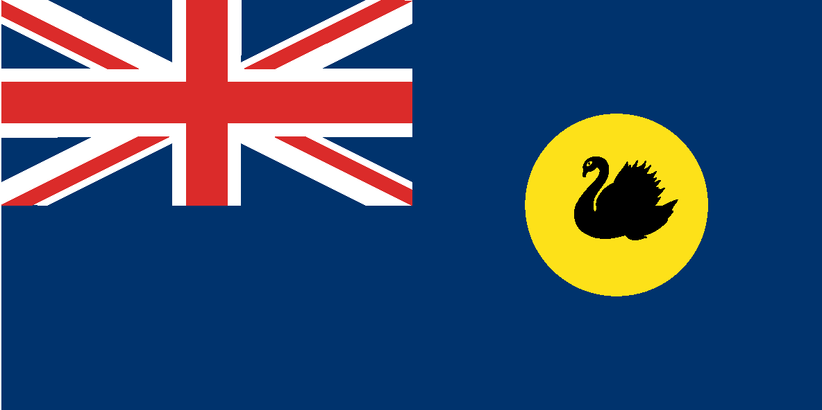

[Part 2 amended: No. 19 of 2010 s. 36(3)(b).]

Notes
¹ This is a compilation of the State Flag Act 2006 and includes the amendments made by the other written laws referred to in the following table.

Compilation table
Short title | Number and Year | Assent | Commencement
State Flag Act 2006 | 22 of 2006 | 24 Aug 2006 | 24 Aug 2006 (see s. 2)
Standardisation of Formatting Act 2010 s. 36 | 19 of 2010 | 28 Jun 2010 | 11 Sep 2010 (see s. 2(b) and Gazette 10 Sep 2010 p. 4341)

