Western Australia
Kambalda Water and Wastewater Facilities (Transfer to Water Corporation) Act 2004

Western Australia
Kambalda Water and Wastewater Facilities (Transfer to Water Corporation) Act 2004
CONTENTS
--Part 1 — Preliminary
1. Short title 2
2. Commencement 2
3. Terms used in this Act 2
4. Kambalda area defined 3
5. Kambalda Water and Wastewater Facilities described 3
Part 2 — Transfer to the Water Corporation
Division 1 — Transfer of facilities and certain rights
6. Ownership of facilities 5
7. Rights to payment for services provided 5
8. Other rights 5
9. Liabilities not to pass 6
Division 2 — Incidental and related matters
10. Pipes and other things taken to have been put in place by the Water Corporation 6
11. Compensation not payable 7
12. Recovery of amounts owing for services provided 7
Division 3 — Transitional provisions
13. Licences and other authorities under written laws 8
14. Completion of things commenced 9
Part 3 — Notifications on title as to location of pipes and works
15. Terms used in this Part 10
16. Steps to be taken for recording of notifications 10
17. Exception where land is not a lot 11
18. Wording of notification 12
19. Recording of notification 12
20. Replacement of deposited plans and notifications 13
21. Amendment or removal of notification 13
22. Cost of complying with section 16(1) and (2) 14
Part 4 — General
23. Agreements on incidental matters 15
24. Saving 15
Schedule 1 — Kambalda area 16
Division 1 — Plan of Kambalda area 16
Division 2 — Map Grid of Australia coordinates 17
Schedule 2 — Treated wastewater pipeline 21
Notes
Compilation table 22

Western Australia
Kambalda Water and Wastewater Facilities (Transfer to Water Corporation) Act 2004
No. 64 of 2004
An Act —
- to transfer ownership of the Kambalda Water and Wastewater Facilities and certain associated rights to the Water Corporation;
- to apply section 84 of the Water Agencies (Powers) Act 1984 to pipes and other things that are part of those facilities; and
- to make incidental and related provisions.

The Parliament of Western Australia enacts as follows:

Part 1 — Preliminary

1. Short title
This Act may be cited as the Kambalda Water and Wastewater Facilities (Transfer to Water Corporation) Act 2004.

2. Commencement
This Act comes into operation on a day fixed by proclamation.

3. Terms used in this Act
In this Act —
commencement day means the day on which this Act comes into operation;
coordinates means Map Grid of Australia 1994 grid coordinates in Zone 51 of the Universal Transverse Mercator Grid System based on the Geocentric Datum of Australia;
Kambalda area has the meaning given by section 4;
Kambalda Water and Wastewater Facilities or the transferred facilities has the meaning given by section 5;
pipe means a main, reticulation or service pipe used for water supply or sewerage services, and includes —
(a) any plug, stop-cock, water-cock, syphon, branch or apparatus used in connection with such pipe; and
(b) any part of a pipe;
Water Corporation means the Water Corporation established by section 4 of the Water Corporation Act 1995;
WMC Resources Ltd means the company incorporated under the Corporations Act 2001 of the Commonwealth as WMC Resources Ltd (ACN 004 184 598);
works includes excavations, buildings, structures, plant and equipment.

4. Kambalda area defined
(1) The Kambalda area is the area defined by notional straight lines on the surface of the Earth connecting the points identified by numbers on the plan in Schedule 1 Division 1 starting at point number 1, moving in a clockwise direction and ending at that point.
(2) The position on the surface of the Earth of a numbered point referred to in subsection (1) is to be determined by reference to the coordinates specified in the second and third columns in Schedule 1 Division 2 opposite the number.

5. Kambalda Water and Wastewater Facilities described
(1) In this section —
fitting, fixture and sewer have the meanings given by section 3 of the Water Agencies (Powers) Act 1984;
headworks and reticulation have the meanings given by section 65 of the Water Agencies (Powers) Act 1984;
sewerage works means sewers and —
(a) all headworks, reticulation works and other works; and
(b) all pipes, meters and things,
connected with any sewer;
treated wastewater pipeline means the pipeline that starts at or near the point fixed by the coordinates 373008.84E / 6548603.23N and ends at or near the point fixed by the coordinates 371239.69E / 6546413.50N, as shown by the coordinates specified on the plan in Schedule 2;
water works means all works for the supply, storage and distribution of water, including headworks, reticulation works, pipes, meters and things that are part of such works.
(2) The Kambalda Water and Wastewater Facilities (the transferred facilities) comprise —
(a) the water works; and
(b) the sewerage works,
located within the Kambalda area that immediately before the commencement day were maintained or operated by WMC Resources Ltd to provide water supply and sewerage services within that area.
(3) The transferred facilities do not include —
(a) the treated wastewater pipeline; and
(b) any —
(i) water pipe or water supply fixture or fitting downstream from the meter assembly on a lot or parcel of land in the Kambalda area; or
(ii) sewer pipe or sewerage fixture or fitting located on such a lot or parcel,
being a pipe, fixture or fitting that services only the lot or parcel concerned.

Part 2 — Transfer to the Water Corporation

Division 1 — Transfer of facilities and certain rights

6. Ownership of facilities
On the commencement day —
(a) the ownership of the Kambalda Water and Wastewater Facilities is by virtue of this section transferred to the Water Corporation; and
(b) any claim, right, title or interest of any other person in respect of —
(i) the transferred facilities as they existed immediately before the commencement day; or
(ii) any thing that formed part of the transferred facilities immediately before that day,
is extinguished by the operation of paragraph (a).

7. Rights to payment for services provided
(1) On the commencement day all rights of WMC Resources Ltd to be paid for water supply services or sewerage services provided by it in the Kambalda area before that day, to the extent that payment has not been made for those services, are by virtue of this section transferred to the Water Corporation.
(2) Subsection (1) applies to a right to be paid for a service whether or not an account for the service has been issued before the commencement day.

8. Other rights
On the commencement day the right of WMC Resources Ltd to any remedy or redress whether actual, contingent or prospective, other than a right to which section 7 applies, against any person in relation to the transferred facilities is by virtue of this section transferred to the Water Corporation.

9. Liabilities not to pass
(1) In this section —
liability means any liability, duty or obligation whether actual, contingent or prospective or liquidated or unliquidated, and includes a liability for breach of any term or condition of an authority referred to in section 13.
(2) Nothing in this Act is to be read as having the effect that a liability of WMC Resources Ltd as at the commencement day becomes on and after that day a liability of the Water Corporation.

Division 2 — Incidental and related matters

10. Pipes and other things taken to have been put in place by the Water Corporation
(1) In this section —
land has the meaning given by section 3(1) of the Water Agencies (Powers) Act 1984.
(2) On and after the commencement day —
(a) section 84(1) of the Water Agencies (Powers) Act 1984 has effect in respect of all pipes, works or other things that —
(i) form part of the transferred facilities; and
(ii) are on, in, over or under any land,
as if before that day the pipes, works or things were placed on, in, over or under the land by the Water Corporation in exercise of a power conferred by that Act; and
(b) section 84(2) and (3) of that Act have effect accordingly in respect of the pipes, works and other things.

11. Compensation not payable
(1) A person is not entitled to receive from the Water Corporation or another person any amount by way of compensation, reimbursement or otherwise for any loss, detriment or cost that the person suffers or incurs because of —
(a) the transfer of ownership effected by section 6; or
(b) the operation of section 10.
(2) Without limiting subsection (1), section 81(1) and (2) of the Water Agencies (Powers) Act 1984 apply to any works or other things that form part of the transferred facilities.

12. Recovery of amounts owing for services provided
(1) The Water Corporation may take any action that is necessary or expedient for the recovery of any amount to which it is entitled by virtue of section 7.
(2) Without limiting subsection (1), an amount required by virtue of section 7 to be paid to the Water Corporation by a person for water supply services or sewerage services provided by WMC Resources Ltd may be recovered from the person —
(a) in the case of an amount to be paid for water supply services, under Part VII of the Country Areas Water Supply Act 1947 as if it were a water supply charge within the meaning in that Act; and
(b) in the case of an amount to be paid for sewerage services, under Part VII of the Country Towns Sewerage Act 1948 as if it were a sewerage charge within the meaning in that Act,
that is recoverable from that person.

Division 3 — Transitional provisions

13. Licences and other authorities under written laws
(1) In this section —
authority means a licence, permit, registration, right, approval, exemption or other authority issued or granted under a written law in relation to or in connection with the transferred facilities;
relevant Minister means the Minister administering the written law under which the authority concerned was issued or granted.
(2) Any authority in force immediately before the commencement day —
(a) that —
(i) is issued or granted to WMC Resources Ltd; or
(ii) otherwise confers authority on that company to do or refrain from doing any thing;
and
(b) that is of a kind which the Water Corporation is required to hold,
continues to have effect by force of this section as if it had been issued or granted to, or conferred authority on, the Water Corporation.
(3) In relation to an authority of a particular kind subsection (2) applies on and after the commencement day until —
(a) an authority of that kind, or an exemption from the requirement to hold an authority of that kind, is issued or granted to the Water Corporation; or
(b) the expiry of the period of 3 years, or such longer period as the relevant Minister may determine, after the commencement day,
whichever first occurs.
(4) Subsections (2) and (3) have effect despite any provision of a written law or any term or condition of an authority.
(5) The Water Corporation must, as soon as is practicable after the commencement day, make any application under a written law that is necessary for the purposes of subsection (3)(a).

14. Completion of things commenced
Anything commenced to be done by WMC Resources Ltd before the commencement day in relation to the transferred facilities may, subject to section 9, be continued by the Water Corporation so far as the doing of that thing is within the powers of the Water Corporation after that day.

Part 3 — Notifications on title as to location of pipes and works

15. Terms used in this Part
In this Part —
approved, in relation to a form, means approved by the relevant official;
notification means a notification referred to in section 16;
relevant official, in relation to a lot or parcel of land, means —
(a) the Registrar of Titles under the Transfer of Land Act 1893; or
(b) the Registrar of Deeds and Transfers under the Registration of Deeds Act 1856,
according to which of them has responsibility for the register relating to the lot or parcel;
sewerage works means the sewerage works referred to in section 5(2) but excluding the pipes, fixtures and fittings referred to in section 5(3)(b);
water works means the water works referred to in section 5(2) but excluding the pipes, fixtures and fittings referred to in section 5(3)(b).
[Section 15 amended by No. 47 of 2011 s. 16.]

16. Steps to be taken for recording of notifications
(1) As soon as is practicable after the commencement day the Water Corporation is to deposit with the relevant official —
(a) one or more plans of the sewerage works; and
(b) one or more plans of the water works,
showing the location or approximate location of the pipes, works and other things that immediately before the commencement day were part of the works referred to in paragraphs (a) and (b).
(2) For each lot or parcel of land in the Kambalda area the Water Corporation is to lodge with the relevant official, after subsection (1) has been complied with —
(a) a notification, in accordance with an approved form, in respect of pipes, works and other things referred to in that subsection that were part of the sewerage works; and
(b) a notification, in accordance with an approved form, in respect of pipes, works and other things referred to in that subsection that were part of the water works.
(3) Despite subsection (2) —
(a) where appropriate, a single notification in accordance with an approved form may be lodged under that subsection in respect of all pipes, works and other things referred to in subsection (1); and
(b) a notification need not be lodged for a lot or parcel in respect of pipes, works and other things referred to in subsection (1) if the Water Corporation has satisfied itself that there were no such pipes, works or other things on, in, over or under the land concerned immediately before the commencement day.
(4) Subsection (2) does not apply to a lot or parcel of land of which the Water Corporation is registered under the Transfer of Land Act 1893 as the owner of the freehold.

17. Exception where land is not a lot
(1) The Water Corporation is not required —
(a) to comply with section 16(2) in respect of any land that is not a lot; or
(b) to take any steps for the creation of a lot to enable that subsection to be complied with in respect of any land.
(2) However, the Water Corporation is to comply with section 16(2) in respect of land if at any time it appears to the Corporation that subsection (1)(a) has ceased to apply to the land.

18. Wording of notification
(1) In this section —
title means —
(a) a certificate of title under the Transfer of Land Act 1893; and
(b) a relevant document in the register of deeds under the Registration of Deeds Act 1856.
(2) A notification —
(a) is to be worded so that it constitutes notice to —
(i) the proprietor of; and
(ii) a person searching the title relating to,
a lot or parcel of land that pipes, works and other things that immediately before the commencement day were part of —
(iii) the sewerage works; or
(iv) the water works,
may be on, in, over or under the land; and
(b) is to refer to the pipes, works and other things as shown on the relevant plan deposited under this Part.

19. Recording of notification
When —
(a) a notification under section 16(2) has been lodged in respect of a lot or parcel; and
(b) the required fee has been paid,
the relevant official is to record the notification —
(c) on the certificate of title for the lot or parcel; or
(d) in the register of deeds under the Registration of Deeds Act 1856,
as the case may require.

20. Replacement of deposited plans and notifications
(1) If the Water Corporation considers that it is necessary or desirable to better show the location or approximate location of any pipe, works or other thing for the purposes of this Part, it may deposit with the relevant official a plan that replaces a plan deposited under section 16(1).
(2) Where a plan is replaced by another deposited plan (the new plan) the Water Corporation must lodge with the relevant official —
(a) a request, in accordance with an approved form, for the removal of any existing notification that refers to the replaced plan; and
(b) a notification —
(i) in accordance with an approved form; and
(ii) referring to the pipes, works and other things as shown on the new plan,
to replace the existing notification.
(3) Subject to payment of the required fee, the relevant official is to comply with a request that is lodged under subsection (2)(a).
(4) Section 19 applies with all necessary changes where a notification is lodged under subsection (2)(b).

21. Amendment or removal of notification
(1) Where a notification has been recorded under section 19, the Water Corporation may, in accordance with an approved form —
(a) request the relevant official to amend the notification; or
(b) with the approval of the Minister, request the relevant official to remove the notification, whether in whole or in part.
(2) The Minister is not to give an approval for the purposes of subsection (1)(b) in respect of any land unless he or she is satisfied that it is no longer necessary for notice to be given to persons searching the title as mentioned in section 18(2)(a).
(3) Subject to payment of the required fee, the relevant official is to comply with a request that is duly made under subsection (1).

22. Cost of complying with section 16(1) and (2)
(1) WMC Resources Ltd must pay to the Water Corporation on demand the amount of any cost or expense reasonably incurred by the Water Corporation —
(a) in complying with section 16(1) and (2); and
(b) in doing anything required to enable it to comply with those subsections.
(2) The Water Corporation may recover an amount referred to in subsection (1) in a court of competent jurisdiction as a debt due to it by WMC Resources Ltd.

Part 4 — General

23. Agreements on incidental matters
(1) Nothing in this Act is to be taken to limit the ability of WMC Resources Ltd and the Water Corporation —
(a) to determine any matter incidental or supplementary to the operation of this Act by agreement made between them, whether before or after the commencement day; and
(b) to give effect to any such agreement.
(2) An agreement referred to in subsection (1) must not be inconsistent with this Act.

24. Saving
The operation of any provision of this Act is not to be regarded —
(a) as a breach of contract or confidence or otherwise as a civil wrong;
(b) as a breach of any contractual provision prohibiting, restricting or regulating the assignment or transfer of assets or rights or the disclosure of information;
(c) as giving rise to any remedy by a party to an instrument or as causing or permitting the termination of any instrument, because of a change in the beneficial or legal ownership of any asset or right;
(d) as causing any contract or instrument to be void or otherwise unenforceable; or
(e) as releasing or allowing the release of any surety.

Schedule 1 — Kambalda area
[s. 4]

Division 1 — Plan of Kambalda area
Note: For the interpretation of this plan, see section 4.
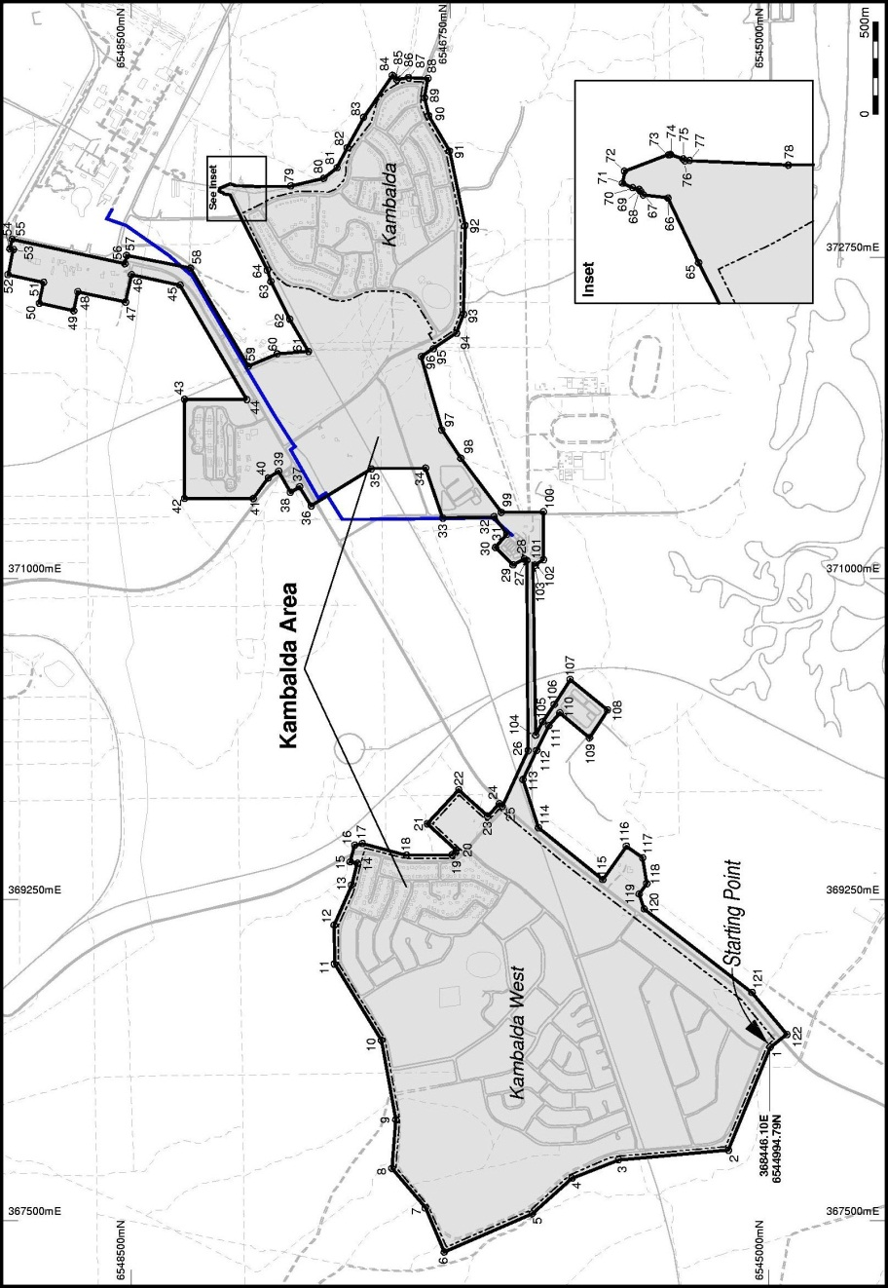

Division 2 — Map Grid of Australia coordinates

Point | Coordinates mE | Coordinates mN
1 | 368446.102 | 6544994.798
2 | 367886.400 | 6545224.837
3 | 367833.889 | 6545826.212
4 | 367734.730 | 6546081.617
5 | 367540.564 | 6546299.906
6 | 367332.541 | 6546781.454
7 | 367572.089 | 6546885.625
8 | 367786.969 | 6547069.154
9 | 368052.680 | 6547047.689
10 | 368485.289 | 6547126.784
11 | 368900.656 | 6547383.817
12 | 369113.441 | 6547385.558
13 | 369331.024 | 6547290.171
14 | 369449.552 | 6547258.767
15 | 369457.992 | 6547298.298
16 | 369548.640 | 6547273.000
17 | 369557.235 | 6547229.825
18 | 369494.095 | 6546988.986
19 | 369496.053 | 6546739.394
20 | 369520.263 | 6546717.020
21 | 369664.666 | 6546873.970
22 | 369850.083 | 6546702.364
23 | 369706.252 | 6546544.717
24 | 369774.758 | 6546480.357
25 | 369760.744 | 6546463.301
26 | 370062.828 | 6546322.450
27 | 371098.875 | 6546329.974
28 | 371106.726 | 6546343.087
29 | 371075.234 | 6546405.012
30 | 371170.265 | 6546501.367
31 | 371241.937 | 6546438.936
32 | 371337.976 | 6546508.613
33 | 371330.141 | 6546789.810
34 | 371602.096 | 6546883.464
35 | 371597.974 | 6547181.674
36 | 371396.160 | 6547511.439
37 | 371501.101 | 6547575.387
38 | 371470.411 | 6547625.179
39 | 371585.705 | 6547689.908
40 | 371547.989 | 6547746.487
41 | 371436.555 | 6547829.435
42 | 371437.000 | 6548205.000
43 | 371977.000 | 6548205.000
44 | 371975.968 | 6547864.237
45 | 372599.111 | 6548229.843
46 | 372656.843 | 6548496.126
47 | 372506.739 | 6548528.672
48 | 372563.459 | 6548790.299
49 | 372459.701 | 6548812.796
50 | 372500.434 | 6549002.210
51 | 372614.546 | 6548977.670
52 | 372656.598 | 6549173.197
53 | 372793.467 | 6549143.765
54 | 372797.672 | 6549163.315
55 | 372848.795 | 6549151.009
56 | 372715.966 | 6548532.206
57 | 372760.441 | 6548523.748
58 | 372691.337 | 6548173.548
59 | 372157.843 | 6547855.307
60 | 372224.631 | 6547697.430
61 | 372237.818 | 6547526.216
62 | 372413.643 | 6547628.482
63 | 372618.943 | 6547732.082
64 | 372681.065 | 6547751.835
65 | 373002.673 | 6547913.141
66 | 373090.653 | 6547955.427
67 | 373094.721 | 6547988.878
68 | 373099.482 | 6547992.383
69 | 373102.403 | 6547994.664
70 | 373104.722 | 6548003.360
71 | 373110.785 | 6548017.432
72 | 373127.206 | 6548014.632
73 | 373149.545 | 6547954.669
74 | 373149.769 | 6547951.764
75 | 373143.909 | 6547934.173
76 | 373141.408 | 6547932.147
77 | 373141.753 | 6547925.646
78 | 373135.553 | 6547790.305
79 | 373139.417 | 6547623.298
80 | 373180.736 | 6547442.140
81 | 373238.940 | 6547369.545
82 | 373348.194 | 6547313.729
83 | 373512.576 | 6547223.476
84 | 373741.477 | 6547066.060
85 | 373729.743 | 6547049.864
86 | 373718.022 | 6547041.823
87 | 373728.961 | 6546977.963
88 | 373725.256 | 6546871.628
89 | 373619.853 | 6546890.673
90 | 373521.045 | 6546867.464
91 | 373328.692 | 6546752.695
92 | 372922.432 | 6546668.432
93 | 372440.438 | 6546674.993
94 | 372337.978 | 6546714.788
95 | 372253.190 | 6546842.128
96 | 372210.380 | 6546907.594
97 | 371810.791 | 6546795.325
98 | 371656.326 | 6546691.655
99 | 371360.953 | 6546468.827
100 | 371365.096 | 6546238.628
101 | 371103.517 | 6546237.453
102 | 371073.800 | 6546283.105
103 | 371078.923 | 6546294.663
104 | 370147.902 | 6546280.846
105 | 370221.223 | 6546242.527
106 | 370314.669 | 6546179.128
107 | 370450.743 | 6546091.936
108 | 370284.511 | 6545886.863
109 | 370132.558 | 6545986.087
110 | 370269.418 | 6546148.566
111 | 370198.957 | 6546208.931
112 | 370064.883 | 6546275.730
113 | 369906.611 | 6546349.931
114 | 369643.455 | 6546265.494
115 | 369360.702 | 6545912.184
116 | 369542.583 | 6545784.093
117 | 369479.402 | 6545694.393
118 | 369338.482 | 6545672.213
119 | 369282.861 | 6545713.588
120 | 369200.769 | 6545685.187
121 | 368745.153 | 6545094.527
122 | 368516.792 | 6544903.767

Schedule 2 — Treated wastewater pipeline
[s. 5(1)]
Note: For the interpretation of this plan, see the definitions of “treated wastewater pipeline” in section 5(1) and of “coordinates” in section 3.
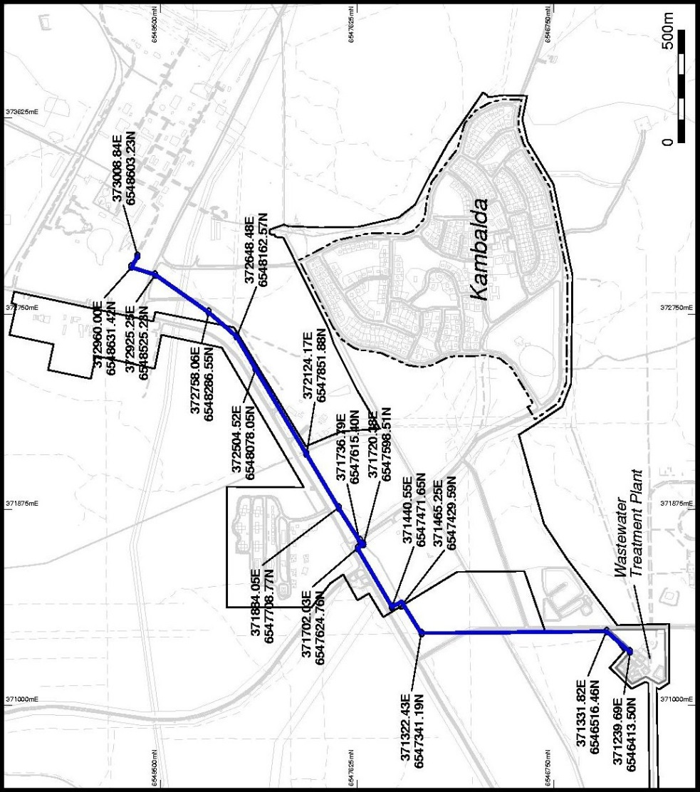

Notes
¹ This is a compilation of the Kambalda Water and Wastewater Facilities (Transfer to Water Corporation) Act 2004 and includes the amendments made by the other written laws referred to in the following table.

Compilation table
Short title | Number and year | Assent | Commencement
Kambalda Water and Wastewater Facilities (Transfer to Water Corporation) Act 2004 | 64 of 2004 | 30 Nov 2004 | 11 Jun 2005 (see s. 2 and Gazette 10 Jun 2005 p. 2565)
Statutes (Repeals and Minor Amendments) Act 2011 s. 16. | 47 of 2011 | 25 Oct 2011 | 26 Oct 2011 (see s. 2(b))

