Western Australia
Land Drainage Regulations 1978

Western Australia
Land Drainage Regulations 1978
CONTENTS
-1. Citation 1
2. Application 1
4. Interpretation 1
5. Interference with works 1
6. Protection of works and water from trespass and injury 2
7. Damage to works 2
8. Control of animals 2
9. Bathing 2
10. Pollution 2
11A. Form of notice of rate assessment 4
11B. Grading of land for differential rating 4
11C. Minimum rate 4
12. Penalties 4
Schedule 1
Schedule 2
Notes
Compilation table 8

Western Australia
Land Drainage Act 1925 ²
Land Drainage Regulations 1978

1. Citation
These regulations may be cited as the Land Drainage Regulations 1978 ¹.

2. Application
These regulations apply generally in every district for the time being constituted under the Act.
[Regulation 2 amended in Gazette 23 Dec 1983 p. 4949; 28 Jun 1985 p. 2342.]

[3. Omitted under the Reprints Act 1984 s. 7(4)(f).]

4. Interpretation
In these regulations unless the context requires otherwise the Act means the Land Drainage Act 1925, as amended.
[Regulation 4 amended in Gazette 28 Jun 1985 p. 2342.]

5. Interference with works
A person shall not interfere, or do anything likely to interfere, with any works.

6. Protection of works and water from trespass and injury
A person shall not trespass, or enter without proper authority, upon any works, or upon any land occupied, held or used in connection with any works not open to the public.

7. Damage to works
A person shall not drive, take or ride a vehicle, conveyance or animal, or perform any other act in such a manner as to endanger or damage any works.

8. Control of animals
(1) The owner of an animal, or a person who has control of it, shall not drive it, or allow it to stray, upon any works.
(2) A court of summary jurisdiction may order a person who commits a breach of this regulation to pay, in addition to any penalty prescribed by regulation 12, any expense incurred by the Corporation in consequence of that breach.
[Regulation 8 amended in Gazette 28 Jun 1985 p. 2343; 29 Dec 1995 p. 6296.]

9. Bathing
A person shall not bathe in any drain or other works, except with the written permission of the Corporation.
[Regulation 9 amended in Gazette 28 Jun 1985 p. 2343; 29 Dec 1995 p. 6296.]

10. Pollution
(1) A person shall not cast away, throw or deposit or cause to be deposited on any works or in the vicinity thereof any rubbish, litter or other objectionable matter of any kind or in any place where it is, or its components are, a source or potential source of pollution.
(2) A person shall not carry on any operations or do any act which creates or tends to create any nuisance on or in the vicinity of any works.
(3) An occupier of property or a person using a boat on any works shall not allow any sullage or effluent —
(a) containing sewage, unless treated to a standard approved by the Corporation;
(b) having acidity or alkalinity outside the range of a pH value between pH5 and pH9;
(c) containing poisons; or
(d) containing any substance which is likely to —
(i) contribute to the formation of sludge or other deposit;
(ii) contribute to the formation of scum, fat, oil, grease or floating material;
(iii) contribute to the formation of objectionable odours or discoloration;
(iv) be injurious to marine, animal or human life; or
(v) delete excessively the oxygen content of waters, to be discharged in or upon any works.
(4) Without limiting the generality of the provisions of subregulation (3), wastes shall not be discharged into any of the waters in any works —
(a) if it is reasonably practicable to dispose of them satisfactorily, in some other manner;
(b) unless every reasonable and practicable step has been taken to improve the quality and appearance of the wastes, prior to discharge; and
(c) unless they conform with a bacterial, physical and chemical composition approved by the Corporation.
[Regulation 10 amended in Gazette 28 Jun 1985 p. 2343; 29 Dec 1995 p. 6297.]

[11. Deleted in Gazette 28 Jun 1985 p. 2343.]

11A. Form of notice of rate assessment
The form of the notice of assessment required to be served under section 93 of the Act is as set out in Schedule 1.
[Regulation 11A inserted in Gazette 18 Dec 1981 p. 5219; amended in Gazette 23 Dec 1983 p. 4949.]

11B. Grading of land for differential rating
(1) The grades into which all rateable land within a district shall be divided for the purpose of fixing rates are as set out in Schedule 2.
[(2) deleted]
[Regulation 11B inserted in Gazette 23 Dec 1983 p. 4949; amended in Gazette 28 Jun 1985 p. 2343.]

11C. Minimum rate
(1) For the purposes of section 90 of the Act, the minimum rate for adjoining rural land which is in the same ownership or which is operated as a unit is $13.00.
[(2) deleted]
[Regulation 11C inserted in Gazette 23 Dec 1983 p. 4949; amended in Gazette 28 Jun 1985 p. 2343.]

12. Penalties
A person who commits a breach of any of these regulations is guilty of an offence and is liable on conviction to a penalty not exceeding $200 and in the case of a continuing breach, a further penalty not exceeding $50 for each day the offence continues after notice has been given by or on behalf of the Corporation to the offender.
[Regulation 12 amended in Gazette 29 Dec 1995 p. 6297.]

Schedule 1
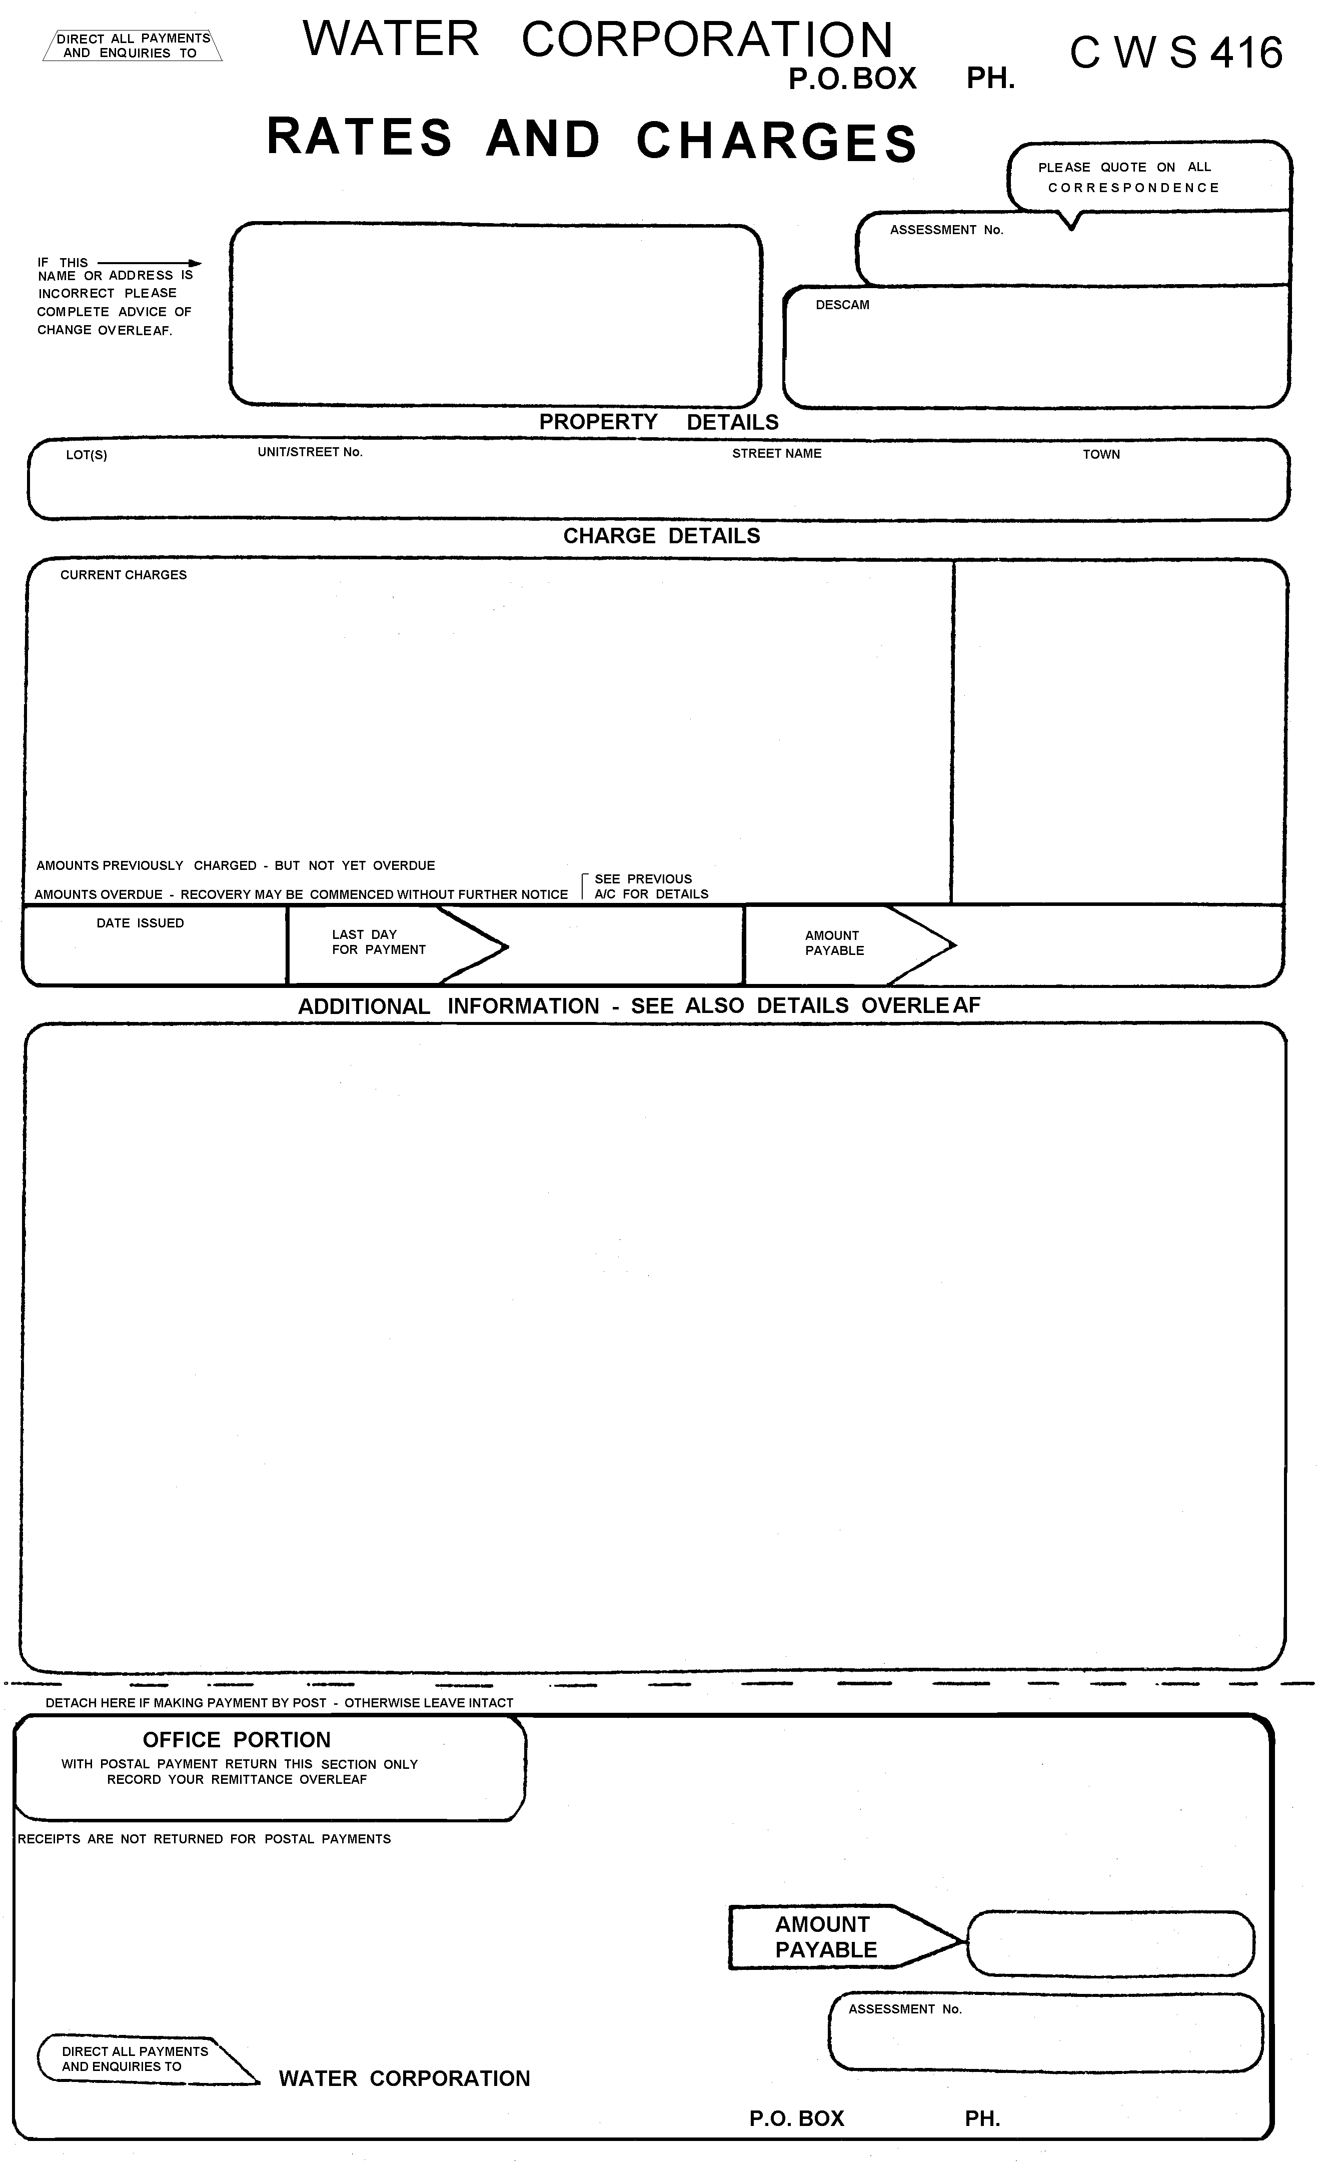
[Schedule 1 inserted in Gazette 28 Jun 1985 p. 2344; amended in Gazette 29 Dec 1995 p. 6297.]

Schedule 2
Reg. 11B
RURAL LAND
Grades of land for purpose of differential rating.
Rural land — direct grade
This grade comprises adjoining rural land within a district which is in the same ownership or is operated as a unit and which is capable of receiving direct benefit from drainage works in that it —
(a) has access to drainage works or a facility into which it is generally capable of discharging water, either by gravity or by pumping; or
(b) is generally being protected by drainage works or a facility from the flow of water from other land, from a river or watercourse, or from the sea,
and for the purposes of the foregoing definition —
facility means a maintained watercourse, or an estuary or lake, where the water level is controlled to facilitate drainage, or prevent flooding;
generally capable of discharging water means that 90% of the land, being land which is in the same ownership or which is operated as a unit, can be drained, whether with or without internal drains up to one metre in depth; and
generally being protected means that floodwaters from other land is prevented from entering on the land.
Rural land — general grade
This grade comprises all rural land within a district which is not within the definition in the preceding grade.
URBAN LAND
Urban land is graded according to which of the following area limits it falls within —
(a) not exceeding 2 500 m ²;
(b) exceeding 2 500 m ² but not exceeding 10 000 m ²;
(c) exceeding 10 000 m ² but not exceeding 15 000 m ²;
(d) exceeding 15 000 m ² but not exceeding 20 000 m ²; and
(e) exceeding 20 000 m ².
[Schedule 2 inserted in Gazette 23 Dec 1983 p. 4950; amended in Gazette 28 Jun 1985 p. 2344.]

Notes
¹ This is a compilation of the Land Drainage Regulations 1978 and includes the amendments made by the other written laws referred to in the following table. The table also contains information about any reprint.

Compilation table
Citation | Gazettal | Commencement
Land Drainage Regulations 1978 | 17 Nov 1978 p. 4309-10 | 17 Nov 1978
Land Drainage Amendment Regulations 1981 | 18 Dec 1981 p. 5219-21 | 18 Dec 1981
Land Drainage Amendment Regulations 1983 | 23 Dec 1983 p. 4949-50 | 23 Dec 1983 (see r. 2)
Land Drainage Amendment Regulations 1984 | 29 Jun 1984 p. 1791 | 29 Jun 1984
Land Drainage Amendment Regulations 1985 | 28 Jun 1985 p. 2342-4 | 1 Jul 1985 (see r. 2)
Water Agencies (Amendment and Repeal) Regulations 1995 Pt. 4 | 29 Dec 1995 p. 6296-7 | 1 Jan 1996 (see r. 2 and Gazette 29 Dec 1995 p. 6291)
Reprint of the Land Drainage Regulations 1978 as at 7 Sep 2001
(includes amendments listed above)
² These regulations have effect for the purposes of the Land Drainage Act 1925 but the formal power to make them is now given by the Water Agencies (Powers) Act 1984 s. 37.

