Western Australia
Rights in Water and Irrigation Act 1914 ²
Water Agencies (Preston Valley Irrigation Services) By-laws 1969

Western Australia
Water Agencies (Preston Valley Irrigation Services) By-laws 1969
CONTENTS
-Part 1 — Preliminary
1. Citation 1
2. Application 1
3. Interpretation 1
Part 2 — Protection of water, grounds and works
5. Unlawful entry prohibited 3
6. Camping and fires 3
8. Driving or riding vehicles of animals 3
9. Rubbish; nuisance; sullage 3
10. Protection of works 4
11. Animals 4
Part 3 — Conditions governing the supply and control of water
12. Diversion of water 5
13. Diversion works 5
14. Application for approval 5
15. Approval of Cooperative required for works 5
19. Meters 6
21. Interference with meters 6
22. Objection to meter reading 7
23. Report of damage to meter 7
26. No guarantee of water quality 8
Part 4 — Miscellaneous
29. Miscellaneous 9
Schedule 1 — Area to which these by-laws apply
Notes
Compilation table 11
Provisions that have not come into operation 12

Western Australia
Rights in Water and Irrigation Act 1914 ²
Water Agencies (Preston Valley Irrigation Services) By-laws 1969

Part 1 — Preliminary
[Heading inserted in Gazette 2 Feb 2001 p. 715.]

1. Citation
These by-laws may be cited as the Water Agencies (Preston Valley Irrigation Services) By-laws 1969 ¹.
[By-law 1 inserted in Gazette 2 Feb 2001 p. 715.]

[1A. Deleted in Gazette 2 Feb 2001 p. 716.]

2. Application
These by-laws apply to that portion of the South West Region Controlled Area (Irrigation Services) (constituted under the Water Services Coordination Act 1995) shown on the plan set out in Schedule 1.
[By-law 2 inserted in Gazette 2 Feb 2001 p. 716.]

3. Interpretation
In these by-laws unless the context requires otherwise —
Approved Diverter means a person who has received approval from the Corporation or the Cooperative to divert water from the Preston River;
Cooperative means the Preston Valley Irrigation Cooperative Ltd;
Preston River means the Preston River within the boundaries of the area referred to in by-law 2 and also any tributary connected to the Preston River, the flow in which is augmented by the water released from storages constructed by the Corporation or the Cooperative.
[By-law 3 amended in Gazette 19 Jul 1985 p. 2506; 29 Dec 1995 p. 6329; 2 Feb 2001 p. 716.]

[Division II (bl. 4) deleted in Gazette 19 Jul 1985 p. 2506.]

Part 2 — Protection of water, grounds and works
[Heading inserted in Gazette 2 Feb 2001 p. 716.]

5. Unlawful entry prohibited
A person shall not, without lawful authority, enter upon —
(a) any fenced-off ground adjacent to or reserved for water supply or irrigation works; or
(b) any water or irrigation work not open to the public.

6. Camping and fires
A person shall not camp or light a fire —
(a) upon any land reserved for the purposes connected with water; or
(b) in the immediate vicinity of any reservoir or headworks,
except on land set apart for such purposes.

[7. Deleted in Gazette 2 Feb 2001 p. 717.]

8. Driving or riding vehicles of animals
A person shall not drive or ride any vehicle, conveyance, or animal in such a manner as to endanger or damage any works.

9. Rubbish; nuisance; sullage
(1) A person shall not —
(a) cast away, throw, or deposit on any works any rubbish of any kind; or
(b) carry on any operations, or do any act which creates or tends to create any nuisance on any works.
(2) An occupier shall not allow any sullage from his land to enter in or upon any works.

10. Protection of works
(1) A person shall not, except with the consent of the Cooperative —
(a) trespass upon, injure or interfere in any way with any works;
(b) do or cause to be done anything likely at any time to injure or interfere with any works;
(c) plant any tree or noxious weed within such distance from any works that any part of the tree or noxious weed or any roots thereof at some or any future time will be likely to injure or interfere with any works;
(d) construct a dam or develop a soak hole within 20 metres of the Preston River banks; or
(e) construct any permanent structure within the waterway of the Preston River.
[(2) deleted]
[By-law 10 amended in Gazette 19 Jul 1985 p. 2506-07; 29 Dec 1995 p. 6330; 2 Feb 2001 p. 717 and 718.]

11. Animals
(1) No person owning or having the right of control of any animal shall drive, or allow the same to stray, upon any works.
(2) A person convicted of an offence against this by-law shall, in addition to the penalties prescribed in by-law 29, be liable for all damage that may thereby be caused to any works.

Part 3 — Conditions governing the supply and control of water
[Heading inserted in Gazette 2 Feb 2001 p. 717.]

12. Diversion of water
A person shall not divert water from the Preston River unless he is an Approved Diverter or is authorised to do so under another written law.
[By-law 12 amended in Gazette 2 Feb 2001 p. 717.]

13. Diversion works
A person shall not construct or maintain any diversion works or pumping installations on the Preston River unless he is an Approved Diverter or is authorised to do so under another written law.
[By-law 13 amended in Gazette 2 Feb 2001 p. 717.]

14. Application for approval
(1) An application to become an Approved Diverter shall be made on the form provided by the Cooperative for the purpose.
[(2) and (3) deleted]
[By-law 14 amended in Gazette 19 Jul 1985 p. 2506-7; 29 Dec 1995 p. 6330; 2 Feb 2001 p. 717 and 718.]

15. Approval of Cooperative required for works
An Approved Diverter shall not —
(a) construct or maintain any diversion works or pumping installations on the Preston River without the written approval of the Cooperative, unless the Approved Diverter is authorised to do so under another written law; or
(b) divert water from the Preston River except in the manner and at the place approved by the Cooperative and in accordance with the provisions of these by-laws, unless the Approved Diverter is authorised to do so under another written law.
[By-law 15 amended in Gazette 19 Jul 1985 p. 2506-7; 29 Dec 1995 p. 6330; 2 Feb 2001 p. 718.]

[16-18. Deleted in Gazette 2 Feb 2001 p. 718.]

19. Meters
The Cooperative may cause a meter or meters to be fitted to the diversion works or pumping installation of any Approved Diverter for the purpose of ascertaining by reference to the index or register incorporated with the meter or meters so fitted the quantity of water supplied to the Approved Diverter through the diversion works or pumping installation.
[By-law 19 amended in Gazette 19 Jul 1985 p. 2506-7; 29 Dec 1995 p. 6330; 2 Feb 2001 p. 718.]

[20. Deleted in Gazette 2 Feb 2001 p. 718.]

21. Interference with meters
A person other than an officer of the Cooperative or a person authorised by the Cooperative shall not —
(a) break or in any way interfere with the seal fixed on a meter;
(b) turn or attempt to turn any screw, bolt or nut on or attached to a meter;
(c) introduce or attempt to introduce any body or substance into a meter;
(d) interfere in any way with the correct registration of a meter; or
(e) cause the supply of water to by-pass a meter.
[By-law 21 amended in Gazette 19 Jul 1985 p. 2506-7; 29 Dec 1995 p. 6329; 2 Feb 2001 p. 718.]

22. Objection to meter reading
(1) Where an Approved Diverter is at any time dissatisfied with the reading of a meter, he may give written notice to the Cooperative within seven days of the reading requiring the meter to be tested, and the meter shall then be tested by passing through it a predetermined quantity of water.
(2) When a test has been completed to the satisfaction of the Cooperative then —
(a) where the meter registers more than 5% in excess of the quantity that actually passes through it at the test, the Cooperative shall bear all direct and incidental expenses of that test;
(b) where the meter registers less than 5% in excess of the quantity that actually passes through it at the test, the Approved Diverter shall pay to the Cooperative all direct and incidental expenses of that test.
[(3) deleted]
(4) An Approved Diverter may only request a test for the period of registration last preceding the date of reading in respect of which he gives notice.
[By-law 22 amended in Gazette 19 Jul 1985 p. 2506-7; 14 Jul 1987 p. 2657; 29 Jun 1988 p. 2125; 29 Dec 1995 p. 6330; 2 Feb 2001 p. 718.]

23. Report of damage to meter
Any Approved Diverter whose diversion works or pumping installations have been fitted with a meter in accordance with these by-laws shall, on finding the meter damaged or not registering, immediately give notice of the fact to the Cooperative.
[By-law 23 amended in Gazette 29 Dec 1995 p. 6330; 2 Feb 2001 p. 718.]

[24, 25. Deleted in Gazette 14 Jul 1987 p. 2658.]

26. No guarantee of water quality
The supply by the Cooperative of water for irrigation purposes shall not be deemed to imply that the water is of potable quality or free from noxious germs or other matter dangerous or injurious to health.
[By-law 26 amended in Gazette 19 Jul 1985 p. 2506-7; 29 Dec 1995 p. 6330; 2 Feb 2001 p. 718.]

[Division V (bl. 27, 28) deleted in Gazette 14 Jul 1987 p. 2658.]

Part 4 — Miscellaneous
[Heading inserted in Gazette 2 Feb 2001 p. 718.]

29. Miscellaneous
Any person who fails to comply with any of the provisions of these by-laws commits an offence and is liable upon conviction to a penalty not exceeding $2 000 and, in the case of a continuing offence, to a further penalty not exceeding $200 for each day the offence continues after notice has been given by or on behalf of the Cooperative to the alleged offender.
[By-law 29 amended in Gazette 19 Jul 1985 p. 2506-7; 29 Dec 1995 p. 6330; 2 Feb 2001 p. 718.]

Schedule 1 — Area to which these by-laws apply
[bl. 2]
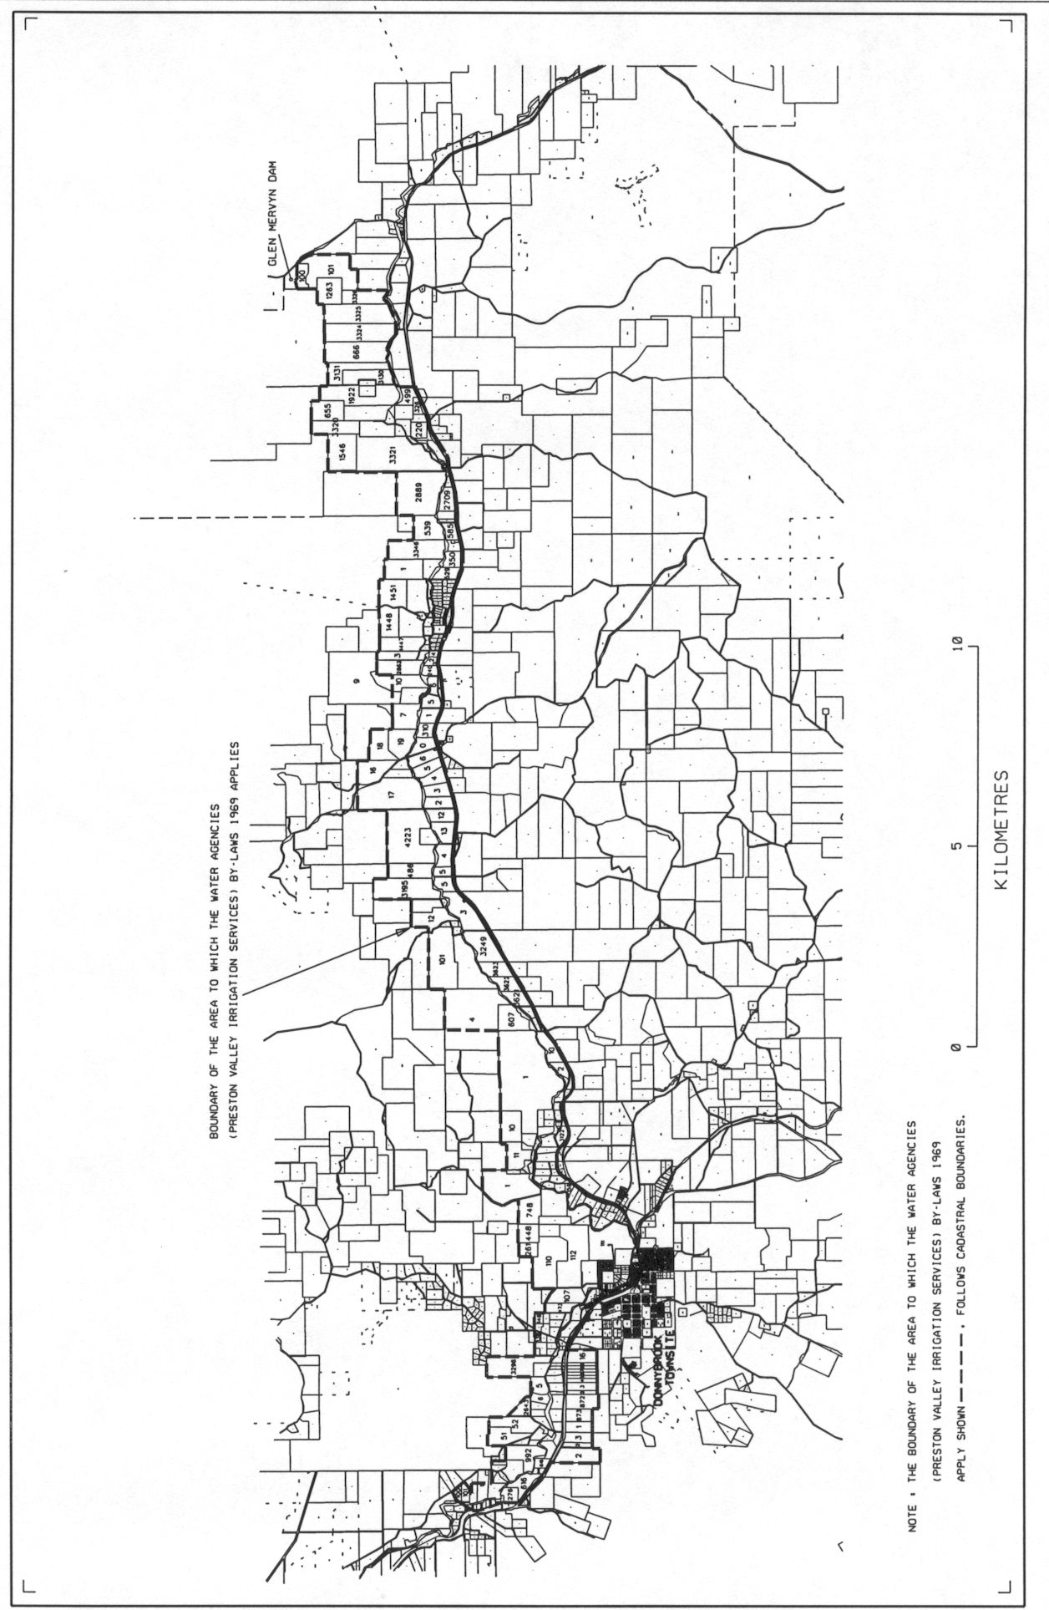
[Schedule 1 inserted in Gazette 2 Feb 2001 p. 719.]

Notes
¹ This is a compilation of the Water Agencies (Preston Valley Irrigation Services) By-laws 1969 and includes the amendments made by the other written laws referred to in the following table ^{1a}. The table also contains information about any reprint.

Compilation table
Citation | Gazettal | Commencement
Untitled by-laws ³ | 19 Dec 1969 p. 4201-4 | 19 Dec 1969
Untitled by-laws | 2 Feb 1973 p. 302 | 2 Feb 1973
Untitled by-laws | 28 Nov 1975 p. 4302 | 28 Nov 1975
Untitled by-laws | 28 Oct 1977 p. 3818 | 28 Oct 1977
Untitled by-laws | 31 Aug 1979 p. 2638 | 31 Aug 1979
Preston Valley Irrigation District (Amendment) By-laws 1980 | 29 Aug 1980 p. 3063 | 1 Sep 1980 (see bl. 2)
Preston Valley Irrigation District Amendment By-laws 1981 | 28 Aug 1981 p. 3577 | 1 Sep 1981 (see bl. 3)
Preston Valley Irrigation District Amendment By-laws 1982 | 27 Aug 1982 p. 3405 | 27 Aug 1982
Preston Valley Irrigation District Amendment By-laws 1983 | 2 Sep 1983 p. 3272 | 2 Sep 1983
Preston Valley Irrigation District Amendment By-laws 1984 | 14 Sep 1984 p. 2926 | 14 Sep 1984
Preston Valley Irrigation District Amendment By-laws 1985 | 28 Jun 1985 p. 2340 | 1 Jul 1985 (see bl. 2)
Preston Valley Irrigation District Amendment By-laws (No. 2) 1985 | 19 Jul 1985 p. 2506-7 | 19 Jul 1985
Preston Valley Irrigation District Amendment By-laws 1986 ⁴ | 27 Jun 1986 p. 2140-1 | 27 Jun 1986
Water Authority Amendment By-laws 1987 Pt. VII | 14 Jul 1987 p. 2649-58 | 14 Jul 1987
Water Authority Amendment By-laws 1988 Pt. 4 | 29 Jun 1988 p. 2122-6 | 1 Jul 1988 (see bl. 3)
Water Authority Amendment By-laws 1989 Pt. 9 | 29 Jun 1989 p. 1883-91 | 1 Jul 1989 (see bl. 3)
Water Authority Amendment By-laws 1990 Pt. 8 | 29 Jun 1990 p. 3240-8 | 1 Jul 1990 (see bl. 3)
Water Authority Amendment By-laws 1991 Pt. 8 | 28 Jun 1991 p. 3281-9 | 1 Jul 1991 (see bl. 3)
Water Authority Amendment By-laws 1992 Pt. 8 | 26 Jun 1992 p. 2832-44 | 1 Jul 1992 (see bl. 3)
Water Authority Amendment By-laws 1993 Pt. 8 ⁵ | 1 Jul 1993 p. 3238-50 | 1 Jul 1993
Water Agencies (Amendment and Repeal) By-laws 1995 Pt. 10 | 29 Dec 1995 p. 6305-32 | 1 Jan 1996 (see bl. 2 and Gazette 29 Dec 1995 p. 6291)
Preston Valley Irrigation District Amendment By-laws 2001 | 2 Feb 2001 p. 715-19 | 2 Feb 2001
Reprint 1: The Water Agencies (Preston Valley Irrigation Services) By-laws 1969 as at 25 Jul 2003 (includes amendments listed above)
^{1a} On the date as at which this compilation was prepared, provisions referred to in the following table had not come into operation and were therefore not included in this compilation. For the text of the provisions see the endnotes referred to in the table.

Provisions that have not come into operation
Short title | Number and year | Assent | Commencement
Water Services Legislation Amendment and Repeal Act 2012 s. 199(d) ⁶ | 25 of 2012 | 3 Sep 2012 | To be proclaimed (see s. 2(b))
² These by-laws have effect for the purposes of the Rights in Water and Irrigation Act 1914 but the formal power to make them is now given by the Water Agencies (Powers) Act 1984 s. 34.
³ Now known as the Water Agencies (Preston Valley Irrigation Services) By-laws 1969; citation inserted (see note under bl. 1).
⁴ The Preston Valley Irrigation District Amendment By-laws 1986 bl. 5 reads as follows:
“
5. Savings
Nothing in these by-laws affects the application of the principal by-laws, as in force before the coming into operation of these by-laws, in relation to the amount of a charge prescribed for late notification or for water diverted or made available, where the notification was given or the water was diverted or made available, as the case may be, before 1 July 1986.
”.
⁵ The Water Authority Amendment By-laws 1993 bl. 2 reads as follows:
“
2. Application
Nothing in these by-laws affects the application after 1 July 1993 of a by-law in force before that day in so far as that by-law relates to a fee or charge for a period commencing before that day or to a fee or charge for any matter or thing done before that day.
”.
⁶ On the date as at which this compilation was prepared, the Water Services Legislation Amendment and Repeal Act 2012 s. 199(d) had not come into operation. It reads as follows:

199. Irrigation legislation repealed
These written laws are repealed:
(d) the Water Agencies (Preston Valley Irrigation Services) By-laws 1969.

