Western Australia

Alumina Refinery (Mitchell Plateau) Agreement (Termination) Act 2015

Western Australia
Alumina Refinery (Mitchell Plateau) Agreement (Termination) Act 2015
Contents
Part 1 — Preliminary
1. Short title 2
2. Commencement 2
Part 2 — Alumina Refinery (Mitchell Plateau) Agreement Act 1971 amended
3. Act amended 3
4. Long title amended 3
5. Section 2 amended 3
6. Section 4 replaced 4
4. Ratification and operation of termination agreement 4
5A. Cancellation of Temporary Reserve 5610H 4
5B. Termination of pending applications in respect of Mitchell Plateau area 4
5C. Temporary prohibition on tenement applications in respect of Mitchell Plateau area 4
7. Fourth and Fifth Schedules inserted 6
Fourth Schedule — Termination agreement
Fifth Schedule — Mitchell Plateau area
Division 1 — Description
1. Mitchell Plateau area 14
Division 2 — Map
Division 3 — Coordinates
Part 3 — Mining Act 1978 amended
8. Act amended 20
9. Section 6 amended 20

Western Australia
Alumina Refinery (Mitchell Plateau) Agreement (Termination) Act 2015
No. 31 of 2015
An Act to amend the Alumina Refinery (Mitchell Plateau) Agreement Act 1971 to provide for the ratification of an agreement for the termination of the Alumina Refinery (Mitchell Plateau) Agreement and to provide for related matters, and to consequentially amend the Mining Act 1978.
[Assented to 2 November 2015]
The Parliament of Western Australia enacts as follows:

Part 1 — Preliminary

1. Short title
This is the Alumina Refinery (Mitchell Plateau) Agreement (Termination) Act 2015.

2. Commencement
This Act comes into operation as follows —
(a) Part 1 — on the day on which this Act receives the Royal Assent;
(b) the rest of the Act — on the day after that day.

Part 2 — Alumina Refinery (Mitchell Plateau) Agreement Act 1971 amended

3. Act amended
This Part amends the Alumina Refinery (Mitchell Plateau) Agreement Act 1971.

4. Long title amended
In the long title delete “effect;” and insert:

effect, to ratify a further agreement for the termination of the Agreement,

5. Section 2 amended
In section 2 insert in alphabetical order:

Mitchell Plateau area has the meaning given in the Fifth Schedule clause 1;
pending application means a tenement application made, but not determined, under the Mining Act 1978 before the day on which the Alumina Refinery (Mitchell Plateau) Agreement (Termination) Act 2015 section 6 comes into operation;
Temporary Reserve 5610H means the reserve of that designation created under the Mining Act 1904 and continued under the Mining Act 1978;
tenement application means an application for a mining tenement under the Mining Act 1978;
termination agreement means the agreement a copy of which is set out in the Fourth Schedule;

6. Section 4 replaced
Delete section 4 and insert:

4. Ratification and operation of termination agreement
(1) The termination agreement is ratified.
(2) Without limiting or otherwise affecting the operation of the Government Agreements Act 1979, the termination agreement is to operate and take effect despite any other Act or law.
5A. Cancellation of Temporary Reserve 5610H
Temporary Reserve 5610H is cancelled by force of this section.
5B. Termination of pending applications in respect of Mitchell Plateau area
(1) Each pending application in respect of land wholly or partly within the Mitchell Plateau area is terminated by force of this section.
(2) No action, claim or demand lies against the State, the Minister or any other person in respect of any matter or thing arising from the termination of a pending application under this section.
5C. Temporary prohibition on tenement applications in respect of Mitchell Plateau area
(1) In this section —
relevant area means the Mitchell Plateau area or that area modified to the extent necessary to reflect any changes to the boundaries of land contiguous to that area resulting from survey or cadastral information.
(2) Despite anything in the Mining Act 1978, a tenement application cannot be made during the designated period in respect of land wholly or partly within the Mitchell Plateau area.
(3) For the purposes of subsection (2), the designated period is the period —
(a) beginning on the day on which the Alumina Refinery (Mitchell Plateau) Agreement (Termination) Act 2015 section 6 comes into operation; and
(b) ending on the day fixed under subsection (4).
(4) When the Minister is satisfied that the relevant area has been reserved under the Land Administration Act 1997 Part 4 for the purposes of a national park and classified as a class A reserve under that Part, the Minister must, by notice published in the Gazette, fix a day for the purposes of subsection (3)(b).
(5) The day fixed must be the day after the day on which the notice is published in the Gazette.

7. Fourth and Fifth Schedules inserted
After the Third Schedule insert:

Fourth Schedule — Termination agreement
[s. 2]
2015

THE HONOURABLE COLIN JAMES BARNETT
PREMIER OF THE STATE OF WESTERN AUSTRALIA

AND

MITCHELL PLATEAU BAUXITE CO. PTY. LIMITED
ACN 008 545 499

ALCOA OF AUSTRALIA LIMITED
ACN 004 879 298

ALUMINA REFINERY (MITCHELL PLATEAU) AGREEMENT 1971
TERMINATION AGREEMENT

[Solicitor's details]

THIS AGREEMENT is made this 20th day of February 2015
BETWEEN
THE HONOURABLE COLIN JAMES BARNETT, MEc., M.L.A., Premier of the State of Western Australia, acting for and on behalf of the said State and instrumentalities thereof from time to time ("the State") of the one part
AND
MITCHELL PLATEAU BAUXITE CO. PTY. LIMITED ACN 008 545 499 of 123 Albert Street, Brisbane, Queensland and ALCOA OF AUSTRALIA LIMITED ACN 004 879 298 of Corner Davy and Marmion Streets, Booragoon, Western Australia (together called "the Company" in which term shall be included their respective successors and permitted assigns) of the other part.
WHEREAS:
A. The State and the Company are now the parties to the agreement dated 17 November 1971 which agreement was ratified by the Agreement Act and subsequently varied or supplemented by agreements dated 31 August 1972, 15 May 1973, 29 October 1985 and 29 August 2003, and which agreement as subsequently varied or supplemented is referred to in this Agreement as "the Principal Agreement".
B. The State and the Company wish to terminate the Principal Agreement in the manner and on the terms set out in this Agreement.
NOW THIS AGREEMENT WITNESSES:
1. Definitions
In this Agreement subject to the context:
Agreement Act means the Alumina Refinery (Mitchell Plateau) Agreement Act 1971 (WA).
Cape Bougainville Mining Leases means mining leases 80/47 - 80/60 (both inclusive).
LAA means the Land Administration Act 1997 (WA).
Mining Act means the Mining Act 1978 (WA).
Operative Date has the meaning given in clause 3(2).
Right of Occupancy means the right of occupancy in respect of the Temporary Reserve referred to in, and renewed pursuant to, the Principal Agreement.
Temporary Reserve means Temporary Reserve 5610H.
this Agreement, hereof and hereunder refer to this Agreement, whether in its original form or as from time to time added to, varied or amended.
2. Interpretation
In this Agreement:
(a) clause headings do not affect interpretation or construction;
(b) words in the singular shall include the plural and words in the plural shall include the singular according to the requirements of the context;
(c) one gender includes the other genders;
(d) a covenant or agreement by more than one person binds, and is enforceable against, those persons jointly and each of them severally;
(e) a reference to a "person" includes a body corporate;
(f) a reference to an Act includes the amendments to that Act for the time being in force and also any Act passed in substitution therefor or in lieu thereof and the regulations for the time being in force thereunder;
(g) a reference to any document includes that document as from time to time added to, varied or amended and notwithstanding any change in the identity of the parties;
(h) a reference to a clause or schedule is a reference to a clause in or schedule to this Agreement, and a reference to a subclause or paragraph is a reference to the subclause of the clause or paragraph of the clause or subclause as the case may be in, or in relation to, which the reference is made;
(h) a reference to this Agreement includes all recitals, schedules and annexures; and
(i) "including" means "including, but not limited to".
3. Ratification and operation
(1) This Agreement, other than this clause and clauses 1 and 2, does not come into operation except in accordance with subclause (2).
(2) This Agreement, other than this clause and clauses 1 and 2, comes into operation on the day on which it is ratified by an Act of the Parliament of Western Australia (Operative Date) unless, before that day, it terminates under subclauses (4) or (5).
(3) The State must introduce in the Parliament of Western Australia before 31 March 2015, or a later date agreed between the parties to this Agreement, a Bill to ratify this Agreement and must endeavour to secure its passage as an Act.
(4) If by 31 December 2015 this Agreement has not been ratified by an Act of the Parliament of Western Australia then, unless the parties to this Agreement otherwise agree, this Agreement terminates on that day and no party hereto will have any claim against any other party hereto with respect to any matter or thing arising out of, done, performed, or omitted to be done or performed under this Agreement.
(5) The parties agree that if the Principal Agreement is otherwise determined in accordance with its provisions on a day prior to the Operative Date, then this Agreement shall also terminate on and from that day and no party hereto will have any claim against any other party hereto with respect to any matter or thing arising out of, done, performed, or omitted to be done or performed under this Agreement.
4. Termination of Principal Agreement
(1) Subject to the remainder of this clause, the Principal Agreement is hereby terminated with effect on and from the Operative Date and, except as otherwise provided in this Agreement, neither the State nor the Company shall have any claim against the other with respect to any matter or thing in or arising out of the Principal Agreement.
(2) Notwithstanding subclause (1), but subject to subclause (6), the Company shall remain liable for any antecedent breach or default under the Principal Agreement and in respect of any indemnity given under the Principal Agreement.
(3) Notwithstanding subclause (1):
(a) on and from the Operative Date the Cape Bougainville Mining Leases shall continue in force only under and, except as provided in this subclause, subject to the provisions of the Mining Act and, for the avoidance of doubt, shall cease to have the benefit of the rights and privileges conferred by the Principal Agreement;
(b) in relation to each of the Cape Bougainville Mining Leases, for the period from and including the Operative Date up to and including the earlier of:
(i) the date of expiry of the current term of that mining lease; and
(ii) the date on which the companies comprising the Company at the date of this Agreement cease to hold greater than a 30% interest in that mining lease (where such interest may be held individually by one of those companies or by both of them in the aggregate),
the holder of that mining lease shall not be required:
(iii) to comply with the expenditure conditions prescribed under the Mining Act that are applicable to that mining lease; or
(iv) to lodge a Form 5 (operations report–expenditure on mining tenement) in relation to that mining lease in compliance with the requirements of the Mining Act; and
(c) in relation to each of the Cape Bougainville Mining Leases, if exploration or mining expenditure has been incurred in the relevant reporting period in relation to that mining lease, the holder of that mining lease must notwithstanding the reporting exemption contained in paragraph (b)(iv) file, or cause to be filed, as the case may be, the mineral exploration report required by section 115A of the Mining Act in relation to that mining lease at the times that would otherwise have been applicable (including whenever required under section 115A(2)(b)) if such exemption had not been granted,
and on application under section 103G of the Mining Act made within 3 months after the Operative Date, the State shall cause an endorsement to be made in the register maintained under section 103F of the Mining Act that the provisions of this subclause apply to the Cape Bougainville Mining Leases.
(4) Within 14 days after the Operative Date the Company shall pay to the State an amount of $760,000 to fund rehabilitation and other proposed on-ground activities of the State within the area of land comprised within the Temporary Reserve immediately before the Operative Date.
(5) Subject to subclause (6), on and from the Operative Date the Company will indemnify and keep indemnified the State and the State's employees, agents and contractors in respect of all actions, suits, claims, demands or costs of third parties arising out of or in connection with any work carried out by the Company pursuant to the Principal Agreement or relating to its operations under the Principal Agreement or arising out of or in connection with the construction, maintenance or use by the Company or its employees, agents, contractors, assignees or sublessees of the Company's works or services the subject of the Principal Agreement or the plant, apparatus or equipment installed in connection with the Principal Agreement.
This indemnity shall remain in force for a period ending on the date which is 20 years after the Operative Date.
(6) The Company is not liable to indemnify the State and the State's employees, agents and contractors under subclause (5) or under the Principal Agreement (as the case may be):
(a) to the extent that the relevant action, suit, claim, demand or cost relates to activities or works carried out before the Operative Date by the State or the State's employees, agents or contractors (including activities or works funded by the Company);
(b) to the extent that the relevant action, suit, claim, demand or cost relates to rehabilitation or other on-ground activities of the State undertaken after the Operative Date as contemplated by subclause (4);
(c) to the extent that the relevant action, suit, claim, demand or cost relates to earthworks or ground disturbances, within the area of land comprised within the Temporary Reserve immediately before the Operative Date, relating to exploration activities conducted pursuant to the Principal Agreement; or
(d) to the extent that the relevant action, suit, claim, demand or cost relates to third party use after the Operative Date of works, services, plant, apparatus or equipment constructed, operated or maintained by the Company within the area of land comprised within the Temporary Reserve immediately before the Operative Date, including the airstrip and the access road.
(7) For the avoidance of doubt a reference to matters or things in, under, pursuant to, conferred by or arising out of or in connection with the Principal Agreement for the purposes of this clause includes matters or things deemed to be so attributed to the Principal Agreement by section 6 of the Agreement Act.
5. Termination of Right of Occupancy
(1) The Right of Occupancy shall be deemed to have been surrendered with effect on and from the Operative Date.
(2) The Company shall remain liable for any antecedent breach or default of the conditions of the Right of Occupancy.
6. Applicable law
This Agreement is to be interpreted according to the law for the time being in force in the State of Western Australia.

EXECUTED as a deed.

SIGNED by THE HONOURABLE )
COLIN JAMES BARNETT ) [Signature]
in the presence of: )

[Signature]
Signature of witness

NICOLE JANE HENDERSON
Name of witness
EXECUTED by MITCHELL PLATEAU )
BAUXITE CO. PTY. LIMITED )
ACN 008 545 499 in accordance with )
section 127(1) of the Corporations Act 2001 (Cth) )

[Signature] [Signature]
Signature of Director Signature of Secretary

PAUL GERARD ARNOLD ALFRED PATRICK GRIGG
Full Name Full Name

EXECUTED by ALCOA OF AUSTRALIA )
LIMITED ACN 004 879 298 in accordance )
with section 127(1) of the Corporations Act )
2001 (Cth) )

[Signature] [Signature]
Signature of Director Signature of Secretary

SIMON NICOLAS BUTTERWORTH MELANIE KATHERINE BROWN
Full Name Full Name
Fifth Schedule — Mitchell Plateau area
[s. 2]
Division 1 — Description
1. Mitchell Plateau area
(1) In this clause —
high water mark means ordinary high water mark at spring tides;
point means a point on the surface of the Earth identified by a number on the map set out in Division 2.
(2) The Mitchell Plateau area is the area of land bounded by —
(a) the straight line starting at the intersection of the high water mark and the straight line connecting points 1 and 2, and ending at point 2; and
(b) the straight lines connecting points 2 to 38; and
(c) the straight line starting at point 38 and ending at the intersection of the high water mark and the straight line connecting points 38 and 39; and
(d) the line along the high water mark starting at the intersection of the high water mark and the straight line connecting points 38 and 39 and ending at the intersection of the high water mark and the straight line connecting points 40 and 41; and
(e) the straight line starting at the intersection of the high water mark and the straight line connecting points 40 and 41, and ending at point 41; and
(f) the straight lines connecting points 41 to 44; and
(g) the straight line starting at point 44 and ending at the intersection of the high water mark and the straight line connecting points 44 and 45; and
(h) the line along the high water mark starting at the intersection of the high water mark and the straight line connecting points 44 and 45 and ending at the intersection of the high water mark and the straight line connecting points 1 and 2.
(3) However, the Mitchell Plateau area does not include the area of land bounded by straight lines connecting points 46, 47, 48 and 49, starting at point 46 and ending at that point.
(4) The Mitchell Plateau area is depicted on the map set out in Division 2.
(5) The position of a point is to be determined by reference to the coordinates set out in Division 3 opposite the relevant point number.
(6) The coordinates referred to in subclause (5) are Geocentric Datum of Australia 1994 coordinates.
Division 2 — Map
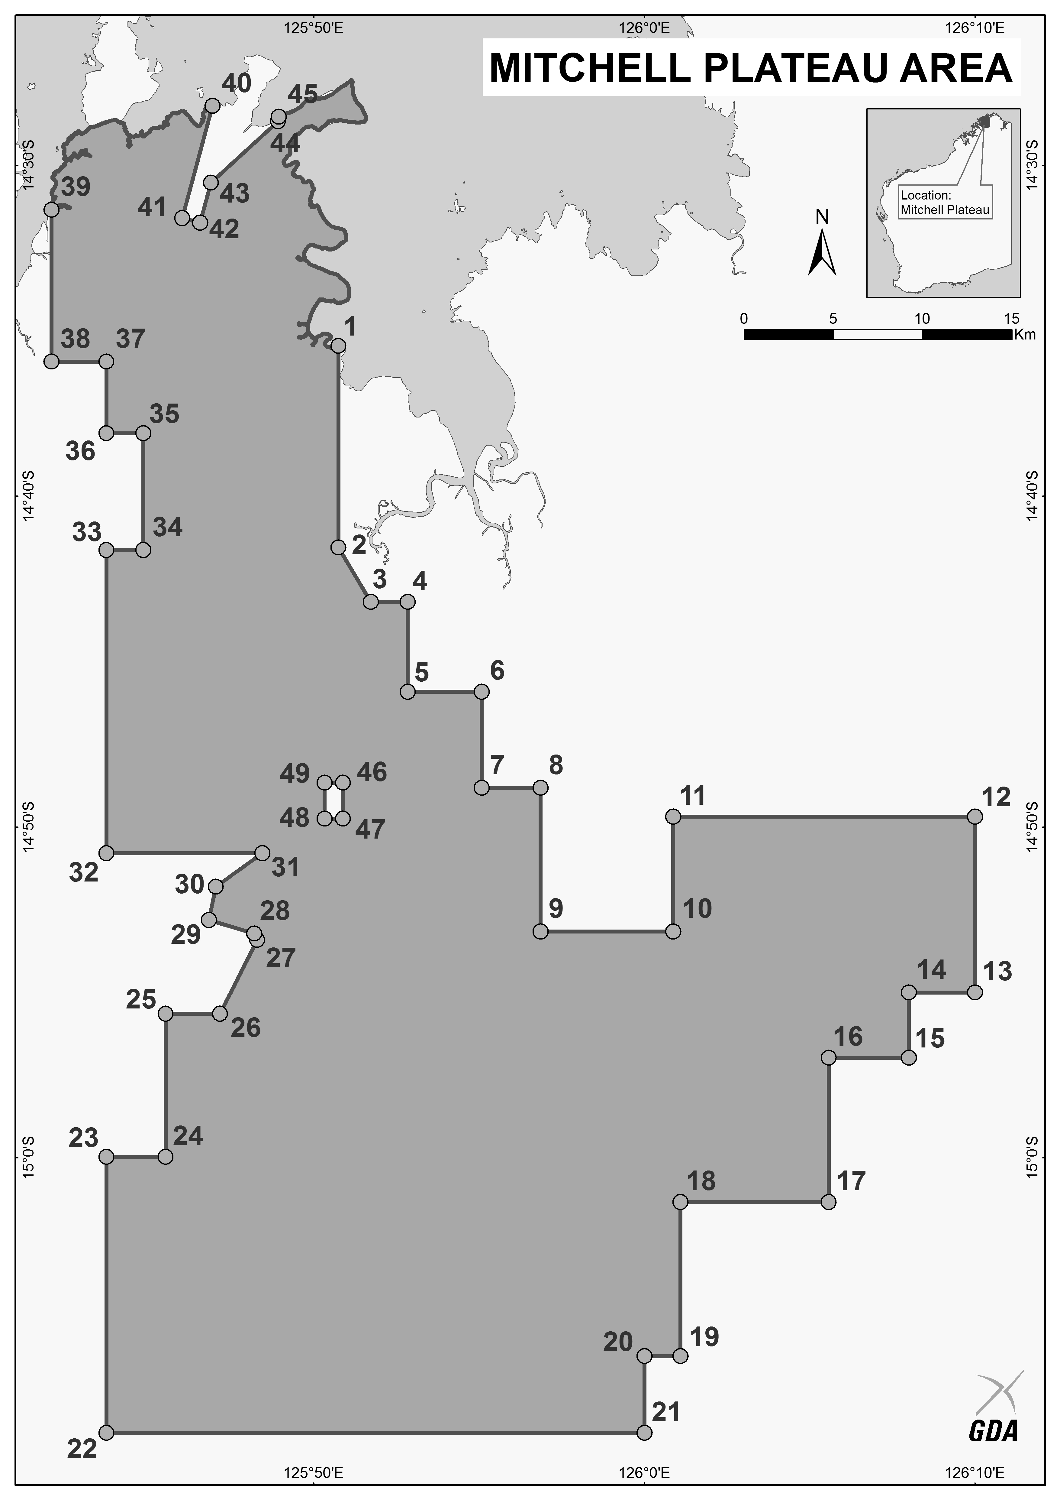
Division 3 — Coordinates
Point | Latitude | Longitude
1 | 14°35'27.24" S | 125°50'44.84" E
2 | 14°41'33.24" S | 125°50'44.84” E
3 | 14°43'11.86" S | 125°51'43.34" E
4 | 14°43'11.86" S | 125°52'50.20" E
5 | 14°45'54.54" S | 125°52'50.20" E
6 | 14°45'54.55" S | 125°55'04.55" E
7 | 14°48'49.00" S | 125°55'04.55" E
8 | 14°48'49.00" S | 125°56'51.57" E
9 | 14°53'09.28" S | 125°56'51.58" E
10 | 14°53'09.28" S | 126°00'52.45" E
11 | 14°49'41.05" S | 126°00'52.45" E
12 | 14°49'41.04" S | 126°10'00.00" E
13 | 14°55'00.00" S | 126°10'00.00" E
14 | 14°55'00.00" S | 126°08'00.00" E
15 | 14°56'58.36" S | 126°08'00.00" E
16 | 14°56'58.38" S | 126°05'34.55" E
17 | 15°01'20.19" S | 126°05'34.55" E
18 | 15°01'20.19" S | 126°01'05.17" E
19 | 15°06'00.00" S | 126°01'05.17" E
20 | 15°06'00.00" S | 126°00'00.00" E
21 | 15°08'19.08" S | 126°00'00.00" E
22 | 15°08'19.09" S | 125°43'43.74" E
23 | 14°59'58.66" S | 125°43'43.74" E
24 | 14°59'58.66" S | 125°45'30.86" E
25 | 14°55'38.38" S | 125°45'30.86" E
26 | 14°55'38.38" S | 125°47'09.57" E
27 | 14°53'24.97" S | 125°48'17.01" E
28 | 14°53'13.00" S | 125°48'11.84" E
29 | 14°52'48.63" S | 125°46'49.63" E
30 | 14°51'48.34" S | 125°47'02.22" E
31 | 14°50'47.19" S | 125°48'26.40" E
32 | 14°50'47.19" S | 125°43'43.76" E
33 | 14°41'37.33" S | 125°43'43.75" E
34 | 14°41'37.33" S | 125°44'50.60" E
35 | 14°38'05.84" S | 125°44'50.60" E
36 | 14°38'05.85" S | 125°43'43.77" E
37 | 14°35'55.70" S | 125°43'43.77" E
38 | 14°35'55.70" S | 125°42'03.54" E
39 | 14°31'20.50" S | 125°42'03.53" E
40 | 14°28'11.87" S | 125°46'56.18" E
41 | 14°31'35.31" S | 125°46'01.21" E
42 | 14°31'43.46" S | 125°46'33.54" E
43 | 14°30'31.09" S | 125°46'53.10" E
44 | 14°28'40.14" S | 125°48'55.22" E
45 | 14°28'31.60" S | 125°48'56.22" E
46 | 14°48'39.88" S | 125°50'52.95" E
47 | 14°49'44.95" S | 125°50'52.95" E
48 | 14°49'44.95" S | 125°50'19.50" E
49 | 14°48'39.88" S | 125°50'19.51" E

Part 3 — Mining Act 1978 amended

8. Act amended
This Part amends the Mining Act 1978.

9. Section 6 amended
After section 6(3) insert:

(4) The operation of this Act is subject to the Alumina Refinery (Mitchell Plateau) Agreement Act 1971 sections 5B and 5C.

