Western Australia

Grain Marketing Act Regulations 1975
Compare between:
[10 Jan 1996, 00-c0-03] and [31 Oct 2002, 00-d0-08]

Western Australia
GRAIN MARKETING ACT 1975
Grain Marketing Act Regulations 1975

[Heading to Part I deleted by Gazette 9 January 1996 p.52.]

1. Citation
These regulations may be cited as the Grain Marketing Act Regulations 1975.
[Heading deleted by Gazette 9 January 1996 p.52.]

2. Interpretation
In these regulation unless the contrary intention appears: —
“Act” means the Grain Marketing Act 1975;
“barley” includes a sample of barley containing not less that sixty per centum of barley grain or seed;
“Board” means the Board of Directors of The Grain Pool of W.A. established under the Act;
“certificate” means a certificate issued by the Board in respect of a grain received by The Grain Pool for a pool;
“closing date” means the date on or before which grain for a pool may be delivered to The Grain Pool or a licensed receiver;
“grain” means the seed of any crop of pasture species;
“Grain Pool” means The Grain Pool of W.A. established under the Act;
“Grain Research Committee” means the Grain Research Committee referred to in section 28 of the Act;
“licensed receiver” means a person who has under section 34 of the Act a licence to receive and handle grain on behalf of The Grain Pool;
“lupin” means —
(a) the Uniwhite, Uniharvest, and Unicrop cultivars of Lupinus angustifolius L. (narrow-leaved lupin); and
(b) the Weiko III cultivar of Lupinus luteus L. (yellow lupin);
“pool” means a pool established under the act for the marketing of a grain;
“season” means the period between the 1st April in any one year and the 31st March in the next following year.
[Regulation 2 amended in Gazette 9 January 1996 p.52.]
[Heading to Part II deleted in Gazette 9 January 1996 p.52.]
[Heading deleted in Gazette 9 January 1996 p.52.]

3. Form of certificate for receipt of grain
A certificate issued by the Board for the receipt of grain in accordance with section 30 of the Act shall be in the form of Form 1 in Appendix I to these regulations.
[Regulation 3 inserted by Gazette 21 October 1983 p.4298.]

4. Form of claim for compensation
A claim for compensation for grain accepted by the Board shall be made in accordance with Form 2 in Appendix I to these regulations.

5. Application of that part of the Grain Research Fund transferred from the Soil Fertility Research Fund
For the purposes of section 19B (c) of the Act, that part of the Grain Research Fund in respect of which a separate balance is kept under section 19B of the Act is to be applied —
(a) for the purpose of providing 2 scholarships, which are to be known as the “Wheat Grower Scholarships”, in each calender year for such amounts and in accordance with such selection criteria as the Grain research Committee decides; and
(b) for any other purpose relating to grain research.
[Regulation 5 inserted in Gazette 9 January 1996 p.52.]

Appendix I

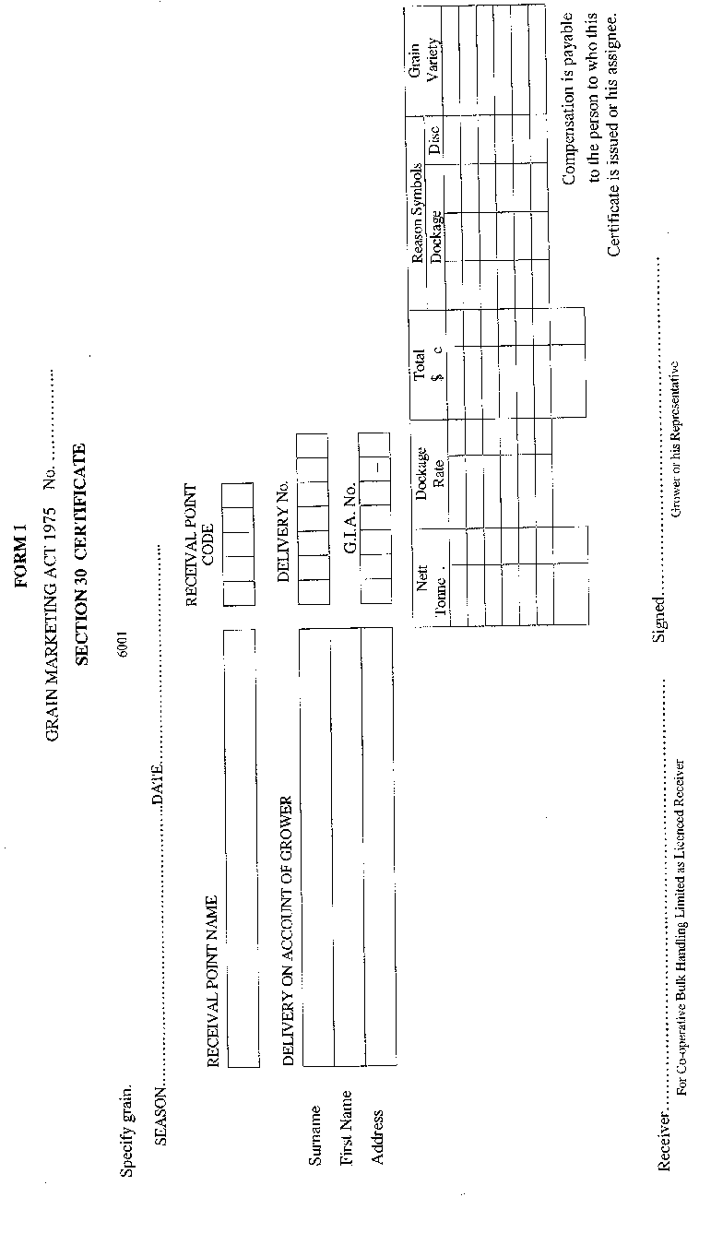
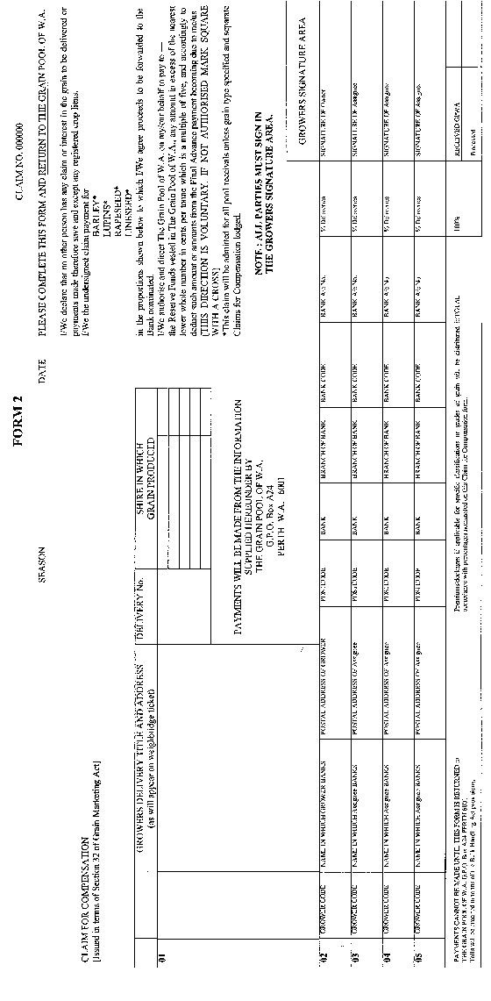
[Appendix I amended by Gazette 21 October 1983 pp.4298-300.]

Notes
^{1.} This is a compilation of the Grain Marketing Act Regulations 1975 and includes the amendments referred to in the following Table.

Compilation table
Citation | Gazettal | Commencement
Grain Marketing Act Regulations 1975 | 21 Nov 1975 p. 4260-1
 | 21 Oct 1983 p. 4298-300
Grain Marketing Amendment Regulations 1996 | 9 Jan 1996 p. 51-2 | 10 Jan 1996 (see r. 2 and Gazette 9 Jan 1996 p. 51)
These regulations were repealed as a result of the repeal of the Grain Marketing Act 1975 by the Grain Marketing Act 2002 s. 45 (No. 30 of 2002) as at 31 Oct 2002 (see s. 2 and Gazette 30 Oct 2002 p. 5351)

