Western Australia
Clean Air Regulations 1967

Western Australia
Clean Air Regulations 1967
CONTENTS
1. Citation 1
2. Commencement 1
3. Interpretation 1
4. Prescribed periods 2
5. Prescribed period for renewal of licence 2
6. Application for licence 2
6A. Form of licence 2
7. Application for renewal of licence 3
7A. Renewal of licence 3
8. Application for transfer of licence 3
9. Offence and penalty 3
10. Fees for transfer 3
11. Fee for approval under S.34 3
12. Plans and specifications 4
13. Register of licences 4
14. Licensing fees 4
17. Chimneys 5
18. Solid Particles in Smoke 5
19. Dark smoke permitted periods 5
20. Dark smoke — vessels 5
Schedule
NOTES

Western Australia
CLEAN AIR ACT 1964
Clean Air Regulations 1967

1. Citation
These regulations may be cited as the Clean Air Regulations 1967.

2. Commencement
These regulations shall come into operation on and from the day on which the Clean Air Act 1964 comes into operation.

3. Interpretation
In these regulations, unless the contrary intention appears —
“dark smoke” means smoke that, if compared with a chart known as the Ringelmann Chart as described in the British Standard (of the British Standards Institution) 2742: 1958, using for the purpose of the test British Standard Ringelmann Chart BS2742C: 1957 or British Standard Miniature Ringelmann Chart BS2742M: 1960, would appear darker than shade 1 on either of those charts;
“incinerator” means any structure or part of a structure used to dispose of combustible refuse by burning;
“master” includes every person having lawfully, or de facto the command, charge or management of a vessel for the time being;
“section” means section of the Act.
[Regulation 3 amended by Gazettes 27 May 1983 p.1605; 21 June 1985 p.2202.]
LICENSING AND OTHER PROVISIONS

4. Prescribed periods
The prescribed period for the purposes of —
[(a) deleted]
(b) paragraph (b) of section 23 (2), is 1 month from the time the person making application for a licence in respect of any premises, first commenced to use them as scheduled premises;
(c) paragraph (c) of section 23 (2), is 3 months after the publication of the Order in Council in the Gazette;
(d) paragraph (d) of section 23 (2), is 1 month after the person became the occupier of the scheduled premises.
[Regulation 4 amended by Gazettes 27 May 1983 p.1605; 2 March 1984 p.544.]

5. Prescribed period for renewal of licence
An application for the renewal of a licence shall be made not earlier than 1 month before the date of expiry of the licence.

6. Application for licence
An application for a licence pursuant to the provisions of Division 1 of Part III of the Act shall be in or to the effect of Form 1.

6A. Form of licence
A licence issued pursuant to the provisions of Division 1 of Part III of the Act shall be in the form of Form 6.
[Regulation 6A inserted by Gazette 25 May 1983 p.1605.]

7. Application for renewal of licence
An application for renewal of a licence pursuant to the provisions of Division 1 of Part III of the Act shall be made in or to the effect of Form 2.

7A. Renewal of licence
The renewal of a licence pursuant to the provisions of Division 1 of Part III of the Act shall be in the form of Form 7.
[Regulation 7A inserted by Gazette 27 May 1983 p.1605.]

8. Application for transfer of licence
An application for transfer of a licence pursuant to the provisions of Division 1 of Part III of the Act shall be made in or to the effect of Form 3.

9. Offence and penalty
A person who makes an application —
(a) for a licence:
(b) for the renewal of a licence; or
(c) for the transfer of a licence,
that is false in any material particular is guilty of an offence against these regulations and is liable to a penalty of $2 000.
[Regulation 9 amended by Gazette 27 May 1983 p.1605.]

10. Fees for transfer
The fee payable in respect of a transfer of a licence shall be $30.
[Regulation 10 amended by Gazette 7 October 1983 p.4069.]

11. Fee for approval under S.34
An application for approval under the provisions of section 34 shall be made in or to the effect of Form 4 and shall be accompanied by a fee of $50.
[Regulation 11 amended by Gazettes 7 October 1983 p.4069; 29 June 1984 p.1781; 21 June 1985 p.2202.]

12. Plans and specifications
The plans and specifications required to be submitted under section 34 (2) (d) —
(a) shall be submitted in duplicate; and
(b) shall be drawn to such scale and be set forth in such detail as shall provide adequate information of the work, building, erection or alteration to which the plans and specifications relate so far as the work, building, erection or alteration affects air pollution control.

13. Register of licences
The register of licences required under section 28 to be kept shall be as set out in, or to the effect of, Form 5.
Regulation 13 inserted by Gazette 21 June 1985 p.2202.]

14. Licensing fees
(1) Subject to subregulation (2), the fees payable for licences in respect of scheduled premises or any renewal thereof under the provisions of section 24 shall be as follows —
A. PREMISES BEING USED FOR — | $
(a) Abrasive Blasting Works —
(i) in which all blasting is carried out in an enclosed chamber from which particulate emissions from the exit gases conform to the standard of concentration prescribed in section 33 . . . . . . . . . . . . . . . . . . . . . | 50
(ii) all other abrasive blasting works . . . | 200
(b) Asphalt and Bitumen Works —
(i) processing not more than 10 000 tonnes of material per year . . . . . . . . | 50
(ii) processing more than 10 000 tonnes but not more than 100 000 tonnes of material per year . . . . . . . . . . . . . . . . | 250
(iii) processing more than 100 000 tonnes but not more than 1 000 000 tonnes per year . | 500
(iv) processing more than 1 000 000 tonnes of material per year . . . . . . . . | 1 000
(c) Cement and Lime Works —
(i) producing lime or grinding cement clinker not more than 200 000 tonnes of material per year . . . . . . . . | 1 000
(ii) producing more than 200 000 tonnes of lime or grinding more than 200 000 tonnes of cement clinker per year . . . . . . . . . . . . | 2 000
(d) Cement Product Manufacturing Works —
(i) processing more than 500 tonnes but not more than 5 000 tonnes of concrete per year . . . . . . . . . . . . . . . | 50
(ii) processing more than 5 000 tonnes but not more than 50 000 tonnes of concrete per year . . . . . . . . . . . . . . . | 250
(iii) processing more than 50 000 tonnes but not more than 500 000 tonnes of concrete per year . . . . . . . . . . . . . . . | 500
(iv) processing more than 500 000 tonnes of concrete per year . . . . . . . | 1 000
(e) Ceramic Works — Excluding glass works —
(i) producing not more than 5 000 tonnes of products per year . . . . . . . | 50
(ii) producing more than 5 000 tonnes but not more than 50 000 tonnes of products per year . . . . . . . . . . . . . . . | 250
(iii) producing more than 50 000 tonnes but not more than 500 000 tonnes of products per year . . . . . . . . . . . . . . . | 500
(iv) producing more than 500 000 tonnes of products per year . . . . . . . . . . . . . | 1 000
(f) Chemical Manufacturing Works —
(i) excluding plaster (gypsum) works and alumna or bauxite refineries —
(A) producing not more than 100 tonnes of total chemical products per year . | 50
(B) producing more than 100 tonnes but not more than 1 000 tonnes of total chemical products per year . . . . . . . | 250
(C) producing more than 1 000 tonnes but not more than 10 000 tonnes of total chemical products per year . . | 500
(D) producing more than 10 000 tonnes but not more than 100 000 tonnes of total chemical products per year . . | 1 000
(E) producing more than 100 000 tonnes but not more than 500 000 tonnes of total chemical products per year . . | 2 000
(F) producing more than 500 000 tonnes of total chemical products per year . | 3 000
(ii) used for the treatment or processing of plaster (gypsum) . . . . . . . . . . . . . | 250
(iii) used for the treatment or processing of bauxite or alumina —
(A) processing not more than 1 000 000 tonnes of material per year . . . . . . . | 1 000
(B) processing more than 1 000 000 tonnes of material per year . . . . . . . | 2 000
(g) Concrete Batching Plants —
(i) processing more than 500 tonnes (230 cubic metres) but not more than 5 000 tonnes (2 300 cubic metres) of concrete or concrete products per year . . . . . . . . . . . . . . . | 50
(ii) processing more than 5 000 tonnes (2 300 cubic metres) but not more than 50 000 tonnes (23 000 cubic metres) of concrete or concrete products per year . . . . . . . . . . . . | 250
(iii) processing more than 50 000 tonnes (23 000 cubic metres) but not more than 500 000 tonnes (230 000 cubic metres) of concrete or concrete products per year . . . | 500
(iv) processing more than 500 000 tonnes (230 000 cubic metres) of concrete or concrete products per year . . . . . . . . . . . . | 1 000
(h) Fibreglass works —
(i) using more than 500 kilogrammes but not more than 5 tonnes of polyester resin per year . . . . . . . . . . | 50
(ii) using more than 5 tonnes but not more than 250 tonnes of polyester resin per year | 100
(iii) using more than 250 tonnes of polyester resin per year | 200
(i) Gas Works based on coal, oil or hydrocarbon derivatives —
(i) producing not more than 50 000 gigajoules per year . . . . . . . . . . . . . . | 250
(ii) producing more than 50 000 gigajoules but not more than 1 000 000 gigajoules per year . . . . . | 500
(iii) producing more than 1 000 000 gigajoules but not more than 5 000 000 gigajoules per year . . . . . | 1 000
(iv) producing more than 5 000 000 gigajoules per year | 2 000
(j) Glass Works —
(i) producing not more than 1 000 tonnes of products per year . . . . . . . | 50
(ii) producing more than 1 000 tonnes but not more than 10 000 tonnes of products per year . . . . . . . . . . . . . . . | 250
(iii) producing more than 10 000 tonnes but not more than 100 000 tonnes of products per year . . . . . . . . . . . . . . . | 500
(iv) producing more than 100 000 tonnes of products per year . . . . . . . . . . . . . | 1 000
(k) Grinding and Milling Works —
(i) producing more than 200 tonnes but not more than 5 000 tonnes of material per year . . . . . . . . | 50
(ii) producing more than 5 000 tonnes but not more than 50 000 tonnes of material per year . . . . . . . . . . . . . . . . | 250
(iii) producing more than 50 000 tonnes but not more than 500 000 tonnes of material per year . . . . . . . . . . . . . . . . | 500
(iv) producing more than 500 000 tonnes but not more than 5 000 000 tonnes of material per year . . . . . . . . . . . . . | 1 000
(v) producing more than 5 000 000 tonnes of material per year . . . . . . . . | 2 000
(l) Loading or Unloading Vessels . . . . . . . . . . | 200
(m) Primary Metallurgical Works smelting or converting ores to metal of any kind —
(i) producing not more than 10 000 tonnes of metal per year . . . . . . . . . . | 500
(ii) producing more than 10 000 tonnes per year but not more than 200 000 tonnes per year . . . . . . . . . . . . . . . . . | 1 000
(iii) producing more than 200 000 tonnes per year . . . . . . . . . . . . . . . . . . . . . . . | 2 000
(n) (i) Oil Refinery . . . . . . . . . . . . . . . . . . . . . . . | 2 000
(ii) Waste Oil Reclaiming Refinery . . . . . . . . . | 250
(o) Scrap Metal Reclaiming Works —
(i) reclaiming not more than 200 tonnes of metal per year . . . . . . . . . . . . . . . . | 50
(ii) reclaiming more than 200 tonnes but not more than 2 000 tonnes of metal per year | 250
(iii) reclaiming more than 2 000 tonnes but not more than 10 000 tonnes of metal per year | 500
(iv) reclaiming more than 10 000 tonnes of metal per year . . . . . . . . . . . . . . . . | 1 000
(p) Stockyards . . . . . . . . . . . . . . . . . . . . . . . . . | 50
(q) Waste Water Treatment Plants — Where the volume treated is —
(i) more than 20 m³, per day but not more than 200 m³ per day . . . . . . . . | 50
(ii) 200 m³ per day but not more than 2 000 m³ per day . . . . . . . . . . . . . . . . | 100
(iii) 2 000 m³ per day but not more than 10 000 m³ per day . . . . . . . . . . . . . . . | 150
(iv) 10 000 m³ per day or more . . . . . . . . | 250
(r) Works used for the Rendering or Reduction of Animal Matter —
(i) producing not more than 100 tonnes of products per week . . . . . . . . . . . . | 100
(ii) producing more than 100 tonnes of products per week . . . . . . . . . . . . . . | 250

B. PREMISES ON WHICH THERE IS ERECTED ANY —
(a) Boiler or boilers consuming or capable of consuming either alone or in the aggregate more than 500 kilogrammes of combustible material per hour —
(i) consuming more than 500 kilogrammes and not more than 1 tonne of combustible material per hour . . . . . . . . . . . . . . . . . . . | 50
(ii) consuming more than 1 tonne and not more than 10 tonnes of combustible material per hour . . . . . | 100
(iii) consuming more than 10 tonnes but not more than 50 tonnes of combustible material per hour . . . . . | 250
(iv) consuming more than 50 tonnes but not more than 100 tonnes of combustible material per hour . . . . . | 500
(v) consuming more than 100 tonnes of combustible material per hour . . . . . | 1 000
(b) Coke works —
(i) producing not more than 10 000 tonnes of coke per year . . . . . . . . . . | 250
(ii) producing more than 10 000 tonnes of coke but not more than 100 000 tonnes of coke per year . . . . . . . . . . | 500
(iii) producing more than 100 000 tonnes of coke per year . . . . . . . . . . . . . . . . | 1 000
(c) Furnace used for the melting of non-ferrous metals —
(i) melting not more than 200 tonnes of metal per year . . . . . . . . . . . . . . . . . . | 50
(ii) melting more than 200 tonnes but not more than 2 000 tonnes of metal per year . . . . . | 250
(iii) melting more than 2 000 tonnes but not more than 10 000 tonnes of metal per year | 500
(iv) melting more than 10 000 tonnes of metal per year . . . . . . . . . . . . . . . . . . | 1 000
(d) Furnace or cupola used for the smelting of alloys of iron or steel —
(i) melting not more than 1 000 tonnes of metal per year . . . . . . . . . . . . . . . . | 50
(ii) melting more than 1 000 tonnes but not more than 10 000 tonnes of metal per year | 250
(iii) melting more than 10 000 tonnes of metal per year | 500
(iv) melting more than 100 000 tonnes of metal per year . . . . . . . . . . . . . . . . . . | 1 000

C. PREMISES ON WHICH FUEL BURNING EQUIPMENT OR INDUSTRIAL PLANT IS OPERATED BY THE WESTERN AUSTRALIAN GOVERNMENT RAILWAYS COMMISSION CONSTITUTED UNDER THE GOVERNMENT RAILWAYS ACT 1904 —
In the aggregate in respect to all such premises . . . | 2 000
(2) Where premises at one location and occupied by the same person, as determined by the Minister, fall within more than one of the descriptions or classes of scheduled premises specified in subregulation (1) only one fee is payable, and that fee shall be the fee appropriate to the classification or description in respect of which the higher or highest fee is payable.
[Regulation 14 inserted by Gazette 7 October 1983 pp.4069-72; amended by Gazettes 15 June 1984 p.1632; 21 June 1985 p.2202.]

[15-16. Repealed by Gazette 7 October 1983 p.4072.]
CHIMNEY HEIGHTS

17. Chimneys
(1) This regulation applies to any furnace, boiler or any other fuel burning equipment that can under normal operation emit 1.5 kilogrammes or more of sulphur dioxide in an hour.
(2) The height of a chimney serving or connected to any such furnace, boiler or other fuel burning equipment shall be in accordance with that given under the third edition of a memorandum on chimney heights entitled “CHIMNEY HEIGHTS — Third edition of the 1956 Clean Air Act Memorandum'' published in the United Kingdom by Her Majesty” Stationery Office on behalf of the Department of the Environment Scottish Development Department Welsh Office of that country, as determined within the scope of that Memorandum.
Penalty: $2 000 and, in the case of a continuing offence, a further sum of $400 for each day during which the offence continues.
[Regulation 17 amended by Gazettes 4 June 1968 p.1696; 23 December 1971 p.5318; 27 May 1983 p.1605; 3 May 1985 p.1539.]
EMISSION OF SOLID PARTICLES IN SMOKE

18. Solid Particles in Smoke
(1) Subject to subregulation (2), a person shall not erect or install in any premises any fuel burning equipment or incinerator of any kind that is likely to emit solid particles in smoke unless the person proposing to erect or install it has before commencing the erection or installation thereof, submitted to the Minister full details including details of any control equipment for preventing or minimizing the emission of solid particles in smoke.
Penalty: $2 000 and, in the case of a continuing offence, a further sum of $400 for each day during which the offence continues.
(2) This regulation does not apply to domestic fires or to individual free standing incinerators of a capacity of less than 0.25 of a cubic metre which is used for burning household or garden refuse, but applies to any incinerator that is built into a building.
[Regulation 18 amended by Gazettes 27 May 1983 p.1605; 21 June 1985 p.2202.]
EMISSION OF DARK SMOKE (GENERAL)

19. Dark smoke permitted periods
(1) The emission of dark smoke lasting for not longer than 4 minutes in any hour from a chimney of, or used in connection with, any scheduled or other premises shall be left out of account for the purposes of sections 32 and 37.
(2) In any prosecution for an offence against this regulation it shall be a defence to prove —
(a) that the contravention happened on an isolated occasion; and
(b) that the contravention was due solely to —
(i) the lighting up of the fuel burning equipment served by the chimney and that all practicable means had been adopted to prevent or minimise the emission of dark smoke. but where the fuel burning equipment is a boiler or incinerator, the emission of dark smoke and lighting up period did not exceed a period of 20 minutes in the aggregate in any period of 24 hours; or
(ii) the failure of the fuel burning equipment or of any apparatus used in connection therewith and that the failure could not have been foreseen or provided against and that all practicable means had been adopted to prevent the failure by maintaining the equipment or apparatus in a reasonable state of repair; or
(iii) the unavoidable use of unsuitable or variable fuel and that all practicable means had been adopted to prevent or minimize the emission of the dark smoke resulting from the use thereof.
[Regulation 19 amended by Gazette 3 August 1973 p.2906.]
DARK SMOKE PERMITTED PERIODS (VESSELS)

20. Dark smoke — vessels
The emission of dark smoke front any vessel within the limits of any harbour or in any inland navigable waters lasting for not longer than the periods set out in this regulation shall be left out of account for the purposes of section 37 —
(a) continuously for 4 minutes, except when soot blowing a water tube boiler in the vessel or in the cases referred to in paragraph (e);
(b) in the case of the emission of dark smoke from a forced draught oil-fired boiler furnace or an oil engine in the vessel, for 10 minutes in the aggregate in any period of 2 hours;
(c) in the case of the emission of dark smoke from a natural draught oil-fired boiler furnace in the vessel for 10 minutes in the aggregate in any period of 1 hour;
(d) in the case of the emission of dark smoke from a coal-fuel boiler furnace in the vessel, for 10 minutes when the vessel is not under way, except in the cases referred to in paragraph (e), or for 20 minutes in the aggregate in any period of 1 hour when the vessel is under way;
(e) in the case of the emission of dark smoke front a natural draught boiler furnace, whether oil or coal fired, and for tugs not under way but preparing to get under way or supplying power to other vessels or shore installations, or for vessels not under way but using main power for dredging, lifting, pumping or performing some other special operation for which the vessel is designed, for 20 minutes in the aggregate in any period of 1 hour or for 10 minutes continuously in the case of the emission of dark smoke front an oilfired boiler furnace, except when soot blowing a water tube boiler:
(f) for 5 minutes in the aggregate in any period of 1 hour in any other case not previously referred to in this regulation.

[21. Repealed by Gazette 27 May 1983 p.1605.]

Schedule
Form 1
[Section 24]
WESTERN AUSTRALIA
CLEAN AIR ACT 1964
APPLICATION FOR A LICENCE
¹ Where an applicant is a wholly owned subsidiary company, the application shall be made in the name of the subsidiary with the name of the parent of holding company also stated.
² Where a company, firm or person operates on more than one premises or location, a separate application must be made for each.
³ Where two or more processes which are scheduled are carried on in the same scheduled premises, a separate application must be made for each.
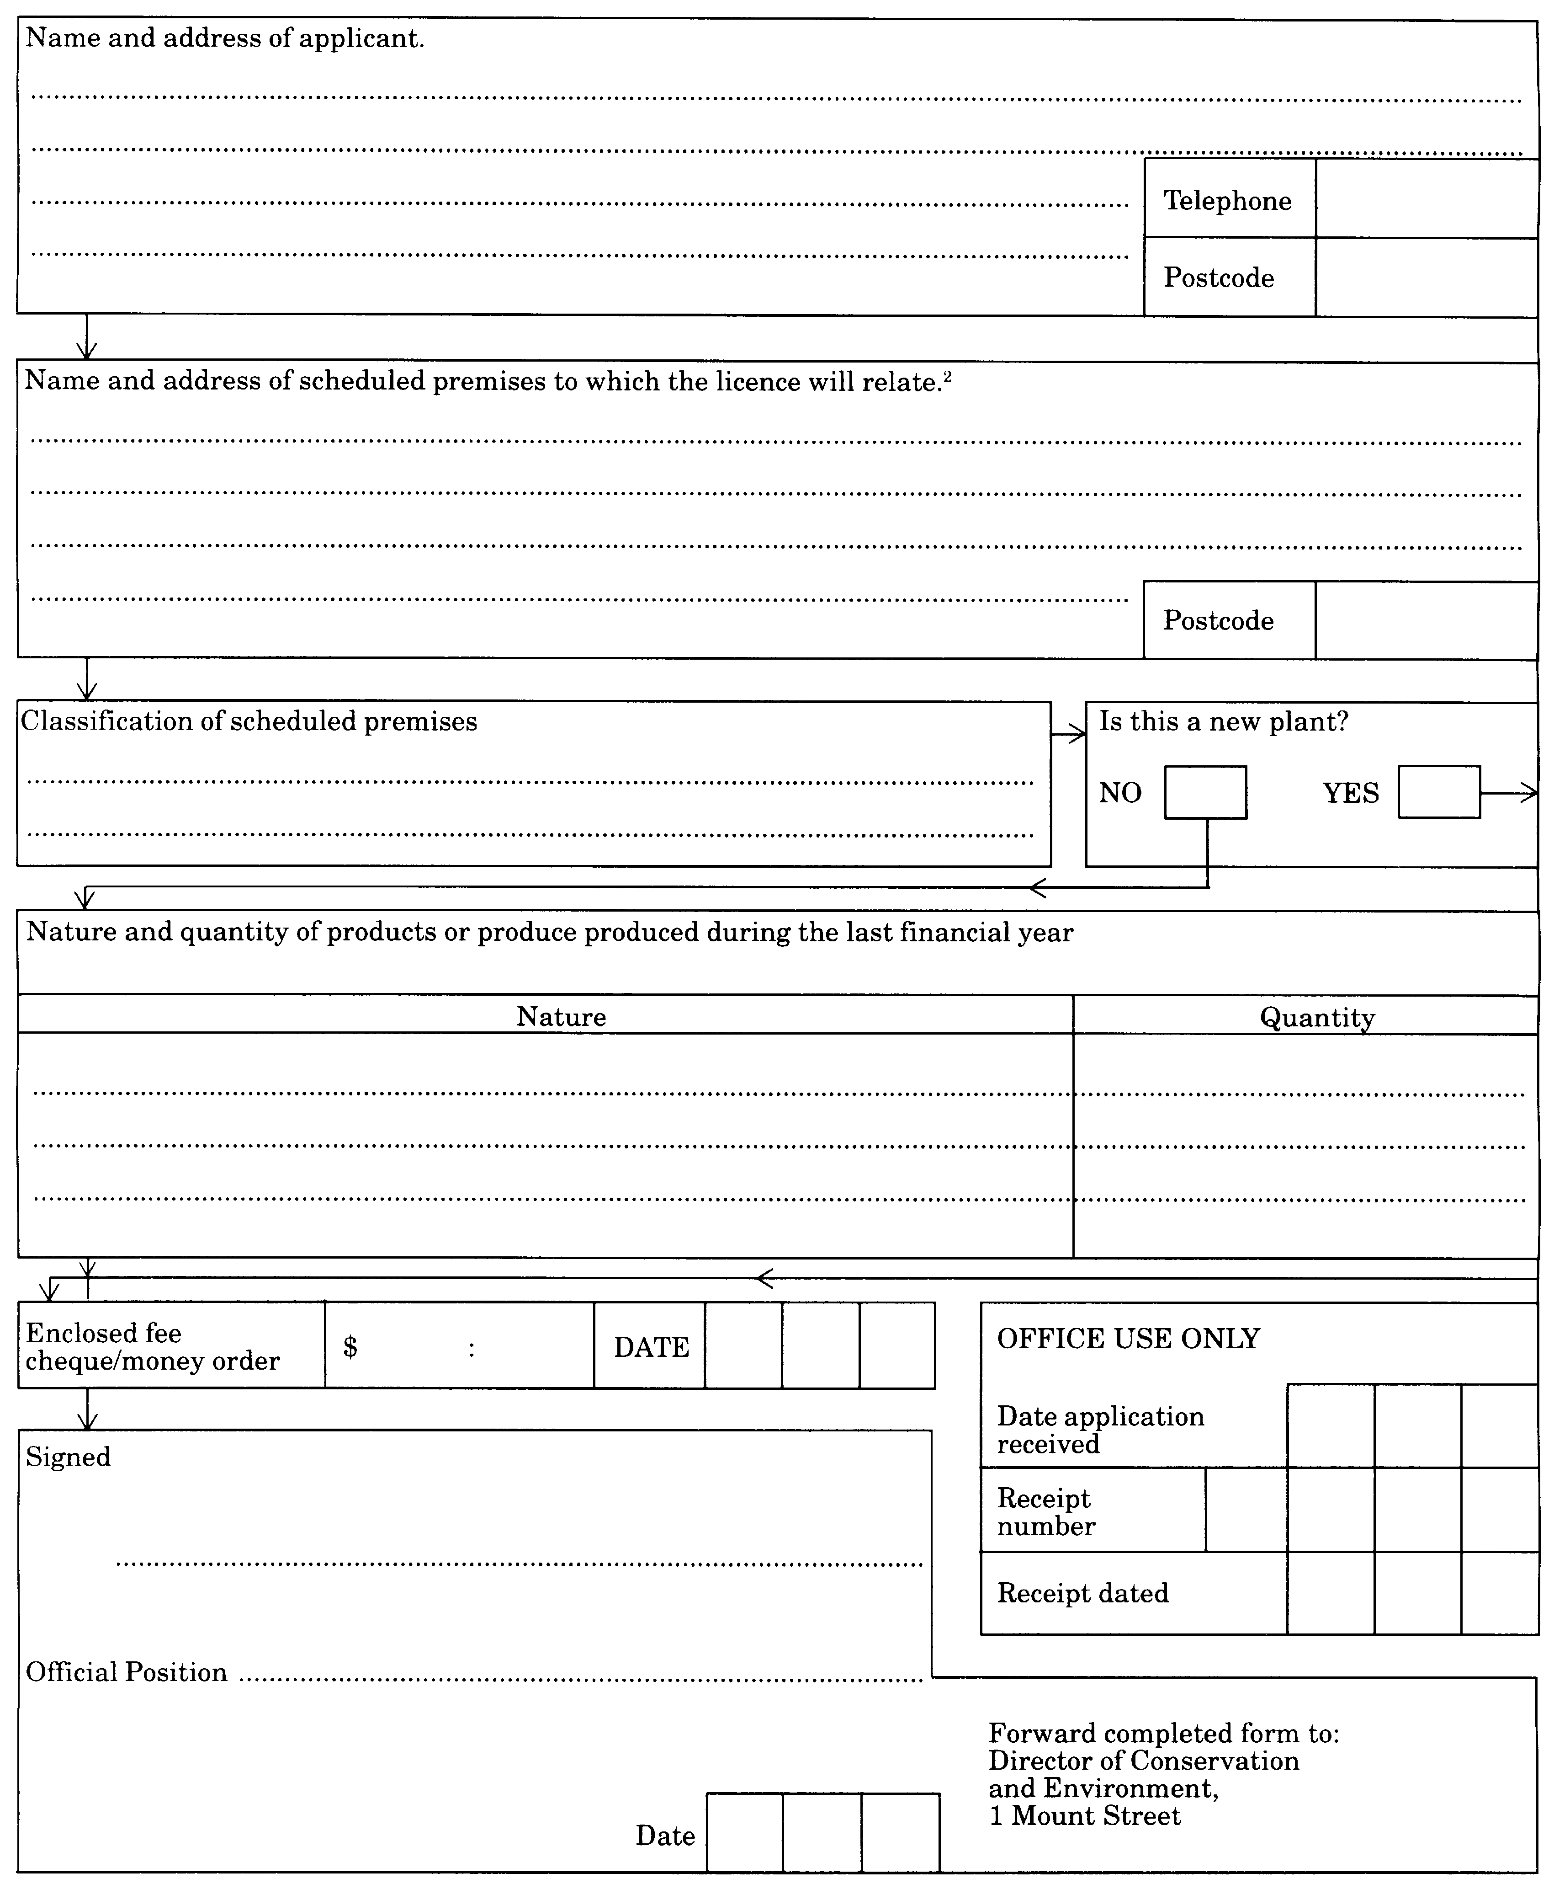
[Form 1 inserted by Gazette 27 May 1983 p.1606; amended by Gazettes 29 June 1984 p.1781; 21 June 1985 p.2202.]
Form 2
[Section 24]
WESTERN AUSTRALIA
CLEAN AIR ACT 1964
APPLICATION FOR RENEWAL OF A LICENCE
¹ Where an applicant is a wholly owned subsidiary company, the application shall be made in the name of the subsidiary with the name of the parent of holding company also stated.
^{2.} Where a company, firm or person operates on more than one premises or location, a separate application must be made for each.
Forward completed form to:
Director of Conservation and Environment,
1 Mount Street
PERTH WA 6000
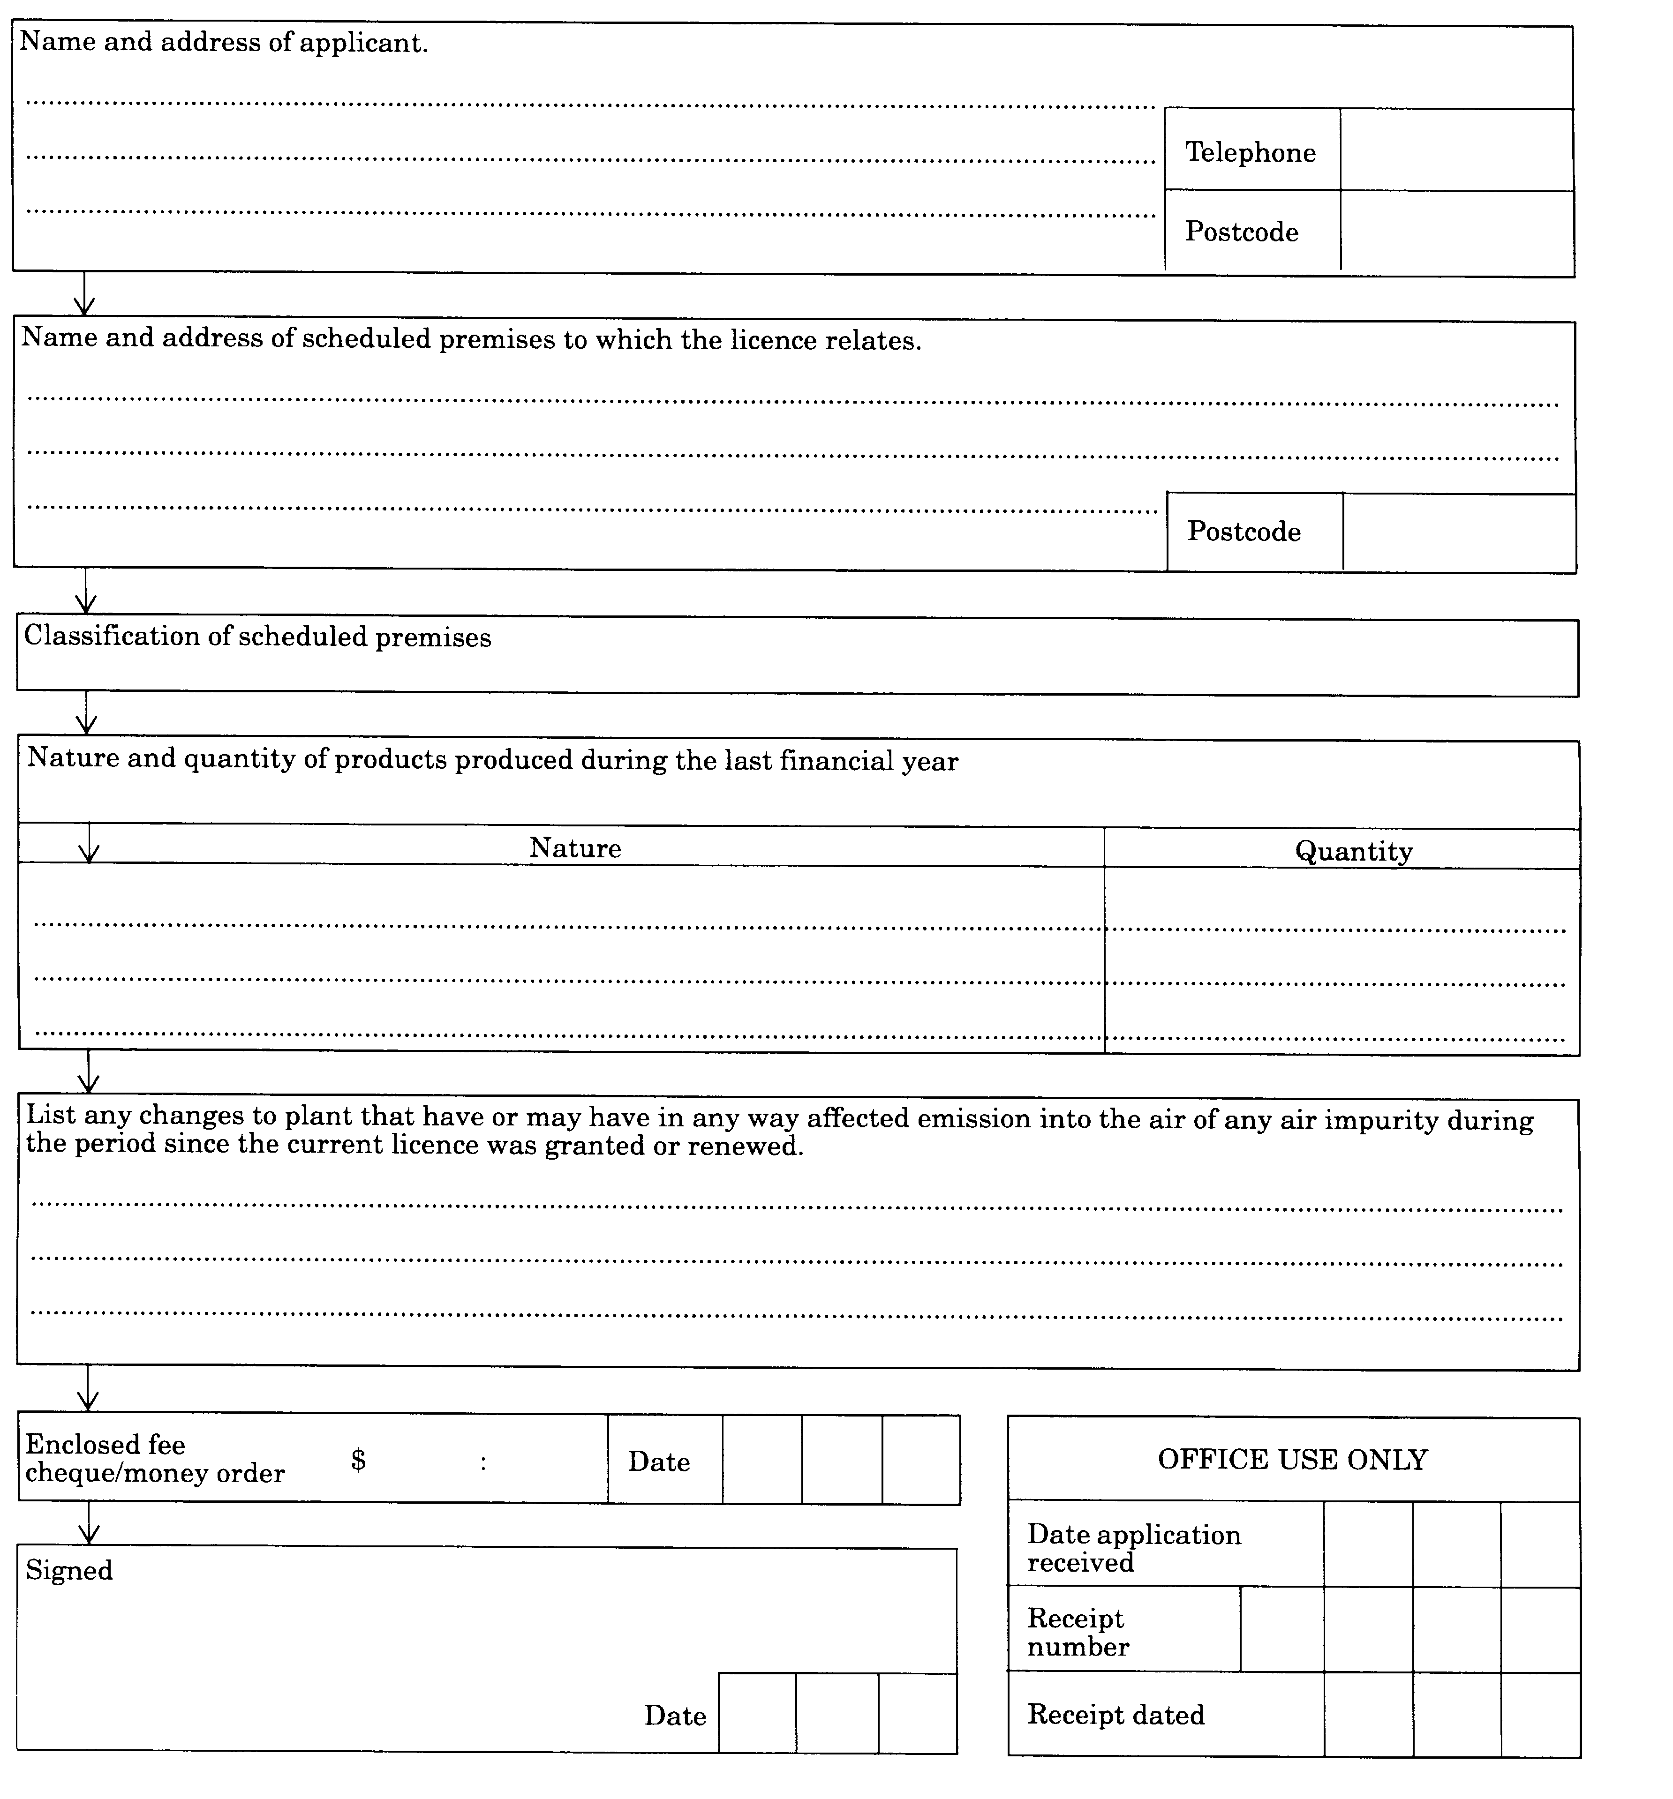
[Form 2 inserted by Gazette 27 May 1983 p.1607; amended by Gazettes 29 June 1984 p.1781; 21 June 1985 p.2202.]
Form 3
[Section 24]
WESTERN AUSTRALIA
CLEAN AIR ACT 1964
APPLICATION FOR THE TRANSFER OF A LICENCE
Forward completed form to:
Director of Conservation and Environment,
1 Mount Street
PERTH WA 6000
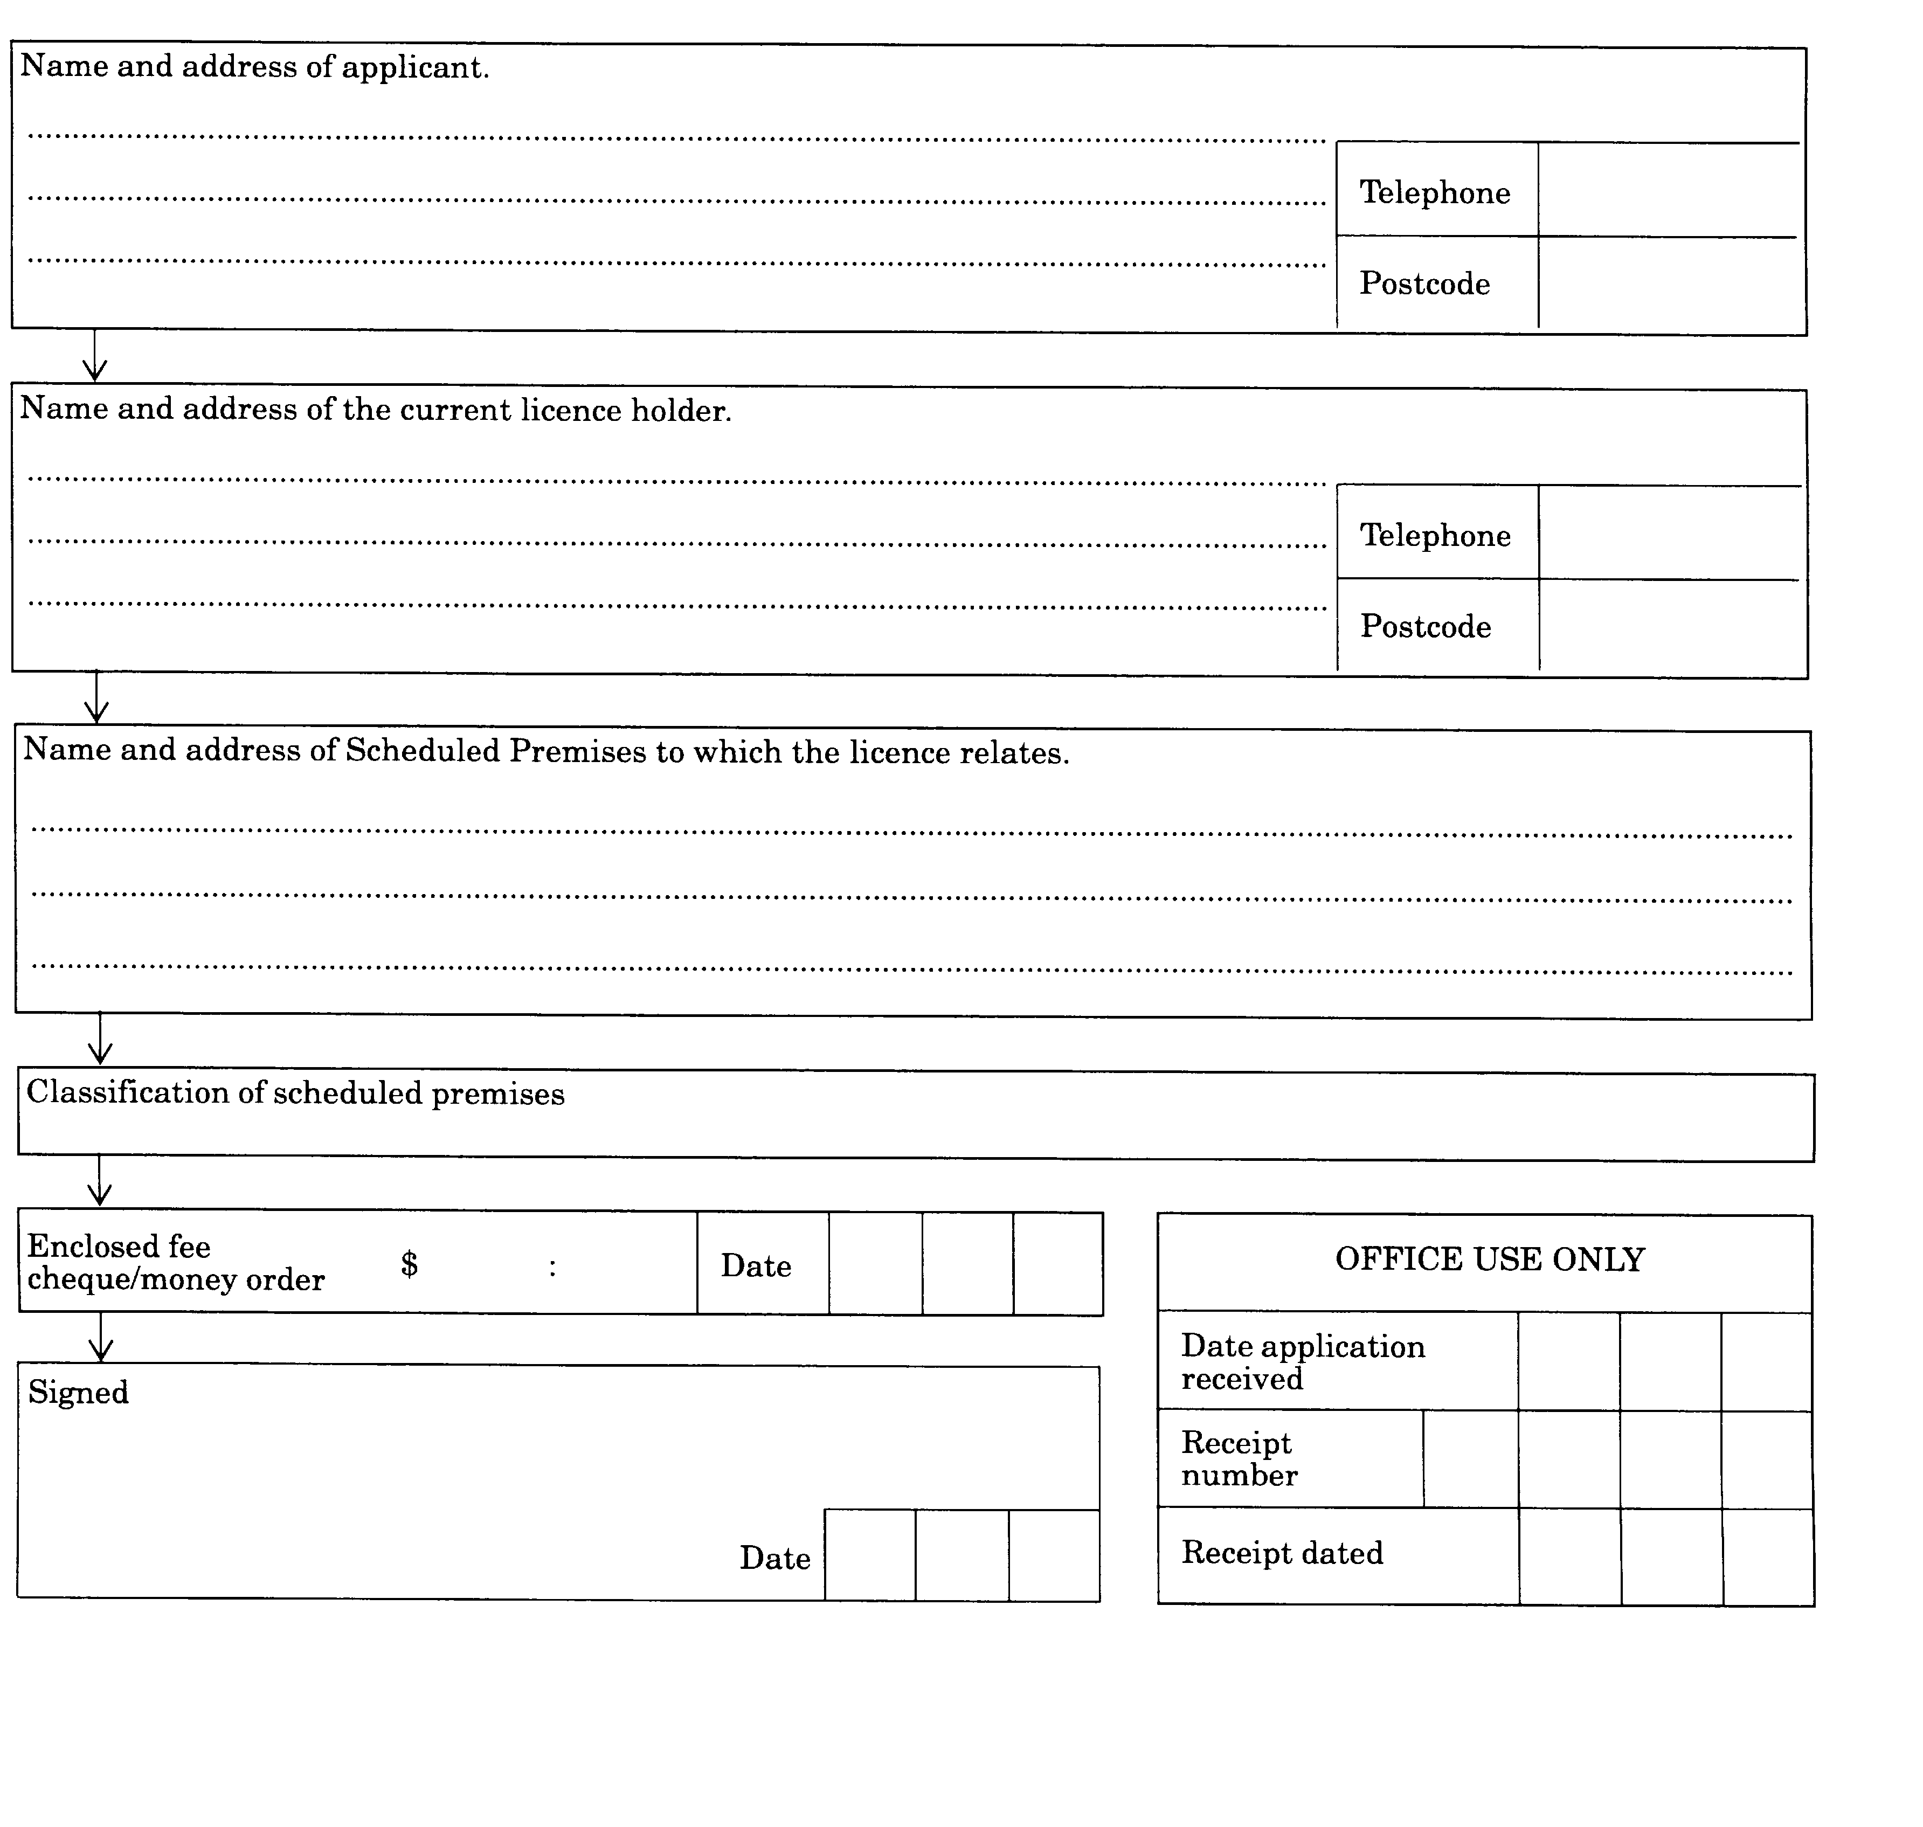
[Form 3 inserted by Gazette 27 May 1983 p.1608; amended by Gazettes 29 June 1984 p.1781; 21 June 1985 p.2202.]
Form 4
[Section 34]
WESTERN AUSTRALIA
CLEAN AIR ACT 1964
APPLICATION TO CONSTRUCT A BUILDING OR TO CARRY ON AN ADDITIONAL OR ALTERED PROCESS ON SCHEDULED PREMISES
Forward completed form to:
Director of Conservation and Environment,
1 Mount Street
PERTH WA 6000
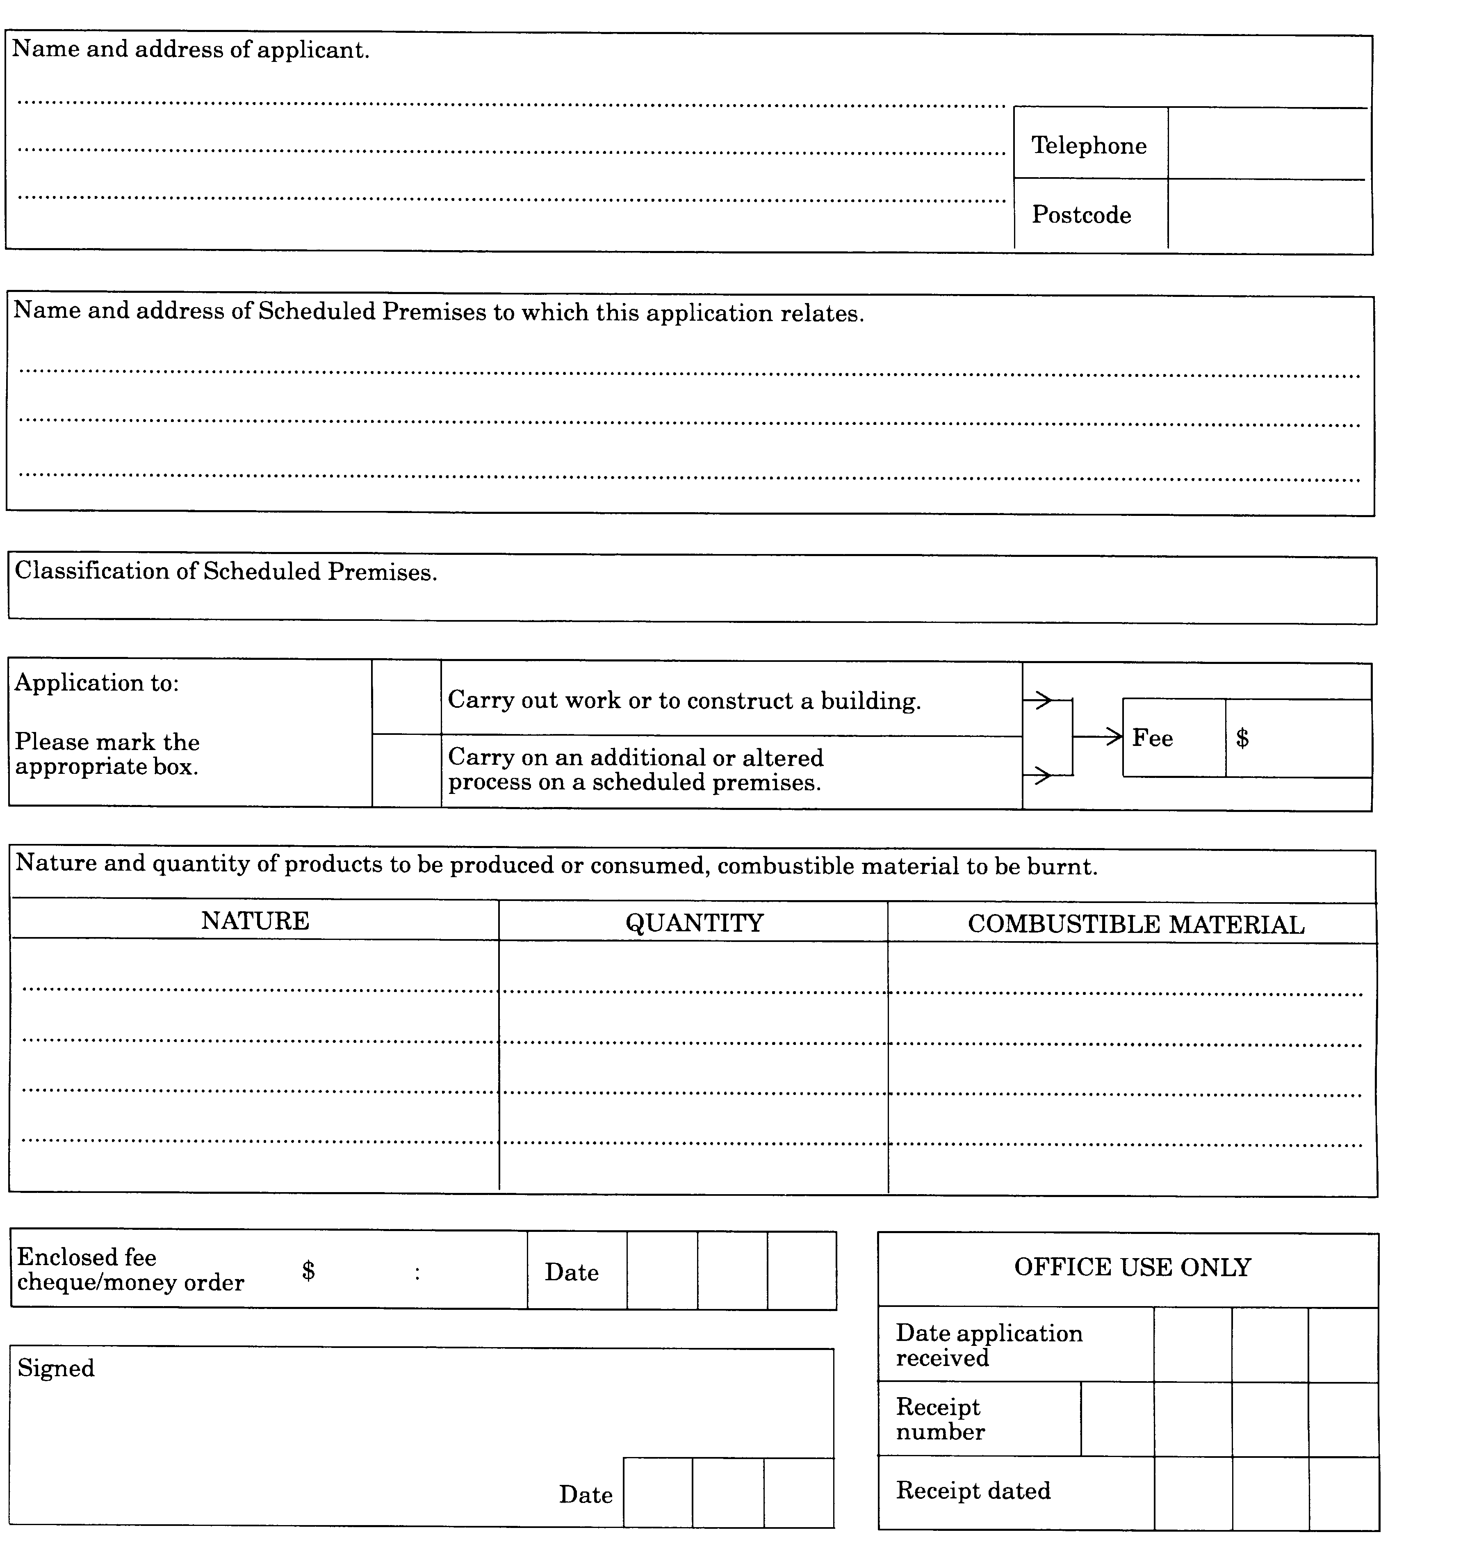
[Form 4 inserted by Gazette 27 May 1983 p.1609; amended by Gazettes 29 June 1984 p.1787; 21 June 1985 p.2202.]
Form 5
[Section 28]
WESTERN AUSTRALIA
CLEAN AIR ACT 1964
REGISTER OF LICENCES
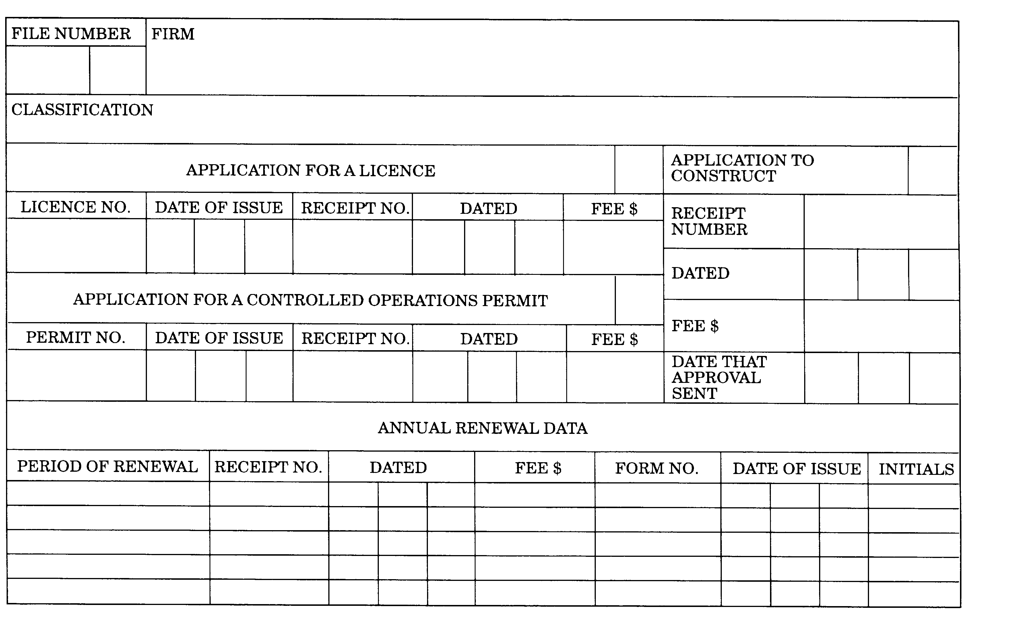
[Form 5 inserted by Gazette 27 May 1983 p.1610.]
Form 6
WESTERN AUSTRALIA
CLEAN AIR ACT 1964
LICENCE
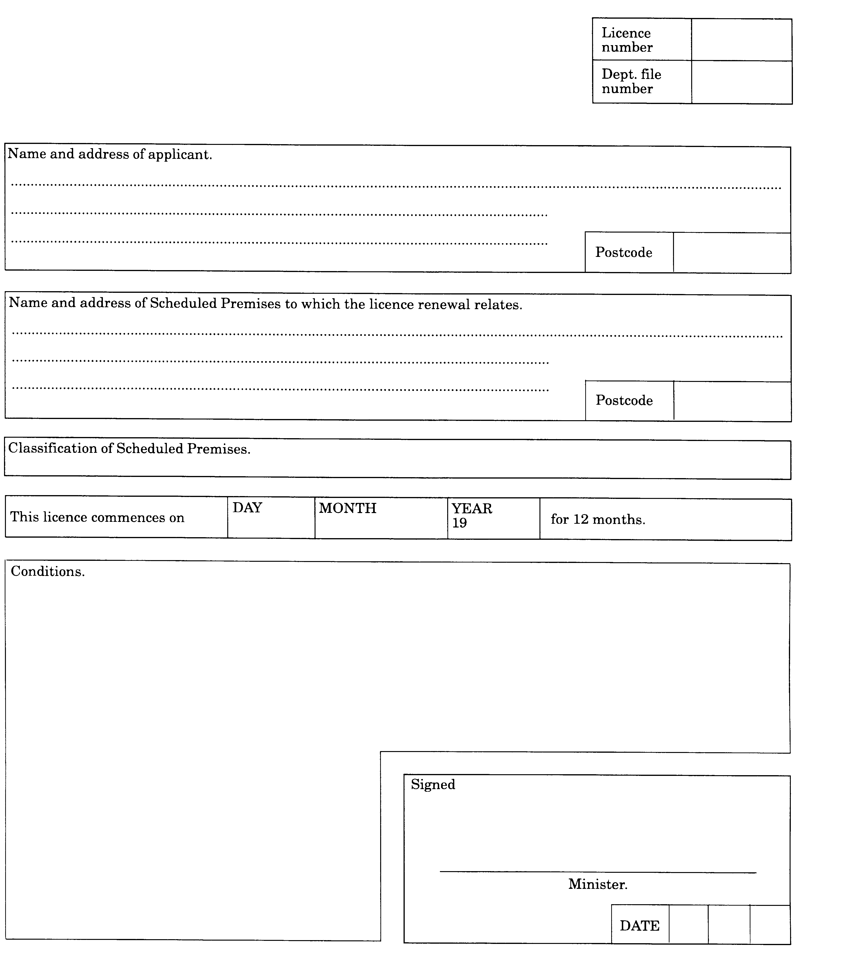
[Form 6 inserted by Gazette 27 May 1983 p.1610; amended by Gazette 21 June 1985 p.2202.]
Form 7
WESTERN AUSTRALIA
CLEAN AIR ACT 1964
LICENCE RENEWAL
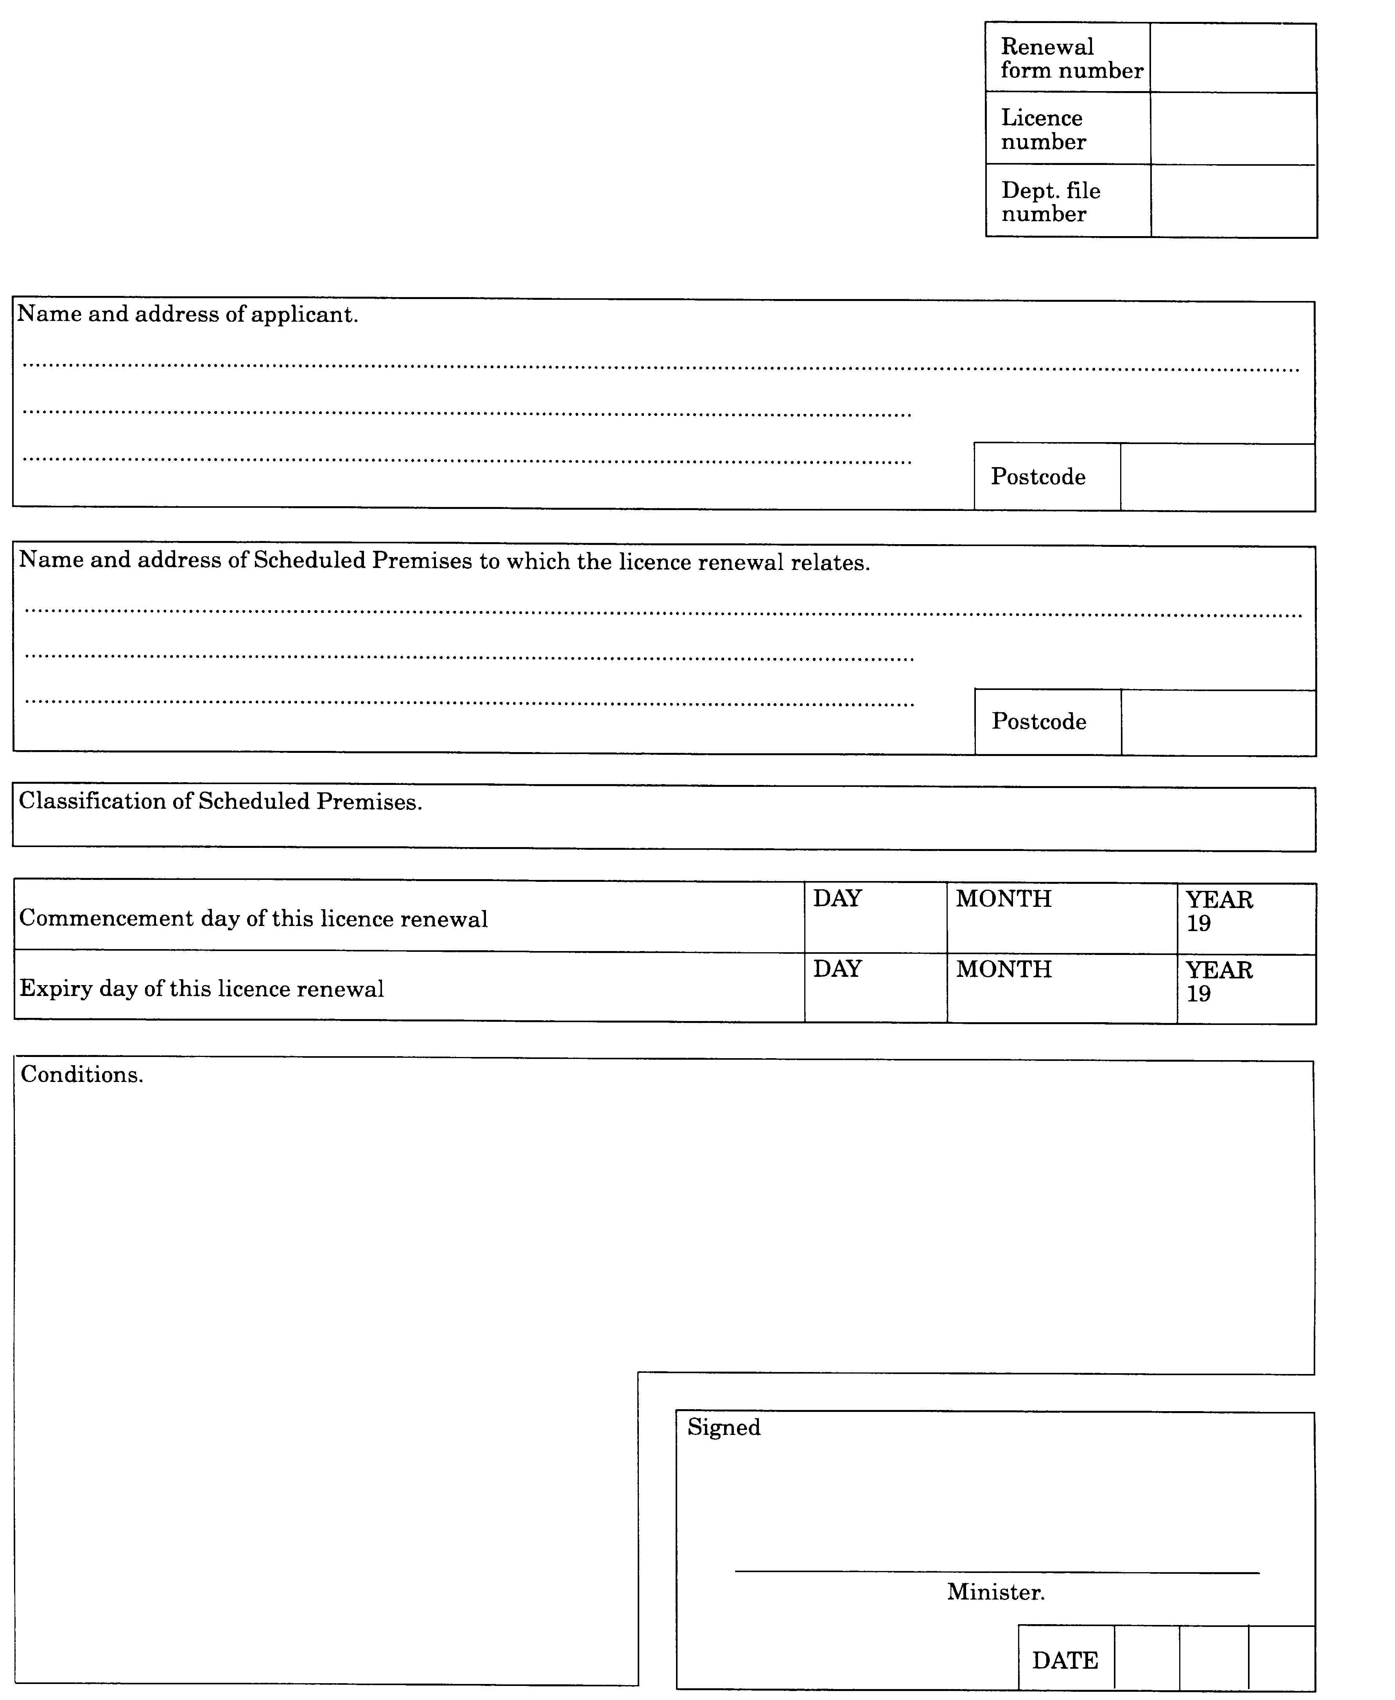
[Form 7 inserted by Gazette 27 May 1983 p.1611; amended by Gazette 21 June 1985 p.2202.]

Notes
¹ This is a compilation of the Clean Air Regulations 1967 and includes the amendments referred to in the following Table.

Compilation table
Citation | Gazettal | Commencement
Clean Air Regulations 1967 | 12 Apr 1967 pp.932-40 | 14 Apr 1967 (see regulation 2)
 | 4 Jun 1968 p.1696 | 4 Jun 1968
 | 30 Nov 1971 p.4941 | 30 Nov 1971
 | 23 Dec 1971 p.5318 | 23 Dec 1971
 | 3 Aug 1973 p.2906 | 3 Aug 1973
 | 27 May 1983 pp.1605-11 | 26 Jul 2983
 | 7 Oct 1983 pp.4069-72 | 7 Oct 1983
 | 2 Mar 1984 p.544 | 2 Mar 1984
 | 15 Jun 1984 p.1632 | 15 Jun 1984
 | 29 Jun 1984 p.1781 | 1 Jul 1984
 | 3 May 1985 p.1539 | 3 May 1985
 | 21 Jun 1985 p.2202 | 21 Jun 1985

