Western Australia
Environmental Protection Act 1986

Environmental Protection (Darling Range Bauxite Mining Proposals) Exemption Order 2023

Western Australia
Environmental Protection (Darling Range Bauxite Mining Proposals) Exemption Order 2023
Contents
1. Citation 1
2. Commencement 1
3. Terms used 1
4. Declaration of exemption from s. 41 2
5. Declaration of exemption from s. 41A 2
Schedule 1 — Conditions to which exemption from s. 41A is subject
Division 1 — Preliminary
1. Terms used 3
Division 2 — Controls on activities
2. Limitations and maximum extent 7
3. Prohibited activities 8
4. Restricted activities 8
5. Activities requiring drainage control and stabilisation 10
6. Drainage incidents 11
Division 3 — Compliance
7. Term used: compliance 12
8. Appointment of compliance monitor 12
9. Compliance assessment plan 13
10. Reports by Alcoa 14
11. Reports by compliance monitor 15
Division 4 — Miscellaneous
12. Provision of information 16
13. Publication of information 16
14. CEO may authorise people to perform functions 17

Environmental Protection Act 1986
Environmental Protection (Darling Range Bauxite Mining Proposals) Exemption Order 2023
Made by the Minister with the approval of the Governor under section 6 of the Act.

1. Citation
This order is the Environmental Protection (Darling Range Bauxite Mining Proposals) Exemption Order 2023.

2. Commencement
This order comes into operation as follows —
(a) clauses 1 and 2 — on the day on which this order is published on the WA legislation website;
(b) the rest of the order — on the day after that day.

3. Terms used
(1) In this order —
Act means the Environmental Protection Act 1986;
Alcoa means Alcoa of Australia Limited ACN 004 879 298;
Darling Range bauxite mining proposal means —
(a) the Bauxite mining on the Darling Range in the southwest of WA for the years 2022 to 2026 proposal of 27 February 2023 referred to the Authority under section 38 of the Act; and
(b) the Bauxite mining on the Darling Range in the southwest of WA for the years 2023 to 2027 proposal of 27 February 2023 referred to the Authority under section 38 of the Act;
relevant DMA means a decision-making authority that is given notice under section 38G(1)(b)(iii) or (5) of the Act that a Darling Range bauxite mining proposal is going to be assessed.
(2) Terms used in this order that are defined in the Act have the same meaning in this order as they have in the Act.

4. Declaration of exemption from s. 41
Section 41 of the Act does not apply in respect of a decision by a relevant DMA relating to a Darling Range bauxite mining proposal.

5. Declaration of exemption from s. 41A
Subject to the conditions specified in Schedule 1, section 41A of the Act does not apply in respect of anything a person does to implement a Darling Range bauxite mining proposal.

Schedule 1 — Conditions to which exemption from s. 41A is subject
[cl. 5]

Division 1 — Preliminary

1. Terms used
(1) In this Schedule —
associates, in relation to Alcoa, includes —
(a) contractors and subcontractors engaged in connection with the implementation of a Darling Range bauxite mining proposal; and
(b) any person acting in partnership with, in concert with or on behalf of Alcoa in the implementation of a Darling Range bauxite mining proposal;
calendar month means a period starting at the beginning of the 1st day of any of the 12 named months and ending immediately before the beginning of the 1st day of the next named month;
clause means a clause of this Schedule, unless a clause of this order is specified;
commencement day means the day on which clause 5 of this order comes into operation;
compliance assessment plan means the plan required by clause 9(1);
compliance monitor means the person or body for the time being appointed and retained under clause 8(2);
disturb —
(a) in relation to fauna, includes the following —
(i) to chase, drive, follow, harass, herd or hunt fauna by any means;
(ii) to apply an identifier to fauna by any means;
(iii) to engage in an activity that has the effect, whether directly or indirectly, of altering the natural behaviour of fauna to its detriment;
(iv) to cause or permit anything referred to in subparagraph (i), (ii) or (iii) to be done;
and
(b) in relation to native vegetation and other flora, includes the following —
(i) clearing;
(ii) to engage in another activity that has the effect, whether directly or indirectly, of altering the long term persistence of the flora in its habitat;
(iii) to cause or permit an activity referred to in subparagraph (i) or (ii) to be engaged in;
and
(c) in relation to land, includes the following —
(i) to disturb fauna or flora for which the land is a habitat;
(ii) to work the land, or to alter the surface or the subsoil of the land, in a way that renders it unsuitable or less suitable as a habitat for fauna or flora for which it is or was formerly a habitat;
(iii) to cause or permit an activity referred to in subparagraph (i) or (ii) to be engaged in;
disturbance area means an area of land —
(a) on which mining activities associated with the implementation of the Darling Range bauxite mining proposal are being carried out; or
(b) that has been disturbed by an activity mentioned in paragraph (a);
drainage control means measures to manage surface water runoff from a disturbance area to the surrounding environment;
exploration means activities carried out in search of minerals, including (without limitation) —
(a) mapping; and
(b) surveying; and
(c) drilling; and
(d) the collection and assaying of soil, rock, groundwater and mineral samples; and
(e) other activities involving the application of 1 or more of the geological sciences;
figure means a map or plan —
(a) that was prepared by the Department on 7 December 2023; and
(b) that is held by the CEO and is available for inspection at the head office of the Department during business hours; and
(c) a copy of which is annexed to this Schedule for indicative purposes;
Figure 1 means the figure entitled Figure 1 — Darling Range exploration disturbance footprint;
Figure 2 means the figure entitled Figure 2 — Huntly Mine disturbance footprint;
Figure 3 means the figure entitled Figure 3 — Huntly Mine native vegetation disturbance footprint;
Figure 4 means the figure entitled Figure 4 — Willowdale Mine disturbance footprint;
Figure 5 means the figure entitled Figure 5 — Forest clearing advice area;
Huntly Mine disturbance footprint has the meaning given in clause 2(1);
landscaping means the moving or shaping of land, including but not limited to —
(a) resloping or altering disturbed surface topography for the purpose of shaping the landform to blend with the adjacent landscape surface; and
(b) movement, placement or removal of bauxite or other material; and
(c) ripping for the purpose of shaping the landform to blend with the surrounding environment;
mining activities means —
(a) extraction and processing of bauxite from mineral reserves below the surface of the earth, including but not limited to —
(i) the removal of topsoil and overburden; and
(ii) blasting, ripping or otherwise breaking caprock to expose bauxite; and
(iii) removal of bauxite; and
(iv) crushing of bauxite; and
(v) transport of bauxite to a refinery;
and
(b) activities that are preparatory to, incidental to or consequential upon extraction and processing of bauxite, including but not limited to —
(i) exploration; and
(ii) land clearing; and
(iii) the construction or maintenance of mining infrastructure; and
(iv) rehabilitation;
mining infrastructure means any structures that enable or support mining activities, including but not limited to —
(a) stockpiles; and
(b) haul roads; and
(c) conveyors; and
(d) crushers; and
(e) structures for water storage; and
(f) water pumps;
prohibited zone has the meaning given in the Metropolitan Water Supply, Sewerage and Drainage By-laws 1981 by-law 4.2.2.2;
rehabilitation, in relation to an area that has been disturbed, includes —
(a) stabilisation of the area; and
(b) restoration of the landforms of the area to a state that is as close as practicable to their original undisturbed state; and
(c) the return of the native vegetation of the area to a state that is as close as practicable to its original undisturbed state;
stabilise, in relation to an area that has been disturbed, means carry out landscaping, ripping and other appropriate operations to prevent erosion of sediment, promote infiltration and manage surface water runoff;
State Development Minister means the Minister to whom the administration of the Alumina Refinery Agreements (Alcoa) Amendment Act 1987 is committed.
(2) In relation to a function of the CEO under this Schedule, a reference to the CEO includes a reference to an officer or member of staff of the Department authorised under clause 14 to perform that function.

Division 2 — Controls on activities

2. Limitations and maximum extent
(1) In this clause —
Darling Range exploration disturbance footprint means the areas measuring in aggregate 233 490 ha that are shaded in blue and outlined in black on Figure 1;
Huntly Mine disturbance footprint means the areas measuring in aggregate 39 047 ha that are shaded in red and outlined in black on Figure 2;
Huntly Mine native vegetation disturbance footprint means the areas measuring in aggregate 3 538 ha that are coloured green on Figure 3;
Willowdale Mine disturbance footprint means the areas measuring in aggregate 2 136 ha that are shaded in orange and outlined in black on Figure 4.
(2) Mining activities associated with the Huntly Mine —
(a) must not disturb land outside the Huntly Mine disturbance footprint; and
(b) must not disturb native vegetation outside the Huntly Mine native vegetation disturbance footprint.
(3) Mining activities associated with the Willowdale Mine —
(a) must not disturb land outside the Willowdale Mine disturbance footprint; and
(b) must not disturb native vegetation.
(4) Exploration activities associated with the implementation of the Darling Range bauxite mining proposals must not disturb land outside the Darling Range exploration disturbance footprint.
(5) The amount of bauxite extracted, conveyed, crushed or otherwise processed in the implementation of the Darling Range bauxite mining proposals must not exceed 38 megatonnes (wet) in any calendar year.
(6) In carrying out exploration activities in the implementation of the Darling Range bauxite mining proposals Alcoa and its associates must not bore more than 105 000 drill holes in any calendar year.

3. Prohibited activities
(1) In this clause —
forest clearing advice area means an area coloured yellow on Figure 5.
(2) In implementing the Darling Range bauxite mining proposals, Alcoa and its associates must not engage in clearing or other activities likely to disturb a forest clearing advice area.
(3) Subclause (2) does not apply to —
(a) rehabilitation; or
(b) monitoring activities implemented in accordance with Division 3.

4. Restricted activities
(1) In this clause —
black cockatoo nesting tree means a tree containing 1 or more hollows —
(a) that appear to be, or have been, used as a black cockatoo breeding habitat; or
(b) that have a diameter of not less than 100 mm and a depth of not less than 500 mm;
Huntly Mine black cockatoo significant tree means —
(a) a jarrah tree with a diameter of not less than 2 000 mm at a height of 1 300 mm above ground level; and
(b) a marri tree with a diameter of not less than 1 500 mm at a height of 1 300 mm above ground level;
top water level margin, in relation to a water reservoir, means the margin of the surface of the water in the reservoir when the level of water in the reservoir is at the point above which water will spill;
water reservoir means a dam, weir or reservoir for the storage of water for a potable water supply service.
(2) In implementing the Darling Range bauxite mining proposals, Alcoa and its associates must not undertake any mining activities —
(a) within 1 km of the top water level margin of any water reservoir; or
(b) within the Serpentine Pipehead Dam Catchment Area (constituted under the Metropolitan Water Supply, Sewerage, and Drainage Act 1909 section 13(a) by a proclamation of 9 November 1982 published in the Gazette on 3 December 1982 at p. 4678); or
(c) in any area that —
(i) is within the prohibited zone associated with any water reservoir; and
(ii) has an average slope (based on the Landgate derived slope dataset) greater than 16%;
or
(d) within 10 metres of a black cockatoo nesting tree or a Huntly Mine black cockatoo significant tree; or
(e) on or after 1 January 2027, within 50 metres of a black cockatoo nesting tree.
(3) Subclause (2) does not apply to —
(a) rehabilitation; or
(b) monitoring activities implemented in accordance with Division 3; or
(c) use and maintenance of existing mining infrastructure; or
(d) modification of existing road infrastructure; or
` (e) construction of drainage control infrastructure; or
(f) mining within 1 km of the top water level margin of any water reservoir within the Huntly Mine disturbance footprint carried out before 30 June 2024.

5. Activities requiring drainage control and stabilisation
(1) In this clause —
stabilisation date, in relation to an activity, means the earlier of —
(a) 12 months after the day on which the activity ceases; and
(b) the first 30 April falling more than 6 calendar months after the day on which the activity ceases.
(2) If, in implementing the Darling Range bauxite mining proposals, an activity mentioned in clause 4(3) is undertaken in an area mentioned in clause 4(2) then, after the activity has ceased, Alcoa must —
(a) implement drainage control until the area affected by the activity is stabilised; and
(b) as soon as practicable, but in any event not later than the stabilisation date for the activity, stabilise the area; and
(c) as soon as practicable, complete the rehabilitation of the area.
(3) Subclause (4) applies if, in implementing the Darling Range bauxite mining proposals, any mining activities are undertaken —
(a) in the prohibited zone associated with a water reservoir; or
(b) within 1.5 km of the peak of Mount Solus.
(4) After the activity has ceased Alcoa must —
(a) as soon as practicable, but in any event not later than the stabilisation date for the activity, either —
(i) commence stabilising the area affected by the activity; or
(ii) implement drainage control until the area is stabilised;
and
(b) not later than 24 months after the activity has ceased, stabilise the area.

6. Drainage incidents
(1) In this clause —
containment infrastructure means a basin, pond, sump, culvert or other structure on, or associated with, a disturbance area that —
(a) is designed or intended to contain liquids and sediment that may include environmentally hazardous material; and
(b) is used —
(i) to capture and temporarily store flood water to prevent excessive runoff and channel erosion in receiving environments; and
(ii) to remove particulate-based contaminants and sediment;
drainage incident means —
(a) a runoff from a disturbance area to the surrounding environment of surface water that has a turbidity of at least 25 nephelometric turbidity units for a period of at least 1 hour; or
(b) a discharge from containment infrastructure that includes or may include environmentally hazardous material;
environmentally hazardous material means material which by its characteristics poses a threat or risk to public health, safety or the environment, including but not limited to material that is —
(a) toxic; or
(b) infectious; or
(c) mutagenic; or
(d) carcinogenic; or
(e) teratogenic; or
(f) explosive; or
(g) flammable; or
(h) corrosive; or
(i) oxidising; or
(j) radioactive.
(2) Upon becoming aware of a drainage incident arising from or associated with the implementation of the Darling Range bauxite mining proposals, Alcoa must —
(a) report the incident to the CEO within 24 hours; and
(b) investigate —
(i) the cause of the incident; and
(ii) the environmental impacts of the incident;
and
(c) within 21 days, advise the CEO of —
(i) the outcome of investigations made under paragraph (b); and
(ii) the measures that have been, are being or will be implemented to rectify the incident; and
(iii) other measures that have been, are being or will be implemented to avoid or minimise the environmental impact of the incident.

Division 3 — Compliance

7. Term used: compliance
In this Division —
compliance means compliance by Alcoa and its associates with the requirements of Division 2.

8. Appointment of compliance monitor
(1) In this clause —
independent qualified expert means a person or body —
(a) that is not owned or controlled by Alcoa or its associates; and
(b) that has appropriate expertise and experience to monitor and report on —
(i) the implementation of the Darling Range bauxite mining proposals; and
(ii) compliance.
(2) With the prior written approval of the Minister, Alcoa must appoint and retain an independent qualified expert —
(a) to undertake continuous monitoring, by means of inspections and measurements made not less frequently than weekly, of —
(i) the implementation of the Darling Range bauxite mining proposals; and
(ii) compliance;
and
(b) to make the reports required by clause 11.
(3) Alcoa must make the first appointment under subclause (2) not later than 60 days after commencement day.
(4) If an appointment made under subclause (2) terminates, Alcoa must —
(a) as soon as practicable, notify the CEO of the termination; and
(b) not later than 30 days after the termination, make a new appointment under subclause (2).

9. Compliance assessment plan
(1) Alcoa must —
(a) prepare a plan for assessing compliance; and
(b) not later than 60 days after commencement day, submit to the CEO —
(i) the plan; and
(ii) a statement in writing signed by or on behalf of the compliance monitor to the effect that, in the compliance monitor’s opinion, the plan will be sufficient, if implemented, to enable a failure in compliance to be detected and identified.
(2) The compliance assessment plan must —
(a) state the name, qualifications, address and other contact details of the compliance monitor; and
(b) include an up-to-date professional resume for each member of staff of the compliance monitor who will be engaged in monitoring implementation of the Darling Range bauxite mining proposals or compliance; and
(c) state what information will be collected and recorded to assess compliance, and when and how the information will be collected; and
(d) state what methods the compliance monitor will use to assess compliance.
(3) Alcoa must ensure that the compliance assessment plan is kept up-to-date by submitting to the CEO a revised plan whenever a change is made to —
(a) any of the particulars required by subclause (2) to be included in the plan; or
(b) any other particulars included in the plan.
(4) A revised plan submitted under subclause (3) must be accompanied by a new statement in the terms required by subclause (1)(b)(ii) relating to the revised plan.

10. Reports by Alcoa
(1) In respect of each calendar month after the calendar month in which commencement day occurs, Alcoa must give to the CEO a report in writing that complies with subclause (2).
(2) Alcoa’s report must —
(a) specify the calendar month to which it relates; and
(b) set out the results of any monitoring (including raw monitoring data) undertaken by Alcoa during the specified month; and
(c) set out —
(i) the activities carried out to implement the Darling Range bauxite mining proposals during the specified month; and
(ii) the activities mentioned in clause 4(3), undertaken in an area mentioned in clause 4(2), that have ceased during the specified month and the date on which each activity ceased; and
(iii) the activities proposed to be undertaken to implement the Darling Range bauxite mining proposals during the 2 calendar months following the specified month.
(3) Alcoa must give the report to the CEO not later than 15 days after the end of the specified month.

11. Reports by compliance monitor
(1) Alcoa must appoint the compliance monitor on terms that are effective to ensure that the compliance monitor gives reports as required by this clause.
(2) In respect of each calendar month after the first calendar month in which a compliance monitor is appointed under clause 8(2), the compliance monitor must give to the CEO a report in writing that complies with subclause (3).
(3) The compliance monitor’s report must —
(a) specify the calendar month to which it relates; and
(b) outline the activities undertaken by the compliance monitor during the specified month to assess compliance; and
(c) set out the results of any monitoring (including raw monitoring data) undertaken by the compliance monitor during the specified month; and
(d) say whether, in the compliance monitor’s opinion, the results of the monitoring, together with any additional information provided to the compliance monitor by Alcoa or its associates, is sufficient to enable the compliance monitor to detect and identify a failure in compliance; and
(e) in respect of each condition included in Division 2 —
(i) state the compliance monitor’s opinion as to the extent of compliance during the specified month; and
(ii) identify any incidents of failure of compliance occurring during the specified month that the compliance monitor has detected.
(4) The compliance monitor must give the report to the CEO not later than 15 days after the end of the specified month.

Division 4 — Miscellaneous

12. Provision of information
(1) Alcoa must give the Minister or the CEO information relating to the implementation of a Darling Range bauxite mining proposal as requested by the Minister or the CEO.
(2) A request for information under subclause (1) —
(a) must be in writing; and
(b) must specify the information that Alcoa must provide; and
(c) may specify the form in which Alcoa must provide the information; and
(d) may specify a date by which Alcoa must provide the information.

13. Publication of information
(1) In this clause —
mining and management programme means a mining and management programme submitted by Alcoa and agreed by the State Development Minister under commitment 2 of Schedule 2 to Ministerial Statement 728 published on 14 September 2006 under section 45 of the Act;
sensitive information means confidential information that has commercial value to a person that would be, or could reasonably be expected to be, destroyed or diminished if the confidential information were published.
(2) Subject to subclause (3), Alcoa must publish on its website each document or item of information listed in column 1 of the Table to this subclause at or within the time specified in relation to that document or item of information in column 2 of the Table to this clause.
Table
Document or item of information | Time limit for publication
All geospatial data in the possession or procurement of Alcoa that is relevant to the conditions in Division 2 | Within 30 days after commencement day
A report given to the CEO under clause 10(1) | Within 60 days after the day by which the report is required by clause 10(3) to be given to the CEO
If the Minister gives Alcoa notice in writing under this subclause requiring publication of a report given to the CEO under clause 11(2) — the report | Within 7 days after the notice is given
If the State Development Minister gives Alcoa notice in writing under this subclause requiring publication of a mining and management programme — the mining and management programme | Within 7 days after the notice is given
(3) If a document or item of information required by subclause (2) to be published includes sensitive information Alcoa may, with the approval in writing of the Minister, omit the sensitive information when publishing the document or item of information.

14. CEO may authorise people to perform functions
(1) The CEO may, by written instrument, authorise an officer or member of staff of the Department (an authorised person) to perform all or any of the functions of the CEO under this Schedule, other than this power of authorisation.
(2) This clause does not limit the ability of the CEO to perform a function through an officer or agent.
Figure 1
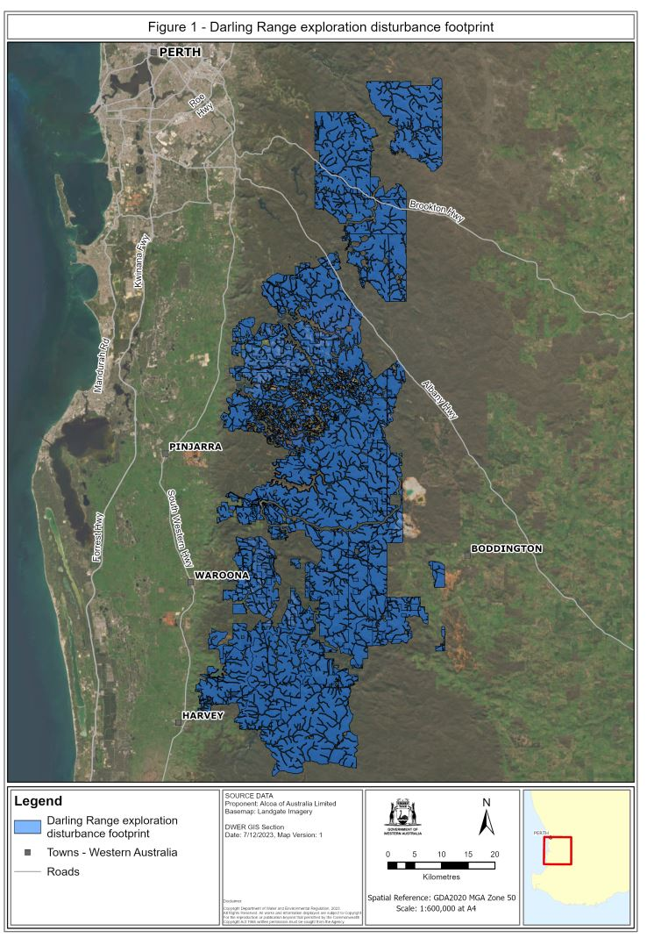
Figure 2
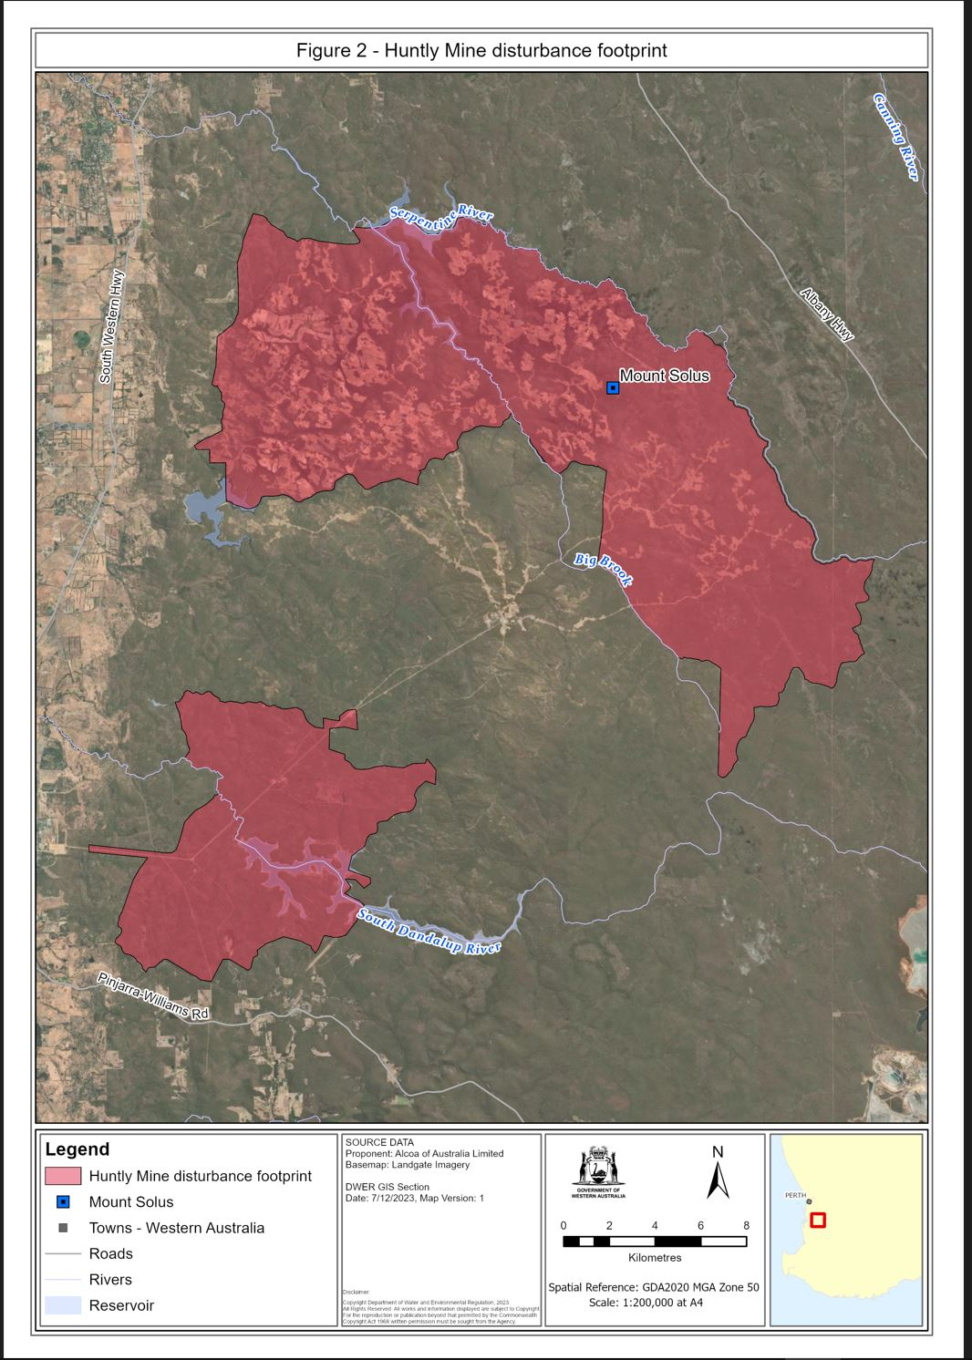
Figure 3
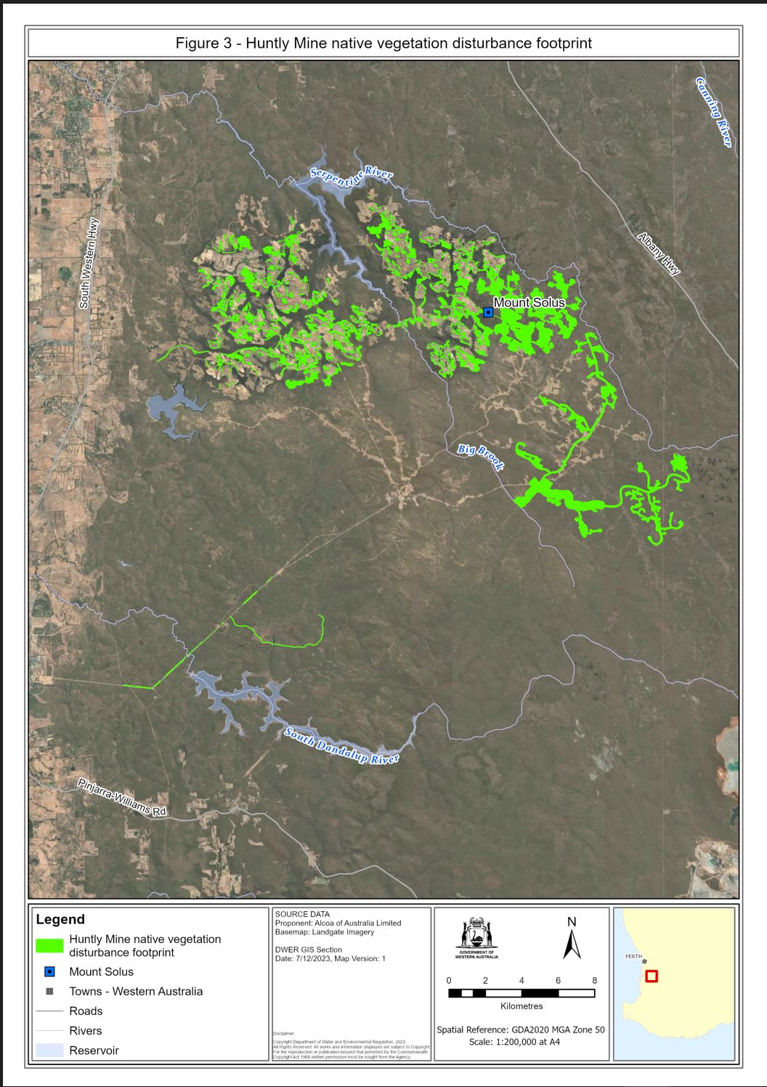
Figure 4
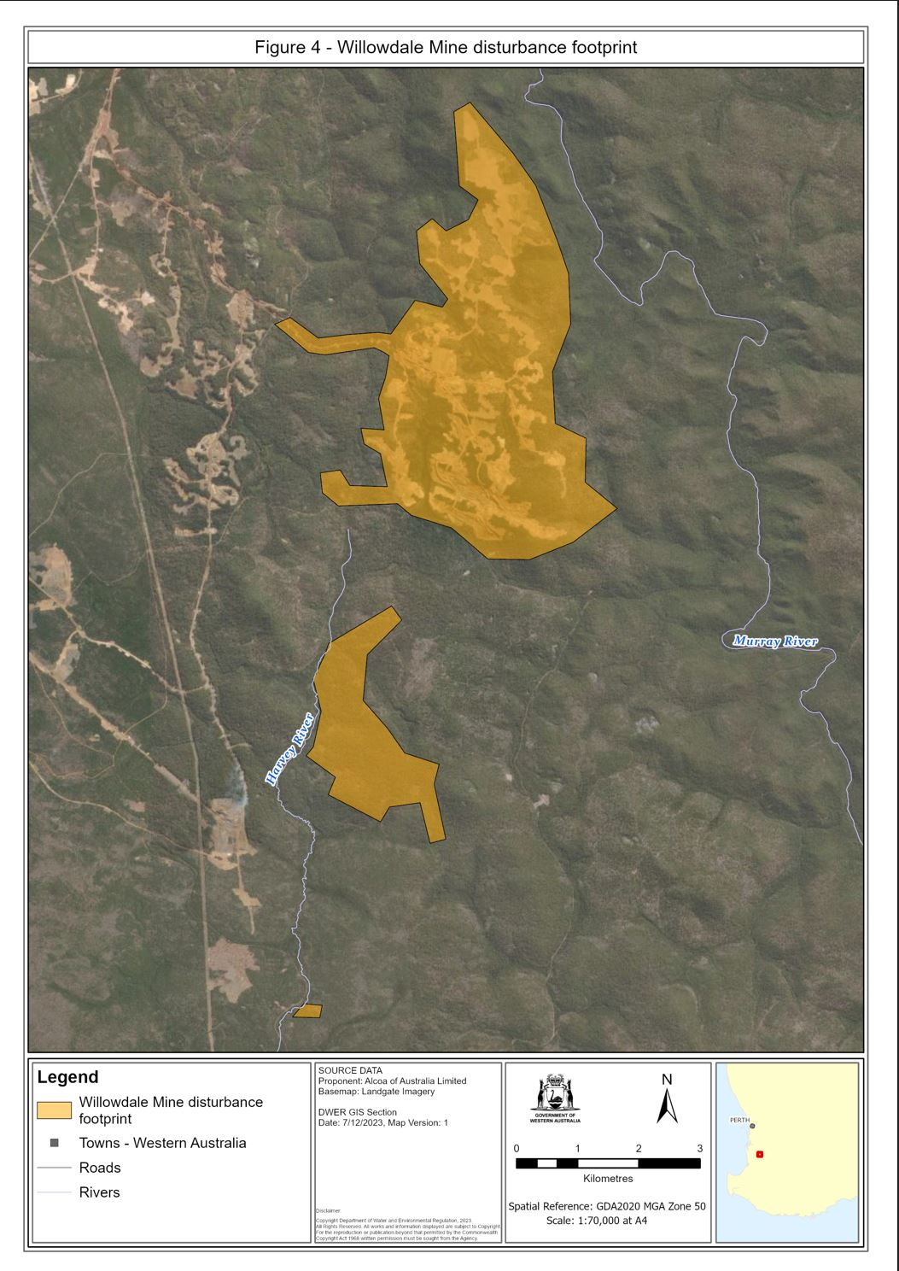
Figure 5
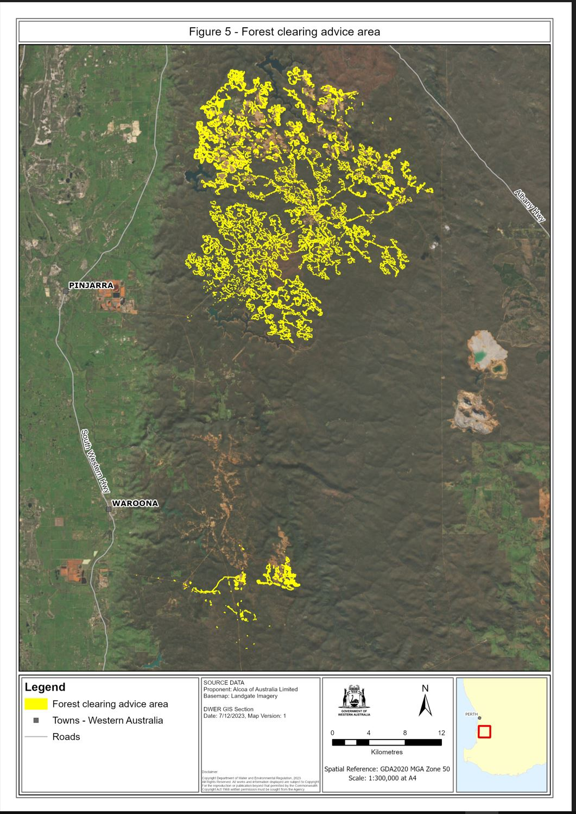

R. WHITBY, Minister for Environment
© State of Western Australia 2023.
This work is licensed under a Creative Commons Attribution 4.0 International Licence (CC BY 4.0). To view relevant information and for a link to a copy of the licence, visit www.legislation.wa.gov.au.
Attribute work as: © State of Western Australia 2023.
By Authority: GEOFF O. LAWN, Government Printer

