Western Australia

Noongar (Koorah, Nitja, Boordahwan) (Past, Present, Future) Recognition Act 2016

Western Australia
Noongar (Koorah, Nitja, Boordahwan) (Past, Present, Future) Recognition Act 2016
Contents
Preamble 2
1. Short title 3
2. Commencement 3
3. Noongar lands 3
4. Purpose 3
5. Recognition of the Noongar people 3
6. Effect of this Act 4
Schedule 1 — Noongar recognition statement
Schedule 2 — Noongar lands: description
Schedule 3 — Noongar lands: map
Notes
Compilation table 10

Western Australia
Noongar (Koorah, Nitja, Boordahwan) (Past, Present, Future) Recognition Act 2016
An Act for the recognition of the Noongar people as the traditional owners of lands in the south-west of the State.

Preamble
A. Since time immemorial, the Noongar people have inhabited lands in the south-west of the State; these lands the Noongar people call Noongar boodja (Noongar earth).
B. Under Noongar law and custom, the Noongar people are the traditional owners of, and have cultural responsibilities and rights in relation to, Noongar boodja.
C. The Noongar people continue to have a living cultural, spiritual, familial and social relationship with Noongar boodja.
D. The Noongar people have made, are making, and will continue to make, a significant and unique contribution to the heritage, cultural identity, community and economy of the State.
E. The Noongar people describe in Schedule 1 their relationship to Noongar boodja and the benefits that all Western Australians derive from that relationship.
F. So it is appropriate, as part of a package of measures in full and final settlement of all claims by the Noongar people in pending and future applications under the Native Title Act 1993 (Commonwealth) for the determination of native title and for compensation payable for acts affecting that native title, to recognise the Noongar people as the traditional owners of the lands described in this Act.
The Parliament of Western Australia enacts as follows:

1. Short title
This is the Noongar (Koorah, Nitja, Boordahwan) (Past, Present, Future) Recognition Act 2016.

2. Commencement
This Act comes into operation as follows —
(a) sections 1 and 2 — on the day on which this Act receives the Royal Assent;
(b) the rest of the Act — on a day fixed by proclamation, and different days may be fixed for different provisions.

3. Noongar lands
(1) For this Act, the Noongar lands are the lands described in Schedule 2.
(2) The map in Schedule 3 shows the location of the Noongar lands.

4. Purpose
The purpose of this Act is to recognise the Noongar people as the traditional owners of the Noongar lands.

5. Recognition of the Noongar people
(1) Parliament acknowledges and honours the Noongar people as the traditional owners of the Noongar lands.
(2) Parliament recognises —
(a) the living cultural, spiritual, familial and social relationship that the Noongar people have with the Noongar lands; and
(b) the significant and unique contribution that the Noongar people have made, are making, and will continue to make, to the heritage, cultural identity, community and economy of the State.

6. Effect of this Act
This Act does not —
(a) create any right, title or interest, whether in law or equity; or
(b) give rise to or affect any civil claim, action or proceeding; or
(c) give rise to or affect any right of review of an administrative decision; or
(d) affect the interpretation of any law of, or that applies in, the State.

Schedule 1 — Noongar recognition statement
[recital E]
Noonakoort moort nitja burranginge noongar boodja
Noonakoort moort kwomba
Djinunge nitja mungarrt — koorah
Noonakoort moort yirra yarkinje kwomba noongar boodja
Koorah — nitja — boordahwan
Noonakoort moort yarkinje noongar boodja
Nyidiung koorah barminje noonakoort moort
Wierrnbirt domberrinje
Noonakoort moort koort boodja
Nitja gnulla moorditj karrl boodja
All our Noongar people stand here on Noongar land.
Past, present and future.
We stand strong on our land.
The mungart tree symbolises our strength and survival.
All of our people stand firm on our land.
Our people are here to stay — we will always be.
We, the Noongar people, are the traditional owners of South West Western Australia, and have been since before time immemorial. As the First People of South West Western Australia, we continue to practise the laws and customs of our culture. Through this culture, we continue to hold rights, responsibilities and obligations in relation to our people, traditional lands and waters.
We, the Noongar people, are the largest single Aboriginal cultural bloc on the Australian continent. We belong to one of the oldest surviving living cultures on this earth. As a people, we have a common ancestral language, and a similar history and spirituality. We know that our traditional country is south and west of a line that stretches from Geraldton in the north to Cape Arid in the south-east, and that the spirit of this place can never be conquered.
Noongar culture, spirit and economy have always depended on the resources of Noongar boodja. Families still return to the biddi (paths) of our ancestors. Our people continue to refer to natural landmarks, especially hills and waterways when describing which families belong to different areas of Noongar boodja. Although barriers may exist, it is still in our hearts, in our blood, it is still our country.
Our living culture, which is long and continuing in this part of the world, begins with Noongar people. This is the opportunity for all Western Australians to experience the ancient tradition of respect, relationships and reciprocity with Noongar people. We have survived.
Note:
The Noongar nation is made up of a number of different groups. Variations in pronunciation and spelling occur amongst the Amangu, Yued/Yuat, Whadjuk/Wajuk, Binjareb/Pinjarup, Wardandi, Balardong/Ballardong, Nyakinyaki, Wilman, Wirlomin, Ganeang, Bibulmun/Piblemen, Mineng, Goreng, Wudjari and Njunga. For instance, the word “Noongar” can also be spelled “Nyungar”, “Nyoongar” and “Nyoongah”.

Schedule 2 — Noongar lands: description
[s. 3(1)]
All the lands and waters contained within a line that —
- starts at the intersection of the prolongation westerly of the northern boundary of the Shire of Coorow with the low water mark, being a point on a northern boundary of native title determination application WAD6192/1998 (WC97/71) as accepted for registration on the Register of Native Title Claims on 22 August 1997;
- then continues generally easterly and generally south-easterly along the boundaries of that native title application to the intersection with native title determination application WAD6181/1998 (WC00/7) as accepted for registration on the Register of Native Title Claims on 3 July 2008;
- then continues generally easterly, generally south-easterly and westerly along the boundaries of that native title application to the intersection with native title determination application WAD6286/1998 (WC98/70) as accepted for registration on the Register of Native Title Claims on 29 September 1998;
- then continues generally southerly along the boundaries of that native title application to the intersection with the low water mark;
- then continues generally south-westerly, generally north-westerly and generally northerly along the low water mark back to the starting point,
other than any land or waters the subject of native title determination application WAD6193/1998 (WC97/72-6) as accepted for registration on the Register of Native Title Claims on 12 December 2011.
And all the islands landward of the low water mark that exist within the area contained within a line that —
- starts at the intersection of the prolongation westerly of the northern boundary of the Shire of Coorow with the low water mark;
- then continues generally southerly, generally south-easterly and generally north-easterly along the low water mark to the intersection with longitude 120.465236;
- then continues southerly to the intersection of the 3 nautical mile limit with longitude 120.465236;
- then continues generally south-westerly, generally north-westerly and generally northerly along the 3 nautical mile limit to the prolongation westerly of the northern boundary of the Shire of Coorow;
- then continues easterly along that prolongation back to the starting point.
Notes:
1. The low water mark is sourced from the Spatial Cadastral Database maintained by the Western Australian Land Information Authority as at 29 October 2012.
2. Coordinate references are to Geocentric Datum of Australia 1994 (GDA94) coordinates in decimal degrees.
3. The 3 nautical mile limit is sourced from Australian Maritime Boundaries (AMB), 6th edition, released in February 2006.

Schedule 3 — Noongar lands: map
[s. 3(2)]
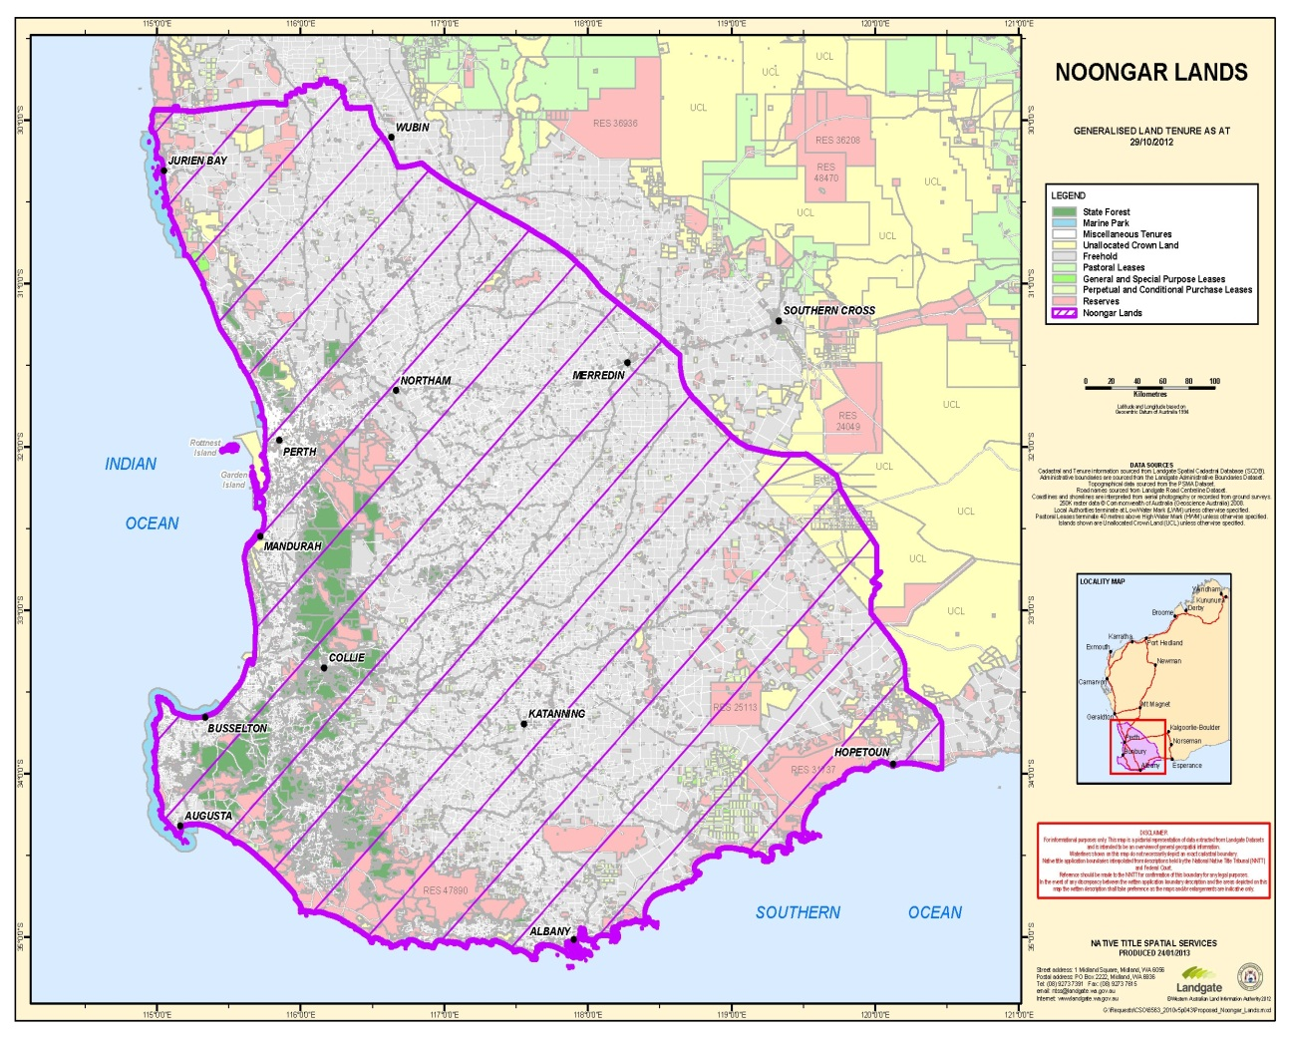

Notes
¹ This is a compilation of the Noongar (Koorah, Nitja, Boordahwan) (Past, Present, Future) Recognition Act 2016. The following table contains information about that Act.

Compilation table
Short title | Number and year | Assent | Commencement
Noongar (Koorah, Nitja, Boordahwan) (Past, Present, Future) Recognition Act 2016 | 9 of 2016 | 16 May 2016 | s. 1 and 2: 16 May 2016 (see s. 2(a));  Act other than s. 1 and 2: 6 Jun 2016 (see s. 2(b) and Gazette 27 May 2016 p. 1547)

