Western Australia
Perry Lakes Redevelopment Regulations 2006

Western Australia
Perry Lakes Redevelopment Regulations 2006
CONTENTS
-1. Citation 1
2. Extension of the AK redevelopment area 1
3. Form of application (Act s. 32(1)) 1
4. Documents with applications, requirements for 2
5. Fee for application (Act s. 32(1)) 3
Schedule 1 — Depiction of Deposited Plan 52693
Schedule 2 — Forms
1. Application for development approval (r. 3) 5
Notes
Compilation table 7

Perry Lakes Redevelopment Act 2005
Perry Lakes Redevelopment Regulations 2006

1. Citation
These regulations are the Perry Lakes Redevelopment Regulations 2006.

2. Extension of the AK redevelopment area
(1) The land shaded grey on Deposited Plan 52693 (depicted in Schedule 1) is declared to be part of the AK redevelopment area.
(2) The Deposited Plan referred to in subregulation (1) is that held by the Western Australian Land Information Authority established by the Land Information Authority Act 2006 section 5.
[Regulation 2 amended in Gazette 29 Dec 2006 p. 5905.]

3. Form of application (Act s. 32(1))
(1) Schedule 2 Form 1 is prescribed for the purposes of section 32(1) of the Act.
(2) An application for a development approval referred to in section 32(1) of the Act must be accompanied by 4 copies of —
(a) a plan, drawn to a scale not smaller than 1:2000, that identifies the land on which the development described in the application is proposed; and
(b) documents that fully and clearly illustrate and detail the proposed development, being —
(i) a plan or plans, drawn to a scale generally not smaller than 1:500; and
(ii) written verbal specifications.

4. Documents with applications, requirements for
(1) A plan required by regulation 3(2) must be drawn on a white background.
(2) The documents required by regulation 3(2) must use metric measurements.
(3) The documents required by regulation 3(2)(b) must include the following —
(a) the location and proposed use of any existing buildings and outbuildings to be retained and the location and use of buildings proposed to be erected or demolished on the land;
(b) the existing and proposed means of access for pedestrians and vehicles to and from the land;
(c) the location, number, dimension and layout of all car parking spaces intended to be provided;
(d) the location and dimensions of any area proposed to be provided for the loading and unloading of vehicles carrying goods or commodities to and from the land and the means of access to and from those areas;
(e) the location, dimensions, design and particulars of the manner in which it is proposed to develop any landscaped area, including the retention of existing trees, vegetation, fences and walls;
(f) plans, elevations and sections of any building proposed to be erected or altered and of any building it is intended to retain, including details of materials of construction, finishes and external colour;
(g) details of any impact of the proposed development on —
(i) the appearance of streets and of vegetation and buildings in streets; and
(ii) the views, privacy and overshadowing of neighbours’ land;
(h) details of the proposed use and operation of the proposed development;
(i) details of any signs or advertising structures that are proposed to be included in the proposed development.

5. Fee for application (Act s. 32(1))
The fee to be paid with an application for a development approval under the Act is as set out in the Table to this regulation.
Table
Item | Estimated cost of the development | Fee ($)
1. | Not more than $50 000 | $100
2. | More than $50 000 but not more than $500 000 | 0.23% of the estimated cost of development
3. | More than $500 000 but not more than $2.5m | $1 150 + 0.18% for every $1 in excess of $500 000
4. | More than $2.5m but not more than $5m | $4 750 + 0.15% for every $1 in excess of $2.5m
5. | More than $5m but not more than $21.5m | $8 500 + 0.1% for every $1 in excess of $5m
6. | More than $21.5m | $25 000

Schedule 1 — Depiction of Deposited Plan 52693
[r. 2]
[Heading inserted in Gazette 7 Aug 2007 p. 4046.]
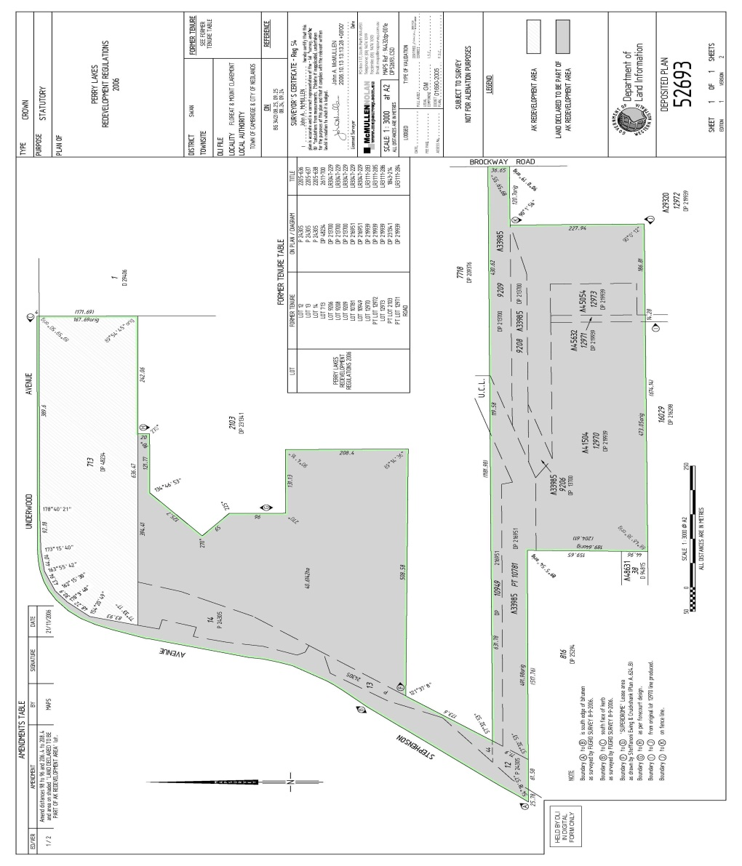
[Schedule 1 inserted in Gazette 7 Aug 2007 p. 4046.]

Schedule 2 — Forms

1. Application for development approval (r. 3)
(Office Use Only) Application No. . . . . .
Perry Lakes Redevelopment Act 2005 s. 32(1)
Application for a development approval
To: Western Australian Planning Commission
1. Owner(s) of land proposed to be developed:
Surname (or Company name) . . . . . . . . . . . . . Other names . . . . . . . . . . .
Address . . . . . . . . . . . . . . . . . . . . . . . . . . . . . . . . . . . . . . . . . . . . . . . . . . . .
Surname (or Company name) . . . . . . . . . . . . . Other names . . . . . . . . . . .
Address . . . . . . . . . . . . . . . . . . . . . . . . . . . . . . . . . . . . . . . . . . . . . . . . . . . .
2. Applicant’s name in full (if owner put ‘Owner’) . . . . . . . . . . . . . . . . . . . . .
3. Address for correspondence . . . . . . . . . . . . . . . . . . . . . . . . . . . . . . . . . . . . .
Telephone No(s). . . . . . . . . . . . . . . . . . . . . . . . . . . . . . . . . . . . . . . . . . . . . .
4. Address of land where development is proposed:
. . . . . . . . . . . . . . . . . . . . . . . . . . . . . . . . . . . . . . . . . . . . . . . . . . . . . . . . . . .
5. Nearest road junction/intersection . . . . . . . . . . . . . . . . . . . . . . . . . . . . . . . .
6. Name of local government(s) of the district(s) in which the land is situated:
. . . . . . . . . . . . . . . . . . . . . . . . . . . . . . . . . . . . . . . . . . . . . . . . . . . . . . . . . . . .
7. Formal description of the land:
Lot No(s). . . . . Location No. . . . . . . Deposited plan/Diagram No. . . . . .
Certificate of Title Vol. . . . . . Folio . . . . . . . .
Lot No(s). . . . . Location No. . . . . . . Deposited plan/Diagram No. . . . . .
Certificate of Title Vol. . . . . . Folio . . . . . . . .
8. Purpose for which the land is currently being used . . . . . . . . . . . . . . . . . . . .
9. Description of existing buildings on the land . . . . . . . . . . . . . . . . . . . . . . . .
10. Are existing buildings to be demolished in whole or in part?
(a) YES/NO (b) WHOLE/PART
11. Description of the proposed development . . . . . . . . . . . . . . . . . . . . . . . . . . .
12. Materials and colour to be used on external surfaces (including the roof) and any paved areas of the development . . . . . . . . . . . . . . . . . . . . . . . . . . . .
13. Estimated cost of the development $ . . . . . . . . . . . . . . . . . . . . . . . . . . . . . . .
14. Estimated completion date of the development . . . . . . . . . . . . . . . . . . . . . . .
Signature(s) of owner(s) of the land. Signature(s) of applicant(s).
. . . . . . . . . . . . . Date . . . . . . . . . . . . . . . . . . . . . . . Date . . . . . . . . .
. . . . . . . . . . . . . Date . . . . . . . . . . . . . . . . . . . . . . . Date . . . . . . . . .
If signing on behalf of a company state how authorised to sign.
Note: This application must be accompanied by 4 copies of the plan(s) and specifications for the development and the prescribed fee.

Notes
¹ This is a compilation of the Perry Lakes Redevelopment Regulations 2006 and includes the amendments made by the other written laws referred to in the following table.

Compilation table
Citation | Gazettal | Commencement
Perry Lakes Redevelopment Regulations 2006 | 31 Oct 2006 p. 4603-6 | 31 Oct 2006
Perry Lakes Redevelopment Amendment Regulations 2006 | 29 Dec 2006 p. 5904-5 | 1 Jan 2007 (see r. 2 and Gazette 8 Dec 2006 p. 5369)
Perry Lakes Redevelopment Amendment Regulations 2007 | 7 Aug 2007 p. 4045-6 | r. 1 and 2: 7 Aug 2007 (see r. 2(a));  Regulations other than r. 1 and 2: 8 Aug 2007 (see r. 2(b))

