Western Australia

Industrial Training (General Apprenticeship) Regulations 1981
Compare between:
[01 Aug 2008, 02-e0-05] and [14 Nov 2008, 03-a0-02]

Reprinted under the Reprints Act 1984 as
at 14 November 2008
Western Australia
Industrial Training Act 1975
Industrial Training (General Apprenticeship) Regulations 1981

1. Citation
These regulations may be cited as the Industrial Training (General Apprenticeship) Regulations 1981 ¹.

2. Repeal and commencement
The Industrial Training (General Apprenticeship) Regulations 1978 ², as amended, are repealed on, and these regulations take effect on and from, 20 July 1981 ¹.

3. Application
These regulations apply to and in relation to apprenticeships in the apprenticeship trades.
[Regulation 3 amended in Gazette 23 Jul 2008 p. 3374.]

4. Terms used
In these regulations unless the contrary intention appears —
employer means the person employing the apprentice, probationer or employee in question;
examiner means a person appointed by the Minister pursuant to section 17 of the Act to carry out duties relating to the examination of apprentices in relation to the trade in question;
registered training provider has the meaning given in the Vocational Education and Training Act 1996 section 5(1);
training includes theoretical and practical tuition and instruction and the type of employment required to be given to an apprentice pursuant to any regulation made under the Act in relation to the trade in which he is apprenticed;
Training Contract means the document entitled “Apprenticeship/Traineeship Training Contract Western Australia”, prepared by the Department, the text of which is set out in Schedule 1;
union means a union of workers or employers registered under any law relating to the registration of trade unions or the prevention and settlement of industrial disputes.
[Regulation 4 amended in Gazette 24 Dec 1987 p. 4550; 23 Jul 2008 p. 3374.]

5. Apprenticeship trades
(1) Each trade listed in Schedule 1 to the Industrial Training (Apprenticeship Training) Regulations 1981 is an apprenticeship trade for the purposes of the Act.
(2) The term building trade means the following trades, namely —
Bricklaying;
Stonemasonry;
Plastering;
Tilelaying.
[Regulation 5 amended in Gazette 24 Dec 1987 p. 4550.]

6. Eligibility for apprenticeship
(1) Subject to subregulation (2), a person is eligible to commence an apprenticeship if he —
(a) has fulfilled the conditions of eligibility prescribed by the regulations relating to that apprenticeship; and
(b) produces such evidence as satisfies the Director that he has fulfilled those conditions.
(2) Notwithstanding subregulation (1), a person shall not be eligible to commence an apprenticeship in —
(a) electrical fitting;
(b) electrical mechanics;
(c) painting and decorating;
(d) painting (vehicle building);
(e) signwriting;
(f) electronic servicing;
(g) instrument fitting;
(h) weighing instrument mechanics;
(i) trimming;
(j) refrigeration fitting; or
(k) mechanics (office machines),
unless the Director is satisfied that he does not suffer from any defect of colour vision that would render him unfit to undertake his apprenticeship training.
[Regulation 6 amended in Gazette 24 Dec 1987 p. 4550.]

7. Probationary employment
(1) A notification to the Registrar under section 29A of the Act is to be made by submitting to the Registrar a duly completed and executed copy of the Training Contract.
(2) If an employer submits the Training Contract in accordance with subregulation (1), the employer is taken to have made an application to the Director under section 29A of the Act for approval to establish the apprenticeship specified in the Training Contract.
[Regulation 7 inserted in Gazette 23 Jul 2008 p. 3375.]

8. Notification to unions
(1) Where the Director receives a notification and application pursuant to section 29A of the Act he shall cause the relevant unions to be notified of that fact.
(2) A union that desires to object to the application shall lodge notice of its objection with the Registrar within 14 days of the date of the notice given pursuant to subregulation (1).
(3) The Registrar shall notify the employer and the probationer (and, if the probationer is under 18 years of age, the probationer’s parent or guardian) of any objection lodged pursuant to subregulation (2).
(4) Any objection lodged pursuant to subregulation (2) shall be referred by the Registrar to the Director for hearing and determination.
(5) The Director shall notify his determination and the reasons therefor in writing to the employer and the probationer.
[Regulation 8 amended in Gazette 23 Jul 2008 p. 3375.]

9. Extension, termination and expiration of probationary period
(1) An application pursuant to section 29 to extend the term of probation shall be made to the Director before the expiration of the initial 3 months’ period.
(2) If the employment of a probationer is terminated during the period of probation, the employer shall, within 5 working days after the termination, notify the Registrar of that fact.
(3) If at the expiration of the period of probation, the employer or the apprentice (or, if the apprentice is under 18 years of age, the apprentice’s parent or guardian) does not wish to continue with the employment, the employer shall, within 5 working days after the expiration of the period of probation, notify the Registrar of that fact.
[Regulation 9 amended in Gazette 23 Jul 2008 p. 3375-6.]

10. Agreement
(1) For the purposes of section 30(1)(b) of the Act, an apprenticeship agreement is to be in the form of the Training Contract.
(2) A Training Contract duly completed and executed by an employer and an apprentice (and, if the apprentice is under 18 years of age, the apprentice’s parent or guardian) has effect as an apprenticeship agreement only if —
(a) the Training Contract is submitted in accordance with regulation 7(1); and
(b) the establishment of the apprenticeship specified in the Training Contract is approved by the Director; and
(c) no notice is required to be given under regulation 9(2) or (3) in respect of the employment.
(3) The following provisions apply in relation to a Training Contract that has effect under subregulation (2) —
(a) the employer and the apprentice (and, if the apprentice is under 18 years of age, the apprentice’s parent or guardian) are to be taken to have entered into the apprenticeship agreement on the day after the period of probation expires;
(b) the employer is to be taken to have made an application to the Registrar under section 31(2) of the Act, on the 14th day after the period of probation expires, for registration of the apprenticeship agreement.
(4) The Registrar shall not register an apprenticeship agreement unless he or she is satisfied that no objection in relation to that apprenticeship has been lodged, or, if an objection has been so lodged, the Director has approved of the registration of the agreement.
[Regulation 10 inserted in Gazette 23 Jul 2008 p. 3376-7.]

11. Credit
Notwithstanding anything in the regulations prescribing the period of apprenticeship to be served in a particular trade, where the Director is satisfied that a person has, before becoming indentured as an apprentice, acquired some experience or skill in that trade by reason of former service or otherwise the Director may direct that the period to be served by that person as an apprentice in that trade shall be such period as he specifies in his direction.

11A. Minimum hours of employment
For the purposes of section 29B(1)(b)(iii) of the Act, the minimum hours of employment of an apprentice employed on a part-time basis are —
(a) in the case of an apprentice who is a student within the meaning that term has under the School Education Act 1999, an average of 8 hours of paid employment a week during the period of apprenticeship, excluding any time required to attend technical training classes for instruction in the apprenticeship;
(b) in any other case, 20 hours of paid employment a week, including any time required to attend technical training classes for instruction in the apprenticeship.
[Regulation 11A inserted in Gazette 28 Mar 2007 p. 1444.]

12. Transfer
(1) Where an employer employs an apprentice by way of the transfer of the employment of the apprentice pursuant to section 34 of the Act the employer shall notify the Registrar within 14 days of the date that the apprentice commences employment with him.
(2) Where the Registrar receives notification pursuant to subregulation (1) he shall cause the relevant unions to be notified of that fact.
(3) A union that desires to object to the transfer of the employment of an apprentice shall lodge notice of its objection with the Registrar within 14 days of the date of the notice given pursuant to subregulation (2).
(4) Where pursuant to subregulation (3) an objection is made to the transfer of the employment of an apprentice the Registrar shall refer the objection to the Director for hearing and determination and notify the employer of the apprentice, the employer to whom the employment is to be transferred and the apprentice (and, if the apprentice is under 18 years of age, the apprentice’s parent or guardian) of the objection.
(5) The employer to whom the employment of an apprentice is transferred shall, within 60 days after the commencement of the employment of the apprentice, lodge the completed transfer of apprenticeship agreement for registration with the Registrar in accordance with section 34(5) of the Act.
(6) The Director shall notify his determination and the reasons therefor, in writing, to the employer of the apprentice, the apprentice (and, if the apprentice is under 18 years of age, the apprentice’s parent or guardian), and the employer to whom the apprenticeship is to be transferred.
(7) The Registrar shall not register the transfer of apprenticeship agreement unless he is satisfied that no objection in relation to the transfer has been lodged, or where an objection has been lodged, the Director has authorised the transfer.
(8) Where the Registrar registers a transfer of apprenticeship agreement he shall forward a copy thereof to each of the parties referred to therein.
[Regulation 12 amended in Gazette 23 Jul 2008 p. 3377.]

13. Cancellation
(1) The Director may on the application of the apprentice (or, if the apprentice is under 18 years of age, the apprentice’s parent or guardian) cancel the apprenticeship agreement and thereupon the apprentice ceases to be bound as an apprentice to his employer.
(2) Where —
(a) an apprentice abandons his apprenticeship; or
(b) an employer is satisfied on reasonable grounds that an apprentice has abandoned his apprenticeship,
the employer shall, within 14 days of the apprentice abandoning his apprenticeship or being so satisfied, as the case may be, notify the Registrar of that fact.
(3) Upon receipt of a notice pursuant to subregulation (2) the Director may notify the apprentice (and, if the apprentice is under 18 years of age, the apprentice’s parent or guardian) that if the apprentice does not comply with the terms of his apprenticeship agreement the agreement may be cancelled and if after the notice has been forwarded to the apprentice he does not so comply the Director may cancel the apprenticeship agreement.
(4) An apprenticeship agreement may be cancelled by the mutual consent of the employer and the apprentice (and, if the apprentice is under 18 years of age, the apprentice’s parent or guardian) by entering into an agreement for the cancellation of the apprenticeship agreement.
(5) An agreement for the cancellation of an apprenticeship agreement shall be lodged with the Registrar within 14 days of the date of its execution and on receipt thereof the Registrar shall cancel the apprenticeship agreement.
(6) Where an apprenticeship agreement is cancelled pursuant to this regulation the apprentice ceases to be bound as an apprentice to his employer.
[Regulation 13 amended in Gazette 23 Jul 2008 p. 3378.]

14. Misconduct
(1) An application pursuant to section 37(1) or (2) of the Act shall be lodged with the Registrar.
(2) On receipt of an application lodged pursuant to subregulation (1) the Registrar shall forward the application to the Director for hearing and determination.
(3) The Registrar shall notify the parties to the apprenticeship agreement and the relevant union or unions of the date of hearing of the application.
(4) The Director shall notify his determination and the reasons therefor, in writing, to the parties to the apprenticeship agreement and the relevant union or unions.

15. Reduction
Where the Director is satisfied that because of the special circumstances of the particular case it is not necessary for an apprentice to serve his apprenticeship for the whole of the period prescribed in relation to the trade in which he is apprenticed he may on application by the apprentice (or, if the apprentice is under 18 years of age, the apprentice’s parent or guardian) or the employer, reduce the period of apprenticeship to be served by the apprentice.
[Regulation 15 amended in Gazette 23 Jul 2008 p. 3378.]

15A. Reduction of term if apprentice competent
(1) If the Director is reasonably satisfied that an apprentice —
(a) is competent to work as a tradesperson in the trade in which he or she is apprenticed; and
(b) has successfully completed all the technical training that the apprentice is required under the Act to complete during his or her apprenticeship,
the Director may reduce the term of the apprentice’s apprenticeship to the period of the apprenticeship already served.
(2) For the purpose of determining whether he or she is satisfied as to the matters set out in subregulation (1) the Director may —
(a) accept evidence from the employer as to the apprentice’s competence; and
(b) require the apprentice to undertake such assessment or provide such evidence of his or her competence as the Director requires.
[Regulation 15A inserted in Gazette 19 Sep 2006 p. 3709.]

16. Satisfactory progress
(1) The Director may require any person training an apprentice to furnish him with a report on the conduct, diligence, application and progress of the apprentice.
(2) Where, in the opinion of the Director, an apprentice is not making satisfactory progress in his training the Director may do any one or more of the following —
(a) direct that the period of apprenticeship specified in the apprenticeship agreement of that apprentice be extended in the year being served or require that the apprentice serve an additional period after his last normal year of service;
(b) require the apprentice to undertake such additional training as the Director deems necessary;
(c) suspend the operation of the apprenticeship agreement for such period and upon such conditions as he thinks fit;
(d) cancel the apprenticeship agreement of that apprentice,
but the Director shall not take any action pursuant to this subregulation unless he gives the parties to the apprenticeship agreement an opportunity to make representations to him.
(3) Where pursuant to subregulation (2) he has extended an apprenticeship agreement or required an apprentice to undertake additional training and he is satisfied with the progress the apprentice is making with his training the Director may cancel or vary the direction or requirement, as the case may be.

17. Technical training
(1) An apprentice shall attend technical training classes for instruction in his apprenticeship course as prescribed by the regulations in relation to the trade in which he is being trained.
(2) An apprentice who is required to attend technical training classes —
(a) shall attend regularly and punctually at the time appointed for the commencement of the classes and shall not without permission of the lecturer leave before the appointed time for leaving;
(b) shall be diligent and behave in a decorous manner while in the training institution;
(c) shall not destroy and shall take care of any material or equipment provided for his use in the training institution; and
(d) shall attend in each term every prescribed technical training class.
(3) An apprentice who is, in the opinion of the Director, unable to attend regular technical training classes in his apprenticeship course, shall undertake his technical training course by correspondence as directed.
(4) Where any regulation relating to training in a particular trade prescribes that the course of training for the trade be undertaken at a particular rate or in particular stages an apprentice undertaking the course shall complete the course at the rate prescribed, or in the stages prescribed, as the case may be, in relation to that trade.
(5) Subject to subregulation (6), where an apprentice is required to undertake instruction by correspondence he shall submit lessons monthly at the rate of the number of lessons prescribed for the stage divided by 9 and rounded to nearest whole number.
(6) Notwithstanding subregulation (5), the Director may vary the rate of submission of correspondence lessons to be completed by a particular apprentice.
(7) Where an apprentice is undertaking his technical training course by correspondence his employer shall permit him during ordinary working hours, without deduction from his wages —
(a) to attend such technical training classes as may be directed; and
(b) to perform the theoretical or practical work of or incidental to his correspondence course either on the employer's premises or at such other place as is agreed between the apprentice and the employer,
for up to an equivalent number of hours to the number prescribed in the Industrial Training (Apprenticeship Training) Regulations 1981 for apprentices attending technical training classes in his trade.
(8) Where an apprentice is required to undertake instruction by correspondence the employer shall forward all correspondence lessons completed by the apprentice to the body that conducts the course.
(9) Where an apprentice fails to attend a class or carry out a correspondence lesson he shall within 7 days provide the person conducting the course with a written explanation signed by him (or, if he is under 18 years of age, his parent or guardian) stating the reason for his failure to so attend or carry out a lesson.
(10) Where an apprentice fails to attend a class or to carry out any requirement of his training by reason of illness the Director may require him to provide a medical certificate signed by a legally qualified medical practitioner substantiating the reason for his absence or failure.
(11) The employer shall not obstruct or hinder an apprentice from attending any class or from undertaking any correspondence instruction that he is required to attend or undertake under the Act.
(12) Notwithstanding subregulations (1) and (3) the Director may exempt an apprentice from attendance at classes or from undertaking his technical training by correspondence and may make the exemption subject to such conditions as he thinks fit.
(13) An exemption granted pursuant to subregulation (12) may be given in relation to a particular apprentice or in relation to any grouping of apprentices.
(14) An apprentice shall submit himself to be examined at such examinations conducted by a registered training provider in relation to the trade in which he is being trained.
[Regulation 17 amended in Gazette 23 Jul 2008 p. 3379.]

18. Examinations
(1) The results of every examination of an apprentice conducted by a registered training provider shall be forwarded by that registered training provider to the Director.
(2) Where an apprentice does not sit for, or attend, an examination, or fails an examination, the registered training provider may recommend to the Director that action be taken under regulation 16.
[Regulation 18 amended in Gazette 27 Mar 1987 p. 1017; 23 Jul 2008 p. 3379.]

19. Final certificate
The Director shall issue to an apprentice who has completed his apprenticeship in accordance with the Act, a final certificate.
[Regulation 19 inserted in Gazette 27 Mar 1987 p. 1017.]
[20, 21. Repealed in Gazette 27 Mar 1987 p. 1017.]

22. Hearings by Director
Subject to the Act, the procedure on a hearing by the Director shall be as follows —
(a) the Registrar shall give notice to all persons entitled to be heard at the hearing of the time and date fixed for the hearing, which notice shall not, except with the agreement of all such persons, be less than 7 days before the day fixed for the hearing;
(b) the conduct of the hearing shall be as determined by the Director;
(c) the Director may require any party to the proceedings to produce documents for inspection by the Director;
(d) the Director may require any witness or any party to the proceedings the subject of the hearing to make an oath or affirmation under the Evidence Act 1906.

23. Appeals to The Western Australian Industrial Relations Commission
(1) Every appeal under section 37C of the Act shall be instituted by a notice of appeal given by the appellant and lodged with the Registrar within 14 days from the date the decision appealed against is given.
(2) The notice referred to in subregulation (1) shall clearly and concisely set forth the grounds upon which the appeal is made.
(3) The filing of an appeal under subregulation (1) stays the operation of the decision, which is the subject of the appeal.
(4) Upon receipt of a notice of appeal referred to in subregulation (1) the Registrar shall forward a copy thereof to the other parties concerned and shall provide proof of such notification to the Commission.
(5) Regulation 101 of the Industrial Relations Commission Regulations 2005 as amended applies to and in relation to an appeal to the Commission under section 37C of the Act.
[Regulation 23 amended in Gazette 23 Jul 2008 p. 3380.]

24. Transitional provisions
Schedule 2 sets out transitional provisions.
[Regulation 24 inserted in Gazette 23 Jul 2008 p. 3380.]

Schedule 1 — Training Contract
[r. 4]
[Heading inserted in Gazette 23 Jul 2008 p. 3380.]

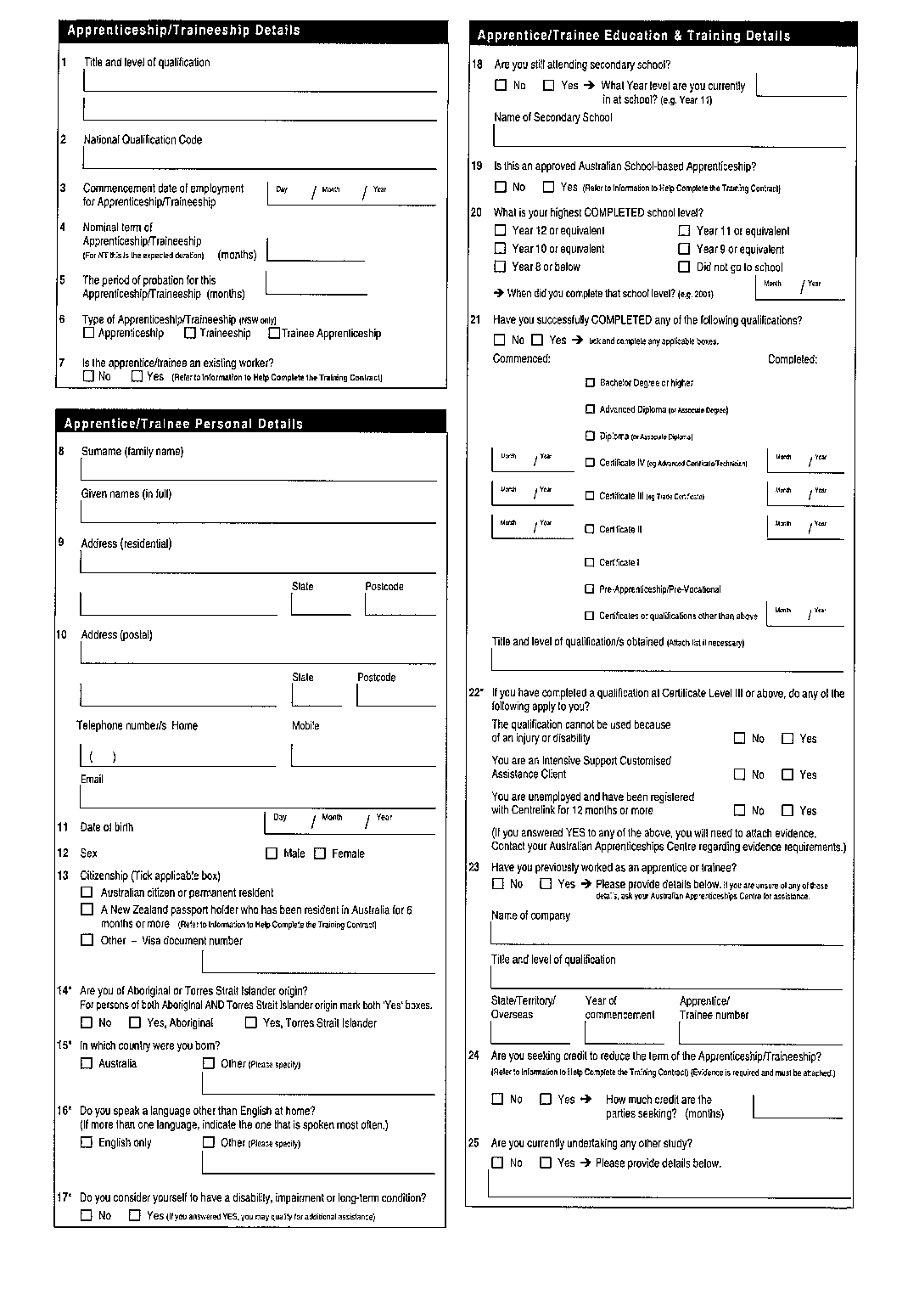
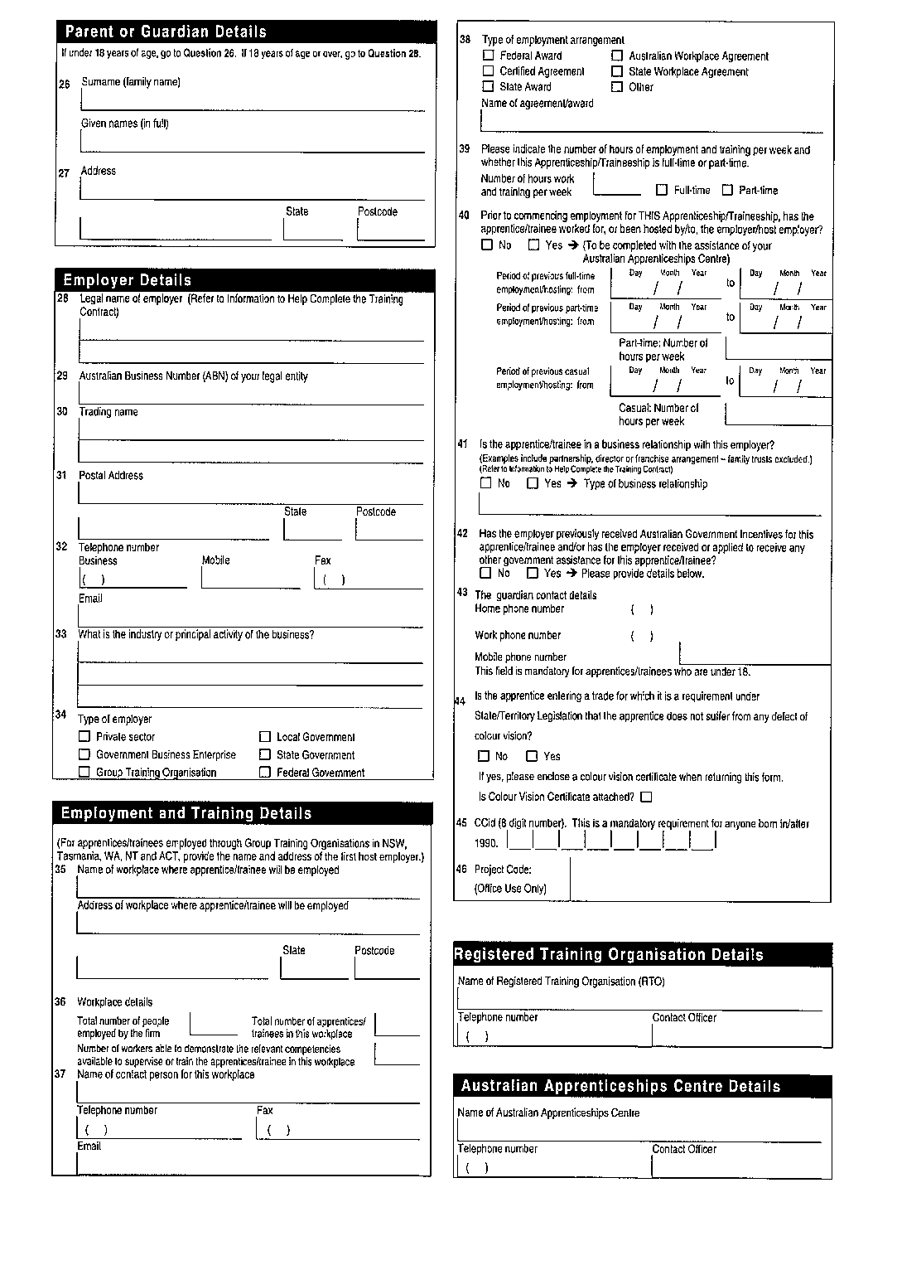
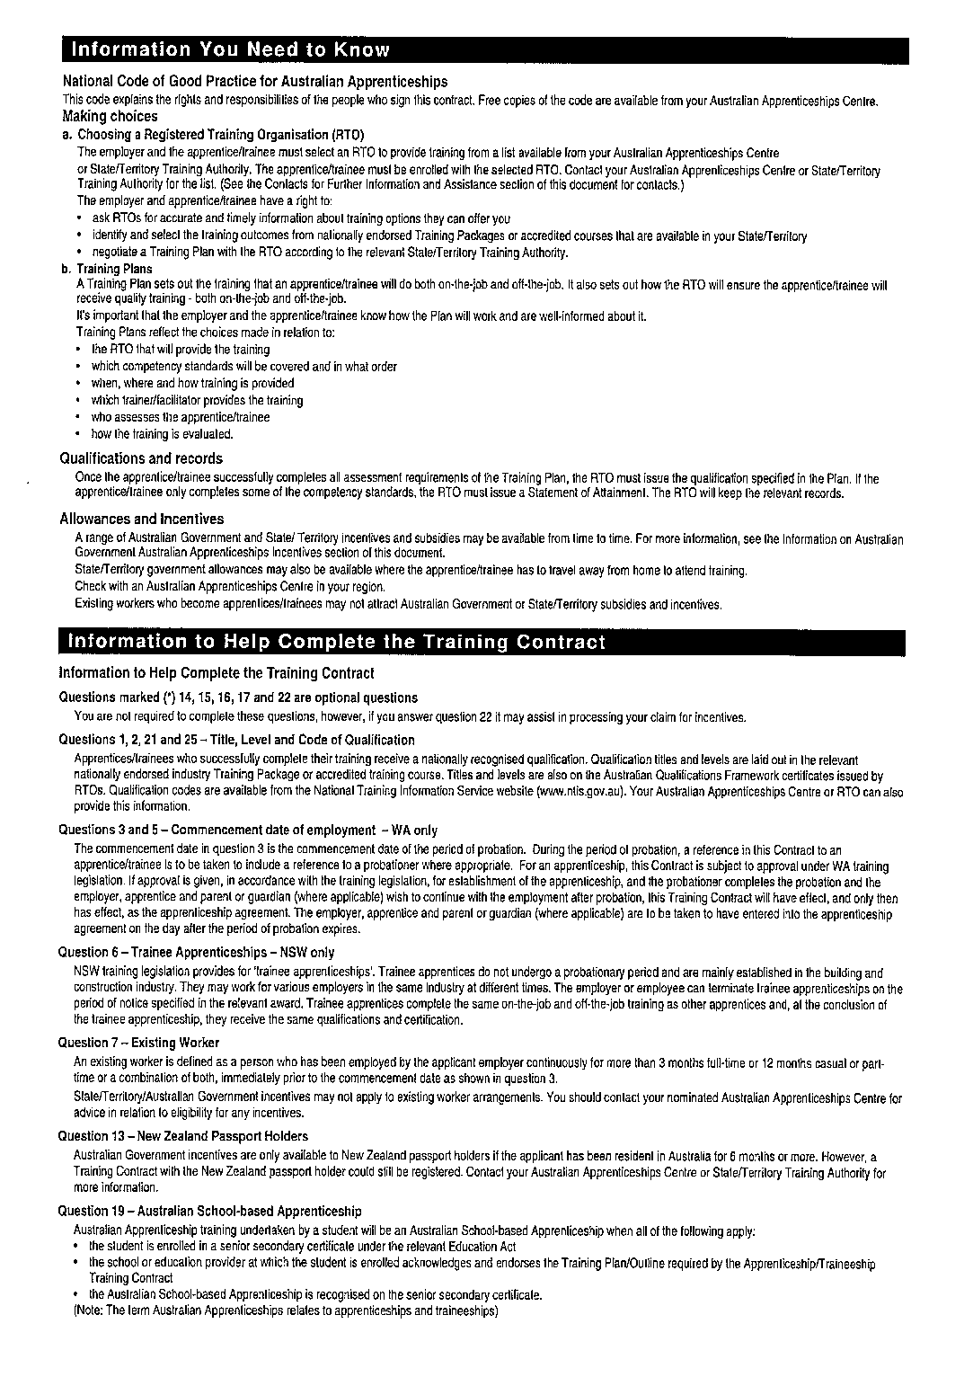
[Schedule 1 inserted in Gazette 23 Jul 2008 p. 3380-6.]

Schedule 2 — Transitional provisions
[r. 24]
[Heading inserted in Gazette 23 Jul 2008 p. 3387.]

1. Provisions relating to the Industrial Training Legislation Amendment Regulations 2008
(1) In this clause —
pre - 1 August 2008 regulations means these regulations as in force immediately before 1 August 2008.
(2) Regulations 7 to 10, 12, 13, 15 and 17(9) and Schedules 2 and 3 of the pre - 1 August 2008 regulations continue to apply to and in relation to a person who commenced employment as a probationer before 1 August 2008.
(3) These regulations do not apply to and in relation to a person who commenced employment as a probationer before 1 August 2008 to the extent that they are inconsistent with the provisions of the
pre - 1 August 2008 regulations applied under subclause (2).
[Clause 1 inserted in Gazette 23 Jul 2008 p. 3387.]
[Schedule 3 repealed in Gazette 23 Jul 2008 p. 3380.]

Notes
¹ This reprint is a compilation as at 14 November 2008 of the Industrial Training (General Apprenticeship) Regulations 1981 and includes the amendments made by the other written laws referred to in the following table. The table also contains information about any reprint.

Compilation table
Citation | Gazettal | Commencement
Industrial Training (General Apprenticeship) Regulations 1981 | 17 Jul 1981 p. 2921-35 | 20 Jul 1981 (see r. 2)
Industrial Training (General Apprenticeship) Amendment Regulations 1983 | 30 Dec 1983 p. 5028 | 1 Jan 1984 (see r. 2)
Industrial Training (General Apprenticeship) Amendment Regulations (No. 2) 1984 ³ | 18 Jan 1985 p. 264 | 18 Jan 1985
Industrial Training (General Apprenticeship) Amendment Regulations 1985 | 1 Nov 1985 p. 4228 | 1 Nov 1985
Industrial Training (General Apprenticeship) Amendment Regulations (No. 2) 1985 | 8 Nov 1985 p. 4296 | 8 Nov 1985
Industrial Training (General Apprenticeship) Amendment Regulations (No. 3) 1985 | 20 Dec 1985 p. 4881 | 20 Dec 1985
Industrial Training (General Apprenticeship) Amendment Regulations 1987 | 27 Mar 1987 p. 1017 | 27 Mar 1987
Industrial Training (General Apprenticeship) Amendment Regulations (No. 2) 1987 | 24 Dec 1987 p. 4550 | 1 Jan 1988 (see r. 2)
Reprint of the Industrial Training (General Apprenticeship) Regulations 1981 as at 1 Jul 1997 (includes amendments listed above)
Reprint 2: The Industrial Training (General Apprenticeship) Regulations 1981 as at 13 Feb 2004 (includes amendments listed above)
Industrial Training Amendment Regulations 2006 r. 2 | 19 Sep 2006 p. 3708-9 | 19 Sep 2006
Industrial Training (General Apprenticeship) Amendment Regulations 2007 | 28 Mar 2007 p. 1441-4 | 29 Mar 2007 (see r. 2 and Gazette 28 Mar 2007 p. 1445)
Industrial Training Legislation Amendment Regulations 2008 Pt. 2 | 23 Jul 2008 p. 3371-88 | 1 Aug 2008 (see r. 2(b))
Reprint 3: The Industrial Training (General Apprenticeship) Regulations 1981 as at 14 Nov 2008 (includes amendments listed above)
² Published in the Government Gazette on 27 Jan 1978 p. 291-301.

³ The Miscellaneous Regulations (Validation) Act 1985 applied to these regulations. It deems the regulations not to have ceased to have effect as a result of the failure to comply with section 42(1) of the Interpretation Act 1984, subject to their being laid before the Legislative Assembly. The Interpretation Act 1984 s. 42(2) then applied as if the words “or if any regulations are not laid before both Houses of Parliament in accordance with subsection (1)” had been omitted.

