Western Australia

Port Kennedy Development Act 2017

Western Australia
Port Kennedy Development Act 2017
Contents
Part 1 — Preliminary
1. Short title 2
2. Commencement 2
Part 2 — Planning scheme amendments
3. Terms used 3
4. Metropolitan Region Scheme amended 4
5. Rockingham local planning scheme amended 4
6. Effect of amendments 4
Part 3 — Repeal and amendment of Acts
7. Port Kennedy Development Agreement Act 1992 repealed 6
8. Aquatic Resources Management Act 2016 amended 6
Schedule 1 — Port Kennedy Revised Development Plan (indicative only)
Schedule 2 — Rockingham development zone plan (indicative only)
Notes
Compilation table 9
Defined terms

Western Australia
Port Kennedy Development Act 2017
An Act —
- to repeal the Port Kennedy Development Agreement Act 1992; and
- to provide for planning changes to allow a revised Port Kennedy project to proceed; and
- for related purposes.
The Parliament of Western Australia enacts as follows:

Part 1 — Preliminary

1. Short title
This is the Port Kennedy Development Act 2017.

2. Commencement
This Act comes into operation as follows —
(a) Part 1 — on the day on which this Act receives the Royal Assent;
(b) the rest of the Act — on a day fixed by proclamation, and different days may be fixed for different provisions.

Part 2 — Planning scheme amendments

3. Terms used
(1) In this Part —
Area A means the area shown as Area A on the Port Kennedy Revised Development Plan;
Area B means the area that is —
(a) shown as Area B on the Port Kennedy Revised Development Plan; and
(b) shown as the hachured area on the Rockingham development zone plan;
Commission means the Western Australian Planning Commission established by the Planning Act section 7;
Metropolitan Region Scheme has the meaning given in the Planning Act section 4(1);
Planning Act means the Planning and Development Act 2005;
Port Kennedy Revised Development Plan means the plan entitled Port Kennedy Revised Development Plan held at the office of the Commission and certified by the Commission as the plan prepared for the purposes of describing the areas in which the reservation or zoning of land under the Metropolitan Region Scheme is to be changed by this Act;
Rockingham development zone plan means the plan entitled Rockingham development zone plan held at the office of the Commission and certified by the Commission as the plan prepared for the purposes of describing the area in which the zoning of land under the Rockingham local planning scheme is to be changed by this Act;
Rockingham local planning scheme means the local planning scheme for the City of Rockingham under the Planning Act known as the City of Rockingham Town Planning Scheme No. 2 — District Zoning Scheme.
(2) An indicative depiction of the Port Kennedy Revised Development Plan is in Schedule 1.
(3) An indicative depiction of the Rockingham development zone plan is in Schedule 2.

4. Metropolitan Region Scheme amended
(1) The Metropolitan Region Scheme is amended by changing the reservation of the land in Area A to “Parks and Recreation”.
(2) The Metropolitan Region Scheme is amended by changing the zoning of any land in Area B that is not zoned as “Urban” to “Urban”.
(3) In any proceedings, a plan purporting to be a copy of the Port Kennedy Revised Development Plan showing the boundaries of the area affected by subsection (1) or (2), as the case may be, is evidence of those boundaries.

5. Rockingham local planning scheme amended
(1) The Rockingham local planning scheme is amended by rezoning any land in Area B that is not in the Development Zone to the Development Zone.
(2) In any proceedings, a plan purporting to be a copy of the Rockingham development zone plan showing the boundaries of the area affected by subsection (1) is evidence of those boundaries.

6. Effect of amendments
(1) The amendments effected by this Part have effect as though the amendments were enacted under the Planning Act.
(2) Despite subsection (1) the Planning Act section 126(3) to (6) do not apply to the amendment to the Metropolitan Region Scheme effected by section 4(2).
(3) Nothing in this Part affects the operation of the Planning Act with respect to amendments to the Metropolitan Region Scheme or the Rockingham local planning scheme as amended by this Part.

Part 3 — Repeal and amendment of Acts

7. Port Kennedy Development Agreement Act 1992 repealed
The Port Kennedy Development Agreement Act 1992 is repealed.

8. Aquatic Resources Management Act 2016 amended
(1) This section amends the Aquatic Resources Management Act 2016.
(2) In section 377 in the Table delete the item relating to the Port Kennedy Development Agreement Act 1992.

Schedule 1 — Port Kennedy Revised Development Plan (indicative only)
[s. 3(2)]
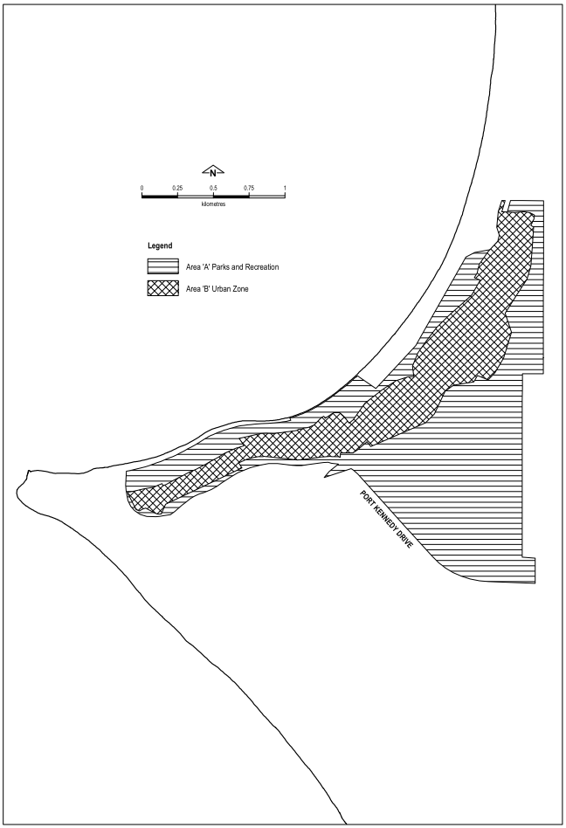

Schedule 2 — Rockingham development zone plan (indicative only)
[s. 3(3)]
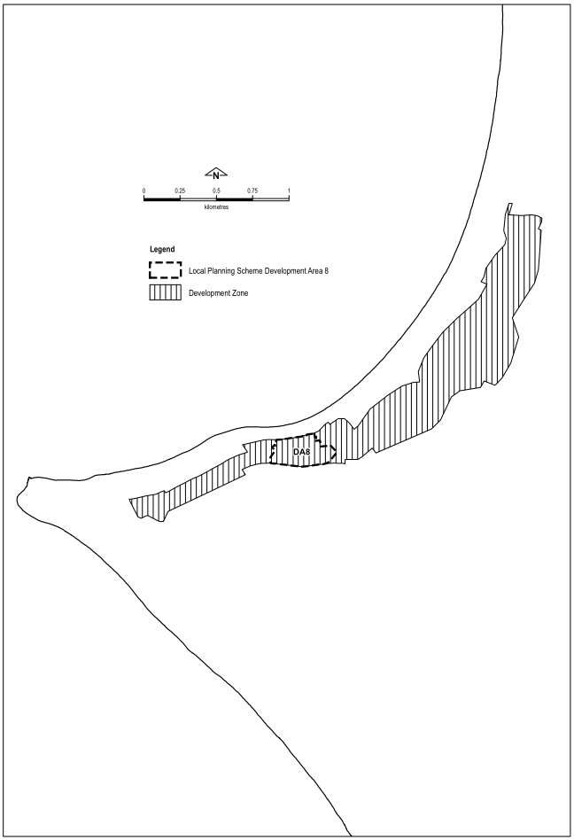

Notes
¹ This is a compilation of the Port Kennedy Development Act 2017. The following table contains information about that Act.

Compilation table
Short title | Number and year | Assent | Commencement
Port Kennedy Development Act 2017 | 8 of 2017 | 15 Sep 2017 | Pt. 1: 15 Sep 2017 (see s. 2(a));  Act other than Pt. 1: 27 Feb 2018 (see s. 2(b) and Gazette 27 Feb 2018 p. 531)

Defined terms

[This is a list of terms defined and the provisions where they are defined. The list is not part of the law.]
Defined term Provision(s)
Area A 3(1)
Area B 3(1)
Commission 3(1)
Metropolitan Region Scheme 3(1)
Planning Act 3(1)
Port Kennedy Revised Development Plan 3(1)
Rockingham development zone plan 3(1)
Rockingham local planning scheme 3(1)

