Western Australia

Water Agencies (Water Use) By-laws 2007
Compare between:
[12 Dec 2009, 00-b0-02] and [01 Apr 2010, 00-c0-05]

Western Australia
Water Agencies (Powers) Act 1984
Water Agencies (Water Use) By-laws 2007

Part 1 — Preliminary

1. Citation
These by-laws are the Water Agencies (Water Use) By-laws 2007.

2. Commencement
These by-laws come into operation as follows:
(a) by-laws 1 and 2 — on the day on which these by-laws are published in the Gazette;
(b) the rest of the by-laws — on the day after that day.

3. Terms used in these by-laws
In these by-laws, unless the contrary intention appears —
approved means approved by the Corporation;
consumption year has the meaning given in the Water Agencies (Charges) By-laws 1987 by-law 2(1);
evening period means the period after 6.00 p.m.;
high pressure water cleaner means a cleaning device that uses pressurised water flowing at a rate of not more than 6 L per minute;
morning period means the period before 9.00 a.m.;
non-residential lot means a lot as defined in section 41GA(5) of the Act, except a habitable lot as defined in that section;
north of the State means that part of the State that is north of the north/south line;
north/south line means a line —
(a) starting at latitude 27.428° and longitude 114.063°; and
(b) extending to latitude 30.117° and longitude 117.081°; and
(c) extending to latitude 30.117° and longitude 128.993°,
a map of which is shown for information purposes in Schedule 1;
south of the State means that part of the State that is south of the north/south line;
specified —
(a) in relation to a stage of restrictions applicable under by-law 6 — means specified in Schedule 3; and
(b) in relation to a stage of restrictions applicable under a notice made under by-law 7 — means specified in the relevant notice;
stage of restrictions means a stage of restrictions set out in Schedule 2;
water means water supplied by the Corporation;
water efficiency management plan has the meaning given in by-law 9.

Part 2 — Water restrictions

4. Use of water restricted
A person must not, without the written approval of the Corporation, use water in contravention of the stage of restrictions applicable under these by-laws.
Penalty: a fine of $500.

5. Stage of restrictions applicable to the north of the State
Subject to by-law 7, the stage of restrictions designated stage 2 applies to the north of the State.

6. Stage of restrictions applicable to the south of the State
Subject to by-law 7, the stage of restrictions designated stage 4 applies to the south of the State.

7. Notices may impose different stage of restrictions
(1) The Corporation may, by notice published in the Gazette, apply a different stage of restrictions to a specified area of the State.
(2) A notice under sub-bylaw (1) must specify the day from which the stage of restrictions applies to the area, being a day not less than 48 hours after the publication of the notice in the Gazette.
(3) The Corporation may, by subsequent notice published in the Gazette, revoke a notice under sub-bylaw (1).
[By-law 7 amended in Gazette 11 Dec 2009 p. 5061.]

8. Exemptions for market gardeners
A person does not commit an offence under by-law 4 if —
(a) the person uses water to water a market garden or plant nursery to the minimum extent necessary to ensure the viable operation of the market garden or plant nursery; and
(b) the market garden or plant nursery is not supplied with water other than by the Corporation.

Part 3 — Water efficiency management plans

Division 1 — General

9. Meaning of “water efficiency management plan”
(1) In this Part —
water efficiency management plan, in relation to a non-residential lot, means a plan for ensuring that water supplied to the lot is used as efficiently as practicable, prepared in accordance with sub-bylaw (2).
(2) A water efficiency management plan must be in an approved form and must contain —
(a) the full name and address of each owner and occupier of the lot; and
(b) a description of the nature of any business or other work being conducted on the lot; and
(c) details of the measures comprising the plan, including proposed timeframes for implementing each of those measures; and
(d) the estimated savings in water use under the plan; and
(e) the substance of the most recent report under by-law 19 (if any) prepared in relation to the lot; and
(f) such other information as the Corporation reasonably requires, as specified in any notice under by-law 11(2), 12(2) or 18(1).

10. Extensions of time
(1) Where under this Part —
(a) it is an offence for a person to fail to do something within a specified period; and
(b) in a particular case it is not practicable for the person to do the thing within that period,
the person may, before the end of the period, make a written application to the Corporation to extend that period.
(2) The Corporation may, on an application under sub-bylaw (1) extend the period.
(3) The person does not commit the offence if the person does the thing within the extended period.

11. Initial preparation and submission of water efficiency management plans
(1) This by-law applies to an owner or occupier of a non-residential lot in a particular consumption year unless —
(a) the lot was supplied with less than 20 ML of water in the consumption year immediately before that year; or
(b) the owner or occupier has submitted to the Corporation a water efficiency management plan, the approval of which —
(i) is being considered under by-law 12; or
(ii) has been given and remains in force under by-law 15.
(2) The Corporation may, by notice in writing, require the owner or occupier to prepare and submit for approval to the Corporation a water efficiency management plan.
(3) A person who is served with a notice under sub-bylaw (2) must prepare the water efficiency management plan and submit it for approval to the Corporation within 90 days after the notice is served on the person.
Penalty: a fine of $2 000.

12. Approvals, requests for further information and requests for amendments
(1) This by-law applies when the Corporation receives from a person —
(a) a water efficiency management plan prepared and submitted under sub-bylaw (4) or by-law 11(3), 13, 17 or 18(3); or
(b) further information provided under sub-bylaw (3).
(2) The Corporation must, by notice in writing served on the person within 60 days after the plan is received by the Corporation —
(a) approve the plan in the form most recently submitted; or
(b) request further information from the person relating to the plan, including the person’s comments on any specific amendments to the plan the Corporation considers might be necessary; or
(c) request an amended water efficiency management plan in accordance with any instructions specified in the notice; or
(d) if, while the Corporation is considering the plan, a subsequent revised water efficiency management plan is submitted to the Corporation under by-law 13, do anything referred to in paragraph (a), (b) or (c) in relation to the revised plan.
(3) A person who is served with a notice under sub-bylaw (2)(b) must provide the further information within 30 days after the notice is served on the person.
Penalty: a fine of $2 000.
(4) A person who is served with a notice under sub-bylaw (2)(c) must prepare the amended water efficiency management plan and submit it for approval to the Corporation within 60 days after the notice is served on the person.
Penalty: a fine of $2 000.

13. Persons may submit revised plans for approval at any time
A person who has submitted a water efficiency management plan for approval to the Corporation under this Part may, at any time after that submission (whether or not the plan has been approved), prepare a revised water efficiency management plan and submit it for approval to the Corporation.

Division 2 — After approval of water efficiency management plans

14. Application
This Division applies where a person has submitted a water efficiency management plan under by-law 11(3), 12(4), 13, 17 or 18(3) and the plan has been approved.

15. Period of approval of water efficiency management plan
The approval remains in force on and from the day the approval was given until —
(a) the person ceases to be an owner or occupier of the lot; or
(b) the approval is revoked under by-law 20; or
(c) a revised water efficiency management plan is submitted by the person under by-law 13, 17 or 18(3) and is approved; or
(d) a period of 5 years expires,
whichever occurs first.

16. Compliance with water efficiency management plans
(1) The person must comply with the water efficiency management plan during the period that the approval remains in force under by-law 15.
Penalty: a fine of $2 000.
(2) If the Corporation reasonably suspects that the person has not complied, or is not complying, with the plan during the period that the approval remains in force under by-law 15, the Corporation may, by notice in writing, require the person to provide a written report on the person’s implementation of the plan.
(3) A person who is served with a notice under sub-bylaw (2) must prepare the report in an approved form and submit it to the Corporation within 30 days after the notice is served on the person.
Penalty: a fine of $2 000.

17. Persons to submit revised water efficiency management plans before end of approval period
(1) Except as provided in sub-bylaw (2), the person must, at least 90 days before the end of the period that the approval remains in force under by-law 15, prepare and submit for approval to the Corporation a revised water efficiency management plan.
Penalty: a fine of $2 000.
(2) Sub-bylaw (1) does not apply to the person if —
(a) the lot was supplied with less than 20 ML of water in the consumption year immediately before the consumption year in which the approval is due to expire; and
(b) the person has submitted to the Corporation a written notice in an approved form —
(i) confirming the circumstances in paragraph (a); and
(ii) stating that the person does not intend to use 20 ML or more of water in the consumption year in which the approval is due to expire.

18. Corporation may require revised water efficiency management plans
(1) In addition to by-law 17, the Corporation may, by notice in writing at any time during the period that the approval remains in force under by-law 15, require the person to prepare and submit for approval to the Corporation a revised water efficiency management plan if —
(a) there has been a significant change in —
(i) the use of water supplied to the lot; or
(ii) the quantity of water available for supply to the lot,
since the approval was given; or
(b) otherwise where the Corporation thinks it is necessary on the basis of a report under by-law 19.
(2) The notice may specify measures to be included in the revised plan, including timeframes for implementing each of those measures.
(3) A person who is served with a notice under sub-bylaw (1) must prepare the revised plan and submit it for approval to the Corporation within 60 days after the notice is served on the person.
Penalty: a fine of $2 000.

19. Annual reports on water efficiency management plans
(1) During the period that the approval remains in force under by-law 15 the person must, within 30 days after each anniversary of the approval, prepare and submit to the Corporation a report on the efficacy of the water efficiency management plan.
Penalty: a fine of $2 000.
(2) The report must be in an approved form and must —
(a) compare the use of water supplied to the property during the period to which the report relates against the estimated savings in water use under the plan for that period; and
(b) contain such other information relating to the efficacy of the plan as the Corporation reasonably requires, as specified in —
(i) any notice under by-law 11(2), 12(2) or 18(1); or
(ii) any other written notice served on the person for the purposes of this paragraph.
(3) The Corporation may, by notice in writing served on the person within 90 days after the report is received by the Corporation, request such further information from the person relating to the efficacy of the plan as the Corporation reasonably requires.
(4) A person who is served with a notice under sub-bylaw (3) must provide the information in an approved form and submit it to the Corporation within 30 days after the notice is served on the person.
Penalty: a fine of $2 000.

20. Corporation may revoke approval of water efficiency management plan
(1) The person may, in an approved form, make an application for the Corporation to revoke its approval of the water efficiency management plan.
(2) On an application under sub-bylaw (1) the Corporation may revoke its approval if it is satisfied that —
(a) the lot was supplied with less than 20 ML of water in the consumption year immediately before the consumption year in which the application was made; and
(b) the person does not intend to use 20 ML or more of water in the consumption year in which the application was made.

Part 4 — Repeal, saving and transitional

21. Repeal
The Water Agencies (Water Restrictions) By-laws 1998 are repealed.

22. Saving and transitional provisions for the Water Agencies (Water Restrictions) By-laws 1998
(1) In this by-law —
commencement day means the day on which these by-laws, other than by-laws 1 and 2, come into operation;
former notice means a notice issued under the Water Agencies (Water Restrictions) By-laws 1998 by-law 2(3).
(2) Except as provided in sub-bylaw (3) or (4), a former notice continues to apply on and after the commencement day as if it were a notice made under by-law 7.
(3) A former notice issued in respect of an area in the north of the State is to be taken to have been revoked if the stage of restrictions applicable under that notice was designated stage 1 or 2.
(4) A former notice issued in respect of an area in the south of the State is to be taken to have been revoked if the stage of restrictions applicable under that notice was designated stage 1, 2, 3 or 4.

Schedule 1 — Map showing north/south line
[bl. 3]
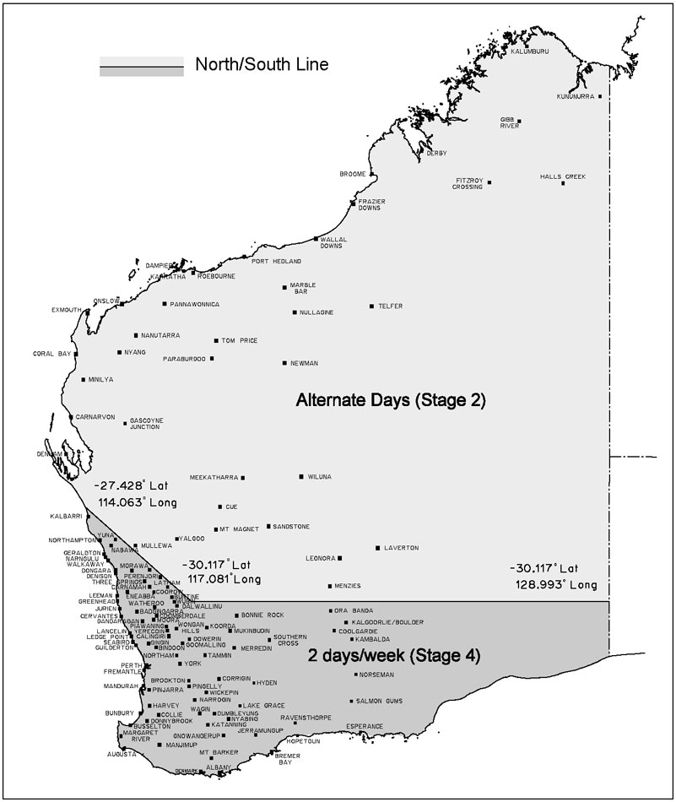

Schedule 2 — Stages of restrictions
[bl. 3]

1. Stage 1
A person must not water a lawn or garden except by —
(a) reticulation during either, but not both, the morning period or the evening period on a particular day; or
(b) a hand held hose with one outlet; or
(c) a hand held watering can.

2. Stage 2
(1) A person must not water a lawn or garden except by —
(a) reticulation during either, but not both, the morning period or the evening period —
(i) on any even numbered day of the month if the relevant property has an even street number or, where there is no street number, an even lot number; or
(ii) on any odd numbered day of the month if the relevant property has an odd street number or, where there is no street number, an odd lot number;
or
(b) a hand held hose with one outlet; or
(c) a hand held watering can.
(2) A person must not spray a building, building site, demolition site (including vacant land resulting from a demolition), path, paved area or road except —
(a) to the minimum extent necessary for fire fighting; or
(b) with —
(i) a high pressure water cleaner; or
(ii) a hand held hose with one outlet,
to the minimum extent necessary for the cleaning of the building, building site, demolition site (including vacant land resulting from a demolition), path, paved area or road so as to avoid a threat to public health or safety; or
(c) with a hand held hose with one outlet to the minimum extent necessary for purposes related to the construction, demolition or repair of the building, path, paved area or road.
(3) A person must not fill a swimming pool except to the minimum extent necessary for the proper functioning of the pool.
[By-law 2 amended in Gazette 11 Dec 2009 p. 5062.]

3. Stage 3
(1) A person must not water a lawn or garden except by —
(a) reticulation during either, but not both, the morning period or the evening period —
(i) on any Saturday, Monday or Thursday if the relevant property has an even street number or, where there is no street number, an even lot number; or
(ii) on any Sunday, Tuesday or Friday if the relevant property has an odd street number or, where there is no street number, an odd lot number;
or
(b) a hand held hose with one outlet; or
(c) a hand held watering can.
(2) A person must not spray a building, building site, demolition site (including vacant land resulting from a demolition), path, paved area or road except —
(a) to the minimum extent necessary for fire fighting; or
(b) with —
(i) a high pressure water cleaner; or
(ii) a hand held hose with one outlet,
to the minimum extent necessary for the cleaning of the building, building site, demolition site (including vacant land resulting from a demolition), path, paved area or road so as to avoid a threat to public health or safety; or
(c) with a hand held hose with one outlet to the minimum extent necessary for purposes related to the construction, demolition or repair of the building, path, paved area or road.
(3) A person must not fill a swimming pool except to the minimum extent necessary for the proper functioning of the pool.
[By-law 3 amended in Gazette 11 Dec 2009 p. 5062.]

4. Stage 4
(1) A person must not water a lawn or garden except by —
(a) reticulation during either, but not both, the morning period or the evening period on one or both of 2 days of the week specified in relation to the relevant property; or
(b) a hand held hose with one outlet; or
(c) a hand held watering can.
(2) A person must not spray a building, building site, demolition site (including vacant land resulting from a demolition), path, paved area or road except —
(a) to the minimum extent necessary for fire fighting; or
(b) with —
(i) a high pressure water cleaner; or
(ii) a hand held hose with one outlet,
to the minimum extent necessary for the cleaning of the building, building site, demolition site (including vacant land resulting from a demolition), path, paved area or road so as to avoid a threat to public health or safety; or
(c) with a hand held hose with one outlet to the minimum extent necessary for purposes related to the construction, demolition or repair of the building, path, paved area or road.
(3) A person must not fill a swimming pool except to the minimum extent necessary for the proper functioning of the pool.
[By-law 4 amended in Gazette 11 Dec 2009 p. 5062.]

5. Stage 5
(1) A person must not water a lawn or garden except by —
(a) reticulation during either, but not both, the morning period or the evening period on one day of the week specified in relation to the relevant property; or
(b) a hand held hose with one outlet; or
(c) a hand held watering can.
(2) A person must not spray a building, building site, demolition site (including vacant land resulting from a demolition), path, paved area or road except —
(a) to the minimum extent necessary for fire fighting; or
(b) with —
(i) a high pressure water cleaner; or
(ii) a hand held hose with one outlet,
to the minimum extent necessary for the cleaning of the building, building site, demolition site (including vacant land resulting from a demolition), path, paved area or road so as to avoid a threat to public health or safety; or
(c) with a hand held hose with one outlet to the minimum extent necessary for purposes related to the construction, demolition or repair of the building, path, paved area or road.
(3) A person must not fill a swimming pool except to the minimum extent necessary for the proper functioning of the pool.
[By-law 5 amended in Gazette 11 Dec 2009 p. 5062.]

6. Stage 6
(1) A person must not water a lawn or garden except by —
(a) a hand held hose with one outlet; or
(b) a hand held watering can.
(2) A person must not spray a building, building site, demolition site (including vacant land resulting from a demolition), path, paved area or road except —
(a) to the minimum extent necessary for fire fighting; or
(b) with —
(i) a high pressure water cleaner; or
(ii) a hand held hose with one outlet,
to the minimum extent necessary for the cleaning of the building, building site, demolition site (including vacant land resulting from a demolition), path, paved area or road so as to avoid a threat to public health or safety; or
(c) with a hand held hose with one outlet to the minimum extent necessary for purposes related to the construction, demolition or repair of the building, path, paved area or road.
(3) A person must not fill a swimming pool except —
(a) to replace water lost from the pool through evaporation or ordinary use; and
(b) to the minimum extent necessary for the proper functioning of the pool.
[By-law 6 amended in Gazette 11 Dec 2009 p. 5062.]

7. Stage 7
(1) A person must not water a lawn or garden except by a hand held watering can.
(2) A person must not spray a building, building site, demolition site (including vacant land resulting from a demolition), path, paved area or road except —
(a) to the minimum extent necessary for fire fighting; or
(b) with —
(i) a high pressure water cleaner; or
(ii) a hand held hose with one outlet,
to the minimum extent necessary for the cleaning of the building, building site, demolition site (including vacant land resulting from a demolition), path, paved area or road so as to avoid a threat to public health or safety; or
(c) with a hand held hose with one outlet to the minimum extent necessary for purposes related to the construction, demolition or repair of the building, path, paved area or road.
(3) A person must not fill a swimming pool.
(4) A person must not wash a motor vehicle except —
(a) to the minimum extent necessary to enable the vehicle to be driven safely; and
(b) by using a bucket of water and a cloth.
[By-law 7 amended in Gazette 11 Dec 2009 p. 5062.]

Schedule 3 — Specified days for watering by reticulation in the south of the State
[bl. 3, 6, Sch 2 cl. 4]

Last digit of property’s street number or, where there is no street number, lot number | Days for watering by reticulation
1 | Wednesday and Saturday
2 | Thursday and Sunday
3 | Friday and Monday
4 | Saturday and Tuesday
5 | Sunday and Wednesday
6 | Monday and Thursday
7 | Tuesday and Friday
8 | Wednesday and Saturday
9 | Thursday and Sunday
0 | Friday and Monday
[Schedule 3 amended in Gazette 11 Dec 2009 p. 5062.]

Notes
¹ This is a compilation of the Water Agencies (Water Use) By-laws 2007 and includes the amendments made by the other written laws referred to in the following table.

Compilation table
Citation | Gazettal | Commencement
Water Agencies (Water Use) By-laws 2007 | 28 Sep 2007 p. 4867-88 | bl. 1 and 2: 28 Sep 2007 (see bl. 2(a));  By-laws other than bl. 1 and 2: 29 Sep 2007 (see bl. 2(b))
Water Agencies (Water Use) Amendment By-laws 2009 | 11 Dec 2009 p. 5061-2 | bl. 1 and 2: 11 Dec 2009 (see bl. 2(a));  By-laws other than bl. 1 and 2: 12 Dec 2009 (see bl. 2(b))
These by-laws were repealed by the Water Agencies (Water Use) By-laws 2010 bl. 30 as at 1 Apr 2010 (see bl. 2(b) and Gazette 16 Mar 2010 p. 1020)

