Western Australia

Busselton Water Board (Supply of Water to Dunsborough) Act 2009
Compare between:
[24 Nov 2009, 00-a0-01] and [03 Sep 2012, 00-b0-02]

Western Australia
Busselton Water Board (Supply of Water to Dunsborough) Act 2009
An Act to facilitate the supply of water to the Dunsborough area by —
- enabling the Busselton Water Board to supply water to the Water Corporation; and
- extending the application of the Water Boards Act 1904 in respect of that supply,
and for related purposes.

The Parliament of Western Australia enacts as follows:

1. Short title
This is the Busselton Water Board (Supply of Water to Dunsborough) Act 2009.

2. Commencement
This Act comes into operation as follows —
(a) sections 1 and 2 — on the day on which this Act receives the Royal Assent;
(b) the rest of the Act — on the day after that day.

3. Terms used
In this Act —
Board means the Busselton Water Board constituted under the Water Boards Act 1904 for the Busselton Water Area;
Busselton Water Area means the Busselton Water Area constituted under the Water Boards Act 1904;
Corporation means the Water Corporation established by the Water Corporation Act 1995 section 4;
Dunsborough area means that part of the Dunsborough operating area (water supply services) of the Water Corporation’s licence (under the Water Services Licensing Act 1995) shown on the map in Schedule 1.

4. Busselton Water Board may supply water to the Water Corporation
(1) The Board may supply water to the Corporation, on such terms and conditions as are agreed, to facilitate the supply of water to the Dunsborough area.
(2) To the extent to which the Board is not otherwise empowered to do so, the Board may do all things necessary or convenient to be done for or in connection with giving effect to subsection (1).

5. Application of the Water Boards Act 1904
The Water Boards Act 1904 applies to and in relation to the supply of water under section 4 and, for that purpose, the supply is to be taken to be under and for the purposes of that Act.

Schedule 1 — Dunsborough part of the Dunsborough operating area
[s. 3]

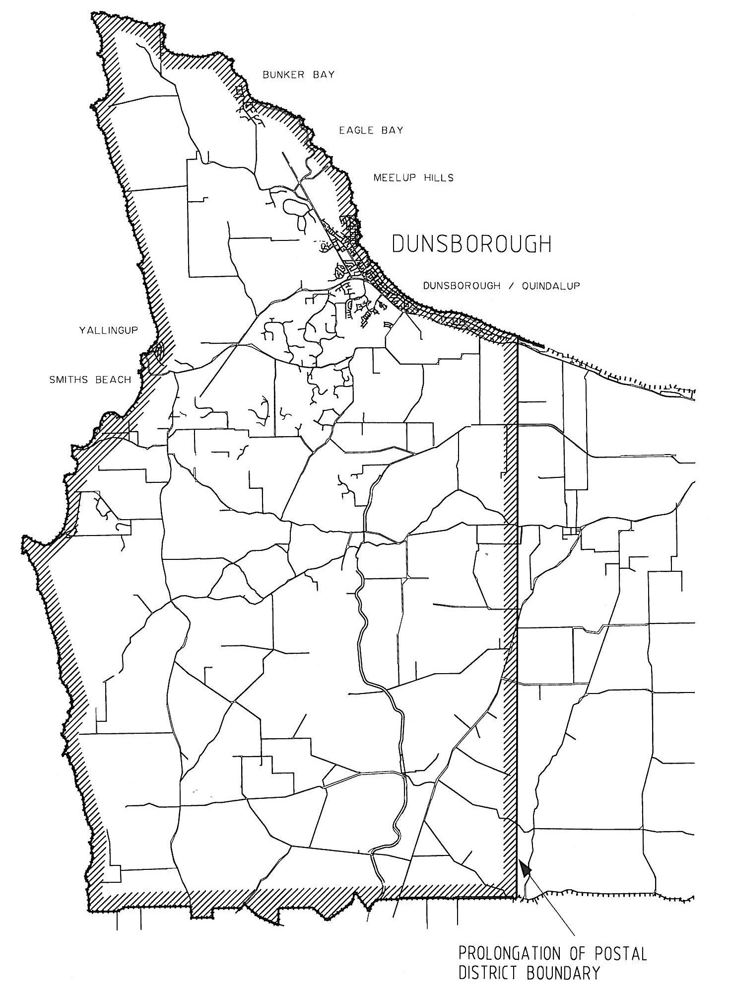
Note: The Dunsborough operating area also includes an area that includes Jarrahwood. That area is not shown on this map.

Notes
¹ This is a compilation of the Busselton Water Board (Supply of Water to Dunsborough) Act 2009. The following table contains information about that Act ^{1a}.

Compilation table
Short title | Number and year | Assent | Commencement
Busselton Water Board (Supply of Water to Dunsborough) Act 2009 | 31 of 2009 | 23 Nov 2009 | s. 1 and 2: 23 Nov 2009 (see s. 2(a));  Act other than s. 1 and 2: 24 Nov 2009 (see s. 2(b))
^{1a} On the date as at which this compilation was prepared, provisions referred to in the following table had not come into operation and were therefore not included in this compilation. For the text of the provisions see the endnotes referred to in the table.

Provisions that have not come into operation
Short title | Number and year | Assent | Commencement
Water Services Legislation Amendment and Repeal Act 2012 s. 201(b) ² | 25 of 2012 | 3 Sep 2012 | To be proclaimed (see s. 2(b))
² On the date as at which this compilation was prepared, the Water Services Legislation Amendment and Repeal Act 2012 s. 201(b) had not come into operation. It reads as follows:

201. Water boards legislation repealed
These written laws are repealed:
(b) the Busselton Water Board (Supply of Water to Dunsborough) Act 2009;

