Western Australia
Art Gallery Act 1959

Art Gallery Act (Common Seal) Regulations 1979

Western Australia
Art Gallery Act (Common Seal) Regulations 1979
Contents
1. Citation 1
2. Definitions 1
3. Form of common seal 1
4. Safe custody and affixing common seal 1
Schedule
Notes
Compilation table 4
Defined terms

Western Australia
Art Gallery Act 1959
Art Gallery Act (Common Seal) Regulations 1979

1. Citation
These regulations may be cited as the Art Gallery Act (Common Seal) Regulations 1979 ¹.

2. Definitions
In these regulations, unless the context otherwise requires —
Administrative Officer means the officer appointed by the Board as the Administrative Officer;
common seal means the common seal of the Board;
the Act means the Art Gallery Act 1959.

3. Form of common seal
Whereas the form of the common seal was, until immediately before the date of coming into operation of these regulations, the form set out in regulation 3 of the Art Gallery Act Regulations 1961 published in the Government Gazette on 20 September 1961, the form of the common seal on and after that first mentioned date is the form set out in the Schedule to these regulations.

4. Safe custody and affixing common seal
(1) The Director or, in his absence, the Administrative Officer shall keep the common seal in safe custody.
(2) The common seal shall not be affixed to a document unless —
(a) the Board has directed by a resolution at one of its regular meetings that the common seal be affixed to the document; and
(b) the common seal is affixed to the document by the Director or, in his absence, the Administrative Officer in the presence of the chairman or, in his absence, one of the other members of the Board.

Schedule
(Regulation 3)
Form of Common Seal
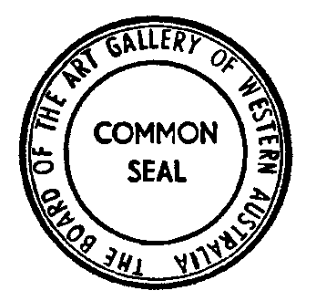

Notes
¹ This is a reprint as at 23 July 2004 of the Art Gallery Act (Common Seal) Regulations 1979. The following table contains information about those regulations and any reprint.

Compilation table
Citation | Gazettal | Commencement
Art Gallery Act (Common Seal) Regulations 1979 | 12 Apr 1979 p. 1023 | 12 Apr 1979
Reprint 1: The Art Gallery Act (Common Seal) Regulations 1979 as at 23 Jul 2004

Defined terms

[This is a list of terms defined and the provisions where they are defined. The list is not part of the law.]
Defined term Provision(s)
Administrative Officer 2
common seal 2
the Act 2

