Western Australia
Armadale Redevelopment Act 2001
Armadale Redevelopment (Subtracted Area) Regulations (No. 2) 2011

Western Australia
Armadale Redevelopment (Subtracted Area) Regulations (No. 2) 2011
CONTENTS
-Part 1 — Preliminary
1. Citation 1
2. Commencement 1
3. Terms used 1
Part 2 — Amendment of Schedule 1 and planning schemes
4. Schedule 1 amended 1
5. Minister empowered to amend planning schemes 1
Part 3 — Transitional provisions
6. Transitional modifications to the City of Armadale Town Planning Scheme No. 4 1
PART 5C — STRATEGIC REGIONAL CENTRE, DISTRICT CENTRE, LOCAL CENTRE AND MIXED BUSINESS/RESIDENTIAL ZONE REQUIREMENTS
7. Certain approvals continue to have effect 1
8. Saving of rights 1
Notes
Compilation table 1

Western Australia
Armadale Redevelopment Act 2001
Armadale Redevelopment (Subtracted Area) Regulations (No. 2) 2011

Part 1 — Preliminary

1. Citation
These regulations are the Armadale Redevelopment (Subtracted Area) Regulations (No. 2) 2011 ¹.

2. Commencement
These regulations come into operation as follows —
(a) regulations 1 and 2 — on the day on which these regulations are published in the Gazette;
(b) the rest of the regulations — on the day after that day.

3. Terms used
In these regulations —
City Scheme means the City of Armadale Town Planning Scheme No. 4;
redevelopment scheme means the Armadale Redevelopment Scheme 2004;
Schedule 1 means the Armadale Redevelopment Act 2001 Schedule 1;
subtracted area means the area that ceases to be in the redevelopment area when Schedule 1 is amended under regulation 4.

Part 2 — Amendment of Schedule 1 and planning schemes

4. Schedule 1 amended
When an order under regulation 5(1) takes effect, in Schedule 1 delete Plan No. 1 and insert:

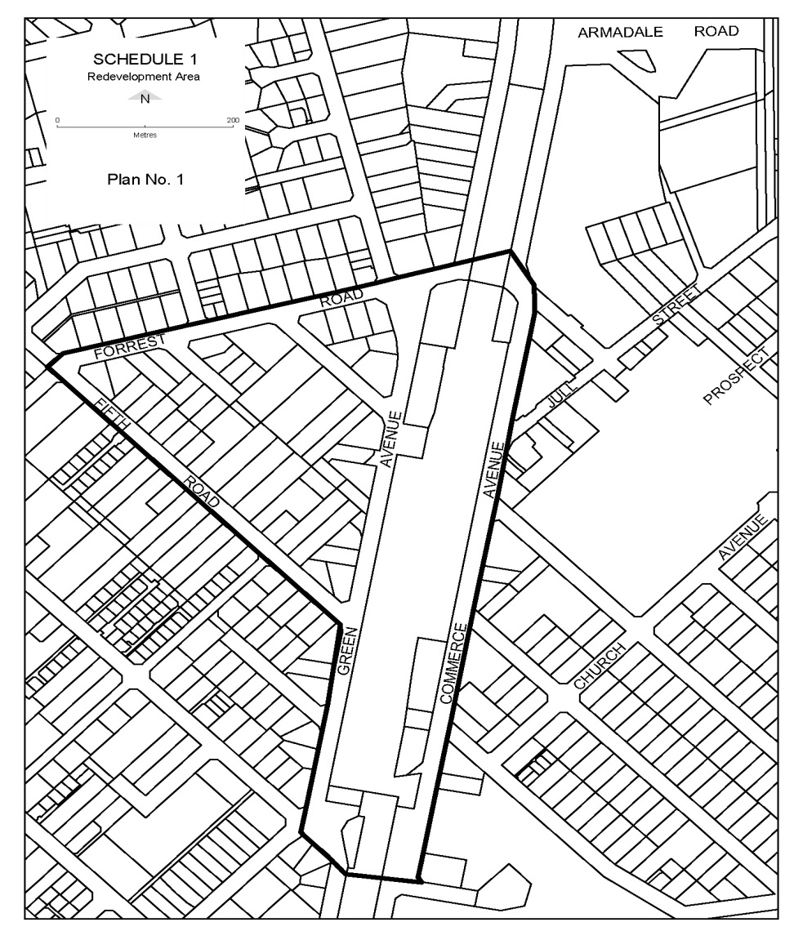

5. Minister empowered to amend planning schemes
(1) The Minister may, by order published in the Gazette, amend the Metropolitan Region Scheme or the City Scheme to provide for —
(a) land in the subtracted area to be included in the area to which that scheme applies; and
(b) the land to have a reservation or zoning under that scheme the same as, or similar to, that which applied to the land immediately before it ceased to be in the redevelopment area.
(2) The order takes effect at the beginning of the day after the day on which it is published in the Gazette.

Part 3 — Transitional provisions

6. Transitional modifications to the City of Armadale Town Planning Scheme No. 4
(1) This regulation applies in relation to land included by an order under regulation 5(1) in the area to which the City Scheme applies, but only to the extent that the City Scheme has not been amended —
(a) to insert at the end of clause 4.2 a new subclause 4.2.11 as set out in subregulation (2), or substantially to the same effect; and
(b) to delete clause 4.6 and replace it with a new clause as set out in subregulation (3), or substantially to the same effect; and
(c) to delete the heading to Part 5C and replace it with a new heading as set out in subregulation (4), or substantially to the same effect; and
(d) to insert at the end of the Table in Schedule 3 new Table items 7 and 8 as set out in subregulation (5), or substantially to the same effect.
(2) The City Scheme is to be read as if the following subclause were inserted at the end of clause 4.2:

4.2.11 Strategic Regional Centre
(a) To provide for an extended range of shopping, commercial, administrative, business and employment opportunities in the retail core of the Armadale Strategic Regional Centre and a range of predominantly non-retail supportive mixed uses in the Civic and Cultural and South West Highway precincts peripheral to the retail core.
(b) To encourage mixed use development that incorporates residential development to R-AC3 of the Residential Design Codes in the core retail area, where the residential development will not constrain the effective operation of retail activities and R80 in the peripheral Civic and Cultural and South West Highway precincts.
(c) To ensure the urban design of new developments in the Armadale Strategic Regional Centre provides for a high amenity mixed use shopping environment and contributes to Armadale’s distinctive sense of place and community.

(3) The City Scheme is to be read as if clause 4.6 were deleted and the following clause inserted instead:

4.6 Restricted uses
The land specified in Schedule 3 and on the Scheme Map indicates where the permissibility of uses listed in the general Zoning Table is modified by Schedule 3 such that approval of Schedule 3 listed uses will only be in accordance with the permissibility listed for Restricted Uses and specified Conditions under Schedule 3.

(4) The City Scheme is to be read as if the heading to Part 5C were deleted and the following heading inserted instead:

PART 5C — STRATEGIC REGIONAL CENTRE, DISTRICT CENTRE, LOCAL CENTRE AND MIXED BUSINESS/RESIDENTIAL ZONE REQUIREMENTS

(5) The City Scheme is to be read as if the following items were inserted at the end of the Table in Schedule 3:

No. | Description of Land | Restricted Use | Conditions
7. | City Centre Civic and Cultural Area  This precinct as described on the Scheme Maps includes the existing City of Armadale administration buildings, the district Court House and the public spaces of Minnawarra Park, together with other civic, cultural and mixed uses. | Civic, community and cultural uses are the primary activities to be retained and fostered with tourism-oriented and cultural facilities. Limited retail/commercial development would be permitted where it contributes to the continuity of activity between the main retail precinct to the west and developments at the eastern end of Jull Street. Residential development opportunities in the eastern areas of this precinct, either as stand-alone developments or in mixed-use projects, would also be encouraged.  The intent of Restricting permissible land uses is to maintain the central retail Town Centre functions located within the central core area of the Strategic Regional Centre zone, preventing their diffusion into the adjacent linear Restricted area while also varying the (X) not permitted use classes listed in the core retail zone and thereby providing additional discretionary use opportunities within the Restricted area, notwithstanding that similar or same uses are not suitable and shall not be permitted (X) within the central retail core of the Strategic Regional Centre zone.  - The following uses potentially permissible (P) (D) or (A) in the retail commercial core of the Strategic Regional Centre zone shall be uses that are Not Permitted (X) in the Restricted Use Area:  - Amusement Parlour (X)  - Betting Agency (X)  - Restricted Premises (X)  - Tavern (X)  - The following uses potentially permissible (P) or (D) in the retail commercial core of the Strategic Regional Centre zone shall be uses that are not permitted in the Restricted Use Area unless listed as (P) in the Restricted Use Area or the City has exercised its discretion either by granting planning approval without special notice (D) or after giving special notice (A) in accordance with clause 9.4:  - Civic Use (P)  - Consulting Rooms (P)  - Exhibition Centre (P)  - Cinema/Theatre (A)  - Convenience Store (Note 2) (A)  - Fast Food Outlet (A)  - Garden Centre — Retail (A)  - Hotel (A)  - Service Station (A)  - Shop (A)  - Showroom (A)  - Lunch Bar (D)  - Market (D)  - Restaurant (D)  - The following uses that are Not Permitted (X) in the central retail core of the Strategic Regional Centre zone shall be uses that are potentially permissible in the Restricted Use Area:  - Place of Worship (P)  - Family Day Care (D)  - Residential Building (D)  - Motel (D)  - Hospital (A)  - Industry — Service (A)  - Veterinary Centre (A) | 7.1 In determining any planning application for development approval the City shall have regard to the compatibility of proposed uses with the existing and potential uses of the site.  7.2 Where proposed development interfaces with existing or proposed residential development, special design consideration shall be required for the screening, separation or noise attenuation of adjacent premises.  7.3 The City may impose conditions and require proposed developments to specifically address the following issues:  - a high quality unified architectural design and overall development of the site that reflects a level of integration and consistency with the surrounding built environment;  - the amalgamation of lots or provision of reciprocal rights of access where appropriate;  - the screening and/or landscaping of car parking areas from adjacent residential uses;  - interface with adjacent Parks and Recreation reservations;  - the retention of existing on-site trees or significant vegetation.
8. | City Centre South West Highway Area  This precinct as described on the Scheme Maps includes existing residential housing with some mixed use and former school sites. | The area is characterised by existing housing with discretion for progressive residential intensification through the redevelopment of existing properties to medium density housing to increase the resident population within walking distance of the city centre’s shopping and other facilities. There is also scope for increasing small business activities, through home-based business arrangements or in new small-scale commercial and mixed use developments, especially on the Church Avenue frontages. The prominent site of the St Francis Xavier Primary School adjacent to South West Highway is a significant redevelopment opportunity.  The intent of Restricting permissible land uses is to maintain the central retail Town Centre functions located within the unrestricted central core area of the Strategic Regional Centre zone, preventing their diffusion into an adjacent linear Restricted area, while also varying the (X) not permitted use classes listed in the core retail zone and thereby providing additional discretionary use opportunities within the Restricted area, notwithstanding that similar or same uses are not suitable and shall not be permitted (X) within the central retail core of the Strategic Regional Centre zone.  - The following uses potentially permissible (P) (D) or (A) in the retail commercial core of the Strategic Regional Centre zone shall be uses that are Not Permitted (X) in the Restricted Use Area:  - Amusement Parlour (X)  - Betting Agency (X)  - Cinema/Theatre (X)  - Night Club (X)  - Restricted Premises (X)  - Shop (X)  - Showroom (X)  - Tavern (X)  - The following uses potentially permissible (P) or (D) in the retail commercial core of the Strategic Regional Centre zone shall be uses that are not permitted unless listed as (P) in the Restricted Use Area or the City has exercised its discretion either by granting planning approval in the Restricted Use Area without special notice (D) or after giving special notice (A) in accordance with clause 9.4:  - Club Premises (A)  - Fast Food Outlet (A)  - Garden Centre — Retail (A)  - Hotel (A)  - Market (A)  - Occasional Uses (A)  - Community Purpose (D)  - Convenience Store (Note 2) (D)  - Lunch Bar (D)  - Multiple Dwelling (Note 3) (D)  - Grouped Dwelling (D)  - Restaurant (D)  - Consulting Rooms (P)  - Single House (P)  - The following uses that are Not Permitted (X) in the central retail core of the Strategic Regional Centre zone shall be uses that are potentially permissible in the Restricted Use Area:  - Family Day Care (P)  - Funeral Parlour (A)  - Hospital (A)  - Industry — Service (A)  - Veterinary Centre (A)  - Motel (D)  - Place of Worship (D)  - Residential Building (D) | 8.1 In determining any planning application for development approval the City shall have regard to the compatibility of proposed uses with the existing and potential uses of the site.  8.2 Where proposed development interfaces with existing or proposed residential development, special design consideration shall be required for the screening, separation or noise attenuation of adjacent premises.  8.3 The City may impose conditions and require proposed developments to specifically address the following issues:  - a high quality unified architectural design and overall development of the site that reflects a level of integration and consistency with the surrounding built environment;  - the amalgamation of lots or provision of reciprocal rights of access where appropriate;  - the screening and/or landscaping of car parking areas from adjacent residential uses;  - interface with adjacent Parks and Recreation reservations;  - the retention of existing on-site trees or significant vegetation.

7. Certain approvals continue to have effect
(1) In this regulation —
approval includes the approval of development, a structure plan or a detailed area plan.
(2) When an order under regulation 5(1) takes effect —
(a) any approval previously granted under a redevelopment scheme in relation to land in the subtracted area continues to have effect as if the approval had been granted under the City Scheme; and
(b) without limiting paragraph (a), any condition to which the approval was subject under the redevelopment scheme may be enforced by the City of Armadale as if the approval were subject to that condition under the City Scheme.

8. Saving of rights
(1) In this regulation —
subtraction time means the time when an order under regulation 5(1) takes effect.
(2) This regulation has effect subject to any provision of a redevelopment scheme relating to non-conforming uses.
(3) The subtraction of the subtracted area from the redevelopment area by the operation of regulation 4 and the inclusion of the land in the subtracted area in the Metropolitan Region Scheme or the City Scheme by an order under regulation 5(1) do not affect —
(a) any right to use land in the subtracted area for the purpose for which the land was being lawfully used immediately before the subtraction time; or
(b) any right to undertake any development on land in the subtracted area that was being lawfully undertaken on the land immediately before the subtraction time.

Notes
¹ This is a compilation of the Armadale Redevelopment (Subtracted Area) Regulations (No. 2) 2011. The following table contains information about those regulations.

Compilation table
Citation | Gazettal | Commencement
Armadale Redevelopment (Subtracted Area) Regulations (No. 2) 2011 | 16 Dec 2011 p. 5350-8 | r. 1 and 2: 16 Dec 2011 (see r. 2(a));  Regulations other than r. 1 and 2: 17 Dec 2011 (see r. 2(b))

