Western Australia
Health Act 1911
Health (Treatment of Sewage and Disposal of Effluent and Liquid Waste) Regulations 1974

Western Australia
Health (Treatment of Sewage and Disposal of Effluent and Liquid Waste) Regulations 1974
CONTENTS
-Part 1 — Preliminary
1. Citation and application 1
3. Interpretation 1
Part 2 — General
Division 1 — Construction and installation of an apparatus
4. Approval of the construction or installation of an apparatus by local government 5
4A. Approval of the construction or installation of an apparatus by the Executive Director, Public Health 6
5. Documents to accompany an application for approval 8
6. Construction or installation under an approval to be completed within a certain time 10
6A. Adoption of codes 11
7. Construction and installation of an apparatus generally 11
7A. Compliance with adopted Codes 12
8. Educt and back vents 12
8A. Location of a septic tank 12
Division 2 — Use of an apparatus
9. Notice of completion 13
10. Permit to use an apparatus 13
11. Preparation of an apparatus for inspection 16
12. Testing an apparatus 16
13. Equipment, material, power and labour for an inspection 16
15. Wastes from business or industry 17
16. Matter interfering with the efficient operation of an apparatus 17
16A. Use to comply with adopted Codes 17
17. Certain matter not to be discharged into an apparatus 17
18. Interfering with an apparatus 18
18A. Structures not to be erected above an apparatus 19
19. Use of a damaged or defective apparatus prohibited 19
Division 3 — Decommissioning of an apparatus
20. Application 20
20A. Apparatus to be decommissioned in certain circumstances 20
21. Decommissioning an apparatus 21
Division 4 — Review
22. Review of a decision of a local government 22
23. Review of a decision of the Executive Director, Public Health 22
Part 3 — Construction and sizes of septic tanks and sedimentation tanks
24. Minimum water level of a septic tank 24
25. Partition of a septic tank 24
26. Septic tank to be impervious 24
27. Construction of a septic tank generally 24
28. Liquid capacity of septic tanks on residential premises 25
29. Size of a septic tank 25
30. Minimum air space in a septic tank 26
31. Dimensions of a septic tank 26
32. Construction of a precast concrete septic tank 26
33. Testing a precast concrete septic tank 30
34. Construction of an in situ concrete septic tank 31
35. Construction of a brick septic tank 32
36. Manufacturer of a fibreglass septic tank 33
Part 4 — Restricted flush fixtures
38. Minimum flush fixtures and fittings generally 38
39. Minimum flush fixtures and fittings on any land 39
40. Certificate of approval of fixtures and fittings 41
41. Testing a closet pan or flushing cistern 41
42. Restriction on variations 42
Part 4A — Maintenance of aerobic treatment units
42A. Owner to ensure arrangements in place for maintenance of unit 43
42B. Units to be maintained in accordance with standard 43
42C. Maintenance of units to be carried out by authorised persons 43
42D. Authorised person to notify new owner of maintenance requirements for unit 45
Part 5 — Dry type septic tank
43. Dry type septic tank 46
44. Area prescribed under section 110 47
45. Chemical closet pan 47
Part 6 — Emptying apparatus
46. Emptying a tank or other waste storage component of an apparatus 48
Part 7 — Disposal of effluent and liquid wastes
47. Receptacles for drainage 49
48. Receptacles for drainage — blackwater disposal 49
49. Requirements for receptacles for drainage 49
50. Drainage of effluent and liquid wastes 52
Part 8 — Manufacturing
51. Marks and brands 58
52. Wet or steam curing 58
53. Refusal to sell 59
Part 9 — Offences and penalties
54. Offence 60
Schedule 1 — Fees
Schedule 3
Concrete covers for in situ septic tanks
Schedule 4
Structural details of brick septic tank (sand conditions only)
Schedule 5
Schedule 6
Dry type septic tank
Schedule 7
Schedule 8
Method of determining absorptive capacity of a soil
1. 80
2. 80
3. 80
4. 80
5. 81
Schedule 9 — Wastewater volume for residential premises
Notes
Compilation table 84

Western Australia
Health Act 1911
Health (Treatment of Sewage and Disposal of Effluent and Liquid Waste) Regulations 1974

Part 1 — Preliminary
[Heading inserted in Gazette 29 Jul 1997 p. 4065.]

1. Citation and application
(1) These regulations may be cited as the Health (Treatment of Sewage and Disposal of Effluent and Liquid Waste) Regulations 1974 ¹.
(2) These regulations have effect in every district within the State.
[Regulation 1 amended in Gazette 4 Sep 1992 p. 4471; 29 Jul 1997 p. 4065.]

[2. Deleted in Gazette 4 Sep 1992 p. 4471.]

3. Interpretation
In these regulations, unless the contrary intention appears —
adopted Code means a code adopted by regulation 6A(1);
aerobic treatment unit means an apparatus for treating sewage either wholly or partially by aerobic means and includes any associated effluent disposal system;
alternating system means any apparatus containing a flow alternation device that is connected to 2 receptacles for drainage to allow infiltration of effluent into the soil;
apparatus has the same meaning as is given by section 3 of the Act to the term “apparatus for the treatment of sewage”;
approval means an approval under regulation 4 or 4A;
approved means —
(a) in the case of an apparatus to which regulation 4 applies, approved by the relevant local government; and
(b) in the case of an apparatus to which regulation 4A applies, approved by the Executive Director, Public Health;
approving body means —
(a) in the case of an application for an approval under regulation 4, the relevant local government; or
(b) in the case of an application for an approval under regulation 4A, the Executive Director, Public Health;
AS means Standards Australia standard;
authorised person, in relation to an aerobic treatment unit, means a person who is authorised under regulation 42C to carry out maintenance on that type of unit;
blackwater means water containing faeces or urine;
blackwater system means an apparatus designed to receive blackwater;
certificate of compliance has the meaning given to that term in the Water Services Licensing (Plumbers Licensing and Plumbing Standards) Regulations 2000;
combined system means an apparatus designed to receive household and such other liquid wastes as the Executive Director, Public Health may approve, as well as sewage;
drainage plumbing work has the meaning given to that term in the Water Services Licensing (Plumbers Licensing and Plumbing Standards) Regulations 2000;
dwelling means a building or part of a building that is occupied or intended to be occupied for the purpose of human habitation;
effluent means the liquid discharge from the treatment tank;
fittings means all pipes, meters, or other apparatus used for or in connection with the supply of water, and all pipes, cisterns, traps, syphons, manholes, ventilators and all other apparatus connected with and requisite to secure the safe and proper working of any sewer, drain or water supply fixtures;
fixtures means all necessary appurtenances, that may be attached to the plumbing or drainage system of premises and are intended for the collection or retention of any wastes or waste waters for ultimate discharge into a drain or sewer;
greywater means water containing kitchen, laundry or bathroom waste other than faeces or urine;
greywater system means an apparatus for treating greywater and enabling it to be used for garden irrigation;
infiltrative area means the internal surface of the bottom area and sidewall areas between the inverted level of the inlet and the base of a receptacle for drainage;
liquid waste system means an apparatus designed to receive liquid wastes only;
liquid wastes means wastewater or any other liquid waste from domestic, industrial or commercial activities, other than effluent;
non-alternating system means an apparatus that does not contain a flow alternation device;
owner, in relation to an apparatus, means the owner of the premises on which the apparatus is constructed or installed;
plumbing standards has the meaning given to that term in regulation 3(1) of the Water Services Licensing (Plumbers Licensing and Plumbing Standards) Regulations 2000;
receptacle for drainage means —
(a) an evaporation drain, a soak well, French drain, leach drain or impervious sump; or
(b) any other device or system for the disposal or re-use of effluent approved by the Executive Director, Public Health;
relevant local government means —
(a) in relation to an application for an approval, the local government of the district where it is proposed the apparatus will be constructed or installed; or
(b) in relation to an existing apparatus, the local government of the district where the apparatus is situated;
residential premises means premises used solely for residential purposes and in the case of flats or units means a block of flats or block of units, but does not include any premises of a type listed in regulation 29(1);
sedimentation tank means that part of an apparatus designed to retain liquid waste for sedimentation, flotation and treatment;
septic tank means the part of an apparatus for the treatment of sewage designed to retain sewage for bacteriolytic treatment;
single dwelling means a dwelling —
(a) that is occupied or intended to be occupied for the purpose of human habitation by not more than 8 persons;
(b) standing on a lot within the meaning of the Town Planning and Development Act 1928; and
(c) that is the only dwelling standing on that lot;
wastewater means greywater and blackwater.
[Regulation 3 amended in Gazette 29 Jun 1984 p. 1781; 15 Dec 1989 p. 4547-8; 4 Sep 1992 p. 4471-2; 29 Jul 1997 p. 4065-6; 28 Jun 2004 p. 2393-4; 7 Jan 2005 p. 64-5.]

Part 2 — General
[Heading inserted in Gazette 29 Jul 1997 p. 4067.]

Division 1 — Construction and installation of an apparatus
[Heading inserted in Gazette 29 Jul 1997 p. 4067.]

4. Approval of the construction or installation of an apparatus by local government
(1) For the purposes of section 107(2)(a) of the Act, an apparatus is to be approved by a local government if it is intended to serve —
(a) a single dwelling; or
(b) any other building that produces not more than 540 litres of sewage per day.
(2) A person may apply for an approval under this regulation by —
(a) completing an application in a form approved by the Executive Director, Public Health; and
(b) forwarding the application to the relevant local government together with —
(i) any documents required under regulation 5; and
(ii) the fee specified in item 1 of Schedule 1.
(3) Upon an application under subregulation (2), a local government shall, as soon as practicable after receiving the application —
(a) subject to these regulations, grant the approval —
(i) in a form approved by the local government; and
(ii) subject to such conditions as the local government thinks fit;
or
(b) refuse to grant the approval.
(3a) Any conditions imposed on the grant of an approval that relate to drainage plumbing work must not be inconsistent with the plumbing standards.
(4) A local government may grant an approval under this regulation only if, under the application, the apparatus is to be constructed or installed in accordance with these regulations.
(5) Where a local government refuses to grant an approval under this regulation, it shall, as soon as practicable, provide to the person applying for the approval a written notice —
(a) advising the person of the refusal; and
(b) setting out the reasons for the refusal.
[Regulation 4 inserted in Gazette 29 Jul 1997 p. 4067-8; amended in Gazette 28 Jun 2004 p. 2394; 7 Jan 2005 p. 65.]

4A. Approval of the construction or installation of an apparatus by the Executive Director, Public Health
(1) In this regulation —
local government report, in relation to an application for an approval under this regulation, means a report of the relevant local government setting out recommendations as to —
(a) whether or not the approval should be granted; and
(b) if an approval is recommended, the conditions, if any, to which the approval should be subject.
(2) For the purposes of section 107(2)(b) of the Act, an apparatus is to be approved by the Executive Director, Public Health if it is intended to serve a building that —
(a) is not a single dwelling; and
(b) produces more than 540 litres of sewage per day.
(3) A person may apply for an approval under this regulation by —
(a) completing an application in a form approved by the Executive Director, Public Health; and
(b) forwarding the application to the Executive Director, Public Health together with —
(i) any documents required under regulation 5;
(ii) the relevant fee specified in item 2 of Schedule 1; and
(iii) except where subregulation (4) applies, a local government report in relation to the application.
(4) Where —
(a) a person makes a request to the relevant local government for it to provide a local government report in relation to an application for an approval under this regulation; and
(b) the local government does not provide the report to the person within 28 days of the request,
the person may make an application under subregulation (3) without forwarding to the Executive Director, Public Health a local government report.
(5) Upon an application under subregulation (3), the Executive Director, Public Health shall, as soon as practicable after receiving the application and after considering any local government report —
(a) subject to these regulations, grant the approval —
(i) in a form approved by the Executive Director, Public Health; and
(ii) subject to such conditions as the Executive Director, Public Health thinks fit;
or
(b) refuse to grant the approval.
(5a) Any conditions imposed on the grant of an approval that relate to drainage plumbing work must not be inconsistent with the plumbing standards.
(6) The Executive Director, Public Health may grant an approval under this regulation only if, under the application, the apparatus is to be constructed and installed in accordance with these regulations.
(7) Where the Executive Director, Public Health refuses to grant an approval under this regulation, the Executive Director, Public Health shall, as soon as practicable, provide to the person applying for the approval a written notice —
(a) advising the person of the refusal; and
(b) setting out the reasons for the refusal.
[Regulation 4A inserted in Gazette 29 Jul 1997 p. 4068-9; amended in Gazette 28 Jun 2004 p. 2394.]

5. Documents to accompany an application for approval
(1) An application under regulation 4 or 4A shall be accompanied by —
(a) a copy of plan and specifications of the proposed apparatus, that comply with all relevant provisions of these regulations, showing plan and longitudinal section to a scale of not less than 1:50;
(b) 2 copies of a site plan of the premises accurately drawn to a scale not less than 1:100, showing —
(i) the position of all buildings erected or proposed and the position of the proposed apparatus;
(ii) the position, type and proposed use of all fixtures intended to discharge into the apparatus;
(iii) the position of all drains, pipes, inspection openings, vents, traps and junctions in relation to buildings and boundaries;
(iv) the size of pipes and fittings and the fall of the drains;
(v) details of the effluent disposal system; and
(vi) the source of water supply to be used in connection with the apparatus,
and except where the plans refer to a building of Class 1a under the Building Code the plans shall be separate from the application form;
(c) if so requested by the approving body —
(i) a detailed architectural drawing of the proposed apparatus;
(ii) a certificate from an independent technical expert that the apparatus —
(I) complies with these regulations or any relevant code or standard;
(II) is capable of performing its proposed functions; and
(III) is reliable and durable;
and
(iii) any other information or documents relevant to the application;
and
(d) in the case where the proposed apparatus is an aerobic treatment unit, details of arrangements that have been made for the future maintenance of the unit by an authorised person, including a copy of any agreement entered into for that purpose.
(2) Where an application for an approval is made, the approving body shall, for the duration of the life of the apparatus, retain a copy of —
(a) the application;
(b) every document forwarded with the application; and
(c) the approval.
(3) An approving body shall make any documents retained under subregulation (2) available for inspection by members of the public.
(4) A person shall not provide false or misleading information in an application for an approval.
(5) In subregulation (1)(b) —
Building Code means the Building Code of Australia 1996, as from time to time amended and for the time being in force, issued by the Australian Building Codes Board.
[Regulation 5 amended in Gazette 29 Jun 1984 p. 1781; 15 Dec 1989 p. 4548; 4 Sep 1992 p. 4472; 29 Jul 1997 p. 4069-70.]

6. Construction or installation under an approval to be completed within a certain time
(1) An approval shall be subject to a condition that the construction or installation to which the approval relates is completed prior to the expiration of —
(a) a period of 2 years; or
(b) any lesser period specified in the approval.
(2) Where —
(a) an approval is granted for the construction or installation of an apparatus;
(b) the construction or installation is commenced but is not completed within the period referred to in subregulation (1); and
(c) a fresh approval to continue the construction or installation has not been granted,
the owner of the premises on which the apparatus was being constructed or installed shall, as soon as practicable after the expiration of that period, ensure that the apparatus is decommissioned in accordance with regulation 21.
[Regulation 6 inserted in Gazette 29 Jul 1997 p. 4070-1.]

6A. Adoption of codes
(1) Under section 344A(1) of the Act, the following codes are adopted —
(a) “Code of Practice for the Design, Manufacture, Installation and Operation of Aerobic Treatment Units (ATUs) Serving Single Dwellings”, published by the Executive Director, Public Health in August 2001, as amended from time to time;
(b) “Code of Practice for the Reuse of Greywater in Western Australia” published by the Executive Director, Public Health in January 2005, as amended from time to time.
(2) For the purposes of section 344A(3) of the Act, the prescribed place is the office of the Environmental Health Directorate of the Department of Health, Grace Vaughan House, 227 Stubbs Terrace, Shenton Park, Western Australia.
[Regulation 6A inserted in Gazette 7 Jan 2005 p. 65-6.]

7. Construction and installation of an apparatus generally
(1) All materials, fixtures and fittings to be used in the construction and installation of an apparatus shall be first approved by the Executive Director, Public Health but for the purposes of this regulation, a material, fixture or fitting which has been branded in accordance with the by-laws made under the Metropolitan Water Supply, Sewerage, and Drainage Act 1909, or the Country Towns Sewerage Act 1948, shall be deemed to have been so approved by the Executive Director, Public Health if the material, fixture or fitting bears a mark indicating that it has been inspected by a person authorised under one of those Acts or these regulations, and passed as fit for use.
(2) All materials, pipes, bends, junctions, traps, vents and apparatus shall be sound and free from defects and the Metropolitan Water Supply, Sewerage and Drainage By-laws 1981, and the Country Towns Sewerage By-laws 1952 apply to them in addition to these regulations.
(3) An apparatus of a kind to which an adopted Code applies must be of a design and manufacture that complies with that Code.
(4) An apparatus shall be constructed and installed to a trade finish.
[Regulation 7 amended in Gazette 29 Jun 1984 p. 1781; 4 Sep 1992 p. 4472; 29 Jul 1997 p. 4071; 6 Nov 2001 p. 5839; 7 Jan 2005 p. 66.]

7A. Compliance with adopted Codes
A person who constructs or installs an apparatus of a kind to which an adopted Code applies, must ensure that its construction or installation complies with that Code.
[Regulation 7A inserted in Gazette 7 Jan 2005 p. 66.]

8. Educt and back vents
(1) All educt vents in connection with septic tanks, aerobic treatment units, and receptacles for drainage, whether on combined systems, blackwater systems or liquid waste systems shall be fitted, by the owner, with an approved mosquito-proof cowl and be so maintained by the owner.
(2) Where a back vent is required it shall also be fitted, by the owner, with an approved mosquito-proof cowl and be so maintained by the owner.
[Regulation 8 amended in Gazette 15 Dec 1989 p. 4548; 4 Sep 1992 p. 4473; 29 Jul 1997 p. 4071; 7 Jan 2005 p. 66.]

8A. Location of a septic tank
(1) A person shall not cause or permit the construction of a septic tank closer than 1.2 m to the foundations of any building, or the boundary of any lot, unless otherwise approved.
(2) A person shall not cause or permit the construction of foundations of any building closer than 1.2 m to any existing septic tank, unless otherwise approved.
[Regulation 8A inserted in Gazette 29 Jul 1997 p. 4071.]

Division 2 — Use of an apparatus
[Division heading inserted in Gazette 29 Jul 1997 p. 4072.]
[Heading deleted in Gazette 5 Sep 1997 p. 5037.]

9. Notice of completion
A person who constructs or installs an apparatus must forthwith after the construction or installation is completed, give to the local government a notice —
(a) stating that construction or installation of the apparatus has been completed; and
(b) if the apparatus is of a kind to which an adopted Code applies, certifying that the construction or installation of the apparatus complies with that Code.
[Regulation 9 inserted in Gazette 7 Jan 2005 p. 66-7.]

[9A. Deleted in Gazette 7 Jan 2005 p. 67.]

10. Permit to use an apparatus
(1) Where a local government receives a notification under regulation 9, the local government shall, as soon as practicable after receiving that notification, arrange for the apparatus to be inspected by an environmental health officer to ensure that the apparatus conforms with —
(a) these regulations; and
(b) the approval granted in respect of the apparatus.
(2) Where —
(a) an environmental health officer inspects an apparatus under this regulation and is satisfied that it conforms to these regulations and the approval; and
(b) the owner pays the fee set out in Schedule 1 item 3,
the local government shall grant to the owner, in a form approved by the Executive Director, Public Health, a permit to use the apparatus.
(2a) If the local government has received a certificate of compliance that covers the drainage plumbing work connected to the apparatus, the environmental health officer is to be satisfied as set out in subregulation (2)(a) in relation to the drainage plumbing work, unless the officer has reason to believe that, despite the certificate, the drainage plumbing work does not comply with the plumbing standards.
(3) Where an environmental health officer inspects an apparatus under this regulation and is not satisfied that the apparatus conforms with these regulations or the approval, the environmental health officer shall —
(a) advise the owner as to what corrective works are necessary to ensure that the apparatus does so conform; and
(b) arrange for a further inspection of the apparatus by an environmental health officer within a period that allows the owner to undertake practicably the corrective works.
(4) Where an environmental health officer inspects an apparatus under subregulation (3)(b) and is not satisfied that the necessary corrective works have been undertaken —
(a) the environmental health officer shall notify the local government of the failure to undertake the corrective works; and
(b) the local government may, upon receiving the notification under paragraph (a), forward to the owner a written notice requiring the owner to undertake those works or decommission the apparatus in accordance with regulation 21.
(5) Where a local government requires an owner to undertake corrective works or decommission the apparatus under subregulation (4), the owner shall do so within the prescribed time.
(6) In subregulation (5) —
prescribed time means —
(a) in the case where the owner has not, within 14 days of receiving notice of the requirement —
(i) made an application under regulation 22 for a review of the requirement; or
(ii) made an application for a review of the decision under section 36 of the Act,
as soon as practicable after the owner receives notice of the requirement;
(b) in the case where the owner has, within 14 days of the requirement, made an application under regulation 22 for a review of the requirement, as soon as practicable after the local government has —
(i) determined that application; and
(ii) provided to the owner written notification of that determination;
or
(c) in the case where the owner has made an application for a review of the decision under section 36 of the Act, as soon as practicable after the State Administrative Tribunal has made a final decision in relation to the application.
[Regulation 10 inserted in Gazette 29 Jul 1997 p. 4072-3; amended in Gazette 25 Jun 2004 p. 2241; 28 Jun 2004 p. 2395; 30 Dec 2004 p. 6937-8.]

11. Preparation of an apparatus for inspection
A person who gives notice to the local government in accordance with regulation 9 shall prepare the apparatus for an inspection under regulation 10 at the time set by the local government or an environmental health officer, and in particular shall —
(a) fill the treatment tank to overflow level with clean water 24 hours prior to inspection; and
(b) ensure that all lines of drain, fixtures and fittings are exposed to view, and all inspection openings are unsealed.
[Regulation 11 amended in Gazette 29 Jul 1997 p. 4073 and 4082.]

[Heading deleted in Gazette 29 Jul 1997 p. 4082.]

12. Testing an apparatus
Where an environmental health officer inspects an apparatus under subregulation 10, the environmental health officer may submit the apparatus to —
(a) a hydrostatic test; and
(b) such other tests as the environmental health officer or the local government thinks fit.
[Regulation 12 inserted in Gazette 29 Jul 1997 p. 4074.]

13. Equipment, material, power and labour for an inspection
The equipment, material, power and labour required by an environmental health officer for an inspection under regulation 10 and any tests under regulation 12 shall be furnished by the owner.
[Regulation 13 amended in Gazette 29 Jul 1997 p. 4074.]

[14. Deleted in Gazette 25 Jun 2004 p. 2241.]
[Heading deleted in Gazette 29 Jul 1997 p. 4082.]

15. Wastes from business or industry
A person shall not cause or permit any wastes from any business or industry to discharge into an apparatus except with the written permission of the relevant local government.
[Regulation 15 amended in Gazette 29 Jun 1984 p. 1781; 29 Jul 1997 p. 4075 and 4082; 5 Sep 1997 p. 5037.]

16. Matter interfering with the efficient operation of an apparatus
A person shall not cause or permit the discharge into an apparatus of any matter which may interfere with the efficient operation of the apparatus.
[Regulation 16 amended in Gazette 29 Jun 1984 p. 1781; 29 Jul 1997 p. 4075.]

16A. Use to comply with adopted Codes
The owner and the occupier of a premises on which there is installed an apparatus to which an adopted Code applies, must ensure that it is operated in compliance with that Code.
[Regulation 16A inserted in Gazette 7 Jan 2005 p. 67.]

17. Certain matter not to be discharged into an apparatus
Without limiting regulation 16, a person shall not cause or permit the discharge into any apparatus or receptacle for drainage used for the reception of effluent or liquid wastes —
(a) any surface or subsoil drainage, rain water from any pavement or roof, or overflow water from rainwater tanks or flushing systems, or other relatively clean water;
(b) any inflammable or explosive materials that are not readily soluble in water, or any materials which when mixed with sewage or water are liable to form explosive compounds or to interfere with the treatment process.
(c) any insoluble matter or articles, dead animals, or rubbish whatsoever; or
(d) any liquids or solids that are bactericidal in effect in such quantity as to affect the proper functioning of the septic tank.
[Regulation 17 amended in Gazette 29 Jul 1997 p. 4075.]

[Heading deleted in Gazette 29 Jul 1997 p. 4082.]

18. Interfering with an apparatus
(1) In this regulation —
interfere, in relation to an apparatus, means —
(a) to dismantle the apparatus;
(b) to remove the apparatus wholly or in any part; or
(c) to alter or change the mode of operating the apparatus.
(2) Except as provided in subregulation (3) and regulation 20, a person shall not interfere with an apparatus without first obtaining the written permission of —
(a) in the case of an apparatus to which regulation 4 applies, the local government; or
(b) in the case of an apparatus to which regulation 4A applies, the Executive Director, Public Health.
(3) Subregulation (2) does not apply to, or in relation to —
(a) an authorised person carrying out maintenance work on an aerobic treatment unit in accordance with these regulations; or
(b) a person emptying an apparatus in accordance with —
(i) the Environmental Protection (Liquid Waste) Regulations 1996 ²; or
(ii) regulation 46,
as the case requires.
[Regulation 18 inserted in Gazette 29 Jul 1997 p. 4075-6.]

18A. Structures not to be erected above an apparatus
(1) A person shall not cause or permit any structure to be erected above any septic tank, aerobic treatment unit, greywater system or drainage line if that structure —
(a) obstructs free access to the apparatus; or
(b) has walls on more than 3 sides.
(2) A person shall not, without the permission of the relevant local government, cause or permit a receptacle for drainage —
(a) to have any structure erected above it;
(b) to be subject to vehicular traffic or be located less than 1.2 m from an area that is subject to vehicular traffic; or
(c) to be paved or covered with a surface treatment.
(3) Where, as permitted by a local government under subregulation (2), a receptacle for drainage is covered by paving or a surface treatment, the owner shall ensure that access points are provided —
(a) that are suitable for the inspection or service of the receptacle for drainage; and
(b) that do not require the removal of the paving or surface treatment.
[Regulation 18A inserted in Gazette 29 Jul 1997 p. 4076; amended in Gazette 7 Jan 2005 p. 67.]

[Heading deleted in Gazette 29 Jul 1997 p. 4082.]

19. Use of a damaged or defective apparatus prohibited
(1) A person shall not use an apparatus that becomes damaged or defective.
(2) The owner of any premises shall not permit or suffer any person to use on such premises any apparatus which is damaged or defective.
[Regulation 19 amended in Gazette 29 Jul 1997 p. 4076-7.]

[Heading deleted in Gazette 29 Jul 1997 p. 4082.]

Division 3 — Decommissioning of an apparatus
[Heading inserted in Gazette 29 Jul 1997 p. 4077.]

20. Application
The regulations in this Division apply to all districts as if they were local laws made under the Act.
[Regulation 20 inserted in Gazette 17 Mar 1998 p. 1417.]

20A. Apparatus to be decommissioned in certain circumstances
(1) Subject to subregulation (2), where a premises is connected to a sewer, the owner of those premises shall decommission any apparatus on the premises under regulation 21 —
(a) if there is a material change in the use of the premises, not more than 60 days after the day on which the change in use occurred;
(b) not more than 60 days after the day on which every person who was an owner of the premises at the time the premises was connected to the sewer ceases to be an owner of the premises; or
(c) if foundations for a building on the premises are to be built closer than 1.2 metres to the apparatus or a building is to be constructed above the apparatus, before work commences on building the foundations or before the building is constructed above the apparatus, as the case may be.
(2) Subregulation (1) does not apply in relation to a greywater system if —
(a) the system is of a kind approved for use on premises connected to a sewer; and
(b) before the sewer is connected, the owner (having obtained permission under regulation 18A) makes any alterations to the system necessary for it to comply with the code adopted by regulation 6A(1)(b) when the sewer is connected.
[Regulation 20A inserted in Gazette 17 Mar 1998 p. 1417; amended in Gazette 7 Jan 2005 p. 67-8.]

21. Decommissioning an apparatus
Where an apparatus is required to be decommissioned under these regulations or as a condition of an approval of another apparatus on the same premises, the apparatus shall be decommissioned by —
(a) emptying the apparatus in accordance with —
(i) the Environmental Protection (Liquid Waste) Regulations 1996 ²; or
(ii) regulation 46,
as the case requires;
(b) in the case of a septic tank, aerobic treatment unit or greywater system — removing the apparatus or, if that is not practicable, breaking up its base;
(c) the backfilling of the apparatus with clean fill; and
(d) in the case where the decommissioning is a condition of an approval, the carrying out of such other works as may be specified in writing by the approving body.
[Regulation 21 inserted in Gazette 29 Jul 1997 p. 4077; amended in Gazette 7 Jan 2005 p. 68.]

Division 4 — Review
[Heading inserted in Gazette 29 Jul 1997 p. 4077.]

22. Review of a decision of a local government
(1) A person who is aggrieved by a decision of a local government under these regulations may apply in writing to the local government for it to review the decision.
(2) Where a local government has received an application under subregulation (1), the local government shall, as soon as practicable after receiving the application —
(a) make a determination in respect of the application; and
(b) provide to the person making the application a written notice —
(i) advising the person of the determination; and
(ii) setting out the reasons for that determination.
[Regulation 22 inserted in Gazette 29 Jul 1997 p. 4077-8.]

23. Review of a decision of the Executive Director, Public Health
(1) A person who is aggrieved by a decision of the Executive Director, Public Health under these regulations may apply in writing to the Executive Director, Public Health for him or her to review the decision.
(2) Where the Executive Director, Public Health has received an application under subregulation (1), the Executive Director, Public Health shall, as soon as practicable after receiving the application —
(a) make a determination in respect of the application; and
(b) provide to the person making the application a written notice —
(i) advising the person of that determination; and
(ii) setting out the reasons for that determination.
[Regulation 23 inserted in Gazette 29 Jul 1997 p. 4078.]

Part 3 — Construction and sizes of septic tanks and sedimentation tanks
[Heading inserted in Gazette 29 Jul 1997 p. 4078.]

24. Minimum water level of a septic tank
Every septic tank shall have a minimum water level of 1 065 mm except where otherwise approved by the Executive Director, Public Health.
[Regulation 24 amended in Gazette 29 Jun 1984 p. 1781.]

25. Partition of a septic tank
(1) When the capacity of a septic tank exceeds 2 045 litres the tank shall be divided into 2 chambers by means of a fixed durable partition, and the partition shall be located so that the capacity of the first chamber is twice that of the second chamber.
(2) Suitable openings with a full unobstructed area of not less than 0.015 m² shall be provided in the partition at approximately half the liquid depth in the tank and so placed as to ensure the maximum length of flow through the tank.

26. Septic tank to be impervious
Every septic tank shall be so constructed as to be impervious.

27. Construction of a septic tank generally
Every septic tank shall be constructed of good quality bricks set in 3 in 1 cement mortar, and covered internally with a 12 mm thick watertight cement render, or spun or vibrated, reinforced concrete, or other material approved by the Executive Director, Public Health.
[Regulation 27 amended in Gazette 29 Jul 1997 p. 4078.]

28. Liquid capacity of septic tanks on residential premises
(1) Every septic tank described in column 1 of the Table serving or to serve residential premises with the number of bedrooms specified in column 2 of the Table shall have a liquid capacity of at least that specified in column 3 of the Table opposite the relevant entries in columns 1 and 2 of the Table.
(2) Notwithstanding subregulation (1), if a septic tank serves or is to serve residential premises used by more than 100 people, the liquid capacity of the tank shall be as approved by the Executive Director, Public Health.
Table
Type of tank | Number of bedrooms | Liquid capacity (litres)
Septic tank serving water closets and urinals only | 5 or less | 1 820
 | more than 5 | 1 360 plus 90 litres per bedroom
Septic tank treating all wastes | 5 or less | 3 180
 | more than 5 | 1 820 plus 270 litres per bedroom
[Regulation 28 inserted in Gazette 15 Dec 1989 p. 4549; amended in Gazette 29 Jul 1997 p. 4078; 7 Jan 2005 p. 68.]

29. Size of a septic tank
(1) The sizes for septic tanks, other than septic tanks on residential premises shall be calculated on a basis of 1 360 litres for a blackwater system and 1 820 litres for a combined system plus the number of litres per person shown in the following Table —

Type of premises | Blackwater system litres | Combined system litres
Hotel .............................................................. | 90 | 180
Motel ............................................................. | 70 | 140
School (boarding) .......................................... | 70 | 140
School (day) .................................................. | 30 | 45
Public building (frequent use) ....................... | 15 | 30
Public building (infrequent use) .................... | 5 | 10
Caravan park ................................................. | 90 | 140
Swimming pool ............................................ | 10 | 15
Drive-in theatres (2 persons per car) ............ | 10 | 10
Factories and shops (based on the number of persons therein on any 8 hour shift) .............. | 45 | 70
Construction camps (temporary) .................. | 25 | 45
Clubs ............................................................. | 10 | 15
Clubs (licensed) ............................................ | 25 | 35
(2) The sizes of septic tanks to be used in hospitals, nursing homes and similar establishments, shall be as required by the Health Department ³, provided that no blackwater system shall be of less than 1 820 litres capacity and no combined system shall be of less than 3 180 litres capacity.
[Regulation 29 amended in Gazette 29 Jun 1984 p. 1781; 15 Dec 1989 p. 4549; 7 Jan 2005 p. 68.]

30. Minimum air space in a septic tank
A septic tank shall have a minimum air space between water level and under side of cover of 380 mm vertically.

31. Dimensions of a septic tank
Rectangular septic tanks shall be so constructed that the internal effective length shall be not less than twice the internal effective width, and the partition so placed that the first compartment is twice the capacity of the second compartment.
[Heading deleted in Gazette 29 Jul 1997 p. 4082.]

32. Construction of a precast concrete septic tank
All precast concrete septic tanks shall conform to the following requirements:
(a) Concrete shall contain not less than 354 kg of cement per cubic metre, with a maximum water/cement ratio of 22 litres of water to every 40 kg of cement, and shall be mixed from materials complying with AS 3600-1988, AS 2758.1-1985 or AS 1379-1973, and shall have a compressive strength of not less than 20 MPa at 28 days.
(b) All concrete produced in precasting yards, and intended for the construction of any apparatus for the bacteriolytic treatment of sewage, shall be weigh batched.
(c)(i) Total compaction shall be secured by high ratio spinning, suitable to the diameter of the section chosen, or, in the case of vertically and horizontally cast tanks, shall be by the use of foam, immersion or table vibrators operating at not less than 75 Hz per second.
(ii) Immersion vibrators shall be inserted into the concrete at intervals of not more than 460 mm and the concrete shall be placed in continuous shallow layers not exceeding 300 mm in depth.
(iii) The vibrators shall be inserted vertically and shall not be used to flow the concrete.
(iv) Where form vibrators are used, the forms shall be capable of withstanding the vibration without loss of watertightness.
(v) Vibration at a rate of not less than 75 Hz per second shall continue for not less than one minute in the case of form and table vibrators.
(vi) Where immersion vibrators are used, each insertion of a poker vibrator shall be of not less than 20 seconds duration.
(vii) The diameter of any immersion vibrators shall not exceed one-third of the thickness of the concrete section.
(d)(i) Form work shall be coated with a suitable release agent which will not retard the surface of the concrete.
(ii) Forms shall be gently prised from the concrete surfaces.
(iii) Any surface exhibiting honey-combing, voids, flow lines, or cold joints shall be rejected.
(e) Precast concrete septic tanks may be one of 2 types —
(i) series type as shown on application form, the internal diameter of the first tank to be 1 520 mm and of the second to be 1 220 mm; or
(ii) horizontal cylindrical tanks as shown on application form, the length to be 2 400 mm and the internal diameter to be of 1 520 mm with a water level of 1 065 mm.
(f)(i) The walls of cylindrical septic tanks shall be reinforced with steel mesh complying with AS 1304-1991 and with the requirements of the following Table —

Internal pipe diameter | Reinforcement mesh No.
1 220 mm | F. — 41
1 520 mm | F. — 41
or, by a helically wound grid of hard drawn steel wire providing an equivalent strength of circumferential steel per unit length of cylinder.
(ii) All joins in the steel fabric shall be made by tying a full 2 mesh over-lap. Spun tanks shall have a minimum of 12 mm cover and vibrated tanks shall have a minimum of 20 mm cover.
(g) The minimum wall thickness shall not be less than 1/24th of the maximum internal diameter.
(h) Each septic tank shall —
(i) have maximum absorption of 10%; and
(ii) be able to withstand a load of at least 6 600 N on the barrel of the pipe, at 14 days.
(i) The ends of concrete cylindrical horizontal tanks shall be in one piece, not less than 65 mm thick, and shall be reinforced with F.41 steel mesh and shall be keyed and mortared to the body of the tank and shall be watertight.
(j) The bottom in vertically installed tanks shall be poured using concrete complying with paragraph (a) and shall be 100 mm thick and extending 75 mm beyond the walls in all directions and shall be reinforced, as and where required by the local government.
(k) A separate bottom may be provided for each tank in a series type installation if the tanks are spaced not less than 1 000 mm or more than 1 800 mm apart and the pipe connecting the tanks complies with regulation 7 or is P.V.C. piping not less than 100 mm in diameter complying with AS 1260.1 to 4 (inclusive)-1984 class P.C.
(l) The covers of vertical tanks shall be of concrete, not less than 65 mm thick and shall be reinforced with F.41 steel mesh, made in sections and the joins shall be rebated.
(m) Heavy duty covers that are to be subjected to wheeled traffic shall be to individual specifications, approved by the Executive Director, Public Health.
(n) Concrete test specimens of covers shall provide a flexural strength of 2 MPa at 28 days and shall be designed to carry a uniformly distributed load of 7 kPa.
(o) Partitions where required, shall be constructed of concrete complying with paragraph (a) and shall be 50 mm thick, reinforced with F.41 steel mesh and all joints of mesh to have a full 2 mesh overlap and not less than 12 mm concrete cover.
(p) Appropriate inspection openings, 150 mm in diameter, shall be provided in the cover above the vertical leg of the inlet and outlet fittings of the septic tank.
(q) The covers to inspection openings shall be of cast iron or other material approved by the Executive Director, Public Health and when in place after installation, the inspection opening covers shall fit neatly to prevent the ingress of water or egress of mosquitoes.
[Regulation 32 amended in Gazette 29 Jun 1984 p. 1781; 4 Sep 1992 p. 4473; 29 Jul 1997 p. 4082.]

33. Testing a precast concrete septic tank
(1) Where a precast concrete septic tank is tested for the purpose of ascertaining whether it complies with these regulations the test shall be carried out in accordance with AS 1342-1973 and AS 1012.1 to 13 (inclusive)-1981, and precast concrete and concrete masonry segments shall be tested in accordance with AS 2733-1984 concrete blocks.
(2) Each pipe or block selected by the environmental health officer for testing shall be so marked by the manufacturer, that it may be identified at any time with the consignment or batch it represents.
(3) Tests shall be carried out, either —
(a) in an approved laboratory; or
(b) on the premises of a manufacturer where testing equipment is provided.
(4) Where tests are carried out on the premises of a manufacturer, those tests shall be carried out in the presence of an environmental health officer or an inspector appointed under the Act, who shall select the items to be tested by random sampling.
(5) A manufacturer shall not allow testing equipment on his premises to be used unless it has been inspected and a certificate of efficiency relating to that equipment has been issued by an approved laboratory within the previous 12 months.
(6) One tank in every 50 with the same nominal diameter shall be subjected to a load test.
(7) Where a tank develops a clearly visible crack while undergoing a load test it shall be rejected.
(8) Where a tank, after being tested is rejected, the entire batch of 50 shall be rejected, but where the manufacturer so desires, each of the remaining 49 tanks may be tested separately and individual tanks which pass the test may be accepted.
(9) Every tank which is accepted shall be branded, the brand shall be the word “TESTED” and the initials of the local government or Health Department ³ (either of whom may apply the brand) in letters at least 20 mm high, and shall be placed on the inner side of the tank not more than 305 mm from the top.
(10) A certificate from an approved laboratory, identifying an item shall be accepted as proof that the item has been tested, and the local government or officer of the Department may brand a tank accordingly.
(11) The samples for segment testing shall be blocks which are representative of the batch from which they are selected, the blocks being chosen at random by an authorised inspecting officer, and where a block fails the test the whole batch shall be rejected but where a batch complies with the specifications a certificate to that effect shall be issued by the inspecting officer, a copy of which shall be forwarded to the Department.
(12) All costs and fees in relation to the testing of tanks and segments shall be borne by the manufacturer.
(13) The fee for testing each tank shall be $5.00.
[Regulation 33 amended in Gazette 29 Jun 1984 p. 1781; 4 Sep 1992 p. 4473-4; 29 Jul 1997 p. 4082 and 4083; 5 Sep 1997 p. 5037.]

[Heading deleted in Gazette 29 Jul 1997 p. 4082.]

34. Construction of an in situ concrete septic tank
(1) All concrete work in connection with the construction of in situ concrete septic tanks, shall be carried out in strict accordance with A.S. C.A.2-1973, employing concrete mixes complying with regulation 32(a).
(2) All concrete shall be poured in continuous shallow layers not exceeding 300 mm in depth.
(3) An immersion vibrator, operating at not less than 75 Hz per second, shall be inserted vertically at not more than 460 mm intervals.
(4) All form work shall be watertight, and coated with a suitable release agent which will not retard the surface of the concrete.
(5) Dimensions and reinforcements shall be in accordance with the plans and specifications set out in Schedule 3 and shall be inspected immediately prior to the pouring of the concrete.
(6) All steel meshes shall comply with AS 1304-1991.
(7) The tank shall be filled with water immediately the forms are removed.
(8) The covers shall consist of a central in situ reinforced slab 125 mm thick rebated on each end 50 mm x 40 mm, and each end shall be covered with removable precast slabs 760 mm long by not more than 460 mm x 50 mm thick reinforced with F.41 steel mesh.
(9) Every partition shall be of concrete 50 mm thick reinforced with F.41 steel mesh.
[Regulation 34 amended in Gazette 15 Dec 1989 p. 4549; 4 Sep 1992 p. 4474.]

[Heading deleted in Gazette 29 Jul 1997 p. 4082.]

35. Construction of a brick septic tank
(1) All brick septic tanks shall be constructed of good quality bricks properly bonded and set in 3 in 1 cement mortar, and rendered internally to a smooth finish with a 2 in 1 cement mortar 12 mm thick.
(2) A reinforced concrete floor, a minimum of 100 mm thick, shall be poured prior to the laying of the bricks, and the floor shall extend 75 mm beyond the brickwork in all directions.
(3)(a) The walls shall be a minimum of 230 mm (1 bk) thick to a maximum depth of 1 300 mm.
(b) From a depth of 1 300 mm to 1 900 mm, the walls shall be a minimum of 350 mm thick (1½ bks).
(c) From a depth of 1 900 mm to a maximum depth of 2 400 mm the walls shall be a minimum of 470 mm thick (2 bks).
(4) No brick tank shall be so constructed as to have a depth of more than 2 400 mm.
(5) Partitions shall be in accordance with the provisions of regulations 25 and 32 or subregulation (1) of this regulation, as the case requires.
(6) Covers shall be so constructed as to comply with the provisions of regulation 34(8).
(7) The dimensions and reinforcements of a brick septic tank to be constructed in sandy conditions shall be in accordance with the plan and specifications set out in Schedule 4.
[Regulation 35 amended in Gazette 15 Dec 1989 p. 4549.]

36. Manufacturer of a fibreglass septic tank
(1) A manufacturer shall not produce fibreglass septic tanks unless the design of each model has been approved by the Executive Director, Public Health and each tank conforms with the following requirements:
(a) the resin shall be isophthalic or bisphenol type resin and shall be chemically resistant, suitable for curing at ambient and advanced temperatures with addition of suitable catalysts and promoters in accordance with the resin manufacturer’s recommendations;
(b) the glass reinforcement shall be composed of “E” type glass fibres;
(c) the gel coat shall be unreinforced or reinforced isophthalic or bisphenol resin free from cracks, pinholes and surface defects and shall be a minimum of 0.25 mm and a maximum of 0.4 mm thick and shall include not more than 0.5% by weight of polyester compatible translucent pigment, and where isophthalic resin is used to fabricate the laminate, the gel coat must comprise an isophthalic resin, and similarly with bisphenol resins;
(d) the tank —
(i) shall have a minimum total wall thickness of 5 mm and shall contain not less than 30% glass, and no fillers or pigments shall be included in the laminate;
(ii) shall have the exposed side of the laminate (away from the mould) coated with a clear layer of catalysed resin after the laminate has cured;
(iii) the inlet and outlet holes shall be accurately moulded to neatly accept all attachments which may be secured according to instructions from the manufacturer, or which may be fibreglassed into place and then coated internally with gel in accordance with the provisions of paragraph (c), and coated externally with resin in accordance with the provisions of paragraph (d)(ii); and
(iv) shall not exceed 3 180 litres capacity measured at the operating liquid level for which the tank has been designed;
(e) a tank cover shall be a minimum of 5 mm thick maintaining the 30% glass content ratio and reinforced to withstand a minimum load of 0.5 tonnes and a cover shall —
(i) be supplied with 3 openings;
(ii) provide 150 mm diameter inspection openings over inlet and outlet squares; and
(iii) provide a minimum 510 mm diameter opening in the centre of the lid for cleaning purposes;
(f) the gel coat for a tank cover may contain an opaque polyester compatible pigment in accordance with the manufacturer’s recommendations;
(g) all cured laminate used in the manufacture of fibreglass tanks shall have the following properties —

Specific Gravity ..................... | 1.5 min.
Flexural Strength .................... | 10 x 10⁴kPa min.
Flexural Modulus ................... | 8 x 10⁶kPa min.
Impact Strength ...................... | 533 Joules/Metre
Hardness (Barcol) Ref,  AS 1799.4-1985 ................. | 50 min. (after 48 hours)
Moisture pick up ..................... | 0.5% max. 24 hours
Glass content .......................... | 30% min.
Thickness ................................ | 4 mm for body per min.  5 mm for lid per min.
Specific Tolerance on length .. | Plus or minus 12.7 mm
Diameter including out of round ................................... | Plus or minus 6.5 mm
Entrapped air Max. No. of Bubbles ............................... | 15 per 1 000 mm²
Max. Size ................................ | 1.6 mm thick;
(h) where the manufacturer uses the “lay up by hand” or the “lay up by spray application” method of applying fibreglass to septic tanks, he shall have available the following plant and equipment:
(i) a mould for the tank which may be fixed or capable of being rotated mechanically at a speed that can be adjusted by the operator;
(ii) equipment for measuring the thickness and degree of hardness of the walls of the completed tank at any point;
(iii) platform scales capable of weighing the completed tank and smaller scales for weighing the glass rovings;
(i) one of the following means of antibuoyancy anchorage shall be provided within the tank:
(i) a fibreglass flange around the outer wall of the tank at least 100 mm wide placed midway between the bottom and top of the tank; or
(ii) a galvanized iron pipe across the underside of the tank, held in place by nylon cord loops bonded to the base of the tank, the pipe being embedded into the earth at the side of the hole;
(j) the following details shall be permanently affixed or incorporated within the resin in a prominent position:
(i) inlet and outlet positions;
(ii) the manufacturer’s name or trade mark both on the body and cover;
(iii) a serial number on both the tank and the lid placed beside or under the name of the trade mark.
(2) The manufacturer shall make available a sample from each moulding, identifiable with the original moulding, and the specimen shall be at least 0.15 m² in size and be identified by the appropriate serial number.
(3) The sample referred to in subregulation (2), shall be retained for a period of not less than 2 years.
(4) An environmental health officer or inspector appointed under the Act may inspect any fibreglass septic tank, conducting such tests, including the drilling of holes in the body of a tank, as he considers necessary to ascertain if it complies with these regulations, and where the fibreglass tank is accepted, it shall be branded in accordance with regulation 33(9).
(5) All costs and fees, including the cost of any repairs, in relation to the testing of a fibreglass tank shall be borne by the manufacturer.
(6) The fee for testing each tank shall be $5.00.
[Regulation 36 inserted in Gazette 21 Apr 1978 p. 1218-20; amended in Gazette 29 Jun 1984 p. 1781; 4 Sep 1992 p. 4474; 29 Jul 1997 p. 4083; 5 Sep 1997 p. 5037.]

Part 4 — Restricted flush fixtures
[Heading inserted in Gazette 29 Jul 1997 p. 4078.]

[37. Deleted in Gazette 28 Jun 2004 p. 2395.]
[Heading deleted in Gazette 29 Jul 1997 p. 4082.]

38. Minimum flush fixtures and fittings generally
(1) Notwithstanding the provisions of any other Part of these regulations and the plumbing standards where —
(a) inspections and tests have been made, and it is not possible to dispose of effluent to a septic tank used with a water closet pan that complies with the plumbing standards; or
(b) where there is insufficient water to operate a flush of 3.5 litres or more at all times,
the Executive Director, Public Health may, provided that he is satisfied that satisfactory means of disposal of effluent can thereby be made available and that no nuisance will be created, approve the use of an alternative fixture and fitting comprising a cistern flushing arrangement and pan (herein referred to as minimum flush fixtures and fittings) of a design approved by the Executive Director, Public Health, in which event the modifications set out in regulations 38 and 39 may be made.
(2) The Executive Director, Public Health shall not approve a type of minimum flush fixtures and fittings unless —
(a) the pan complies with the provisions of the plumbing standards except that the trap may be omitted and replaced by a mechanically operated sealing device;
(b) the seal is maintained by water or by a sealing device held in close contact with the pan outlet and the seal is maintained at all times except when the fitting is in use;
(c) the design of the sealing device is such that force is required to open it and that it shall return to the closed position automatically after the pan is flushed;
(d) the mechanism of the sealing device is readily accessible, reliable and not adversely affected by corrosive atmosphere; and
(e) the pan is capable of being flushed with 1 litre of water and the manufacture of the minimum flush fittings shall brand in an approved manner the flushing capacity thereof and for testing purposes the fittings shall flush with the quantity of water so indicated as the flushing capacity.
(3) Fixtures and fittings approved under this regulation shall be tested in suites and be clearly marked, and shall be so sold.
[Regulation 38 amended in Gazette 29 Jun 1984 p. 1781; 29 Jul 1997 p. 4083; 28 Jun 2004 p. 2395.]

39. Minimum flush fixtures and fittings on any land
(1) The Executive Director, Public Health shall not approve the use of minimum flush fixtures and fittings on any land unless —
(a) the pan is mounted within 2.4 m of the septic tank;
(b) the pan compartment is detached from the residential premises or, if attached to the residential premises, at least 2 sides are external walls, has no opening to the inside of the residential premises and no opening to the pan compartment is within 915 mm of any opening to the residential premises;
(c) the dimensions and construction of the compartment shall be in accordance with the by-laws in force under the Act but, in addition, fixed glass louvres of not less than 0.19 m² shall be provided in one of the external walls and any screens or partitions erected for the purpose of securing privacy are so placed as not to interfere with adequate fresh air ventilation of the pan compartment; and
(d) a water supply of not less than 9 kl is available to the land.
(2) Fixtures and fittings approved by the Executive Director, Public Health under this regulation shall not be connected to septic tanks to serve residential premises containing more than 5 bedrooms or to tanks treating all household wastes.
(3) Notwithstanding Part 3, a septic tank connected to the fixtures and fittings referred to in this Part shall —
(a) have a liquid capacity of at least 1 820 litres;
(b) where the tank is cylindrical, have a cylindrical diameter of at least 1 520 mm; and
(c) where the tank is rectangular, have a length that is at least twice its width,
and effluent from the tank shall be disposed of within the boundary of the premises on which the tank is situated by one of the means approved under Part 7.
(4) Notwithstanding the provisions of regulation 38(2) —
(a) where a water seal is used, the depth approved by the Executive Director, Public Health of the seal shall be maintained after flushing;
(b) where there is no water seal, the sealing device shall be such that 570 ml of water poured into the pan above the seal will not leak past the seal in less than 20 seconds; and
(c) the inspecting officer shall from time to time after the installation has been completed repeat the test on the seal and where the seal is defective shall require the owner by notice in writing within a time specified in such notice to repair or adjust the seal, or both, so that the test will be passed.
[Regulation 39 amended in Gazette 29 Jun 1984 p. 1781; 15 Dec 1989 p. 4549; 29 Jul 1997 p. 4079 and 4083.]

40. Certificate of approval of fixtures and fittings
(1) The manufacture of, or agent for fixtures or fittings referred to in this Part, may apply to the Executive Director, Public Health for a certificate of approval of any type of fixture or fitting and each application shall be accompanied by —
(a) full scale drawings and specifications relating to the type of pan or cistern in question; and
(b) an application fee calculated at the rate of $2 for each type of pan or cistern in respect of which the certificate is sought.
(2) The Executive Director, Public Health may require an applicant to furnish him with a specimen or working model of the type of pan or cistern in respect of which the certificate is sought and with such further particulars relating to that type as he considers necessary for the purpose.
(3) Upon receipt of an application the Executive Director, Public Health shall cause to be examined and inspected the drawings and specifications and the specimen or model and the further particulars furnished, if any, and if he approves of the type, he shall cause a certificate of approval in the form of Form No. 2 in Schedule 5 to be issued to the applicant.
[Regulation 40 amended in Gazette 29 Jun 1984 p. 1781; 15 Dec 1989 p. 4549; 29 Jul 1997 p. 4083.]

41. Testing a closet pan or flushing cistern
(1) Upon receipt of an application in the form of Form No. 1 in Schedule 5 by a person who wishes to have a closet pan or flushing cistern tested, the Executive Director, Public Health shall cause the pan or cistern to be tested by an inspector who is qualified to test such apparatus.
(2) If the closet pan or flushing cistern is found fit for use, the inspector shall affix a brand thereto consisting of the letters HD ↑ which shall be 12 mm in height.
(3) Before a brand is affixed to any closet pan or flushing cistern, the applicant shall upon demand pay to the Executive Director, Public Health a charge for the registration of the application calculated as follows —

 | $
For each closet pan tested ................................................... | 0.20
For each flushing cistern tested ......................................... | 0.20
And for each application ..................................................... | 1.00
(4) No person other than an inspector referred to in subregulation (1) shall affix a brand of such description as is referred to in that subregulation or any mark resembling that brand to a closet pan or flushing cistern.
[Regulation 41 amended in Gazette 29 Jun 1984 p. 1781; 15 Dec 1989 p. 4549.]

42. Restriction on variations
The variations set out in this Part shall be the only variations permissible in respect of installations of restricted flush fixtures and fittings, respectively, for use with septic tanks and the installations shall in all other respects be carried out in complete accordance with the requirements of the plumbing standards and the other Parts of these regulations.
[Regulation 42 amended in Gazette 29 Jul 1997 p. 4079 and 4083; 28 Jun 2004 p. 2396.]

Part 4A — Maintenance of aerobic treatment units
[Heading inserted in Gazette 29 Jul 1997 p. 4079.]

42A. Owner to ensure arrangements in place for maintenance of unit
(1) The owner of any premises on which an aerobic treatment unit is installed shall ensure that at all times satisfactory arrangements are in place for the maintenance of the unit by an authorised person.
(2) Subregulation (1) applies in relation to an aerobic treatment unit whether that unit was installed before or after the commencement of this regulation.
[Regulation 42A inserted in Gazette 4 Sep 1992 p. 4474.]

42B. Units to be maintained in accordance with standard
An authorised person who is responsible for the maintenance of an aerobic treatment unit that services a single dwelling (whether pursuant to an arrangement with the owner or otherwise), shall ensure that the unit is maintained in accordance with the code adopted under regulation 6A(1)(a).
[Regulation 42B inserted in Gazette 4 Sep 1992 p. 4474; amended in Gazette 6 Nov 2001 p. 5839; 7 Jan 2005 p. 68.]

42C. Maintenance of units to be carried out by authorised persons
(1) A person shall not carry out maintenance work on an aerobic treatment unit, and the owner of any premises on which an aerobic treatment unit is installed shall not arrange for a person to carry out maintenance work on the unit, unless the person is authorised by the Executive Director, Public Health under this regulation to carry out maintenance work on that type of aerobic treatment unit.
(2) A person may apply in writing to the Executive Director, Public Health for authorisation to carry out maintenance work on aerobic treatment units.
(3) Upon application under subregulation (2), the Executive Director, Public Health may authorise the applicant to carry out maintenance work on aerobic treatment units and the Executive Director shall specify in the authorisation the type or types of unit which the applicant is authorised to maintain.
(4) The Executive Director, Public Health shall not authorise a person to carry out maintenance work on any type of aerobic treatment unit unless the Executive Director is satisfied that the person is duly qualified to carry out maintenance work on that type of unit.
(5) Authorisation may be given —
(a) to a specified person or to a specified class of persons; and
(b) subject to such conditions or restrictions as the Executive Director, Public Health thinks fit.
(6) Authorisation may at any time be amended or revoked by the Executive Director, Public Health if the Executive Director is satisfied that a person —
(a) has failed to maintain an aerobic treatment unit in accordance with these regulations; or
(b) has contravened a condition or restriction attached to the authorisation.
(7) A person who is aggrieved by a decision of the Executive Director, Public Health under this regulation may appeal in writing against that decision to the Minister who may uphold, set aside or amend the decision.
(8) An appeal under subregulation (7) shall be lodged within 28 days of the decision of the Executive Director, Public Health and shall set out the grounds for the appeal.
(9) The Minister shall determine the appeal on the material that was before the Executive Director, Public Health and on such other materials as the Minister thinks fit to consider.
[Regulation 42C inserted in Gazette 4 Sep 1992 p. 4474-5.]

42D. Authorised person to notify new owner of maintenance requirements for unit
Where an authorised person becomes aware of any change in the ownership of premises on which an aerobic treatment unit is installed, the authorised person shall, as soon as practicable after becoming aware of that change in ownership, take reasonable steps to inform the new owner of —
(a) the general requirements for the maintenance of the unit;
(b) the requirement for the owner to ensure that satisfactory arrangements are in place for the maintenance of the unit; and
(c) the need to maintain the irrigation system of the unit in an unaltered form.
[Regulation 42D inserted in Gazette 4 Sep 1992 p. 4475.]

Part 5 — Dry type septic tank
[Heading inserted in Gazette 29 Jul 1997 p. 4079.]

43. Dry type septic tank
Notwithstanding the provisions of any of the preceding Parts, where, for any reason, it is impractical to install any other type of treatment tanks, the Executive Director, Public Health may approve the installation of a “Dry Type” Septic Tank, which shall comply with the following conditions:
(a) the tank shall only be installed with the written approval of the Executive Director, Public Health and in a position approved by an environmental health officer;
(b) the tank shall be constructed as set out in Schedule 6, unless otherwise specified by the Executive Director, Public Health;
(c) the tank shall not be within 6 m of any house, or 1.8 m of any boundary or 30 m of any well, creek or underground source of water;
(d) the door of the privy shall be hung so that there is, when the door is closed, a clear space of at least 75 mm above and below it;
(e) the wall of the privy opposite the door shall have a fixed glazed louvre of not less than 0.1 m² situated 1.8 m above floor level;
(f) the pedestal pan shall be of an approved type, built into the floor of the closet and shall be provided with a close fitting lid;
(g) the liquid capacity of the tank shall be at least 1 820 litres;
(ga) the tank shall serve only residential premises with not more than 5 bedrooms;
(h) effluent disposal shall be by one of the means set out in Part 7 except that a soak well may be reduced to 915 mm diameter and 1.2 m deep, a French or leach drain to 6 m minimum length, and an evaporation drain to 9 m minimum length; and
(i) the educt vent shall be fitted with a mosquito proof cowl approved by the Executive Director, Public Health.
[Regulation 43 amended in Gazette 29 Jun 1984 p. 1781; 15 Dec 1989 p. 4550; 29 Jul 1997 p. 4079 and 4083; 5 Sep 1997 p. 5037.]
[Heading deleted in Gazette 29 Jul 1997 p. 4082.]

44. Area prescribed under section 110
In pursuance of section 110 of the Act, the whole of every local government district is prescribed as being the area within which provision may be made for the reception of blackwater below ground by means of a bore-hole type privy.
[Regulation 44 amended in Gazette 29 Jun 1984 p. 1781; 1 Jul 1997 p. 3255; 29 Jul 1997 p. 4082; 7 Jan 2005 p. 68.]
[Heading deleted in Gazette 29 Jul 1997 p. 4082.]

45. Chemical closet pan
Chemical closet pans and the sanitary powders or sanitary fluids associated therewith shall not be installed or used without the approval of the Executive Director, Public Health.
[Regulation 45 amended in Gazette 29 Jun 1984 p. 1781.]

Part 6 — Emptying apparatus
[Heading inserted in Gazette 29 Jul 1997 p. 4080; amended in Gazette 7 Jan 2005 p. 68.]

46. Emptying a tank or other waste storage component of an apparatus
Where the Environmental Protection (Liquid Waste) Regulations 1996 ² do not apply, a tank or other waste storage component of an apparatus shall be emptied —
(a) in a manner; and
(b) by a person,
approved by the relevant local government.
[Regulation 46 inserted in Gazette 29 Jul 1997 p. 4080; amended in Gazette 7 Jan 2005 p. 69.]

Part 7 — Disposal of effluent and liquid wastes
[Heading inserted in Gazette 29 Jul 1997 p. 4080.]

47. Receptacles for drainage
(1) Every apparatus shall have at least one receptacle for drainage, that complies with regulations 49 and 50, for the efficient disposal of effluent.
[(2) deleted]
[Regulation 47 inserted in Gazette 15 Dec 1989 p. 4550; amended in Gazette 7 Jan 2005 p. 69.]

48. Receptacles for drainage — blackwater disposal
Where blackwater is disposed of by means other than deep sewerage or bacteriolytic treatment tanks, every premises so served shall be provided with a receptacle for drainage approved by the Executive Director, Public Health.
[Regulation 48 amended in Gazette 29 Jul 1997 p. 4080; 7 Jan 2005 p. 69.]

49. Requirements for receptacles for drainage
(1) The receptacles for drainage referred to in regulations 47 and 48 shall —
(a) be constructed in the manner and using the materials —
(i) set out in Schedule 7; or
(ii) approved by the Executive Director, Public Health;
(aa) if they are part of an apparatus of a kind to which an adopted Code applies, be constructed in compliance with that Code;
(b) subject to subregulation (5) be constructed so that effluent or liquid wastes will not be discharged into the ground at a distance less than 30 m from any well, stream or underground source of water intended for consumption by humans;
(c) not be constructed within 6 m of any subsoil drainage system or open drainage channel;
(d) be located where approved; and
(e) if on residential premises, comply with subregulation (2) or (3).
(2) On residential premises with a combined system (other than blocks of flats or units with more than 4 bedrooms) —
(a) that have an alternating system, the type, minimum number and size of receptacles for drainage and the minimum infiltrative area of those receptacles shall be as specified in the Table to this regulation in relation to the number of bedrooms of the premises and the classification of soil on the premises;
(b) that have a non-alternating system, the receptacles for drainage used shall provide a minimum infiltrative area of twice the minimum infiltrative area required under the Table to this regulation if the system was an alternating system.
(3) On residential premises where subregulation (2) does not apply, the receptacles for drainage on any apparatus shall provide a minimum infiltrative area determined in accordance with the following formula —
where —
A = minimum infiltrative area (m²)
V = volume of wastewater (litres), calculated under Schedule 9
L.I.R. = loading infiltration rate, in accordance with Schedule 8.
(4) An approving body may approve of the use of a type or minimum number and size of receptacles for drainage for drainage that vary from those specified under subregulation (2)(a) provided that —
(a) an equivalent minimum infiltrative area to that provided under subregulation (2)(a) is achieved; and
(b) structural integrity is maintained.
(5) An approving body may approve the construction of a receptacle for drainage, at a distance less than 30 metres from a well, stream or underground source of water referred to in subregulation (1)(b) where the Executive Director, Public Health is satisfied that such construction would not cause any risk to public health.
Table
For combined systems, other than blocks of flats or units with more than 4 bedrooms
Number of bedrooms | Soil classification
 | Sand |  |  | Loams or gravels
 | Minimum infiltrative area (m²) | French, leach or evaporation drain (number x length) | Soak wells | Minimum infiltrative area (m²) | French, leach or evaporation drain (number x length)
2 or less  3  4 or more | 18.8  25.4  27.6 | 2 x 6m  2 x 8m  2 x 9m | 3  4  4 | 28.2  38.1  41.5 | 2 x 9m  2 x 12m  2 x 13m
NOTES
1. French drain sizes are calculated on the basis of the standard dimensions of 400 mm effective depth and 600 mm internal width.
2. Leach drain sizes are calculated on the basis of the standard dimensions of 600 mm effective depth and 400 mm internal width.
3. Evaporation drain sizes are calculated on the basis of the standard dimensions of 410 mm effective depth and 610 mm internal width.
[Regulation 49 inserted in Gazette 15 Dec 1989 p. 4550-1; amended in Gazette 12 Nov 1993 p. 6143; 29 Jul 1997 p. 4080-1; 7 Jan 2005 p. 69.]

50. Drainage of effluent and liquid wastes
(1) Unless otherwise specified in regulation 49, all effluent and liquid wastes from premises shall be conducted by means of an earthenware drain, or a drain of other material approved by the Executive Director, Public Health and installed in accordance with the plumbing standards —
(a) direct into a soak well or soak wells complying with the following provisions:
(i) a sketch plan showing design, situation and construction of the soak well or wells together with the connections with the soak well, or soak wells, shall be submitted to and approved in writing;
(ii) the soak well shall be at least 1.2 m in diameter and 1.5 m effective depth, unless otherwise approved in writing;
(iii) where there is a series of more than one soak well, the earthenware drain from the house shall connect with only one of those wells, and the connection between the well into which the connection discharges and subsequent wells shall be by means of a long square junction on the outlet pipe;
(iv) any combined system shall have at least 2 soak wells, the dimensions of the trenches for which shall be determined taking into account the absorptive capacity of the soil as determined using the formula set out in Schedule 8; and
(v) the soak well shall not be situated closer than 1.8 m to any boundary of a lot, building, septic tank or other soak well, unless otherwise approved;
(b) into a ventilated, impervious receptacle fitted with a gas-tight cover that is approved by the Executive Director, Public Health and which complies with the following conditions:
(i) the contents of the receptacle shall be removed at such times and with such frequency and in such manner as are directed by an environmental health officer;
(ii) the occupier shall not permit the receptacle to overflow or become offensive;
(iii) the receptacle shall be situated where directed by an environmental health officer;
(iv) where the contents of the receptacle are to be disposed of by pumping to some other outlet, the capacity of the receptacle shall be as approved and the receptacle shall be provided with an approved automatically operated electrically driven pump, permanently installed and equipped with an approved warning device;
(v) where the contents of the receptacle are to be disposed of by tanker, then the capacity of the receptacle shall be as approved;
(vi) impervious receptacles shall be suitably anchored in the ground to prevent them from floating or otherwise moving when subjected to external hydrostatic pressure; and
(vii) the material used in the construction of an impervious receptacle shall be to the same specification as that for a septic tank of equivalent size;
(c) into a French drain, which complies with the following conditions:
(i) a sketch plan showing the design, situation and construction, together with the connections with, the French drain shall be submitted to and approved before construction is commenced;
(ii) the dimensions of the trench shall be determined taking into account the absorptive capacity of the soil as determined using the formula set out in Schedule 8 but shall not have a greater effective depth than 610 mm;
(iii) the French drain shall not be situated closer than 3.5 m from any dwelling, no closer than 6 m from any window or door of any dwelling, nor closer than 1.8 m from any boundary, unless otherwise approved; and
(iv) the French drain, and all fittings connected thereto, shall at all times be maintained in good order and condition;
(d) into a leach drain which complies with the following conditions:
(i) a sketch plan of the proposed leach drain showing details of construction, dimensions, levels and situation and connections to be made shall have been submitted to and approved before construction is commenced;
(ii) the drain shall have a 610 mm overall width;
(iii) the dimensions of the trench shall be determined taking into account the absorptive capacity of the soil as determined using the formula set out in Schedule 8, provided that no drain shall have a greater effective depth than 610 mm;
(iv) the drain shall be constructed of good quality bricks laid with open joints and having the top 3 courses or all courses above the overt of the inlet set in 6-1-1 mortar, or of precast concrete and concrete masonry segments which comply with the standard for blocks, AS 2733-1984 and having all courses above the overt of the inlet set in 6-1-1 sand cement and lime mortar;
(v) the bed of the drain shall have a fall of 1 in 200 away from the inlet pipe;
(vi) a concrete slab shall be fitted into the bed beneath the inlet pipe to prevent scouring of the beds;
(vii) bridging pieces shall be placed between the walls of the drain at not more than 1.2 m centres, and the bridging pieces shall have apertures equal to at least 15% of their surface area and be so positioned as to allow the free passage of liquids;
(viii) if the walls of the drain are constructed of bricks, the bridging pieces shall extend to the top of the drain;
(ix) the drain shall be fitted with 610 mm x 610 mm reinforced concrete slabs, 50 mm thick, the reinforcement shall be F.41 steel fabric over the whole slab and the joints shall be rebated and be grouted and sealed with weak mortar if the final earth cover is less than 150 mm;
(x) the drain shall not be situated closer than 1.8 m from any septic tank, building or boundary of a lot, unless otherwise approved; and
(xi) the leach drain, and all fittings connected thereto shall at all times be maintained in good order and condition, and when required by an environmental health officer any leach drain shall be emptied, cleaned and rebuilt in such manner and within such time as may be specified in the requisition;
(e) into an evaporation drain which complies with the following conditions:
(i) the trench shall be not less than 9 m long, of level grade, surround filling consisting of 50 mm or 75 mm gauge broken blue metal or approved gravel particles; filling on top to be of sharp, clean sand over a layer of paper or other similar material, but not water-proof;
(ii) a sketch plan showing design, situation and construction of the type of drain provided shall have been submitted to and approved before construction is commenced;
(iii) the dimensions of the trench shall be determined taking into account the absorptive capacity of the soil as determined using the formula set out in Schedule 8 provided that no drain shall have a greater effective depth than 610 mm.
(iv) the profile shall be fibreglass or plastic of corrugated construction with a curved roof and shall be within the dimensional range of 230 mm to 610 mm in height and 450 mm to 610 mm in width and of sufficient strength to withstand a load of 7 kPa applied vertically on the roof.
Sufficient orifices of at least 5% of the surface area shall be built into both vertical sides and so constructed as to prevent stone, sand, or gravel ingress from the outside and a bearing flange of moulded construction shall be built into the bottom of the vertical sides.
(v) the minimum property requirements of fibreglass sheeting shall comply with regulation 36(g); and
(vi) plastic manufacture shall be in accordance with the approval of the Executive Director, Public Health;
or
(f) into a waste stabilization pond constructed in accordance with plans, specifications and dimensions approved by the Executive Director, Public Health and complying with the following conditions:
(i) the pond shall have an effective depth of 1.07 m unless otherwise approved by the Executive Director, Public Health;
(ii) the sides shall have a slope of 3 : 1;
(iii) the bank shall have a minimum width of 2.4 m, and shall be raised at least 228 mm above natural ground level;
(iv) the inner banks shall be kept clear of weed growth at all times;
(v) all overflow channels and drainage areas shall be kept free of weed growth; and
(vi) the pond shall be surrounded with a 1.8 m wire mesh fence, with a locked access gate.
(2) Where a grease intercepting trap, soap trap, junction box, distribution pit, or any other fitting approved by the Executive Director, Public Health, is considered necessary by an environmental health officer for the efficient functioning of the receptacle for drainage, it shall be installed at the premises and situated where directed by the environmental health officer.
(3) The provision and repair, but not the maintenance and cleansing, of a receptacle for drainage as referred to in this regulation shall be the responsibility of the owner of the premises whereon the receptacle for drainage is provided or to be provided.
[Regulation 50 amended in Gazette 29 Jun 1984 p. 1781; 15 Dec 1989 p. 4551; 4 Sep 1992 p. 4475; 29 Jul 1997 p. 4081 and 4083; 5 Sep 1997 p. 5037; 28 Jun 2004 p. 2396.]

Part 8 — Manufacturing
[Heading inserted in Gazette 29 Jul 1997 p. 4081.]

51. Marks and brands
(1) Any person who manufactures for sale any article intended for use in the installation of an apparatus for the treatment of sewage, or receptacle for drainage, shall apply to the Executive Director, Public Health for registration of a mark or distinguishing brand to be used for the purposes of this Division.
(2) Every article intended for use in the construction of an apparatus for the treatment of sewage shall be legibly marked with the name of the manufacturer or his registered mark or brand.
(3) The name, mark or brand referred to in subregulation (2) shall be moulded into the article at the time of casting or shall be marked by the use of a stencil with a durable branding material before the article is removed from the factory.
(4) Every septic tank shall, immediately the moulds are removed, have the words “inlet” and “outlet” stencilled above their respective openings on the inside of the pipe.
(5) Every septic tank shall be marked legibly with the date of its manufacture.
(6) Concrete segments intended for use in any apparatus shall be so stacked that each day’s manufacture is segregated from any other day’s manufacture, and each stack shall be clearly labelled with the date of manufacture and be visible at all times to a purchaser or inspecting officer.
[Regulation 51 amended in Gazette 29 Jun 1984 p. 1781; 4 Sep 1992 p. 4475.]

52. Wet or steam curing
A person shall not sell any article intended for use as a septic tank, receptacle for drainage or lid thereof unless the article has been continuously wet cured for at least 7 days, or alternatively steam cured at 75°C for a minimum of 8 hours, and no such article shall be removed from the factory within 14 days.

53. Refusal to sell
A manufacturer of any article intended for use in the installation of any apparatus for the treatment of sewage or receptacle for drainage who refuses to sell to a person, authorised in that behalf by the Executive Director, Public Health, any such article or sample or portion thereof commits an offence.
[Regulation 53 amended in Gazette 29 Jun 1984 p. 1781; 4 Sep 1992 p. 4475.]

Part 9 — Offences and penalties
[Heading inserted in Gazette 29 Jul 1997 p. 4081.]

54. Offence
A person who contravenes these regulations commits an offence.
Maximum penalty: $1 000.
Minimum penalty: for —
(a) a first offence, $100;
(b) a second offence, $200; and
(c) a third or subsequent offence, $500.
Daily penalty for a continuing offence: not less than $50 nor more than $100.
[Regulation 54 inserted in Gazette 7 Jan 2005 p. 69.]

Schedule 1 — Fees
[r. 4, 4A, 10]
[Heading inserted in Gazette 18 May 2007 p. 2253.]
Item Description | Fee
 | $
1. Application for the approval of an apparatus by local government under regulation 4 ....... | 108.00
2. Application for the approval of an apparatus by the Executive Director, Public Health under regulation 4A —  (a) with a local government report ........  (b) without a local government report under regulation 4A(4) ..................... | 35.00  110.00
3. Fee for the grant of a permit to use an apparatus under regulation 10(2) .................. | 108.00
[Schedule 1 inserted in Gazette 18 May 2007 p. 2253; amended in Gazette 4 Apr 2008 p. 1309; 15 May 2009 p. 1631.]

[Schedule 2 deleted in Gazette 29 Jul 1997 p. 4084.]

Schedule 3
[Reg. 34]
[Heading inserted in Gazette 15 Dec 1989 p. 4552.]
Concrete covers for in situ septic tanks
[Heading inserted in Gazette 15 Dec 1989 p. 4552.]
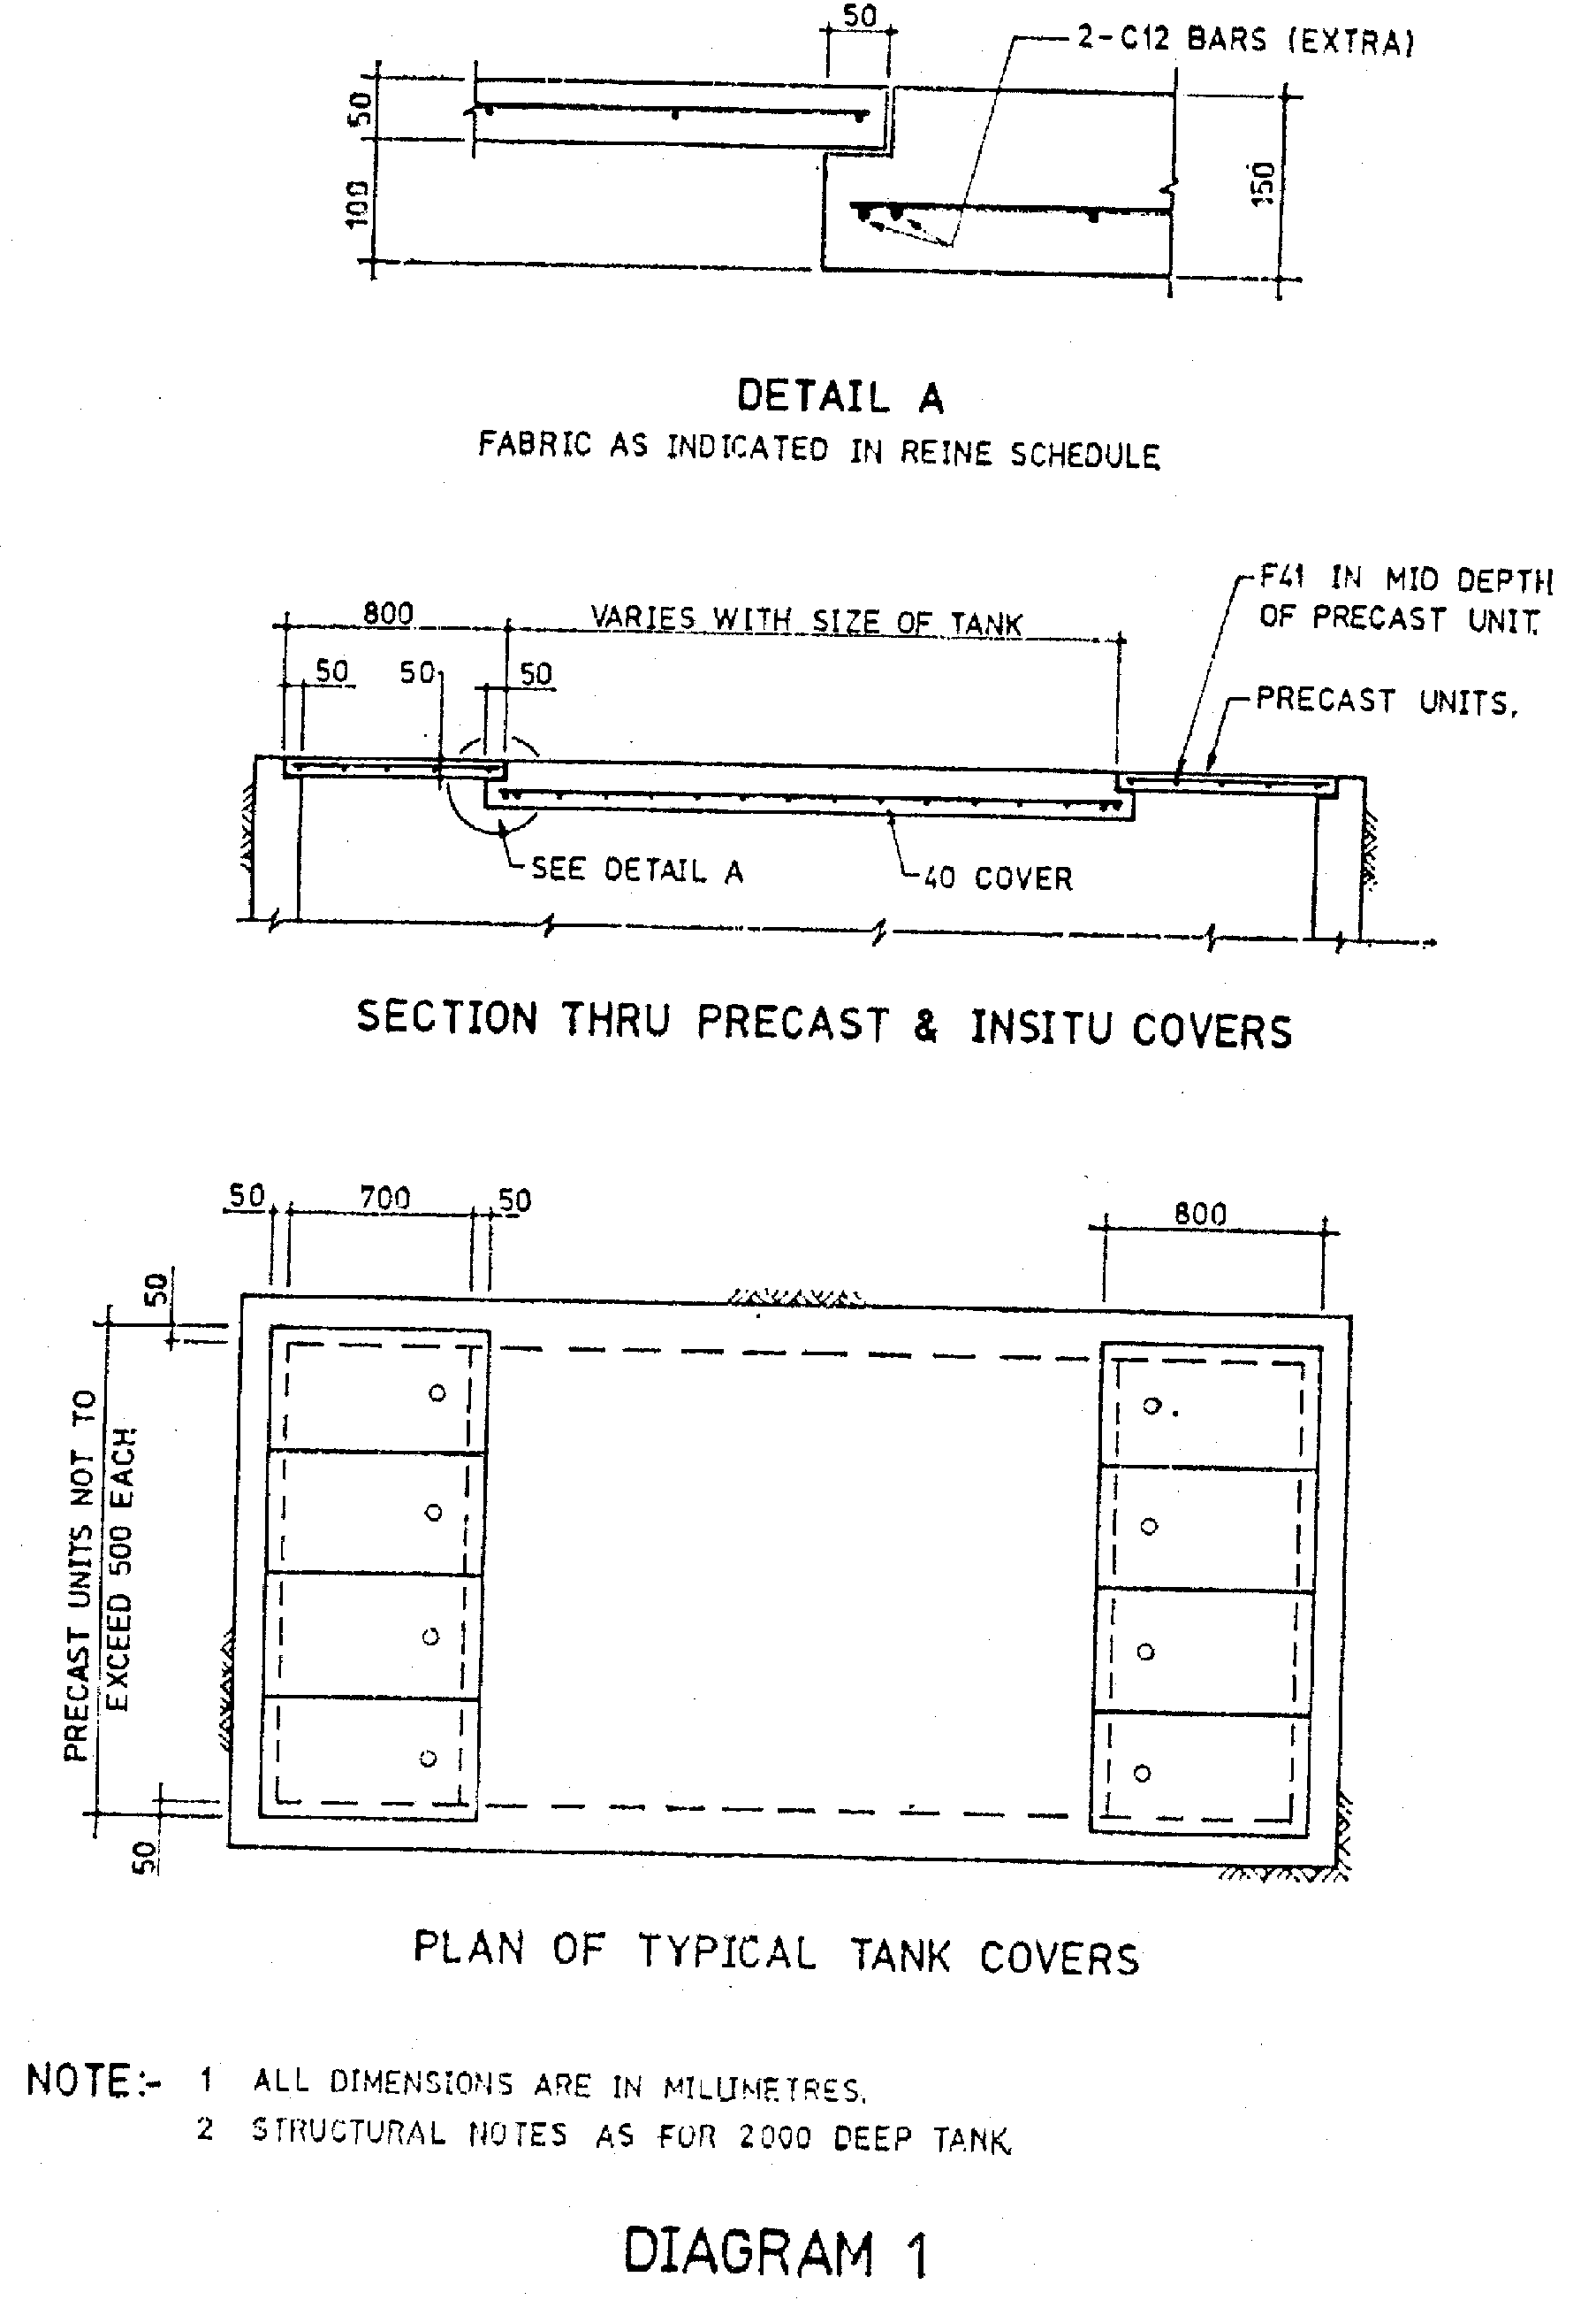
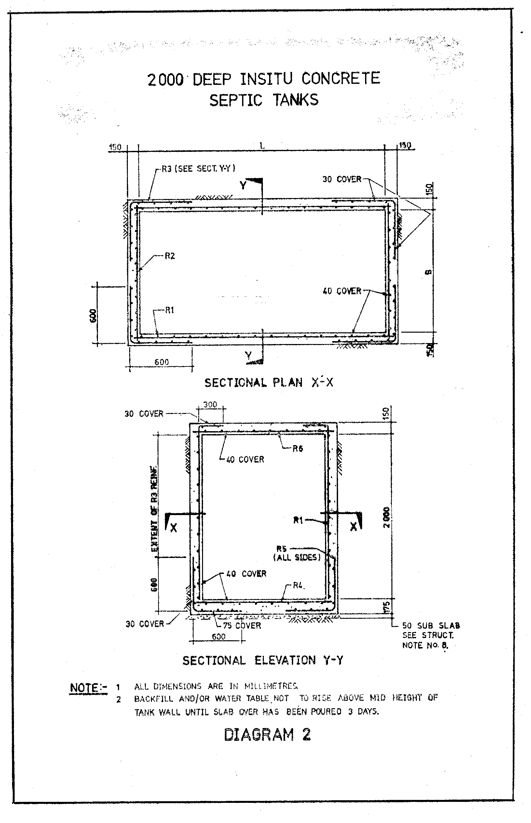
DEPTH 2 000
L x B | FABRIC REINFORCEMENT FOR 2 000 DEEP TANK
 | R1 | R2 | R3 | R4 | R5 | R6
3 000 x 1 500 | F82 | F82 | F82 | F92 | F82 | F92
3 600 x 1 900 | F82 | F82 | F82 | F92 | F82 | F92
4 200 x 2 200 | F82 | F82 | F82 | F92 | F82 | F92
4 800 x 2 500 | F82 | F82 | F82 | F102 | F82 | F102
5 500 x 2 800 | F82 | F82 | F82 | F81 | F82 | F81
STRUCTURAL NOTES
1 ALL DIMENSIONS ARE IN MILLIMETRES.
2 CONCRETE TO BE GRADE 25.
3 MAX. SLUMP (A) IN WALLS TO BE 100mm.
(B) IN COVERS AND FLOOR TO BE 80mm.
4 CONCRETE WORK TO BE CARRIED OUT IN ACCORDANCE WITH S.A.A. CODE AS 1480.
5 ALL FABRIC IS TO COMPLY WITH A.S. No. 1304.
6 CONCRETE TO BE PLACED USING VIBRATORS.
7 REINF. TO BE HELD IN PLACE USING PLASTIC TIPPED WIRE CHAIRS.
8 UNREINFORCED CONCRETE SUB SLAB 50 mm. THICK MAY BE USED UNDER STRUCTURAL BASE SLAB IF REQUIRED BY UNFAVOURABLE SOIL CONDITIONS.
9 THIS DRG. TO BE READ IN CONJUNCTION WITH PLAN AND SPEC. ON APPLICATION FORM
10 ALL CODES MUST BE LATEST EDITION WITH ALL AMENDMENTS ATTACHED.
ALTERNATIVE REINFORCEMENT
L x B | BAR REINFORCEMENT FOR 2 000 DEEP TANK
 | R1 | R2 | R3 | R4 | R5 | R6
3 000 x 1 500 | C12 AT  400 E.W. | C12 AT  400 E.W. | C12 AT  400 E.W. | C12 AT  300 E.W. | C12 AT  400 E.W. | C12 AT  300 E.W.
3 600 x 1 900 | AS ABOVE | AS ABOVE | AS ABOVE | AS ABOVE | AS ABOVE | AS ABOVE
4 200 x 2 200 | AS ABOVE | AS ABOVE | AS ABOVE | AS ABOVE | AS ABOVE | AS ABOVE
4 800 x 2 500 | AS ABOVE | AS ABOVE | AS ABOVE | C12 AT  250 E.W. | AS ABOVE | C12 AT  250 E.W.
5 500 x 2 800 | AS ABOVE | AS ABOVE | AS ABOVE | C12 AT  200 E.W. | AS ABOVE | C12 AT  200 E.W.
LEGEND
C COLD TWISTED DEFORMED BARS IN ACCORDANCE WITH AS 1002.
E.W. EACH WAY.
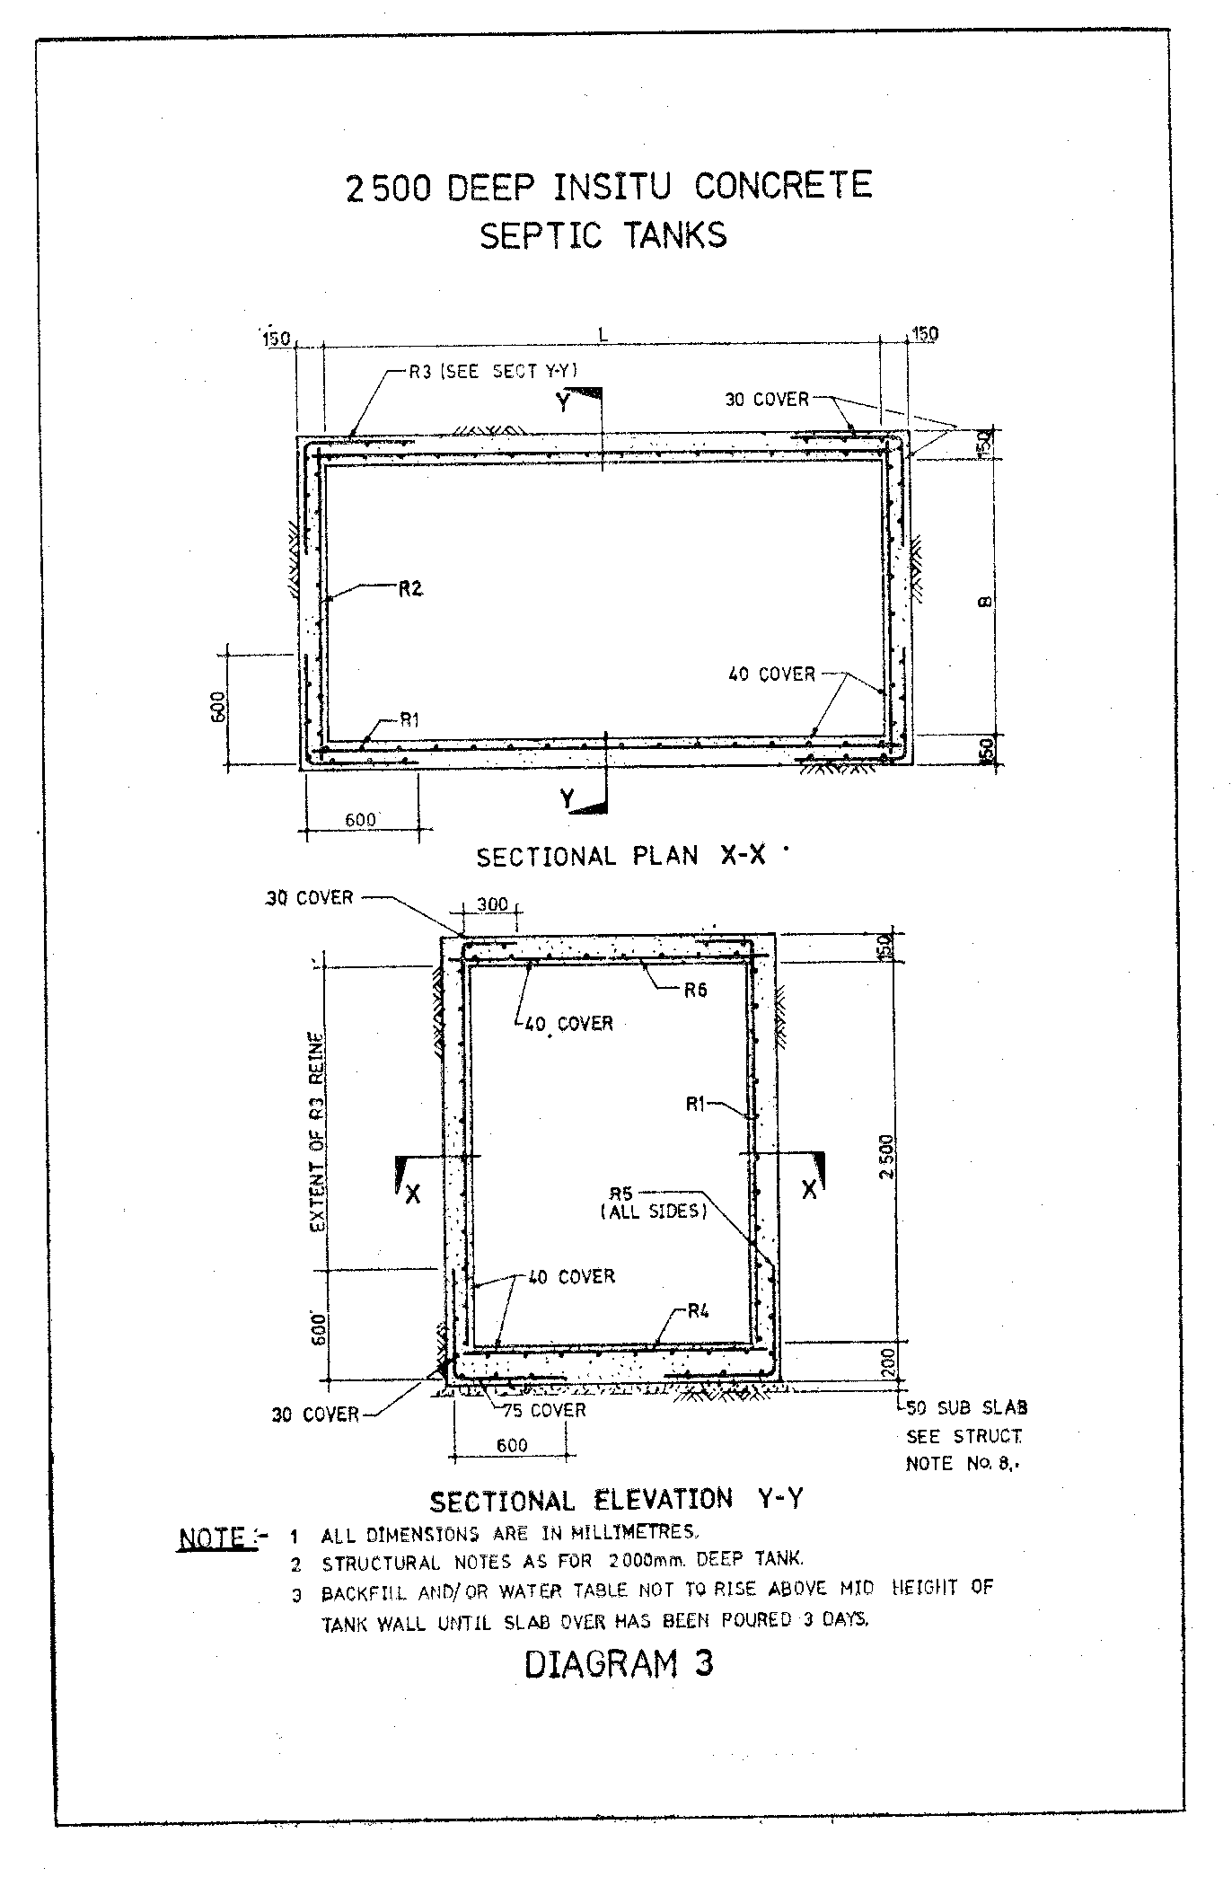
DEPTH 2 500
L x B | FABRIC REINFORCEMENT FOR 2 500 DEEP TANK
 | R1 | R2 | R3 | R4 | R5 | R6
3 000 x 1 500 | F92 | F92 | F92 | F92 | F92 | F92
3 600 x 1 900 | F92 | F92 | F92 | F92 | F92 | F92
4 200 x 2 200 | F92 | F92 | F92 | F92 | F92 | F92
4 800 x 2 500 | F92 | F92 | F92 | F102 | F92 | F102
5 500 x 2 800 | F92 | F92 | F92 | F81 | F92 | F81
ALTERNATIVE REINFORCEMENT
L x B | BAR REINFORCEMENT FOR 2 500 DEEP TANK
 | R1 | R2 | R3 | R4 | R5 | R6
3 000 x 1 500 | C12 AT  300 E.W. | C12 AT  300 E.W. | C12 AT  300 E.W. | C12 AT  300 E.W. | C12 AT  300 E.W. | C12 AT  300 E.W.
3 600 x 1 900 | AS ABOVE | AS ABOVE | AS ABOVE | AS ABOVE | AS ABOVE | AS ABOVE
4 200 x 2 200 | AS ABOVE | AS ABOVE | AS ABOVE | AS ABOVE | AS ABOVE | AS ABOVE
4 800 x 2 500 | AS ABOVE | AS ABOVE | AS ABOVE | C12 AT  250 E.W. | AS ABOVE | C12 AT  250 E.W.
5 500 x 2 800 | AS ABOVE | AS ABOVE | AS ABOVE | C12 AT  200 E.W. | AS ABOVE | C12 AT  200 E.W.
LEGEND
C COLD TWISTED DEFORMED BARS IN ACCORDANCE WITH AS 1302.
E.W. EACH WAY.
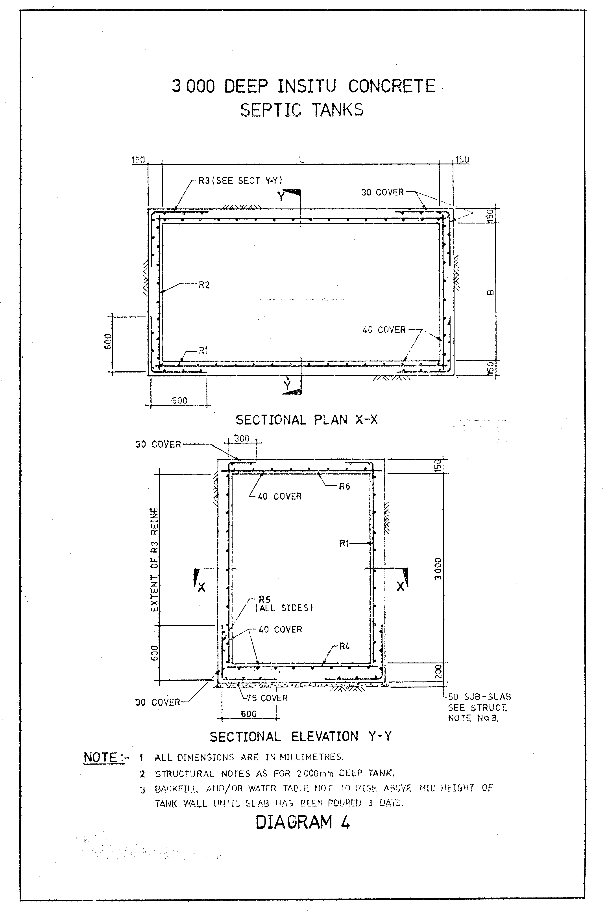
DEPTH 3 000
L x B | FABRIC REINFORCEMENT FOR 3 000 DEEP TANK
 | R1 | R2 | R3 | R4 | R5 | R6
3 000 x 1 500 | F92 | F92 | F92 | F92 | F92 | F92
3 600 x 1 900 | F92 | F92 | F92 | F92 | F92 | F92
4 200 x 2 200 | F102 | F92 | F92 | F102 | F92 | F102
4 800 x 2 500 | F102 | F92 | F92 | F102 | F92 | F102
5 500 x 2 800 | F81 | F92 | F92 | F81 | F92 | F81
ALTERNATIVE REINFORCEMENT
L x B | BAR REINFORCEMENT FOR 3 000 DEEP TANK
 | R1 | R2 | R3 | R4 | R5 | R6
3 000 x 1 500 | C12 AT  300 E.W. | C12 AT  300 E.W. | C12 AT  300 E.W. | C12 AT  300 E.W. | C12 AT  300 E.W. | C12 AT  300 E.W.
3 600 x 1 900 | AS ABOVE | AS ABOVE | AS ABOVE | AS ABOVE | AS ABOVE | AS ABOVE
4 200 x 2 200 | C12 AT  250 E.W. | AS ABOVE | AS ABOVE | C12 AT  250 E.W. | AS ABOVE | C12 AT  250 E.W.
4 800 x 2 500 | AS ABOVE | AS ABOVE | AS ABOVE | AS ABOVE | AS ABOVE | AS ABOVE
5 500 x 2 800 | C12 AT  200 E.W. | AS ABOVE | AS ABOVE | C12 AT  200 E.W. | AS ABOVE | C12 AT  200 E.W.
LEGEND
C COLD TWISTED DEFORMED BARS IN ACCORDANCE WITH AS 1302.
E.W. EACH WAY.

Schedule 4
[Reg. 35]
[Heading inserted in Gazette 15 Dec 1989 p. 4552.]
Structural details of brick septic tank (sand conditions only)

Schedule 5
[Reg. 41]
[Heading amended in Gazette 15 Dec 1989 p. 4552.]
Form No. 1
HEALTH ACT 1911
Health (Treatment of Sewage and Disposal of Effluent and Liquid Waste) Regulations 1974
APPLICATION FOR TESTING OF SANITARY FIXTURES AND FITTINGS
To the Executive Director, Public Health and Scientific Support Services:
It is requested that you arrange for the articles specified hereunder to be tested for approval in accordance with the Health Act 1911.
I undertake to pay the prescribed fee for the service on demand.
Articles:
Description: .................................................................................................
Number: ......................................................................................................
Location: .....................................................................................................
Signature of Applicant: ......................................
Date: ......................................
[Form 1 amended in Gazette 29 Jun 1984 p. 1781.]
Form No. 2
HEALTH ACT 1911
Health (Treatment of Sewage and Disposal of Effluent and Liquid Waste) Regulations 1974
CERTIFICATE OF APPROVAL
This Certificate of Approval is granted in respect of the type of article described hereunder in accordance with the Health Act 1911.
................................................................................................................................
................................................................................................................................
................................................................................................................................
................................................................................................................................
Issued at Perth, this day of , 20.........
..............................................
EXECUTIVE DIRECTOR,
PUBLIC HEALTH AND
SCIENTIFIC SUPPORT
SERVICES
[Form 2 amended in Gazette 29 Jun 1984 p. 1781.]

Schedule 6
[Reg. 43]
[Heading inserted in Gazette 15 Dec 1989 p. 4552.]
Dry type septic tank
PLAN.

Schedule 7
[Reg. 49(1)]
[Heading inserted in Gazette 15 Dec 1989 p. 4552.]
Form No. 1
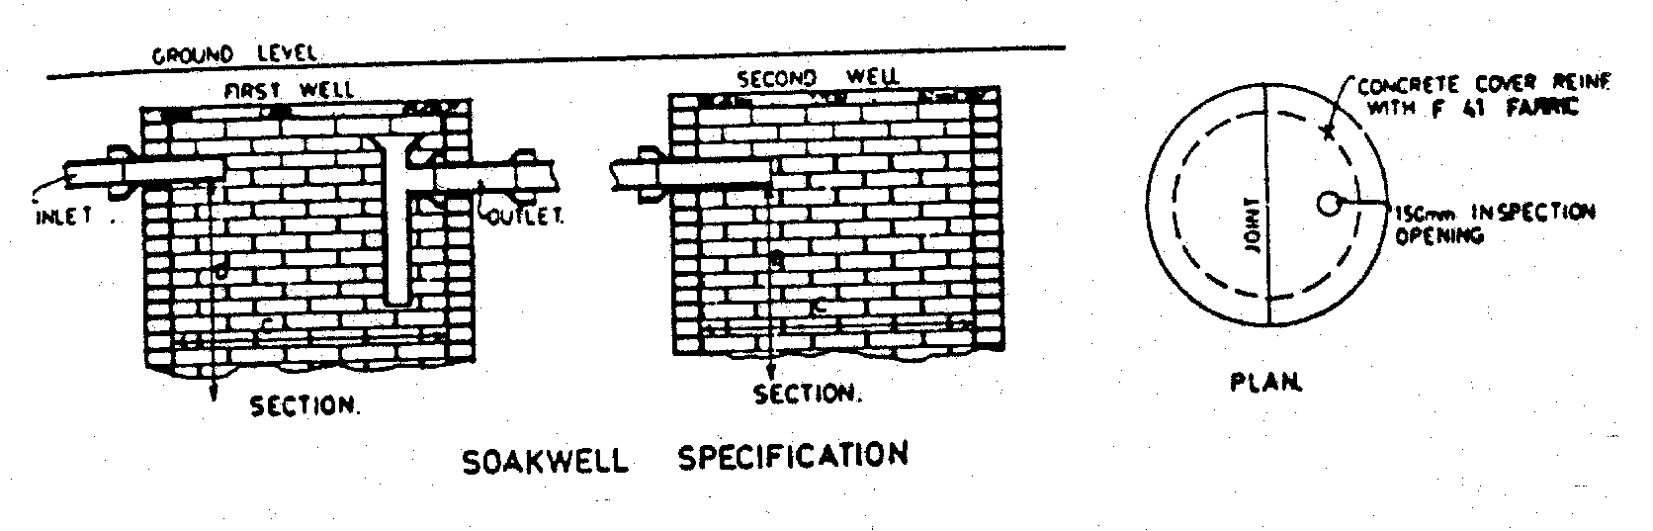
‘D’ & ‘C’ TO BE AT COURSE HEIGHT BUT NOT LESS
THAN 1200 FOR ‘C’ AND 1500 FOR ‘D’.
Soak Well — To be constructed as shown on plan, having the 3 top courses or all courses above the overt to be set in 2 in 1 cement mortar, the remainder in open jointed brickwork, laid dry, in stretcher courses, or constructed in approved cement segments or bricks which comply with the standard for blocks, class A.A.S. A87-1963.
Size — Bricks or segments shall have a minimum bearing face of 100 mm and shall be laid over the full bearing face in each course.
Sufficient openings shall be provided in any soak well to allow for the efficient disposal of the effluent, and shall be not less than 10% of the surface area.
Inspection Openings and square junction to be provided as shown.
When completed it shall show a circular, smooth and regular internal surface.
All soak wells shall be 1.2 m in dia. and with a 1.5 m effective depth unless otherwise specified or approved by the local government.
The top of the soak well shall not be more than 300 mm or less than 150 mm below ground level, unless otherwise approved by the local government.
Soak wells in series shall have a long square on the outlet as shown.
Cover — Shall be of concrete in section with rebated joint as shown, reinforced with No. F.41 steel mesh fabric, joints of mesh shall be securely tied with a full 2 mesh overlap, unless otherwise specified.
The covers shall withstand a flexural test of 2 MPa and a load bearing of 7 kPa.
Traffic covers shall be constructed to specific Departmental specifications.
No soak well shall be situated closer than 1.8 m to any building, boundary fence or septic tank, unless otherwise approved by the local government.
[Form 1 amended in Gazette 29 Jul 1997 p. 4084; 5 Sep 1997 p. 5037.]
Form No. 2
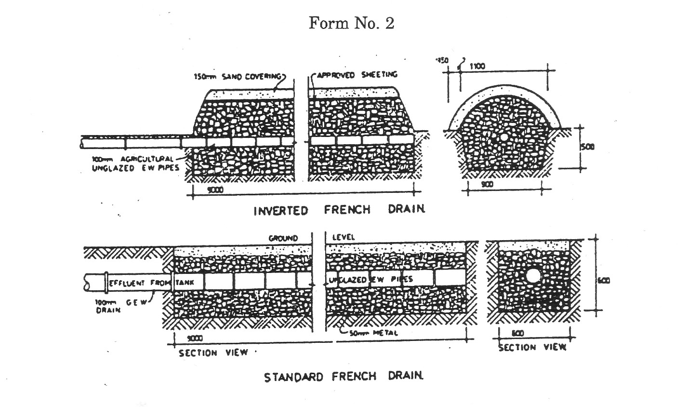
Specifications
Trench to be not less than 9 m long, constructed as shown.
Filling to consist of 50 mm or 75 mm gauge broken blue metal; filling on top may be of smaller gauge metal with sand over approved sheeting.
Distributing pipe to be 75 mm or 100 mm diameter unglazed agricultural pipes laid with open butt joints, or other approved piping.
Grade shall be laid at not more than 1 in 200.
A French drain shall not be situated closer than 3.5 m from any dwelling nor closer than 6 m from any window or door of any dwelling, nor closer than 1.8 m from any lot boundary, unless otherwise approved by the local government.
[Form 2 amended in Gazette 29 Jul 1997 p. 4084.]
Form No. 3
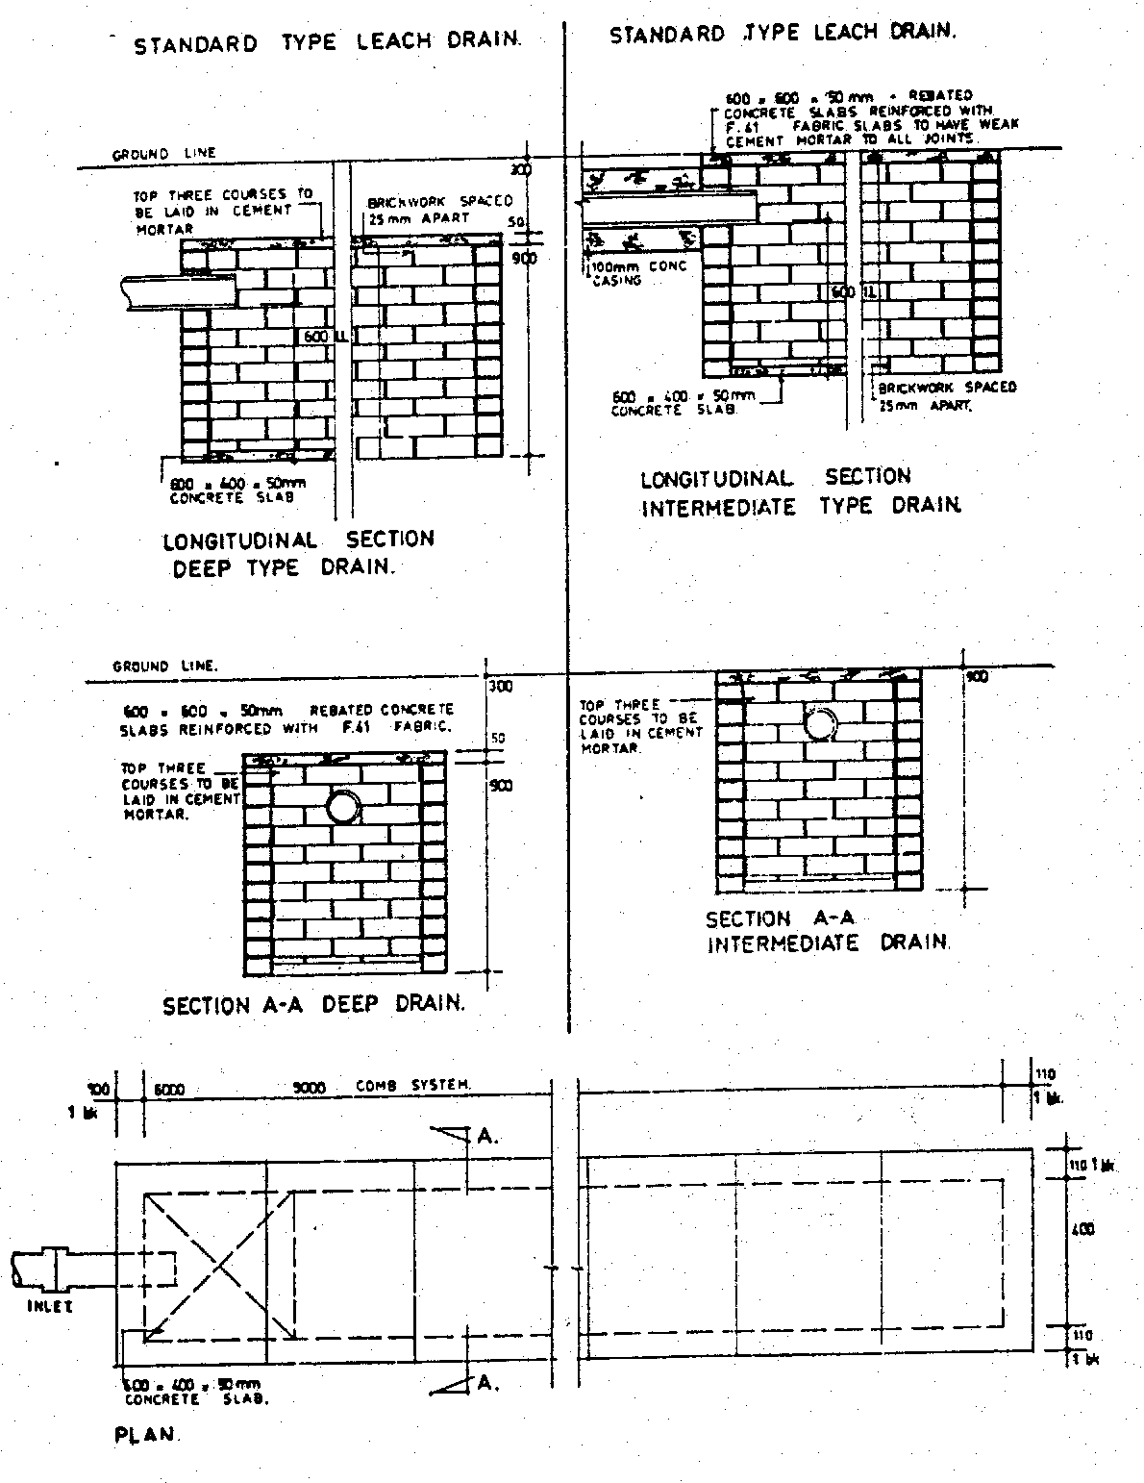
SEMI INVERTED TYPE LEACH DRAIN.
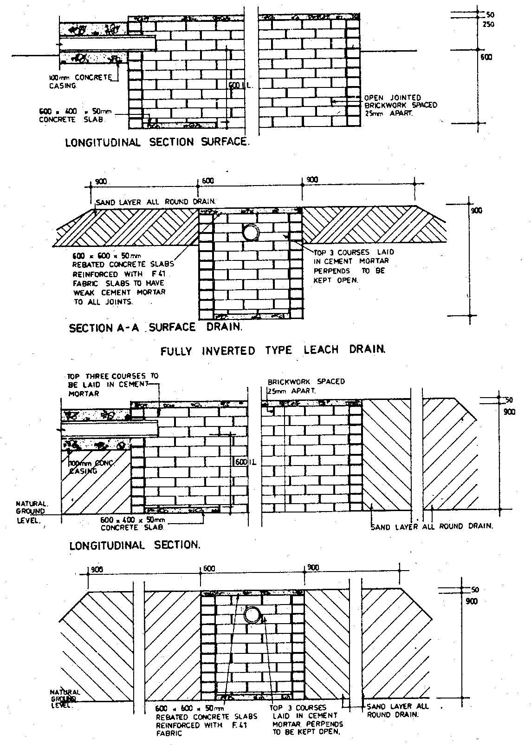
SECTION A - A.
DETAILS OF LEACH DRAIN.
THE DRAIN SHALL NOT BE SITUATED CLOSER THAN 2000 FROM ANY SEPTIC TANK, BUILDING OR BOUNDARY OF A LOT, UNLESS OTHERWISE APPROVED BY THE LOCAL GOVERNMENT.
MINIMUM LENGTH BLACKWATER SYSTEMS TO HAVE DRAIN 6000 LONG COMBINED SYSTEMS TO HAVE DRAIN 9000 LONG REINFORCED CONCRETE PAVING SLABS POSITIONED BENEATH INLET AND BRICK SPREADER WALLS PROVIDED NOT MORE THAN 1200 cts
SEGMENTS WHERE SEGMENTS ARE USED ALL COURSES ABOVE THE OVERT OF THE INLET TO BE LAID 3:1 CEMENT MORTAR.
[Form 3 amended in Gazette 29 Jul 1997 p. 4084; 7 Jan 2005 p. 70.]
Form No. 4
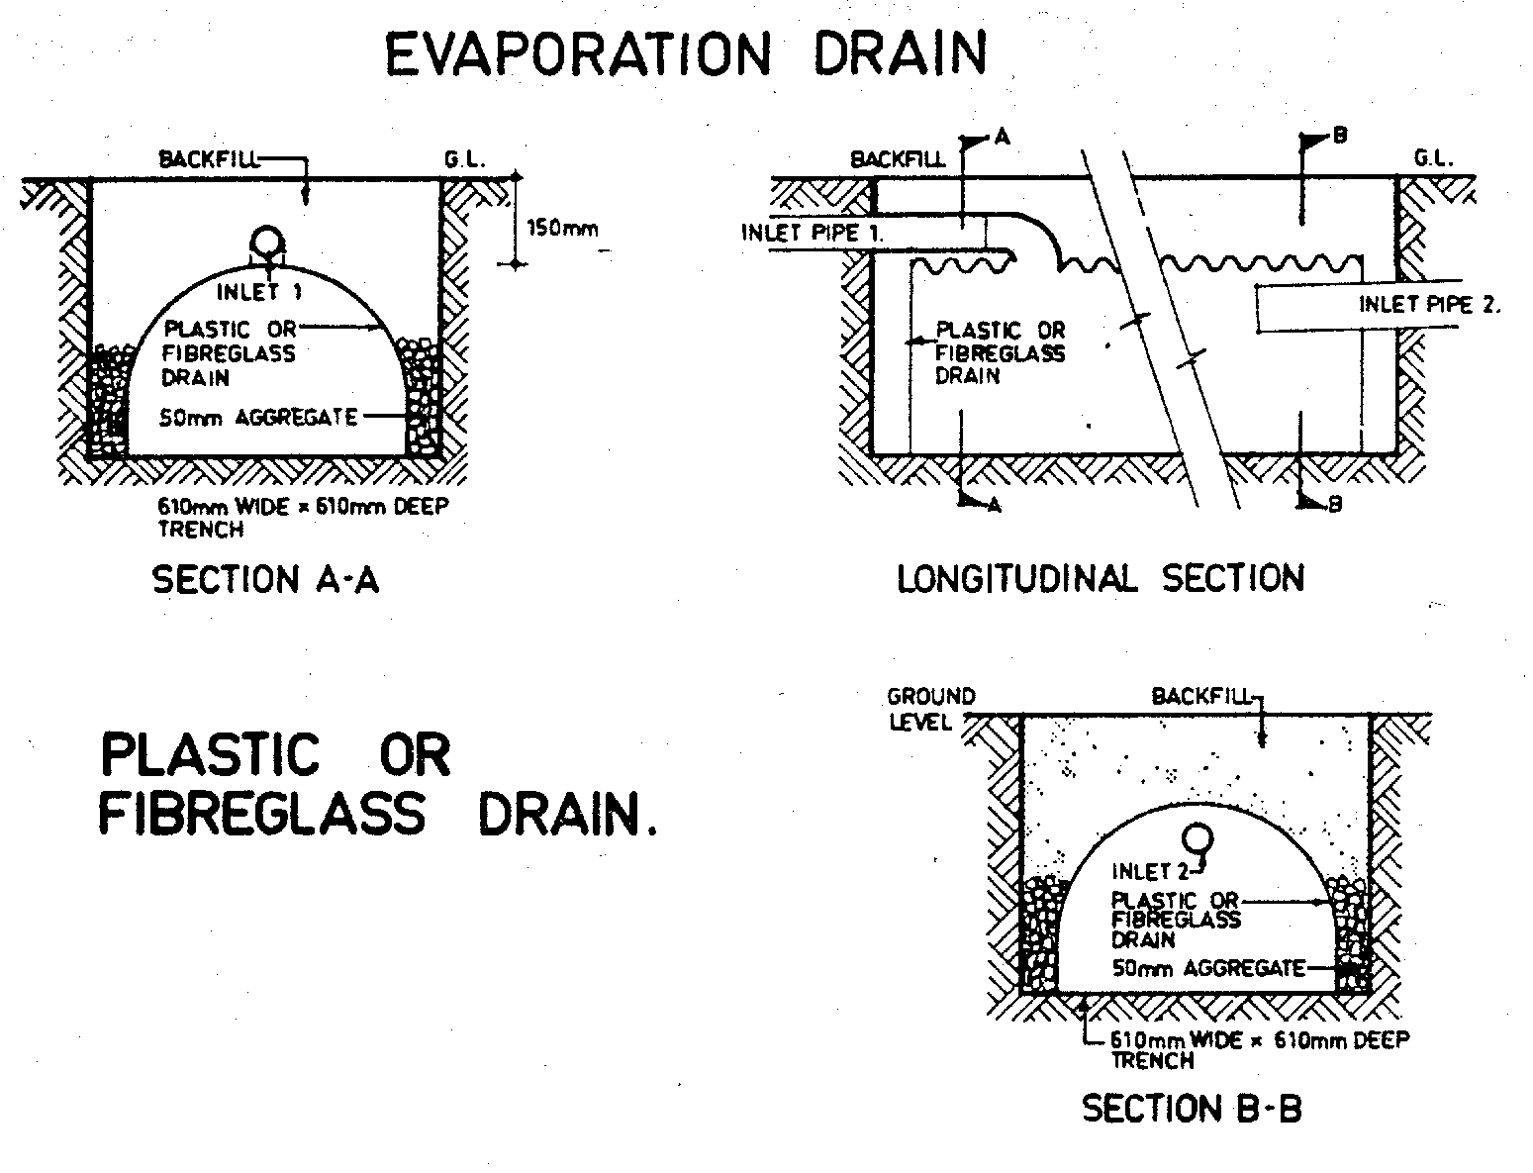

Schedule 8
[Reg. 49(3)]
[Heading inserted in Gazette 15 Dec 1989 p. 4552.]
Method of determining absorptive capacity of a soil
[Heading inserted in Gazette 15 Dec 1989 p. 4552.]
1.
Dig a hole with dimensions of 300 mm square and vertical sides to the depth of the proposed absorption trench.
2.
Carefully scarify the bottom and sides of the hole in order to remove any smeared soil surfaces and to provide a natural soil interface into which the water may percolate. Remove all loose material from the hole. Add 50 mm of blue metal, or screened gravel, to protect the bottom from scouring and sediment.
3.
Fill the hole with water and allow it to soak away. Preferably keep the hole filled overnight, possibly by means of an automatic siphon.
4.
The following morning, fill or adjust water level to a depth of 150 mm above blue metal or gravel, insert measuring stick (as shown in the diagram at the end of this Schedule) and note time taken for water to fall 25 mm.
The amount of effluent which can be disposed of per square metre of infiltrative area per day is given by the following Table —
Table
Time for water to fall 25 m (minutes) | Soil type | Loading infiltration rate litres per m² per day
 |  | Alternating  system | Non-alternating  system
1 to 5  more than 5 to 60  more than 60 | Sand  Loams or gravels  Impervious clays, etc | 30  20 | 15  10
 |  | As approved by the Executive Director, Public Health (see clause 5)
5.
This soil type in its natural state is unsuitable for on site disposal, however the Executive Director, Public Health may approve of a loading infiltration rate in a particular case if satisfied that system design and site modification to justify the loading rate will be carried out.
Diagram
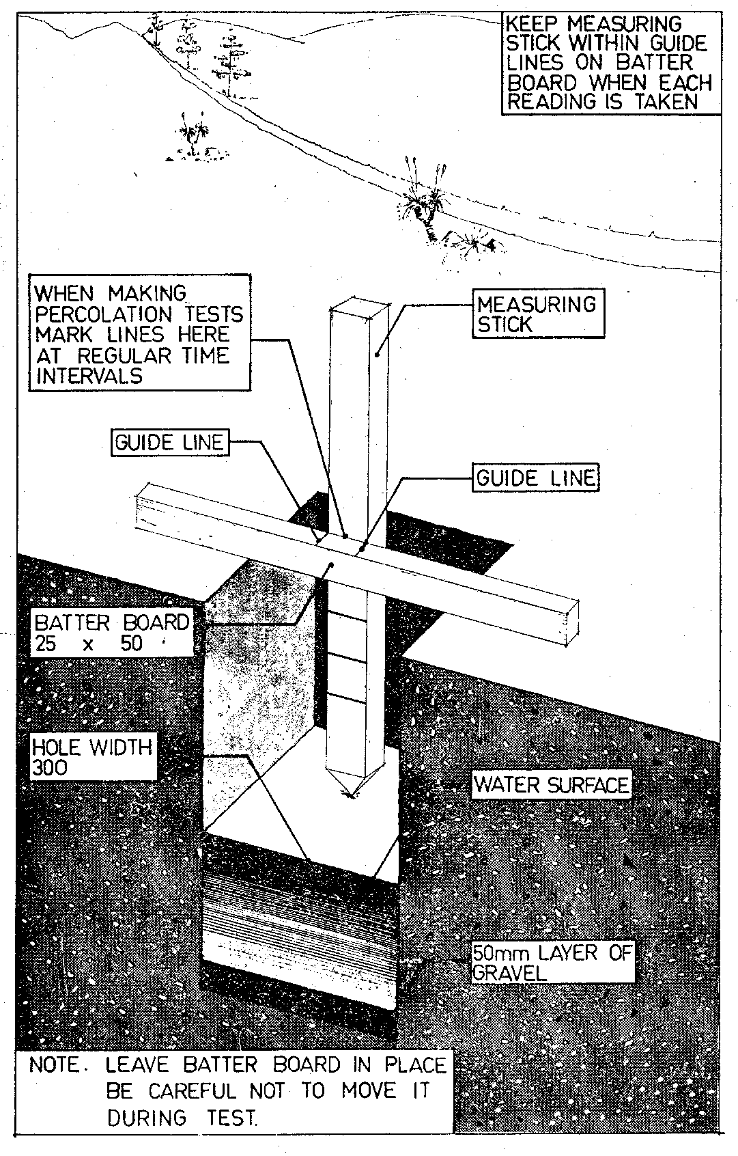
[Schedule 8 amended in Gazette 29 Jun 1984 p. 1781; 15 Dec 1989 p. 4552-3.]

Schedule 9 — Wastewater volume for residential premises
[r. 49(3)]
[Heading inserted in Gazette 7 Jan 2005 p. 70.]

For the purposes of the definition of “V” in the formula in regulation 49(3) the volume of wastewater is to be determined from the following Table according to the number of bedrooms on the premises.
Table
Number of bedrooms | Volume of wastewater (litres)
 | Blackwater system | Combined system  (blackwater and greywater)
2 or less | 188 | 564
3 | 254 | 761
4 or more | 276 | 829
[Schedule 9 inserted in Gazette 7 Jan 2005 p. 70.]

Notes
¹ This is a compilation of the Health (Treatment of Sewage and Disposal of Effluent and Liquid Waste) Regulations 1974 and includes the amendments made by the other written laws referred to in the following table. The table also contains information about any reprint.

Compilation table
Citation | Gazettal | Commencement
Bacteriolytic Treatment of Sewage and Disposal of Effluent and Liquid Waste Regulations ⁴ | 3 Sep 1974 p. 3303-40  (erratum 13 Sep 1974 p. 3440) | 3 Sep 1974
Untitled regulations | 21 Apr 1978 p. 1218-20 | 21 Apr 1978
Bacteriolytic Treatment of Sewage and Disposal of Effluent and Liquid Waste Amendment Regulations 1981 | 18 Dec 1981 p. 5192 | 18 Dec 1981
Health Legislation Amendment Regulations 1984 r. 4 | 29 Jun 1984 p. 1780-4 | 1 Jul 1984 (see r. 2)
Reprint of the Bacteriolytic Treatment of Sewage and Disposal of Effluent and Liquid Waste Regulations authorised 29 Jan 1985 published in Gazette 6 Feb 1985 p. 469-508 (includes amendments listed above)
Bacteriolytic Treatment of Sewage and Disposal of Effluent and Liquid Waste Amendment Regulations 1989 ⁵ | 15 Dec 1989 p. 4547-53 | 15 Dec 1989
Treatment of Sewage and Disposal of Effluent and Liquid Waste Amendment Regulations 1992 | 4 Sep 1992 p. 4471-6 | 4 Sep 1992 (see r. 2 and Gazette 4 Sep 1992 p. 4453)
Treatment of Sewage and Disposal of Effluent and Liquid Waste Amendment Regulations 1993 | 12 Nov 1993 p. 6143 | 12 Nov 1993
Treatment of Sewage and Disposal of Effluent and Liquid Waste Amendment Regulations (No. 2) 1993 | 12 Nov 1993 p. 6145  (correction 23 Nov 1993 p. 6308) | 10 Dec 1993 (see r. 2)
Treatment of Sewage and Disposal of Effluent and Liquid Waste Amendment Regulations 1994 | 27 May 1994 p. 2211 | 1 Jul 1994 (see r. 2)
Treatment of Sewage and Disposal of Effluent and Liquid Waste Amendment Regulations 1995 | 27 Jun 1995 p. 2553 | 1 Jul 1995 (see r. 2)
Treatment of Sewage and Disposal of Effluent and Liquid Waste Amendment Regulations 1996 | 28 Jun 1996 p. 3032-3 | 1 Jul 1996 (see r. 2)
Treatment of Sewerage and Disposal of Effluent and Liquid Waste Amendment Regulations 1997 | 1 Jul 1997 p. 3255 | 1 Jul 1997 (see r. 2)
Treatment of Sewage and Disposal of Effluent and Liquid Waste Amendment Regulations (No. 2) 1997 ⁶ | 29 Jul 1997 p. 4063-84 | 29 Jul 1997 (see r. 2(b) and Gazette 29 Jul 1997 p. 4065)
Health (Treatment of Sewage and Disposal of Effluent and Liquid Waste) Amendment Regulations (No. 3) 1997 | 5 Sep 1997 p. 5036-7 | 5 Sep 1997
Health (Treatment of Sewage and Disposal of Effluent and Liquid Waste) Amendment Regulations 1998 | 17 Mar 1998 p. 1417 | 17 Mar 1998
Health (Treatment of Sewage and Disposal of Effluent and Liquid Waste) Amendment (No. 2) Regulations 1998 | 1 May 1998 p. 2273 | 1 May 1998
Reprint of the Health (Treatment of Sewage and Disposal of Effluent and Liquid Waste) Regulations 1974 as at 2 May 1998 (includes amendments listed above)
Health (Treatment of Sewage and Disposal of Effluent and Liquid Waste) Amendment Regulations 2000 | 30 Jun 2000 p. 3413 | 1 Jul 2000 (see r. 2)
Health (Treatment of Sewage and Disposal of Effluent and Liquid Waste) Amendment Regulations 2001 | 6 Nov 2001 p. 5838-9 | 6 Nov 2001
Health (Treatment of Sewage and Disposal of Effluent and Liquid Waste) Amendment Regulations (No. 2) 2001 | 30 Nov 2001 p. 6074 | 30 Nov 2001
Reprint 3: The Health (Treatment of Sewage and Disposal of Effluent and Liquid Waste) Regulations 1974 as at 8 Aug 2003 (includes amendments listed above)
Health (Treatment of Sewage and Disposal of Effluent and Liquid Waste) Amendment Regulations (No. 3) 2004 | 25 Jun 2004 p. 2240-1 | 1 Jul 2004 (see r. 2)
Health (Treatment of Sewage and Disposal of Effluent and Liquid Waste) Amendment Regulations 2004 ⁷ | 28 Jun 2004 p. 2393-6 | 1 Jul 2004 (see r. 2 and Gazette 28 Jun 2004 p. 2399)
Health (Treatment of Sewage and Disposal of Effluent and Liquid Waste) Amendment Regulations (No. 4) 2004 ⁷ | 24 Aug 2004 p. 3657 | 24 Aug 2004 (see r. 2)
Health (Treatment of Sewage and Disposal of Effluent and Liquid Waste) Amendment Regulations (No. 5) 2004 | 30 Dec 2004 p. 6937-8 | 1 Jan 2005 (see r. 2 and Gazette 31 Dec 2004 p. 7130)
Health (Treatment of Sewage and Disposal of Effluent and Liquid Waste) Amendment Regulations 2005 | 7 Jan 2005 p. 64-70 | 1 Feb 2005 (see r. 2)
Health (Treatment of Sewage and Disposal of Effluent and Liquid Waste) Amendment Regulations (No. 2) 2005 | 31 May 2005 p. 2411 | 1 Jul 2005 (see r. 2)
Reprint 4: The Health (Treatment of Sewage and Disposal of Effluent and Liquid Waste) Regulations 1974 as at 7 Oct 2005 (includes amendments listed above)
Health (Treatment of Sewage and Disposal of Effluent and Liquid Waste) Amendment Regulations 2006 | 2 May 2006 p. 1702 | 1 Jul 2006 (see r. 2)
Health (Treatment of Sewage and Disposal of Effluent and Liquid Waste) Amendment Regulations 2007 | 18 May 2007 p. 2253 | 1 Jul 2007 (see r. 2)
Health (Treatment of Sewage and Disposal of Effluent and Liquid Waste) Amendment Regulations 2008 | 4 Apr 2008 p. 1309 | r. 1 and 2: 4 Apr 2008 (see r. 2(a));  Regulations other than r. 1 and 2: 1 Jul 2008 (see r. 2(b))
Health (Treatment of Sewage and Disposal of Effluent and Liquid Waste) Amendment Regulations 2009 | 15 May 2009 p. 1631 | r. 1 and 2: 15 May 2009 (see r. 2(a));  Regulations other than r. 1 and 2: 1 Jul 2009 (see r. 2(b))
² Repealed by the Environmental Protection (Liquid Waste) Repeal Regulations 2003.
³ Under the Alteration of Statutory Designations Order (No. 3) 2001 references in any law to the Health Department shall be read as references to the Department of Health.
⁴ Now known as the Health (Treatment of Sewage and Disposal of Effluent and Liquid Waste) Regulations 1974; citation changed (see note under r. 1).
⁵ The Bacteriolytic Treatment of Sewage and Disposal of Effluent and Liquid Waste Amendment Regulations 1989 r. 32 is a transitional provision that is of no further effect.
⁶ The Treatment of Sewage and Disposal of Effluent and Liquid Waste Amendment Regulations (No. 2) 1997 is a transitional and savings provision that is of no further effect.
⁷ If, because of an error made in r. 2, the Health (Treatment of Sewage and Disposal of Effluent and Liquid Waste) Amendment Regulations 2004 did not come into operation before 24 Aug 2004, the amendments were made on that day by the Health (Treatment of Sewage and Disposal of Effluent and Liquid Waste) Amendment Regulations (No. 4) 2004, but otherwise the Health (Treatment of Sewage and Disposal of Effluent and Liquid Waste) Amendment Regulations (No. 4) 2004 do not come into operation.

