Western Australia
Midland Redevelopment Act 1999

Midland Redevelopment (Subtracted Area) Regulations 2011
These regulations were repealed by the Metropolitan Redevelopment Authority Act 2011 s. 134(c) (No. 45 of 2011) as at 31 Dec 2011 (see s. 2(b) and Gazette 30 Dec 2011 p. 5573).

Western Australia
Midland Redevelopment (Subtracted Area) Regulations 2011
Contents
1. Citation 1
2. Commencement 1
3. Terms used 1
4. Schedule 1 of the Act amended 1
5. Minister may amend planning schemes 2
6. Other transitional matters 3
7. Expiry of regulations 3
Notes
Compilation table 4

Western Australia
Midland Redevelopment Act 1999
Midland Redevelopment (Subtracted Area) Regulations 2011

1. Citation
These regulations are the Midland Redevelopment (Subtracted Area) Regulations 2011 ¹.

2. Commencement
These regulations come into operation as follows —
(a) regulations 1 and 2 — on the day on which these regulations are published in the Gazette;
(b) the rest of the regulations — on the day after that day.

3. Terms used
In these regulations —
order means an order made under regulation 5(2);
scheme means either of the following —
(a) the Metropolitan Region Scheme;
(b) the City of Swan Local Planning Scheme No. 17.

4. Schedule 1 of the Act amended
When an order takes effect, in Schedule 1 of the Act:
(a) delete “Plan No. 1” (first occurrence) and insert:

Plan No. 2

(b) delete “Plan No. 1 —”and insert:

Plan No. 2 —

(c) delete the representation of Plan No. 1 and insert:

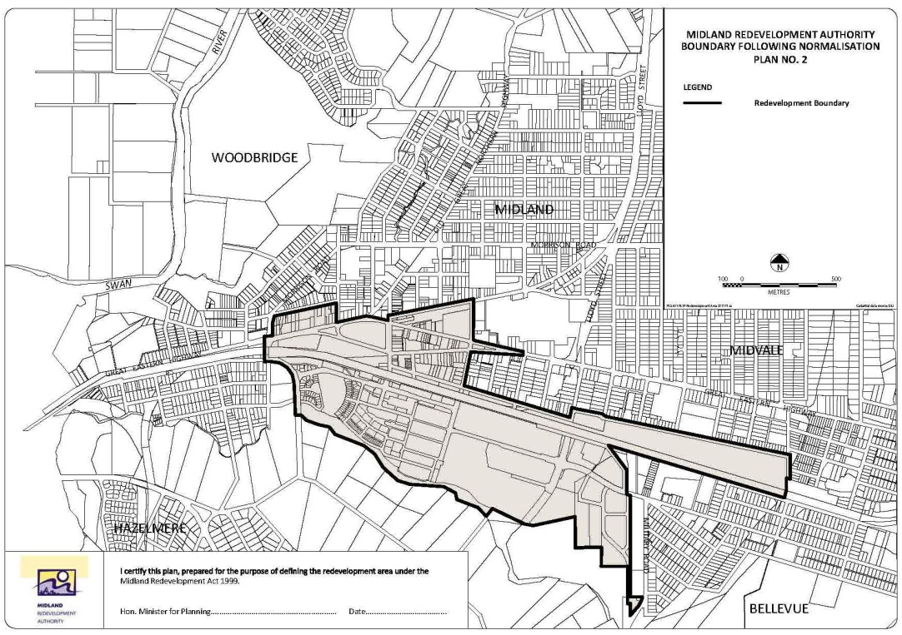

5. Minister may amend planning schemes
(1) In this regulation —
subtracted area means the area that ceases to be in the redevelopment area when Schedule 1 of the Act is amended by regulation 4.
(2) The Minister may, by order published in the Gazette, amend a scheme to provide for any of the following —
(a) land in the subtracted area to be included in the area to which the scheme applies;
(b) land in the subtracted area to have a reservation or zoning under the scheme the same as, or similar to, that which applied to the land immediately before it ceased to be in the redevelopment area.
(3) An order takes effect at the beginning of the day after the day on which it is published in the Gazette.

6. Other transitional matters
When an order takes effect, the effect of a decision, if any, previously made by the Authority about a development application or an approval continues.

7. Expiry of regulations
(1) These regulations expire at the end of the 12 month period following the day on which these regulations came into operation.
(2) The expiry of these regulations does not affect —
(a) the amendment of the redevelopment area under regulation 4; or
(b) an amendment of a scheme under an order.

Notes
¹ This is a compilation of the Midland Redevelopment (Subtracted Area) Regulations 2011. The following table contains information about those regulations.

Compilation table
Citation | Gazettal | Commencement
Midland Redevelopment (Subtracted Area) Regulations 2011 | 13 Dec 2011 p. 5282-4 | r. 1 and 2: 13 Dec 2011 (see r. 2(a));  Regulations other than r. 1 and 2: 14 Dec 2011 (see r. 2(b))
These regulations were repealed by the Metropolitan Redevelopment Authority Act 2011 s. 134(c) (No. 45 of 2011) as at 31 Dec 2011 (see s. 2(b) and Gazette 30 Dec 2011 p. 5573)

Defined terms

[This is a list of terms defined and the provisions where they are defined. The list is not part of the law.]
Defined term Provision(s)
order 3
scheme 3
subtracted area 5(1)

