Western Australia
National Gas Access (WA) Act 2009

National Gas Access (WA) (Part 3) Regulations 2009

Western Australia
National Gas Access (WA) (Part 3) Regulations 2009
Contents
1. Citation 1
2. Commencement 1
3. Interpretation 1
4. Designated pipelines 1
5. Definition of pipeline 1
6. Civil penalty provisions 2
7. Conduct provisions 2
8. Summons to appear as witness 2
9. Dispute resolution body to be able to charge for costs of access disputes 3
12. Definition of small to medium user or end user 4
13. Content of request for Rule 4
14. Fees 4
15. Transitional arrangements for Gas Review Board 5
Schedule 1 — Designated pipelines
Schedule 2 — Exclusions from definition of pipeline
Schedule 3 — Civil penalties
Schedule 4 — Conduct provisions
Schedule 5 — Fees
Notes
Compilation table 21
Defined terms

National Gas Access (WA) Act 2009
National Gas Access (WA) (Part 3) Regulations 2009

1. Citation
These regulations are the National Gas Access (WA) (Part 3) Regulations 2009.

2. Commencement
These regulations come into operation when the National Gas Access (WA) Act 2009 Part 3 comes into operation.

3. Interpretation
In these regulations —
Act means the National Gas Access (WA) Act 2009;
NGL means the National Gas Law.

4. Designated pipelines
(1) For the purposes of the definition of designated pipeline in section 2 of the NGL a pipeline listed in Schedule 1 is prescribed to be a designated pipeline.
(2) For the purposes of Schedule 1, the WA commencement date is the date of commencement of the National Gas Access (WA) (Part 3) Regulations 2009.

5. Definition of pipeline
For the purposes of the definition of pipeline in section 2 of the NGL —
(a) a gas processing plant listed in column 1 of the table in Schedule 2 is a prescribed gas processing plant; and
(b) in relation to a pipeline conveying natural gas from such a gas processing plant — the flange or point described in column 2 of that table opposite the reference to the plant is a prescribed exit flange or prescribed as a connection point (as the case requires).

6. Civil penalty provisions
For the purposes of section 3(b) of the NGL, a provision of the NGL or the Rules listed in Schedule 3 is prescribed to be a civil penalty provision.

7. Conduct provisions
For the purposes of section 4(b) of the NGL, a provision of the NGL or the Rules listed in Schedule 4 is prescribed to be a conduct provision.

8. Summons to appear as witness
(1) A summons issued by the dispute resolution body under Chapter 6 Part 6 of the NGL must include —
(a) the name and address of the person on whom the summons is to be served; and
(b) if the summons is for the production of a document —
(i) a proper description of the document; and
(ii) if the document is to be produced by a person that is a corporation, the name and title of the appropriate officer of the corporation who is to attend and produce the document;
and
(c) the date, time and place of the hearing of the dispute resolution body at which the person is required to attend and (if required) to produce the document.
(2) The summons will remain in force for a period specified in the summons or, if no period is specified, until the conclusion of the proceeding in relation to which the summons has been issued.
(3) The summons will be taken to be effectively served if —
(a) a copy of the summons is handed to the person to be served or, where service by that method is refused or obstructed or made impracticable, a copy of the summons is placed as near as practicable to the person and the person is informed of the nature of the summons; or
(b) a copy of the summons is delivered to a legal practitioner acting for the person to be served and the legal practitioner endorses a statement on the summons to the effect that the legal practitioner accepts service; or
(c) where the person to be served is a corporation, a copy of the summons is served on the corporation in accordance with the provisions of the Corporations Act 2001 of the Commonwealth; or
(d) a copy of the summons is served in accordance with an agreement made between the parties as to the place and method of service and the person on whom service may be effected; or
(e) an answer to the summons is filed with the dispute resolution body; or
(f) the dispute resolution body is satisfied that the person to be served has received a copy of the summons.

9. Dispute resolution body to be able to charge for costs of access disputes
Pursuant to section 216 of the NGL, the dispute resolution body may —
(a) charge the parties to an access dispute for its costs in the access dispute; and
(b) apportion those costs between the parties.
[Note: r. 10 and 11 have intentionally been left blank.]

12. Definition of small to medium user or end user
For the purposes of the definition of small to medium user or end user in section 244 of the NGL, a level of 100 terajoules is fixed.

13. Content of request for Rule
(1) For the purposes of section 298 of the NGL, a request for the making of a Rule must contain the following information —
(a) the name and address of the person making the request;
(b) a description of the Rule that the person proposes be made;
(c) a statement of the nature and scope of the issue that is proposed to be addressed and an explanation of how the proposed Rule would address the issue;
(d) an explanation of how the proposed Rule will or is likely to contribute to the achievement of the national gas objective;
(e) an explanation of the expected benefits and costs of the proposed change and the potential impacts of the change on those likely to be affected;
(f) in the case of a request by a gas market regulatory body in the circumstances described in section 305(1)(a) of the NGL — a summary of the consultation conducted by the gas market regulatory body (including information about the extent of the consultation and about the issues raised during the consultation and the gas market regulatory body’s response to those issues).
(2) A request under section 295 of the NGL for the making of a Rule must be in writing.

14. Fees
(1) The fees set out in Schedule 5 are prescribed.
(2) A fee is not payable for the notification of an access dispute under section 181 of the NGL if the notification is made by a user consuming less than 1 terajoule of gas per year.

15. Transitional arrangements for Gas Review Board
(1) In this regulation —
Board has the meaning given in the Energy Arbitration and Review Act 1998 section 49;
Gas Pipelines Access Law has the meaning given in section 11 of the Act;
transitional provisions means —
(a) the provisions of —
(i) the NGL and National Gas Rules, as defined in the NGL; and
(ii) the Act and the regulations made under it,
that deal with matters of a transitional, application or savings nature relating to the transition from the application of provisions of the Gas Pipelines Access Law to the application of provisions of the NGL; and
(b) any provisions of the Gas Pipelines Access Law that continue to have effect as a result of the provisions referred to in paragraph (a).
(2) The Board has the functions of the local appeals board under the transitional provisions.
(3) Despite the repeal of the Gas Pipelines Access (Western Australia) (Funding) Regulations 1999, in relation to the exercise by the Board of the functions referred to in subregulation (2) —
(a) the Board may exercise the functions of the Board under regulations 9 of those regulations; and
(b) the WA arbitrator may exercise the functions of the arbitrator under regulation 10 of those regulations in relation to amounts payable under regulation 9,
as if those regulations had not been repealed.

Schedule 1 — Designated pipelines
[r. 4(1)]
1. Distribution pipelines — South Australia
(1) | Distribution pipelines which, immediately before 1 July 2008, were subject to the Access Arrangement for the South Australian Gas Distribution System dated October 2006 made under the Gas Code (as drafted and approved by the Essential Services Commission of South Australia) and as varied from time to time in accordance with the NGL and National Gas Rules.
(2) | Extensions to and expansions of the capacity of a pipeline listed in subclause (1) where, by operation of an applicable access arrangement or under the NGL, those extensions or expansions are to be treated as part of the pipeline.
2. Transmission pipelines — Western Australia
(1) | The transmission pipeline which was, immediately before the WA commencement date, the subject of pipeline licence PL 40 under the Petroleum Pipelines Act 1969 of Western Australia (the Dampier to Bunbury Natural Gas Pipeline).
(2) | The transmission pipeline which was, immediately before the WA commencement date, the subject of pipeline licence PL 24 under the Petroleum Pipelines Act 1969 of Western Australia (the Goldfields Gas Pipeline).
(3) | Extensions to and expansions of the capacity of a pipeline listed in subclause (1) or (2) where, by operation of an applicable access arrangement or under the NGL, those extensions or expansions are to be treated as part of the pipeline.
3. Distribution pipelines — Western Australia
(1) | The distributions pipelines which form part of the WA Gas Networks (formerly Alinta Gas) Distributions Systems and which, immediately before the WA commencement date, were subject to the “AlintaGas Networks Pty Ltd’s Access Arrangement for the Mid-West and South-West Gas Distribution Systems” approved by the ERA under the Gas Code on 10 August 2005.
(2) | Extensions to and expansions of the capacity of a pipeline listed in subclause (1) where, by operation of an applicable access arrangement or under the NGL, those extensions or expansions are to be treated as part of the pipeline.

Schedule 2 — Exclusions from definition of pipeline
[r. 5]
Prescribed gas processing plant | Prescribed exit flange or connection point
New South Wales
Rosalind Park (Camden) | In respect of the pipeline mentioned in pipeline licence no. 30 under the Pipelines Act 1967 of New South Wales —  (a) the 150NB flange located approximately 2 metres upstream of the pipeline insulating joint and immediately downstream of the Rosalind Park Gas Plant’s sales gas metering facility.
Northern Territory
Palm Valley  Gas Plant | In respect of the Palm Valley Gas Pipeline the flange —  (a) shown as the insulating flange on the drawing entitled Palm Valley — Alice Springs Gas Pipe Line Well-Head Assembly — Drawing Number 10-011 (Revision 6 of 8/84) held by the Northern Territory Department of Mines and Energy at Darwin; and  (b) situated at the Palm Valley Gas Plant immediately inside the perimeter fence downstream of the main gas plant and immediately upstream of the launching system.
Mereenie Gas Plant | In respect of the Mereenie Gas Pipeline — the flange —  (a) shown as the insulating flange (I.F.) on the drawing entitled Amadeus Basin to Darwin Pipeline Mereenie Meter Station — P & I Diagram Inlet and Station Limit Valve — Drawing Number AD M000-7002 (Revision D of 25.2.86) held by the Northern Territory Department of Mines and Energy at Darwin; and  (b) situated at the Mereenie Gas Plant immediately inside the perimeter fence and downstream of the main gas plant.
Queensland
References to diagrams in the entries relating to Queensland are references to diagrams held by the Department of Mines and Energy at Brisbane.
Wungoona J.V.  (Wallumbilla) | In respect of the pipeline mentioned in pipeline licence PPL no. 2 (Wallumbilla to Brisbane) under the Petroleum Act 1923 of Queensland —  (a) the flange located immediately upstream of the series of valves before the meter run, as shown on diagram W, Wungoona JV-RBP ML 1A Metering Station and marked “AA” on the diagram.
In respect of the pipeline mentioned in pipeline licence PPL no. 30 under the Petroleum Act 1923 of Queensland —
(a) the pipe weld on the upstream side of an insulating joint located immediately upstream of the main flow control valve, as shown on diagram X, Wungoona JV — Duke Energy Pipeline and marked “BB” on the diagram.
Ballera | In respect of the pipeline mentioned in pipeline licence PPL no. 24 under the Petroleum Act 1923 of Queensland —  (a) the 2 flanges on the upstream sides of 2 isolating valves upstream of where the pipeline separates into 2 parallel meter runs, as shown on diagram Y, Ballera Gas Centre — SWQ Unit — Epic Pipeline and marked “CC” and “DD” on the diagram.
In respect of the pipeline mentioned in pipeline licence PPL no. 41 under the Petroleum Act 1923 of Queensland —
(a) the pipe weld on the upstream side of the insulating joint leading to the 2 meter runs operated by the Ballera-Mount Isa Pipeline, as shown on diagram Z, Ballera Gas Centre — SWQ Unit — Ballera and marked “EE” on the diagram.
Gilmore | In respect of the pipeline mentioned in pipeline licence PPL no. 15 under the Petroleum Act 1923 of Queensland —  (a) the upstream flange of the actuated slamshut valve XV-0305 that is located on the metering skid downstream of the gas flow measurement, as shown on Energy Equity’s P & I Drawing No. G101-40F-0004.
Moura Mine | In respect of the pipeline mentioned in mining lease ML no. ML 80032 under the Mineral Resources Act 1923 of Queensland —  (a) the downstream face of the flanged ball valve SLV 0202 located between the dehydration unit and the launcher station, as shown on Drawings Nos NP03777-P11 and NP03777-P77.
Kincora | In respect of the pipeline mentioned in pipeline licence PPL no. 3 under the Petroleum Act 1923 of Queensland —  (a) the 150NB class 600 flange immediately downstream of the Kincora Gas Plant’s 150NB class 600 actuated isolation valve, as shown on P & ID Drawing No. 600-1001 Rev 3.
Central Treatment (Westgrove) | In respect of the pipeline mentioned in pipeline licence PPL no. 11 under the Petroleum Act 1923 of Queensland —  (a) the 200NB class 900 flange located approximately 0.7 m away from the Central Treatment Plant’s main 200NB pipeline and pig launching facility immediately downstream of the plant’s 200NB class 900 main isolation valve, as shown on P & ID Drawing No. 3100 10 0020 Rev 6.
Rolleston | In respect of the pipeline mentioned in pipeline licence PPL no. 10 under the Petroleum Act 1923 of Queensland —  (a) the 150NB class 900 flange located immediately downstream of the 150NB class 900 isolation valve that is immediately downstream of the moisture analyser on the Rolleston Gas Plant’s sales gas metering facility, as shown on P & ID Drawing No. 3500-10-0020 Rev 5.
Dawson River Central | In respect of the pipeline mentioned in pipeline licence PPL no. 26 under the Petroleum Act 1923 of Queensland —  (a) the 150NB class 600 flange located immediately downstream of the 150NB class 600 isolation valve at the tie-in station, as shown on P & ID Drawing No. DR — 11014 Rev 1.
Moura Central | In respect of the pipeline mentioned in pipeline licence PPL no. 26 under the Petroleum Act 1923 of Queensland —  (a) the 150NB class 600 flange located immediately downstream of the 150NB class 600 isolation valve at the tie-in station pit, as shown on P & ID Drawing No. DR — 11014 Rev 1.
South Australia
Moomba Plant | In respect of the pipeline conveying natural gas from the Moomba natural gas processing plant to Adelaide —  (a) the insulating joint situated between the meter station for the pipeline and EPIC’s after cooler (as indicated in Diagram 1 below).
In respect of the pipeline conveying natural gas from the Moomba natural gas processing plant to Sydney —
(a) the downstream weld of the 600 mm x 750 mm reducer situated, upstream of the insulation flange, between the meter station and East Australian Pipeline Ltd’s mainline 750 mm valve on the outlet of the meter station (as indicated in Diagram 2 below).
Katnook Plant | The insulating flange that is located one metre inside the boundary fence of the plant, upstream of the pipeline branch to Safries and downstream of the emergency shut down skid, as shown on drawing 107.5.1 held by the Office of Energy Policy at Adelaide.
Victoria
Longford gas processing plant,  Garretts Road, Longford, Victoria | The exit flanges contained within the Longford Metering Station at Garretts Road, Longford, Victoria which are connected to the two 600 mm pipes from the prescribed gas processing plant to the Longford Metering Station and are —  (a) the 600 mm weld on the 750 mm by 600 mm reducer; and  (b) the upstream flange face of the 600 mm branch valve; and  (c) the 600 mm weld 3000 mm downstream on the side arm of the 600 mm equal tee,  all of which are immediately upstream of the metering runs which form a part of the Longford Metering Station.
North Paaratte gas processing plant, Government Road, Paaratte, Victoria | The exit flange that is the upstream flange face of the first actuated slamshut valve immediately upstream of the metering runs which form a part of the Paaratte Metering Station at Government Road, Paaratte.
Western Australia
North West Shelf Gas Project Domestic Gas | In respect of the pipeline that is the subject of pipeline licence PL40 under the Petroleum Pipelines Act 1969 of Western Australia —  (a) the upstream flange of the flange joint immediately upstream of the most upstream of the monolithic insulation joints that are inside the fence of the pipeline’s Dampier facilities compound.
Tubridgi | In respect of the pipeline that is the subject of pipeline licence PL16 under the Petroleum Pipelines Act 1969 of Western Australia —  (a) the downstream flange of the plant exit shut down valve that —  (i) is between the pipeline pig launcher and the pipeline meter station; and  (ii) is the first shut down valve downstream of the connection to the 150 mm pipe from the filter separator.
Dongara | In respect of the pipeline that is the subject of pipeline licence PL1 under the Petroleum Pipelines Act 1969 of Western Australia —  (a) the upstream flange of the flange joint at the inlet end of the isolating valve that is at the inlet to the pipeline inlet gas flow meter.
Beharra Springs | In respect of the pipeline that is the subject of pipeline licence PL18 under the Petroleum Pipelines Act 1969 of Western Australia —  (a) the upstream flange of the insulated flange joint that —  (i) is immediately upstream of the first barred tee downstream of the pig launcher; and  (ii) is on the through line of the tee.
Griffin | In respect of the pipeline that is the subject of pipeline licence PL19 under the Petroleum Pipelines Act 1969 of Western Australia —  (a) the downstream flange of the flange joint that connects the 200 mm Griffin Gas Header pipe with the 200 mm pipe connecting with the 250 mm pipe to the pipeline meter station.
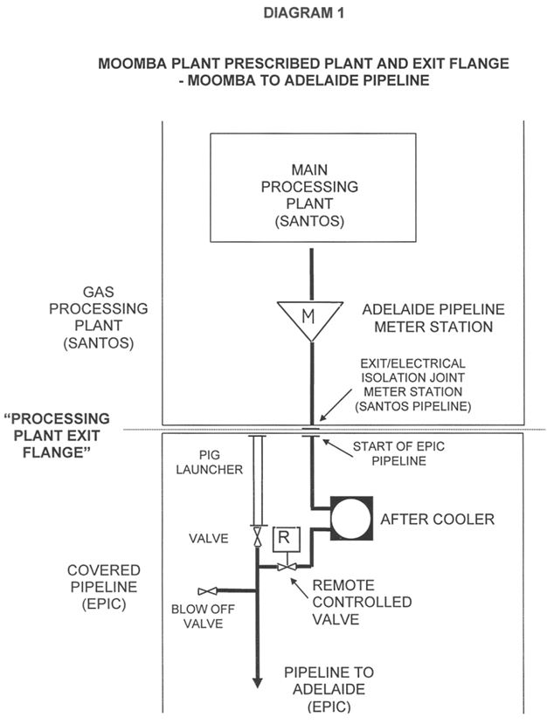

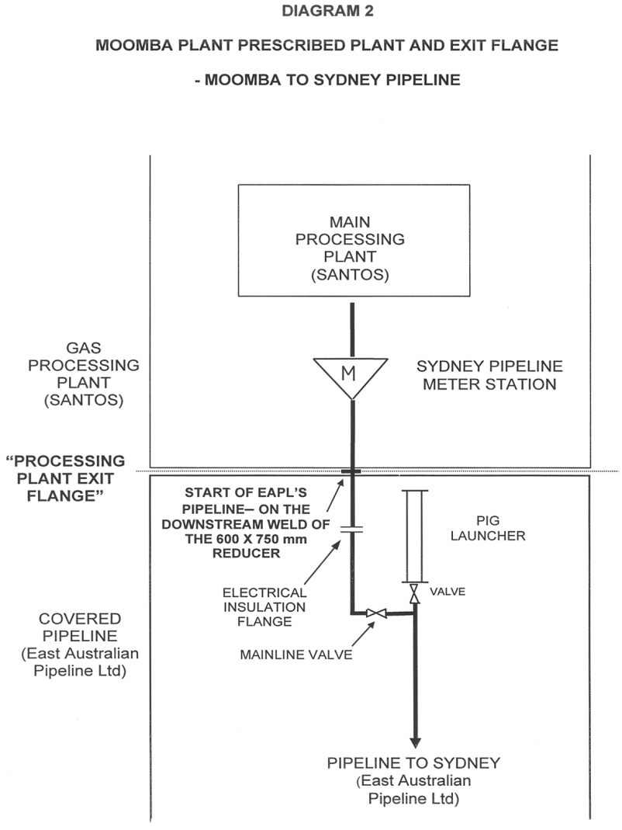

Schedule 3 — Civil penalties
[r. 6]
Provisions of the Rules
Rule 27(4)
Rule 33(1)
Rule 36
Rule 37
Rule 43(1)
Rule 46
Rule 52(1)
Rule 53(6)
Rule 107
Rule 108
Rule 109
Rule 110
Rule 111
Rule 112
Rule 137
Rule 138

Schedule 4 — Conduct provisions
[r. 7]
Provisions of the Rules
Rule 33(1)
Rule 36
Rule 107
Rule 108
Rule 109
Rule 110
Rule 111
Rule 112
Rule 115(3)
Rule 137
Rule 138

Schedule 5 — Fees
[r. 14]
 |  | $
1. | Application for a coverage determination under section 92 of the NGL | 7 500
2. | Application for a coverage revocation determination under section 102 of the NGL | 7 500
3. | Application to the NCC under section 128 of the NGL | 2 000
4. | Application for a 15 year no-coverage determination under section 151 of the NGL | 7 500
5. | Application for a price regulation exemption under section 160 of the NGL | 7 500
6. | Notification of an access dispute under section 181 of the NGL | 2 750

Notes
This is a compilation of the National Gas Access (WA) (Part 3) Regulations 2009. For provisions that have come into operation see the compilation table.

Compilation table
Citation | Gazettal | Commencement
National Gas Access (WA) (Part 3) Regulations 2009 | 31 Dec 2009 p. 5343-64 | 1 Jan 2010 (see r. 2 and Gazette 31 Dec 2009 p. 5327)

Defined terms

[This is a list of terms defined and the provisions where they are defined. The list is not part of the law.]
Defined term Provision(s)
Act 3
Board 15(1)
Gas Pipelines Access Law 15(1)
NGL 3
transitional provisions 15(1)
WA commencement date 4(2)

