Western Australia

Rights in Water and Irrigation (Construction and Alteration of Wells) Regulations 1963
Compare between:
[01 Jan 1996, 00-s0-02] and [10 Jan 2001, 00-t0-05]

Western Australia
WATER AGENCIES (POWERS) ACT 1984
Rights in Water and Irrigation (Construction and Alteration of Wells) Regulations 1963
Regulations

1. Citation
These regulations may be cited as the Rights in Water and Irrigation (Construction and Alteration of Wells) Regulations 1963 ¹.

2. Revocation
The regulations made under the Rights in Water and Irrigation Act 1914 and published in the Government Gazette on the 22nd January, 1915, are revoked.

3. Interpretation
In these regulations, unless the context otherwise requires —
“licensee” means a person who is deemed to be the holder of a licence issued under section 26D;
“well” means an artesian well and, also, a non-artesian well that is situate in an area proclaimed under section 26B.
[Regulation 3 inserted in Gazette 5 July 1985 p.2407.]

4. Application for licence to construct or enlarge a well
Every person applying for a licence for the commencement or construction of a well or for the enlargement, deepening or altering of an existing well, pursuant to the provisions of section 26D, shall make his application to the Commission —
(a) in the case of an artesian well, in the form of Form 1; and
(b) in the case of a non-artesian well, in the form of Form 2;
in the Schedule 1.
[Regulation 4 amended in Gazette 7 May 1976 p.1399; 5 July 1985 p.2407; 29 June 1988 p.2110; 29 December 1995 p.6299.]

4A. Application of regulation 5
The provisions of regulation 5 apply to an application for a licence for the drawing of water from an existing well unless under the terms and conditions of the licence the term for which the licence is valid may be extended by the Commission.
[Regulation 4A inserted in Gazette 7 May 1976 p.1399; amended in Gazette 5 July 1985 p.2407; 29 December 1995 p.6299.]

5. Information to be provided with application
(1) Every application made under regulation 4 shall be accompanied by —
(a) a plan or tracing of a plan, drawn to such scale, and having such bearings and distances or measurements marked thereon, as to show the exact position of the well or proposed well and its relation to an established point depicted on a Department of Land Administration plan or other plan approved by the Commission;
(b) the specifications of the construction of the well; and
(c) a statement setting out the purposes for which the water is used, or is proposed to be used, with particulars of the extent of use for each purpose, such as the number or probable number of stock to be watered, the area or probable area to be irrigated, crops growing or proposed to be grown and the requirements for domestic use.
(2) The plan, specification and statement submitted pursuant to this regulation shall be signed by the applicant, his attorney or authorised agent and shall be dated.
[Regulation 5 amended in Gazette 29 December 1995 p.6297.]

6. Form of licence
Every licence issued pursuant to section 26D of the Act shall be in the form of Form 3 in the Schedule 1 and shall be indorsed with the terms, limitations or conditions (if any) to which the issue of the licence is subject.
[Regulation 6 amended in Gazette 5 July 1985 p.2407; 29 June 1988 p.2110.]

7. Notice to be given of required alterations or refusal
Where, before the issue of the licence, the Commission requires any alterations to be made in, or in connection with the proposed work, plan or specifications or refuses the application, advice of that requirement or refusal shall be sent to the applicant at the address shown on the application.
[Regulation 7 amended in Gazette 5 July 1985 p.2407; 29 December 1995 p.6299.]

8. Objections
(1) A person aggrieved by any decision of the Commission made under the provisions of section 26D of the Act and advised under regulation 7, if wishing to be heard, shall give notice thereof in writing addressed to the Minister for Water Resources within 30 days of his receipt of the advice in this regulation mentioned.
(2) Where the Minister causes an inquiry to be conducted for the purpose of hearing a person aggrieved by his decision, notice of the place of, and day of the commencement of, the inquiry shall be sent to the applicant, at the address shown on the application, at least 14 clear days before that day.
(3) The Minister may, from time to time, at the request of the person requiring to be heard, adjourn the commencement of the inquiry for a sufficient period to enable that person to be present and notice of the adjourned date shall be sent to that person, as provided by subregulation (2) of this regulation.
[Regulation 8 amended in Gazette 5 July 1985 p.2407; 29 June 1988 p.2110; 29 December 1995 p.6299.]

9. Monthly statements
Every person, being the holder of a licence for the commencement, construction, enlargement, deepening or alteration of an artesian well, shall, at the expiration of each calendar month after the day of issue of the licence, until the completion of the work, and within 30 days after the completion of the work, forward to the Commission a statement regarding that well in the form of Form 4 in the Schedule 1.
[Regulation 9 amended in Gazette 5 July 1985 p.2408; 29 June 1988 p.2110; 29 December 1995 p.6299.]

10. Notice of completion
Every person, being the holder of a licence for the commencement, construction, enlargement, deepening or alteration of a non-artesian well in a proclaimed area, shall, within 30 days after the completion of the work, forward to the Commission a statement regarding that well in the form of Form 5 in the Schedule 1.
[Regulation 10 amended in Gazette 5 July 1985 p.2408; 29 June 1988 p.2110; 29 December 1995 p.6299.]
[10A. Inserted in Gazette 2 February 1973 p.301. Disallowed by Legislative Council 1 May 1973; see Gazette 18 May 1973 p.1261.]

11. Statement of emergency works
(1) Where, under the provisions of section 26F of the Act, works necessary for the maintenance of a well in good order or occasioned by any unforeseen emergency are carried out, the notice of those works given pursuant to that section shall be in the form of statement to the Commission, setting forth —
(a) the nature of the works; and
(b) the circumstances that rendered them necessary or the emergency that occasioned them.
(2) Every application for an amended licence, under the provisions of subsection (3) of section 26F of the Act, shall be accompanied by the licence, a statement of the required amendments and the circumstances giving rise to that requirement.
[Regulation 11 amended in Gazette 5 July 1985 p.2408; 29 December 1995 p.6299.]

12. Officers may inspect wells etc
(1) Every well, channel, ditch, flume or other work constructed under the authority of the Act and every regulator or meter used in connection therewith may, at all reasonable times, be inspected by any officer appointed by the Commission for that purpose.
(2) Every person who obstructs or impedes, or interferes with, an officer exercising or attempting to exercise the powers conferred by this regulation commits an offence.
[Regulation 12 amended in Gazette 5 July 1985 p.2408; 29 December 1995 p.6299.]
Fitting Meters to Wells
[Heading inserted in Gazette 10 December 1964 p.3969.]

12A. Commission may install meters
(1) Upon the request of the Commission a licensee shall permit the Commission to fit a meter to any artesian well or non-artesian well for the purpose of stipulating the quantity of water to be drawn from such well.
(2) Upon the request of the Commission, a licensee shall permit the Commission to fit, in proximity to any meter fitted pursuant to any artesian well or non-artesian well, any ancillary equipment, including baffles.
[Regulation 12A inserted in Gazette 10 December 1964 p.3969; amended in Gazette 6 February 1969 p.452; 5 July 1985 p.2408; 29 December 1995 p.6299.]
Damage to Meters
[Heading inserted in Gazette 10 December 1964 p.3969.]

12B. Damage to meters
(1) A licensee whose well is fitted with a meter belonging to the Commission shall pay the cost of —
(a) removing any body or substance, including sand, in the meter which is preventing the meter from registering accurately or at all; and
(b) making good all damage to the meter.
(2) Any work or repairs required shall be done by the Commission, and the expense incurred in so doing shall, on demand, be paid by the licensee, and if not paid on demand shall be a debt due to the Commission.
[Regulation 12B inserted in Gazette 10 December 1964 p.5969; amended in Gazette 17 February 1984 p.442; 5 July 1985 p.2408; 29 December 1995 pp.6298 and 6299.]
Interference with a Meter
[Heading inserted in Gazette 10 December 1964 p.3969.]

12C. Interference with a meter
A person other than an officer of the Commission or a person authorized by the Commission shall not —
(a) break or in any way interfere with the seal fixed on a meter;
(b) turn or attempt to turn any screw, bolt or nut on or attached to a meter;
(c) introduce or attempt to introduce any body or substance into a meter;
(d) interfere in any way with the correct registration of a meter; or
(e) cause the supply of water to by-pass a meter.
[Regulation 12C inserted in Gazette 10 December 1964 p.3969; amended in Gazette 5 July 1985 p.2408; 29 December 1995 p.6298.]
Testing of Meters
[Heading inserted in Gazette 10 December 1964 p.3969.]

12D. Objections to meter readings
(1) Where a licensee is at any time dissatisfied with the reading of a meter, he may give written notice to the Commission within 7 days of the reading requiring the meter to be tested, and the meter shall then be tested by passing through it a predetermined quantity of water.
(2) When a test has been completed to the satisfaction of the Commission then —
(a) where the meter registers more than 5% in excess of the quantity that actually passes through it at the test, the Commission shall bear all direct and incidental expenses of that test;
(b) where the meter registers less than 5% in excess of the quantity that actually passes through it at the test, the licensee shall pay to the Commission all direct and incidental expenses of that test.
(3) The expenses of a test shall be fixed by the Commission, subject to the minimum fee prescribed in Schedule 2.
(4) A licensee may only request a test for the period of registration last preceding the date of reading in respect of which he gives notice.
[Regulation 12D inserted in Gazette 10 December 1964 p.3969; amended in Gazette 5 July 1985 p.2408; 1 July 1987 p.2550; 29 June 1988 p.2110; 29 December 1995 pp.6298 and 6299.]
Averaging of Quantity Drawn
[Heading inserted in Gazette 10 December 1964 p.3969.]

12E. Averaging of quantity of water drawn
(1) Where a meter ceases to register the correct quantity of water drawn from a well, or where a meter is being repaired, the Commission shall estimate the quantity of water drawn by taking an average of the quantities drawn during any previous periods, and the quantity so estimated shall be considered to be the amount of water drawn from the well for the purpose of section 26G of the Act.
(2) Notice of an estimate made under this regulation shall be sent to the licensee.
[Regulation 12E inserted in Gazette 10 December 1964 p.3969; amended in Gazette 29 December 1995 p.6299.]
Evidence of Certificate of Reading
[Heading inserted in Gazette 10 December 1964 p.3969.]

12F. Evidence of certificate of reading
Where in any proceedings the quantity of water drawn from a well is in question, then a certificate signed by an officer appointed by the Commission, which states the quantity registered by the meter attached to the well shall be prima facie evidence of the quantity of water drawn from the well.
[Regulation 12F inserted in Gazette 10 December 1964 p.3969; amended in Gazette 29 December 1995 p.6299.]

13. Breach of regulations an offence
Any person who contravenes or fails to comply with any of the provisions of these regulations is guilty of an offence and liable to a penalty of $1 000.
[Regulation 13 inserted in Gazette 24 July 1968 p.2112; amended in Gazette 5 July 1985 p.2408.]

14. Prescribed form — section 26E
The form required pursuant to section 26E shall be in the form of Form 6 in Schedule 1, furnished to the Commission.
[Regulation 14 inserted in Gazette 5 July 1985 p.2408; amended in Gazette 29 June 1988 p.2110; 29 December 1995 p.6298.]

Schedule 1
[Reg. 4]
Form 1 — Artesian Well
Western Australia
Rights in Water and Irrigation Act 1914 ²
APPLICATION FOR A LICENCE UNDER SECTION 26D
Name, address and occupation of applicant | ............................................................................  ............................................................................
Description, location and approximate height above sea level of proposed new well or of existing well proposed to be enlarged, deepened or altered or drawn upon | Description ........................................................  ............................................................................  ............................................................................  Municipal District of the ..................................  ............................................................................  ............................................................................  Lot, Location, or Lease No ................................  Approximate height above sea level...................  ............................................................................
* Nature of proposed work ............................ | ............................................................................  ............................................................................
Statement of the purposes for which it is proposed to utilise the water (Regulation 5 (1) (c)) | ............................................................................  ............................................................................  ............................................................................  ............................................................................
The several casings proposed to be used with the names of the makers, and whether of soft, wrought iron, or mild steel | ............................................................................  ............................................................................  ............................................................................  ............................................................................
Particulars regarding depth and volume of flow from each artesian well within a radius of 10 miles from the site of the well | Depth .................................................................  Volume ..............................................................
Whether the water will be distributed by natural or artificial drains or by both | ............................................................................  ............................................................................  ............................................................................  ............................................................................
Approximate estimate of the length of each drain, the total aggregate length of drains and their respective routes | ............................................................................  ............................................................................  ............................................................................  ............................................................................
Period for which licence is required............... | ............................................................................  ............................................................................
Remarks or further explanations .................... | ............................................................................  ............................................................................  ............................................................................  ............................................................................  ............................................................................  ............................................................................  ............................................................................
I/WE ..............................................., of .................................................................,
in the State of Western Australia, hereby apply for a licence under the Rights in Water and Irrigation Act 1914 ², for a new well (or to enlarge or deepen or alter or draw water from a now existing well on land situated at .................................,
in the Municipal District of the ..................................................., such land being
shown on accompanying plan marked “A” and shaded pink, and upon which land I/we desire to construct a new well (or to enlarge, or deepen, or alter or draw water from a now existing well) as described above.
Dated at ........................ this ............................. day of ................................ in
the year 19 ..........
........................................................
Signature of Applicant
Note. — Plans and specifications must accompany this application in accordance with Regulation No. 5.
Heading marked * should state whether the proposed work is for a new well or for enlarging, deepening, or altering or drawing water from a now existing well, or as the case may be.
Form No. 2 — Non-Artesian Well
Western Australia
[Reg. 4]
Rights in Water and Irrigation Act 1914 ²
APPLICATION FOR A LICENCE UNDER SECTION 26D
Name, address and occupation of applicant | ............................................................................  ............................................................................
Description, location and approximate height above sea level of proposed new well or of existing well proposed to be enlarged, deepened or altered or drawn upon | Description ........................................................  ............................................................................  ............................................................................  Municipal District of the ...................................  ............................................................................  Lot, Location, or Lease No. ...............................  ............................................................................  Approximate height above sea level ..................  ............................................................................
* Nature of proposed work ............................ | ............................................................................  ............................................................................
Statement of the purposes for which it is proposed to utilise the water (Regulation 5 (1) (c)) | ............................................................................  ............................................................................  ............................................................................  ............................................................................
Period for which licence is required | ............................................................................  ............................................................................
Remarks or further explanations . . . | ............................................................................  ............................................................................  ............................................................................  ............................................................................  ............................................................................  ............................................................................  ............................................................................
I/We ................................................, of ................................................................,
in the State of Western Australia, hereby apply for a licence under the Rights in Water and Irrigation Act 1914 ², for a new well (or to enlarge or deepen or alter or draw water from a now existing well on land situated at ..................................
in the Municipal District of the ..................................................., such land being
shown on accompanying plan marked “A” and shaded pink, and upon which land I/we desire to construct a new well (or to enlarge or deepen or alter or draw water from a now existing well) as described above.
Dated at ................................................ this ...............................................day
of ............................................. in the year of 19 ........
........................................................
Signature of Applicant
Note. — Plans and specifications must accompany this application in accordance with Regulation No. 5.
Heading marked * should state whether the proposed work is for a new well or for enlarging deepening, or altering or drawing water from a now existing well, or as the case may be.
Form 3
Water Agencies (Powers) Act 1984
[Reg. 6]
GROUNDWATER WELL LICENCE
Issued under section 26D of the Rights in Water and Irrigation Act 1914 ²
Name
and
address
of
licensee
Description
of land
upon which
wells are
located
Location
of wells
Things that
may be
done
pursuant to
this licence
Licence
expiry
Purpose
for which
licence
is issued
This licence is subject to the following terms, limitations and conditions
Given under my hand this .............................. day of ............................................
................................................................................................. Authorised Officer
Form 4
[Reg. 9]
Western Australia
Rights in Water and Irrigation Act 1914 ²
MONTHLY OR FINAL STATEMENT IN RESPECT OF ARTESIAN WELLS BEING CONSTRUCTED, ENLARGED, DEEPENED, OR ALTERED UNDER LICENCE
Name and address of licensee ........................ | ............................................................................
Location of well, stating Municipal District and lot or location No. | ............................................................................  ............................................................................
The several casings used, with the names of the makers and the weight per running foot of each size, and whether of soft wrought iron or of mild steel. | ............................................................................  ............................................................................  ............................................................................
Diameter and length of casings inserted, and whether whole or perforated. | ............................................................................  ............................................................................
If perforated, the sizes and lengths, with the position of each perforated length in the bore. | ............................................................................  ............................................................................  ............................................................................
The depth reached in the well ........................ | ............................................................................
The depth from the surface, with the thickness and character of each of the different beds of strata pierced. | ............................................................................  ............................................................................  ............................................................................
Particulars of water struck (if any), whether salt, brackish or fresh, and the depths from the surface at which each water-bearing bed was struck. | ............................................................................  ............................................................................  ............................................................................
Also, the height above ground level to which the water will rise in the casing. | ............................................................................  ............................................................................
The approximate daily volume of the flow of artesian water from each artesian water-bearing bed tapped, and the final or total daily volume from the well on its completion. The day to consist of 24 hours. | ............................................................................  ............................................................................  ............................................................................  ............................................................................  ............................................................................  ............................................................................  ............................................................................
I, ..................................................... of ...................................................................
in the State of Western Australia, being the holder of a licence for the construction, enlargement, deepening, or alteration of an artesian well situated at ................................ in the Municipal District of the ............................. hereby
forward statement (for the month of) ............................ 19 ...... , in respect of the
abovementioned work.
........................................................
Signature of Licensee
........................................................
Date
To the Water and Rivers Commission
Note. — If work suspended, or fishing operations only carried on, state that fact.
The head driller of a bore may make out the monthly statements, also the final statements, but the correctness of any of such statements must be verified as far as practicable by the Licensee or his local representative and forwarded by him to the Water and Rivers Commission.
If work completed this statement must be marked FINAL.
Form 5
[Reg. 10]
Western Australia
Rights in Water and Irrigation Act 1914 ²
FINAL STATEMENT IN RESPECT OF NON-ARTESIAN WELLS BEING CONSTRUCTED, ENLARGED, DEEPENED, OR ALTERED UNDER LICENCE
Name and address of licensee ........................ | ............................................................................
Location of well, stating Municipal District and lot or location No. | ............................................................................  ............................................................................
Diameter and length of casings inserted, and whether whole or perforated. | ............................................................................  ............................................................................  ............................................................................
If perforated, the sizes and lengths, with the position of each perforated length in the well. | ............................................................................  ............................................................................  ............................................................................
The depth reached in the well ........................ | ............................................................................
The depth from the surface, with the thickness and character of each of the different beds of strata pierced. | ............................................................................  ............................................................................  ............................................................................
Particulars of water struck (if any), whether salt, brackish, or fresh, and the depths from the surface at which each water-bearing bed was struck. | ............................................................................  ............................................................................  ............................................................................
Also the height below ground level to which the water will rise in the casing. | ............................................................................  ............................................................................
I, ..................................................... of ...................................................................
in the State of Western Australia, being the holder of a licence for the construction, enlargement, deepening, or alteration of a non-artesian well situated at .................................................................. in the Municipal District of
the ................................................ hereby forward the statement under regulation
No. 10 in respect of the abovementioned work.
........................................................
Signature of Licensee
........................................................
Date
To the Water and Rivers Commission.
Note. — If work suspended, or fishing operations only carried on, state that fact.
The head driller of a bore may make out the final statements, but the correctness of such statements must be verified as far as practicable by the Licensee or his local representative and forwarded by him to the Water and Rivers Commission.
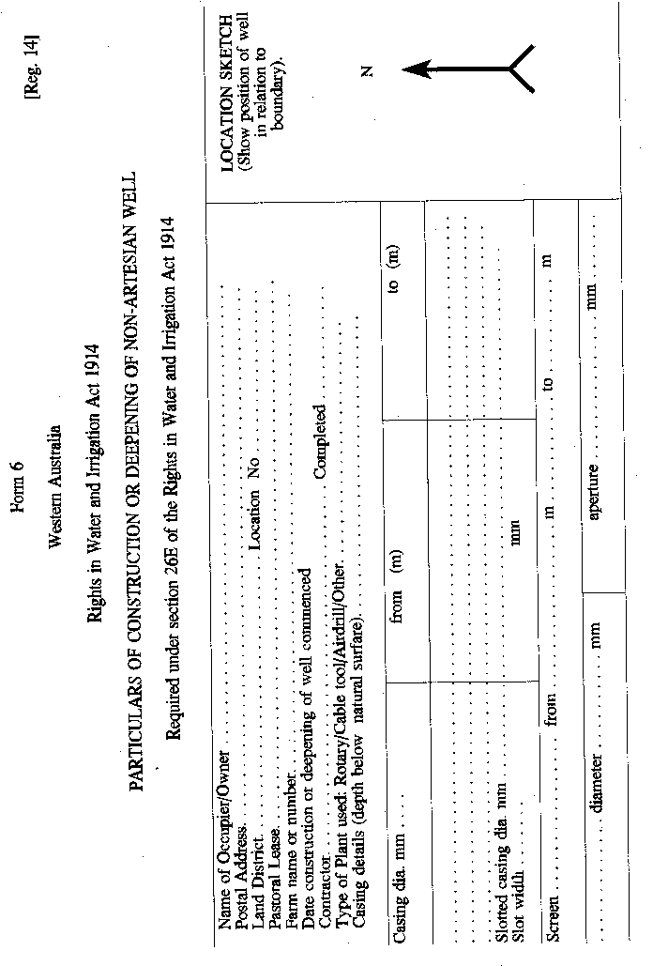
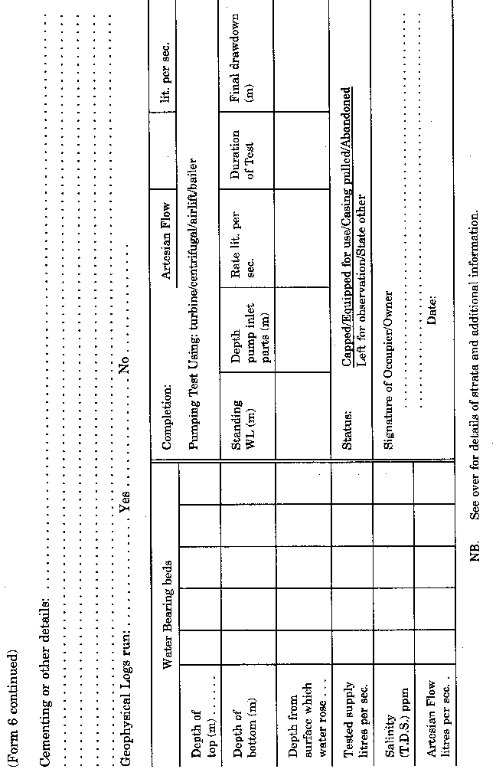
(Reverse of Form 6)
Particulars of Strata
From (m) | To (m) | Thickness | Strata
OTHER ADDITIONAL INFORMATION
.................................................................................................................................
.................................................................................................................................
.................................................................................................................................
.................................................................................................................................
.................................................................................................................................
.................................................................................................................................
.................................................................................................................................
.................................................................................................................................
.................................................................................................................................
TO the Director,
Geological Survey of Western Australia,
Mines Department ³,
66 Adelaide Terrace,
PERTH 6000
[Schedule 1 amended in Gazette 6 July 1965 p.1993-5; 6 February 1969 p.452; 10 May 1974 p.1519; 5 July 1985 pp.2408-9; Erratum in Gazette 19 July 1985 p.2507; amended in Gazette 29 June 1988 p.2111; 12 May 1989 p.1445; 29 December 1995 p.6298.]

Schedule 2
[Reg. 12D]
Minimum fee for testing of meter ................................................ | $8.00
[Schedule 2 added in Gazette 29 June 1988 p.2111; amended in Gazette 29 June 1989 p.1939; 29 June 1990 p.3249; 28 June 1991 p.3289; 26 June 1992 p.2846; 1 July 1993 p.3214.]

Notes
^{1.} This reprint is a compilation as at 27 May 1996 of the Rights in Water and Irrigation (Construction and Alteration of Wells) Regulations 1963 and includes the amendments effected by the regulations referred to in the following Table.

Compilation table
Citation | Gazettal | Commencement
Rights in Water and Irrigation (Construction and Alteration of Wells) Regulations 1963 | 15 May 1963 pp.1297-1305 | 15 May 1963
Amending regulations | 10 Dec 1964 pp.3969-70 | 10 Dec 1964
Amending regulations | 6 Jul 1965 pp.1993-5 | 6 Jul 1965
Amending regulations | 24 Jul 1968 p.2112 | 24 Jul 1968
Amending regulations | 6 Feb 1969 p.452 | 6 Feb 1969
Amending regulations | 2 Feb 1973 p.301  Regulation 10A disallowed: see Gazette 18 May 1973 p.1261 | 2 Feb 1973
Amending regulations | 10 May 1974 p.1519 | 10 May 1974
Amending regulations | 7 May 1976 p.1399 | 7 May 1976
Rights in Water and Irrigation (Construction and Alteration of Wells) Amendment Regulations 1984 | 17 Feb 1984 p.442 | 17 Feb 1984
Rights in Water and Irrigation (Construction and Alteration of Wells) Amendment Regulations 1985  Erratum 19 July 1985 p.2507 | 5 Jul 1985 pp.2407-9 | 5 Jul 1985
Rights in Water and Irrigation (Construction and Alteration of Wells) Amendment Regulations 1987 | 1 Jul 1987 p.2550 | 1 Jul 1987 (see regulation 2)
Rights in Water and Irrigation (Construction and Alteration of Wells) Amendment Regulations 1988 | 29 Jun 1988 pp.2110-11 | 29 Jun 1988
Rights in Water and Irrigation (Construction and Alteration of Wells) Amendment Regulations 1989 | 12 May 1989 p.1445 | 12 May 1989
Rights in Water and Irrigation (Construction and Alteration of Wells) Amendment Regulations (No. 2) 1989 | 30 Jun 1989 p.1939 | 1 Jul 1989 (see regulation 2)
Rights in Water and Irrigation (Construction and Alteration of Wells) Amendment Regulations 1990 | 29 Jun 1990 p.3249 | 1 Jul 1990 (see regulation 2)
Rights in Water and Irrigation (Construction and Alteration of Wells) Amendment Regulations 1991 | 28 Jun 1991 p.3289 | 1 Jul 1991 (see regulation 2)
Rights in Water and Irrigation (Construction and Alteration of Wells) Amendment Regulations 1992 | 26 Jun 1992 pp.2845-6 | 1 Jul 1992 (see regulation 2)
Rights in Water and Irrigation (Construction and Alteration of Wells) Amendment Regulations (No. 2) 1993 | 1 Jul 1993 p.3214 | 1 Jul 1993 (see regulation 2)
Water Agencies (Amendment and Repeal) Regulations 1995 Part 5 | 29 Dec 1995 pp.6297-9 | 1 Jan 1996 (see regulation 2 and Gazette 29 Dec 1995 p.6291)
These regulations were repealed by the Rights in Water and Irrigation Regulations 2000 r. 58(b) as at 10 Jan 2001 (see r. 2 and Gazette 10 Jan 2001 p. 201)
² Now see the Water Agencies (Powers) Act 1984.
³ Now known as Department of Minerals and Energy.

