Western Australia

Water Agencies (Water Use) By-laws 2010
Compare between:
[09 Aug 2022, 01-d0-00] and [01 Sep 2022, 01-e0-00]

Western Australia
Water Agencies (Powers) Act 1984
Water Agencies (Water Use) By-laws 2010

Part 1 — Preliminary

1. Citation
These by-laws are the Water Agencies (Water Use) By-laws 2010.

2. Commencement
These by-laws come into operation as follows —
(a) by-laws 1 and 2 — on the day on which these by-laws are published in the Gazette;
(b) the rest of the by-laws — on 1 April 2010.

3. Terms used
In these by-laws, unless the contrary intention appears —
Area means Area 1, Area 2, Area 3 or Area 4;
Area 1 means that part of the State that is north of the line —
(a) starting at latitude - 27.428° and longitude 114.063°; and
(b) extending to latitude - 30.117° and longitude 117.081°; and
(c) extending to latitude - 30.117° and longitude 128.993°,
as illustrated for information purposes on the maps shown in Schedule 1;
Area 2 means that part of the State that is south of the line —
(a) starting at latitude - 27.428° and longitude 114.063°; and
(b) extending to latitude - 30.117° and longitude 117.081°; and
(c) extending to latitude - 30.117° and longitude 128.993°,
except Area 3 or Area 4, as illustrated for information purposes on the maps shown in Schedule 1;
Area 3 means the local government districts of Bayswater, Mandurah, Murray, Joondalup, Wanneroo, Swan, Perth, Canning, Belmont, Vincent, Kwinana, Rockingham, Cockburn, Armadale, Gosnells, Peppermint Grove, Stirling, Fremantle, Claremont, Subiaco, Cottesloe, East Fremantle, Victoria Park, South Perth, Mundaring, Kalamunda, Melville, Serpentine-Jarrahdale, Nedlands, Mosman Park, Bassendean and Cambridge, as illustrated for information purposes on the maps shown in Schedule 1;
Area 4 means the local government districts of Dardanup, Bunbury, Cranbrook, Donnybrook-Balingup, Collie, Capel, Busselton, Nannup, Augusta-Margaret River, Albany, Boyup Brook, Manjimup, Bridgetown-Greenbushes, Waroona, Harvey, Plantagenet and Denmark, as illustrated for information purposes on the maps shown in Schedule 1;
domestic bore means a non-artesian well as defined in the Rights in Water and Irrigation Act 1914 section 2(1) from which the only water that can be taken is from the water table aquifer;
domestic bore water or water means water taken from a domestic bore;
evening period means the period after 6.00 p.m.;
garden does not include any indoor plants or plants growing inside a glasshouse;
high pressure water cleaner means a cleaning device that uses pressurised water flowing at a rate of not more than 6 L per minute;
lawn does not include a grass-covered sporting ground;
morning period means the period before 9.00 a.m.;
relevant property, in relation to the watering of a lawn, garden or grass-covered sporting ground, means the property on which the lawn, garden or grass-covered sporting ground is located;
stage of restrictions means a stage of restrictions set out in Schedule 2;
synthetic sporting ground means a sporting ground that has a synthetic surface designed to be used after watering;
week means a period of 7 successive days beginning with Sunday.
[By-law 3 amended: Gazette 30 Nov 2010 p. 6016; 14 Nov 2013 p. 5097; 9 May 2017 p. 2431.]

Part 2 — Water restrictions
[Division 1A (bl. 4A) deleted: Gazette 9 May 2017 p. 2431.]
[Division 1 heading deleted: Gazette 9 May 2017 p. 2432.]

4. Contravening restrictions, offence
[(1) deleted]
(2) A person must not, without written approval of the CEO, use water in contravention of the stage of restrictions applicable under these by-laws.
Penalty: a fine of $500.
[By-law 4 amended: Gazette 28 Sep 2010 p. 5063; 14 Nov 2013 p. 5098.]

5. Area 1’s restrictions
[(1) deleted]
(2) The stage of restrictions that applies in relation to the use of domestic bore water in Area 1 is stage 1.
[By-law 5 amended: Gazette 28 Sep 2010 p. 5063; 14 Nov 2013 p. 5098.]

6. Area 2’s restrictions
[(1) deleted]
(2) The stage of restrictions that applies in relation to the use of domestic bore water in Area 2 is stage 1.
[By-law 6 amended: Gazette 28 Sep 2010 p. 5064; 8 Mar 2011 p. 801; 14 Nov 2013 p. 5098.]

7. Area 3’s restrictions
[(1) deleted]
(2) The stage of restrictions that applies in relation to the use of domestic bore water in Area 3 is —
(a) from 1 June to 31 August in a particular year — stage 6; and
(b) at any other time of the year — stage 4.
[By-law 7 amended: Gazette 28 Sep 2010 p. 5064; 30 Nov 2010 p. 6016; 14 Nov 2013 p. 5098; SL 2022/141 bl. 4.]

8. Area 4’s restrictions
[(1) deleted]
(2) The stage of restrictions that applies in relation to the use of domestic bore water in Area 4 is —
(a) from 1 June to 31 August in a particular year — stage 6; and
(b) at any other time of the year — stage 1.
[By-law 8 amended: Gazette 28 Sep 2010 p. 5064; 14 Nov 2013 p. 5098.]
[9, 10AA, 10A. Deleted: Gazette 14 Nov 2013 p. 5098.]
[Division 2 heading deleted: Gazette 9 May 2017 p. 2432.]

Part 3 — Exemptions from water restrictions
[Heading inserted: Gazette 9 May 2017 p. 2432.]

10. Rights in Water and Irrigation Act 1914 s. 5C, use of water under is exempt
A person does not commit an offence under by-law 4 if the person uses water in accordance with a licence under the Rights in Water and Irrigation Act 1914 section 5C.

11. Domestic bore on other property, using water from
(1) This by-law applies to a person using domestic bore water to water a lawn or garden by reticulation in circumstances where —
(a) a stage of restrictions prohibits the use of the water except on a day or days of the month determined by reference to the street number or, where there is no street number, the lot number of the relevant property; and
(b) the domestic bore is located on property with a different street or lot number (the other property).
(2) The person does not contravene the stage of restrictions only because, in any particular week —
(a) the person uses the water on days determined by reference to the street number or, where there is no street number, the lot number of the other property; and
(b) the person does not use the water on any other day.

12. Installing etc. reticulation system, using water for
(1) A person does not commit an offence under by-law 4 if the person operates a reticulation system using domestic bore water to the minimum extent necessary while the reticulation system is being installed, maintained, tested or repaired.
(2) A person does not commit an offence under by-law 4 if, in the course of the person’s occupation in the turf, garden or landscaping industries, the person operates a reticulation system using domestic bore water to the minimum extent necessary while the reticulation system is being installed, maintained, tested or repaired.
[By-law 12 amended: Gazette 14 Nov 2013 p. 5099.]

13. Vertimowing, fertilising etc. by commercial operator, watering after
(1) This by-law applies to the use of water in an Area unless the stage of restrictions designated stage 7 applies to that Area.
(2) A person does not commit an offence under by-law 4 if, in the course of the person’s occupation in the turf, garden or landscaping industries, the person waters a lawn, garden or grass-covered sporting ground immediately after —
(a) vertimowing; or
(b) the application of a fertiliser or wetting agent.

14. Market garden or plant nursery, watering of
A person does not commit an offence under by-law 4 if the person waters a market garden or plant nursery to the minimum extent necessary to ensure the viable operation of the market garden or plant nursery.

15. Caravan park site etc., watering of after vacation of
A person does not commit an offence under by-law 4 if the person waters a site as defined in the Caravan Parks and Camping Grounds Act 1995 section 5(1) immediately after the site has been vacated by an occupier.

16. Aviary, water for birds in
A person does not commit an offence under by-law 4 if the person waters an aviary to the minimum extent necessary to maintain the birds in that aviary.

17. Fire fighting, using water for
A person does not commit an offence under by-law 4 if the person uses water to the minimum extent necessary for fire fighting or training for fire fighting.
[Part 3 (bl. 18-29) deleted: Gazette 9 May 2017 p. 2432.]
[Part 4 (bl. 30-31) deleted: Gazette 9 May 2017 p. 2432.]

Schedule 1 — Maps showing Areas 1, 2, 3 and 4
[bl. 3]
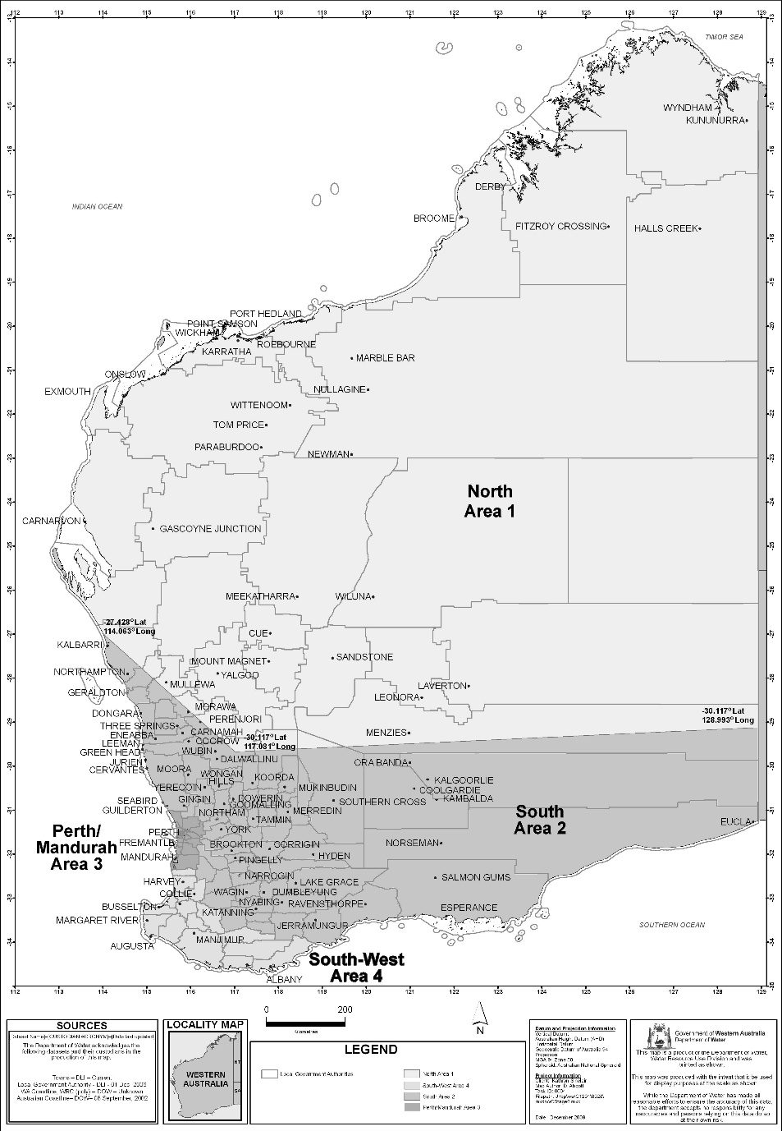
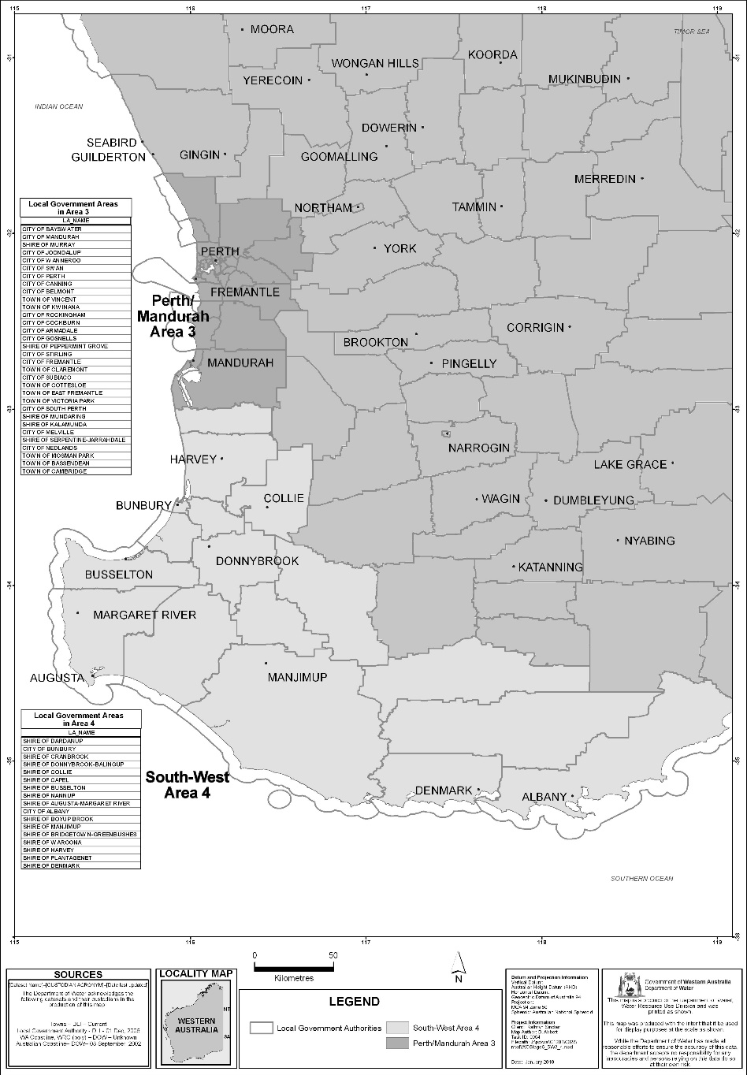

Schedule 2 — Stages of restrictions
[bl. 3]

1. Stage 1
(1) A person must not water a lawn, garden or grass-covered sporting ground except by —
(a) reticulation during either, but not both, the morning period or the evening period on a particular day; or
(b) a handheld hose with one outlet; or
(c) a handheld watering can.
(2) A person must not water a synthetic sporting ground except for 10 minutes or less before a sport is played or practised on the sporting ground.

2. Stage 2
(1) A person must not water a lawn, garden or grass-covered sporting ground except by —
(a) reticulation during either, but not both, the morning period or the evening period —
(i) on any even numbered day of the month if the relevant property has an even street number or, where there is no street number, an even lot number; or
(ii) on any odd numbered day of the month if the relevant property has an odd street number or, where there is no street number, an odd lot number;
or
(b) a handheld hose with one outlet; or
(c) a handheld watering can.
(2) A person must not spray a building, building site, demolition site (including vacant land resulting from a demolition), path, paved area or road except —
(a) with —
(i) a high pressure water cleaner; or
(ii) a handheld hose with one outlet,
to the minimum extent necessary for the cleaning of the building, building site, demolition site (including vacant land resulting from a demolition), path, paved area or road so as to avoid a threat to public health or safety; or
(b) with a handheld hose with one outlet to the minimum extent necessary for purposes related to the construction, demolition or repair of the building, path, paved area or road.
(3) A person must not water a synthetic sporting ground except for 10 minutes or less before a sport is played or practised on the sporting ground.

3. Stage 3
(1) A person must not water a lawn, garden or grass-covered sporting ground except by —
(a) reticulation during either, but not both, the morning period or the evening period on one or more of 3 days of the week specified in relation to the relevant property in Schedule 3 Division 1; or
(b) a handheld hose with one outlet; or
(c) a handheld watering can.
(2) A person must not spray a building, building site, demolition site (including vacant land resulting from a demolition), path, paved area or road except —
(a) with —
(i) a high pressure water cleaner; or
(ii) a handheld hose with one outlet,
to the minimum extent necessary for the cleaning of the building, building site, demolition site (including vacant land resulting from a demolition), path, paved area or road so as to avoid a threat to public health or safety; or
(b) with a handheld hose with one outlet to the minimum extent necessary for purposes related to the construction, demolition or repair of the building, path, paved area or road.
(3) A person must not water a synthetic sporting ground except for 10 minutes or less before a sport is played or practised on the sporting ground.

4. Stage 4
(1) A person must not water a lawn or garden except by —
(a) reticulation during either, but not both, the morning period or the evening period on one or both of 2 days of the week specified in relation to the relevant property in Schedule 3 Division 2; or
(b) a handheld hose with one outlet; or
(c) a handheld watering can.
(2) A person must not water a grass-covered sporting ground except by —
(a) reticulation during either, but not both, the morning period or the evening period on one or more of 3 days of the week specified in relation to the relevant property in Schedule 3 Division 1; or
(b) a handheld hose with one outlet; or
(c) a handheld watering can.
(3) A person must not spray a building, building site, demolition site (including vacant land resulting from a demolition), path, paved area or road except —
(a) with —
(i) a high pressure water cleaner; or
(ii) a handheld hose with one outlet,
to the minimum extent necessary for the cleaning of the building, building site, demolition site (including vacant land resulting from a demolition), path, paved area or road so as to avoid a threat to public health or safety; or
(b) with a handheld hose with one outlet to the minimum extent necessary for purposes related to the construction, demolition or repair of the building, path, paved area or road.
(4) A person must not water a synthetic sporting ground except for 10 minutes or less before a sport is played or practised on the sporting ground.

5. Stage 5
(1) A person must not water a lawn or garden except by —
(a) reticulation during either, but not both, the morning period or the evening period on one day of the week specified in relation to the relevant property in Schedule 3 Division 3; or
(b) a handheld hose with one outlet; or
(c) a handheld watering can.
(2) A person must not water a grass-covered sporting ground except by —
(a) reticulation during either, but not both, the morning period or the evening period on one or more of 3 days of the week specified in relation to the relevant property in Schedule 3 Division 1; or
(b) a handheld hose with one outlet; or
(c) a handheld watering can.
(3) A person must not spray a building, building site, demolition site (including vacant land resulting from a demolition), path, paved area or road except —
(a) with —
(i) a high pressure water cleaner; or
(ii) a handheld hose with one outlet,
to the minimum extent necessary for the cleaning of the building, building site, demolition site (including vacant land resulting from a demolition), path, paved area or road so as to avoid a threat to public health or safety; or
(b) with a handheld hose with one outlet to the minimum extent necessary for purposes related to the construction, demolition or repair of the building, path, paved area or road.
(4) A person must not water a synthetic sporting ground except for 10 minutes or less before a sport is played or practised on the sporting ground.

6. Stage 6
(1) A person must not water a lawn or garden except by —
(a) a handheld hose with one outlet; or
(b) a handheld watering can.
(2) A person must not water a grass-covered sporting ground except by —
(a) reticulation during either, but not both, the morning period or the evening period on one or more of 3 days of the week specified in relation to the relevant property in Schedule 3 Division 1; or
(b) a handheld hose with one outlet; or
(c) a handheld watering can.
(3) A person must not spray a building, building site, demolition site (including vacant land resulting from a demolition), path, paved area or road except —
(a) with —
(i) a high pressure water cleaner; or
(ii) a handheld hose with one outlet,
to the minimum extent necessary for the cleaning of the building, building site, demolition site (including vacant land resulting from a demolition), path, paved area or road so as to avoid a threat to public health or safety; or
(b) with a handheld hose with one outlet to the minimum extent necessary for purposes related to the construction, demolition or repair of the building, path, paved area or road.
(4) A person must not fill a swimming pool except —
(a) to replace water lost from the pool through evaporation or ordinary use; and
(b) to the minimum extent necessary for the proper functioning of the pool.
(5) A person must not water a synthetic sporting ground except for 10 minutes or less before a sport is played or practised on the sporting ground.

7. Stage 7
(1) A person must not water a lawn, garden, grass-covered sporting ground or synthetic sporting ground except by a handheld watering can.
(2) A person must not spray a building, building site, demolition site (including vacant land resulting from a demolition), path, paved area or road except —
(a) with —
(i) a high pressure water cleaner; or
(ii) a handheld hose with one outlet,
to the minimum extent necessary for the cleaning of the building, building site, demolition site (including vacant land resulting from a demolition), path, paved area or road so as to avoid a threat to public health or safety; or
(b) with a handheld hose with one outlet to the minimum extent necessary for purposes related to the construction, demolition or repair of the building, path, paved area or road.
(3) A person must not fill a swimming pool.
(4) A person must not wash a motor vehicle except —
(a) to the minimum extent necessary to enable the vehicle to be driven safely; and
(b) by using a bucket of water and a cloth.

Schedule 3 — Specified days for watering by reticulation
[bl. 3, 6, Sch. 2 cl. 3, 4, 5 and 6]

Division 1 — Specified days for Schedule 2 clauses 3(1)(a), 4(2)(a), 5(2)(a) and 6(2)(a)
Last digit of property’s street number or, where there is no street number, lot number | Days for watering by reticulation
1 | Monday, Wednesday and Saturday
2 | Sunday, Tuesday and Thursday
3 | Monday, Wednesday and Friday
4 | Tuesday, Thursday and Saturday
5 | Sunday, Wednesday and Friday
6 | Monday, Thursday and Saturday
7 | Sunday, Tuesday and Friday
8 | Monday, Wednesday and Saturday
9 | Sunday, Tuesday and Thursday
0 | Monday, Wednesday and Friday

Division 2 — Specified days for Schedule 2 clause 4(1)(a)
Last digit of property’s street number or, where there is no street number, lot number | Days for watering by reticulation
1 | Wednesday and Saturday
2 | Sunday and Thursday
3 | Monday and Friday
4 | Tuesday and Saturday
5 | Sunday and Wednesday
6 | Monday and Thursday
7 | Tuesday and Friday
8 | Wednesday and Saturday
9 | Sunday and Thursday
0 | Monday and Friday

Division 3 — Specified days for Schedule 2 clause 5(1)(a)
Last digit of property’s street number or, where there is no street number, lot number |  | Day for watering by reticulation
1 |  | Wednesday
2 |  | Thursday
3 |  | Friday
4 |  | Saturday
5 |  | Sunday
6 |  | Monday
7 |  | Tuesday
 | 8 | Wednesday
 | 9 | Thursday
 | 0 | Friday
[Division 3 amended: Gazette 28 Sep 2010 p. 5065.]
[Schedule 4 deleted: Gazette 14 Nov 2013 p. 5099.]

Notes
This is a compilation of the Water Agencies (Water Use) By-laws 2010 and includes amendments made by other written laws. For provisions that have come into operation, and for information about any reprints, see the compilation table.

Compilation table
Citation | Published | Commencement
Water Agencies (Water Use) By-laws 2010 | 16 Mar 2010 p. 999-1031 | bl. 1 and 2: 16 Mar 2010 (see bl. 2(a));  By-laws other than bl. 1 and 2: 1 Apr 2010 (see bl. 2(b))
Water Agencies (Water Use) Amendment By-laws 2010 | 28 Sep 2010 p. 5063-5 | bl. 1 and 2: 28 Sep 2010 (see bl. 2(a));  By-laws other than bl. 1 and 2: 1 Oct 2010 (see bl. 2(b))
Water Agencies (Water Use) Amendment By-laws (No. 2) 2010 | 30 Nov 2010 p. 6016-22 | bl. 1 and 2: 30 Nov 2010 (see bl. 2(a));  By-laws other than bl. 1 and 2: 1 Dec 2010 (see bl. 2(b))
Water Agencies (Water Use) Amendment By-laws 2011 | 8 Mar 2011 p. 801-4 | bl. 1 and 2: 8 Mar 2011 (see bl. 2(a));  By-laws other than bl. 1 and 2: 9 Mar 2011 (see bl. 2(b))
Water Agencies (Water Use) Amendment By-laws (No. 2) 2011 | 18 Nov 2011 p. 4818-19 | bl. 1 and 2: 18 Nov 2011 (see bl. 2(a));  By-laws other than bl. 1 and 2: 19 Nov 2011 (see bl. 2(b))
Water Agencies (Water Use) Amendment By-laws 2012 | 24 Aug 2012 p. 3961-3 | bl. 1 and 2: 24 Aug 2012 (see bl. 2(a));  By-laws other than bl. 1 and 2: 25 Aug 2012 (see bl. 2(b))
Reprint 1: The Water Agencies (Water Use) By-laws 2010 as at 5 Apr 2013
(includes amendments listed above)
Water Agencies (Water Use) Amendment By laws 2013 | 14 Nov 2013 p. 5097-9 | bl. 1 and 2: 14 Nov 2013 (see bl. 2(a));  By-laws other than bl. 1 and 2: 18 Nov 2013 (see bl. 2(b) and Gazette 14 Nov 2013 p. 5027)
Water Agencies (Water Use) Amendment By-laws 2016 ¹ | 13 Dec 2016 p. 5657-8 | bl. 1 and 2: 13 Dec 2016 (see bl. 2(a));  By-laws other than bl. 1 and 2: 14 Dec 2016 (see bl. 2(b) and Gazette 13 Dec 2016 p. 5659) (see endnote 1)
Water Agencies (Water Use) Amendment By-laws 2017 | 9 May 2017 p. 24312 | bl. 1 and 2: 9 May 2017 (see bl. 2(a));  By-laws other than bl. 1 and 2: 10 May 2017 (see bl. 2(b))

Water Agencies (Water Use) Amendment By-laws 2022 | SL 2022/141 9 Aug 2022 | bl. 1 and 2: 9 Aug 2022 (see bl. 2(a));  By-laws other than bl. 1 and 2: 1 Sep 2022 (see bl. 2(b))

Other notes
¹ The Water Agencies (Water Use) Amendment By-laws 2016, which purports to amend the principal by-laws, are of no effect as those amending by-laws were made by the Governor. By-laws made under the Water Agencies (Powers) Act 1984 section 34 must be made by the Minister. The amendments purportedly made by the Water Agencies (Water Use) Amendment By-laws 2016 are therefore not included in the compilation of the principal by-laws.

