Western Australia

Electoral (Ballot Paper Forms) Regulations 1990
Compare between:
[13 Aug 2004, 01-a0-04] and [22 Nov 2008, 01-b0-05]

Western Australia
Electoral Act 1907
Electoral (Ballot Paper Forms) Regulations 1990

1. Citation
These regulations may be cited as the Electoral (Ballot Paper Forms) Regulations 1990 ¹.

2. Form of ballot papers
(1) Ballot papers for elections shall be in the appropriate form set out in Schedule 1.
(2) The forms in Schedule 1 replace the forms set out in Schedule 3 to the Act.

Schedule 1
[Regulation 2]
BALLOT PAPERS
Form A: Ballot paper for an election in a region if there are 3 or more candidates and no groups, and one or more voting tickets are registered.
Western Australia Ballot Paper
Election of (a) members of the Legislative Council
(b)

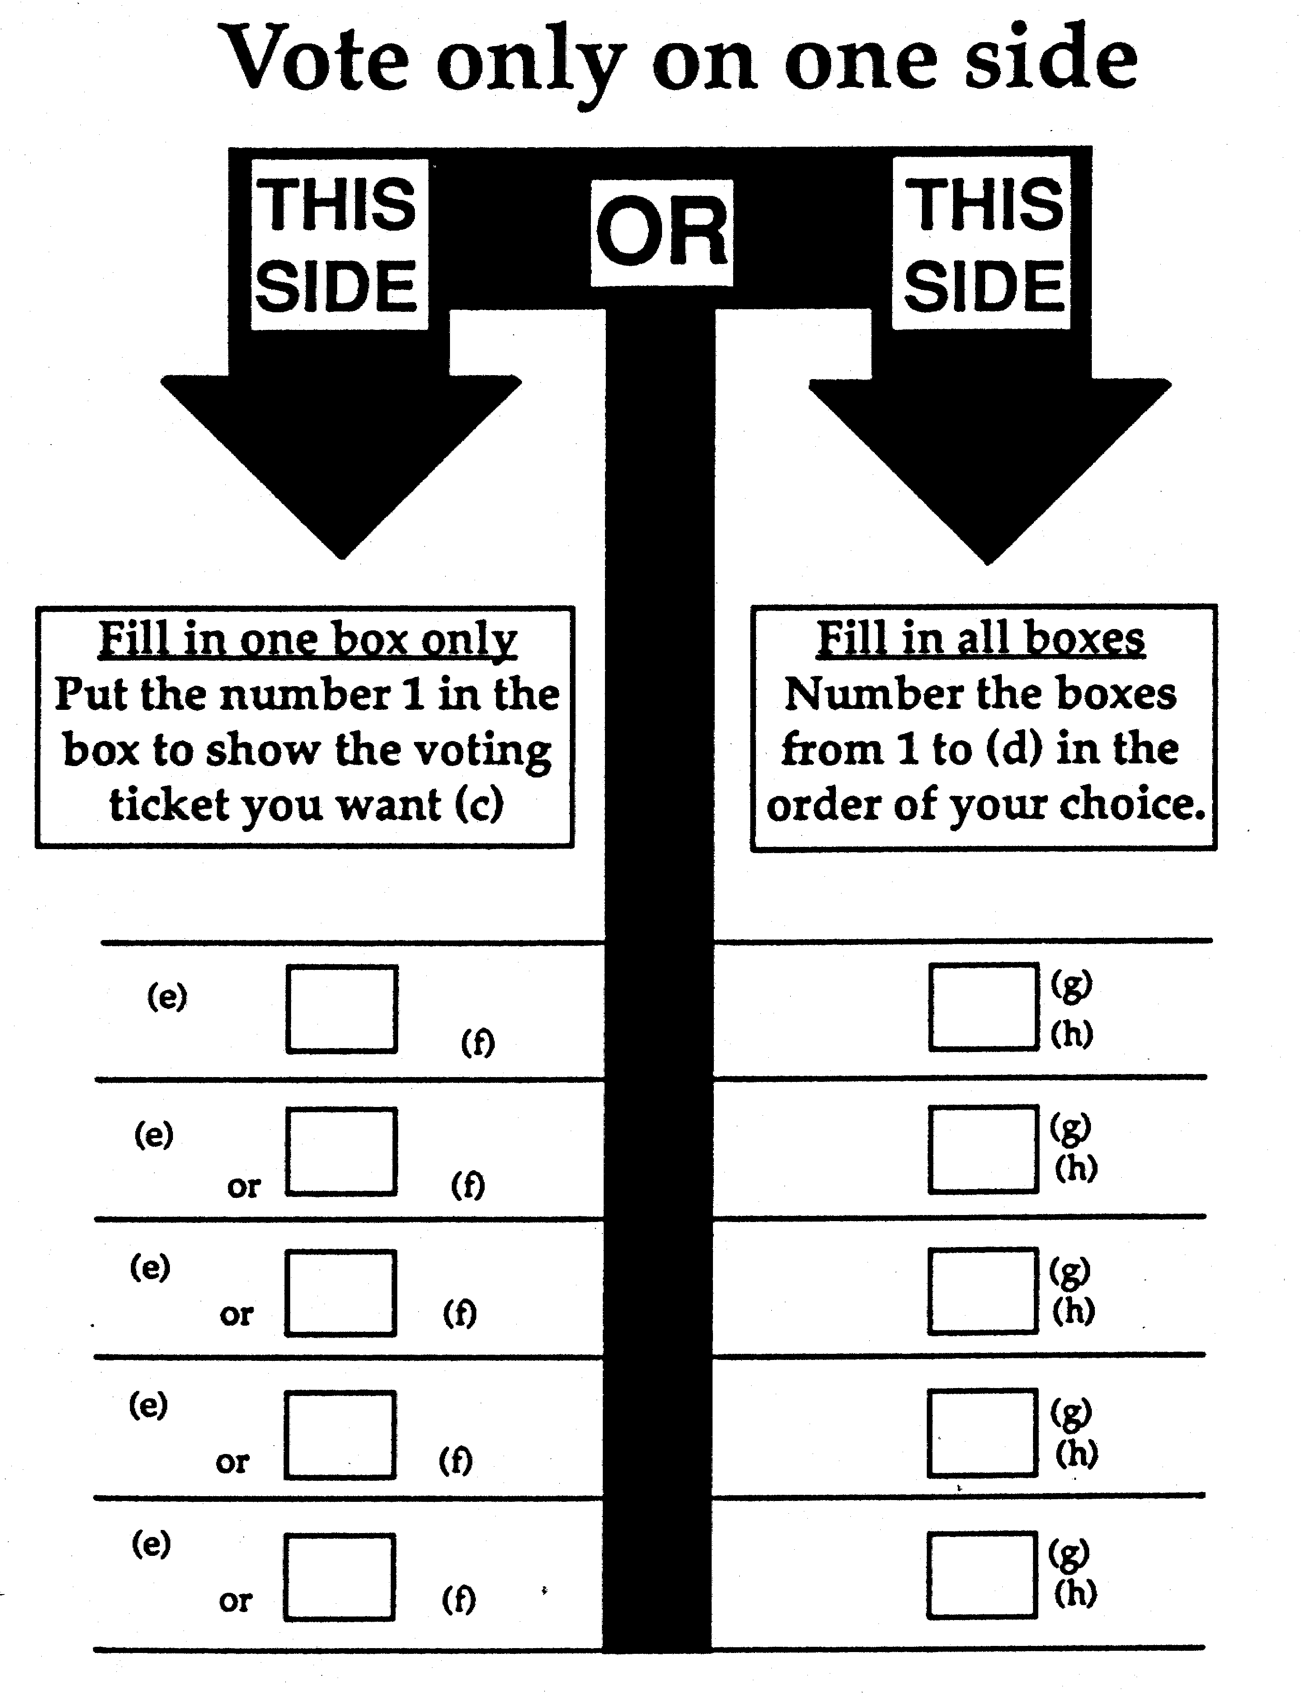
(a) Insert the number of members to be elected.
(b) Insert the name of the region.
(c) If there is only one voting ticket registered in relation to the election substitute the following instruction —
“Put the number 1 in the box to choose the voting ticket of the candidate.”
(d) Insert the number of candidates.
(e) If there is a voting ticket square for the candidate, insert name of political party, or composite name of political parties, or “Independent”, if to be printed.
(f) Print voting ticket square if a voting ticket is registered by or on behalf of the candidate.
(g) Insert name of candidate.
(h) Insert name of political party, or composite name of political parties, or “Independent”, if to be printed.
FORM B: Ballot paper for
— an election in a district,
— an election in a region if there are no groups and no voting tickets are registered,
if there are 3 or more candidates.

Western Australia Ballot Paper
Election of (a) of the Legislative (b)
(c)

Number the boxes
from 1 to (d) in the
order of your choice

(e)
(f)
(e)
(f)
(e)
(f)
(e)
(f)
Remember......

number every box to make your vote
count.

(a) Insert the number of members to be elected.
(b) Insert “Assembly” or “Council”.
(c) Insert the name of the district or region.
(d) Insert the number of candidates.
(e) Insert name of candidate.
(f) Insert name of political party, or composite name of political parties, or “Independent”, if to be printed.

[Form B amended in Gazette 21 Nov 2008 p. 4923.]

FORM C: Ballot paper for
— an election in a district,
— an election in a region if one member is to be elected,
if there are 2 candidates only.

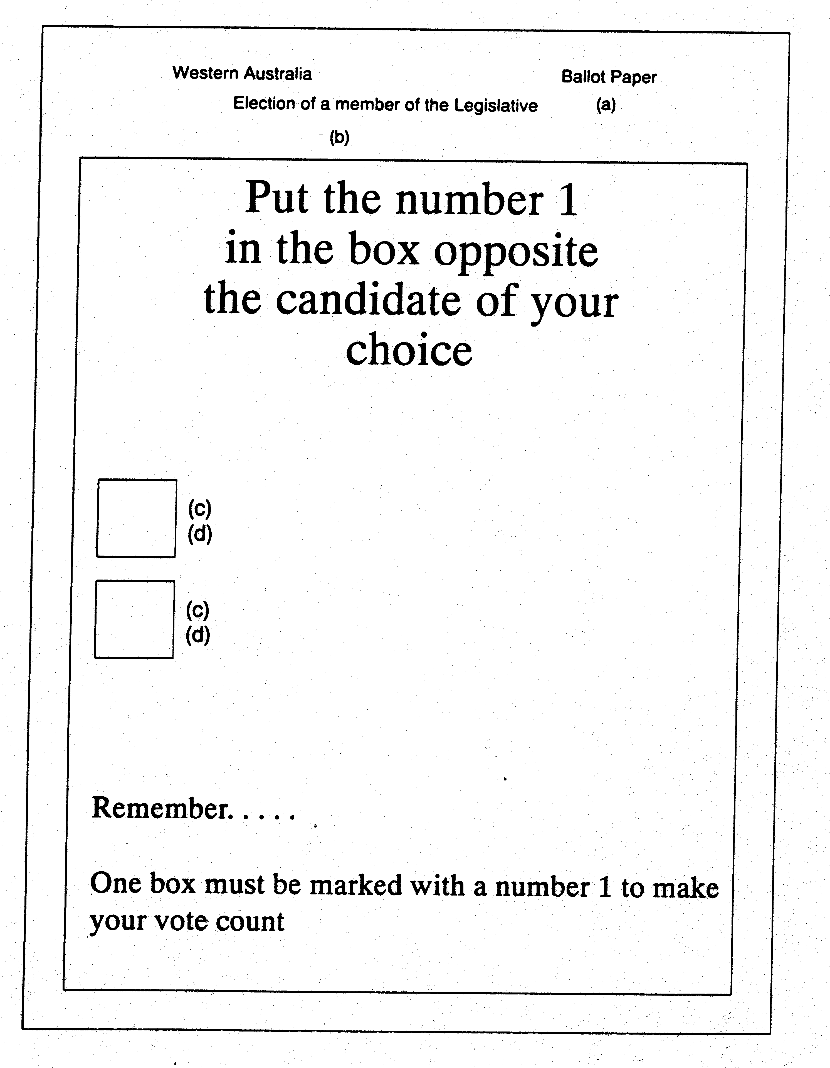
(a) Insert “Assembly” or “Council”.
(b) Insert the name of the district or region.
(c) Insert name of candidate.
(d) Insert name of political party, or composite name of political parties, or “Independent”, if to be printed.

FORM D: Ballot paper for an election in a region if there are one or more groups and one or more voting tickets are registered.
Western Australia Ballot Paper
Election of (a) members of the Legislative Council
(b)

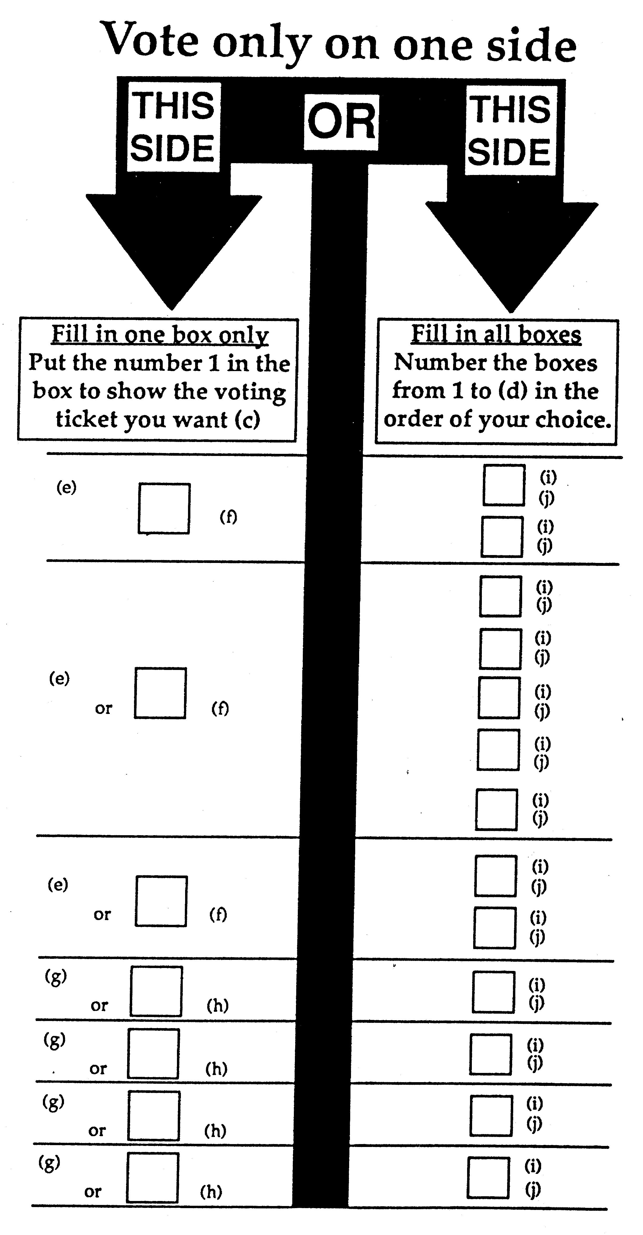
(a) Insert the number of members to be elected.
(b) Insert the name of the region.
(c) If there is only one voting ticket registered in relation to the election, substitute the following instruction —
“Put the number 1 in the box to choose the voting ticket of the candidate/group.”
(d) Insert the number of candidates.
(e) If there is a voting ticket square for the group, insert name of political party, or composite name of political parties, or “Independent”, if to be printed.
(f) Print voting ticket square if a voting ticket is registered by or on behalf of the group.
(g) If there is a voting ticket square for the candidate insert name of political party, or composite name of political parties, or “Independent”, if to be printed.
(h) Print voting ticket square if a voting ticket is registered by or on behalf of the candidate.
(i) Insert name of candidate.
(j) Insert name of political party, or composite name of political parties, or “Independent”, if to be printed.
FORM E: Ballot paper for an election in a region if there are one or more groups, and no voting tickets are registered.

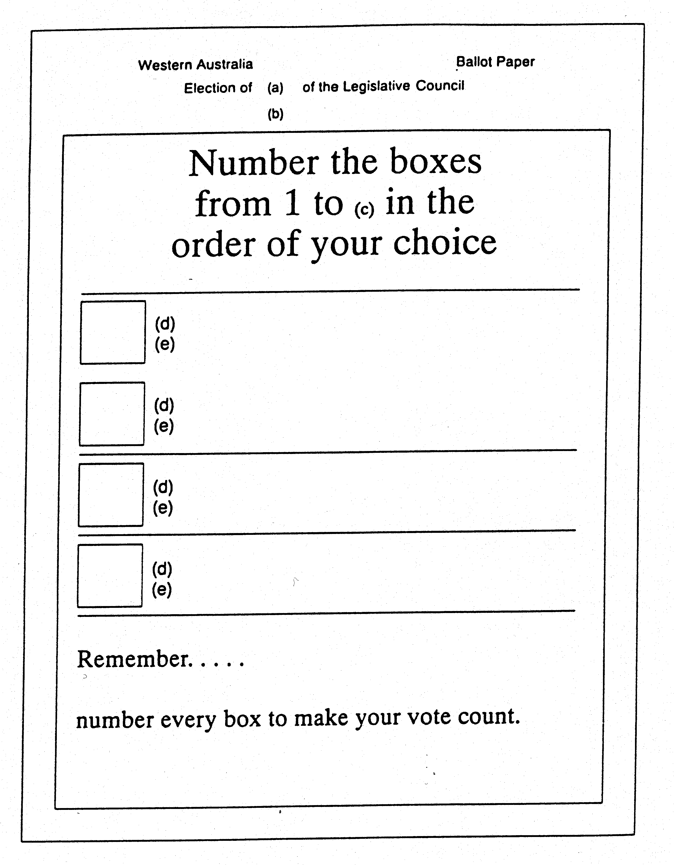
(a) Insert the number of members to be elected.
(b) Insert the name of the region.
(c) Insert the number of candidates.
(d) Insert name of candidate.
(e) Insert name of political party, or composite name of political parties, or “Independent”, if to be printed.
[Schedule 1 amended in Gazette 16 Oct 1992 p. 5119-20.]

Notes
¹ This is a compilation of the Electoral (Ballot Paper Forms) Regulations 1990 and includes the amendments made by the other written laws referred to in the following table. The table also contains information about any reprint.

Compilation table
Citation | Gazettal | Commencement
Electoral (Ballot Paper Forms) Regulations 1990 | 27 Apr 1990 p. 2063-8 | 20 Jun 1990 (see s. 213(6) of the Act)
Electoral (Ballot Paper Forms) Amendment Regulations 1992 | 16 Oct 1992 p. 5119-20 | 4 Dec 1992 (see s. 213(6) of the Act)
Reprint 1: The Electoral (Ballot Paper Forms) Regulations 1990 as at 13 Aug 2004 (includes amendments listed above)
Electoral (Ballot Paper Forms) Amendment Regulations 2008 | 21 Nov 2008 p. 4923 | r. 1 and 2: 21 Nov 2008 (see r. 2(a));  Regulations other than r. 1 and 2: 22 Nov 2008 (see r. 2(b))

