Western Australia
Petroleum and Geothermal Energy Resources Act 1967

Petroleum and Geothermal Energy Resources (Hydraulic Fracturing) Regulations 2017

Western Australia
Petroleum and Geothermal Energy Resources (Hydraulic Fracturing) Regulations 2017
Contents
1. Citation 1
2. Commencement 1
3. Terms used 1
3A. Existing petroleum authority area 2
4. Prohibition on hydraulic fracturing in certain areas of the State 3
5. Moratorium on hydraulic fracturing in other areas of the State 3
Schedule 1 — Dampier Peninsula hydraulic fracturing ban area
Division 1 — Description of area
Division 2 — Map of area (for information purposes only)
Notes
Compilation table 6
Defined terms

Petroleum and Geothermal Energy Resources Act 1967
Petroleum and Geothermal Energy Resources (Hydraulic Fracturing) Regulations 2017

1. Citation
These regulations are the Petroleum and Geothermal Energy Resources (Hydraulic Fracturing) Regulations 2017.

2. Commencement
These regulations come into operation as follows —
(a) regulations 1 and 2 — on the day on which these regulations are published in the Gazette;
(b) the rest of the regulations — on the day after that day.

3. Terms used
In these regulations —
Dampier Peninsula hydraulic fracturing ban area means the area described in Schedule 1 Division 1 (a map of which is included for information purposes in Schedule 1 Division 2);
hydraulic fracturing means the underground petroleum extraction process that involves the injection of fluids under high pressure into low permeability rock to induce fractures for the purpose of increasing the rock’s permeability;
metropolitan region has the meaning given in the Planning and Development Act 2005 section 4(1);
moratorium area means an area of the State that is not —
(a) an existing petroleum authority area as defined in regulation 3A(1); or
(b) an area referred to in regulation 4;
moratorium period means the period beginning on 9 December 2017 and ending on the day on which regulation 5 is repealed;
Peel region means the region described in the Planning and Development Act 2005 Schedule 4 item 6;
petroleum authority means an authority under Part III Divisions 2, 2A or 3 of the Act to carry out a petroleum operation;
public drinking water source area means —
(a) a catchment area or water reserve constituted under the Country Areas Water Supply Act 1947 section 9(1); or
(b) a catchment area or water reserve constituted under the Metropolitan Water Supply, Sewerage, and Drainage Act 1909 section 13; or
(c) an Underground Water Pollution Control Area constituted under the Metropolitan Water Supply, Sewerage, and Drainage Act 1909 section 57A;
South West region means the region described in the Planning and Development Act 2005 Schedule 4 item 8.
[Regulation 3 amended: Gazette 6 Sep 2019 p. 3198-9.]

3A. Existing petroleum authority area
(1) An area of the State is an existing petroleum authority area if —
(a) there was a petroleum authority in force in respect of the area on 26 November 2018; and
(b) in the period since that day there has always been a petroleum authority in force in respect of the area; and
(c) there is currently a petroleum authority in force in respect of the area.
(2) For the purposes of subregulation (1) it does not matter that different petroleum authorities have been in force in respect of the area at different times.
[Regulation 3A inserted: Gazette 6 Sep 2019 p. 3199.]

4. Prohibition on hydraulic fracturing in certain areas of the State
A person must not, in the course of carrying out a petroleum operation under a petroleum authority, carry out hydraulic fracturing in any of the following areas of the State —
(a) the metropolitan region;
(b) the Peel region;
(c) the South West region;
(d) the Dampier Peninsula hydraulic fracturing ban area;
(e) a national park as defined in the Conservation and Land Management Act 1984 section 3;
(f) a public drinking water source area;
(g) an area that is within 2 km of a public drinking water source area.
Penalty: a fine of $10 000 for each day on which the offence occurs.
[Regulation 4 amended: Gazette 6 Sep 2019 p. 3199.]

5. Moratorium on hydraulic fracturing in other areas of the State
[(1) deleted]
(2) During the moratorium period, a person must not, in the course of carrying out a petroleum operation under a petroleum authority, carry out hydraulic fracturing in a moratorium area.
Penalty for this subregulation: a fine of $10 000 for each day on which the offence occurs.
[Regulation 5 amended: Gazette 6 Sep 2019 p. 3200.]

Schedule 1 — Dampier Peninsula hydraulic fracturing ban area
[r. 3]
[Heading inserted: Gazette 6 Sep 2019 p. 3200.]

Division 1 — Description of area
[Heading inserted: Gazette 6 Sep 2019 p. 3200.]
The Dampier Peninsula hydraulic fracturing ban area is the area of the State bounded by a line that —
(a) starts at a point that is the intersection of 17°29'55.01" south latitude and 122°35'04.55" east longitude;
(b) then continues south along the meridian to the intersection of 17°44'55.02" south latitude and 122°35'04.56" east longitude;
(c) then continues west along the parallel to the intersection of 17°44'55.02" south latitude and 122°25'04.58" east longitude;
(d) then continues south along the meridian to the intersection of 17°59'55.04" south latitude and 122°25'04.58" east longitude;
(e) then continues west along the parallel to the intersecting point on the coastline at mean low water at 17°59'55.04" south latitude;
(f) then continues along the coastline at mean low water generally westerly, then generally northerly, then generally north easterly, then generally south easterly to the intersecting point at 17°29'54.98" south latitude;
(g) then continues west along the parallel returning to the starting point.
Note for this Division:
Coordinate references are to Geocentric Datum of Australia 1994 (GDA94) coordinates.
[Division 1 inserted: Gazette 6 Sep 2019 p. 3200.]

Division 2 — Map of area (for information purposes only)
[Heading inserted: Gazette 6 Sep 2019 p. 3201.]
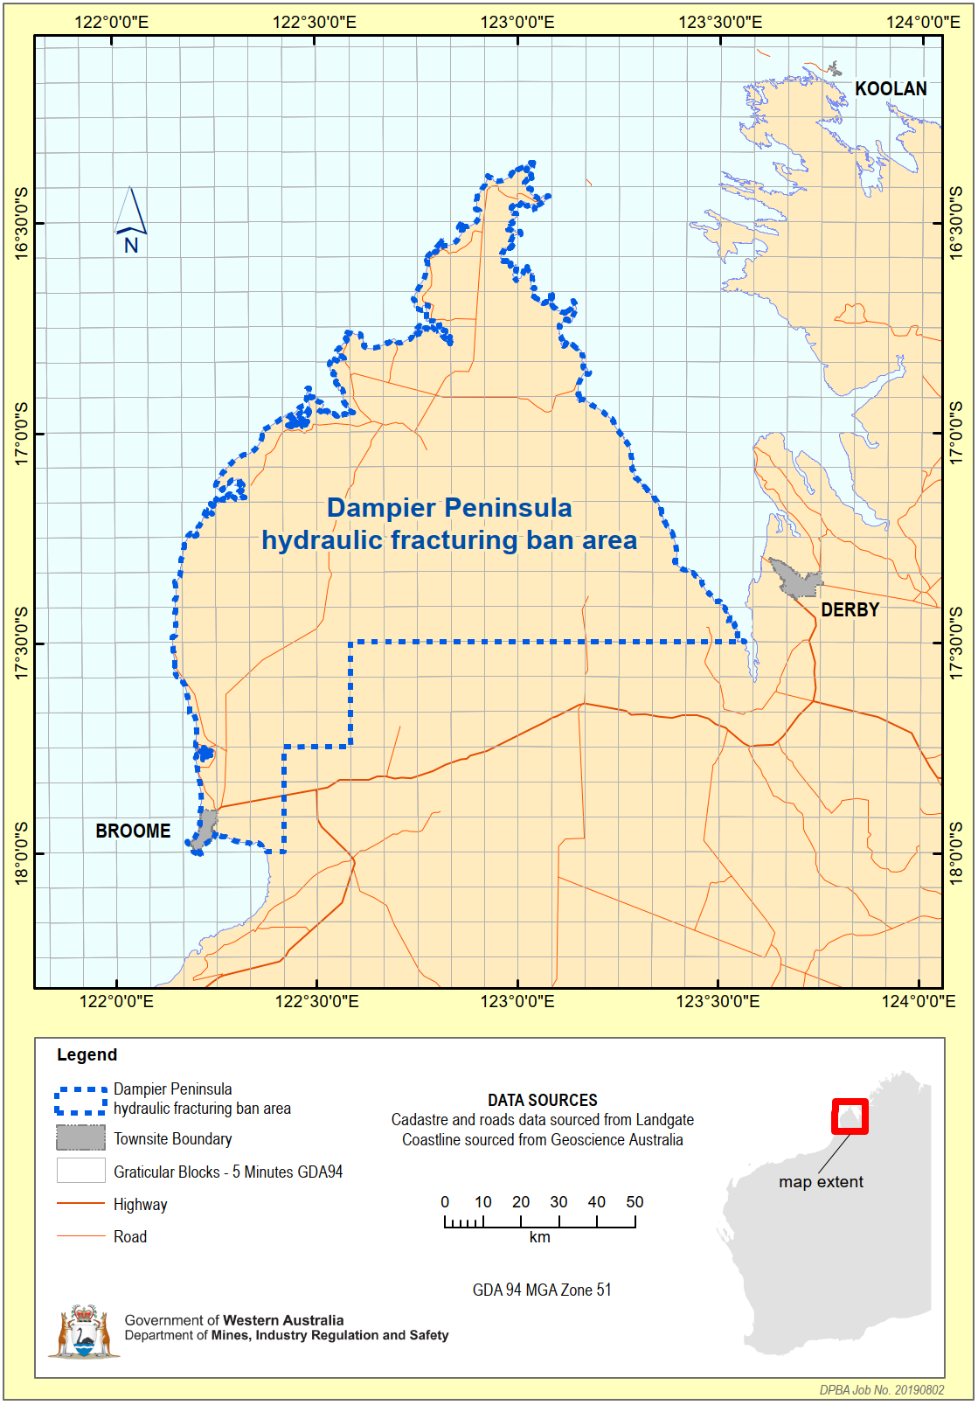
[Division 2 inserted: Gazette 6 Sep 2019 p. 3201.]

Notes
¹ This is a compilation of the Petroleum and Geothermal Energy Resources (Hydraulic Fracturing) Regulations 2017 and includes the amendments made by the other written laws referred to in the following table.

Compilation table
Citation | Gazettal | Commencement
Petroleum and Geothermal Energy Resources (Hydraulic Fracturing) Regulations 2017 | 8 Dec 2017 p. 5848-9 | r. 1 and 2: 8 Dec 2017 (see r. 2(a));  Regulations other than r. 1 and 2: 9 Dec 2017 (see r. 2(b))
Petroleum and Geothermal Energy Resources (Hydraulic Fracturing) Amendment Regulations 2019 | 6 Sep 2019 p. 3198-201 | r. 1 and 2: 6 Sep 2019 (see r. 2(a));  Regulations other than r. 1 and 2: 7 Sep 2019 (see r. 2(b))

Defined terms

[This is a list of terms defined and the provisions where they are defined. The list is not part of the law.]
Defined term Provision(s)
Dampier Peninsula hydraulic fracturing ban area 3
existing petroleum authority area 3A(1)
hydraulic fracturing 3
metropolitan region 3
moratorium area 3
moratorium period 3
Peel region 3
petroleum authority 3
public drinking water source area 3
South West region 3

