Western Australia
Health (Miscellaneous Provisions) Act 1911

Health (Notifications by Midwives) Regulations 1994

Western Australia
Health (Notifications by Midwives) Regulations 1994
Contents
1. Citation 1
3. Notification of private practice as midwife 1
4. Notification of case or delivery attended 1
Schedule
Notes
Compilation table 1

Health (Miscellaneous Provisions) Act 1911
Health (Notifications by Midwives) Regulations 1994

1. Citation
These regulations may be cited as the Health (Notifications by Midwives) Regulations 1994.

[2. Omitted under the Reprints Act 1984 s. 7(4)(f).]

3. Notification of private practice as midwife
A midwife is not to enter into private practice as a midwife unless he or she has notified the Chief Health Officer of his or her intention to do so in the form of Form 1 in the Schedule.
[Regulation 3 amended: Gazette 10 Jan 2017 p. 270.]

4. Notification of case or delivery attended
For the purposes of —
(a) section 335(1) of the Act, the report required to be furnished of a case attended by a midwife, whether of living, premature or full term birth, or stillbirth; and
(b) section 335(5)(b) of the Act, the notice required to be furnished of a delivery attended by a midwife,
is to be in the form of Form 2 in the Schedule.
[Regulation 4 amended: Gazette 14 Dec 2012 p. 6200; SL 2024/20 r. 7.]

Schedule
Form 1
[r. 3]
HEALTH (MISCELLANEOUS PROVISIONS) ACT 1911
HEALTH (NOTIFICATIONS BY MIDWIVES) REGULATIONS 1994
NOTIFICATION OF INTENTION TO ENTER INTO PRIVATE PRACTICE AS A MIDWIFE
CHIEF HEALTH OFFICER
I intend to enter into private practice as a midwife on ____/____/____
PERSONAL PARTICULARS
Full Name: ______________________________________________________
Date of Birth: ______/______/______
Telephone Numbers (*Business or *Private):
(Tel) ____________ (Mob) ____________
Address (*Business or *Private): _____________________________________
_____________________________
Suburb: _________________ Postcode: ____________
Australian Health Practitioner Regulation Agency Midwifery Registration Number: NMW________________________
Professional Indemnity Insurance Provider: _____________________________
Signature: ___________________
Date: ____/____/____
* Delete if not applicable
[Form 1 inserted: Gazette 14 Dec 2012 p. 6200; amended: Gazette 10 Jan 2017 p. 270.]
Form 2
[r. 4]
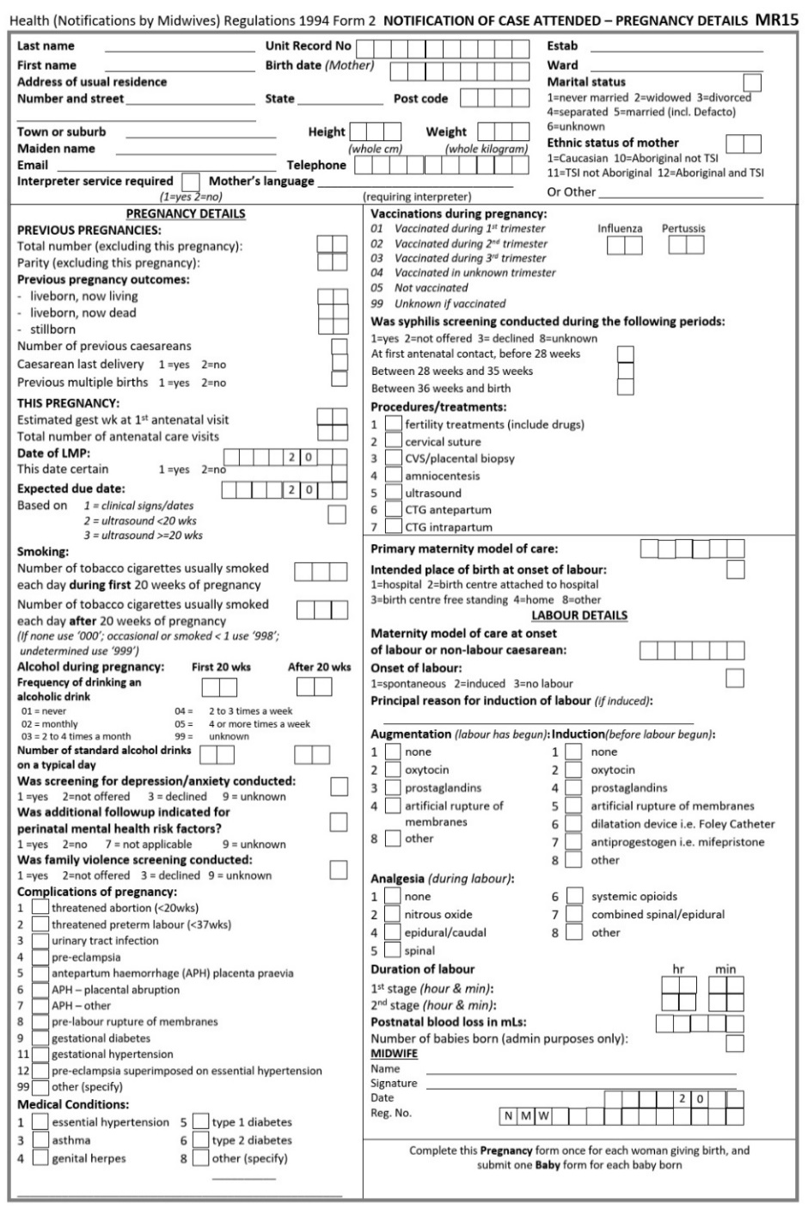
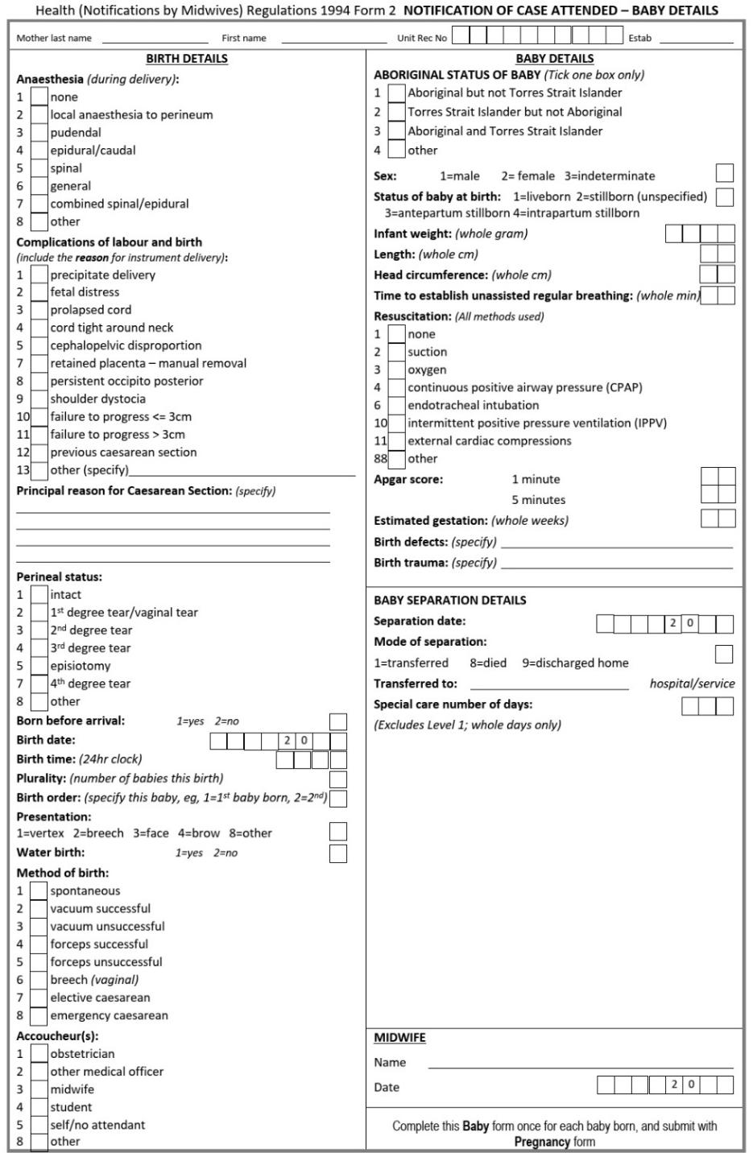
[Form 2 inserted: SL 2023/104 r. 4.]

Notes
This is a compilation of the Health (Notifications by Midwives) Regulations 1994 and includes amendments made by other written laws. For provisions that have come into operation, and for information about any reprints, see the compilation table.

Compilation table
Citation | Published | Commencement
Health (Notifications by Midwives) Regulations 1994 | 28 Jan 1994 p. 283-5 | 28 Jan 1994
Reprint 1: The Health (Notifications by Midwives) Regulations 1994 as at 11 Jun 2004
Health (Notifications by Midwives) Amendment Regulations 2011 | 1 Apr 2011 p. 1178 | r. 1 and 2: 1 Apr 2011 (see r. 2(a));  Regulations other than r. 1 and 2: 2 Apr 2011 (see r. 2(b))
Health (Notifications by Midwives) Amendment Regulations (No. 2) 2011 | 30 Dec 2011 p. 5577-8 | r. 1 and 2: 30 Dec 2011 (see r. 2(a));  Regulations other than r. 1 and 2: 31 Dec 2011 (see r. 2(b))
Health (Notifications by Midwives) Amendment Regulations 2012 | 14 Dec 2012 p. 6199-201 | r. 1 and 2: 14 Dec 2012 (see r. 2(a));  Regulations other than r. 1 and 2: 1 Jan 2013 (see r. 2(b))
Health (Notifications by Midwives) Amendment Regulations 2014 | 24 Apr 2014 p. 1143-5 | r. 1 and 2: 24 Apr 2014 (see r. 2(a));  Regulations other than r. 1 and 2: 1 Jul 2014 (see r. 2(b))
Health (Notifications by Midwives) Amendment Regulations 2016 | 3 May 2016 p. 1356-8 | r. 1 and 2: 3 May 2016 (see r. 2(a));  Regulations other than r. 1 and 2: 1 Jul 2016 (see r. 2(b))
Health Regulations Amendment (Public Health) Regulations 2016 Pt. 17 | 10 Jan 2017 p. 237-308 | 24 Jan 2017 (see r. 2(b) and Gazette 10 Jan 2017 p. 165)
Health (Notifications by Midwives) Amendment Regulations 2017 | 16 May 2017 p. 2489-91 | r. 1 and 2: 16 May 2017 (see r. 2(a));  Regulations other than r. 1 and 2: 1 Jul 2017 (see r. 2(b))
Reprint 2: The Health (Notifications by Midwives) Regulations 1994 as at 22 Sep 2017 (includes amendments listed above)
Health (Notifications by Midwives) Amendment Regulations 2019 | 14 Jun 2019 p. 1894-6 | r. 1 and 2: 14 Jun 2019 (see r. 2(a));  Regulations other than r. 1 and 2: 1 Jul 2019 (see r. 2(b))
Health (Notifications by Midwives) Amendment Regulations 2021 | SL 2021/62 21 May 2021 | r. 1 and 2: 21 May 2021 (see r. 2(a));  Regulations other than r. 1 and 2: 1 Jul 2021 (see r. 2(b))
Health (Notifications by Midwives) Amendment Regulations 2023 | SL 2023/104 30 Jun 2023 | r. 1 and 2: 30 Jun 2023 (see r. 2(a));  Regulations other than r. 1 and 2: 1 Jul 2023 (see r. 2(b))
Health Regulations Amendment (Abortion Legislation Reform) Regulations 2024 Pt. 3 | SL 2024/20 21 Feb 2024 | 27 Mar 2024 (see r. 2(b))

© State of Western Australia 2024.
This work is licensed under a Creative Commons Attribution 4.0 International Licence (CC BY 4.0). To view relevant information and for a link to a copy of the licence, visit www.legislation.wa.gov.au.
Attribute work as: © State of Western Australia 2024.
By Authority: GEOFF O. LAWN, Government Printer

