Western Australia

Perth Theatre Trust (Common Seal) Regulations 1980
Compare between:
[07 May 2004, 01-a0-08] and [09 Sep 2021, 01-b0-01]

Western Australia
Perth Theatre Trust Act 1979
Perth Theatre Trust (Common Seal) Regulations 1980

1. Citation
These regulations may be cited as the Perth Theatre Trust (Common Seal) Regulations 1980.

2. Form of common seal
The form of the common seal of the Trust is the form set out in the Schedule.

3. Safe custody of common seal
The manager or, in his absence, the person appointed to act in his stead shall keep the common seal of the Trust in safe custody.

Schedule
(Regulation 2)

Form of common seal of Trust
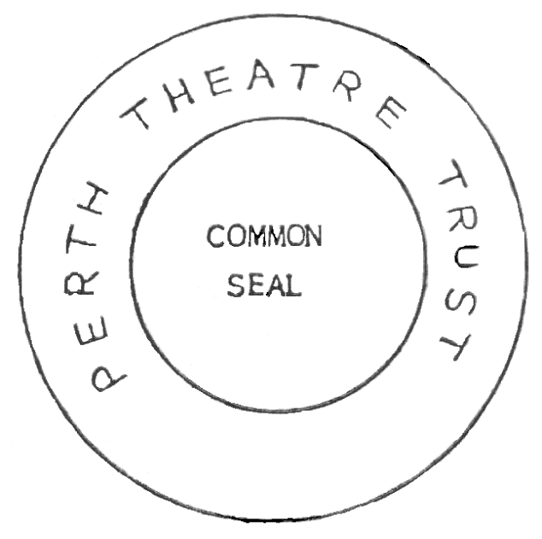

Notes
This is a compilation of the Perth Theatre Trust (Common Seal) Regulations 1980 and includes amendments made by other written laws. For provisions that have come into operation, and for information about any reprints, see the compilation table. For provisions that have not yet come into operation see the uncommenced provisions table.

Compilation table
Citation | Published | Commencement
Perth Theatre Trust (Common Seal) Regulations 1980 | 1 Feb 1980 p. 340 | 1 Feb 1980 (see Gazette 1 Feb 1980 p. 285)
Reprint 1: The Perth Theatre Trust (Common Seal) Regulations 1980 as at 7 May 2004

Uncommenced provisions table
To view the text of the uncommenced provisions see Acts as passed on the WA Legislation website.
Citation | Published | Commencement
Arts and Culture Trust Act 2021 s. 73(2) assented to 9 Sep 2021 |  | 1 Jul 2022 (see s. 2(b) and SL 2022/77 cl. 2)

