Western Australia

Armadale Redevelopment (Subtracted Area) Regulations 2011
Compare between:
[02 Nov 2011, 00-a0-01] and [31 Dec 2011, 00-b0-03]

Western Australia

Armadale Redevelopment Act 2001
Armadale Redevelopment (Subtracted Area) Regulations 2011

Part 1 — Preliminary

1. Citation
These regulations are the Armadale Redevelopment (Subtracted Area) Regulations 2011 ¹.

2. Commencement
These regulations come into operation as follows —
(a) regulations 1 and 2 — on the day on which these regulations are published in the Gazette;
(b) the rest of the regulations — on the day after that day.

3. Terms used
In these regulations —
City Scheme means the City of Armadale Town Planning Scheme No. 4;
redevelopment scheme means the Armadale Redevelopment Scheme 2004 or the Wungong Urban Water Redevelopment Scheme 2007;
Schedule 1 means the Armadale Redevelopment Act 2001 Schedule 1;
subtracted area means the area that ceases to be in the redevelopment area when Schedule 1 is amended under regulation 4.

Part 2 — Amendment of Schedule 1 and planning schemes

4. Schedule 1 amended
When an order under regulation 5(1) takes effect, in Schedule 1 delete Plan No. 2 and insert:
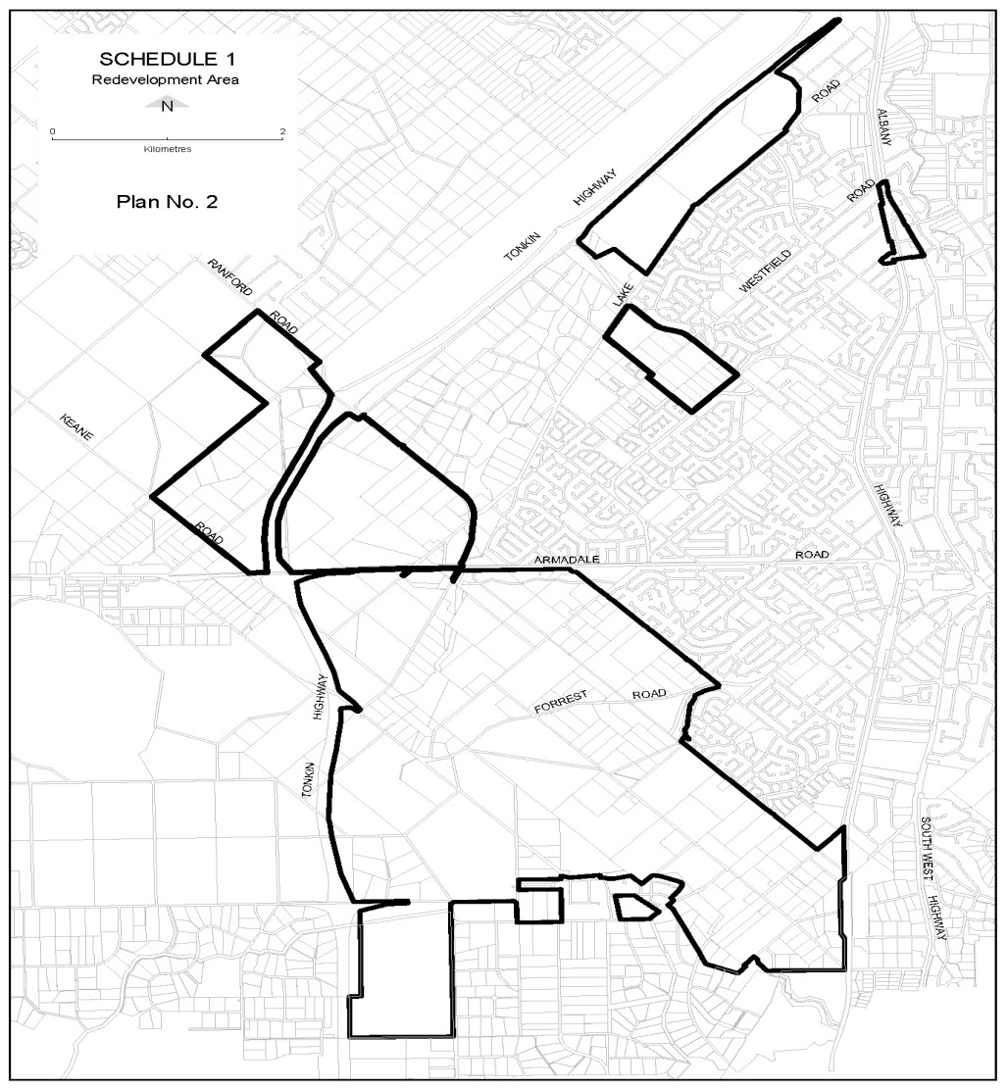

5. Minister empowered to amend planning schemes
(1) The Minister may, by order published in the Gazette, amend the Metropolitan Region Scheme or the City Scheme to provide for —
(a) land in the subtracted area to be included in the area to which that scheme applies; and
(b) the land to have a reservation or zoning under that scheme the same as, or similar to, that which applied to the land immediately before it ceased to be in the redevelopment area.
(2) The order takes effect at the beginning of the day after the day on which it is published in the Gazette.

Part 3 — Transitional provisions

6. Transitional modifications to the City of Armadale Town Planning Scheme No. 4
(1) This regulation applies in relation to land included by an order under regulation 5(1) in the area to which the City Scheme applies, but only to the extent that the City Scheme has not been amended —
(a) to delete Schedule 12 item 19 and replace it with a new item as set out in subregulation (2), or substantially to the same effect; and
(b) to insert after Schedule 12 item 40 a new item as set out in subregulation (3), or substantially to the same effect.
(2) Schedule 12 to the City Scheme is to be read as if item 19 were deleted and the following item inserted instead:
No. | Description of land |  | Additional provisions applicable to subdivision and development
19 | South Armadale Industrial Area bounded by Dickens Place, South West Highway, the Perth to Bunbury Railways Reservation and Reserve No. 39773 (as identified on the Scheme Map) | 19.1  19.2  19.3  19.4  19.5  19.6  19.7  19.8  19.9 | Comprehensive planning for the area shall be undertaken by preparation of a Structure Plan to guide subdivision and development.  The Structure Plan road network design shall have regard to the conceptual objectives outlined in the Armadale Enquiry-by-Design Workshop — Report No. 4 (Department of Planning, 1999).  The Structure Plan shall be complemented by Land use Policy Precincts to guide land use and development over portions of the Development Area.  The Structure Plan shall investigate and, unless otherwise approved by the City, specify a road network design which provides permeability between Dickens Place to the south and Armadale Town Centre to the north including —  (a) a new road extending Hobbs Drive through the brickworks site at Lots 12 and 104 adjacent to the rail reserve and linking to a new road access point on South Western Highway;  (b) linking of the extension of Hobbs Drive in (a) above through Lots 12 and 104 to provide a direct connection to the south to Dickens Place and to a potential new rail crossing at Harber Drive;  (c) a subdivision design for the land fronting South Western Highway which provides access to fronting lots for local traffic, without conflicting with regional traffic movements on South Western Highway.  The Structure Plan road network design shall, unless otherwise approved by the City, make appropriate provision for a new crossing of the rail line and potentially linking Harber Drive located west of the rail line with the future new subdivisional road design described above.  The Structure Plan shall investigate and, unless otherwise approved by the City, specify Policy Precincts for the Industrial Business zoned portions of Lot 12 South Western Highway and Lot 104 Hobbs Drive, to provide for a range of industrial and business commercial land uses that support the local and regional functions of the Armadale Strategic Regional Centre and the South Armadale Industrial Area.  The Policy Precincts for the portions of Lot 12 South Western Highway and Lot 104 Hobbs Drive zoned Industrial Business zone shall include special Development Design Guidelines which specifically address objectives, controls and development standards for the following issues —  — lot size and lot frontages  — access and circulation  — setbacks  — car parking  — access for loading and unloading vehicles  — streetscape and landscaping  — built form  — building location  — building design  — signage  — parapet walls  — storage and bin areas  — fencing  — public open space  The Structure Plan and Policy shall —  (a) identify and describe any places and items within the site of heritage value;  (b) specify arrangements for the recording and recognition of the above heritage values, including where appropriate their future protection and/or preservation on-site, or subject to approval by the City in an alternative location;  (c) identify appropriate land for Public Open Space for local recreation and/or accommodation of heritage value which upon subdivision may be required to be ceded;  (d) specify proposed arrangements for developer contributions towards the cost of infrastructure required by subdivision and development of Lot 12 South Western Highway and Lot 104 Hobbs Drive in accordance with the Structure Plan, including but not confined to contributions to road upgrading, protection of heritage values and establishment of a rail crossing opposite Harber Drive unless otherwise approved by the City.  Potential site contamination considerations shall be addressed for relevant land prior to subdivision and development of Lot 12 South Western Highway and Lot 104 Hobbs Drive and addressing —  (a) The potential for contamination associated with prior land use of the land such that any subdivision or substantial development that proposes a change in land use or the disturbance of a volume of soil greater than or equal to 25 cubic metres such that the application shall be forwarded to the Contamination Sites Branch, Department of Environment and Conservation (DEC). This provision does not include routine maintenance or upgrade works by a public authority or Council.  (b) Where an application is forwarded to the DEC as above, the proposal shall be accompanied by a Detailed Site Investigation to the standards prescribed by the DEC. The DEC shall review the application with regard to the potential for ecological and/or human health related risk, and may request conditions to be imposed upon any approval to address any contamination prior to subdivision and development.  (c) Where remediation is required, conditions shall be imposed on the approval requiring the submission of a Site Management Plan and a Post-Remediation Validation Report  (d) Points (a) and (b) above shall not apply where a development application is submitted for approval to demolish a building so as to enable works relating to the subdivision of the land on which the building is located to proceed.
(3) Schedule 12 to the City Scheme is to be read as if the following item were inserted after item 40:
No. | Description of land |  | Additional provisions applicable to subdivision and development
41 | Brookwood Special Residential Development Area (formerly Adios Estate) bounded by Rowley Road, Reservation for Parks and Recreation (MRS), Lots 26 and 28 Hilbert Road, Lots 2, 3 and 1000 Rowley Road (as identified on the Scheme Map) | 41.1.  41.2  41.3  41.4 | Subdivision and development shall be guided by the Structure Plan/Subdivision Guide Plan adopted by the City for the area.  Overall maximum number of lots permitted on the Structure Plan shall be 132 lots and no further subdivision shall be permitted.  Landowners shall be responsible for ongoing maintenance of the vegetation specified on the Landscape Master Plan.  Fencing shall be limited to open rural type fencing in accordance with the post and wire or post and rail rural fencing model/guidelines depicted on the Landscape Master Plan adopted by the City unless otherwise approved by the City.

7. Certain approvals continue to have effect
(1) In this regulation —
approval includes the approval of development, a structure plan or a detailed area plan.
(2) When an order under regulation 5(1) takes effect —
(a) any approval previously granted under a redevelopment scheme in relation to land in the subtracted area continues to have effect as if the approval had been granted under the City Scheme; and
(b) without limiting paragraph (a), any condition to which the approval was subject under the redevelopment scheme may be enforced by the City of Armadale as if the approval were subject to that condition under the City Scheme.

8. Saving of rights
(1) In this regulation —
subtraction time means the time when an order under regulation 5(1) takes effect.
(2) This regulation has effect subject to any provision of a redevelopment scheme relating to non-conforming uses.
(3) The subtraction of the subtracted area from the redevelopment area by the operation of regulation 4 and the inclusion of the land in the subtracted area in the Metropolitan Region Scheme or the City Scheme by an order under regulation 5(1) do not affect —
(a) any right to use land in the subtracted area for the purpose for which the land was being lawfully used immediately before the subtraction time; or
(b) any right to undertake any development on land in the subtracted area that was being lawfully undertaken on the land immediately before the subtraction time.

Notes
¹ This is compilation of the Armadale Redevelopment (Subtracted Area) Regulations 2011. The following table contains information about those regulations.

Compilation table
Citation | Gazettal | Commencement
Armadale Redevelopment (Subtracted Area) Regulations 2011 | 1 Nov 2011 p. 4593-601 | r. 1 and 2: 1 Nov 2011 (see r. 2(a));  Regulations other than r. 1 and 2: 2 Nov 2011 (see r. 2(b))
These regulations were repealed by the Metropolitan Redevelopment Authority Act 2011 s. 134(a) (No. 45 of 2011) as at 31 Dec 2011 (see s. 2(b) and Gazette 30 Dec 2011 p. 5573)

