Western Australia

Reserves (Marmion Marine Park) Act 2019
Compare between:
[08 Oct 2019, 00-a0-00] and [04 Dec 2019, 00-b0-03]

Western Australia
Reserves (Marmion Marine Park) Act 2019
An Act to excise an area from Marmion Marine Park to facilitate the development of the Ocean Reef Marina.
The Parliament of Western Australia enacts as follows:

1. Short title
This is the Reserves (Marmion Marine Park) Act 2019 ¹.

2. Commencement
This Act comes into operation as follows —
(a) sections 1 and 2 — on the day on which this Act receives the Royal Assent;
(b) the rest of the Act — on a day fixed by proclamation ¹.

3. Terms used
In this Act —
Deposited Plan, followed by a number, means the deposited plan of that number —
(a) lodged with the Western Australian Land Information Authority established by the Land Information Authority Act 2006 section 5 (the Authority); and
(b) available in electronic form on the Authority’s official website;
Development Area means Lot 500 on Deposited Plan 415585 comprising an area of approximately 143 hectares;
Marmion Marine Park means all Western Australian waters reserved as Marine Park Reserve No. 1 under the Conservation and Land Management Act 1984 section 13 by an order published in the Gazette on 13 March 1987 at page 628;
Registrar of Titles means the Registrar of Titles referred to in the Transfer of Land Act 1893 section 7.

4. Act binds Crown
This Act binds the Crown in right of Western Australia and, so far as the legislative power of the Parliament permits, the Crown in all its other capacities.

5. Marmion Marine Park — excision of Development Area
(1) The Marmion Marine Park is amended by excising the Development Area.
(2) The boundaries of the Marmion Marine Park, as amended by subsection (1), are shown for information purposes on the plan in Schedule 1.

6. Registrar of Titles to take certain measures
(1) The Registrar of Titles must take any necessary measures to register the amendments effected by section 5.
(2) For the purposes of subsection (1), section 5 may be treated as if it were an order under the Land Administration Act 1997.

Schedule 1 — Plan of Marmion Marine Park showing Development Area (for information purposes only)
[s. 5(2)]

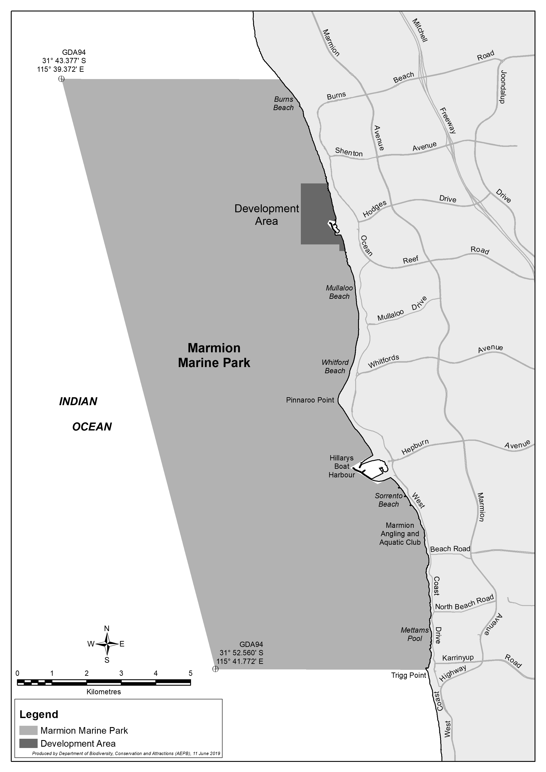

Notes
¹ This is a compilation of the Reserves (Marmion Marine Park) Act 2019. The following table contains information about that Act.

Compilation table
Short title | Number and year | Assent | Commencement
Reserves (Marmion Marine Park) Act 2019 | 24 of 2019 | 8 Oct 2019 | s. 1 and 2: 8 Oct 2019 (see s. 2(a));  Act other than s. 1 and 2: 4 Dec 2019 (see s. 2(b) and Gazette 3 Dec 2019 p. 4157)

