Western Australia
Metropolitan Redevelopment Authority Act 2011

Metropolitan Redevelopment Authority Amendment Regulations 2024

Western Australia
Metropolitan Redevelopment Authority Amendment Regulations 2024
Contents
1. Citation 1
2. Commencement 1
3. Regulations amended 1
4. Regulation 10A inserted 1
10A. Bentley redevelopment area 1
5. Schedule 1A inserted 1
Schedule 1A — Bentley redevelopment area

Metropolitan Redevelopment Authority Act 2011
Metropolitan Redevelopment Authority Amendment Regulations 2024
Made by the Governor in Executive Council.

1. Citation
These regulations are the Metropolitan Redevelopment Authority Amendment Regulations 2024.

2. Commencement
These regulations come into operation as follows —
(a) regulations 1 and 2 — on the day on which these regulations are published on the WA legislation website;
(b) the rest of the regulations — on the day after that day.

3. Regulations amended
These regulations amend the Metropolitan Redevelopment Authority Regulations 2011.

4. Regulation 10A inserted
After regulation 10 insert:

10A. Bentley redevelopment area
(1) In this regulation —
relevant plan means the plan entitled “Bentley Redevelopment Area” held at the office of the Authority, that plan being certified by the Minister as the plan prepared for the purpose of defining the Bentley redevelopment area.
(2) All of the land in the area outlined in bold on the relevant plan is declared to be a redevelopment area.
(3) The name of the redevelopment area is the Bentley redevelopment area.
(4) For guidance, a plan depicting the Bentley redevelopment area is set out in Schedule 1A.

5. Schedule 1A inserted
After Schedule 1 insert:

Schedule 1A — Bentley redevelopment area
[r. 10A(4)]
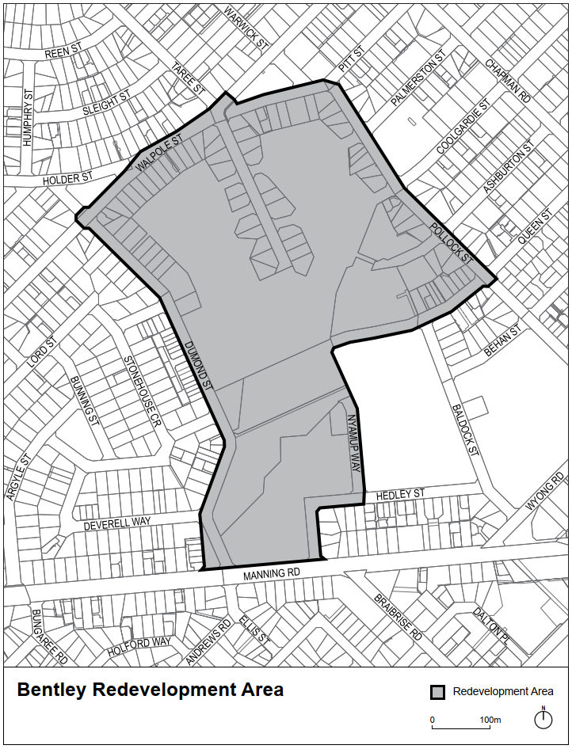

K. COLLERAN, Clerk of the Executive Council
© State of Western Australia 2024.
This work is licensed under a Creative Commons Attribution 4.0 International Licence (CC BY 4.0). To view relevant information and for a link to a copy of the licence, visit www.legislation.wa.gov.au.
Attribute work as: © State of Western Australia 2024.
By Authority: GEOFF O. LAWN, Government Printer

