Western Australia

Sunset Reserve Transformation Act 2014

Western Australia
Sunset Reserve Transformation Act 2014
Contents
Part 1 — Preliminary
1. Short title 2
2. Commencement 2
3. Terms used 2
Part 2 — Sunset Reserve amendments
4. Change of purpose 3
5. Lot 305 3
6. Lot 304 3
7. Lot 302 3
8. Registrar of Titles to take certain measures 3
9. Land Administration Act 1997 not affected 4
Part 3 — Planning scheme amendments
10. Terms used 5
11. Metropolitan Region Scheme amended 5
12. Nedlands planning scheme amended 5
13. Effect of amendments 5
Part 4 — Dealing with excised land
14. Minister for Works may deal with excised land 6
15. Delegation 6
Part 5 — Miscellaneous
16. Sunset Reserve Account 8
17. Regulations 8
Schedule 1 — Deposited plan 49483
Notes
Compilation table 10
Defined terms

Western Australia
Sunset Reserve Transformation Act 2014
An Act to provide for reserve and planning changes to expedite the transformation of the former Sunset Hospital site into an arts, cultural and community asset, and for related purposes.

The Parliament of Western Australia enacts as follows:

Part 1 — Preliminary

1. Short title
This is the Sunset Reserve Transformation Act 2014.

2. Commencement
This Act comes into operation as follows —
(a) sections 1 and 2 — on the day on which this Act receives the Royal Assent;
(b) the rest of the Act — on the day after that day.

3. Terms used
(1) In this Act, unless the contrary intention appears —
class A reserve means a reserve classified as a class A reserve under the Land Administration Act 1997 section 42;
excised land means the land excised under section 7 and includes any part of that land;
Minister for Works means the body corporate created by the Public Works Act 1902 section 5;
Sunset Reserve means Class A reserve No. 1667.
(2) A reference in this Act to a lot is a reference to the lot as shown on deposited plan 49483.
(3) Deposited plan 49483 referred to in this Act is held by the agency that principally assists in the administration of the Transfer of Land Act 1893.
(4) An indicative depiction of deposited plan 49483 is in Schedule 1.

Part 2 — Sunset Reserve amendments

4. Change of purpose
The purpose for which Sunset Reserve is reserved under the Land Administration Act 1997 Part 4 is changed to “Sunset Heritage Precinct for arts, cultural, community and ancillary commercial purposes”.

5. Lot 305
(1) Sunset Reserve is amended by excising the land comprising Lot 305.
(2) Class A reserve No. 29174 is amended by adding the land excised under subsection (1).

6. Lot 304
(1) Sunset Reserve is amended by excising the land comprising Lot 304.
(2) Class A reserve No. 17391 is amended by adding the land excised under subsection (1).

7. Lot 302
(1) Sunset Reserve is amended by excising the land comprising Lot 302.
(2) The excised land is transferred to the Minister for Works in fee simple.
(3) Duty is not chargeable under the Duties Act 2008 on the transfer of the fee simple in the excised land under subsection (2).

8. Registrar of Titles to take certain measures
(1) The Registrar of Titles must take any necessary measures to —
(a) register the amendments to, reservations and classifications of, and other changes to, land effected under sections 4 to 7; and
(b) register the transfer effected under section 7(2).
(2) For the purposes of subsection (1)(a), sections 4 to 7 may be treated as if they were orders under the Land Administration Act 1997.

9. Land Administration Act 1997 not affected
Nothing in this Part affects the powers conferred under the Land Administration Act 1997 on the Minister for Lands in relation to the Sunset Reserve.

Part 3 — Planning scheme amendments

10. Terms used
In this Part —
Metropolitan Region Scheme has the meaning given in the Planning and Development Act 2005 section 4;
Nedlands planning scheme means the City of Nedlands Town Planning Scheme No. 2.

11. Metropolitan Region Scheme amended
The Metropolitan Region Scheme is amended —
(a) by changing the reservation of any part of the land comprising Sunset Reserve that is reserved for “Public Purposes — Hospitals” to “Parks and Recreation”; and
(b) by deleting the reservation of the excised land and zoning that land as “Urban”.

12. Nedlands planning scheme amended
The Nedlands planning scheme is amended —
(a) by zoning the excised land as “Residential”; and
(b) by designating the excised land R12.5 for the purposes of State Planning Policy 3.1: Residential Design Codes.

13. Effect of amendments
(1) The amendments effected by this Part have effect as though the amendments were enacted under the Planning and Development Act 2005.
(2) Nothing in this Part affects the operation of the Planning and Development Act 2005 with respect to amendments to the Metropolitan Region Scheme or the Nedlands planning scheme as amended by this Part.

Part 4 — Dealing with excised land

14. Minister for Works may deal with excised land
(1) The Minister for Works may do all things necessary to plan, undertake, promote and coordinate the disposal of the excised land.
(2) Without limiting subsection (1), the Minister for Works may do the following —
(a) hold, deal with, and dispose of the excised land;
(b) sign any document in connection with dealing with or disposing of the excised land;
(c) enter into any contract or arrangement with any person, including a public authority or a local government, for the performance by the person of any work or the supply of equipment or services;
(d) apply for the grant of any licence, approval or other authority required for the purposes mentioned in subsection (1).
(3) Nothing in this section is to be read as conferring on the Minister for Works in the performance of functions under this section any immunity from the operation of any written law that applies in relation to the excised land.

15. Delegation
(1) The Minister for Works may delegate to a person any function of the Minister for Works under section 14.
(2) The delegation must be in writing signed by the Minister for Works.
(3) The person performing a function delegated under subsection (1) is to be taken to do so in accordance with the terms of the delegation unless the contrary is shown.
(4) This section does not limit the Minister for Works’ ability to act through an officer or agent.

Part 5 — Miscellaneous

16. Sunset Reserve Account
(1) An agency special purpose account called the Sunset Reserve Account is to be established under the Financial Management Act 2006 section 16.
(2) The account is to be credited with the following —
(a) the proceeds of the disposal of the excised land;
(b) moneys received or recovered in respect of the lease or other use of any part of Sunset Reserve;
(c) any amount appropriated by Parliament to, or otherwise lawfully received for, the account.
(3) Moneys held in the account are to be applied in payment of costs and expenses incurred in the conservation and management of Sunset Reserve.

17. Regulations
The Governor may make regulations prescribing all matters that are required or permitted by this Act to be prescribed, or are necessary or convenient to be prescribed, for giving effect to the purposes of this Act.

Schedule 1 — Deposited plan 49483
[s. 3(4)]
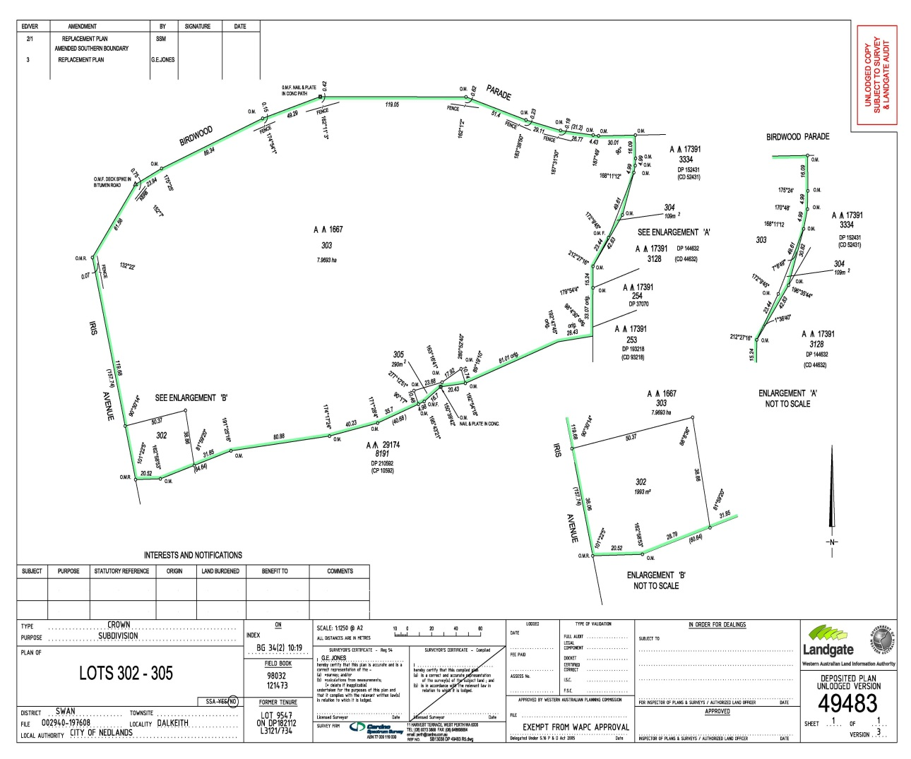

Notes
¹ This is a compilation of the Sunset Reserve Transformation Act 2014. The following table contains information about that Act.

Compilation table
Short title | Number and year | Assent | Commencement
Sunset Reserve Transformation Act 2014 | 7 of 2014 | 22 Apr 2014 | s. 1 and 2: 22 Apr 2014 (see s. 2(a));  Act other than s. 1 and 2: 23 Apr 2014 (see s. 2(b))

Defined terms

[This is a list of terms defined and the provisions where they are defined. The list is not part of the law.]
Defined term Provision(s)
class A reserve 3(1)
excised land 3(1)
Metropolitan Region Scheme 10
Minister for Works 3(1)
Nedlands planning scheme 10
Sunset Reserve 3(1)

