Western Australia

Metropolitan Water Supply, Sewerage and Drainage By-laws 1981
Compare between:
[01 Jul 2005, 04-f0-03] and [01 Jul 2006, 04-g0-03]

Western Australia
Metropolitan Water Supply, Sewerage, and Drainage Act 1909 ²
Metropolitan Water Supply, Sewerage and Drainage By-laws 1981

Preliminary and definitions

1.0 Citation
These by-laws may be cited as the Metropolitan Water Supply, Sewerage and Drainage By-laws 1981¹ and shall come into operation on 1 March 1981.

1.1 Interpretation
In these by-laws, unless the context otherwise requires —
“Approved” means approved by the Corporation or by a duly designated officer of the Corporation.
“AS/NZS”, followed by a designation consisting of a number and a year, means the Australian/New Zealand Standard having that designation that is published jointly by Standards Australia and Standards New Zealand and includes any amendment to that standard made before the commencement of the Metropolitan Water Supply, Sewerage and Drainage Amendment By-laws 1998 ¹.
“Backflow”, in relation to water supply installation, means the flow of water or other fluids into the water supply pipe of a property, or a watermain, from any source or sources or in a manner other than approved.
“Bore”, “Diameter” or “Size”, in reference to —
(a) any pipe of copper or brass, means the external diameter of the pipe; and
(b) any pipe of any other material, means the internal diameter of the pipe.
“Branch property sewer” means any branch off a property sewer.
“Commercial Type” means other than domestic type.
“Container” means the vessel in which the heated water is stored; sometimes referred to as the storage container, cylinder or tank.
“Cross Connection” means any connection or arrangement, physical or otherwise, between any potable water supply system directly connected to a water main, and any fixture, storage tank, receptacle, equipment or device, through which it may be possible for any non-potable, used, unclean, polluted or contaminated water, or any other substance, to enter any part of such potable water supply system under any conditions.
“Disconnector Trap” means a trap used in the separate pipe system for isolating or disconnecting waste pipes from the property sewer and soil pipes and for providing inlet ventilation to the waste pipe or pipes discharging into it.
“Discharge Pipe” means any pipe for the conveyance of sewage or trade waste.
“Domestic Purposes”, in relation to the supply of water, means the supply of water to rated land classified as residential under the Water Agencies (Charges) By-laws 1987 or exempt land used for residential purposes; the term also includes the use of water for watering lawns and gardens appurtenant to the land and for watering lawns and gardens growing in a street or road adjoining the land and for the purpose of these by-laws shall include water used for toilet, ablution or kitchen purposes in land rated as industrial or commercial.
“Domestic Sewage” means all faecal matter, urine, household slops and household liquid refuse.
“Domestic Type” means a fixture or appliance which is designed for use in residential situations. A fixture or appliance of this type may be installed in a non-residential building, but the sewage which it discharges shall be similar to that which would be discharged if installed in a residential situation.
“Educt Vent” means an opening or pipe for the exit of air from a soil pipe, waste pipe, combined waste pipe or property sewer.
“Feeder” means any water course, creek, stream or other channel with either perennial or intermittent flow whereby water can be conveyed to any reservoir.
“Flat” means a suite of rooms used or intended or adapted for use as a separate habitation and comprised in a building containing one or more similar suites.
“Ground” means the surface of the earth, soil, or rock which conform to the established finished grade at a specific location after all excavations have been thoroughly backfilled or otherwise closed and after all surface treatment at said location has been completed.
“High-Water Mark” means the level of full supply of any reservoir or feeder thereto.
“Indirectly Connected” means interrupted by a water seal or air gap as applicable to the situation.
“Induct vent” means an opening or pipe for the admission of air to a soil pipe, waste pipe, combined waste pipe or property sewer.
“Industrial Waste” means the liquid, solid or gaseous refuse from any business, industry, warehouse or manufacturing premises other than domestic sewage, stormwater, or unpolluted water.
“Inspector” means any person appointed by the Corporation for purposes connected with the administration of these by-laws, and also any person acting in the capacity of ranger of any proclaimed catchment area.
“Licensed Plumber” means a person who holds a plumbing contractor’s licence under the Water Services Licensing (Plumbers Licensing and Plumbing Standards) Regulations 2000.
“Observation Well” means a well constructed for the purposes of observing the depth to the ground water from the top of the well, and for obtaining samples of the ground water.
“Pesticides” means a substance or compound used or intended for use for agricultural, pastoral, horticultural, domestic, or industrial purposes for controlling, destroying or preventing the growth and development of any fungus, virus, insect, mite, mollusc, nematode, plant or animal and includes all admixtures containing any proportion of any one or more of them.
“Pipework” is the assembly of pipes and fittings.
“Plumbing Standards” has the meaning given to that term in regulation 3(1) of the Water Services Licensing (Plumbers Licensing and Plumbing Standards) Regulations 2000.
“Private Service” includes all the pipes and fittings, and all connections and apparatus of any nature or kind, whether used temporarily or otherwise, on any part of any land or building, supplied with water, whether by meter or otherwise and includes any pipes or fittings the property of the consumer, which are used for conveying water from the mains of the Corporation whether situated on the premises of the consumer or otherwise.
“Production Well” means a well owned and operated by the Corporation and from which groundwater is extracted for the provision of a public water supply.
“Residential Building” means a building in which sleeping accommodation is provided for persons other than caretakers and their families and includes dwellings, tenements, flats, hotels, lodging houses, dormitories, hospitals and motels.
“Sanitary Plumbing” means plumbing that is the result of sanitary plumbing work as defined in regulation 3(1) of the Water Services Licensing (Plumbers Licensing and Plumbing Standards) Regulations 2000.
“Spill Level” of any fixture, storage tank or receptacle is the maximum height to which water will rise while overflowing freely either over its rim or through any channels or overflows that are provided and have a free discharge to the atmosphere under all conditions, when water is flowing into such fixture, storage tank or receptacle at the maximum rate under a pressure equal to a head of 70 m applied either at the outlet end of the pipe or at the inlet to the fitting or valve actually discharging such water, with all the service outlets of such fixture, storage tank or receptacle closed.
“The Act” means the Metropolitan Water Supply, Sewerage, and Drainage Act 1909 ², as amended from time to time.
“Trade Waste” means liquid waste, other than domestic sewage and as defined by the Corporation. See “Industrial Waste”.
“Vented” refers to a discharge pipe with a vent connected at its upstream end.
“Vent Pipe” means any pipe used or intended to be used for ventilating soil pipes, waste pipes, property sewers, traps, connections or sewers.
“Vent Stack” means a vertical vent pipe installed primarily for the purpose of providing circulation of air to and from any part of a property sewer on the sewerage system.
“Water Heater” means an appliance, usually self-contained, for heating water which is either stored in it or passing through it.
“Water Seal” or “Trap Seal” means the vertical distance between the dip and the crown weir of a trap as shown in sketch.
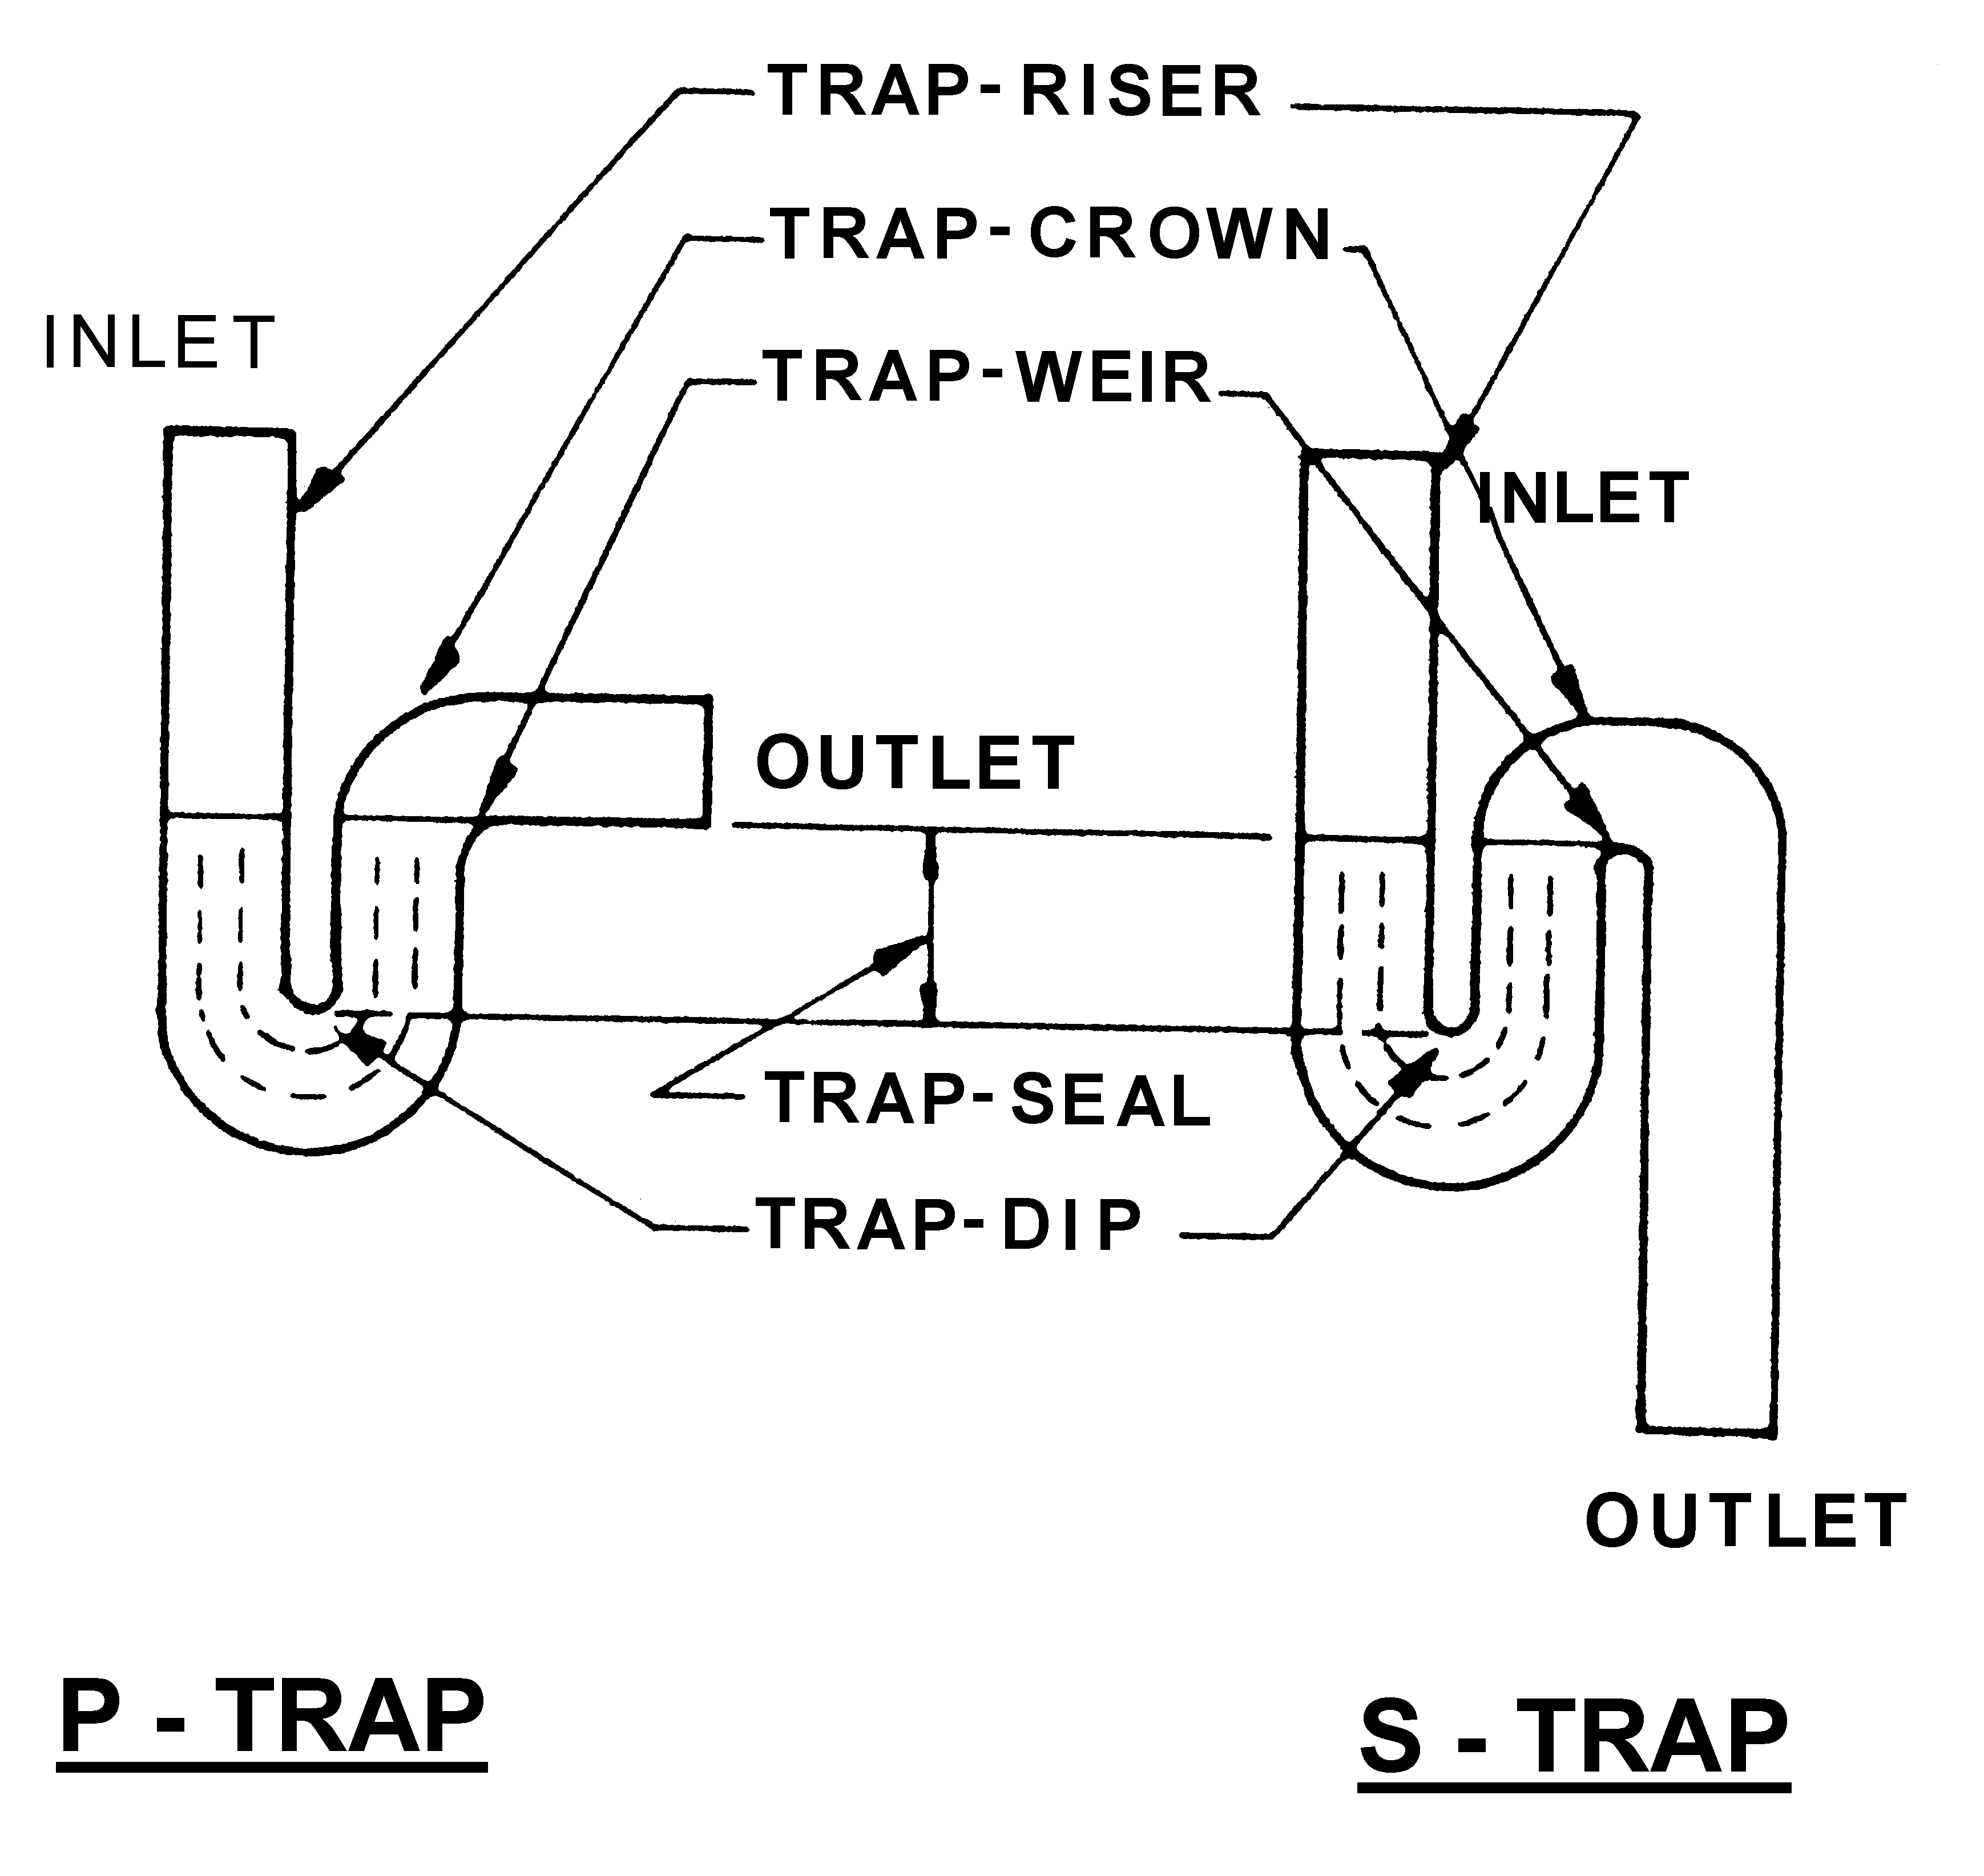
FIGURE 1.2 TRAPS
“Water Service” means the pipes and fittings used or intended to be used for the supply of water from a watermain up to and including the meter assembly and temporary building standpipe, if any, of each property.
“Waste Pipe” means a pipe which conveys the discharge from waste fixtures only.
“Yard Gully” means a disconnector trap which is used externally and fitted with a basin top and grating.
[By-law 1.1 amended in Gazette 24 Dec 1982 p. 4924-5; 29 Jun 1989 p. 1888; 21 Sep 1990 p. 4952; 29 Dec 1995 p. 6319-20 and 6324; 4 Feb 1997 p. 713; 25 Aug 1998 p. 4724-5; 16 Jun 2000 p. 2959; 28 Jun 2004 p. 2373-4.]
[1.2-1.4 Repealed in Gazette 28 Jun 2004 p. 2374.]

2.0 Protection of the Board’s works and property

2.1 General
2.1.1 By-laws in this Part are intended to —
(a) Protect the Corporation’s works and property from interference or damage that would hinder or prevent normal operation of the system.
(b) Regulate the entry of persons onto Corporation property and behaviour of those persons while entered thereon.
2.1.2 Attention is drawn to by-law 31.4 regarding penalties that may be imposed for breaches of these by-laws.
[By-law 2.1 amended in Gazette 29 Dec 1995 p. 6324 and 6326.]

2.2 Protection of works
2.2.1 No unauthorised person shall use waterworks and fittings which are the property of the Corporation.
2.2.2 No person shall wilfully or carelessly damage or cause damage to waterworks and fittings which are the property of the Corporation.
2.2.3 No person shall carry on, or cause to be carried on, any mining or quarrying operation, or make any excavation of any sort, or cause any explosion or other action in the vicinity of the Corporation’s or the Commission’s works which may cause damage or future damage by subsidence of the ground, without the written permission of the Corporation or the Commission as the case requires and under such conditions as the Corporation or the Commission as the case requires may deem necessary.
[2.2.4 repealed]
2.2.5 No person shall drive, take, ride or permit any vehicle, conveyance or animal to cross any exposed pipe, valve, fitting or apparatus except at crossing points approved by the Corporation or the Commission and indicated by sign-boards.
2.2.6 No person shall drive, take or ride any vehicle, conveyance or animal across underground pipelines or works, where warning signs have been erected by the Corporation or the Commission except at crossing points approved by the Corporation or the Commission and indicated by sign-boards.
[By-law 2.2 amended in Gazette 24 Dec 1982 p. 4925; 29 Dec 1995 p. 6320, 6324 and 6326.]

2.3 Protection of grounds
2.3.1 No person shall wilfully or carelessly injure, damage, disfigure, displace, or remove any fence, stake, post, pillar, pipe, survey mark, peg, tablet or notice board belonging to, or installed by the Corporation or the Commission.
2.3.2 No person shall wilfully or carelessly injure, deface or disfigure any notice or copy of a by-law, rule or regulation displayed upon any tablet or notice board erected by the Corporation or the Commission.
2.3.3 No unauthorised person shall open any gate, slip rail, manhole, door, or other entrance into, or trespass upon any enclosure of the Corporation’s or the Commission’s property without the written permission of the Corporation or the Commission as the case requires.
2.3.4 No unauthorised person shall stand, park or leave unattended any vehicle, trailer or item of mobile equipment on property, (including depots) or reserves vested in the Corporation or the Commission except in a place set aside and designated as a Visitors Car Park.
2.3.5 Any person driving or taking vehicles onto property (including depots) or reserves vested in the Corporation or the Commission shall comply with all signs erected thereon for the regulation of traffic speed and movement.
2.3.6 No person shall remove, pluck or damage any wildflower, shrub, bush, tree or other plant growing on any land or reserve vested in the Corporation or the Commission.
2.3.7 No loose paper or any refuse is to be left on any portion of the grounds of any reservoir or water, sewerage or stormwater drainage works except in the receptacles provided. Where no receptacle is provided, the loose paper or other refuse is to be removed from the site.
2.3.8 No person shall post or distribute bills, advertisements, or other notices on any portion of any reservoir or water, sewerage or stormwater drainage works, or on any portion of the ground in the vicinity thereof without permission in writing from the Corporation or the Commission.
2.3.9 No person is to camp on Corporation or the Commission property, or reserves vested in the Corporation or the Commission without the written permission of the Corporation or the Commission as the case requires and subject to any conditions that the Corporation or the Commission may impose.
2.3.10 All persons using picnic or recreation areas set aside for that purpose on Corporation or the Commission property or reserves vested in the Corporation or the Commission shall obey any instructions displayed on notice boards or issued verbally by the officers of the Corporation or the Commission or other authorised persons regarding behaviour in, or use of those picnic or recreation areas.
[By-law 2.3 amended in Gazette 29 Dec 1995 p. 6320 and 6326.]

3. Protection of water against pollution

3.1 General
3.1.1 By-laws contained in Part 3 are intended to prevent the contamination of water stored for distribution by the Corporation.
3.1.2 Attention is drawn to by-law 31.4 regarding penalties for breaches of these by-laws.
[By-law 3.1 amended in Gazette 29 Dec 1995 p. 6324.]

3.2 Protection of water purity
3.2.1 No person shall throw or deposit any refuse, contaminating chemical or noxious substance into —
(a) Any reservoir, pond or tank that holds or is intended to hold water for distribution to the Corporation’s consumers.
(b) Any pipe, conduit, valve, meter, or fitting through which potable water is to be passed.
(c) Any pit, manhole or other structure containing valves, meters, fittings or connections to potable water mains.
3.2.2 No person shall commit a nuisance in, upon, or in the vicinity of any waterworks.
3.2.3 No person shall swim, bathe, or wash in any reservoir, pond, or tank containing water stored for distribution to consumers. Nor shall any person knowingly suffer any child under their control to swim, bathe, or wash in any such reservoir, pond or tank.
3.2.4 No boating, canoeing, fishing, or shooting is permitted in, on or over any reservoir, pond, watercourse, or channel vested in, or under the control of the Corporation without the written authority of the Corporation.
3.2.5 No person shall permit any dog, or other animal or bird under his ownership or control to swim in or trespass on any portion of the ground within the vicinity of any reservoir, pond, tank or watercourse or sewerage or stormwater drainage works without the written permission of the Corporation.
[By-law 3.2 amended in Gazette 29 Dec 1995 p. 6324 and 6326.]

4. Protection of catchment areas and water reserves

4.1 General
4.1.1 The by-laws contained in this Part are intended to —
(a) Prevent any deterioration of the quality of water collected from the Commission’s catchment areas and water reserves by way of increased bacteriological or chemical contamination, increased turbidity, or increased level of nutrients necessary to the growth of undesirable aquatic flora.
(b) Control and manage existing and future development within the catchments and water reserves that could adversely affect water quality.
(c) Regulate the behaviour of persons entering the catchment areas.
4.1.2 Attention is drawn to by-law 31.4 regarding penalties that may be imposed for breaches of these by-laws.
[By-law 4.1 amended in Gazette 29 Dec 1995 p. 6321 and 6326.]

4.2 Application
4.2.1 The by-laws in this Part apply to Water Reserves and Catchment Areas constituted under the Act and within which surface or sub-surface water may be collected into an open storage reservoir before distribution to consumers.
4.2.2 In this Part —
4.2.2.1 All by-laws applicable to a catchment area shall apply equally to any part of a water reserve from which water can flow into an existing storage reservoir.
4.2.2.2 Prohibited Zone means that part of a catchment area which lies —
(a) Upstream of a dam, and
(b) Within 2 kilometres of the top water level of any reservoir in which water is or can be stored.
4.2.2.3 Public road means a road or street as defined in the Local Government Act.
[By-law 4.2 amended in Gazette 29 Dec 1995 p. 6321.]

4.3 Protection of water quality
4.3.1 No person shall throw, deposit, discharge or leave or cause, permit or suffer to be thrown, deposited, discharged or left into or upon a catchment area or water reserve any chemical, radioactive material, litter, rubbish, offal, dung, dead animal or any noisome, noxious or polluting liquid substance, matter, or thing which is likely to pollute the catchment area or water reserve or any reservoir or watercourse in the catchment area, or which is likely to affect purity of the water.
4.3.2 No person shall swim, bathe, or have any bodily contact with the water or wash any clothes or other articles in any stream, reservoir, aqueduct or other water works within a catchment area.
4.3.3 No person shall in or upon any watercourse, lake, reservoir, aqueduct or other water works in a catchment area set afloat, sail, propel or cause to be propelled any craft or vessel, without express permission in writing from the Commission and subject to any conditions that it may deem necessary.
4.3.4 No person shall camp, or shoot, trap or hunt any game or catch, or attempt to catch, any fish or marron within a catchment area, without specific permission in writing from the Commission to which it may attach any conditions that it deems necessary.
4.3.5 No person shall light a fire on Crown land in a prohibited S4.3.6 zone on a catchment area except in the fire places provided at authorised picnic sites unless with the written approval of the Commission, and any person lighting fires at other places on a catchment area shall comply fully with all requirements of the Bush Fires Act or restrictions promulgated under that Act.
4.3.6 No unauthorised person shall enter Crown land within a prohibited zone on any catchment area except for the purposes of —
(a) Travelling through the prohibited area on public roads, or
(b) Travelling along private roads constructed for the Commission or Forests Department ³ and which are open for public use, or
(c) Picnicking within designated picnic sites provided and serviced by the Commission.
4.3.7 No picnic area or amenity to encourage picnicking or public recreation is to be established in any catchment area or water reserve without the written approval of the Commission.
[By-law 4.3 amended in Gazette 29 Dec 1995 p. 6321 and 6325.]

4.4 Disposal of sewage and waste
4.4.1 No person shall permit the water of any property sewer or any filthy or polluted water discharging from premises occupied by him or under his control, to run, flow, or be brought into any reservoir or watercourse in any catchment area or water reserve.
4.4.2 Disposal of domestic sewage on catchment areas and water reserves.
4.4.2.1 All domestic sewage and liquid waste shall be treated and disposed of in accordance with the Health (Treatment of Sewage and Disposal of Effluent and Liquid Waste) Regulations 1974 of the Public Health Department ⁴.
4.4.2.2 Prior approval in writing must be obtained from the Commission before a bacteriolytic treatment plant is installed within a prohibited zone or within 100 metres of the centre line of any watercourse.
4.4.2.3 Any liquid waste not processed through a bacteriolytic treatment plant, or not capable of treatment in such a plant shall be stored in watertight tanks or receptacles (which shall be maintained in good condition) and periodically removed from the catchment area by a liquid waste removal contractor approved by the appropriate Local Health Authority, and by the Commission.
4.4.3 The occupier of every house or premises shall provide and maintain in good condition a sufficient number of receptacles or boxes to contain all solid refuse, and the contents of these receptacles or boxes shall be removed from the catchment area at least once every week.
[By-law 4.4 amended in Gazette 24 Dec 1982 p. 4926; 29 Dec 1995 p. 6325; 26 Jun 1998 p. 3420.]

4.5 Control of animals, livestock etc.
4.5.1 The owner or person in charge of any animals or birds shall not cause or permit any dog, horse, goat, cattle, sheep, pig, duck, geese or fowls or other species of livestock to enter or remain on any portion of a catchment area.
4.5.2 The occupier or owner of any land within a catchment area shall not raise or graze livestock without approval of the Commission.
4.5.3 No person shall ride a horse or any other animal on any of the Commission’s catchment areas (except along public roads) without the written permission of the Commission.
4.5.4 Any animal or bird found straying within a catchment area may be —
(a) Driven away or otherwise removed from such lands;
(b) Sold;
(c) Destroyed; or
(d) Otherwise disposed of,
by any officer or person authorised by the Commission without incurring any liability on the part of the Commission to recompense the owner for the loss.
4.5.5 No person shall slaughter any animal or bird in a catchment area without the permission of the Commission.
4.5.6 The owner of any animal or bird which dies upon any part of a catchment area or the person under whose charge the animal was at or immediately before the time of its death, shall forthwith upon knowing or being informed of the death of the animal or bird remove its body or carcass from the catchment area or bury the same so that all parts of the carcass are not less than 300 mm below the normal surface and restore the ground at least to its original level except that no animal or bird shall be buried within a prohibited zone or within 100 metres of the centre line of any watercourse.
[By-law 4.5 amended in Gazette 29 Dec 1995 p. 6325-6.]

4.6 Chemicals and flammable liquids
4.6.1 The occupier or owner of any house, land or premises situated within a catchment area shall not store or use any animal manure or fertilizer unless written permission therefor has been given by the Commission and subject to any conditions that it may consider necessary.
4.6.2 No person shall lay, place or use upon any part of the catchment area any poison, pesticide, insecticide, herbicide or other dangerous substances without written permission of the Commission and then they shall be applied in the manner required by the Pesticides Regulations of the Public Health Department ⁴.
4.6.3 All persons storing, laying, placing or using any explosive or dangerous goods on a catchment area shall comply with the requirements of the Explosives and Dangerous Goods Act administered by the Mines Department ⁵.
4.6.4 No toxic, dangerous chemicals or radioactive materials are to be stored on the catchment areas without the prior approval of the Commission in writing, and may be subject to such conditions as the Commission considers necessary.
4.6.5 Storage of Petroleum Products on Catchment Areas and Water Reserves
4.6.5.1 Approval in writing from the Commission must be obtained before any licensed installation for the storage of petroleum or petroleum products is constructed.
4.6.5.2 Petroleum products are to be stored and handled in accordance with the Flammable Liquids Regulations ⁶ issued by the Mines Department ⁵ and in addition shall comply with the following —
(a) No underground tanks are to be situated within a prohibited zone or within 100 metres of the centre line of any watercourse.
(b) Every underground tank shall be installed in an impervious containment structure or membrane approved by the Commission that is capable of preventing any leakage from the tank.
(c) Any bunds or compounds on any premises licensed under the Flammable Liquids Regulations ⁶ shall be constructed with walls and floor impervious to the flow of petroleum products to the approval of the Commission.
(d) Any additional conditions that the Commission may deem necessary.
4.6.5.3 Any person storing petroleum products on unlicensed premises are to take all precautions necessary to prevent spillage of petroleum products onto the ground.
[By-law 4.6 amended in Gazette 29 Dec 1995 p. 6321 and 6325.]

4.7 Protection of water from turbidity
4.7.1 No person or corporation shall clear any portion of the catchment area or commence any excavation or any construction, alteration or diversion of roads without first obtaining the approval of the Commission in writing. This approval may be given subject to any conditions that the Commission deems necessary.
4.7.2 No person shall drive a vehicle on any part of a catchment area other than a road or track which has a graded, gravelled, sealed, primed or other prepared surface without written approval of the Commission.
4.7.3 No person or organisation shall conduct a vehicle rally or race on a catchment area without first obtaining the Commission’s written approval and then only under such conditions as the Commission may impose.
[By-law 4.7 amended in Gazette 29 Dec 1995 p. 6325 and 6326.]

4.8 Control of development
4.8.1 No person shall commence, carry out, change or expand any agricultural, industrial, commercial, quarrying or mining development in a catchment area without the approval in writing of the Commission which may impose any conditions thereon that it considers necessary.
4.8.2 No person is to establish or carry on an offensive trade as defined in the Health Act ⁷ on a catchment area or water reserve without written approval from the Commission which may impose conditions regarding the establishment and operation of that trade.
4.8.3 No person shall commence or proceed with the erection of a building or structure of any kind or any alterations or additions to a building or structure on a catchment area or water reserve without the approval in writing of the Commission and subject to any conditions that it may deem necessary.
4.8.4 The occupier or owner of premises in a catchment area shall maintain those premises at all times to the standards required by the Public Health Act ⁷ or the relevant Regulations made under that Act.
[By-law 4.8 amended in Gazette 29 Dec 1995 p. 6325-6.]

4.9 Restoration after commission of an offence
If any person or corporation commits an offence under Part 4, the Commission, upon discovery of that offence, may serve notice on the offending person or corporation to restore any damage, remove any cause of pollution, or dismantle any building carried out in contravention of these by-laws by a nominated date. Failure to comply with the notice by the nominated date shall constitute a continuing offence from that date under section 147 of the Act ⁸, or in accordance with section 17 of the Metropolitan Water Supply, Sewerage, and Drainage Act.
[By-law 4.9 amended in Gazette 29 Dec 1995 p. 6325-6.]

4.10 Control of persons and vehicles
4.10.1 The Commission may erect signs at any position in the catchment areas or water reserves that it considers necessary to control the activities of persons or movement of vehicles entering onto or moving across the catchment areas or water reserves.
4.10.2 Any person driving or taking a vehicle, trailer, or item of mobile equipment onto or across a catchment area shall comply with all signs erected to control the speed, movement or parking of vehicles, trailers or mobile equipment.
4.10.3 Powers of a Ranger
4.10.3.1 Rangers and other persons authorised by the Commission are empowered to demand the name and address of any person committing or reasonably suspected of committing an offence against the Act or these by-laws relating to catchment areas and water reserves.
4.10.3.2 Any person who refuses to give, or gives a false name or address when such is requested by a Ranger or other authorised person is deemed to commit an offence under these by-laws.
[By-law 4.10 amended in Gazette 29 Dec 1995 p. 6321 and 6325-6.]

5.0 Protection of public water supply areas and underground water pollution control areas

5.1 General
5.1.1 The objectives of the by-laws in Part 5 are —
(a) To define provisions governing the licensing, construction and operation of private wells.
(b) To protect the Commission’s production and observation wells from damage or pollution.
(c) To prevent contamination of underground water in the pollution control areas.
(d) To control development over the areas so as to prevent or inhibit contamination.
5.1.2 Penalties for breaches of any by-laws in Part 5 shall be as set out in section 57B(4) of the Act.
5.1.3 The Commission may erect signs and notice boards in any pollution area or Public Water Supply Area for the exhibition of any by-law, rule, regulation or notice.
[By-law 5.1 amended in Gazette 29 Dec 1995 p. 6325-6.]

5.2 Control of private wells
5.2.1 Licences
5.2.1.1 Every application for a licence under section 57G shall be made in the form No. 1 in Schedule B to these by-laws.
5.2.1.2 A person shall not give false or misleading information in his application for a licence.
5.2.1.3 A licence shall, subject to the terms, limitations and conditions endorsed thereon be in the form No. 2 in Schedule B to these by-laws.
5.2.2 Progress Statements
5.2.2.1 A licensee shall within 30 days of completing a well, or completing alterations to a well, for which a licence has been issued, forward to the Commission a statement in the form No. 3 in Schedule B to these by-laws.
5.2.2.2 The provisions of by-law 5.2.2.1 apply notwithstanding that the works relating to the well have been unsuccessful.
5.2.3 Measurement of Water Drawn from Well
5.2.3.1 The Commission or any officer authorised by the Commission may fit a measuring device to any well to measure the quantity of water drawn from the well and to ensure the adequate performance of the measuring device, the Commission may —
(a) Alter the piping or other means of conveying the water from the well, and
(b) Fit screens and traps to the pump to protect the measuring device.
5.2.3.2 A person who damages or interferes with a measuring device or with any piping or channelling installed by or at the direction of the Commission in connection with the measuring device, or who fails to comply with a direction given pursuant to this by-law commits an offence.
5.2.3.3 The provisions of this by-law are in addition to and not in derogation of the provisions contained in by-law 6.7.
5.2.4 A person shall not construct or cause to be constructed or altered a well in any pollution area except in accordance with the Health Act (Underground Water Supply) Regulations 1959 as amended from time to time.
5.2.5 A person shall not place any chemical or other substance that is capable of polluting underground water, down a well during the course of its construction, redevelopment, maintenance or operation without prior approval of the Commission.
[By-law 5.2 amended in Gazette 31 Jul 1981 p. 3169; 29 Dec 1995 p. 6325-6.]

5.3 Protection of works
5.3.1 A person shall not construct, alter or obstruct any watercourse, or drainage works in a manner that causes the flooding of any well or observation well.

5.4 Protection of underground water quality
5.4.1 In a pollution area the use, storage and transport of pesticides, the disposal of pesticide containers and the disposal of spilled pesticides shall be in compliance with the provisions of the Pesticides Regulations as amended from time to time.
5.4.2 In a pollution area a person shall not store animal manures or sewage sludges within 100 metres of a production well except with the approval of the Commission.
5.4.3 In a pollution area a person shall not carry out the burial or disposal of animal or poultry carcasses, blood offal, or other refuse products in excess of 2 tonnes, unless prior approval has been obtained from the Commission.
5.4.4 In a pollution area a person shall not yard or house an animal within 30 m of a production well.
5.4.5 In a pollution area installation or operation of septic tanks, leach drains, soakwells and other apparatus for the disposal of domestic waste waters shall be carried out in conformity with the Health (Treatment of Sewage and Disposal of Effluent and Liquid Waste) Regulations 1974 as amended from time to time and where the site is within 100 m of a production well a person shall obtain prior consent for the installation or operation from the Commission which may impose further conditions and restrictions as to the siting, construction or operation of the apparatus, in which event the Commission shall meet any consequential extra cost incurred in the initial construction of the apparatus.
5.4.6 In a pollution area or a part of a pollution area a person shall not dispose of or discharge onto or into the ground, or into any lake, swamp or drain industrial wastes, chemicals, radioactive material, petroleum or petroleum products, polluted water, or refuse unless that person has been granted permission in writing by the Commission to do so.
5.4.7 A person shall not discharge into any well or observation well any chemical, industrial waste, treated or untreated sewage, effluent or other matter which in the opinion of the Commission may pollute the underground water.
5.4.8 The holder of a permit referred to in by-law 5.5.2, shall notify the Commission immediately any spillage occurs that might pollute the groundwater, either directly or indirectly, and where that spillage occurs.
5.4.9 Any person spilling, or being aware of any leakage of, any petroleum product in a pollution area shall notify the Commission immediately of that occurrence.
[By-law 5.4 amended in Gazette 24 Dec 1982 p. 4926; 29 Dec 1995 p. 6322 and 6325-6; 26 Jun 1998 p. 3420.]

5.5 Control of development
5.5.1 A person shall not establish an offensive trade in accordance with the provisions of the Health Act 1911, in a pollution area, unless they have obtained the consent of the Board to do so, and unless they comply with any conditions which the Board may impose in relation to the establishment of that offensive trade.
5.5.2 The establishment or operation of any premises for the storage, packaging, formulating, processing, manufacturing, sale, testing or use of chemicals or other substances liable to pollute underground water in a pollution area shall be subject to the following terms, provisions and conditions —
(a) application shall be made to the Commission in writing for a permit to operate existing or proposed premises and the application shall set out —
(i) The process or processes of manufacture, packaging, storage, formulating, testing, or use of all raw materials and fuels, intermediate products and final products including waste material and effluents whether gaseous, liquid or solid.
(ii) The quantities of raw materials, and fuels used and the intermediate and final products, waste materials, effluents, being or proposed to be produced.
(iii) The methods proposed to treat and dispose of any wastes, by-products and effluents, including stormwater and wash down water where this may be or could become polluted.
(iv) Plans and procedures proposed to prevent pollution of underground water, including emergency plans and procedures for contingencies such as accidental spillage or malfunction of any manufacturing, storage, transport or treatment process or system, both on and off the premises where this is applicable.
(v) Such other information required by the Commission to assess the pollution risk to underground water and to assist with measures to prevent pollution.
(b) Upon receipt of the permit for the operation of the premises the applicant shall enter into a written agreement with the Commission to comply with the conditions of the permit which may where so required include conditions that where at any time in the opinion of the Commission —
(i) The occupier is not fully and faithfully performing and observing the terms, provisions and conditions of the permit or any by-law;
(ii) The raw materials, intermediate products and final products, wastes, effluents, fuels or any other substances are not in compliance with the terms, provisions or conditions of the permit;
(iii) The apparatus, the subject of the permit is not in efficient working order;
(iv) Pollution of the groundwater may be occurring or about to occur; or
(v) Any other breach of the agreement has been made,
the Commission may serve a notice in writing upon the occupier of the property, by delivering it or posting it addressed to him at the property, specifying the matter or matters in respect of which a breach has taken place, or as to which the occupier is in default, or concerning which there is any complaint by the Commission, and the notice shall require the occupier to make good the same in all things to the satisfaction of the Commission, within a period to be stated therein, from the date of service thereof in a manner so specified, and the notice shall also state that the Commission is at liberty to terminate and put an end to the permit.
(c) The occupier shall notify the Commission in writing of his desire to make any alteration which shall in any way affect the nature and quantity of the raw materials, fuels, intermediate and final products, wastes and effluents, or the apparatus plans and procedures the subject of the permit, and which may affect the risk of pollution to underground water, and shall not make such an alteration without prior approval in writing from the Commission.
(d) The person to whom the permit is granted shall notify the Commission in writing of any change of ownership or occupancy of the property, at least 14 days prior to the change.
(e) The permit shall not be assigned or transferred, unless the consent of the Commission in writing has been first obtained.
(f) The Commission may require the owner or occupier of any premises the subject of a permit from the Commission to install sample collection apparatus, measuring equipment and observation wells in the ground for the purpose of measuring the depth to the ground water and for obtaining samples of ground water, or for any other purpose.
(g) The Commission or any authorised officer, servant, agent, or workman of the Commission shall be at liberty at any time and from time to time to enter upon the property and every part thereof and to take samples or measurements and otherwise to inspect the apparatus stored or situated on the property.
5.5.3 Where the requirements of a notice referred to in by-law 5.5.2(b) have not been complied with on the expiration of the period mentioned therein, the permit shall automatically terminate, and the Commission, by its officers or authorised agents may enter upon the property, and at the expense of the occupier disconnect or stop the apparatus used and take such other action as may be deemed necessary to prevent or stop pollution of groundwater that may be occurring or which might occur, and the occupier shall not be entitled to compensation in connection therewith.
5.5.4 Any person handling petroleum and other flammable liquids in a pollution area shall store and handle those liquids in accordance with the Flammable Liquids Regulations 1967 ⁶, as amended from time to time and in addition shall comply with the following requirements —
(a) Underground tanks for the storage of petroleum products shall not be installed within 100 m of a production well.
(b) All underground tanks for the storage of petroleum products shall be installed in impervious containment structures or membranes approved by the Commission capable of preventing any leakage from the storage tank to the ground or ground water.
(c) Any bunds or compounds on any premises licensed under the Flammable Liquids Regulations 1967 ⁶, as amended from time to time, shall be constructed so that the walls and floor of the bund or compound are of impervious material to the approval of the Commission.
(d) Where a person intends to store flammable liquids in a pollution area, they shall apply to the Commission for its prior approval, setting out the location of proposed structures, buildings and tanks and shall abide by any conditions which the Commission may impose.
5.5.5 A person storing or using petroleum products in a pollution area at unlicensed premises in accordance with Part III of the Flammable Liquids Regulations 1967 ⁶, as amended from time to time, shall take all reasonable care to prevent spillage or leakage of petroleum products onto or into the ground and may be required by the Commission to install suitable impervious catchpits, or similar containment structures approved by the Commission.
[By-law 5.5 amended in Gazette 24 Dec 1982 p. 4926; 29 Dec 1995 p. 6322 and 6325-6.]

5.6 Protection of pollution areas
5.6.1 In this by-law and by-laws 5.6.2, 5.6.3, 5.6.4, 5.6.5, 5.6.6, 5.6.7 and 5.6.8 —
“automotive business premises” means premises associated with the repair, maintenance or servicing of motor vehicles and includes premises that are to be used as or by any of the following —
(a) an automotive maintenance and repair shop or premises where motor vehicle parts are installed;
(b) a motor vehicle detailer, a car wash establishment, a motor vehicle wrecker or a vehicle depot;
(c) a workshop for construction, mining and earthmoving equipment; or
(d) a wholesaler or retailer of fuels and oils;
“bulk liquid storage tank system” means any tank, whether or not mobile, having a capacity of or greater than 250 litres, and includes the pipework fittings and filling and dispensing apparatus associated with the tank, but does not include a tank that is part of any apparatus for the bacteriolytic treatment of sewage or that contains unpolluted water;
“elevated storage tank system” means a bulk liquid storage tank system in which no portion of the tank is on or below the ground;
“establish”, in relation to a mobile bulk liquid storage tank system, includes placing that storage tank system at a location where it will operate for a purpose other than the delivery to, or collection from, another bulk liquid storage tank system;
“ground storage tank system” means a bulk liquid storage tank system in which any portion of the tank is on or below the ground;
“owner” has the same meaning as in section 6 of the Local Government Act 1960 ⁹;
“plans” means the plans showing the locations of pollution areas, priority 1, 2 and 3 source protection areas, wellheads and wellhead protection zones, copies of which are available for public inspection at the offices of the Commission, and representations of which are set out in the Schedule after by-law 5.6.8;
“priority 1 source protection area”, “priority 2 source protection area” and “priority 3 source protection area” mean the portions of pollution areas designated, respectively, “P1”, “P2” and “P3” on the plans;
“tank” includes all the tanks that are connected in, or otherwise form part of, the same bulk liquid storage tank system;
“unpolluted water” means water that, if released from storage, would not contaminate groundwater or other water resources;
“wellhead” means a well, or the location of a proposed well, identified on the plans by its name adjacent to a black circle;
“wellhead protection zone” means that area within a pollution area that surrounds a wellhead, the extent of which is identified on the plans.
5.6.2 Regardless of any other provision of these by-laws, a person shall not establish within a priority 1 or a priority 2 source protection area —
(a) a ground storage tank system;
(b) any automotive business premises; or
(c) an elevated storage tank system inside a wellhead protection zone.
5.6.3 A person shall not establish, or increase the capacity of, an elevated storage tank system within a priority 1 or priority 2 source protection area unless —
(a) the person has applied for a permit under by-law 5.6.4;
(b) the Commission has issued a permit authorising the establishment, or increase in capacity, of the storage tank system; and
(c) the person complies with the terms and conditions of the permit.
5.6.4 An application for a permit to establish, or increase the capacity of, an elevated storage tank system on land within a priority 1 or priority 2 source protection area shall be made —
(a) in writing to the Commission; and
(b) by the owner of the land or, if the owner is not the occupier, by the occupier of the land.
5.6.5 The Commission may only issue a permit applied for under by-law 5.6.4 —
(a) for an elevated storage tank system that, including any proposed increase in capacity, does not exceed 5 000 litres, unless the Commission is satisfied that there are special circumstances relevant to the issue of that permit; and
(b) if, regardless of the present or proposed capacity of the elevated storage tank system the subject of the application, the Commission is satisfied that there is no undue risk that the purity of underground water in the source protection area in which the storage tank system is to be established, or increased in capacity, will be affected detrimentally, either directly or indirectly, by the establishment, or increase in capacity, of that storage tank system.
5.6.6 By-laws 5.5.2 (other than paragraph (a)) and 5.5.3, as they relate to permits, apply, to the extent that they are applicable and with appropriate modifications, to a permit applied for under by-law 5.6.4.
5.6.7 The Commission, by notice in writing served on a person who, in contravention of by-law 5.6.2 or 5.6.3, as the case may be —
(a) has established, or increased the capacity of, a storage tank system; or
(b) has established any automotive business premises,
may direct that person within such period, being not less than 21 days after the service of the notice, as specified in the notice, to dismantle and remove the storage tank system or the business premises.
5.6.8 If a person fails to comply with a notice served on that person under by-law 5.6.7 —
(a) the person commits an offence; and
(b) the Commission may itself dismantle and remove the storage tank system or the business premises the subject of the offence.
Schedule
[bl. 5.6.1]
Locations of Priority Source Protection Areas,
Wellheads and Wellhead Protection Zones
Plan 1 — Mirrabooka Underground Water Pollution Control Area
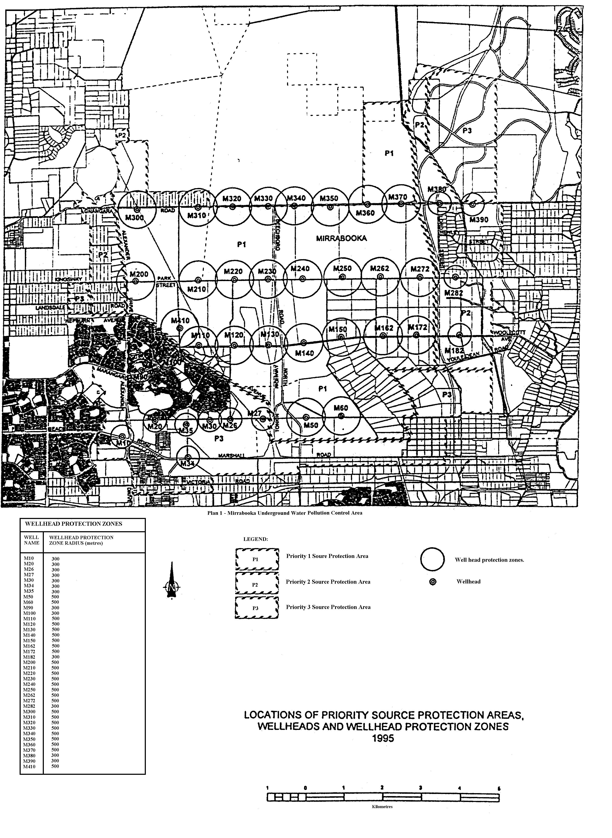
Plan 2 — Gnangara Underground Water Pollution Control Area
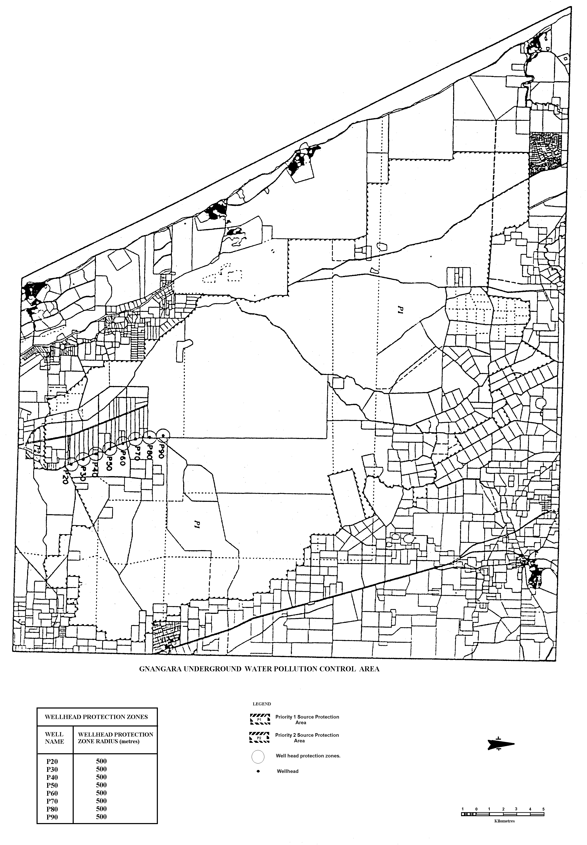
Plan 3 — Wanneroo Underground Water Pollution Control Area
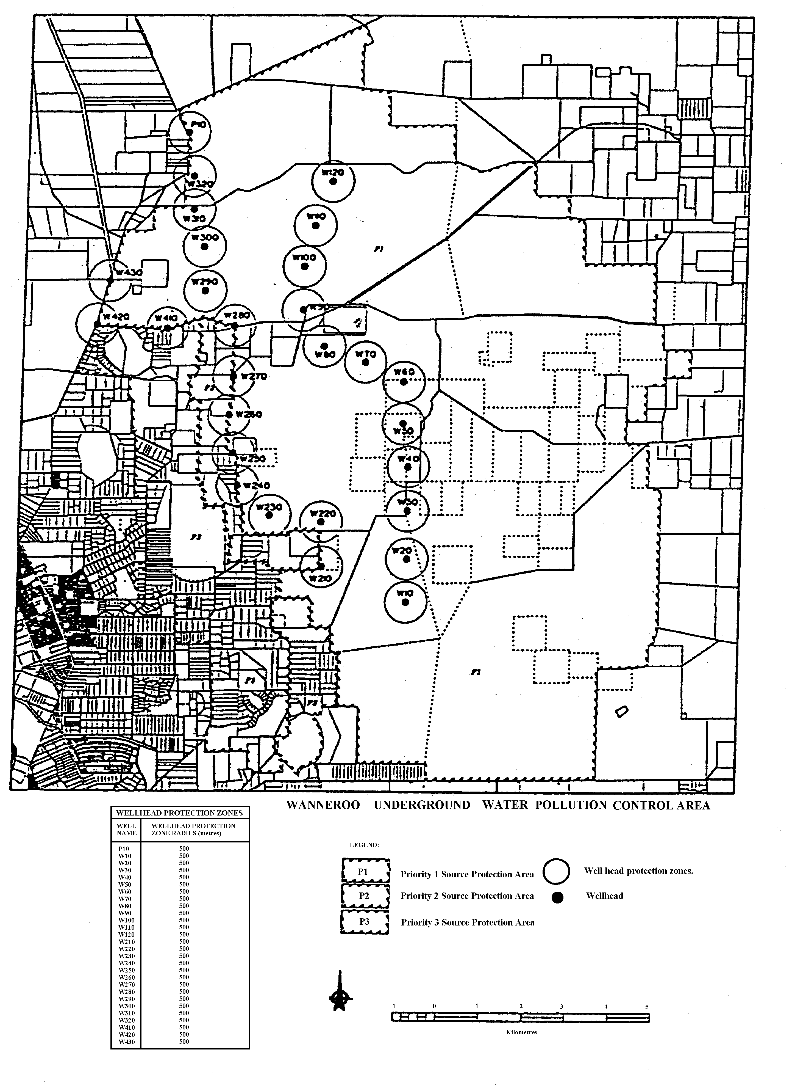
Plan 4 — Jandakot Underground Water Pollution Control Area
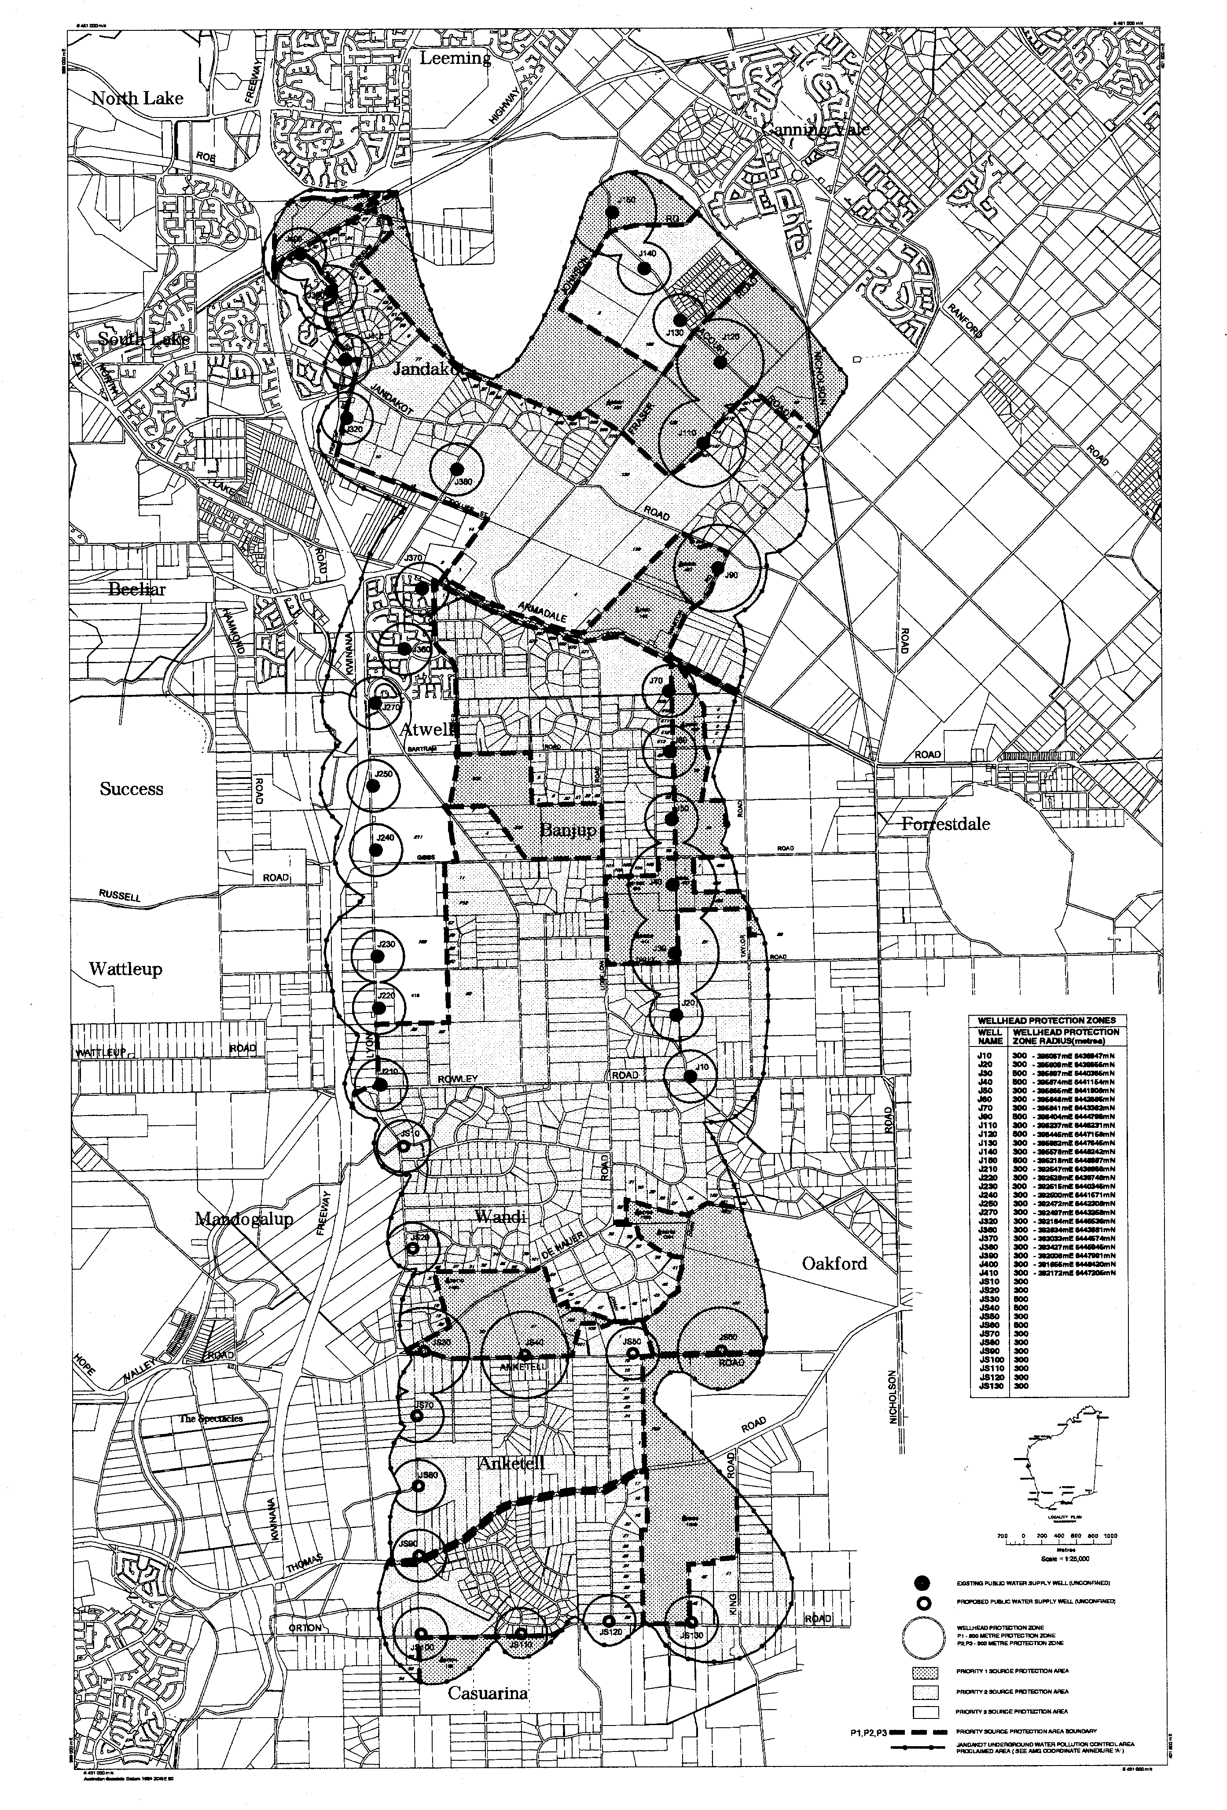
Plan 5 — Locations of Underground Water Pollution Control Areas
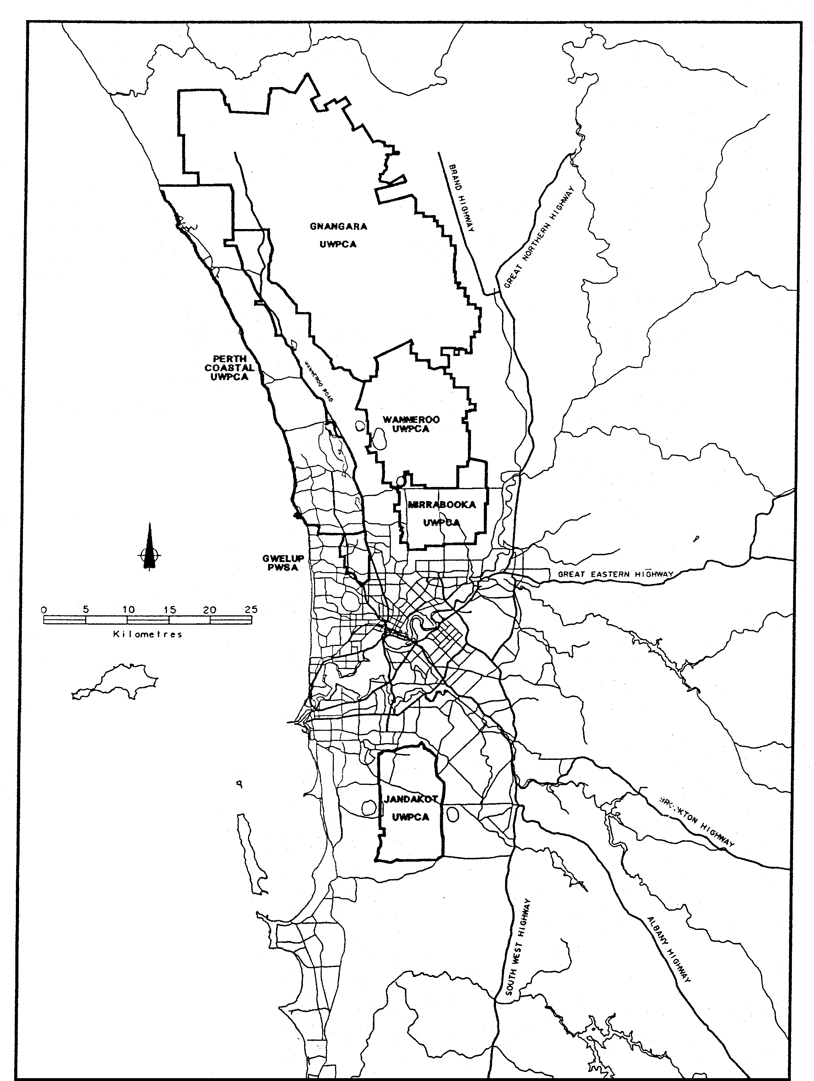
[By-law 5.6 inserted in Gazette 31 Dec 1992 p. 6418-24; (Schedule inserted in Gazette 30 Jul 1993 p. 4166); amended in Gazette 30 Jul 1993 p. 4165; 23 Jun 1995 p. 2510; 29 Dec 1995 p. 6322 and 6327; 1 Sep 2000 p. 5021.]

6.0 Supply of water and the installation of services and meters

6.1 General
6.1.1 By-laws contained in Part 6 are intended to define —
(a) The purposes for which water can be used.
(b) The conditions under which water services will be provided, altered and disconnected, and
(c) The powers of the Corporation to install water meters on services and the consequent responsibilities of occupiers and owners.
6.1.2 Attention is drawn to by-law 31.4 regarding penalties for offences against these by-laws.
[By-law 6.1 amended in Gazette 29 Dec 1995 p. 6324.]

6.2 Supply and use of water
6.2.1 After receipt of an application, the Corporation may supply water for the following purposes subject to any conditions relating to the method of taking, using, and controlling the water that it may deem necessary —
(a) Domestic purposes.
(b) Industrial purposes.
(c) Drinking water for stock.
(d) Fire fighting and protection.
(e) Cleansing, maintenance or construction of public or private roads.
(f) Watering of public or private parks, gardens and playing fields.
(g) Filling and operating ornamental fountains, swimming pools, wading pools, fish ponds, ornamental lakes, or any receptacle of a similar nature.
(h) Construction of buildings or other works on private or public property.
(i) The operation of any form of hydraulic ejector or machine.
(j) The operation of any apparatus in which water is used for cooling including refrigerating equipment, air conditioning or any form of temperature control;
(k) The sale of the water by a person who holds an operating licence under Part 3 of the Water Services Licensing Act 1995.
6.2.2 Any person provided with a supply of water for a specified purpose shall not use such water for any other purpose without the written permission of the Corporation.
6.2.3 No occupier, owner or any other person shall allow water supplied by the Corporation to run to waste or permit undue consumption. If in the opinion of the Corporation any person is wasting or unduly consuming water, it may serve notice on the occupier, owner or other person to cease the waste or undue use within a period nominated by the Corporation. Failure to prevent the waste or undue use within the nominated period shall be deemed an offence against these by-laws and the Corporation may without prejudice to any other penalty contained in these by-laws, forthwith disconnect the supply and debit the cost of the disconnection to the occupier or owner.
6.2.4 The occupier or owner of land or premises supplied with water from the Corporation’s mains shall ensure that such water is not used by persons not connected with said land or premises.
[6.2.5 repealed]
6.2.6 The Corporation may, from time to time, and without giving prior notice to the occupiers or owners affected, cut off the supply of water to any part or parts of the area for the purpose of carrying out work on its mains.
[By-law 6.2 amended in Gazette 29 Dec 1995 p. 6324 and 6326; 29 Sep 1998 p. 5405; 26 Apr 2005 p. 1396.]

6.3 Services to rated properties
6.3.1 The Corporation will provide one service to each rated property provided that the water is required for one of the purposes listed in by-law 6.2.1 except as set out in by-law 6.3.3.
6.3.2 A service will not be laid onto any rated property until the internal water supply system has been completed except as provided in by-law 6.5.2.2.
6.3.3 Where applications are received for water services to a group of properties incorporated or to be incorporated under the Strata Titles Act ¹⁰ or to a group of properties under the one common ownership or use the Corporation shall provide a single water service except where the Corporation at its discretion decides that additional rated services are justified.
6.3.4 Where an applicant requires the Corporation to provide a new water service to a rated property which has an existing disconnected service, the Corporation reserves the right to recover from such applicant the whole or part of the current cost of the disconnected service or services.
6.3.5 The service pipe provided by the Corporation to supply water to any rated property shall not exceed 20 mm nominal internal diameter unless the Corporation at its absolute discretion decides that a pipe of greater diameter is necessary in order to maintain a reasonable supply of water to the said property.
6.3.6 No branch or fitting shall be connected to a private service pipe within a distance of one metre on the consumer’s side of the Corporation’s stop-cock or water meter.
6.3.7 No part of a private water supply system that can be fed from private water tanks or from supplies other than that provided by the Corporation shall be connected to any part of a private water supply system that is connected directly to the Corporation’s service pipe.
6.3.8 No occupier or owner shall connect or allow to be connected any pump to any part of a private water supply system that is supplied directly from the Corporation’s service pipe without the written permission of the Corporation and without accepting in writing any conditions that the Corporation may deem necessary.
6.3.9 No person shall connect or interfere, or allow any connection or interference with the Corporation’s mains, service pipes or meters.
6.3.10 Applications for water services to rated properties shall be made on the printed form procurable at the Head or Branch Offices of the Corporation, and shall be lodged not less than 7 days before the service is required.
6.3.11 Applications for alteration of position or size, and disconnection of the Corporation’s services shall be made on the printed form procurable at the Head or Branch Offices of the Corporation, and the necessary fees paid, if required, before work is commenced.
6.3.12 The occupier or owner of any property provided with a water service from the Corporation shall ensure that the portion of the Corporation’s service on his property is adequately protected from damage and shall be held liable for the cost of any repairs thereto.
[By-law 6.3 amended in Gazette 24 Dec 1982 p. 4926; 29 Dec 1995 p. 6324-6; 28 Jun 2004 p. 2374.]

6.4 Non-rated services
6.4.1 Services covered by this by-law include —
(a) Services to land which is exempt under by-law 4 of the Water Agencies (Charges) By-laws 1987.
(b) Services to land that is not supplied with water by the Corporation and is, in the opinion of the Corporation, not reasonably capable of being so supplied.
(c) Fire services.
(d) Additional services.
(e) Temporary services including hydrant services.
6.4.2 Non-rateable services may be provided at the discretion of the Corporation subject to any conditions which it may see fit to impose.
6.4.3 Applications for non-rateable water services shall be made on the printed form procurable at Head or Branch Offices of the Corporation, and shall be lodged, the fees paid and conditions accepted not less than 7 days before the service is required.
6.4.4 Applicants shall be advised in writing of any conditions to be imposed in a Letter of Conditions. In each case these conditions shall be accepted in writing, and will include provisions for the applicant to pay —
(a) The cost of installation, maintenance where applicable, and disconnection of the service.
(b) The cost of any main extension necessary for provision of the non-rated service.
(c) An annual service fee and meter rental charge if applicable.
(d) The cost of water supplied where applicable.
6.4.5 By-laws 6.3.2, 6.3.3, 6.3.5 to 6.3.9 and 6.3.12 applying to rated services shall also apply to non-rated services.
6.4.6 Private Fire Services
6.4.6.1 Fire services may be provided by the Corporation for the purpose of supplying water for fire fighting and the necessary testing of firefighting equipment.
6.4.6.2 Subject to by-law 6.4.4 the Corporation will lay to each property or group of properties under the one common ownership or use —
(a) A single or dual fire service for the operation of sprinklers, or
(b) A single fire service for the operation of hydrants or hose-reels.
6.4.6.3 Seals may be affixed to hydrant valves at the discretion of the Corporation at the expense of the occupier or owner. In the event of the seals having been broken in the case of fire or by accident or otherwise, the occupier or owner shall give notice forthwith to the Corporation and pay the cost of re-sealing.
6.4.6.4 No water shall be taken from any fire service except for the purpose of extinguishing fires or for the necessary testing of the service. When required by the Corporation, the occupier or owner shall notify and make any necessary arrangements with the Corporation in advance of any proposed test.
6.4.6.5 Where any fire service has been given the Corporation shall not be liable to provide or maintain a continuous supply or pressure of water.
6.4.7 Where any property is provided with 2 or more water services whether rated or otherwise, interconnection of such services through the internal private water supply system is prohibited except in the cases of —
(a) A dual fire service provided under by-law 6.4.6.2(a) where approved non-return valves shall be provided and maintained by the occupier or owner on each service so as to prevent a back-flow of any water into the Corporation’s mains.
(b) An additional service where the Corporation may install and maintain at the expense of the occupier or owner, a non-return valve or other approved backflow prevention device on each or any service capable of being interconnected.
6.4.8 Where a water supply of a non-permanent nature is required for any purpose specified in by-law 6.2.1 a temporary non-rated service may be provided.
[By-law 6.4 amended in Gazette 24 Dec 1982 p. 4926; 29 Dec 1995 p. 6324-6; 29 Jun 1999 p. 2785.]

6.5 Building services
6.5.1 This by-law contains by-laws applicable to the use of water for construction purposes on rated or non-rated properties or other land for the construction of new buildings, extensions or alterations to existing buildings, or for other construction works.
6.5.2 To Unserviced Properties
6.5.2.1 Applications for services shall be made on the printed form available from Head or Branch Offices of the Corporation. Before any application is accepted the applicant must —
(a) Provide 2 copies of the building plans.
[(b) deleted]
(c) In the case of a rated service application pay any charges arising from by-laws 6.3.4 or 6.3.11.
(d) In the case of a non-rated service application accept in writing the terms and conditions of supply and pay the appropriate fees and charges prescribed in these by-laws and the Water Agencies (Charges) By-laws 1987.
6.5.2.2 Unless the Corporation provides and installs a temporary building standpipe under by-law 6.5.2.2A, the builder shall engage a licensed plumber to provide and install an adequately supported stand-pipe complete with hose-tap situated not less than one metre horizontally from the proposed stop-cock position together with the connecting pipe before the Corporation will install its service pipe.
6.5.2.2A The Corporation may provide and install on a building or construction site a temporary building stand-pipe together with hose-tap and pipe connection on payment by the builder of the fee set out in item 6 of Schedule C.
6.5.2.3 The builder or principal contractor shall be responsible for the protection and cost of maintenance of the Corporation’s service and meter (if fitted) until he notifies the Corporation of the date of practical completion of the works under construction.
6.5.3 To properties already serviced
No water is to be used for building or construction purposes from an existing water service until the conditions contained in by-law 6.5.2.1 have been complied with.
6.5.4 All hoses in use on building or construction sites shall be fitted with a selfclosing hand-operated valve at the outlet end except when the hose is connected to any apparatus for the controlled distribution of water for a specific purpose.
6.5.5 The supply to any property may be disconnected at the expense of the builder if water is used in connection with any work in addition to that shown on the plans submitted and on which the building fee was assessed.
[By-law 6.5 amended in Gazette 24 Dec 1982 p. 4926; 29 Jun 1989 p. 1888; 29 Dec 1995 p. 6322 and 6324-7; 27 Jun 1997 p. 3216.]

6.6 Water for cooling and hydraulically operated machines
6.6.1 See by-law 15.4 for details regarding the method of applying for and the conditions applicable to a service or subservice provided for cooling purposes or for the operation of hydraulic machines.

6.7 Meters
6.7.1 The Corporation may install a water meter on any service at its discretion, and shall determine the size and class of meter in each case.
6.7.1A Fee for installation of meter in certain cases
6.7.1A.1 Where the Corporation installs a meter under by-law 6.7.1 on a service to —
(a) a unit; or
(b) a common area or facility,
in a multi-unit development, the owner of the land shall pay the fee specified in item 5(a) of Schedule C for the installation of the meter.
6.7.1A.2 Where a meter is installed other than under by-law 6.7.1 on a service to —
(a) a unit; or
(b) a common area or facility,
in a multi-unit development, the owner of the land may request the Corporation to assess whether the meter is satisfactory for the purpose of measuring the flow of water through that meter.
6.7.1A.3 Where the Corporation assesses a meter under by-law 6.7.1A.2 and finds that it is satisfactory for the purpose of measuring the flow of water through that meter —
(a) the Corporation may use the meter for the measuring of the flow of water through the meter; and
(b) the owner shall pay the fee specified in item 5(b) of Schedule C.
6.7.1A.4 Where the Corporation assesses a meter under by-law 6.7.1A.2 and finds that it is not satisfactory for the purpose of measuring the flow of water through that meter —
(a) the Corporation shall install a meter on the service under by-law 6.7.1; and
(b) the owner shall pay the fee specified in item 5(c) of Schedule C.
6.7.1A.5 In by-laws 6.7.1A.1 and 6.7.1A.2 —
“multi-unit development” means a development of land consisting of 2 or more units for residential or non-residential use.
6.7.2 Where the Corporation installs a meter under by-law 6.7.1, it shall be supplied by the Corporation and shall be set —
(a) above normal ground level inside the boundary of the land and adjacent to the reticulation main through which the water is supplied; or
(b) in a pit or cubicle when this is required by the Corporation under by-law 6.7.2A.
6.7.2A Pits and cubicles
6.7.2A.1 The Corporation may require the owner or occupier of land to provide, at his own cost, a pit for the purpose of housing the meter and its associated valves and fittings.
6.7.2A.2 Where a building is to be constructed or altered, the Corporation may require the owner or occupier of the land on which the building is to be constructed or altered to provide, at his own cost, a cubicle attached to or forming part of the building for the purpose of housing the meter and its associated valves and fittings.
6.7.2A.3 A person required under by-law 6.7.2A.1 or 6.7.2A.2 to provide a pit or cubicle shall do so in accordance with such requirements as the Corporation may specify in writing.
6.7.3 The occupier or owner of premises where a meter has been installed shall maintain a clear space not less than 300 mm horizontally and 1 200 mm vertically from the meter and ensure easy access for the Corporation at all times.
6.7.4 No person shall break or in any way interfere with the seal fixed on the meter through which water is supplied by the Corporation, or turn or attempt to turn any screw, bolt, or nut on or attached to such meter, or use any tool or appliance on any such meter, or introduce or attempt to introduce any body or substance into such meter, or in any way interfere with any portion of such meter, or any pipes or fittings attached thereto.
6.7.5 Any persons supplied by the Corporation through a meter shall, on finding the meter damaged, or not registering, immediately give notice of the damage or non-registration to the Head or any Branch Office of the Corporation.
6.7.6 Protection of Water Meters
6.7.6.1 The occupier or owner of any property supplied through a meter affixed to the Corporation’s service shall take every necessary precaution to protect the Corporation’s meter from damage.
6.7.6.2 All repairs required to damaged meters shall be carried out by the officers of the Corporation.
6.7.6.3 The occupier or owner shall pay to the Corporation the cost of making good any damage to such meter on demand, and if not paid on demand shall be recoverable in the same manner as water rates.
[By-law 6.7 amended in Gazette 14 Oct 1988 p. 4173-4; 21 Apr 1989 p. 1174 (erratum in Gazette 19 May 1989 p. 1499); 29 Dec 1995 p. 6322 and 6324-7; 27 Jun 1997 p. 3216.]
[7.0 and heading repealed in Gazette 28 Jun 2004 p. 2375.]
[8.0: bl. 8.2-8.9 repealed in Gazette 25 Aug 1998 p. 4730
heading and bl. 8.1 repealed in Gazette 28 Jun 2004 p. 2375.]
[9.0 (9.1-9.12). Repealed in Gazette 25 Aug 1998 p. 4730.]
[10.0: bl. 10.3-10.11 repealed in Gazette 4 May 1993 p. 2329
bl. 10.1-10.2 repealed in Gazette 25 Aug 1998 p. 4730.]

11.0 Storage tanks for cold water

11.1 Definition
A storage tank is any vessel used or intended to be used for the storage of water whether under pressure or not, and not being a hot water system, or flushing cistern in accordance with AS 1218.

11.2 Storage tanks required
Where required by the Corporation, water shall be supplied from storage tanks.
[11.2.1 and Figure 11.1 repealed in Gazette 28 Jun 2004 p. 2375.]
[11.2.2-11.2.3 repealed]
[By-law 11.2 amended in Gazette 29 Dec 1995 p. 6322 and 6324-5; 25 Aug 1998 p. 4730; 28 Jun 2004 p. 2375.]
[11.3-11.5. Repealed in Gazette 25 Aug 1998 p. 4730.]

12.0 Joint water supply system

12.1 Joint water service
12.1.1 A “joint water service” is any privately owned water supply pipe which services 2 or more dwelling units.
12.1.2 Each dwelling or common facility shall be serviced by a separate branch from a joint water service.
[12.2-12.4. Repealed in Gazette 28 Jun 2004 p. 2375.]

12.5 Provision for metering
Where required by the Corporation provision shall be made for the installation of meters on the branch supply lines to individual dwelling units and common facilities.
[By-law 12.5 amended in Gazette 29 Dec 1995 p. 6324-5.]
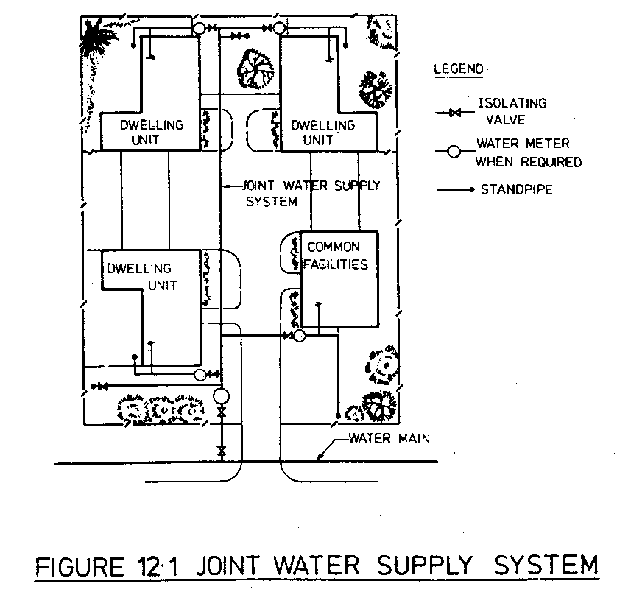

13.0 Fire services

13.1 Fire hose reel installations
[13.1.1-13.1.3 repealed.]
13.1.4 Fire Hose Connection Points
[(a) and (b) repealed]
(c) All fire hose reels shall be connected to a metered supply unless otherwise approved.
[By-law 13.1 amended in Gazette 25 Aug 1998 p. 4731.]
[13.2. Repealed in Gazette 25 Aug 1998 p. 4731.]
[14.0: bl. 14.1, 14.3, 14.5, 14.6 repealed in Gazette 25 Aug 1998 p. 4731
heading and bl. 14.2, 14.4 repealed in Gazette 28 Jun 2004 p. 2375.]

15.0 Private water supply systems

15.1 Pipes and apparatus for private services
In connection with the laying down, maintenance, alteration, or repair of every private service, the following conditions shall be observed by the owner or occupier of the premises —
[(a) to (e) deleted]
(f) No pipe or other apparatus shall be laid through any sewer, property sewer, ash pit, cistern or manure bin, or through, in, or into, any place where in the event of the pipe becoming unsound the water conveyed through the pipe or apparatus would be liable to be polluted or to escape without observation, unless the pipe or apparatus is laid through a sleeve which may consist of an approved iron pipe or box of sufficient length and strength to afford due protection to the pipe or apparatus, and to bring any leakage or waste to notice and easy detection.
[By-law 15.1 amended in Gazette 24 Dec 1982 p. 4926; 29 Dec 1995 p. 6322, 6324-6; 25 Aug 1998 p. 4731.]

15.2 Separate services required
Not more than one house or tenement shall be supplied from one service except as set out in by-law 6.3.3 or with the written permission of the Corporation in special cases. When more than one house or tenement is supplied from a single service, the subservices shall be so arranged that the supply to each house shall be independent of the supply to the remaining houses and controlled by a stop-cock on such subservices.
[By-law 15.2 amended in Gazette 29 Dec 1995 p. 6324-5; 28 Jun 2004 p. 2375.]

15.3 Notice of intention to build
The owner or occupier of any land supplied with water who shall erect, or make, or cause to be erected or made any building or addition to an existing building on such land, shall, before the commencement of same, give notice in writing thereof to the Corporation.
[By-law 15.3 amended in Gazette 29 Dec 1995 p. 6324-5.]

15.4 Water for cooling purposes
15.4.1 Any apparatus in which water is used for cooling purposes, including refrigerating equipment or machinery, or any apparatus or system used for the cooling of roofs, or for any form of air conditioning or temperature control or in connection with any form of hydraulic ejector or hydraulic apparatus for power purposes, shall be deemed to be an apparatus within the meaning of this by-law.
15.4.2 The use of water for any such apparatus shall be subject to the conditions set out in this by-law.
15.4.3 From and after the commencement of this by-law, no apparatus shall be installed or used, and no apparatus previously installed shall be used in, on, or in connection with any property, land, or tenement unless the Corporation shall have first consented thereto in writing.
15.4.4 Applications for consent to install or use such apparatus shall be made on the printed form available at Head and Branch offices of the Corporation and shall state the make and type, the minimum and maximum requirements, and any other information the Corporation may require.
15.4.5 If water used for or in the operation of any apparatus under full output exceeds 2.27 litres per minute, it shall be reused, unless consent to run it to waste shall have been obtained in writing from the Corporation. If installation is such that the unit cuts in and out, the supply of water for cooling purposes must be automatically shut off when the unit cuts out.
15.4.6 The quantity of water run to waste shall be limited to the quantity specified in the Corporation’s consent. The water which shall so run to waste shall be recorded by a meter specially affixed for the purpose and shall not exceed 16.2 litres per min. per 1 000 kilowatts of refrigeration capacity.
15.4.7 Should water in excess of the quantity specified in the Corporation’s consent be run to waste, every owner or occupier of the property, land, or tenement or other persons supplied by the Corporation who so permit or allow such excess water to be run to waste, shall be guilty of an offence.
15.4.8 A person supplied by the Corporation with water shall, at his own expense —
(a) make any alteration to the existing water service necessary in order that the subservice can be separately metered;
(b) pay the cost of removing the meter and disconnecting the subservice, if not further required; and
(c) during the continuance of the service, keep or cause to be kept, such apparatus, and all pipes in connection therewith, in a proper state of repair.
15.4.9.1 Where a person supplied by the Corporation with water desires to draw the supply direct from the Corporation’s main through an additional service, such additional service shall, at the discretion of the Corporation, be installed upon such occupier or owner depositing in advance —
(a) the amount of the estimated cost of installation; and
(b) the amount of the estimated cost of affixing a meter.
15.4.9.2 The owner or occupier shall, on completion of the work pay the actual costs thereof, whether they amount to more or less than the estimates. He shall also pay meter rent and bear the expense of maintaining the additional service and of having it disconnected when no longer required.
15.4.10 An owner, occupier, or other person who is supplied with water by the Corporation aforesaid, who shall fail to comply with this by-law, shall be deemed to be guilty of an offence hereunder, and shall be liable for each offence to a penalty not exceeding $80 and to a further penalty not exceeding $8 for each day the offence continues after notice thereof from the Corporation.
[By-law 15.4 amended in Gazette 29 Dec 1995 p. 6324-6.]
[15.5. Repealed in Gazette 25 Aug 1998 p. 4731.]
[15.6, 15.7. Repealed in Gazette 28 Jun 1985 p. 2349.]

15.8 Maintenance of private services and interference with meters etc.
(a) The owner of a property supplied with water shall at his own risk and expense lay down his private service and keep it in good order and repair, in accordance with the provisions of these by-laws.
(b) (i) Upon receiving notice from the Corporation that service pipes or apparatus, which service, and are within the boundary of land, require repair, the owner of the land shall forthwith employ a licensed plumber to effect the necessary repairs.
(ii) An owner of land who fails to comply with subparagraph (i) shall have committed an offence and be liable to a penalty not exceeding $200 and a further penalty of $20 for each day on which the offence continues.
(iii) Until the necessary repairs have been effected, the Corporation may stop the supply of water to the land.
(iv) The owner of the land shall be deemed to be responsible for loss of water or damage caused by the service pipes or apparatus being out of repair.
(c) In addition to any penalty provided by this by-law, the Corporation may cut off the supply of water to land whereon the private service is not at all times laid, fixed, used and maintained in accordance with the provisions of the said by-law, and may keep the same cut off until such provisions have been fully observed.
(d) A branch shall not be taken off the service pipe within a distance of one metre on the consumer’s side of the Corporation’s stop-cock or meter.
[By-law 15.8 amended in Gazette 24 Dec 1982 p. 4926; 29 Dec 1995 p. 6324-6.]

15.9 Ornamental fountains and swimming pools
(a) Persons shall not connect a supply pipe to an ornamental fountain or swimming or bathing pool, wading pool, fish pond, or ornamental lake or receptacle of a similar nature, without first obtaining the written permission of the Corporation.
(b) Where the Corporation grants permission under sub-bylaw (a), it may specify —
(i) the size and location of the supply pipe or pipes required;
(ii) whether the supply pipe shall be separate from the ordinary supply pipe;
(iii) the rate at which the water will be supplied;
(iv) the hours during which the supply of water will be permitted; and
(v) whether anemometer controls are to be fitted to the fountain,
and may require such supplies to be metered and recirculated.
[By-law 15.9 amended in Gazette 29 Dec 1995 p. 6324-5.]
[16.0 and heading repealed in Gazette 28 Jun 2004 p. 2375.]
[17.0 (17.1, 17.2, 17.4). Repealed in Gazette 25 Aug 1998 p. 4734.]
[17.3. Repealed in Gazette 22 Dec 1989 p. 4631.]

18.0 Connection of fixtures and fittings
[18.1. Repealed in Gazette 25 Aug 1998 p. 4734.]
[18.2, 18.3. Repealed in Gazette 28 Jun 2004 p. 2375.]
[18.4-18.19. Repealed in Gazette 25 Aug 1998 p. 4734.]
[18.20. Repealed in Gazette 28 Jun 2004 p. 2375.]
[18.21, 18.22. Repealed in Gazette 25 Aug 1998 p. 4734.]

18.23 Washing machines
[18.23.1 repealed]
18.23.2 Commercial Type Laundries
Commercial type laundry installations shall not be made until plans and specifications of the proposed work have been approved by the Corporation.
[By-law 18.23 amended in Gazette 28 Jun 1985 p. 2351; 29 Dec 1995 p. 6324-5; 25 Aug 1998 p. 4734.]
[18.24, 18.25. Repealed in Gazette 25 Aug 1998 p. 4734.]
[19.0: bl. 19.1, 19.2 repealed in Gazette 25 Aug 1998 p. 4734
heading and bl. 19.3 repealed in Gazette 28 Jun 2004 p. 2375.]
[19.4-19.8, 20.0-24.0. Repealed in Gazette 25 Aug 1998 p. 4734.]
[25.0: bl. 25.1-25.6 repealed in Gazette 25 Aug 1998 p. 4734
heading and bl. 25.7 repealed in Gazette 28 Jun 2004 p. 2376.]
[25.8-25.15. Repealed in Gazette 25 Aug 1998 p. 4734.]
[26.0: bl. 26.1-26.3 repealed in Gazette 25Aug 1998 p. 3734
heading and bl. 26.4 repealed in Gazette 28 Jun 2004 p. 2376.]

27.0 Sewerage services — general

27.1 Procedure for connections to sewer
When a sewer is completed and ready for use, action may be taken under sections 59 and 60 of the Act.

27.2 Proof of connections having been made: certificate of Corporation’s officer
The certificate of such officer as the Corporation may appoint, in writing, shall be prima facie evidence that a water-closet or water-closets, or drains, appliances, apparatus and connections have been provided or that the works, matters and things have been performed, as the case may be, and prima facie evidence as to the amount of costs, expenses, and interest recoverable in respect thereof.
[By-law 27.2 amended in Gazette 29 Dec 1995 p. 6324-5.]

27.3 Plans required for property sewerage installation and fees for examination of plans
27.3.1 Interpretation
In by-laws 27.3.2 and 27.3.3 “exempt building” means —
(a) a single occupancy dwelling;
(b) a residential or industrial development containing not more than 8 units; or
(c) a commercial development of not more than 160 fixture units.
27.3.2 Notice of Proposed New Works
A person who proposes to erect a new building that is to be connected to a sewer or to make alterations or additions to such a building shall —
(a) give to the Corporation notice of that erection, alteration or addition in the form of a form approved by the Corporation;
(b) furnish to the Corporation 2 copies of a plan of the building in a form acceptable to the Corporation; and
(c) where the building is not an exempt building, furnish to the Corporation a plumbing design plan in a form acceptable to the Corporation.
Where any change to the siting of the building is made prior to local authority approval, or where local authority approval is conditional upon any change to the siting of the building, the plans (showing the proposed re-siting) shall be resubmitted to the Corporation prior to any work starting on the building.
27.3.3 Existing Buildings
The owner or occupier of an existing building who proposes to connect the building to the Corporation’s sewerage system shall, if by-law 27.3.2 does not apply —
(a) give to the Corporation notice of the connection in the form of a form approved by the Corporation;
(b) furnish to the Corporation 2 copies of a plan in a form acceptable to the Corporation showing the location of the building in relation to the boundaries of the land and showing the location and level of the proposed fixtures; and
(c) where the building is not an exempt building, furnish to the Corporation a plumbing design plan in a form acceptable to the Corporation.
27.3.4 Fee for notices about proposed sewer connections
The person who gives the Corporation notice of a proposal under by-law 27.3.2 or 27.3.3 shall pay the fee set out in item 1 of Schedule C, at the time of giving the notice.
27.3.5 Scale of Plans: All plans submitted shall be drawn to a scale of not less than 1:200.
27.3.6 Fees for installation of sewer junction: The fees to be paid by an owner in respect of the installation of an additional sewer junction are as set out in item 2 of Schedule C.
[By-law 27.3 amended in Gazette 29 Jun 1984 p. 1812; 14 Jul 1984 p. 2656; 28 Jun 1985 p. 2348; 27 Jun 1986 p. 2131; 29 Jun 1988 p. 2126; 22 Dec 1989 p. 4635; 1 Jul 1993 p. 3246; 29 Dec 1995 p. 6326-7; 28 Jun 2004 p. 2376.]

27.4 Diagram of existing property sewers
A person may make application to the Corporation for a diagram of existing property sewers in any area the plans or records of which are in the custody of the Corporation, and on payment of such sum as the Corporation requires, be supplied by the Corporation with a diagram of the existing property sewers in that area in accordance with those plans and records.
[By-law 27.4 amended in Gazette 24 Dec 1982 p. 4929; 29 Dec 1995 p. 6324-5.]

27.5 Plan to be available to the Corporation
An approved plan of proposed plumbing work shall be produced whenever required during the progress of work, to the Corporation.
[By-law 27.5 inserted in Gazette 29 Jun 1984 p. 1812; amended in Gazette 29 Dec 1995 p. 6323.]

27.6 Notice and plan of intended new building or additions etc. to existing building
A person intending to erect a building, or rebuild, or to make any addition or alteration to any building, adjacent to the Corporation’s sewers shall give to the Corporation at least 14 days’ notice of such intention, and with such notice shall submit for approval 2 copies of the building plan and shall also submit sections of such intended building, additions or alterations, drawn to a scale of not less than 1:200 showing the position of proposed fixtures and approaches thereto. When required by the Corporation enlarged details to such scale as instructed shall be supplied.
Where any change to the siting of the building is made prior to local authority approval, or where local authority approval is conditional upon any change to the siting of the building, the plans (showing the proposed re-siting) shall be resubmitted to the Corporation prior to any work starting on the building.
[By-law 27.6 amended in Gazette 1 Jul 1993 p. 2346-7; 29 Dec 1995 p. 6324-7.]

27.7 Prescribed proximity to a sewer
For the purposes of section 66 of the Metropolitan Water Supply, Sewerage and Drainage Act 1909 the prescribed proximity to a sewer is —
(a) 1 m around the perimeter of a chamber giving access to a sewer; and
(b) 15 m above the surface of a chamber giving access to a sewer.
[By-law 27.7 inserted in Gazette 14 Nov 2000 p. 6256.]

27.8 Use of property sewers
The owner and the occupier of a sewered property shall discharge into the sewerage system all faecal matter, urine, household slops, and household liquid refuse from such property and such other polluted water from stables, washing areas, manure bins, basements, cellars and roofed yards and, subject to these by-laws such industrial wastes as the Corporation has consented in writing to being so discharged.
[27.8.1 repealed]
[27.8.2, 27.8.3 repealed]
[27.8.4 repealed]
[27.8.5 repealed]
[27.8.6 repealed]
27.8.7 Maintenance by Occupier
A silt trap, grease trap, oil trap or neutraliser, and such other appliance as the Corporation may direct, shall be maintained by the owner or occupier at his own expense and shall be cleaned at such intervals as may be necessary to ensure that such trap or appliance operates in an efficient and hygienic manner.
27.8.8 Separate or Common Property Sewers
(a) A house shall be separately served unless a common property sewer is ordered or approved by the Corporation.
(b) Where a common property sewer is ordered or approved by the Corporation, the provisions of section 70 of the Act, as other conditions required by the Corporation, shall apply.
[27.8.9 repealed]
[By-law 27.8 amended in Gazette 24 Dec 1982 p. 4929; 22 Dec 1989 p. 4636; 21 Sep 1990 p. 4952; 29 Dec 1995 p. 6323-6; 28 Jun 2004 p. 2377.]

27.9 Sewerage services to non-rateable properties
Applications for sewerage services to non-rateable properties shall be made on the prescribed form procurable at the Head or Branch Offices and the Corporation may provide a service on payment of the prescribed annual fee, of the cost of extending the sewer to the land if the sewer is not extended thereto and of installing a property sewer to the boundary of the land. The applicant shall also bear the cost of maintaining the property sewer and of having it sealed when the service is no longer required.
The annual fee shall take the place of a sewerage rate and the general provisions of these by-laws shall apply to such services.
[By-law 27.9 amended in Gazette 24 Dec 1982 p. 4929; 29 Dec 1995 p. 6324-5.]
INDUSTRIAL WASTES AND PLUMBING BY-LAWS NOT INCLUDED IN PARTS 14 TO 24 INCLUSIVE

28.0 Industrial wastes

28.1 Conditions of discharge
The discharge of industrial wastes into a sewer shall be subject to the following terms, provisions and conditions —
(a) An application for permission to discharge industrial wastes from a property into a sewer shall be made in writing to the Corporation and shall set out —
(i) the processes of manufacture from which industrial wastes are discharged into the Corporation’s sewer;
(ii) the nature of the industrial waste from every such process;
(iii) the estimated maximum rate of discharge of industrial waste from every such process;
(iv) the hours of the day during which discharge of industrial wastes from every such process will normally take place; and
(v) the estimated maximum daily discharge of such industrial wastes into the Corporation’s sewer,
and the application shall be accompanied by detailed plans of the apparatus to be used for the treatment of the industrial waste and by such other information regarding the nature, quantity, rates, and times of discharge as may be required by the Corporation;
(b) No industrial waste shall be discharged into the Corporation’s sewer unless a written permit has been first granted by the Corporation, and an agreement executed by the applicant containing a covenant to comply with the conditions of the permit, which shall include the following conditions, namely —
That if at any time in the opinion of the Corporation —
(i) the quantity, quality, or rate of the discharge of the said industrial waste is not in compliance with the terms, provisions, or conditions of the permit;
(ii) the occupier is not fully and faithfully performing and observing the terms, provisions, and conditions of the said permit and of this or any other by-law;
(iii) the treatment apparatus is not in efficient working order; or
(iv) any other breach of the agreement has been made,
the Corporation may serve a notice in writing upon the occupier of the property, by leaving it thereon or posting it addressed to him at the property, specifying the matter or matters in respect of which a breach has taken place, or as to which the occupier is in default, or concerning which there is any complaint by the Corporation, and the notice shall require the occupier to make good the same in all things to the satisfaction of the Corporation, within a period to be stated therein, from the date of service thereof, in the manner so specified, and the notice shall also state that the Corporation is at liberty to terminate and put an end to the permit; and, further, that if the requirements of the notice have not been complied with on the expiration of the period mentioned therein, the permit shall automatically terminate and be deemed to be at an end, save and except as to the power of entry by the Corporation’s officers as mentioned in the permit without any further or other notice from the Corporation, and the Corporation by its officers may enter upon the property, and at the cost and expense in all things of the occupier disconnect the apparatus used to discharge the industrial waste into the Corporation’s sewers, and prevent and put an end to the further entry of industrial waste to the sewers, and the occupier shall be entitled to no compensation whatever in connection therewith;
(ba) A written permit to discharge industrial waste granted by the Corporation shall remain in operation until —
(i) the permit is terminated under paragraph (b);
(ii) the permit is surrendered by the holder of the permit; or
(iii) there is a change of ownership or occupancy of the industrial property from which it is permitted to discharge that industrial waste, unless the Corporation approves of the assignment or transfer of the permit;
(c) The Corporation shall be the sole judge as to the quality, quantity and rate of discharge of such industrial waste and as to whether the same complies with the conditions of the said permit and of Parts 6 to 18 of these by-laws and its decision in regard thereto shall be final and conclusive;
(d) Except by special permission of the Corporation, in writing, the volume of industrial waste discharged from any property into a sewer of the Corporation shall not in any case exceed —
(i) if the industrial waste is discharged into a 100 mm sewer of the Corporation, a discharge rate of 3 kilolitres per hour;
(ii) if the industrial waste is discharged into a 150 mm sewer of the Corporation, a discharge rate of 7 kilolitres per hour; or
(iii) if the industrial waste is discharged into a 230 mm sewer of the Corporation, a discharge rate of 11.5 kilolitres per hour;
(e) The maximum aggregate daily quantity of industrial waste which may pass from any property into a sewer, the size and capacity of the property sewer for conveying such industrial waste from the property to the sewer, and the hours during which such flow will be permitted, shall be determined by the Corporation. The volume of industrial waste discharged shall, if ordered by the Corporation, be determined by meter or by some approved means of measurement provided by the occupier;
[(f) deleted]
(g) All industrial wastes shall be passed through such settling, screening or neutralising chambers or such other apparatus as ordered or approved by the Corporation or any one or more of those chambers or apparatus to ensure that the resulting effluent shall comply with the requirements of the said permit and of this by-law. All such apparatus or machinery shall be approve in type and general arrangement by the Corporation, but the applicant shall determine the size, capacity and details of the treatment apparatus necessary to provide an effluent in compliance with the requirements of the said permit and this by-law;
(h) The occupier shall notify the Corporation in writing of his desire to make any alteration which shall in any way affect —
(i) the nature of the waste from any process of manufacture;
(ii) the estimated maximum rate of discharge from any such process of manufacture; or
(iii) the hours of discharge of industrial waste from any such process; and all alterations or additions to the treatment apparatus shall in all things comply with the requirements of the said permit and of this by-law, but in no case shall any such alteration be made without the approval in writing of the Corporation;
(i) The person to whom the permit is granted shall notify the Corporation in writing of any change of ownership or occupancy of any industrial property connected with the Corporation’s sewers, at least 14 days prior to such change;
(j) The permit shall not be assigned or transferred, unless the consent thereto in writing of the Corporation has been first obtained;
(ja) Any person who, before obtaining a permit from the Corporation, has entered into the ownership or occupation of any property from which has been discharged industrial waste which the Corporation has permitted a previous owner or occupier to discharge into a sewer, is not permitted to discharge industrial waste into a sewer unless —
(i) the Corporation has first permitted the assignment or transfer of the permit under which industrial waste was admitted into a sewer; or
(ii) the Corporation has granted a fresh permit to the incoming owner or occupier to discharge into a sewer industrial waste from that property;
(jb) A person referred to in paragraph (ja) who discharges directly or indirectly industrial waste into a sewer before obtaining the permission of the Corporation or obtaining a fresh permit shall, in addition to any penalties prescribed in these by-laws, be liable for all amounts in respect of the discharge of industrial waste owing at the time that person entered into ownership or occupation of the property as well as such amounts as would have been payable in respect of any discharge of industrial waste after that time if that person had obtained a permit to discharge industrial waste;
(jc) Neither the payment of an amount referred to in paragraph (jb) nor the acceptance of that amount by the Corporation shall in any way constitute permission to discharge industrial waste into a sewer;
(k) The owner or occupier of any property connected with the Corporation’s sewers shall, if and where directed, install to the Corporation’s design an approved chamber for inspection, sampling, and measurement, and every such chamber shall at all times be readily accessible to the Corporation’s officers;
(l) The Corporation or any authorised officer, servant, agent, or workman, of the Corporation shall be at liberty at any time and from time to time to enter upon the property and every part thereof and take samples of industrial waste for analysis and otherwise and also to inspect the treatment apparatus;
(m) Every settling, screening, or neutralising chamber, or other apparatus for the treatment of industrial wastes in accordance with this by-law shall be cleansed and maintained by the occupier at his own expense and, at such intervals as may be considered necessary by the Corporation to ensure the efficient operation of such chamber or apparatus;
(n) Notwithstanding the permission or approval of the Corporation, the occupier of a property shall be solely liable for and in respect of —
(i) accident or damage, loss, or injury directly or indirectly arising out of or resulting from the discharge of industrial waste from the property into the Corporation’s sewer, and the occupier shall agree to hold harmless and keep indemnified the Corporation against all claims and demands for such damage, loss, or injury of any description made and/or suffered by the workmen of the Corporation or any other persons whomsoever; and
(ii) damage, loss, or injury occasioned by or done to the Corporation’s sewer or to property belonging to the Corporation or to a Company, person, or persons by reason of such discharge failing to comply with the terms, conditions, and provisions of the said permit or of the by-laws of the Corporation, and the occupier shall pay the cost of making good any such damage, loss or injury;
(o) The Corporation may from time to time without payment of any compensation exclude from its sewers all industrial waste from any property during the repairing, examination, or maintenance of the sewers or the carrying out by the Corporation of any works in connection therewith; and
(p) Such other conditions as may be required by the Corporation having regard to the special circumstances of the case.
[By-law 28.1 amended in Gazette 18 Jun 1982 p. 2023; 24 Dec 1982 p. 4929; 24 Jun 1983 p. 2008; 29 Jun 1984 p. 1813; 28 Jun 1985 p. 2349; 27 Jun 1986 p. 2131; 14 Jul 1987 p. 2656; 19 Feb 1988 p. 551-2; 29 Jun 1988 p. 2126-7; 29 Dec 1995 p. 6324-7; 4 Feb 1997 p. 713; 28 Jun 2004 p. 2377.]

28.2 Connections prior to by-law
28.2.1 Subject to by-law 28.1, where the Board has, before the date of the coming into operation of this by-law, granted to a person permission to discharge industrial waste into a property sewer or into a sewer of the Board, or where a person has, before the date of the coming into operation of this by-law, been discharging industrial waste into a property sewer or into a sewer of the Board without the express permission of the Board, if after the said date, such person continues so to discharge such industrial waste, the Corporation may, if it thinks fit and notwithstanding anything contained in these by-laws, by notice in writing, direct such person wholly to cease from discharging such industrial waste.
28.2.2 A notice under by-law 28.2.1 shall specify a day, not less than 8 weeks from the date of the notice as the day on and after which such person is directed to cease discharging such industrial waste.
28.2.3 A person who fails to comply with a direction contained in the notice commits an offence.
28.2.4 In this by-law —
“Board” means the former Metropolitan, Water Supply, Sewerage, and Drainage Board constituted under the Metropolitan Water Supply, Sewerage and Drainage Act 1909.
[By-law 28.2 amended in Gazette 24 Dec 1982 p. 4929; 29 Dec 1995 p. 6323-5.]

28.3 Polluted areas
28.3.1 Connection — The Corporation may by notice in writing require any owner or occupier of any land to which section 58 of the Act applies to connect with the sewer of the Corporation dairies, market-places, abattoirs, areas for washing vehicles, or other polluted areas upon such land.
28.3.2 Conditions Governing Connection — A connection of the kind referred to in by-law 28.3.1 shall not be made unless the following conditions have been complied with —
(a) The place, or places, to be connected, if of a total area greater than 17 square metres, shall be so roofed as to prevent the entry of rainwater from it to the sewers, and in no case shall rainwater be permitted to discharge on to such place from adjoining surfaces;
(b) The property to be connected shall be paved with concrete or other approved materials, with a 75 mm raised kerb and graded to the satisfaction of the Inspector; and
(c) The property sewer from any such place shall be provided with an approved silt trap with a removable grating.
28.3.3 Prevention of Storm Water entering Yard Gullies
(a) Stoneware yard gully basins and the top of silt traps provided with stoneware basins shall be so surrounded with an approved impervious kerbing of concrete or other approved material as to prevent the access of surface water to the property sewers, and if the Corporation so directs, the wall at the rear of a gully or silt trap, if of brick or stone, shall be cement rendered to the height of the tap over same, and if of wood, the wall shall be provided with an approved galvanised sheet iron apron.
(b) Rainwater pipes shall not be connected to or discharge into a gully or fixture connected to the Corporation’s sewers.
(c) Gullies or pits for the disposal of road drainage, or for the disposal of storm water from a roof, yard or vacant land shall not be connected to a sewer or property sewer under the control of the Corporation.
[28.3.4, 28.3.5-28.3.13 repealed]
[By-law 28.3 amended in Gazette 24 Dec 1982 p. 4929; 29 Dec 1995 p. 6324-6; 28 Jun 2004 p. 2377.]

28.4 Prohibited discharges
The depositing or discharge of the following substances into a property sewer or sewer without prior approval of the Corporation, shall be an offence against these by-laws, namely —
(a) Animal matter, other than as mentioned in by-law 28.3.1, fleshing, wool, hair, dead animal, grease, dust, ashes, rubbish, garbage, offal, vegetable and fruit or their parings, rags, oil, fat, mud, sand, gravel, or like substance, or any other substance which is, in the opinion of the Corporation, liable to be injurious to any part of the sewerage system or to officers or agents of the Corporation engaged in the operation of maintenance of the sewerage system;
(b) Petrol or other inflammable or explosive substance, whether solid, liquid or gaseous;
(c) Rain, roof, ground, domestic swimming pool, surface, river or flood waters, except by special permission in writing under the hand of the Corporation;
(d) The contents of a nightsoil cart, cesspool, or privy;
(e) Industrial waste or any substance which has a pH outside the range of 6.2 to 9.0;
(f) Industrial waste which is above the temperature of 38 degrees Celsius or such lower temperature as may be prescribed by the Corporation, having regard to the special circumstances of a particular case;
(g) Liquid which contains such percentage of common salt, or of other mineral, salt, acid, solvent or gas, as in the opinion of the Corporation, is injurious to, or liable to form compounds injurious to any part of the sewerage system or to employees of the Corporation engaged in the operation or maintenance of the sewerage system;
(h) Water from a steam exhaust, blow off drip pipe or condenser;
(i) Radio-active substances beyond the safe limits prescribed by the Radiological Council of Western Australia; and
(j) Unless the discharge has been thoroughly disinfected, solid or liquid discharge from patients suffering from any infectious or contagious disease.
[By-law 28.4 amended in Gazette 24 Dec 1982 p. 4929; 29 Dec 1995 p. 6323-5; 28 Jun 2004 p. 2377.]
[Figures 28.1-28.17 repealed in Gazette 28 Jun 2004 p. 2377.]

28.5 Subsoil water
Upon written application the Corporation may grant permission in writing to a person to discharge subsoil water into any property sewer or into any sewer of the Corporation subject to such terms and conditions as may be imposed.
[By-law 28.5 amended in Gazette 24 Dec 1982 p. 4929; 29 Dec 1995 p. 6324-5.]

28.6 Materials and fittings used in connection with the Corporation’s works
[28.6.1 repealed]
28.6.2 Authorisation of materials, fittings and fixtures
(a) A material, fitting or fixture, other than a fixture of a kind described in Part 1 of Schedule D, shall not be connected to the works of the Corporation unless —
(i) it is a product that —
(A) is manufactured or supplied under a StandardsMark licence or a WaterMark licence granted by Standards Australia as a water or sanitary plumbing product intended for use in plumbing installations; and
(B) bears, or the packaging of which, bears the StandardsMark or WaterMark, as appropriate, of Standards Australia and the product or its packaging complies with such other marking requirements as are set out in the “Manual of Authorization Procedures for Plumbing and Drainage Products, SAA MP52 — 1988”, published by Standards Australia;
[(ii) deleted]
or
(iii) it is the same as a material, fitting or fixture that is currently authorised for such connection by the Corporation under paragraph (e) and complies with any conditions as to marking imposed under that paragraph.
(b) Notwithstanding compliance with paragraph (a)(i), a material, fitting or fixture of a kind described in Part 2 of Schedule D shall not be connected to the works of the Corporation.
(c) Every application for authorisation of a material, fitting or fixture for connection to the works of the Corporation shall be made in writing in a form acceptable to the Coordinator and shall be accompanied by —
(i) 2 copies of drawings in a form acceptable to the Coordinator;
(ii) unless exempted by the Coordinator, a sample of the material, fitting or fixture; and
(iii) the application fee set out in item 3(a) of Schedule C.
(d) The Coordinator may, by notice in writing, require the applicant to provide details of test results and such other information as may be needed for the purpose of determining a particular application.
(e) The Coordinator may, by notice in writing, give or refuse to give authorisation to any material, fitting or fixture for connection to the works of the Corporation or may give such authorisation subject to such conditions as the Coordinator thinks fit.
(f) The Coordinator may, by notice in writing, vary, add to or remove conditions imposed under paragraph (e).
(g) Where the Coordinator examines drawings submitted under paragraph (c)(i) or tests, inspects or evaluates a material fitting or fixture for the purpose of assessing its suitability for authorisation, the fee set out in item 3(b) of Schedule C is payable by the applicant for the examination, test, inspection or evaluation.
(h) In addition to the fee payable under paragraph (g), the applicant shall pay the reasonable costs of transport and accommodation incurred by the Coordinator in carrying out a test, inspection or evaluation.
[28.6.3 repealed]
28.6.4 Protection of Workmen, etc.
Adequate precautions shall be adopted, by persons carrying out work, to prevent injury to workmen, property, or the public, and the Corporation shall not be responsible for injury arising from the inadequacy of those precautions.
[By-law 28.6 amended in Gazette 24 Dec 1982 p. 4929; 29 Jun 1984 p. 1813; 22 Dec 1989 p. 4631; 29 Dec 1995 p. 6324-7; 25 Aug 1998 p. 4734; 28 Jun 2004 p.2377; 26 Apr 2005 p. 1396-7.]
[28.7, 28.8 Repealed in Gazette 28 Jun 2004 p. 2377.]

28.9 Plumbing general
[28.9.1-28.9.11 repealed]
28.9.12 Vents Adjoining High Buildings
(a) Where a building is erected next to an existing building of less elevation, and any door, window or other opening of the new building is located within 9 metres of a vent stack on the existing building, the owner of such new building shall defray the cost of such alterations to the vents of the existing building as necessary to conform with the plumbing standards.
(b) Upon the receipt of money, or security therefor sufficient for the purpose, from the owner of the new building, the owner of the existing building shall make the necessary alterations, or shall permit at the request of the owner of the new building the making of such alterations, by the owner of such new building.
[28.9.13-28.9.18 repealed]
28.9.19 Maintenance and Defective Work
28.9.19.1 (a) Where work is done other than in accordance with these by-laws and the plumbing standards or, in the opinion of the Corporation is defective, then, upon receiving notice in writing from the Corporation, the owner or occupier, or, in the case of common property sewerage, the owners or occupiers, of the property in which the work was done shall make good the defects as required, and within the time fixed, by the Corporation and to the satisfaction of the Inspector.
(b) An owner or occupier who fails to comply with the terms of the notice of the Corporation, shall have committed an offence.
(c) If an owner or occupier fails to comply with the notice of the Corporation, the board may make good the defects, and recover the cost incurred by it as a debt due to it by the owner or occupier.
[(d) deleted]
[28.9.19.2 repealed]
[By-law 28.9 amended in Gazette 24 Dec 1982 p. 4925 and 4929; 28 Jun 1985 p. 2351; 22 Dec 1989 p. 4636; 29 Dec 1995 p. 6324-5; 25 Aug 1998 p. 4735; 28 Jun 2004 p. 2377.]
[29.0. Repealed in Gazette 18 Jun 1982 p. 2023.]

30.0 Provisions relating to licensed plumbers
[Heading inserted in Gazette 16 Jun 2000 p. 2959.]
[30.1-30.8. Repealed in Gazette 16 Jun 2000 p. 2960.]

30.9 Notices, applications, permits, and inspection of works
[30.9.1, 30.9.2 repealed]
30.9.3 Diagrams of drainage plumbing
30.9.3.1 A licensed plumber must, within 5 working days of completing major plumbing work that is the installation or alteration of drainage plumbing, give to the Corporation a diagram or diagrams of the completed work in the form required by the Corporation.
Penalty: $1 000.
30.9.3.2 A licensed plumber must, within 5 working days of the end of a month in which the licensed plumber has completed minor plumbing work that is the alteration of drainage plumbing, give to the Corporation a diagram or diagrams of the completed work in the form required by the Corporation.
Penalty: $500.
30.9.3.3 If the Corporation provides plan sheets for the preparation of diagrams under by-law 30.9.3.1 or 30.9.3.2, the appropriate fee set out in item 9 of Schedule C is payable in respect of the provision of those sheets.
30.9.3.4 In this by-law —
“drainage plumbing” has the meaning given to that term in section 3(1) of the Water Services Licensing (Plumbers Licensing and Plumbing Standards) Regulations 2000;
“major plumbing work” has the meaning given to that term in section 3(1) of the Water Services Licensing (Plumbers Licensing and Plumbing Standards) Regulations 2000;
“minor plumbing work” has the meaning given to that term in section 3(1) of the Water Services Licensing (Plumbers Licensing and Plumbing Standards) Regulations 2000.
[30.9.4-30.9.6 repealed]
[30.9.7, 30.9.8 repealed]
30.9.9 Attention is drawn to section 102 of the Metropolitan Water Authority Act 1982 relating to connection to main drains.
30.9.10 An application for approval to connect to a main drain shall be in writing in a form approved by the Corporation and shall be accompanied by one copy of all relevant plans.
30.9.11 Connection to main drain
A person shall not execute work to connect to a main drain without first obtaining approval from the Corporation.
Penalty: $500.
[By-law 30.9 amended in Gazette 24 Dec 1982 p. 4925; 22 Dec 1989 p. 4636-8; 29 Jun 1990 p. 3245-6; 21 Sep 1990 p. 4952; 29 Dec 1995 p. 6323 and 6326-7; 27 Jun 1997 p. 3217; 16 Jun 2000 p. 2960; 28 Jun 2004 p. 2378-9.]
[30.10-30.14. Repealed in Gazette 16 Jun 2000 p. 2960.]
[30.15. Repealed in Gazette 22 Dec 1989 p. 4638.]

30.16 Damage to pipes shall be reported
Damage caused by licensed plumbers or their employees to water, sewer, gas, or other pipes and fittings shall be reported forthwith by the plumber to the authority concerned, and immediate steps shall be taken to have repairs effected, and the cost of same shall be defrayed by such plumber.
[By-law 30.16 inserted in Gazette 4 Feb 1997 p. 717; amended in Gazette 28 Jun 2004 p. 2379.]

30.16A Plumbers to report certain matters
30.16A.1 A licensed plumber shall immediately report to the Corporation anything found by, or brought to the attention of, the plumber, in the course of carrying out plumbing work (as defined in section 59I of the Water Services Licensing Act 1995), that is likely to result in —
(a) the contamination of water supplied by the Corporation’s water supply system; or
(b) the entry into the Corporation’s sewerage system of any substance or matter likely to hinder or prevent the proper functioning of that system.
Penalty: $2 000.
[30.16A.2 and 30.16A.3 repealed]
[By-law 30.16A inserted in Gazette 22 Dec 1989 p. 4638; amended in Gazette 29 Dec 1995 p. 6326-7; 16 Jun 2000 p. 2960; 28 Jun 2004 p. 2379.]
[30.17-30.18. Repealed in Gazette 16 Jun 2000 p. 2960.]

30.19 Penalties for breaches of by-laws by plumbers
30.19.1 A licensed plumber who refuses either by himself or by those employed by him to give information properly required by an officer of the Corporation shall be guilty of an offence and liable to a fine not exceeding $200.00.
[30.19.2 and 30.19.3 repealed]
[By-law 30.19 amended in Gazette 24 Dec 1982 p. 4930; 29 Dec 1995 p. 6324-5; 4 Feb 1997 p. 718; 16 Jun 2000 p. 2960.]

31.0 Offences and penalties

31.1 Gratuities prohibited
Officers, workmen, or agents of the Corporation shall not solicit or receive any fee or gratuity whatever.
[By-law 31.1 amended in Gazette 29 Dec 1995 p. 6324-5.]

31.2 Junction or interference with pipes, sewers, or fittings
No person shall make any connection or interfere with any pipe, sewer, or fitting of the Corporation or with any water pipes, sewer, or drain communicating therewith, at any other place than shall be approved by the Corporation, and the main shall be tapped only by the Corporation.
[By-law 31.2 amended in Gazette 29 Dec 1995 p. 6323-5.]

31.3 Obstruction of sewers and main drains
31.3.1 Attention is drawn to section 66 of the Act relating to construction, in, upon, over, under or in proximity to a sewer.
31.3.2 Attention is drawn to section 101 of the Metropolitan Water Authority Act 1982 relating to construction upon, over, under or in proximity to a main drain.
[By-law 31.3 inserted in Gazette 24 Dec 1982 p. 4925.]

31.4 Penalties
31.4.1 A person committing a breach of any of the provisions of these by-laws, to which no specific penalty is attached shall be liable on summary conviction to a penalty not exceeding $200.00 and in addition may be ordered to pay any expense incurred by the Corporation or the Commission in consequence of such breach.
31.4.2 In the case of a continuing breach the offender shall be liable in addition to the fine and payment of expenses to a daily penalty not exceeding $50.00 for each day the breach continues after notice thereof has been given by or on behalf of the Corporation or the Commission to the offender.
[By-law 31.4 amended in Gazette 24 Dec 1982 p. 4930; 29 Dec 1995 p. 6326; 26 Apr 2005 p. 1397.]

31.5 Authority to enter premises
31.5.1 An officer or other person authorised by the Corporation may at all reasonable times enter any property connected, or in process of being connected with the water mains or sewers, in order to examine whether the water pipes, drains, property sewers and other fittings in such property are in proper order, and any person refusing such admission or in any way hindering such officer or other person in the execution of his duty shall be guilty of an offence.
31.5.2 An Inspector, or any assistant acting under the directions of an Inspector, or other authorised officer may, at his discretion, at any reasonable hour, with or without notice, enter any land, house, or premises for the purpose of ascertaining whether any act or thing is being done or permitted within such property in breach of these by-laws, and to remove, or cause to be removed, anything therein or thereon in breach of these by-laws, or to take such steps as he may deem necessary for carrying out these provisions.
31.5.3 The cost of such removal or such other necessary act shall be borne by the owner or occupier of the property upon which such breach shall occur.
[By-law 31.5 amended in Gazette 24 Dec 1982 p. 4930; 29 Dec 1995 p. 6323-4.]

31.6 Period for compliance with notices
Unless otherwise provided, the time which may elapse between the giving of a notice and the doing of a thing required to be done by any Inspector or other authorised officer shall be determined by the Corporation according to the nature of each case.
[By-law 31.6 amended in Gazette 29 Dec 1995 p. 6324-5.]

32.0 Miscellaneous

32.1 Standard drawings for fixtures and fittings
32.1.1 Approved standard drawings of fixtures and fittings will be exhibited at the Corporation’s office.
32.1.2 Due consideration shall be given by the Corporation to the claims of any other fittings which may be presented for approval, and, if considered satisfactory, the same may be placed among and become one of the approved standard fittings.
32.1.3 The Corporation may, from time to time, amend, alter, or cancel any or all of the standard fittings or type drawings, and replace them by such other approved fittings or drawings.
[By-law 32.1 amended in Gazette 29 Dec 1995 p. 6324-6.]
[32.2. Repealed in Gazette 29 Jun 1999 p. 2785.]
[33.0. Omitted under the Reprints Act 1984 s. 7(4)(f).]
[Schedule A deleted in Gazette 18 Jun 1982 p. 2023.]

Schedule B
(5.2.1.1)
Form 1
WATER AND RIVERS COMMISSION
APPLICATION FOR A WELL LICENCE
(Under Section 57G of the Metropolitan
Water Supply, Sewerage, and Drainage
Act 1909 as amended).
OWNER OF LAND | Name...................................................................................................  Address...............................................................................................  Telephone...........................................................Postcode .................
OCCUPIER (if same as Owner write “As above”) | Name...................................................................................................  Address...............................................................................................  Telephone...........................................................Postcode .................
PROPERTY | Hse No. ..................Lot No. ................ Street ..................................  Postal District.....................................................................................  Town/City/Shire of.............................................................................
CLASSIFICA-TION | (Place in relevant box)  Existing Well (or bore) Month/year  Sink a new Well (or bore) constructed....... /.......  Alter or deepen a Well (or bore) Licence No. ..............  Change of licence conditions Licence No. ..............
CONSTRUC- TION | Proposed depth (if known) .............................................m  Method of construction (if known)  Self  Contractor Name .....................................................  ................................................................  Other ................................................................  Proposed pump rate ............................................litres/second
OFFICE USE
DOMESTIC GARDEN WATERING
HOUSEHOLD USE
PURPOSE OF WELL OR BORE  Indicate by a [tick] in the relevant box |  | STOCK WATERING — number of  horses ................................................  cattle .................................................  sheep .................................................  pigs — open run ...............................  penned ...............................  other ..................................................
COMMERCIAL POULTRY
Number of birds ...............................
Roof sprinklers
Foggers
COMMERCIAL IRRIGATION Area ha
Vegetables ..............
Lucerne ..............
Other pasture ..............
Nursery ..............
Orchard ..............
Other ..............
Information given should include that for adjacent lots where it is proposed water from the well will be shared with these lot owners |  | PARK & RECREATION  Area irrigated .............................. ha  ...........................................................  ...........................................................  ...........................................................  INDUSTRIAL  Specify intended purposes for water use giving annual quantities.  ...........................................................  ...........................................................  ...........................................................
OTHER
...........................................................
...........................................................
...........................................................
...........................................................
...........................................................
...........................................................
ADJACENT  PROPERTIES | If water from a well is to be shared with adjacent properties give details below.
 | Street Name |  | Hse. Number |  |  | Lot Number
 | 1. ............................ |  | ................................ |  |  | ................................
 | 2. ............................ |  | ................................ |  |  | ................................
 | 3. ............................ |  | ................................ |  |  | ................................
 | 4. ............................ |  | ................................ |  |  | ................................
 | 5. ............................ |  | ................................ |  |  | ................................
 | 6. ............................ |  | ................................ |  |  | ................................
Nature of agreements...........................................................................
..............................................................................................................
..............................................................................................................
APPLICANTS SIGNATURE ............................................................
ADDRESS (IF NOT OWNER ...........................................................
OR OCCUPIER) ........................................................................
TELEPHONE .....................................................................................
DATE ..................................................................................................
SITE PLAN.
• Distances of existing and proposed wells from side boundaries of the property are to be shown in metres.
• Show the location of any existing or abandoned septic tanks, leach drains or soak wells and their distance from the proposed well.
• The Health Act (Underground Water Supply) Regulations 1959 require wells to be not less than 30 m from septic tanks, soak wells or leach drains.
• The Commission may require alterations to the location, plans and specification of any work proposed in this application before it issues a licence.
Form 2
Water Agencies (Powers) Act 1984
GROUNDWATER WELL LICENCE
Issued under section 57G of the Metropolitan Water Supply, Sewerage and Drainage Act 1901 as amended
Name
And address
of licensee
Description
of land
upon which
wells are
located
Location
of wells
Things that
May be
Done
Pursuant to
This licence
Licence
Expiry
Purpose
for which
water may
be used
This licence is subject to the following terms, limitations and conditions.
Given under my hand this ......................................... day of ...............................
....................................................................................... Authorised Officer
Form 3
(5.2.2.1)
WATER AND RIVERS COMMISSION
WELL COMPLETION STATEMENT
LICENCE No.
LICENSEE: | Name.........................................................................................
 | Address.....................................................................................
 | Telephone..................................................Postcode ................
PROPERTY: | Hse No. ..................Lot No. ................ Street ........................
 | Postal District...........................................................................
 | Town/City/Shire of...................................................................
CONTRACTOR:  (if applicable) | Name.........................................................................................  Address.....................................................................................  ...................................................................Postcode ................
COMPLETION: | Date Commenced........................Date Completed ..................
 | How was the completed well left:
 | Capped Equipment for use
 | Casing pulled Abandoned
 | Left for water level Other................................
 | Observation
 | Motor power .................. kW/HP Depth ...................... m
 | Approx.
LOCATION  PLAN:  REMARKS: | Draw a location plan of the well on the back of this Statement where indicated.
Signature of Licensee..........................................................Date ...........................
Note: The Contractor may complete this form but the accuracy of the information should be verified as far as possible by the licensee or his representative and forwarded to:
Chief Executive Officer
Water and Rivers Commission
Hyatt Centre, 87 Adelaide Terrace
EAST PERTH WA 6004
LOCATION PLAN OF WELL.
Distances from side boundaries should be measured in metres.
Location of septic tanks, leach drains and soak wells should be shown in relation to the well.
SUPPLEMENTARY INFORMATION
To be completed only when requested.
PLANT  USED: | Rotary Drill Rig  Cable Tool Drill Rig  Air Drill Rig | Sand or Sludge Pump  Other..............................................

STRATA  DETAILS: | Depth from surface |  | Description of Strata
 | From | To
 | 0 m
 | eg. Fine sand, coarse sand, shelly sand, limestone, peat, clay, coffey rock, or other such description.

WATER
FOUND
 | Strata | Description of Quality & Supply
 | ....... m to ....... m
 | ....... m to ....... m
 | ....... m to ....... m

REMARKS: | ................................................................................................  ................................................................................................  ................................................................................................  ................................................................................................  ................................................................................................  ................................................................................................  ................................................................................................  ................................................................................................  ................................................................................................
SIGNATURE OF LICENSEE...............................................DATE ...................
AS CONSTRUCTED DATA
SEE DIAGRAMS BELOW
1. DEPTH: | A .................................. metres
 | B .................................. metres
 | C .................................. metres
 | D .................................. metres
 | E .................................. metres to water
2. CASING: | Diam ................... mm from .................. m to ...................m
 | ................... mm from ................. m to ...................m
 | Material: Steel/GWI/PVC
 | Other......................................................................
 | Is casing slotted? YES/NO If so give details in remarks.
 | Well liners Number ....... mm Total well liner length .......m
3. SCREENS: | Length ............ m diam ............... mm Aperture ........... mm
 | Material of construction.........................................................
 | Make.......................................................................................

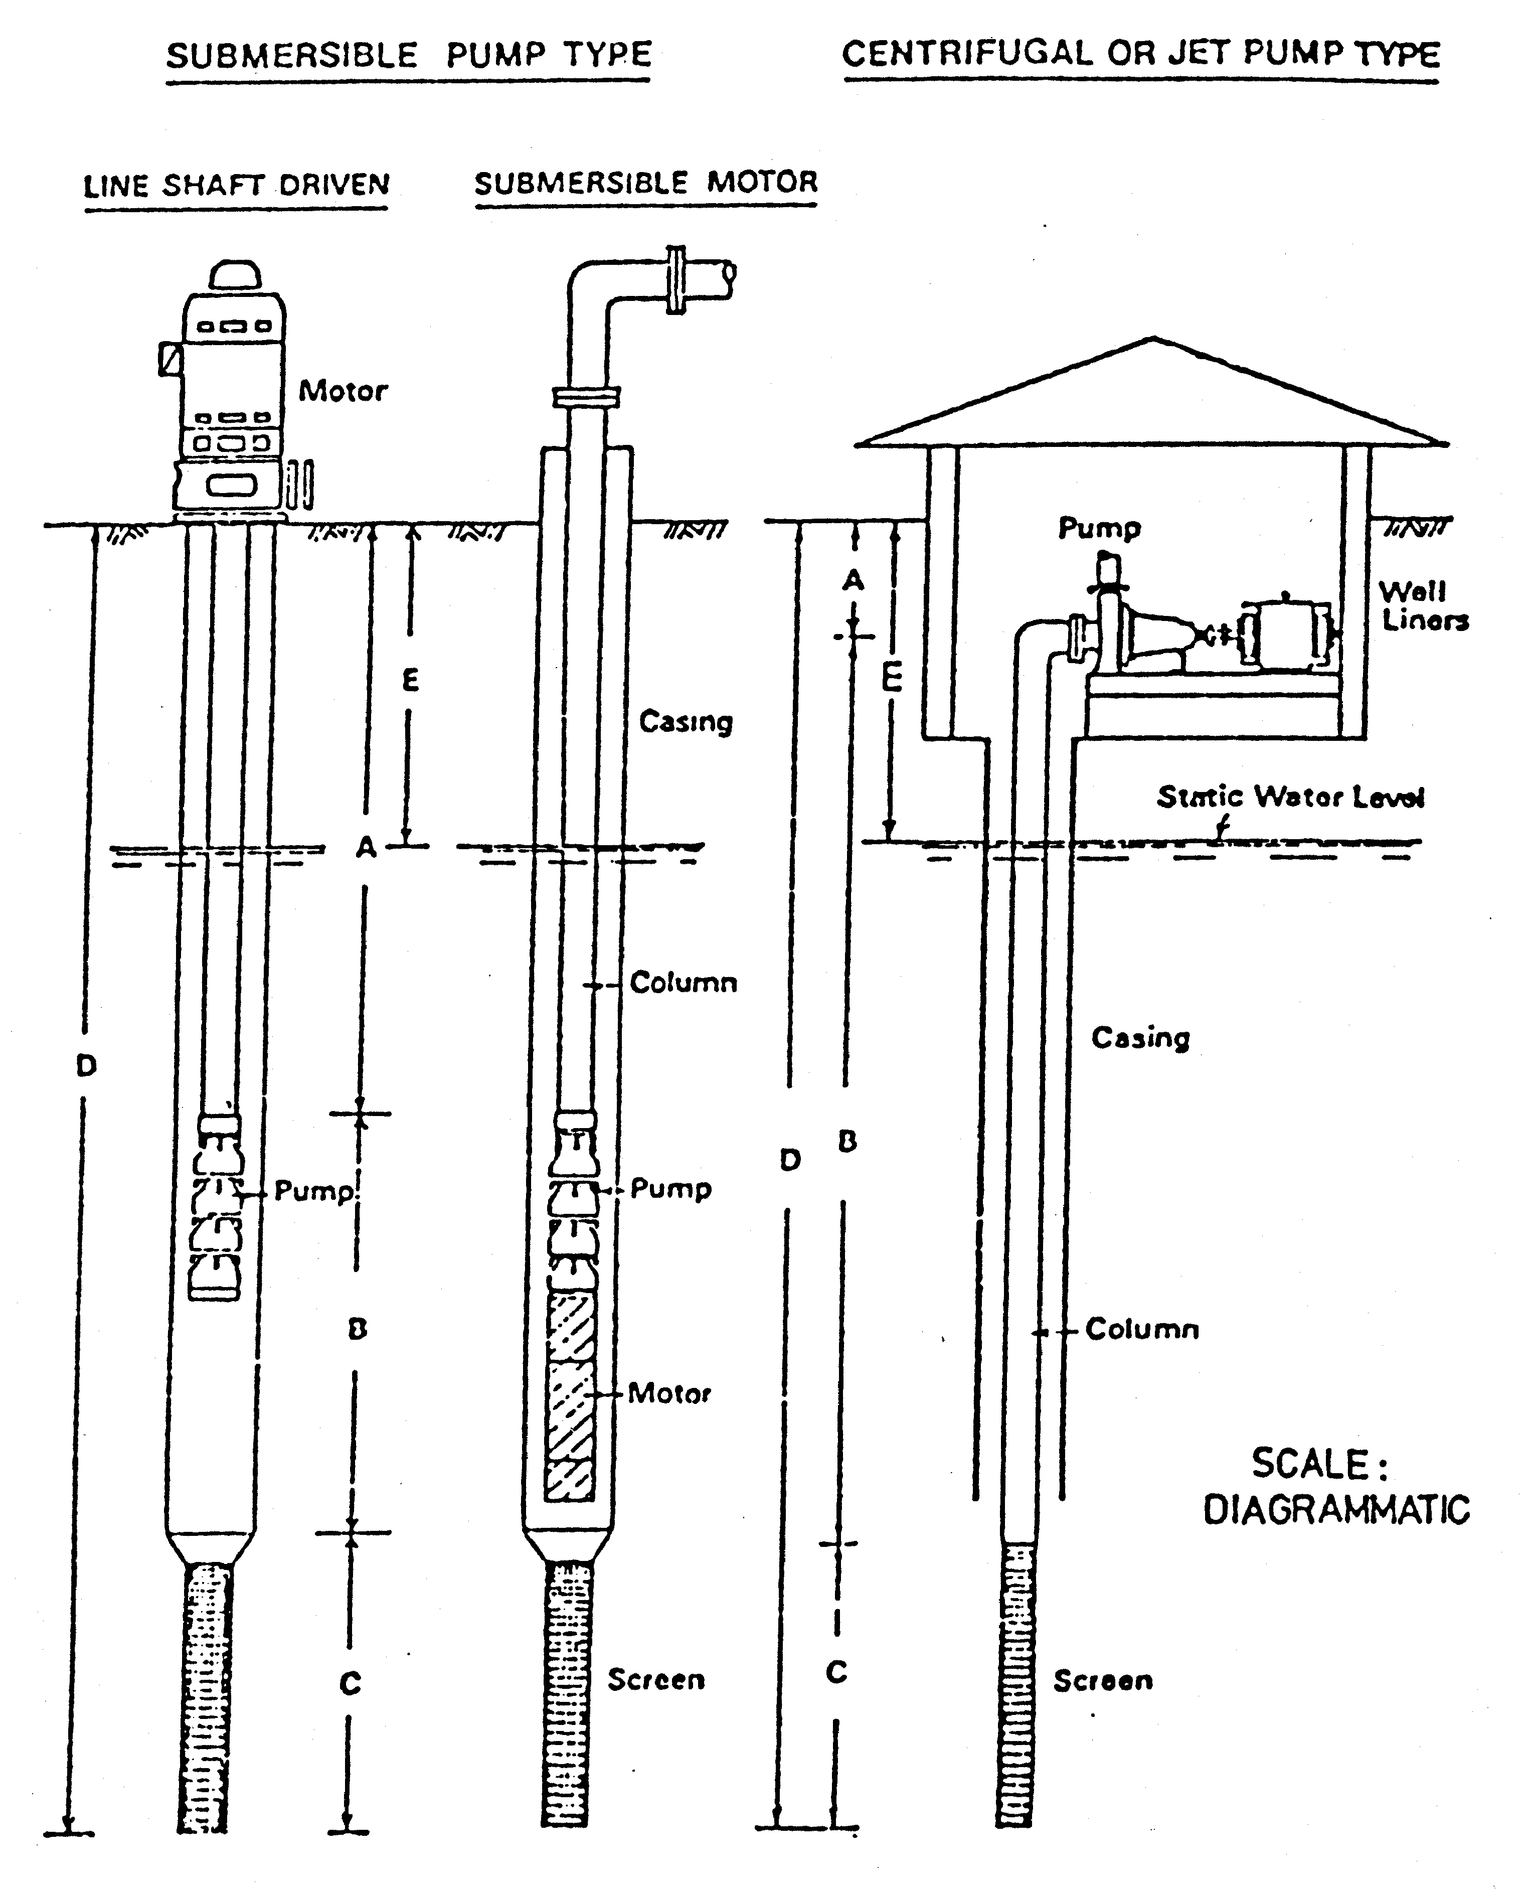
[Schedule B inserted in Gazette 31 Jul 1981 p. 3169-73; amended in Gazette 12 May 1989 p. 1445-6; 29 Dec 1995 p. 6324.]

Schedule C — Fees
[Heading inserted in Gazette 30 Jun 2006 p. 2411.]
 |  | $
1. | Fee in respect of a proposal to connect plumbing to the sewer ……..………………………………...……. | 15.90
2. | Fee for installation of sewer junction —
 | 100 mm sewer junction ...............................… | 332.00
 | 150 mm sewer junction ...............................… | 411.00
3. | Fees for authorisation of materials, fittings and fixtures —
 | (a) application —
 | (i) first item of product type ......................... | 468.60
 | (ii) each additional item of product type ....... | 65.45
 | (b) examination, testing, inspection or evaluation (per hour or part of an hour) .......................... | 108.35
5. | (a) Fee for installing a meter under by-law 6.7.1A.1 ...........................................…. | 268.00
 | (b) Fee for assessing a meter under by-law 6.7.1A.3 ............................................. | 191.00
 | (c) Fee for assessing a meter and installing a new meter under by-law 6.7.1A.4 ......................... | 249.50
6. | Fee for installation of a temporary building standpipe .... | 103.00
9. | Fees for the provision of plan sheets for preparation of diagrams of property sewer installations —
 | (a) A4 size (per pad of 25 sheets) ....................... | 4.95
 | (b) A3 size (per pad of 25 sheets) ....................... | 8.80
 | (c) A1 size (per sheet) ......................................... | 1.65
[Schedule C inserted in Gazette 30 Jun 2006 p. 2411-2.]

Schedule D
(By-law 28.6.2(a) and (b))
Part 1 — Fixtures
Baths Laundry troughs
Basins Shower recess bases
Sinks
Part 2 — Prohibited materials, fittings and fixtures
Food waste disposal units
Rubber or plastic olives in metallic water service fittings
Non-demand operated urinal flushing devices
[Schedule D inserted in Gazette 22 Dec 1989 p. 4631.]

Notes
¹ This is a compilation of the Metropolitan Water Supply, Sewerage and Drainage By-laws 1981 and includes the amendments made by the other written laws referred to in the following table. The table also includes information about any reprint.

Compilation table
Citation |  | Gazettal |  |  | Commencement
Metropolitan Water Supply, Sewerage and Drainage By-laws 1981 |  | 22 Jan 1981 p. 165-384  (Corrigendum 30 Jan 1981 p. 488) |  |  | 1 Mar 1981 (see bl. 1.0)
Metropolitan Water Supply, Sewerage and Drainage Amendment By-laws No. 1 of 1981 |  | 20 Feb 1981  p. 773 |  |  | 1 Mar 1981 (see bl. 2)
Metropolitan Water Supply, Sewerage and Drainage Amendment By-laws (No. 3) 1981 |  | 26 Jun 1981  p. 2326-7 |  |  | 1 Jul 1981 (see bl. 2)
Metropolitan Water Supply, Sewerage and Drainage Amendment By-laws No. 2 of 1981 |  | 31 Jul 1981  p. 3169-73 |  |  | 31 Jul 1981
Metropolitan Water Supply, Sewerage and Drainage Amendment By-laws 1982 |  | 26 Mar 1982  p. 1088 |  |  | 1 Jul 1982 (see bl. 2)
Metropolitan Water Supply, Sewerage and Drainage Amendment By-laws (No. 2) 1982 |  | 18 Jun 1982  p. 2022-3 |  |  | 1 Jul 1982 (see bl. 2)
Metropolitan Water Supply, Sewerage and Drainage Amendment By-laws (No. 3) 1982 |  | 24 Dec 1982  p. 4924-30  (Corrigendum 4 Feb 1983  p. 425) |  |  | 31 Dec 1982 (see bl. 2 and Gazette 31 Dec 1982 p. 4969)
Metropolitan Water Supply, Sewerage and Drainage Amendment By-laws 1983 |  | 24 Jun 1983  p. 2007-8 |  |  | 1 Jul 1983 (see bl. 2)
Metropolitan Water Supply, Sewerage and Drainage Amendment By-laws 1984 |  | 6 Apr 1984  p. 978 |  |  | 1 Jul 1984 (see bl. 2)
Metropolitan Water Supply, Sewerage and Drainage Amendment By-laws (No. 2) 1984 |  | 29 Jun 1984  p. 1812-13 |  |  | 1 Jul 1984 (see bl. 3)
Metropolitan Water Supply, Sewerage and Drainage Amendment By-laws (No. 2) 1985 |  | 8 Mar 1985  p. 907 |  |  | Bl. 5: 1 Jul 1985 (see bl. 2(2)); balance 8 Mar 1985 (see bl. 2(1))
Metropolitan Water Supply, Sewerage and Drainage Amendment By-laws 1985 |  | 28 Jun 1985  p. 2349-51 |  |  | 28 Jun 1985
Metropolitan Water Supply, Sewerage and Drainage Amendment By-laws (No. 3) 1985 |  | 28 Jun 1985  p. 2348-9 |  |  | 1 Jul 1985 (see bl. 2)
Metropolitan Water Supply, Sewerage and Drainage Amendment By-laws 1986 |  | 27 Jun 1986  p. 2131-2 |  |  | 1 Jul 1986 (see bl. 2)
Reprint of the Metropolitan Water Supply, Sewerage and Drainage By-laws 1981 as at 7 Nov 1986 (includes amendments listed above)
 | Water Authority Amendment By-laws 1987 ¹² Pt. V |  | 14 Jul 1987 p. 2649-58 |  |  | 14 Jul 1987
 | Metropolitan Water Supply, Sewerage and Drainage Amendment By-laws 1988 |  | 19 Feb 1988 p. 551-2 |  |  | 19 Feb 1988
 | Metropolitan Water Supply, Sewerage and Drainage Amendment By-laws (No. 3) 1988 |  | 29 Jun 1988 p. 2126-7 |  |  | 1 Jul 1988 (see bl. 2)
 | Metropolitan Water Supply, Sewerage and Drainage Amendment By-laws (No. 2) 1988 |  | 14 Oct 1988 p. 4173-4 |  |  | 14 Oct 1988
 | Metropolitan Water Supply, Sewerage and Drainage Amendment By-laws 1989 |  | 21 Apr 1989 p. 1174-5  (Erratum 19 May 1989 p. 1499) |  |  | 21 Apr 1989
 | Metropolitan Water Supply, Sewerage and Drainage Amendment By-laws (No. 3) 1989 |  | 12 May 1989 p. 1445-6 |  |  | 12 May 1989
 | Water Authority Amendment By-laws 1989 ¹³ Pt. 5 |  | 29 Jun 1989 p. 1883-91 |  |  | 1 Jul 1989 (see bl. 3)
 | Metropolitan Water Supply, Sewerage and Drainage Amendment By-laws (No. 2) 1989 ¹⁴ |  | 22 Dec 1989 p. 4635-9 |  |  | 1 Feb 1990 (see bl. 2 and Gazette 5 Jan 1990 p. 38)
 | Metropolitan Water Supply, Sewerage and Drainage Amendment By-laws (No. 4) 1989 |  | 22 Dec 1989 p. 4622 |  |  | 1 Jan 1990 (see bl. 3)
 | Metropolitan Water Supply, Sewerage and Drainage Amendment By-laws (No. 5) 1989 |  | 22 Dec 1989 p. 4630-2 |  |  | 1 Feb 1990 (see bl. 2 and Gazette 5 Jan 1990 p. 38)
 | Water Authority Amendment By-laws 1990 ¹⁵ Pt. 5 |  | 29 Jun 1990 p. 3240-8  (Errata 6 Jul 1990 p. 3318) |  |  | 1 Jul 1990 (see bl. 3)
 | Metropolitan Water Supply, Sewerage and Drainage Amendment By-laws 1990 |  | 21 Sep 1990 p. 4951-2 |  |  | 21 Sep 1990
 | Water Authority Amendment By-laws 1991 ¹⁶ Pt. 5 |  | 28 Jun 1991 p. 3281-9 |  |  | 1 Jul 1991 (see bl. 3)
 | Metropolitan Water Supply, Sewerage and Drainage Amendment By-laws 1991 |  | 3 Jan 1992 p. 34 |  |  | 3 Jan 1992
 | Water Authority Amendment By-laws 1992 ¹⁷ Pt. 5 |  | 26 Jun 1992 p. 2832-44 |  |  | 1 Jul 1992 (see bl. 3)
 | Water Authority Amendment By-laws (No. 2) 1992 Pt. 2 |  | 31 Dec 1992 p. 6414-17 |  |  | 1 Jan 1993 (see bl. 2)
 | Metropolitan Water Supply, Sewerage and Drainage Amendment By-laws 1992 |  | 31 Dec 1992 p. 6417-24 |  |  | 31 Dec 1992
 | Metropolitan Water Supply, Sewerage and Drainage Amendment By-laws (No. 2) 1993 |  | 4 May 1993 p. 2329-30 |  |  | 4 May 1993
 | Water Authority Amendment By-laws 1993 ¹⁸ Pt. 5 |  | 1 Jul 1993 p. 3238-50 |  |  | 1 Jul 1993
 | Metropolitan Water Supply, Sewerage and Drainage Amendment By-laws 1993 |  | 30 Jul 1993 p. 4165-6 |  |  | 30 Jul 1993
 | Water Authority Amendment By-laws 1994 ¹⁹ Pt. 5 |  | 29 Jun 1994 p. 3159-70 |  |  | 1 Jul 1994 (see bl. 2)
 | Metropolitan Water Supply, Sewerage and Drainage Amendment By-laws 1995 |  | 23 Jun 1995 p. 2509-10 |  |  | 23 Jun 1995
 | Water Authority Amendment By-laws 1995 ²⁰ Pt. 5 |  | 30 Jun 1995 p. 2767-76 |  |  | 1 Jul 1995 (see bl. 2)
 | Metropolitan Water Supply, Sewerage and Drainage Amendment By-laws (No. 2) 1995 |  | 30 Jun 1995  p. 2778 |  |  | 30 Jun 1995
 | Water Agencies (Amendment and Repeal) By-laws 1995 Pt. 8 |  | 29 Dec 1995 p. 6305-32 |  |  | 1 Jan 1996 (see bl. 2 and Gazette 29 Dec 1995 p.6291)
 | Metropolitan Water Supply, Sewerage and Drainage Amendment By-laws 1996 |  | 4 Feb 1997 p. 712-18 |  |  | 4 Feb 1997
 | Reprint of the Metropolitan Water Supply, Sewerage and Drainage By-laws 1981 as at 19 May 1997 (includes amendments listed above)
Water Agencies Amendment By-laws 1997 ²¹ Pt. 5 |  | 27 Jun 1997 p. 3204-20 |  |  | 1 Jul 1997 (see bl. 2)
Water Agencies Amendment By-laws 1998 ²² Pt. 5 |  | 26 Jun 1998 p. 3417-21 |  |  | 1 Jul 1998 (see bl. 2)
Metropolitan Water Supply, Sewerage and Drainage Amendment By-laws 1998 |  | 25 Aug 1998 p. 4724-35 |  |  | 25 Aug 1998
Metropolitan Water Supply, Sewerage and Drainage Amendment By-laws (No. 2) 1998 |  | 29 Sep 1998 p. 5405 |  |  | 29 Sep 1998 (see bl. 2)
Water Agencies Amendment By-laws 1999 ²³ Pt. 6 |  | 29 Jun 1999 p. 2775-87 |  |  | 1 Jul 1999 (see bl. 2)
Reprint of the Metropolitan Water Supply, Sewerage and Drainage By-laws 1981 as at 5 May 2000 (includes amendments listed above)
Metropolitan Water Supply, Sewerage and Drainage Amendment By-laws 2000 |  | 16 Jun 2000  p. 2958-60 |  |  | 19 Jun 2000 (see bl. 2 and Gazette 16 Jun 2000 p. 2939)
Water Agencies Amendment By-laws 2000 ²⁴ Pt. 6 |  | 29 Jun 2000 p. 3365-79 |  |  | 1 Jul 2000 (see bl. 2)
Metropolitan Water Supply, Sewerage and Drainage Amendment By-laws (No. 2) 2000 |  | 1 Sep 2000 p. 5020-1 |  |  | 1 Sep 2000
Metropolitan Water Supply, Sewerage and Drainage Amendment By-laws (No. 4) 2000 |  | 29 Sep 2000 p. 5551 |  |  | 29 Sep 2000
Metropolitan Water Supply, Sewerage and Drainage Amendment By-laws (No. 3) 2000 |  | 14 Nov 2000 p. 6255-6 |  |  | 14 Nov 2000
Water Agencies Amendment By-laws 2001 ²⁵ Pt. 7 |  | 29 Jun 2001 p. 3230-42 |  |  | 1 Jul 2001 (see bl. 2)
Reprint of the Metropolitan Water Supply, Sewerage and Drainage By-laws 1981 as at 17 Aug 2001 (includes amendments listed above)
Water Agencies Amendment By-laws 2002 Pt. 5 |  |  |  | 1 Jul 2002 p. 3137-53 |  |  | 1 Jul 2002
Water Agencies Amendment By-laws 2003 ²⁶ |  |  |  | 27 Jun 2003 p. 2422-32 |  |  | 1 Jul 2003 (see bl. 2)
Metropolitan Water Supply, Sewerage and Drainage Amendment By-laws 2004 |  |  |  | 28 Jun 2004 p. 2371-9 |  |  | 1 Jul 2004 (see bl. 2 and Gazette 28 Jun 2004 p. 2399)
Water Agencies Amendment By-laws 2004 Pt. 5 |  |  |  | 29 Jun 2004 p. 2497-503 |  |  | 1 Jul 2004 (see bl. 2)
Metropolitan Water Supply, Sewerage and Drainage Amendment By-laws 2005 |  |  |  | 26 Apr 2005 p. 1396-7 |  |  | 26 Apr 2005
Water Agencies Amendment By-laws 2005 Pt. 6 |  |  |  | 1 Jul 2005 p. 3009-17 |  |  | 1 Jul 2005 (see bl. 2)
Water Agencies Amendment By-laws 2006 Pt. 6 ²⁷ |  |  |  | 30 Jun 2006 p. 2399-412 |  |  | 1 Jul 2006 (see bl. 2)
² The power to make these by-laws is now contained in the Water Agencies (Powers) Act 1984 s. 34.
³ Under the Conservation and Land Management Act 1984 s. 151(a), a reference in any law to the former Forests Department shall be read as a reference to the Department of Conservation and Land Management.
⁴ Under the Public Sector Management Act 1994 the names of departments can be changed. At the date of this reprint the former Public Health Department is called the Department of Health.
⁵ Under the Public Sector Management Act 1994 the names of departments can be changed. At the date of this reprint the former Department of Mines is known as the Department of Mineral and Petroleum Resources.
⁶ The Flammable Liquids Regulations 1967 were repealed by the Dangerous Goods Regulations 1992 r. 8.2.
⁷ See Health Act 1911.
⁸ The Metropolitan Water Supply, Sewerage, and Drainage Act 1909 s. 147 was repealed by the Acts Amendment and Repeal (Water Authorities) Act 1985 s. 76.
⁹ Now see the Local Government Act 1995.
¹⁰ See the Strata Titles Act 1985.
¹¹ Footnote no longer applicable.
¹² The Water Authority Amendment By-laws 1987 bl. 2 reads as follows:
“
2. Application
Nothing in these by-laws affects the application after the day of the coming into operation of these by-laws of a by-law in force before that day in so far as that by-law relates to a fee, rate, or charge for a period commencing before that day, to a fee or charge for any matter or thing done before that day, or to a charge for water supplied during a period ending before 31 October 1987.
”.
¹³ The Water Authority Amendment By-laws 1989 bl. 2 reads as follows:
“
2. Application
Nothing in these by-laws affects the application after 1 July 1989 of a by-law in force before that day in so far as that by-law relates to a fee or charge for a period commencing before that day or to a fee or charge for any matter or thing done before that day.
”.
¹⁴ The Metropolitan Water Supply, Sewerage and Drainage Amendment By-laws (No. 2) 1989 bl. 11 reads as follows:
“
11. Savings and transitional
(1) Notwithstanding these by-laws, during the period from the commencement until 1 March 1990, a licensed plumber may commence, carry out or complete work as if these by-laws had not come into operation.
(2) Nothing in these by-laws shall be taken to prevent a licensed plumber from commencing, carrying out or completing work, on or after 1 March 1990, for which a permit was issued and in force immediately before that date, and the principal by-laws as in force immediately before the commencement apply in respect of such work.
(3) In this by-law:
“commencement” means the commencement of these by-laws.
”.
¹⁵ The Water Authority Amendment By-laws 1990 bl. 2 reads as follows:
“
2. Application
Nothing in these by-laws affects the application after 1 July 1990 of a by-law in force before that day in so far as that by-law relates to a fee or charge for a period commencing before that day or to a fee or charge for any matter or thing done before that day.
”.
¹⁶ The Water Authority Amendment By-laws 1991 bl. 2 reads as follows:
“
2. Application
Nothing in these by-laws affects the application after 1 July 1991 of a by-law in force before that day in so far as that by-law relates to a fee or charge for a period commencing before that day or to a fee or charge for any matter or thing done before that day.
”.
¹⁷ The Water Authority Amendment By-laws 1992 bl. 2 reads as follows:
“
2. Application
Nothing in these by-laws affects the application after 1 July 1992 of a by-law in force before that day in so far as that by-law relates to a fee or charge for a period commencing before that day or to a fee or charge for any matter or thing done before that day.
”.
¹⁸ The Water Authority Amendment By-laws 1993 bl. 2 reads as follows:
“
2. Application
Nothing in these by-laws affects the application after 1 July 1993 of a by-law in force before that day in so far as that by-law relates to a fee or charge for a period commencing before that day or to a fee or charge for any matter or thing done before that day.
”.
¹⁹ The Water Authority Amendment By-laws 1994 bl. 3 reads as follows:
“
3. Application
Nothing in these by-laws affects the application after 1 July 1994 of a by-law in force before that day in so far as that by-law relates to a fee or charge for a period commencing before that day or to a fee or charge for any matter or thing done before that day.
”.
²⁰ The Water Authority Amendment By-laws 1995 bl. 3 reads as follows:
“
3. Application
Nothing in these by-laws affects the application after 1 July 1995 of a by-law in force before that day in so far as that by-law relates to a fee or charge for a period commencing before that day or to a fee or charge for any matter or thing done before that day.
”.
²¹ The Water Agencies Amendment By-laws 1997 bl. 3 reads as follows:
“
3. Application
Nothing in these by-laws affects the application after 1 July 1997 of a by-law in force before that day in so far as that by-law relates to a fee or charge for a period commencing before that day or to a fee or charge for any matter or thing done before that day.
”.
²² The Water Agencies Amendment By-laws 1998 bl. 3 reads as follows:
“
3. Application
Nothing in these by-laws affects the application after 1 July 1998 of a by-law in force before that day in so far as that by-law relates to a fee or charge for a period commencing before that day or to a fee or charge for any matter or thing done before that day.
”.
²³ The Water Agencies Amendment By-laws 1999 bl. 3 reads as follows:
“
3. Application
Nothing in these by-laws affects the application after 1 July 1999 of a by-law in force before that day in so far as that by-law relates to a fee or charge for a period commencing before that day or to a fee or charge for any matter or thing done before that day.
”.
²⁴ The Water Agencies Amendment By-laws 2000 bl. 3 reads as follows:
“
3. Application
Nothing in these by-laws affects the application after 1 July 2000 of a by-law in force before that day in so far as that by-law relates to a fee or charge for a period commencing before that day or to a fee or charge for any matter or thing done before that day.
”.
²⁵ The Water Agencies Amendment By-laws 2001 bl. 3 reads as follows:
“
3. Application
Nothing in these by-laws affects the application after 1 July 2001 of a by-law in force before that day in so far as that by-law relates to a fee or charge for a period commencing before that day or to a fee or charge for any matter or thing done before that day.
”.
²⁶ The Water Agencies Amendment By-laws 2003 bl. 3 reads as follows:
“
3. Application
Nothing in these by-laws affects the application after 1 July 2003 of a by-law in force before that day in so far as that by-law relates to a fee or charge for a period commencing before that day or to a fee or charge for any matter or thing done before that day.
”.
²⁷ The Water Agencies Amendment By-laws 2006 bl. 3 reads as follows:
“
3. Application
Nothing in these by-laws affects the application after 1 July 2006 of a by-law in force before that day in so far as that by-law relates to a fee or charge for a period commencing before that day or to a fee or charge for any matter or thing done before that day.
”.

